Supporting Information

One-Pot Synthesis of Oxazolidinones and Five-Membered Cyclic Carbonates from Epoxides and Chlorosulfonyl isocyanate: Theoretical Evidence for the Asynchronous Concerted Pathway
Esra Demir¹, Ozlem Sari², Yasin Çetinkaya³, Ufuk Atmaca^{1,3}, Safiye Sağ Erdem⁴,
Murat Çelik^{*1}
¹Department of Chemistry, Faculty of Science, Atatürk University, 25240 Erzurum, Turkey
²Department of Chemistry, Faculty of Arts and Sciences, Kırşehir Ahi Evran University, 40100 Kırşehir, Turkey
³Department of Food Technology, Oltu Vocational School, Atatürk University, 25400 Oltu, Erzurum, Turkey
⁴Department of Chemistry, Faculty of Arts and Sciences, Marmara University, Goztepe Campus, 34722 Istanbul, Turkey

Contents Page

Experimental ………………………………………………………………………………...S3
General remarks …………………………………………………………………………………….S3
General procedure Synthesis of Epoxidation ...……………………………………………...S3
¹H NMR and ¹³C NMR spectra of 8a ……………………………………………………………..S4
¹H NMR and ¹³C NMR spectra of 9a ………………………………………………………….….S5
¹H NMR and ¹³C NMR spectra of 8b ……………………………………………………………..S6
¹H NMR and ¹³C NMR spectra of 9b ……………………………………………………………..S7
¹H NMR and ¹³C NMR spectra of 8c ……………………………………………………………...S8
¹H NMR and ¹³C NMR spectra of 9c ……………………………………………………………...S9
¹H NMR and ¹³C NMR spectra of 8d …………………………………………………………….S10
¹H NMR and ¹³C NMR spectra of 9d …………………………………………………………….S11
¹H NMR and ¹³C NMR spectra of 8e …………………………………………………………….S12
¹H NMR and ¹³C NMR spectra of 9e ………………………………………………………….…S13
¹H NMR and ¹³C NMR spectra of 8f ……………………………………………………………..S14
¹H NMR and ¹³C NMR spectra of 9f ……………………………………………………………..S15
¹H NMR and ¹³C NMR spectra of 8g …………………………………………………………….S16
¹H NMR and ¹³C NMR spectra of 9g …………………………………………………………….S17
¹H NMR and ¹³C NMR spectra of 8h …………………………………………………………….S18
¹H NMR and ¹³C NMR spectra of 9h …………………………………………………………….S19
¹H NMR and ¹³C NMR spectra of 8i …………………………………………………………….S20
¹H NMR and ¹³C NMR spectra of 9i …………………………………………………………….S21
¹H NMR and ¹³C NMR spectra of 8j ………………………………………………………….....S22
¹H NMR and ¹³C NMR spectra of 9j ……………………………………………………………..S23
Table S1. Absolute energies of optimized structures for the formation of 10 and 11
in gas phase (M06-2X/6-31+G(d,p)) …………………………………………………...S24
Table S2. Single point energies for the formation of 10 and 11 at
PCM(DCM)/M06-2X/6-31+G(d,p)//M06-2X/6-31+G(d,p) level .…………………….S24
Table S3. Absolute energies of optimized structures for path 1a, path 1b and path 2
in gas phase (M06-2X/6-31+G(d,p)) …………………………………………………...S24
Table S4. Single point energies for path 1a, path 1b and path 2 at
PCM(DCM)/M06-2X/6-31+G(d,p)//M06-2X/6-31+G(d,p) level ..……………………S25
Table S5. Absolute energies of optimized structures for the formation of 8f in gas phase
(M06-2X/6-31+G(d,p)) ………………………………………………………………..S25
Table S6. Single point energies for the formation of 8f at
PCM(DCM)/M06-2X/6-31+G(d,p)//M06-2X/6-31+G(d,p) level .…………………….S25
Cartesian Coordinates for the Optimized Structures Given in Paths ……………………….S26
References ………………………………………………………………………………….S42

EXPERIMENTAL

General remarks

The epoxides were synthesized from related alkenes with m-CPBA. All solvents and reagents were used as purchased from commercial suppliers. Melting points were determined on a melting-point apparatus (Gallenkamp; WA11373) and are uncorrected. IR spectra were obtained from solutions in 0.1mm cells and in CH₂Cl₂ with a Perkin–Elmer spectrophotometer. ¹H and ¹³C NMR spectra were recorded on an instruments (Varian and Bruker spectrometers) 400 and 100 MHz, respectively, and NMR shifts are presented as δ in ppm. Elemental analyses were performed on LECO CHNS-932 apparatus. MS spectra were carried out on an LC/MS High-Resolution Time of Flight (TOF) Agilent 1200/6530 instrument. All column chromatography was performed on silica gel (60-mesh, Merck).

General procedure Synthesis of Epoxidation:
1 g of the alkene was dissolved in CH₂Cl₂ (40 mL) and cooled to 0 ºC. Then metachloroperbenzoic acid (1.2 equiv) was slowly added to the solution. The solution was left stirring for 12 h at ambient temperature. The solution was washed with 1 M Na₂SO₃ (3 × 30 mL, 1 M), a saturated solution of NaHCO₃ (3 × 30 mL) and brine. The organic phase was dried over sodium sulfate and the product obtained after removal of the solvent in vacuo (rotary evaporator).

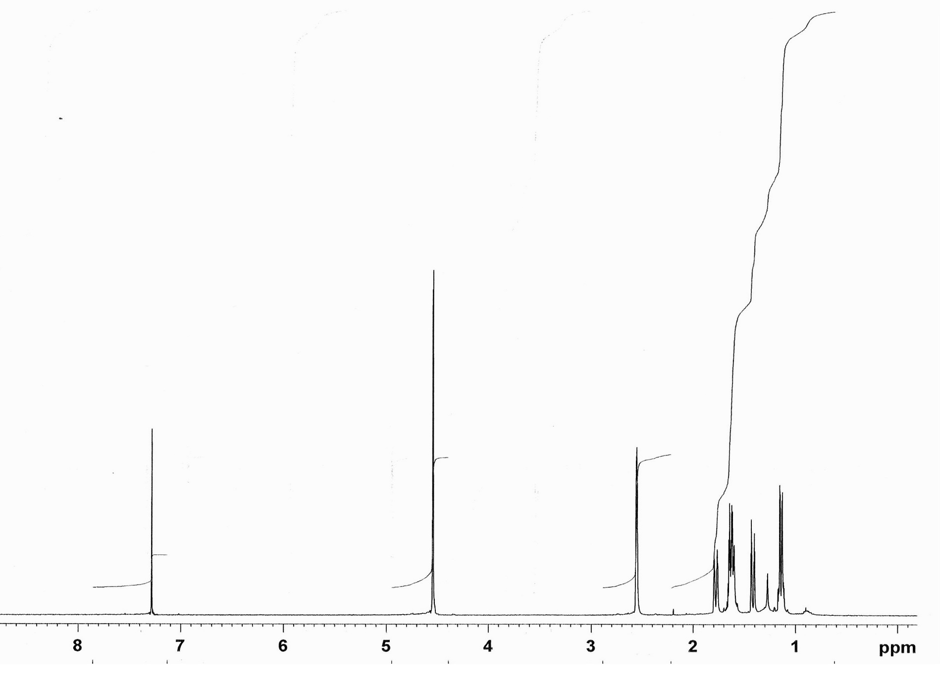
¹H NMR Spectrum of Hexahydro-4,7-methanobenzo[d][1,3]dioxol-2-one (8a)

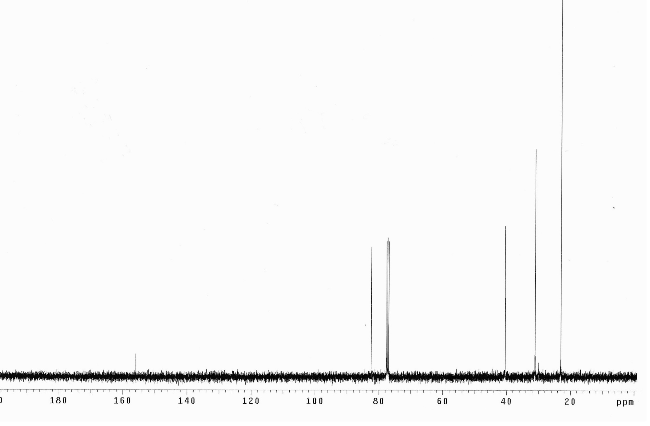
¹³C NMR Spectrum of Hexahydro-4,7-methanobenzo[d][1,3]dioxol-2-one (8a)
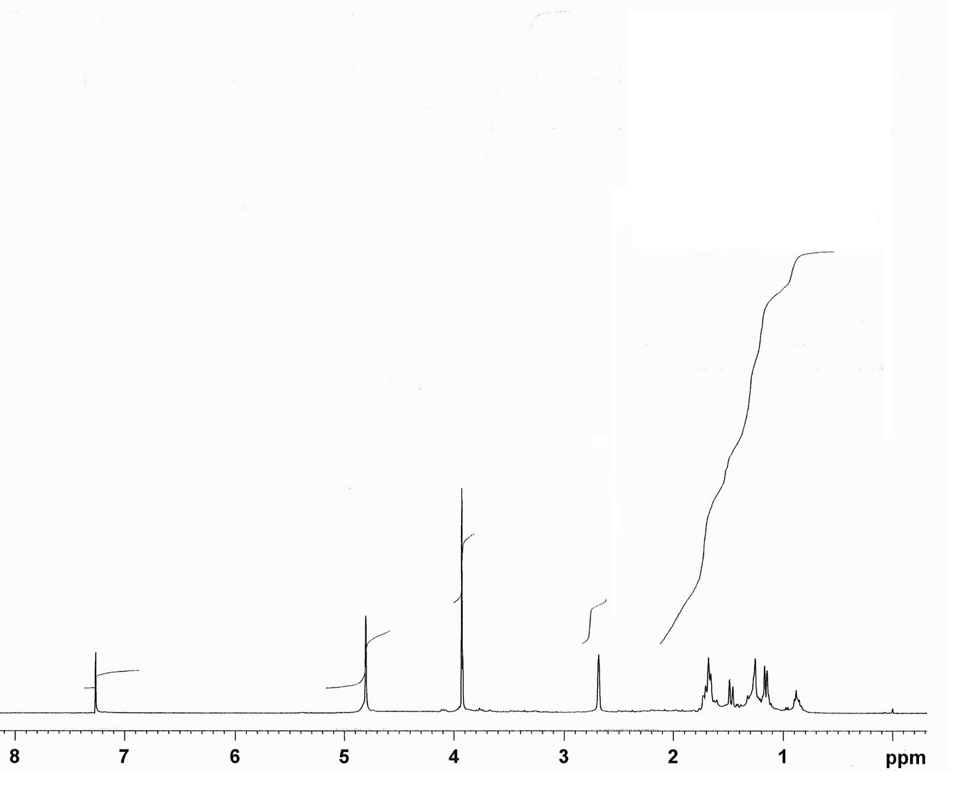
¹H NMR Spectrum of Hexahydro-4,7-methanobenzo[d]oxazol-2(3H)-one (9a)

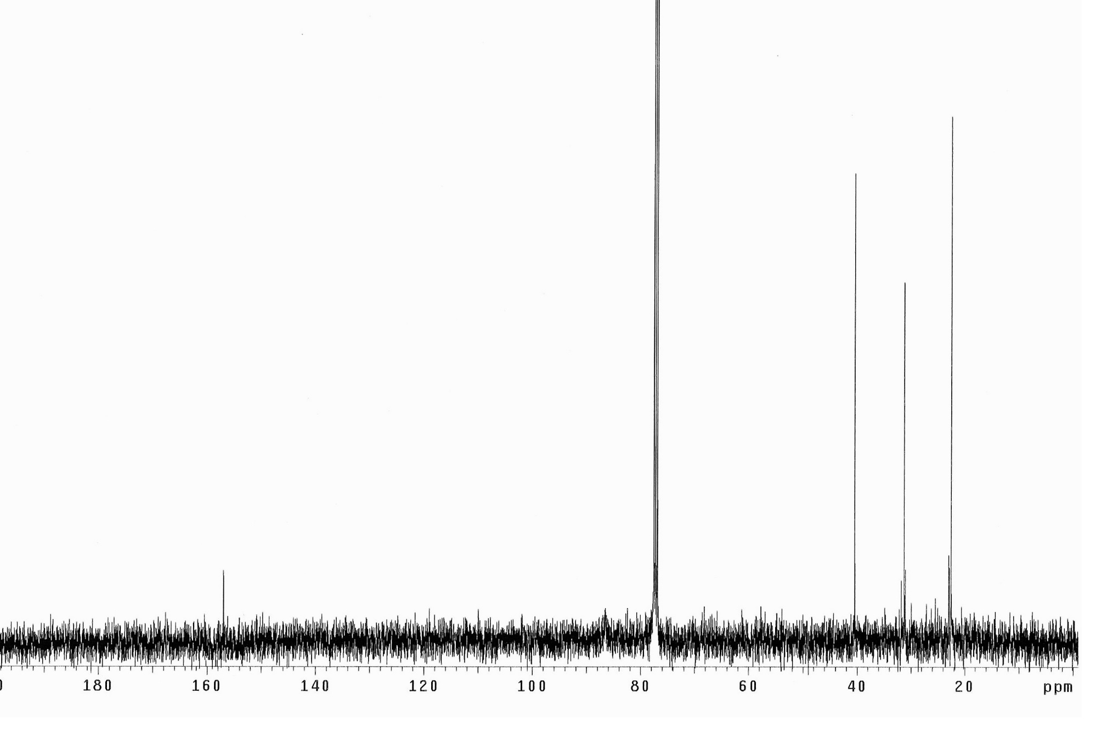
¹³C NMR Spectrum of Hexahydro-4,7-methanobenzo[d]oxazol-2(3H)-one (9a)

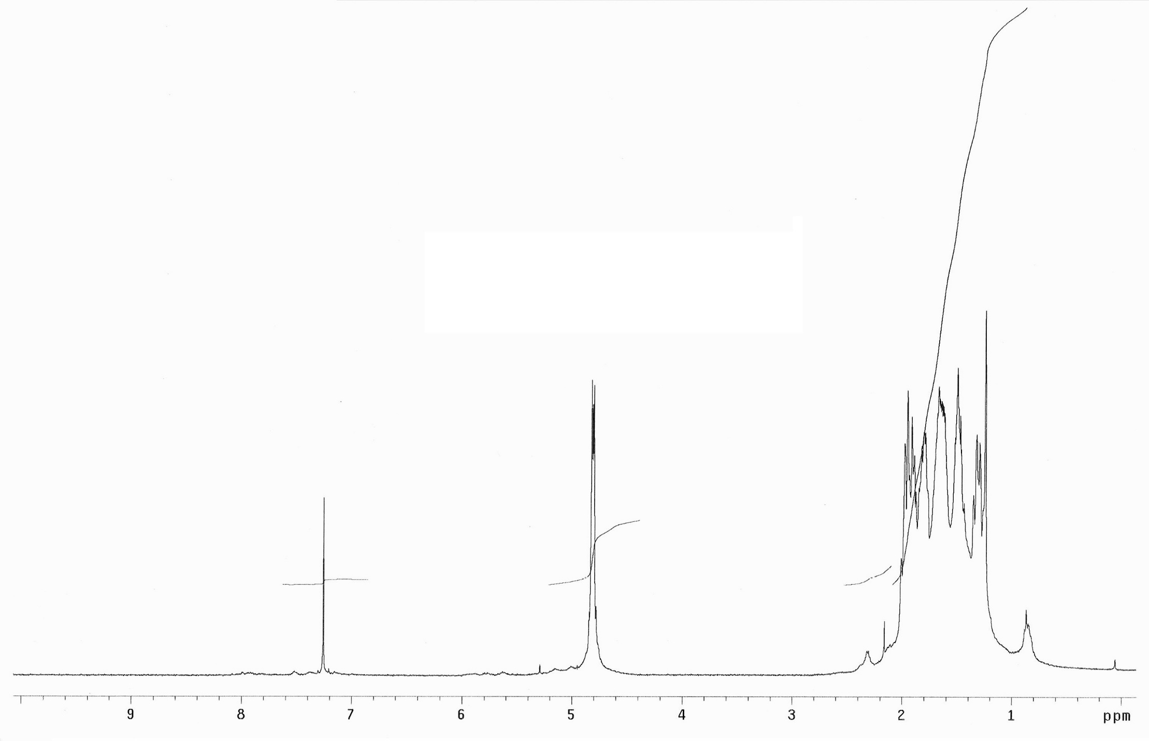
¹H NMR Spectrum of Hexahydro-4H-cyclohepta[d][1,3]dioxol-2-one (8b)

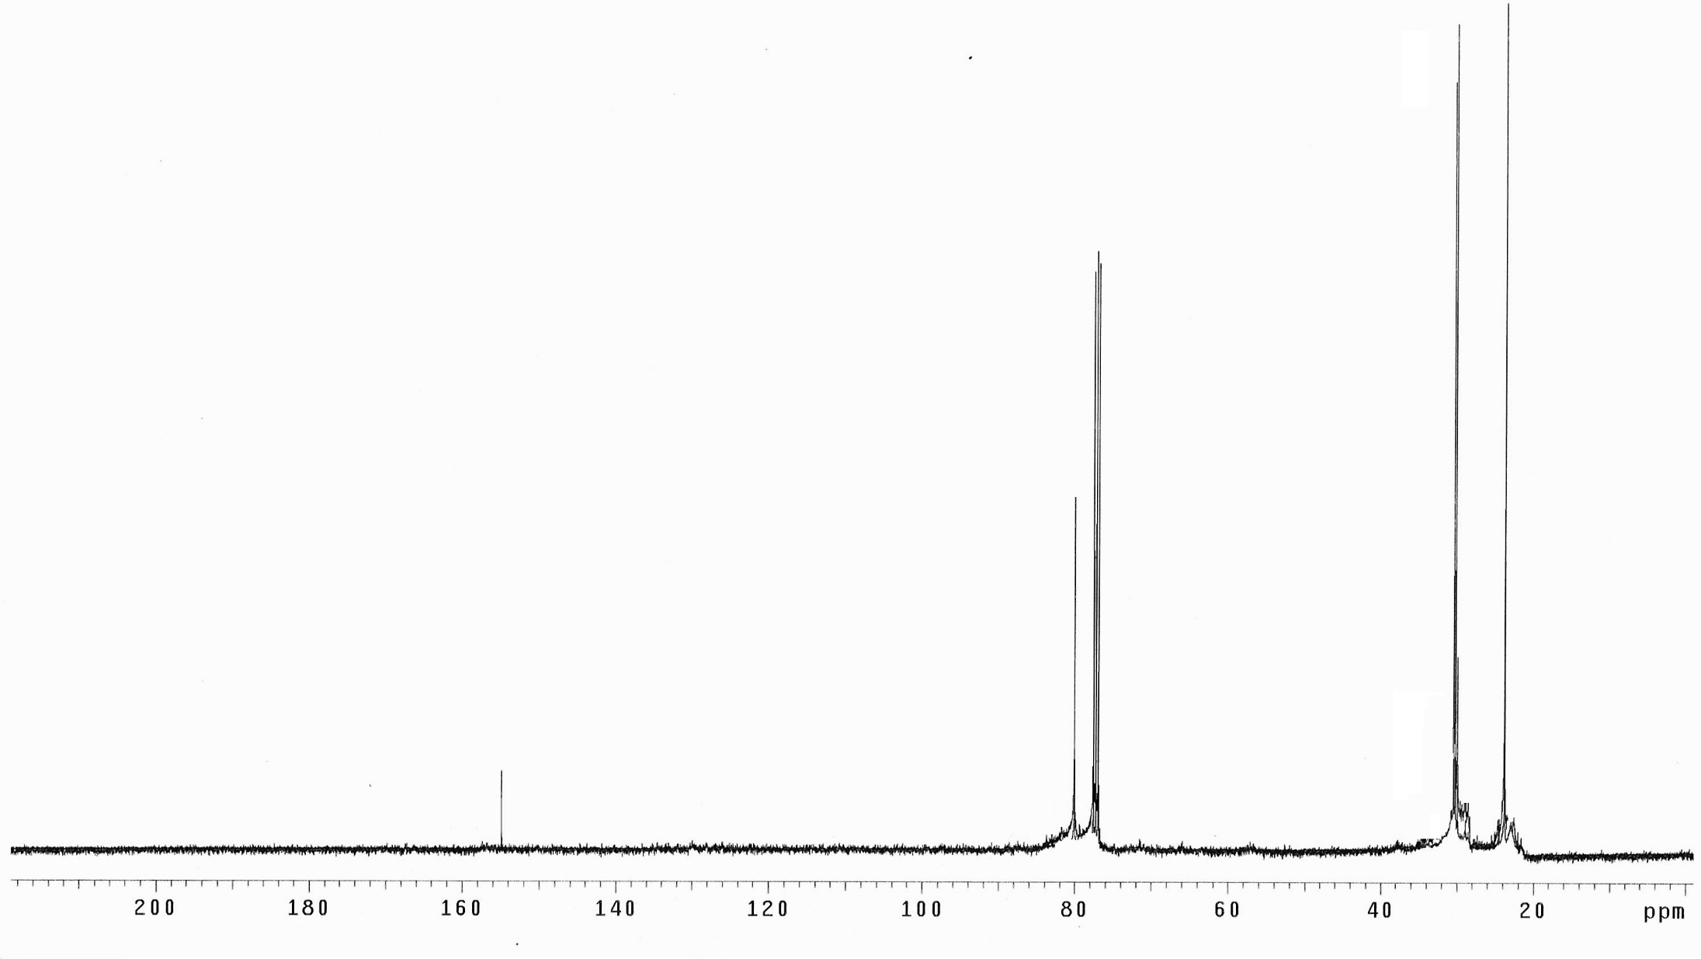
¹³C NMR Spectrum of Hexahydro-4H-cyclohepta[d][1,3]dioxol-2-one (8b)

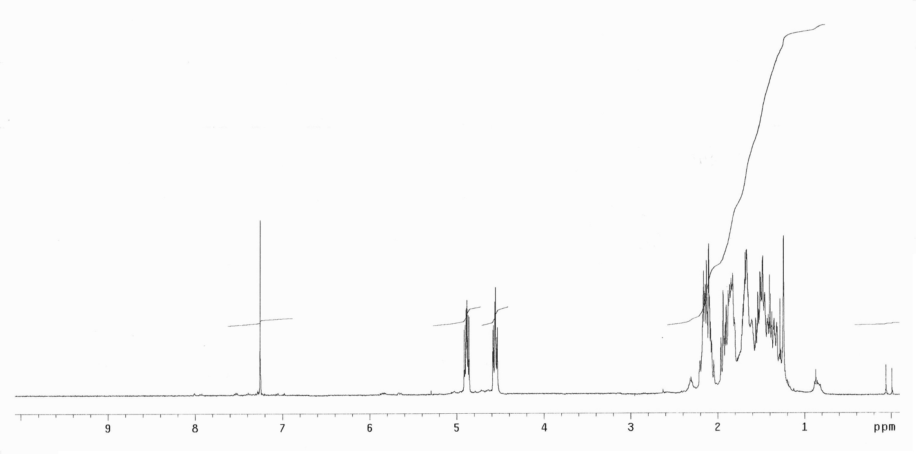
¹H NMR Spectrum of Octahydro-2H-cyclohepta[d]oxazol-2-one (9b)

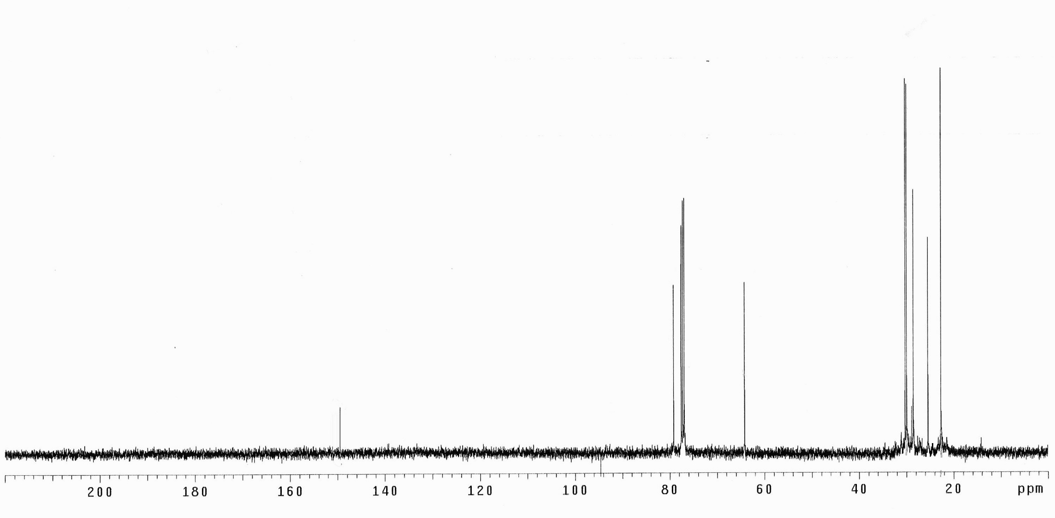
¹³C NMR Spectrum of Octahydro-2H-cyclohepta[d]oxazol-2-one (9b)

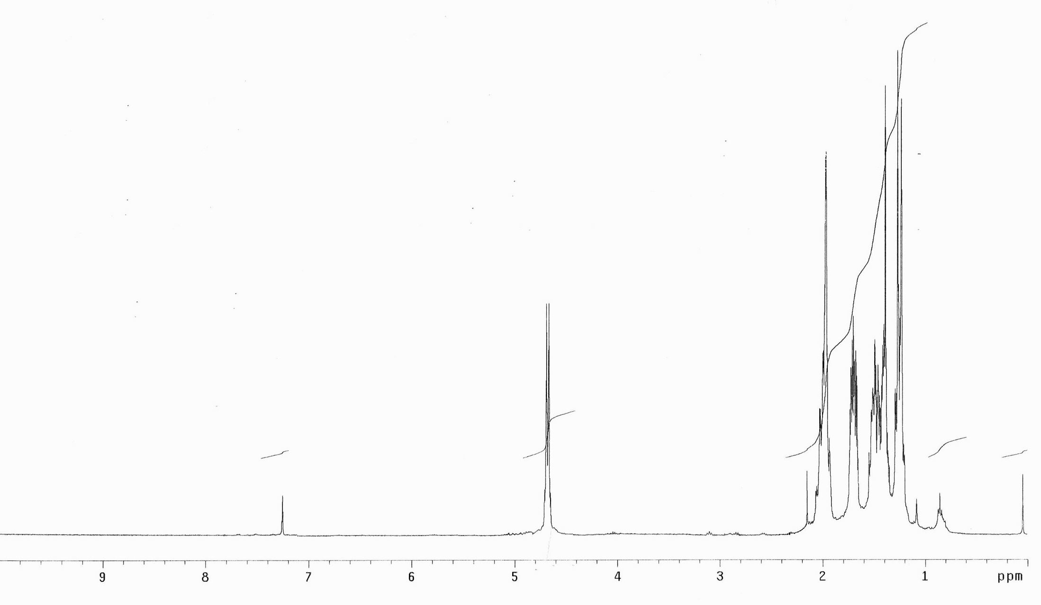
¹H NMR Spectrum of Octahydrocycloocta[d][1,3]dioxol-2-one (8c)
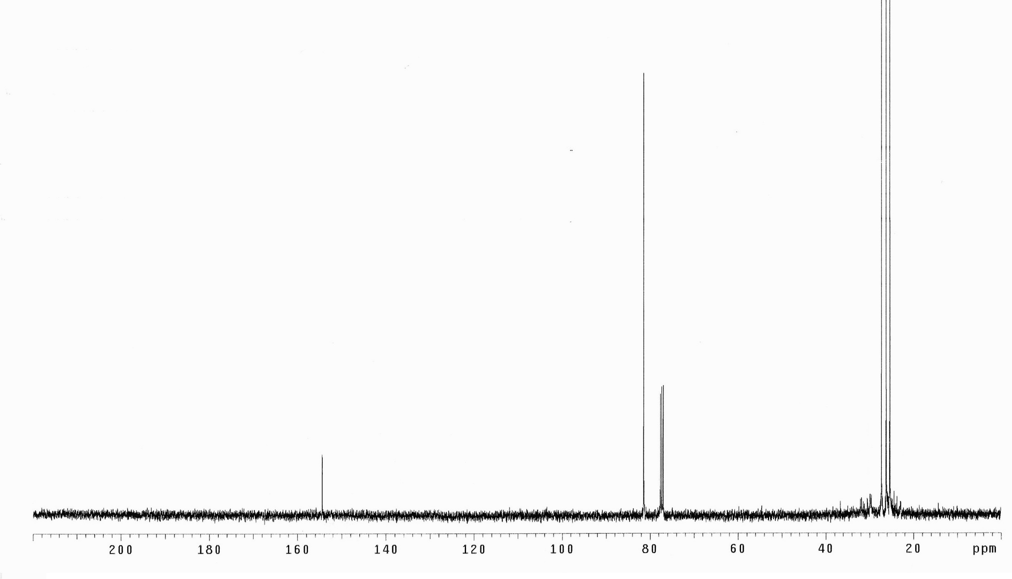
¹³C NMR Spectrum of Octahydrocycloocta[d][1,3]dioxol-2-one (8c)
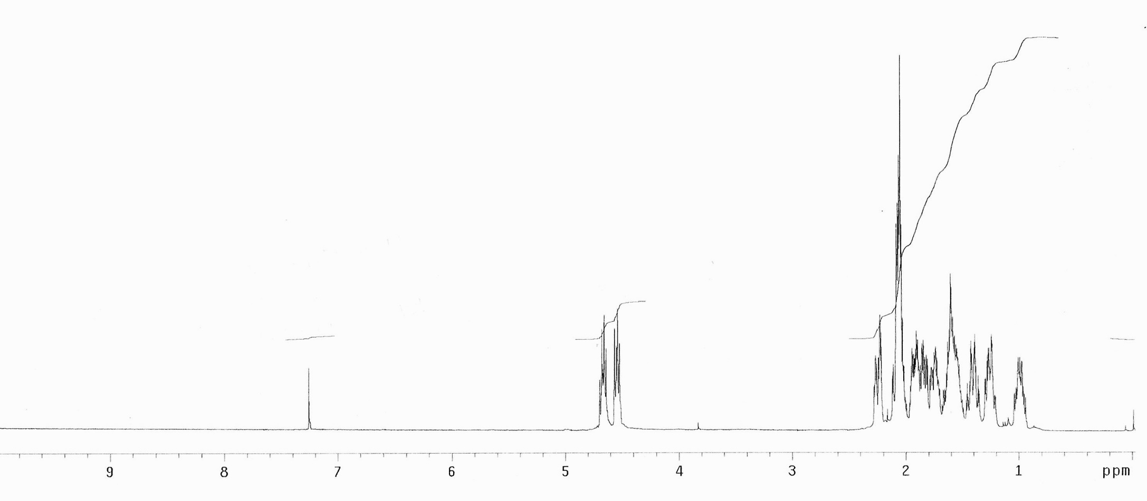

¹H NMR Spectrum of Octahydrocycloocta[d]oxazol-2(3H)-one (9c)

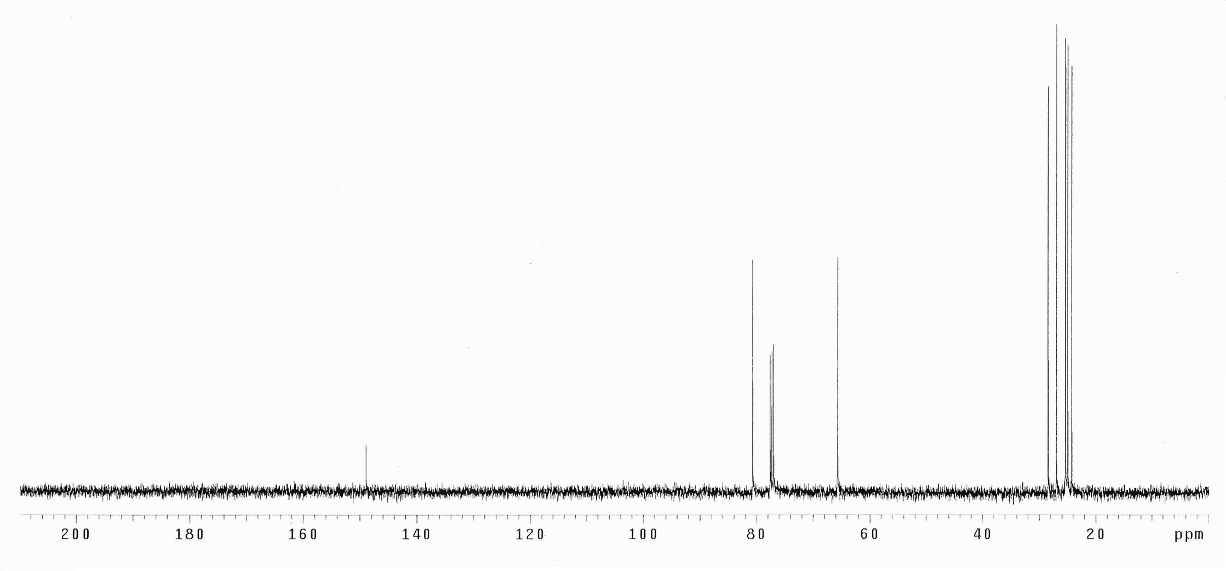
¹³C NMR Spectrum of Octahydrocycloocta[d]oxazol-2(3H)-one (9c)

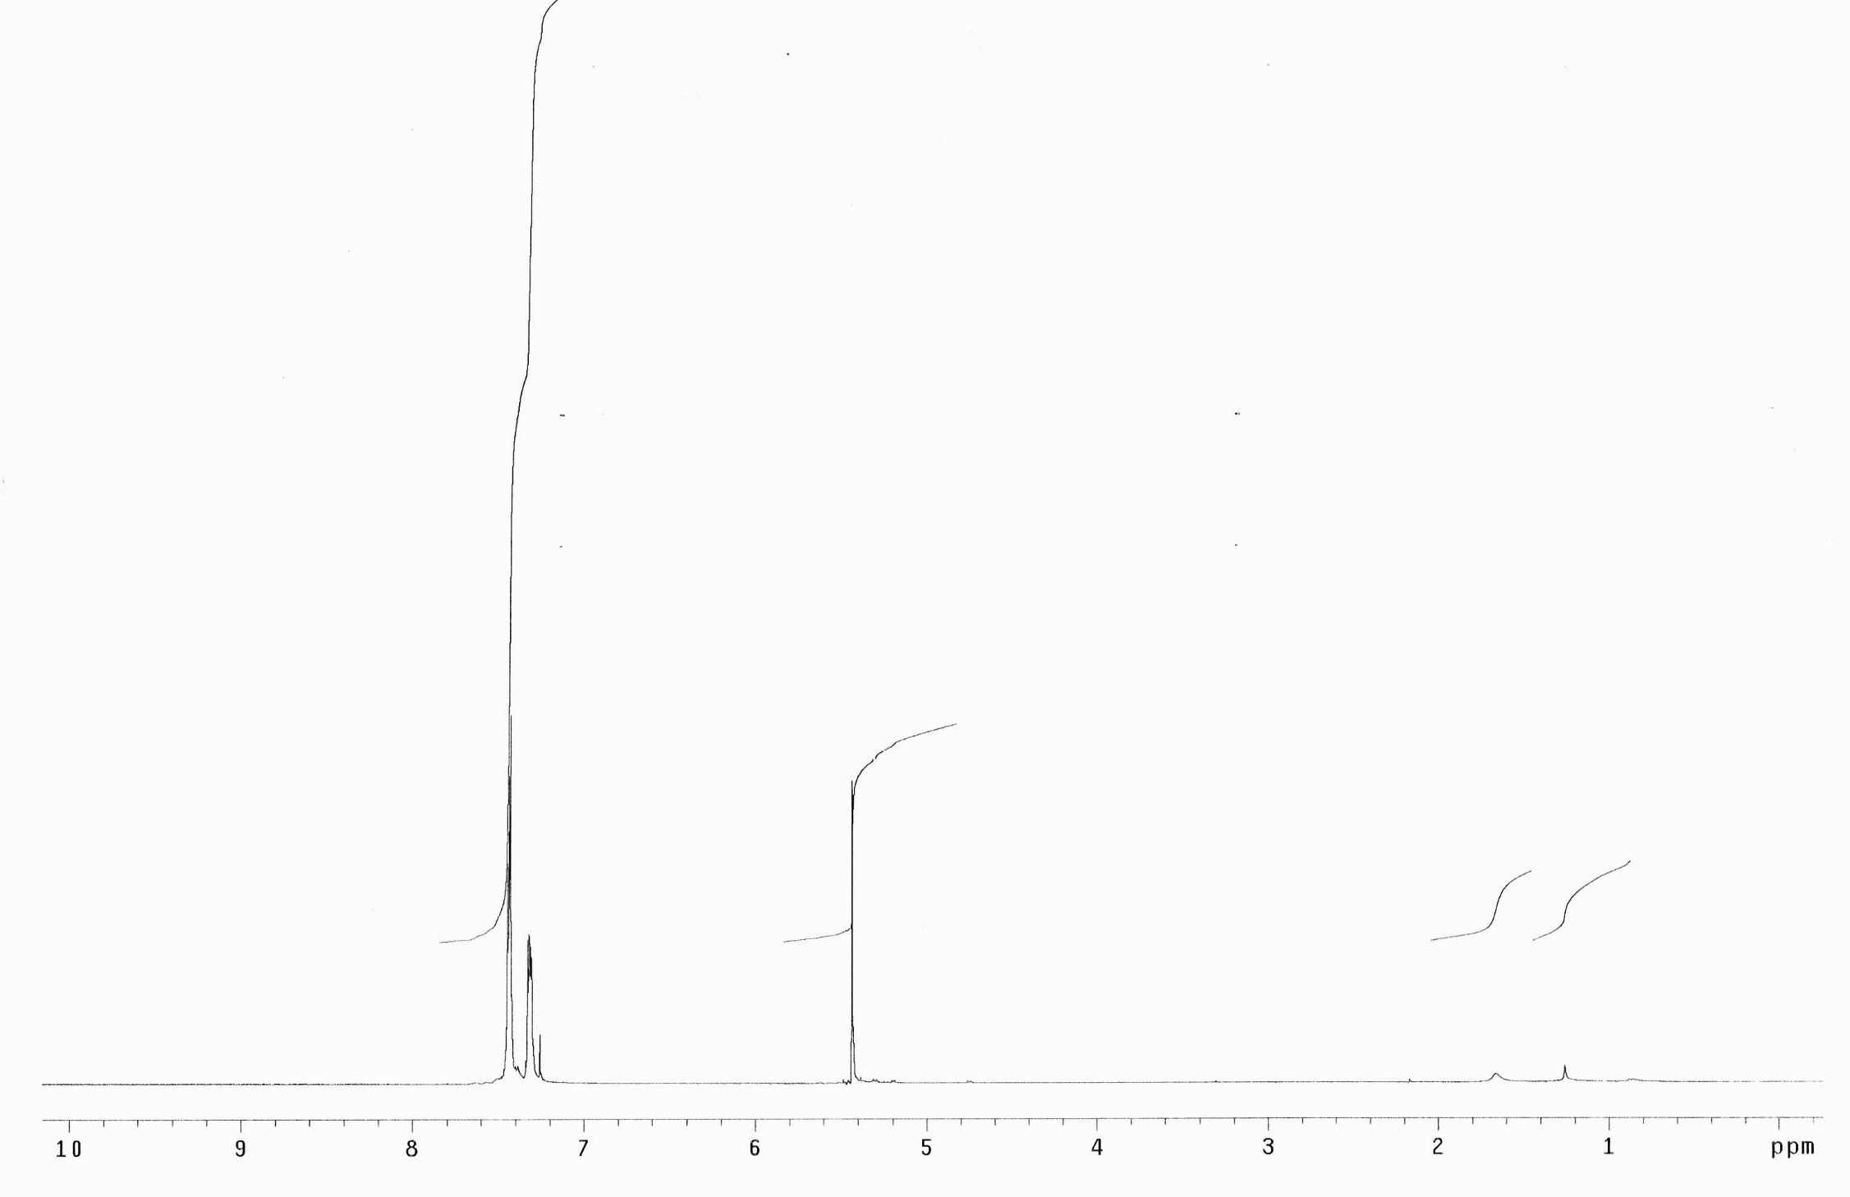
¹H NMR Spectrum of Trans 4,5-diphenyl-1,3-dioxolan-2-one (8d)

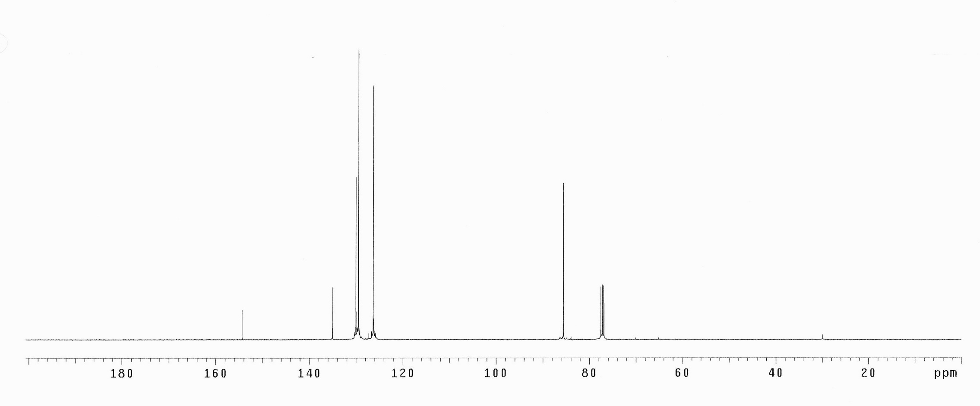
¹³C NMR Spectrum of Trans 4,5-diphenyl-1,3-dioxolan-2-one (8d)
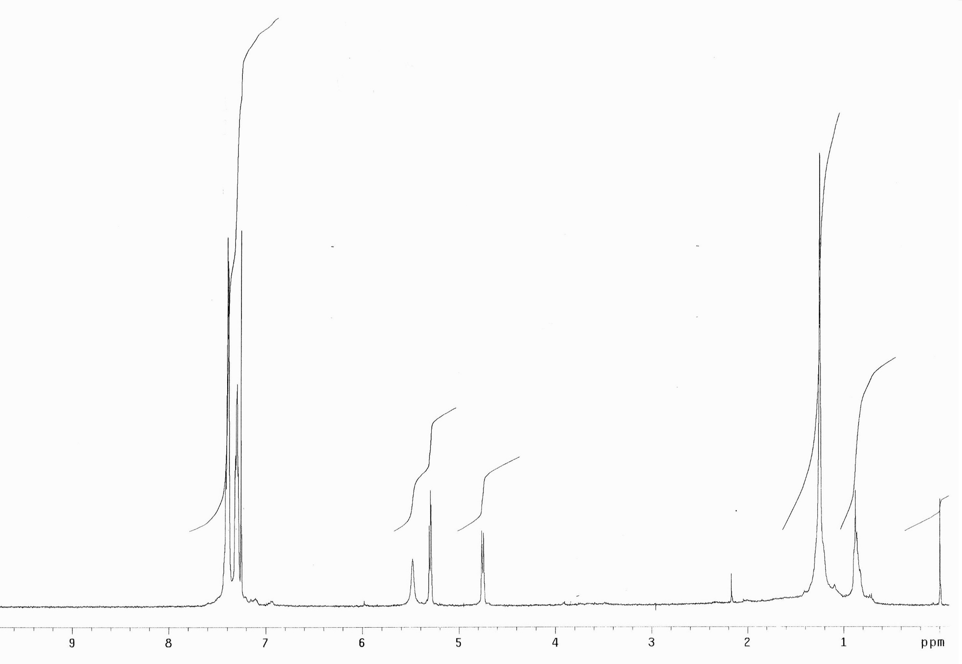
¹H NMR Spectrum of Trans 4,5-diphenyloxazolidin-2-one (9d)

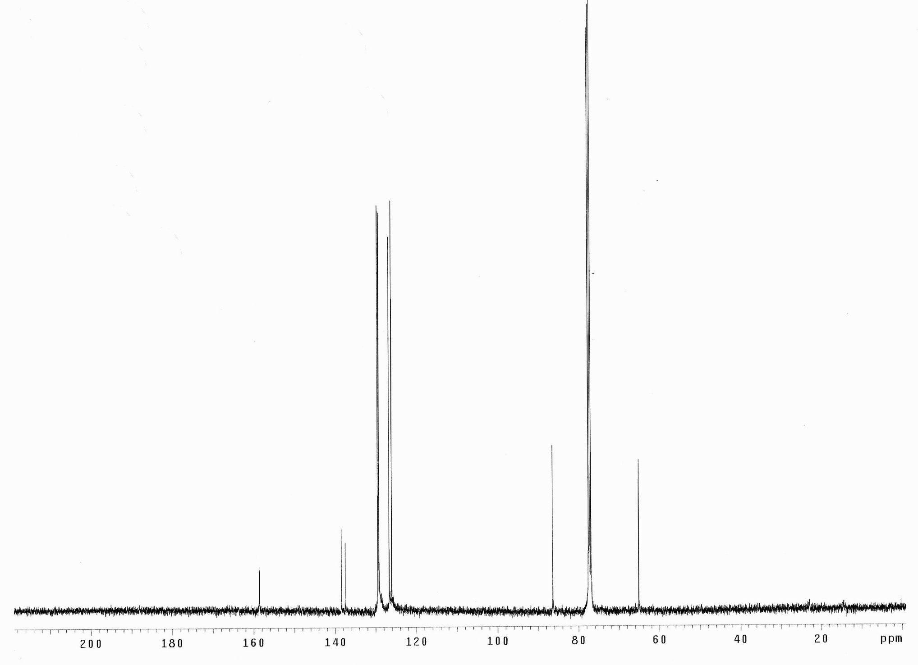
¹³C NMR Spectrum of Trans 4,5-diphenyloxazolidin-2-one (9d)

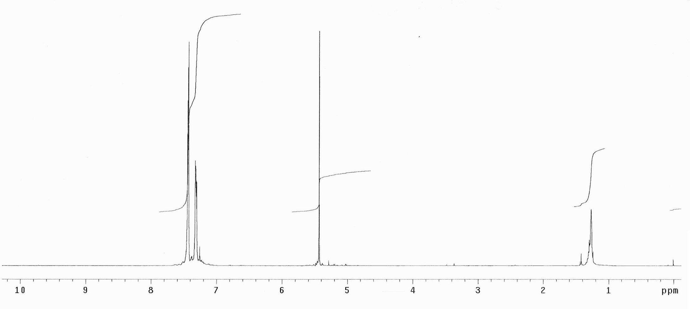
¹H NMR Spectrum of Cis 4,5-diphenyl-1,3-dioxolan-2-one (8e)

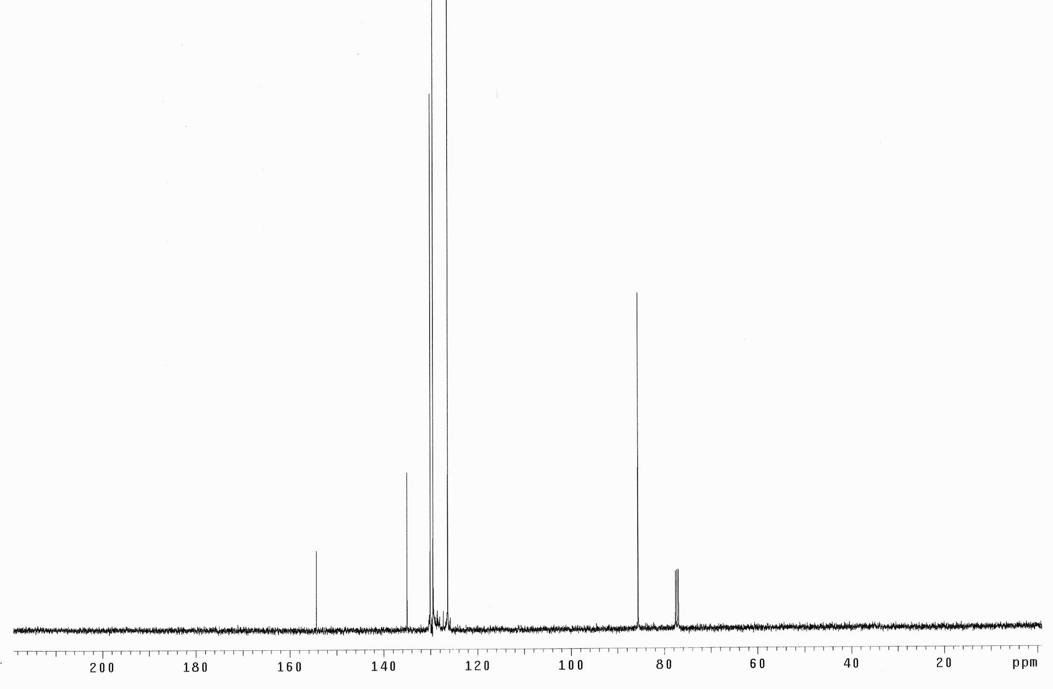
¹³C NMR Spectrum of Cis 4,5-diphenyl-1,3-dioxolan-2-one (8e)

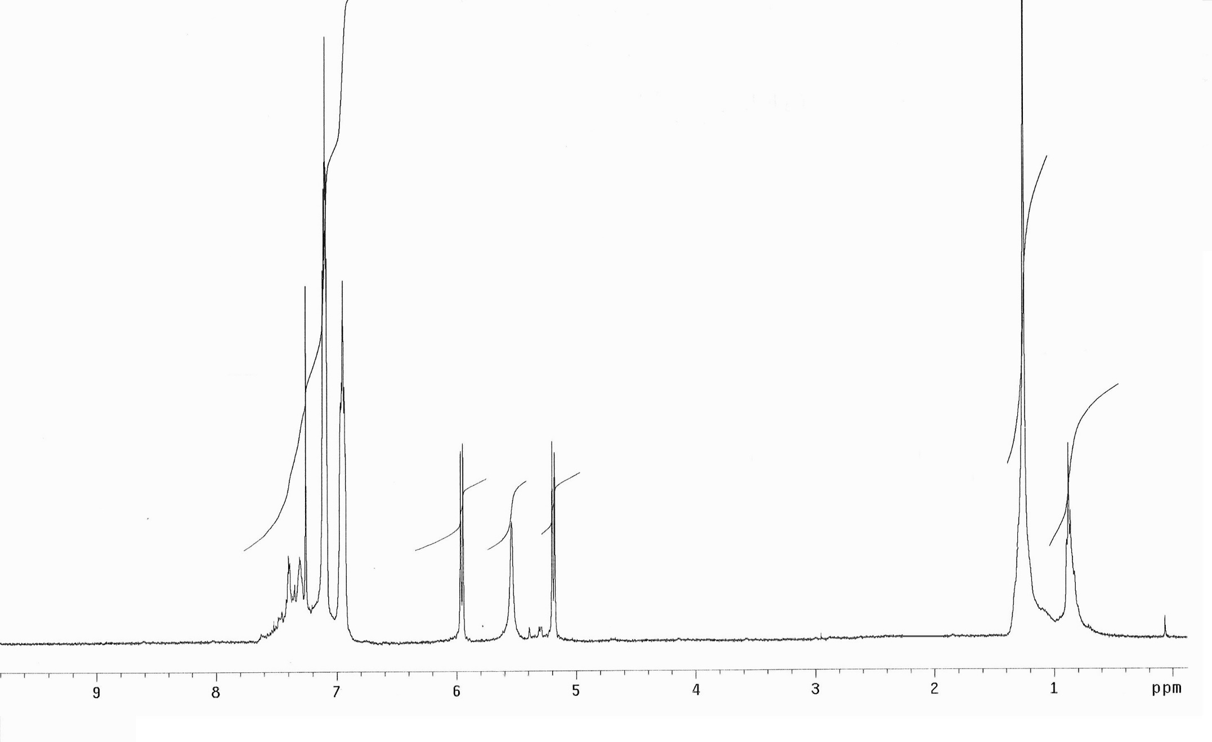
¹H NMR Spectrum of Cis 4,5-diphenyloxazolidin-2-one (9e)

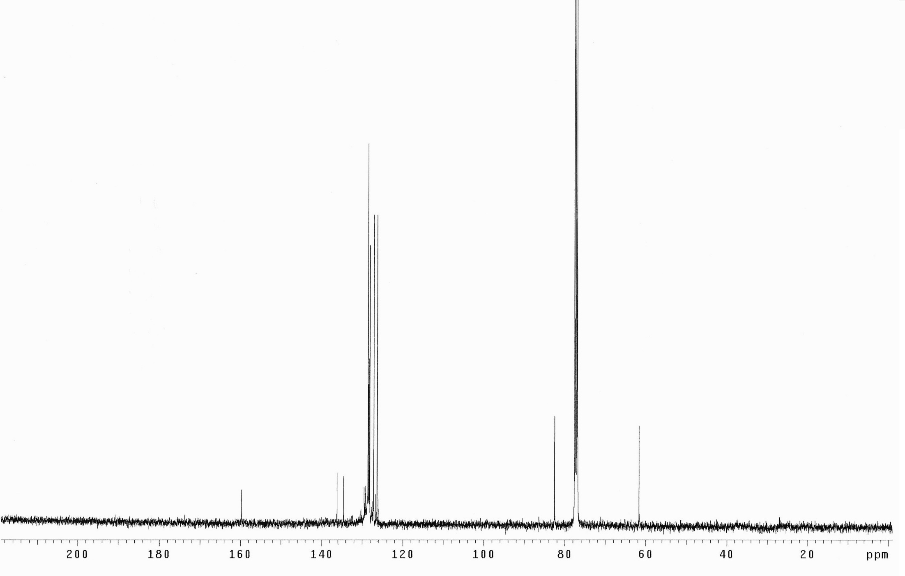
¹³C NMR Spectrum of Cis 4,5-diphenyloxazolidin-2-one (9e)

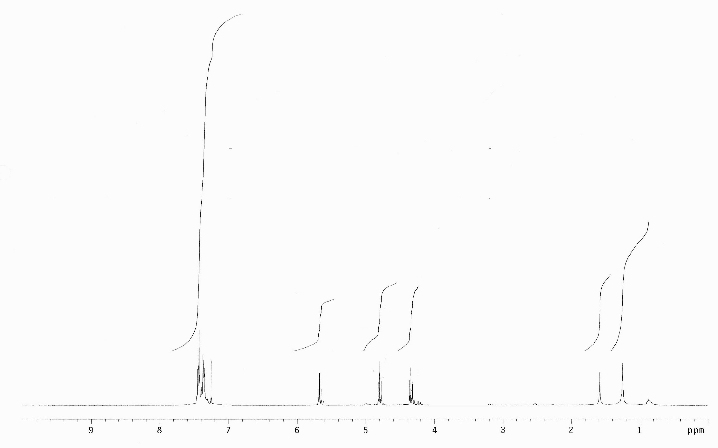
¹H NMR Spectrum of 4-Phenyl-1,3-dioxolan-2-one (8f)

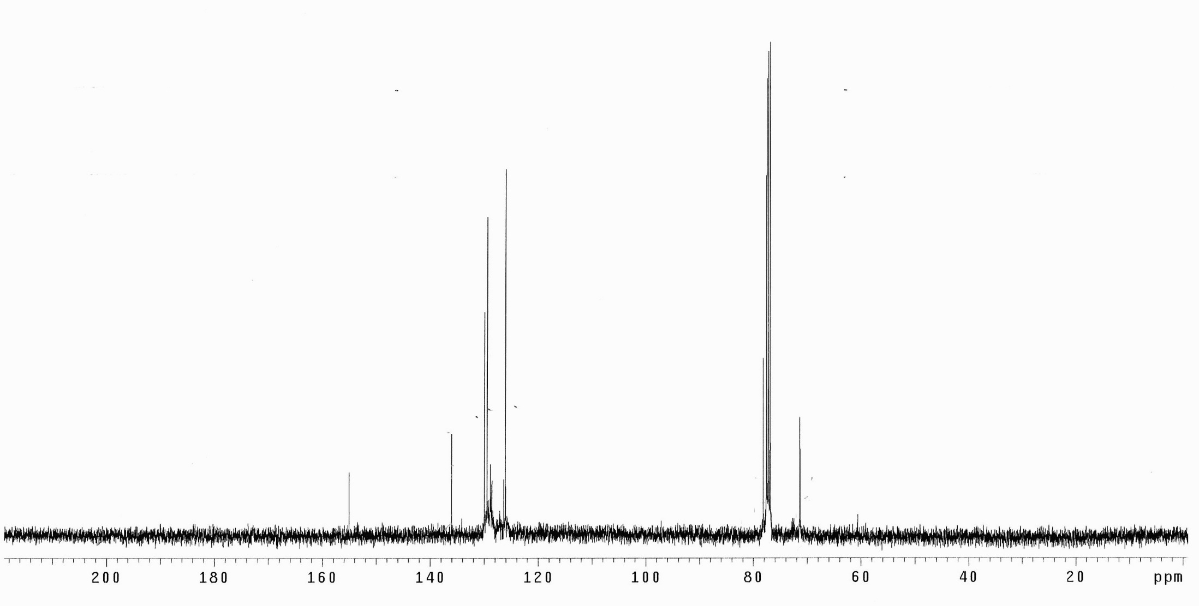
¹³C NMR Spectrum of 4-Phenyl-1,3-dioxolan-2-one (8f)
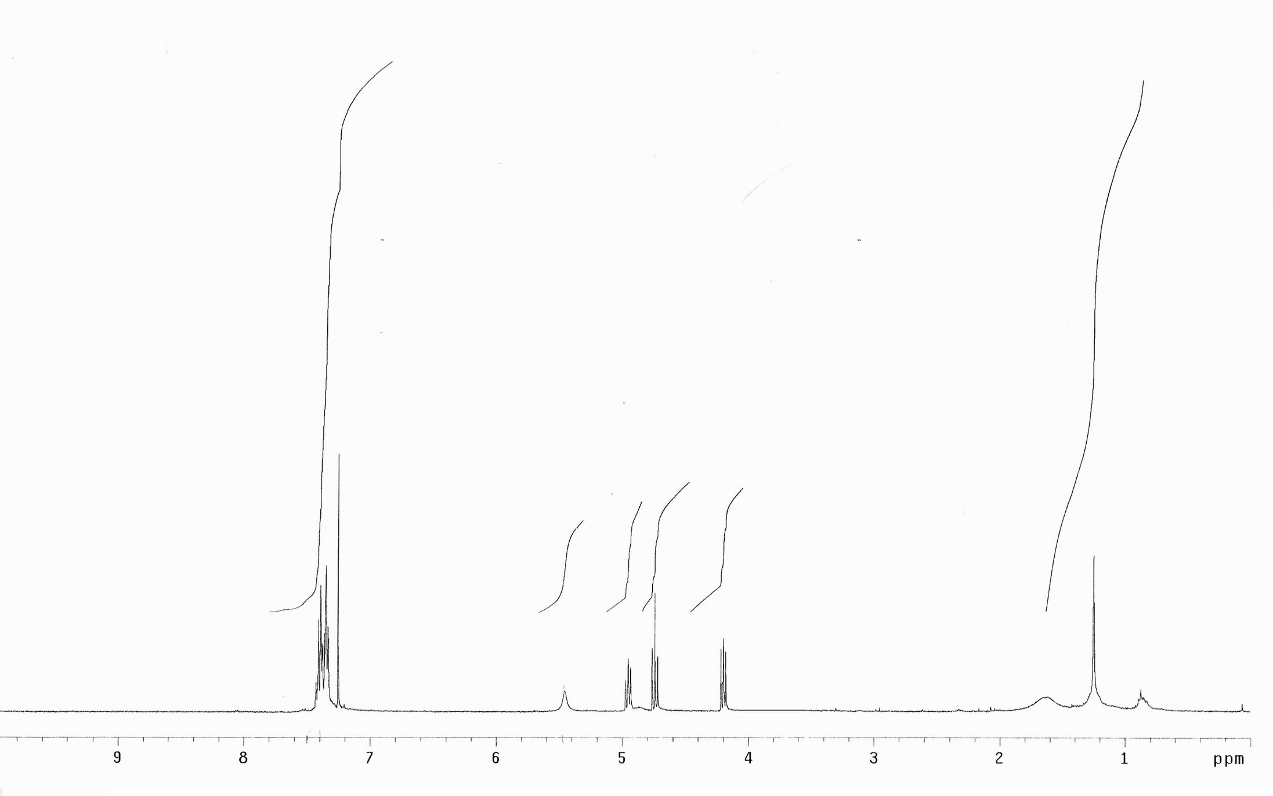
¹H NMR Spectrum of 4-Phenyloxazolidin-2-one (9f)

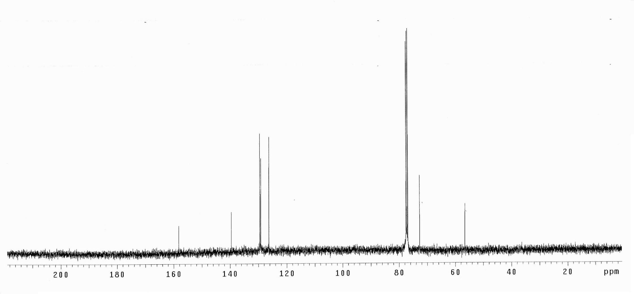
¹³C NMR Spectrum of 4-Phenyloxazolidin-2-one (9f)

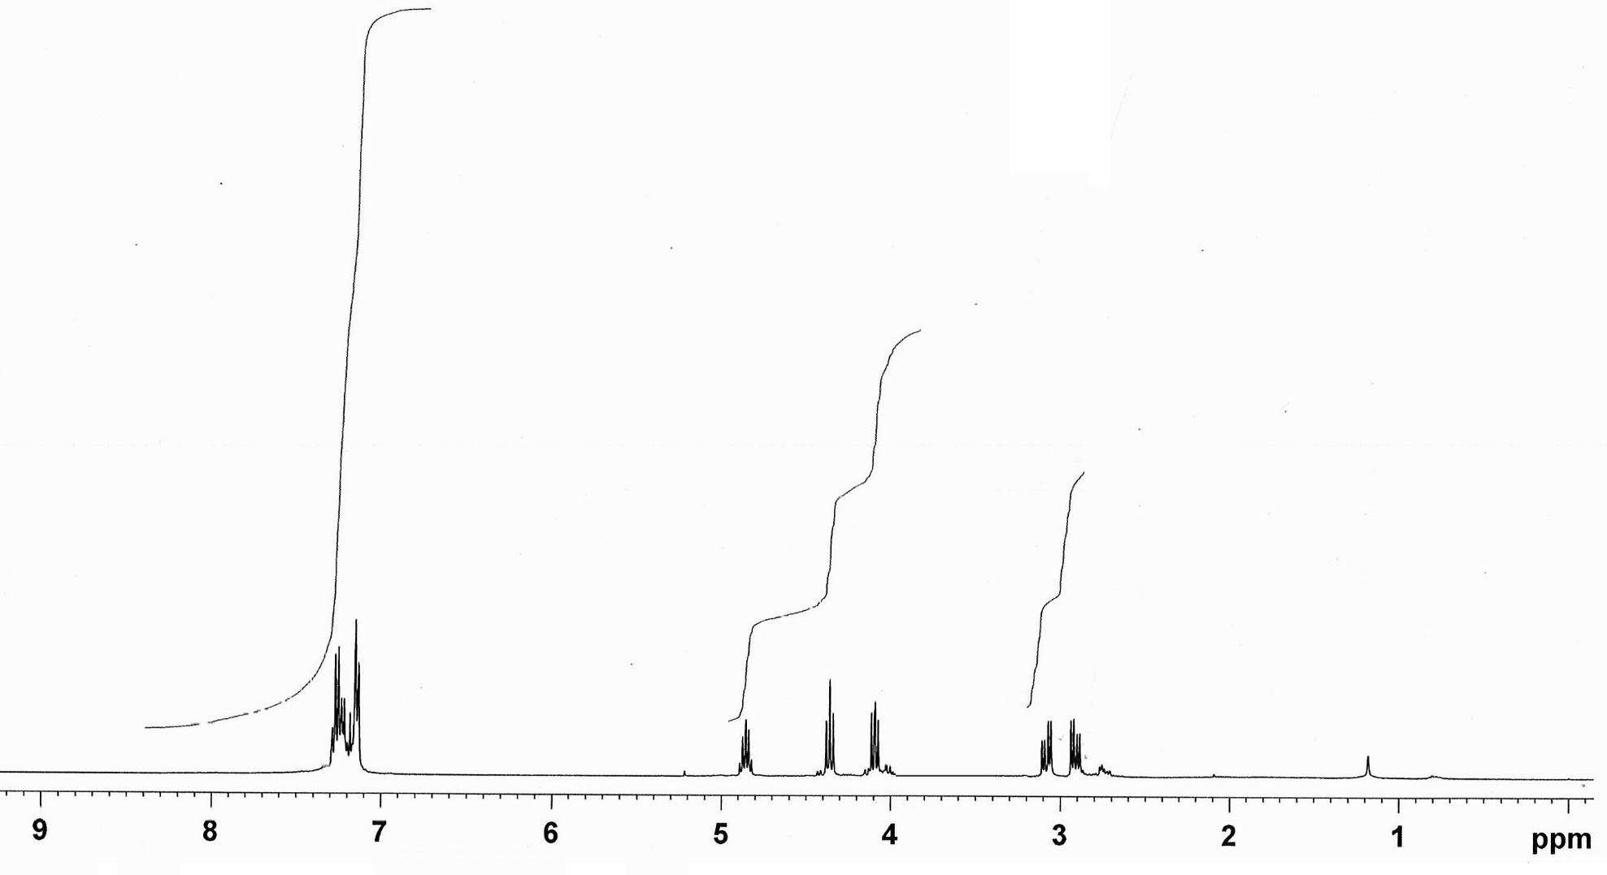
¹H NMR Spectrum of 4-Benzyl-1,3-dioxolan-2-one (8g)

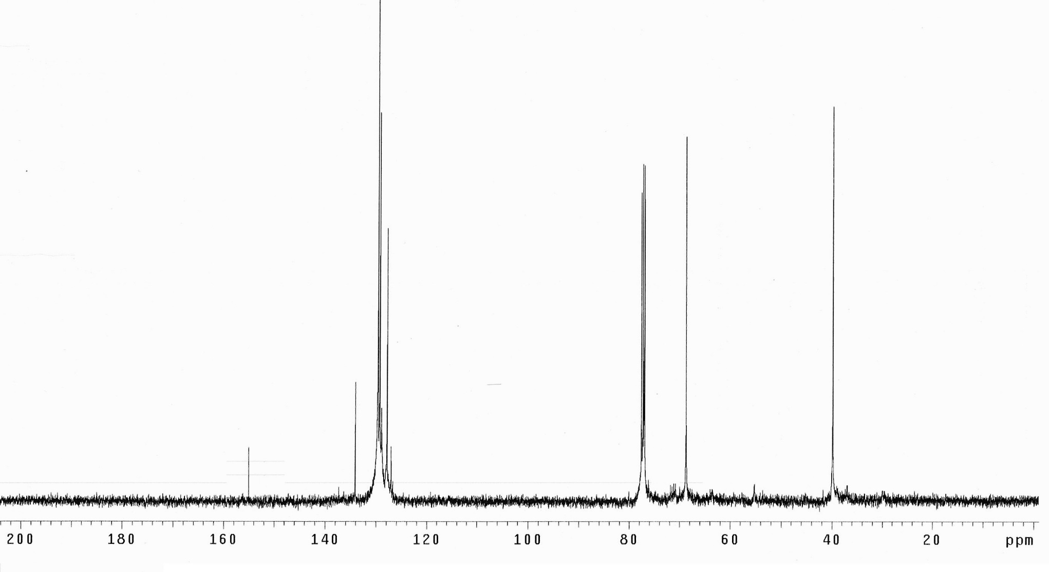
¹³C NMR Spectrum of 4-Benzyl-1,3-dioxolan-2-one (8g)
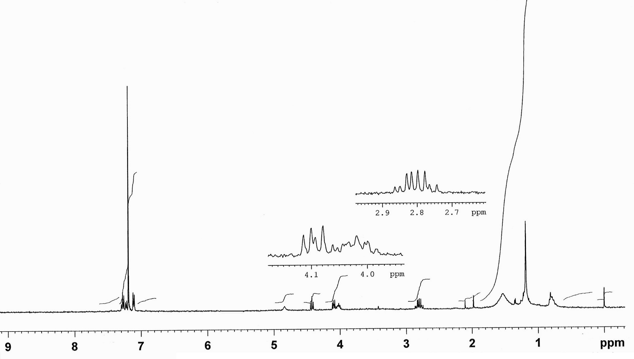
¹H NMR Spectrum of 4-Benzyloxazolidin-2-one (9g)

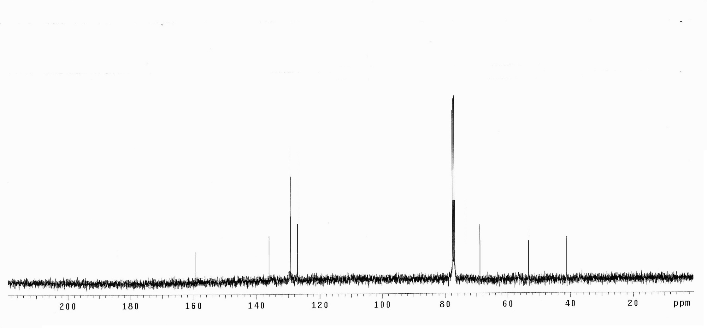
¹³C NMR Spectrum of 4-Benzyloxazolidin-2-one (9g)

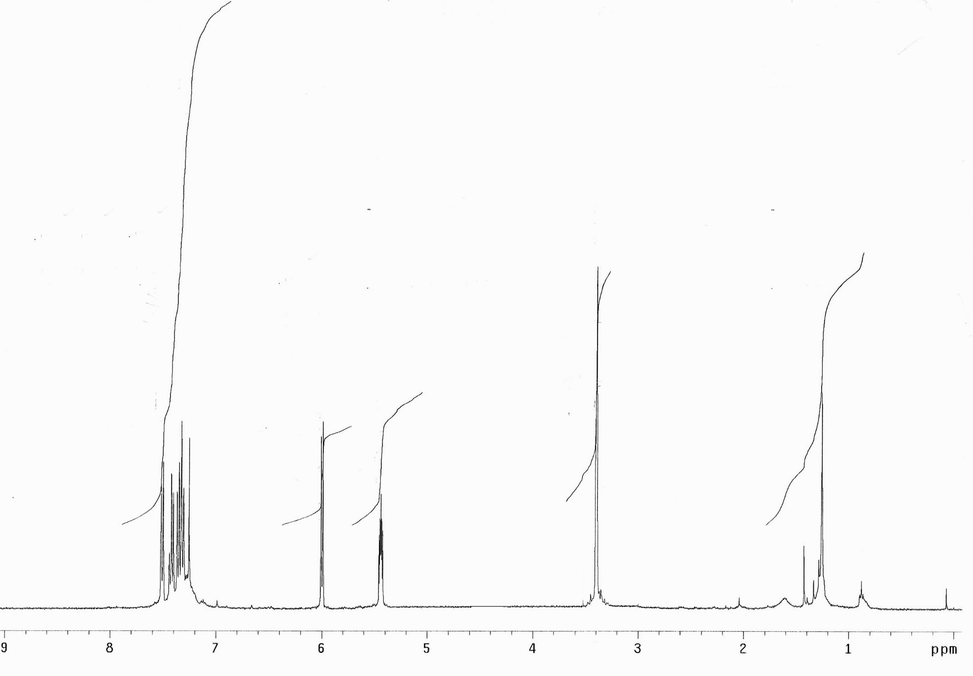
¹H NMR Spectrum of 8,8a-dihydro-3aH-indeno[1,2-d][1,3]dioxol-2-one (8h)

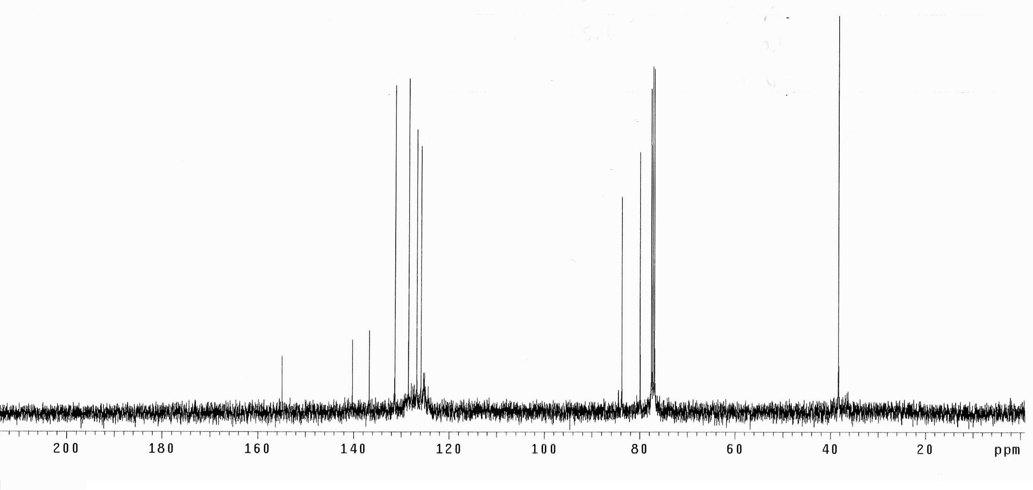
¹³C NMR Spectrum of 8,8a-dihydro-3aH-indeno[1,2-d][1,3]dioxol-2-one (8h)
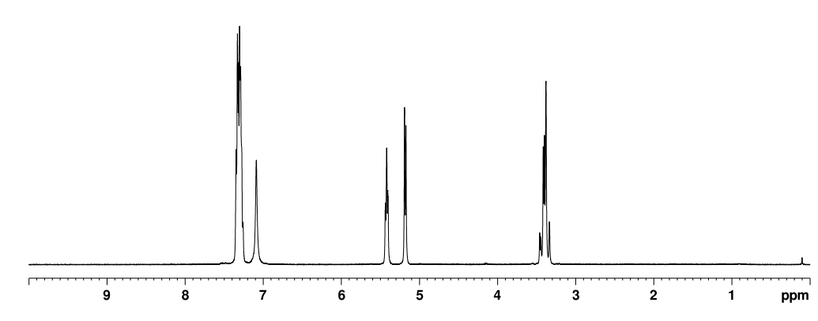
¹H NMR Spectrum of 3,3a,8,8a-tetrahydro-2H-indeno[1,2-d]oxazol-2-one (9h)

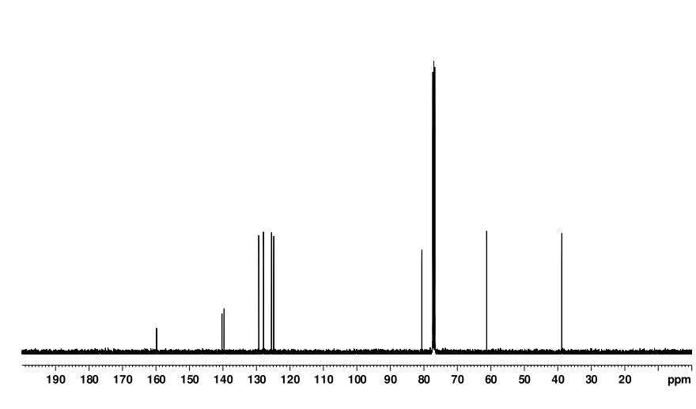
¹³C NMR Spectrum of 3,3a,8,8a-tetrahydro-2H-indeno[1,2-d]oxazol-2-one (9h)

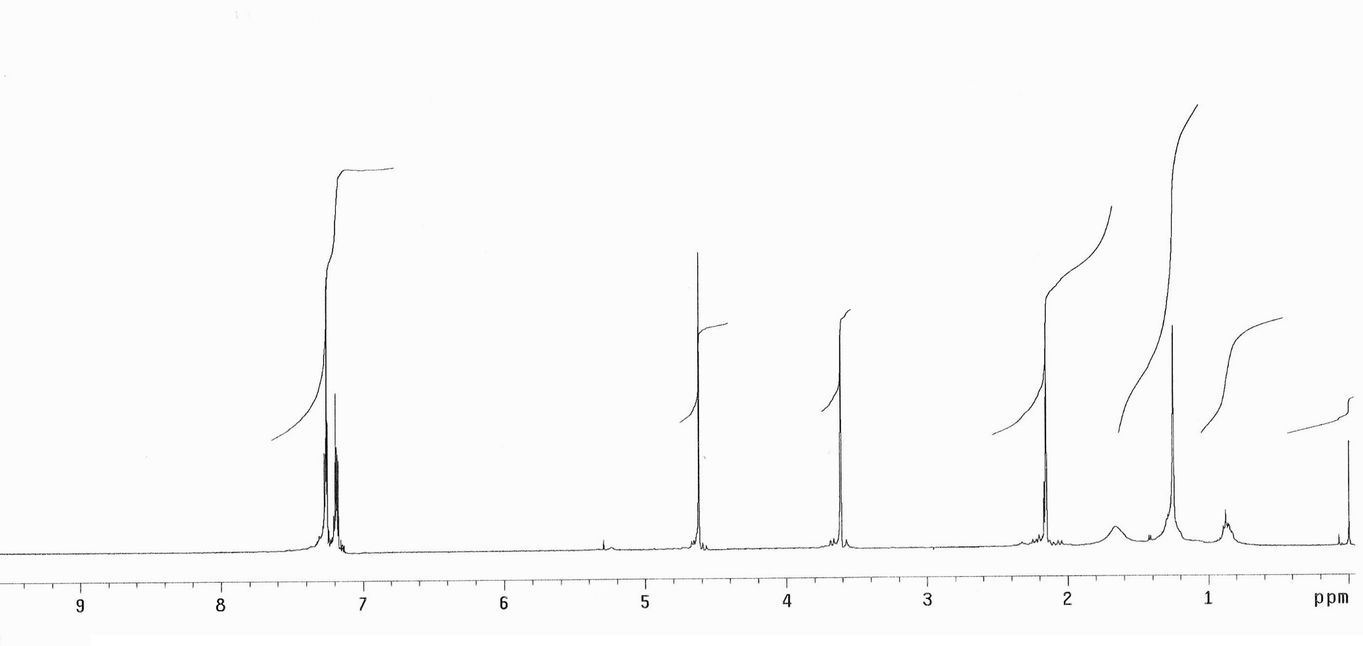
¹H NMR Spectrum of 3a,4,9,9a-tetrahydro-4,9-methanonaphtho[2,3-d][1,3]dioxol-2-one (8i)

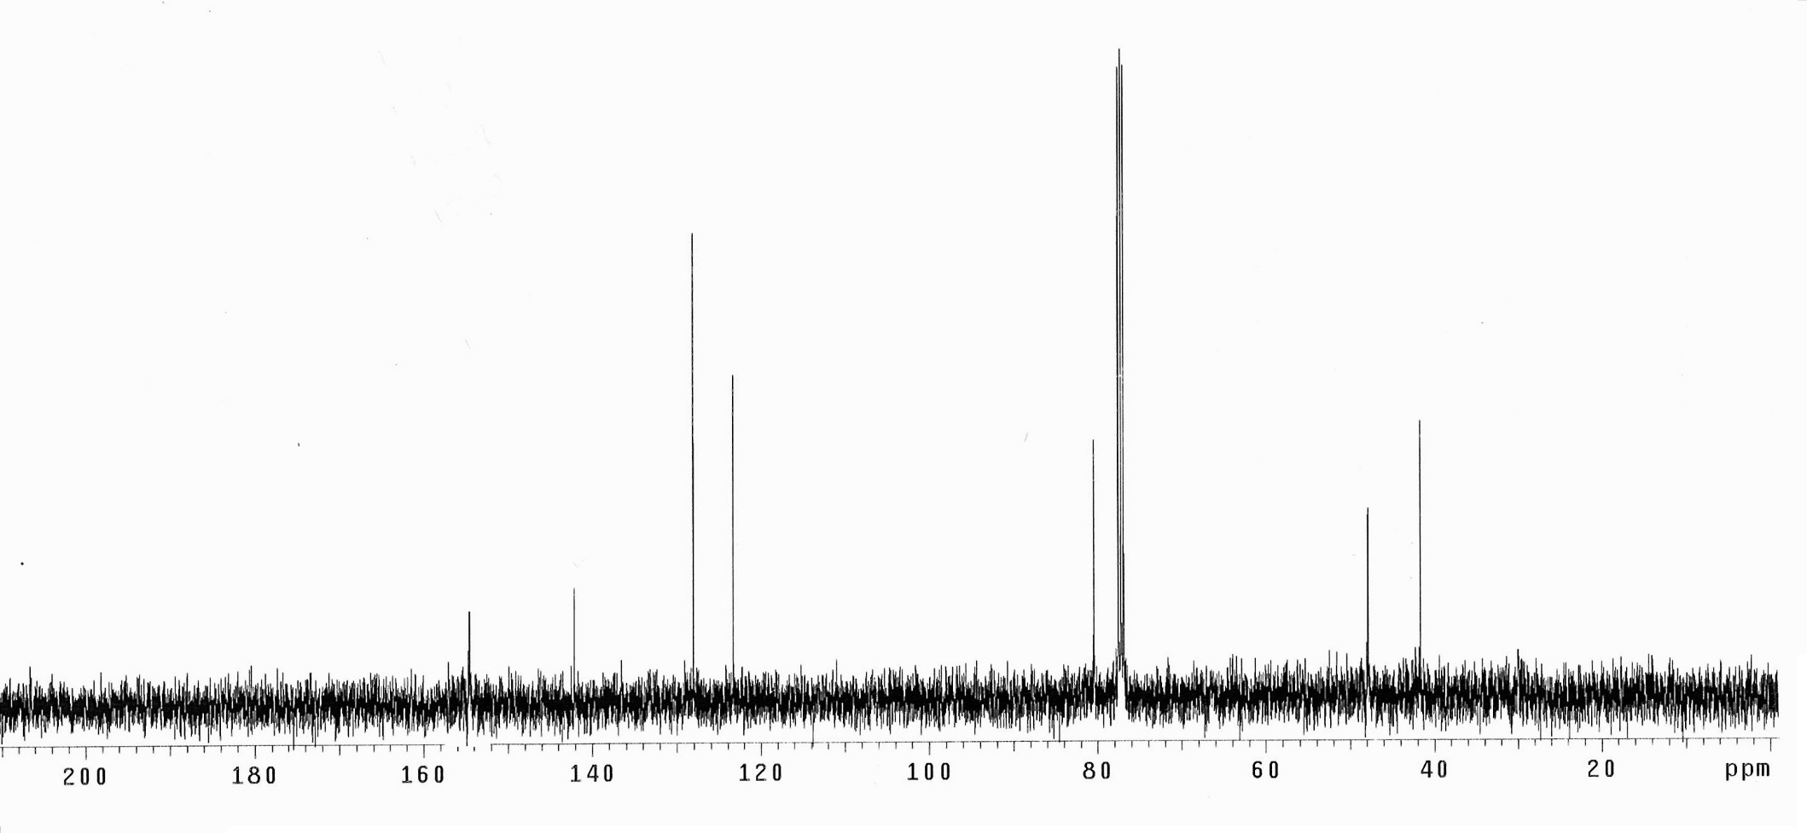
¹³C NMR Spectrum of 3a,4,9,9a-tetrahydro-4,9-methanonaphtho[2,3-d][1,3]dioxol-2-one (8i)

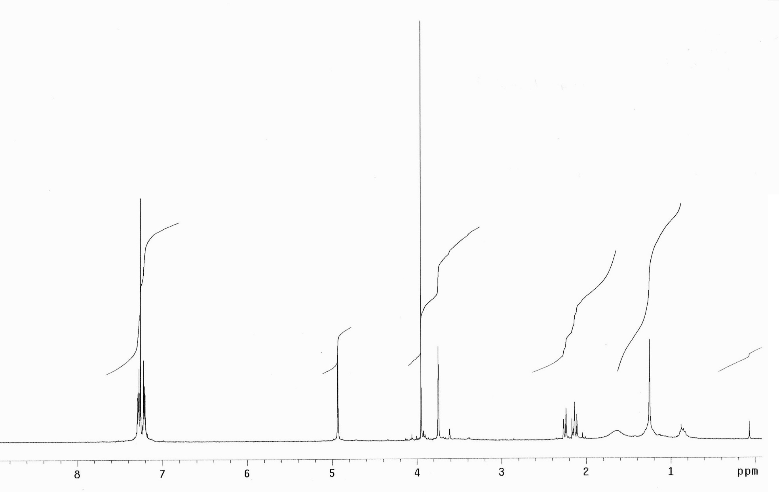
¹H NMR Spectrum of 3a,4,9,9a-tetrahydro-4,9-methanonaphtho[2,3-d]oxazol-2(3H)-one (9i)

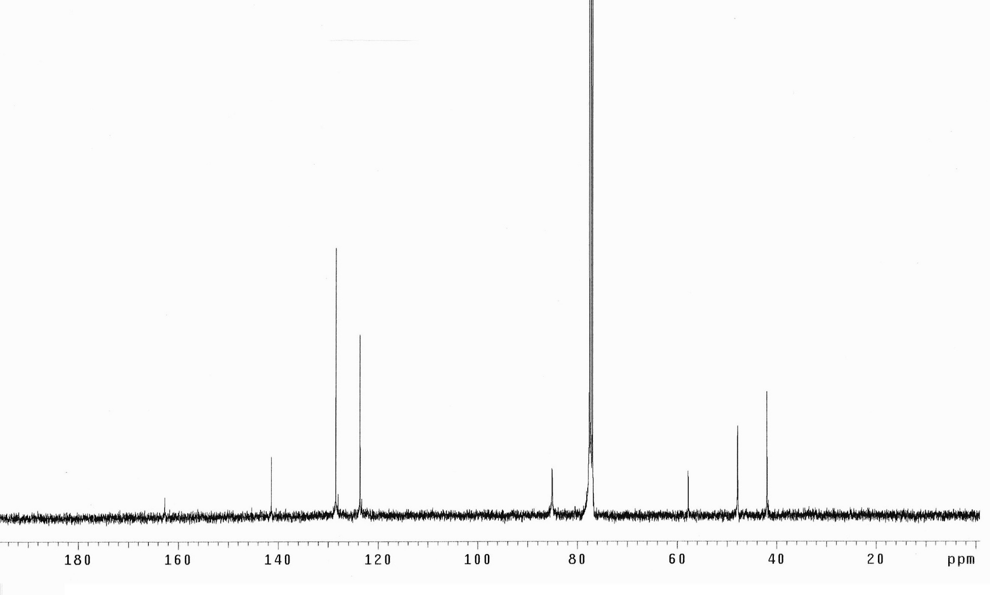
¹³C NMR Spectrum of 3a,4,9,9a-tetrahydro-4,9-methanonaphtho[2,3-d]oxazol-2(3H)-one (9i)

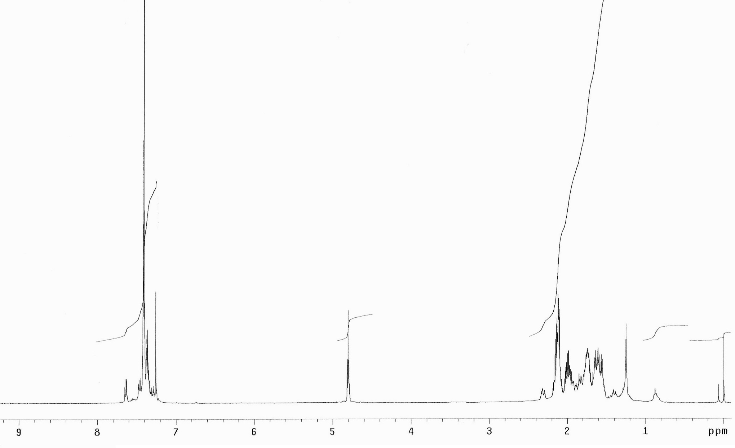
¹H NMR Spectrum of 3a-Phenylhexahydrobenzo[d][1,3]dioxol-2-one (8j)

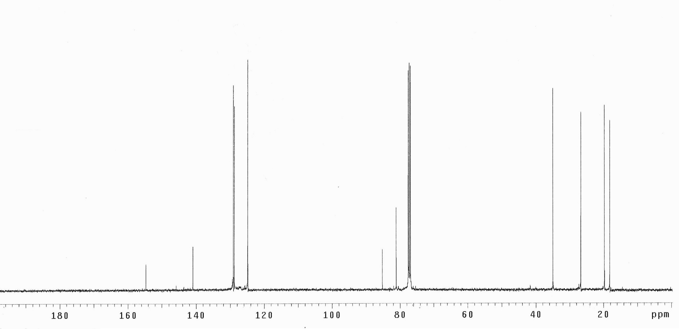
¹³C NMR Spectrum of 3a-Phenylhexahydrobenzo[d][1,3]dioxol-2-one (8j)

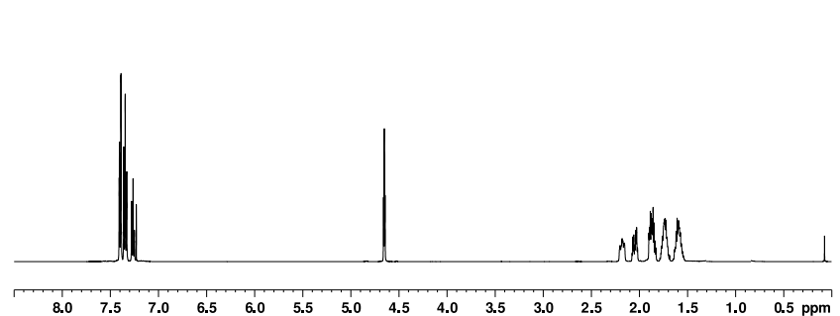
¹H NMR Spectrum of 3a-Phenylhexahydrobenzo[d]oxazol-2(3H)-one (9j)

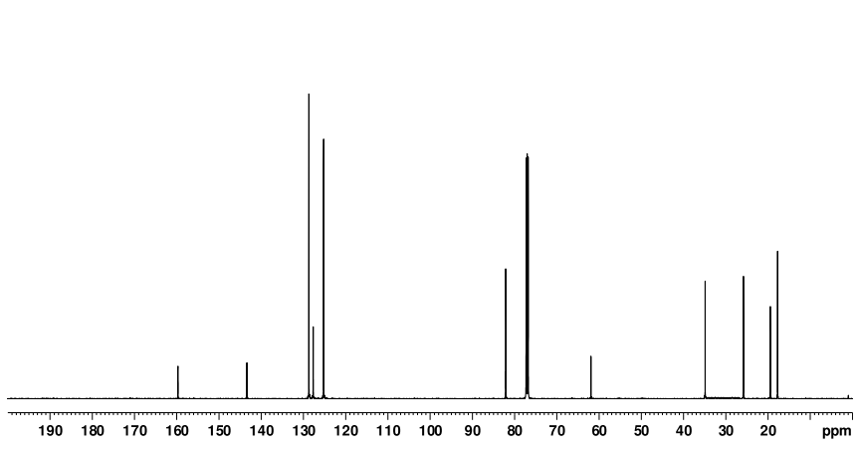
¹³C NMR Spectrum of 3a-Phenylhexahydrobenzo[d]oxazol-2(3H)-one (9j)

Absolute Energies of Structures
Energies are given in terms of ZPE-corrected total energy (Eel+ZPE), enthalpy (Eel+H) and Gibbs free-energy (Eel+G) as extracted from Gaussian output of each structure.

Table S1. Absolute energies of optimized structures for the formation of 10 and 11 in gas phase (M06-2X/6-31+G(d,p))

Compound No | Eel^{[a]}+ZPE^{[b]} (au) | Eel+H^{[c]} (au) | Eel+G^{[d]} (au) | Imaginary Frequency (i)
RC1(7f+CSI) | -1561.194746 | -1561.178848 | -1561.241301 | −
TS1 | -1561.153888 | -1561.138832 | -1561.197491 | -100.6
10 | -1561.259136 | -1561.244428 | -1561.302205 | −
RC(7f+CSI) | -1561.194356 | -1561.177605 | -1561.242869 | −
TS1' | -1561.124586 | -1561.109231 | -1561.169734 | -638.32
11 | -1561.259812 | -1561.244978 | -1561.303961 | −
[a] Eel = Total electronic energy. [b] ZPE = Zero point energy correction. [c] H = Enthalpy correction. [d] G = Gibbs free energy correction.

Table S2. Single point energies for the formation of 10 and 11 at PCM(DCM)/M06-2X/6-31+G(d,p)//M06-2X/6-31+G(d,p) level.

Compound No | Eel^{[a]} (au) | Eel+G^{[b]} (au)
RC1(7f+CSI) | -1561.369067 | -1561.24944
TS1 | -1561.361003 | -1561.236926
10 | -1561.443435 | -1561.31507
RC(7f+CSI) | -1561.368896 | -1561.250916
TS1' | -1561.315231 | -1561.194255
11 | -1561.444182 | -1561.317096

Table S3. Absolute energies of optimized structures for path 1a, path 1b and path 2 in gas phase (M06-2X/6-31+G(d,p))

Compound No | Eel^{[a]}+ZPE^{[b]} (au) | Eel+H^{[c]} (au) | Eel+G^{[d]} (au) | Imaginary Frequency (i)
RC2(10+H₂O) | -1637.645459 | -1637.62761 | -1637.691332 | −
TS2 | -1637.547131 | -1637.530831 | -1637.592093 | -723.3
PC2(9f+12) | -1637.671332 | -1637.655843 | -1637.715451 | −
RC3(10+2H₂O) | -1714.024727 | -1714.003944 | -1714.074618 | −
TS3 | -1713.958869 | -1713.941923 | -1714.004302 | -527.9
PC3(9f+12+H₂O) | -1714.04547 | -1714.025749 | -1714.095205 | −
RC4(10+2H₂O) | -1714.024112 | -1714.002993 | -1714.074864 | −
TS4 | -1713.935637 | -1713.916326 | -1713.983151 | -230.1
13+H₂O+HCl | -1714.024503 | -1714.003043 | -1714.102387 | −
RC5(13+H₂O) | -1253.279008 | -1253.261331 | -1253.323976 | −
TS5 | -1253.182873 | -1253.166892 | -1253.226232 | -966.5
PC5(9f+14) | -1253.296965 | -1253.28041 | -1253.343945 | −
Table S4. Single point energies for path 1a, path 1b and path 2 at PCM(DCM)/M06-2X/6-31+G(d,p)//M06-2X/6-31+G(d,p) level.

Compound No | Eel^{[a]} (au) | Eel+G^{[b]} (au)
RC2(10+H₂O) | -1637.855513 | -1637.705082
TS2 | -1637.758664 | -1637.61003
PC2(9f+12) | -1637.881053 | -1637.727922
RC3(10+2H₂O) | -1714.261539 | -1714.089819
TS3 | -1714.207323 | -1714.032324
PC3(9f+12+H₂O) | -1714.286479 | -1714.11308
RC4(10+2H₂O) | -1714.26671 | -1714.096141
TS4 | -1714.195502 | -1714.021157
13+H₂O+HCl | -1714.262539 | -1714.126365
RC5(13+H₂O) | -1253.504294 | -1253.339321
TS5 | -1253.407798 | -1253.243687
PC5(9f+14) | -1253.523423 | -1253.35909

Table S5. Absolute energies of optimized structures for the formation of 8f in gas phase (M06-2X/6-31+G(d,p))

Compound No | Eel^{[a]}+ZPE^{[b]} (au) | Eel+H^{[c]} (au) | Eel+G^{[d]} (au) | Imaginary Frequency (i)
RC6(7f+CSI) | -1561.191475 | -1561.174617 | -1561.240605 | −
TS6 | -1561.150784 | -1561.135859 | -1561.194273 | -118.2
16 | -1561.239888 | -1561.225413 | -1561.282908 | −
RC7(16+H₂O) | -1637.627309 | -1637.609558 | -1637.673558 | −
TS7 | -1637.566139 | -1637.55039 | -1637.60951 | -1251.3
17 | -1637.633906 | -1637.617977 | -1637.676911 | −
RC8(17+H₂O) | -1637.632267 | -1637.616177 | -1637.676000 | −
TS8 | -1637.591580 | -1637.575304 | -1637.636346 | -199.9
PC8(8f+18) | -1637.655022 | -1637.639003 | -1637.699032 | −

Table S6. Single point energies for the formation of 8f at PCM(DCM)/M06-2X/6-31+G(d,p)//M06-2X/6-31+G(d,p) level.

Compound No | Eel^{[a]} (au) | Eel+G^{[b]} (au)
RC6(7f+CSI) | -1561.366947 | -1561.249535
TS6 | -1561.362049 | -1561.237508
16 | -1561.426792 | -1561.29803
RC7(16+H₂O) | -1637.839263 | -1637.688891
TS7 | -1637.777903 | -1637.627503
17 | -1637.845407 | -1637.689378
RC8(17+H₂O) | -1637.843896 | -1637.688757
TS8 | -1637.809078 | -1637.657218
PC8(8f+18) | -1637.866644 | -1637.712687

Cartesian Coordinates for the Optimized Structures Given in Paths

Structure No: RC1 (7f+CSI) (M06-2X/6-31+G(d,p))

X Y Z
---------------------------------------------------------------------
6 -0.798109 0.522489 1.479827
6 -1.373568 -0.051007 0.249713
6 1.574494 1.422758 -0.782489
1 0.196886 0.213123 1.796450
1 -0.756765 -0.766881 -0.294025
8 -0.839363 1.268893 0.268905
8 1.463753 2.534085 -1.056486
7 1.637964 0.216568 -0.502202
16 3.075441 -0.608660 -0.437455
8 4.067541 0.048924 -1.247780
8 2.757131 -2.000755 -0.563971
17 3.596030 -0.288139 1.523004
6 -2.845837 -0.178208 0.062732
6 -3.389973 -1.412364 -0.296976
6 -3.689281 0.917297 0.260336
6 -4.767974 -1.556567 -0.442116
1 -2.732476 -2.261921 -0.464759
6 -5.066157 0.772585 0.110871
1 -3.255753 1.881084 0.512137
6 -5.608852 -0.464159 -0.237018
1 -5.183425 -2.519758 -0.721611
1 -5.717461 1.628253 0.260341
1 -6.682326 -0.574233 -0.354675
1 -1.474970 0.875150 2.255146

Structure No: TS1 (M06-2X/6-31+G(d,p))

X Y Z
---------------------------------------------------------------------
6 -0.746216 -1.451023 -1.209600
6 -1.386374 -0.139017 -0.947315
6 0.950632 -1.049606 0.533417
1 0.077884 -1.374430 -1.918808
1 -0.704333 0.708499 -1.020047
8 -0.291363 -1.660322 0.126473
8 1.399860 -1.470137 1.563410
7 1.318437 -0.118350 -0.361517
16 2.575999 0.825516 -0.027956
8 2.550097 1.377228 1.310875
8 2.767044 1.703036 -1.164589
17 4.213499 -0.480106 -0.061291
6 -2.677897 0.075044 -0.442037
6 -3.038692 1.405546 -0.101599
6 -3.614286 -0.977427 -0.258861
6 -4.303987 1.679538 0.384917
1 -2.305498 2.197378 -0.226432
6 -4.871457 -0.694346 0.234825
1 -3.332656 -1.999469 -0.487731
6 -5.212226 0.629474 0.551292
1 -4.585905 2.693091 0.646088
1 -5.593109 -1.489060 0.385878
1 -6.203498 0.840681 0.941919
1 -1.429497 -2.262251 -1.460595

Structure No: 10 (M06-2X/6-31+G(d,p))

X Y Z
---------------------------------------------------------------------
6 0.375729 2.265702 -1.079604
6 0.420374 0.720367 -1.066649
6 -1.150129 1.614211 0.492966
1 -0.149068 2.645141 -1.960790
1 0.298508 0.316744 -2.074188
8 -0.372692 2.636244 0.085433
8 -1.979594 1.665385 1.348744
7 -0.803928 0.492707 -0.286480
16 -1.343430 -1.045719 0.061868
8 -1.254388 -1.319914 1.468490
8 -0.738958 -1.885540 -0.940627
17 -3.328576 -0.865909 -0.387980
6 1.666092 0.153059 -0.422441
6 2.690352 -0.327465 -1.238842
6 1.831520 0.153804 0.964804
6 3.876476 -0.794679 -0.677789
1 2.554219 -0.349979 -2.317404
6 3.016477 -0.317496 1.524972
1 1.034921 0.501092 1.618417
6 4.040857 -0.789153 0.705985
1 4.664663 -1.173962 -1.320174
1 3.134701 -0.322289 2.603573
1 4.960789 -1.161268 1.145366
1 1.368012 2.708037 -1.000391

Structure No: RC (7f+CSI) (M06-2X/6-31+G(d,p))

X Y Z
---------------------------------------------------------------------
6 1.438491 0.000450 0.382318
6 0.971381 0.812900 1.520024
6 -1.523119 1.324335 -0.796683
1 0.771168 -0.789788 0.037167
1 1.714710 1.286689 2.157790
1 0.001298 0.596796 1.964320
8 0.924597 1.314257 0.188709
6 2.889546 -0.196491 0.107086
6 3.400190 -1.488341 -0.033865
6 3.748266 0.900254 0.004633
6 4.760934 -1.683995 -0.260227
1 2.731003 -2.342651 0.033231
6 5.107362 0.703181 -0.225529
1 3.338057 1.902460 0.089147
6 5.617357 -0.588480 -0.355534
1 5.151283 -2.691203 -0.367486
1 5.769562 1.559406 -0.308900
1 6.676732 -0.740633 -0.536403
8 -1.325215 2.225761 -1.482797
7 -1.677045 0.329367 -0.073218
16 -3.169430 -0.171235 0.450579
8 -4.108650 0.919234 0.394546
8 -2.945068 -0.947767 1.635540
17 -3.678317 -1.478920 -1.041584

Structure No: TS1' (M06-2X/6-31+G(d,p))

X Y Z
---------------------------------------------------------------------
6 -1.181822 0.244875 0.215947
6 -0.636570 -0.066117 1.537576
6 0.849790 -0.956046 -0.534661
1 -0.703392 1.095990 -0.272530
1 -1.096992 -0.907508 2.048672
1 0.140326 0.495802 2.037599
8 -0.572733 -1.009155 -0.172141
6 -2.673399 0.210146 0.055054
6 -3.366718 1.415375 -0.068211
6 -3.362757 -1.003851 0.066238
6 -4.755242 1.407249 -0.172619
1 -2.823295 2.356489 -0.093887
6 -4.750758 -1.005492 -0.046705
1 -2.812895 -1.937675 0.132000
6 -5.446859 0.197090 -0.161226
1 -5.293476 2.343785 -0.274249
1 -5.288303 -1.947990 -0.051942
1 -6.528300 0.190510 -0.250887
8 1.158763 -1.456840 -1.572251
7 1.456667 -0.325998 0.476694
16 3.053492 -0.050553 0.449462
8 3.826110 -1.199915 0.049035
8 3.359366 0.679993 1.658176
17 3.242807 1.331140 -1.109056

Structure No: 11 (M06-2X/6-31+G(d,p))

X Y Z
---------------------------------------------------------------------
6 0.957091 -0.182730 -0.617830
6 0.034819 -0.567907 0.555749
6 -0.778568 1.330080 -0.634340
1 0.785012 -0.851093 -1.468993
1 0.495973 -0.373007 1.527090
1 -0.283050 -1.611428 0.508837
8 0.499544 1.126663 -1.008001
6 2.417226 -0.152884 -0.266534
6 3.259809 -1.165786 -0.721165
6 2.926747 0.860523 0.549212
6 4.605399 -1.175404 -0.355198
1 2.867098 -1.946267 -1.368138
6 4.271485 0.856451 0.905022
1 2.273801 1.661693 0.885496
6 5.111504 -0.164288 0.456861
1 5.256823 -1.966422 -0.712259
1 4.666317 1.650546 1.530552
1 6.160128 -0.165844 0.736775
8 -1.491302 2.190349 -1.042608
7 -1.090689 0.348948 0.348740
16 -2.639675 -0.126238 0.679388
8 -3.510374 1.008883 0.705277
8 -2.535671 -1.087584 1.746088
17 -3.110772 -1.209166 -1.022792

Structure No: RC2 (10+H₂O) (M06-2X/6-31+G(d,p))

X Y Z
---------------------------------------------------------------------
6 -0.229395 1.660957 -2.106377
6 0.110273 0.235196 -1.630581
6 -1.640787 1.232389 -0.358845
1 0.652158 2.296847 -2.178833
1 -0.778878 1.652040 -3.050852
1 0.102303 -0.471514 -2.462380
8 -1.088030 2.208731 -1.093262
16 -1.391469 -1.433851 -0.043277
8 -2.789532 -1.539772 0.254211
7 -1.102572 0.009477 -0.808709
8 -2.436838 1.398091 0.519222
1 -1.193022 2.786282 1.708530
8 -0.286914 2.648922 2.013925
1 -0.348960 1.914823 2.634664
8 -0.660140 -2.415890 -0.802365
17 -0.419815 -1.230558 1.757660
6 1.397372 0.112124 -0.846017
6 2.217887 -0.998913 -1.039568
6 1.746491 1.080334 0.100854
6 3.390634 -1.140768 -0.299411
1 1.926047 -1.764449 -1.753923
6 2.916431 0.934542 0.839941
1 1.097997 1.931047 0.301491
6 3.740633 -0.173558 0.639801
1 4.024070 -2.008522 -0.453251
1 3.178183 1.687332 1.577067
1 4.652871 -0.283584 1.218064

Structure No: TS2 (M06-2X/6-31+G(d,p))

X Y Z
---------------------------------------------------------------------
6 1.007142 2.021434 -1.355524
6 0.816134 0.534068 -0.994339
6 -0.349353 1.958244 0.479078
1 2.056529 2.299083 -1.462170
1 0.452214 2.298097 -2.255828
1 0.446749 -0.031432 -1.850509
8 0.462721 2.748714 -0.250820
16 -1.927947 -0.316124 -0.280721
8 -2.716173 0.869457 -0.518394
7 -0.235815 0.610836 0.037414
8 -1.020582 2.332244 1.394777
1 -0.412789 -0.251756 1.207207
8 -1.369825 -0.674169 1.488510
1 -1.492090 -1.611493 1.725514
8 -1.339386 -1.251149 -1.220536
17 -3.590431 -1.606022 0.324688
6 2.046214 -0.148138 -0.436911
6 2.392553 -1.428308 -0.868898
6 2.818848 0.478042 0.547504
6 3.503781 -2.076867 -0.328477
1 1.787629 -1.919283 -1.627360
6 3.925407 -0.169092 1.088369
1 2.554862 1.476449 0.892677
6 4.270140 -1.448723 0.649719
1 3.768356 -3.071690 -0.672741
1 4.519713 0.323851 1.851200
1 5.134794 -1.952056 1.070537

Structure No: PC2 (9f+12) (M06-2X/6-31+G(d,p))

X Y Z
---------------------------------------------------------------------
6 2.297702 2.413899 0.264136
6 1.943435 1.332819 -0.783303
6 0.078736 2.031120 0.381231
1 3.116527 2.123757 0.921535
1 2.498766 3.382245 -0.201759
1 2.353452 1.608586 -1.759300
8 1.107364 2.545705 1.059439
16 -2.821242 -0.431823 -0.510358
8 -4.016935 -1.002742 -1.056715
7 0.496353 1.484337 -0.778496
8 -1.067927 2.104186 0.824851
1 -0.127670 0.847324 -1.269455
8 -3.093328 0.991763 0.006697
1 -2.199495 1.485281 0.330043
8 -1.573290 -0.463655 -1.257602
17 -2.401704 -1.446860 1.237359
6 2.417094 -0.059267 -0.405316
6 3.765885 -0.376255 -0.595507
6 1.560514 -1.015077 0.139993
6 4.256085 -1.625747 -0.230818
1 4.437184 0.358646 -1.036242
6 2.052064 -2.269320 0.503038
1 0.503103 -0.804028 0.269770
6 3.397117 -2.576810 0.322006
1 5.304463 -1.860720 -0.385136
1 1.373373 -3.005652 0.921528
1 3.775806 -3.554250 0.603000

Structure No: RC3 (10+2H₂O) (M06-2X/6-31+G(d,p))

X Y Z
---------------------------------------------------------------------
6 -0.148129 2.358322 -1.045614
6 0.175299 0.865674 -1.150016
6 -0.876138 1.408377 0.900881
1 0.689124 3.004432 -1.305418
1 -1.032854 2.626347 -1.629085
1 -0.166064 0.430543 -2.091083
8 -0.448676 2.556301 0.348727
16 -1.730366 -0.891451 -0.194610
8 -1.955043 -1.505192 1.081461
7 -0.670138 0.369969 -0.037198
8 -1.315917 1.296280 2.007636
1 0.893516 -2.053940 1.256147
8 0.743045 -2.653174 0.503175
8 -1.368080 -1.592749 -1.394876
17 -3.490037 0.124960 -0.640004
6 1.613584 0.487281 -0.860468
6 2.070383 -0.767020 -1.264148
6 2.446486 1.314640 -0.096547
6 3.348671 -1.192667 -0.911099
1 1.407001 -1.433201 -1.808094
6 3.726531 0.887498 0.252495
1 2.104751 2.289941 0.241600
6 4.177784 -0.368112 -0.154131
1 3.683421 -2.180202 -1.209631
1 4.367449 1.533974 0.843767
1 5.170885 -0.704038 0.126449
1 0.107198 -3.304605 0.816831
8 1.031945 -0.653873 2.479928
1 1.596808 0.031109 2.100867
1 0.181195 -0.235944 2.675349

Structure No: TS3 (M06-2X/6-31+G(d,p))

X Y Z
------------------------------------------------------
6 -0.060067 2.344481 -0.474309
6 0.291738 0.861801 -0.701873
6 -1.087629 1.206764 1.233614
1 0.818500 2.988192 -0.427253
1 -0.769084 2.692705 -1.224183
1 -0.115657 0.524686 -1.656615
8 -0.706004 2.403244 0.806987
16 -1.642104 -1.099734 -0.145645
8 -2.979679 -1.120476 0.400205
7 -0.465216 0.181453 0.397695
8 -1.732686 0.954358 2.201930
1 0.388400 -1.932951 1.632296
8 -0.996751 -2.180666 1.078624
8 -1.027994 -1.729141 -1.290719
17 -2.551665 0.770078 -1.608147
6 1.752656 0.483677 -0.583179
6 2.208830 -0.630394 -1.295937
6 2.613794 1.125982 0.312120
6 3.509220 -1.099459 -1.110758
1 1.529984 -1.138434 -1.976660
6 3.914721 0.658320 0.495981
1 2.268748 1.981651 0.888204
6 4.362476 -0.457815 -0.211530
1 3.854786 -1.963788 -1.668951
1 4.574963 1.161423 1.195123
1 5.374433 -0.822522 -0.067324
1 -1.722799 -2.312300 1.709439
8 1.098541 -1.207600 1.796703
1 1.933857 -1.398930 1.338129
1 0.494490 -0.463393 1.208151

Structure No: PC3 (9f+12+H₂O) (M06-2X/6-31+G(d,p))

X Y Z
---------------------------------------------------------------------
6 1.628801 2.130400 -1.326401
6 1.018560 0.921455 -0.592372
6 0.319357 2.922963 0.358625
1 2.685129 2.255740 -1.062400
1 1.516036 2.080611 -2.409328
1 0.151805 0.538795 -1.149036
8 0.889240 3.249658 -0.835829
16 -2.587216 -1.146905 -0.254031
8 -3.804178 -1.577569 -0.873564
7 0.601518 1.598231 0.625887
8 -0.305751 3.695076 1.033690
1 0.394575 -1.459037 0.919188
8 -2.565683 -1.651126 1.226883
8 -1.288399 -1.383260 -0.852198
17 -2.709451 0.885391 0.007387
6 1.984765 -0.213361 -0.348817
6 1.874787 -1.397975 -1.082168
6 2.983787 -0.100363 0.625668
6 2.756797 -2.456388 -0.848616
1 1.086099 -1.497286 -1.823626
6 3.860947 -1.155673 0.857963
1 3.051301 0.813782 1.209521
6 3.748047 -2.337795 0.122057
1 2.660932 -3.373193 -1.421716
1 4.632395 -1.058762 1.615711
1 4.430366 -3.161252 0.307624
8 -0.084499 -1.215360 1.730305
1 0.490574 -1.419991 2.476943
1 -0.010650 1.126211 1.279641
1 -1.623993 -1.553311 1.585267

Structure No: RC4 (10+2H₂O) (M06-2X/6-31+G(d,p))

X Y Z
---------------------------------------------------------------------
6 -1.988521 1.943252 1.488851
6 -1.157976 0.659023 1.325844
6 -0.543547 2.345288 -0.240589
1 -3.060194 1.748589 1.520056
1 -1.675702 2.515717 2.365530
1 -0.745171 0.327538 2.280147
8 -1.711756 2.722557 0.314730
16 1.262385 0.364246 0.061204
8 2.328878 1.278856 -0.247622
8 1.378116 -0.674224 1.055897
17 0.701756 -0.524676 -1.685858
7 -0.067395 1.243233 0.512137
8 -0.031917 2.846649 -1.192408
8 4.160305 -1.716636 1.724697
1 3.220415 -1.575015 1.877188
8 4.116934 -0.755807 -1.015263
1 4.757088 -0.977079 -1.698313
1 4.028446 0.205827 -1.002914
1 4.281970 -1.478219 0.793901
6 -1.865985 -0.483781 0.631291
6 -1.612123 -1.793571 1.038005
6 -2.726443 -0.248829 -0.446714
6 -2.212814 -2.863397 0.376507
1 -0.924896 -1.976459 1.859521
6 -3.325431 -1.317517 -1.106346
1 -2.926182 0.766849 -0.781851
6 -3.067862 -2.626083 -0.696589
1 -2.006390 -3.879429 0.696828
1 -3.990966 -1.128823 -1.942559
1 -3.534941 -3.458039 -1.213967

Structure No: TS4 (M06-2X/6-31+G(d,p))

X Y Z
---------------------------------------------------------------------
6 -1.267644 2.751753 -0.339769
6 -0.950427 1.501327 0.497927
6 0.986114 2.456622 -0.591936
1 -1.744609 2.470070 -1.282461
1 -1.878529 3.474354 0.198923
1 -0.867522 1.756187 1.560664
8 0.000481 3.359062 -0.627003
16 1.250469 -0.112010 0.176955
8 2.318927 -0.161672 -0.754381
8 0.504414 -0.940673 1.067032
17 0.788094 -2.633546 -1.314520
7 0.412770 1.249503 -0.032137
8 2.115629 2.622572 -0.908298
8 2.702771 0.177739 1.696558
1 2.316023 0.157207 2.584570
8 3.041867 -2.324792 0.973058
1 2.321994 -2.601922 0.348683
1 3.855750 -2.624226 0.552144
1 3.048108 -0.761254 1.524921
6 -1.954081 0.394996 0.299043
6 -2.945123 0.221415 1.265751
6 -1.932032 -0.419094 -0.834488
6 -3.921359 -0.757221 1.094075
1 -2.949379 0.842282 2.158741
6 -2.888611 -1.417745 -0.986653
1 -1.144418 -0.332839 -1.579553
6 -3.889315 -1.580204 -0.030047
1 -4.690579 -0.889783 1.847804
1 -2.826259 -2.082086 -1.841506
1 -4.632922 -2.361044 -0.151551

Structure No: 13 (M06-2X/6-31+G(d,p))

X Y Z
---------------------------------------------------------------------
6 -0.078237 2.401228 -0.191584
6 0.165129 0.949901 -0.660306
6 -1.966906 1.245022 0.315756
1 0.490986 2.614200 0.717374
1 0.141461 3.141378 -0.959870
1 0.040753 0.855000 -1.745768
8 -1.478851 2.478360 0.120802
16 -1.344714 -1.325735 -0.101434
8 -1.515428 -1.835442 1.232086
8 -0.399476 -1.869105 -1.035378
7 -0.968808 0.321596 0.027071
8 -3.096218 0.992672 0.654639
8 -2.755159 -1.281123 -0.836589
1 -3.396407 -0.825983 -0.250102
6 1.514093 0.414983 -0.248591
6 2.524963 0.300311 -1.200926
6 1.771689 0.074109 1.081428
6 3.793202 -0.141016 -0.827644
1 2.316391 0.540799 -2.240413
6 3.035621 -0.375736 1.451396
1 0.976857 0.137838 1.821077
6 4.049304 -0.479718 0.498708
1 4.574252 -0.233691 -1.575344
1 3.227609 -0.652477 2.483075
1 5.033079 -0.833885 0.789516

Structure No: RC5 (13+H₂O) (M06-2X/6-31+G(d,p))

X Y Z
---------------------------------------------------------------------
6 0.678470 -2.522285 -0.870992
6 0.157845 -1.075253 -1.062515
6 2.013775 -1.199027 0.410163
1 -0.115571 -3.213796 -0.591940
1 1.212734 -2.880912 -1.754076
1 0.117255 -0.818041 -2.123554
8 1.617344 -2.460740 0.218203
16 1.262150 1.291765 -0.135101
8 0.693760 1.543020 1.167917
8 0.704645 1.899966 -1.314909
7 1.287355 -0.368866 -0.437395
8 2.873386 -0.844822 1.180584
8 2.815597 1.580694 -0.104651
1 3.210973 1.048539 0.623022
8 -1.972464 2.612927 0.119657
1 -1.428500 2.307087 0.855604
1 -1.362208 2.649136 -0.626540
6 -1.178803 -0.798197 -0.413885
6 -2.280851 -0.506671 -1.215882
6 -1.330252 -0.861993 0.974562
6 -3.530317 -0.286882 -0.639872
1 -2.157994 -0.432597 -2.293805
6 -2.577020 -0.638441 1.548885
1 -0.474701 -1.066847 1.614885
6 -3.678205 -0.351800 0.741628
1 -4.379581 -0.041054 -1.268504
1 -2.687573 -0.678589 2.627729
1 -4.646705 -0.164161 1.193608

Structure No: TS5 (M06-2X/6-31+G(d,p))

X Y Z
---------------------------------------------------------------------
6 0.101777 1.708283 -1.433272
6 0.355352 0.289690 -0.895374
6 -0.931682 1.619273 0.609177
1 1.017611 2.208918 -1.747392
1 -0.640993 1.705157 -2.231843
1 0.029135 -0.465360 -1.614646
8 -0.438888 2.437540 -0.323249
16 -2.068304 -0.887280 -0.021255
8 -3.267586 -0.725536 0.778458
8 -1.647045 -1.998350 -0.865341
7 -0.563706 0.247820 0.275775
8 -1.547434 1.930458 1.575912
8 -2.444039 0.242583 -1.234162
1 -3.385487 0.446347 -1.135423
8 -1.084515 -1.572142 1.496047
1 -0.335016 -0.499704 1.127004
1 -0.823454 -2.484052 1.308137
6 1.766638 0.002218 -0.438440
6 2.311778 -1.264025 -0.655694
6 2.512417 0.968845 0.243255
6 3.596514 -1.560880 -0.203350
1 1.726711 -2.017094 -1.178335
6 3.794211 0.670793 0.696320
1 2.093060 1.956913 0.423756
6 4.338012 -0.594221 0.471955
1 4.016741 -2.545927 -0.379104
1 4.368000 1.425055 1.224945
1 5.338459 -0.824788 0.823792

Structure No: PC5 (9f+14) (M06-2X/6-31+G(d,p))

X Y Z
---------------------------------------------------------------------
6 1.174365 2.052064 -0.936788
6 1.057776 0.554249 -0.599895
6 -0.693955 1.748379 0.292789
1 1.953784 2.531715 -0.336251
1 1.331499 2.252176 -1.995786
1 0.608586 0.009323 -1.441219
8 -0.098608 2.598415 -0.554233
16 -3.018254 -0.915701 -0.152190
8 -4.052538 -1.882973 -0.392920
8 -2.116313 -0.462204 -1.183892
7 0.088265 0.654779 0.486016
8 -1.781792 1.993953 0.800474
8 -3.647427 0.293253 0.606236
1 -2.936656 1.025398 0.732189
8 -2.006540 -1.522302 0.973600
1 -0.357652 -0.179497 0.853589
1 -2.516333 -2.004376 1.644624
6 2.367855 -0.085710 -0.214807
6 3.033727 -0.894402 -1.136134
6 2.945459 0.150418 1.035972
6 4.268600 -1.457150 -0.817991
1 2.579627 -1.091276 -2.104246
6 4.175986 -0.416201 1.356378
1 2.419778 0.768372 1.759230
6 4.841024 -1.219178 0.429392
1 4.777146 -2.087161 -1.540791
1 4.615989 -0.234602 2.331995
1 5.799170 -1.662254 0.681982

Structure No: RC6 (7f+CSI) (M06-2X/6-31+G(d,p))

X Y Z
---------------------------------------------------------------------
6 -1.620993 1.963123 -1.090884
6 -1.966637 1.128917 0.075091
6 1.497227 1.116206 0.226556
1 -1.042956 2.873962 -0.944971
1 -1.618458 1.471838 1.050020
8 -0.921954 0.755165 -0.815713
16 3.166980 -0.815755 0.278629
8 3.093381 -2.098942 -0.352960
8 3.249576 -0.646451 1.706445
17 4.776242 0.165637 -0.531294
1 -2.268282 1.926543 -1.964518
6 -3.181237 0.266130 0.083645
6 -3.406850 -0.654132 -0.942328
6 -4.110579 0.389575 1.118089
6 -4.560017 -1.435039 -0.936341
1 -2.663936 -0.764583 -1.726975
6 -5.265673 -0.389282 1.120039
1 -3.929778 1.096544 1.924148
6 -5.492796 -1.302708 0.091943
1 -4.727059 -2.154713 -1.731663
1 -5.984729 -0.286980 1.926693
1 -6.389424 -1.914287 0.095662
8 1.075562 2.091751 0.678761
7 1.918519 0.097002 -0.323083

Structure No: TS6 (M06-2X/6-31+G(d,p))

X Y Z
---------------------------------------------------------------------
6 1.045920 2.092945 0.117007
6 1.763376 1.101620 -0.726534
6 -0.888221 0.679200 0.094663
1 0.439793 2.775323 -0.479322
1 1.256343 0.843205 -1.656176
8 0.252416 1.153043 0.828300
16 -2.845938 -0.864243 0.274267
8 -3.582333 -1.500762 1.340604
8 -2.461383 -1.629104 -0.896363
17 -4.140614 0.634275 -0.444510
1 1.665494 2.623674 0.838659
6 2.888176 0.355554 -0.349992
6 3.564667 0.568255 0.881971
6 3.349882 -0.649188 -1.242203
6 4.674025 -0.190883 1.192022
1 3.190987 1.304737 1.584782
6 4.470162 -1.395759 -0.926988
1 2.809374 -0.820333 -2.168941
6 5.125155 -1.163775 0.287013
1 5.190938 -0.045871 2.133751
1 4.830439 -2.160958 -1.604891
1 5.998813 -1.756897 0.540624
8 -0.969444 1.001465 -1.079483
7 -1.618518 -0.043230 0.924813

Structure No: 16 (M06-2X/6-31+G(d,p))

X Y Z
---------------------------------------------------------------------
6 -1.104860 2.425217 -0.367748
6 -1.191637 1.304232 0.680614
6 0.665180 1.061799 -0.574577
1 -0.804399 3.384880 0.060397
1 -1.310422 1.698872 1.691952
8 -0.048302 1.966754 -1.227710
16 2.463768 -0.695221 -0.368665
8 3.633030 -1.019323 -1.137511
8 1.490162 -1.707893 -0.018969
17 3.161502 0.086304 1.427485
1 -2.007717 2.529602 -0.968148
6 -2.222702 0.239732 0.380464
6 -1.855055 -1.077295 0.106934
6 -3.573124 0.601833 0.394585
6 -2.844820 -2.023402 -0.164987
1 -0.808838 -1.369799 0.116214
6 -4.554081 -0.345943 0.123883
1 -3.862798 1.625885 0.624137
6 -4.188821 -1.662903 -0.159243
1 -2.556089 -3.047209 -0.379658
1 -5.600815 -0.059458 0.136709
1 -4.952888 -2.404529 -0.369071
8 0.140190 0.756593 0.606514
7 1.748145 0.598492 -1.082755

Structure No: RC7 (16+H₂O) (M06-2X/6-31+G(d,p))

X Y Z
---------------------------------------------------------------------
6 1.191579 1.145638 -0.308652
6 1.060149 2.070167 0.921935
6 -0.686803 0.664031 0.852614
1 1.182411 1.726329 -1.234052
8 -0.046499 0.412524 -0.272422
8 -0.066629 1.524565 1.630141
7 -1.815029 0.152293 1.216518
16 -2.431518 -1.063090 0.324514
8 -1.436450 -2.053186 -0.021527
8 -3.697101 -1.435166 0.893956
17 -2.926233 -0.102576 -1.496486
8 -1.309446 2.822996 -0.746311
1 -1.997156 3.391822 -0.384123
1 -1.775371 2.162670 -1.277911
1 1.925269 2.024172 1.583251
1 0.815699 3.095526 0.645453
6 2.359996 0.191142 -0.262835
6 2.183322 -1.174512 -0.042156
6 3.646385 0.711257 -0.431998
6 3.298806 -2.011095 0.020868
1 1.183183 -1.586603 0.060368
6 4.754460 -0.126872 -0.365729
1 3.783841 1.774223 -0.621878
6 4.581102 -1.492361 -0.136053
1 3.158003 -3.073873 0.189584
1 5.750445 0.283220 -0.498970
1 5.444165 -2.148530 -0.087958

Structure No: TS7 (M06-2X/6-31+G(d,p))

X Y Z
---------------------------------------------------------------------
6 1.142330 1.436558 -0.108117
6 0.549296 1.822607 1.246928
6 -1.127517 1.415452 -0.217610
1 1.441165 2.326826 -0.675330
8 -0.019984 0.864582 -0.747575
8 -0.812075 2.129489 0.906345
7 -2.311765 0.652458 -0.239680
16 -2.280046 -0.815990 0.394738
8 -1.253107 -0.878046 1.422695
8 -3.623678 -1.276614 0.632105
17 -1.551543 -2.048674 -1.128448
8 -1.757853 2.442311 -1.236418
1 -1.973234 3.264306 -0.762476
1 -2.591973 1.654151 -1.150693
1 0.554493 0.978264 1.942740
1 1.004086 2.706976 1.692230
6 2.256191 0.431508 -0.063223
6 2.003047 -0.870113 0.381707
6 3.545365 0.801958 -0.443146
6 3.044294 -1.791006 0.440273
1 0.993522 -1.157853 0.667048
6 4.588379 -0.120607 -0.371965
1 3.735215 1.810578 -0.802374
6 4.336622 -1.417748 0.067384
1 2.845891 -2.803702 0.776314
1 5.590554 0.171652 -0.668620
1 5.145126 -2.140527 0.116130

Structure No: 17 (M06-2X/6-31+G(d,p))

X Y Z
---------------------------------------------------------------------
6 1.067852 1.418514 -0.070462
6 0.437125 1.735436 1.288023
6 -1.180452 1.542099 -0.323577
1 1.374399 2.341600 -0.579227
8 -0.062184 0.866210 -0.764030
8 -0.911991 2.058938 0.940303
7 -2.335820 0.648335 -0.285724
16 -2.254807 -0.852508 0.362376
8 -1.311880 -0.821820 1.452726
8 -3.603752 -1.336619 0.493659
17 -1.397304 -2.033526 -1.101519
8 -1.524875 2.565063 -1.193024
1 -1.818580 3.313980 -0.657023
1 -2.953546 0.722399 -1.089292
1 0.439954 0.862344 1.946310
1 0.887238 2.596929 1.782798
6 2.201514 0.434080 -0.038741
6 1.983507 -0.873508 0.406979
6 3.480747 0.827732 -0.428849
6 3.041816 -1.775061 0.455535
1 0.984647 -1.179495 0.707431
6 4.542857 -0.074028 -0.370082
1 3.647060 1.840912 -0.786338
6 4.322947 -1.376510 0.070060
1 2.867803 -2.790825 0.796356
1 5.536132 0.239508 -0.675093
1 5.146696 -2.082330 0.111576

Structure No: RC8 (17+H₂O) (M06-2X/6-31+G(d,p))

X Y Z
---------------------------------------------------------------------
6 1.304566 1.220124 0.112038
6 0.430818 1.035137 1.355965
6 -0.863980 1.365418 -0.511113
1 1.609155 2.270103 0.006957
8 0.364476 0.900027 -0.920018
8 -0.866780 1.420301 0.886000
7 -1.893367 0.475582 -1.035306
16 -2.245578 -0.960326 -0.350529
8 -3.120013 -1.664180 -1.251733
8 -1.031582 -1.520514 0.186543
17 -3.422218 -0.494405 1.289298
8 -1.137897 2.620989 -1.032448
1 -1.491445 3.159980 -0.312409
1 0.404094 -0.012089 1.671357
1 0.709365 1.685201 2.186126
6 2.499733 0.313829 0.037384
6 2.323920 -1.060809 -0.147013
6 3.783530 0.835632 0.189442
6 3.432459 -1.901319 -0.179771
1 1.320015 -1.457507 -0.272974
6 4.892276 -0.009815 0.166174
1 3.919746 1.906608 0.319256
6 4.717100 -1.378512 -0.020896
1 3.294078 -2.967349 -0.330410
1 5.889193 0.402766 0.284447
1 5.579132 -2.037712 -0.046375
1 -2.660972 0.919923 -1.528434

Structure No: TS8 (M06-2X/6-31+G(d,p))

X Y Z
---------------------------------------------------------------------
6 1.674487 1.465716 0.374970
6 0.573169 1.371293 1.444451
6 -0.305607 2.146621 -0.429245
1 2.339963 2.315146 0.550374
8 0.887905 1.845753 -0.817053
8 -0.510224 2.131762 0.847923
7 -1.516355 0.244095 -0.867694
16 -2.002300 -0.854464 0.149548
8 -1.483788 -2.189852 -0.121893
8 -1.916488 -0.337781 1.510213
17 -4.084852 -1.059589 -0.179686
8 -1.105760 2.751208 -1.244338
1 -1.980087 2.317973 -1.131406
1 0.197447 0.361210 1.616713
1 0.834647 1.858040 2.381883
6 2.465370 0.218713 0.122442
6 1.826745 -1.004153 -0.109029
6 3.859458 0.287863 0.124700
6 2.586620 -2.146764 -0.335969
1 0.743010 -1.079231 -0.127006
6 4.617763 -0.860009 -0.094477
1 4.354176 1.240328 0.297833
6 3.980195 -2.076759 -0.325980
1 2.082938 -3.090888 -0.515299
1 5.701207 -0.802065 -0.087627
1 4.568286 -2.972544 -0.499346
1 -1.390187 -0.196036 -1.780355

Structure No: PC8 (8f+18) (M06-2X/6-31+G(d,p))

X Y Z
---------------------------------------------------------------------
6 1.635477 1.405601 0.272449
6 0.531303 1.122422 1.299755
6 -0.404986 1.887831 -0.601689
1 2.144214 2.350766 0.493291
8 0.860841 1.609937 -0.928065
8 -0.605421 1.773770 0.721775
7 -3.279486 0.198271 -1.178984
16 -2.539281 -0.942753 -0.311282
8 -3.231078 -2.192532 -0.482817
8 -1.114362 -0.798003 -0.514351
17 -2.846851 -0.434113 1.685085
8 -1.262623 2.208272 -1.382034
1 -2.787600 1.099460 -1.219681
1 0.314813 0.053035 1.382922
1 0.725128 1.558105 2.279153
6 2.639136 0.303613 0.091018
6 2.235099 -0.945930 -0.389600
6 3.975459 0.520044 0.424489
6 3.169870 -1.966226 -0.533389
1 1.194834 -1.112299 -0.656986
6 4.908564 -0.507308 0.289530
1 4.291291 1.495731 0.785532
6 4.506003 -1.750245 -0.191728
1 2.854507 -2.932612 -0.913524
1 5.947221 -0.332003 0.551008
1 5.231757 -2.549330 -0.305196
1 -4.289209 0.214851 -1.090636

References

[57] M. J. Frisch, G. W. Trucks, H. B. Schlegel, G. E. Scuseria, M. A. Robb, J. R. Cheeseman, G. Scalmani, V. Barone, B. Mennucci, G. A. Petersson, H. Nakatsuji, M. Caricato, X. Li, H. P. Hratchian, A. F. Izmaylov, J. Bloino, G. Zheng, J. L. Sonnenberg, M. Hada, M. Ehara, K. Toyota, R. Fukuda, J. Hasegawa, M. Ishida, T. Nakajima, Y. Honda, O. Kitao, H. Nakai, T. Vreven, J. A. Montgomery Jr., J. E. Peralta, F. Ogliaro, M. Bearpark, J. J. Heyd, E. Brothers, K. N. Kudin, V. N. Staroverov, R. Kobayashi, J. Normand, K. Raghavachari, A. Rendell, J. C. Burant, S. S. Iyengar, J. Tomasi, M. Cossi, N. Rega, J. M. Millam, M. Klene, J. E. Knox, J. B. Cross, V. Bakken, C. Adamo, J. Jaramillo, R. Gomperts, R. E. Stratmann, O. Yazyev, A. J. Austin, R. Cammi, C. Pomelli, J. W. Ochterski, R. L. Martin, K. Morokuma, V. G. Zakrzewski, G. A. Voth, P. Salvador, J. J. Dannenberg, S. Dapprich, A. D. Daniels, Ö. Farkas, J. B. Foresman, J. V. Ortiz, J. Cioslowski, D. J. Fox, Gaussian 09, Revision B.01, Gaussian, Inc., Wallingford CT, 2009.

