Supporting Information for:
4-Hydroxy-3-methyl-2(1H)-quinolone, originally discovered from a Brassicaceae plant, produced by a soil bacterium of the genus Burkholderia sp.: determination of a preferred tautomer and antioxidant activity
Dandan Li¹, Naoya Oku¹, Yukiko Shinozaki², Yoichi Kurokawa³, and Yasuhiro Igarashi*¹

¹Biotechnology Research Center and Department of Biotechnology, Toyama Prefectural University, 5180 Kurokawa, Imizu, Toyama 939-0398, Japan, ²National Institute of Technology, Toyama College, 13 Hongo-machi, Toyama City, Toyama 939-8630 Japan, ³Department of Bioscience and Biotechnology, Fukui Prefectural University, Eiheiji-cho, Fukui, Japan

Table of contents
Synthetic procedure of 1 S1-2
4-Hydroxy-3-methyl-2(1H)-quinolone (1)
UV spectrum of natural 1 S3
IR spectrum of natural 1 S4
UV spectrum of synthetic 1 S5
IR spectrum of synthetic 1 S6
¹H NMR spectra of natural (upper) and synthetic (lower) 1 (DMSO-d₆, 500 MHz) S7
¹³C NMR spectra of natural (upper) and synthetic (lower) 1 (DMSO-d₆, 125 MHz) S8
COSY spectrum of natural 1 (DMSO-d₆, 500 MHz) S9
HSQC spectrum of natural 1 (DMSO-d₆, 500 MHz) S10
HMBC spectrum of natural 1 (DMSO-d₆, 500 MHz) S11
COSY spectrum of synthetic 1 (DMSO-d₆, 500 MHz) S12
HSQC spectrum of synthetic 1 (DMSO-d₆, 500 MHz) S13
HMBC spectrum synthetic 1 (DMSO-d₆, 500 MHz) S14
Ethyl 2-methyl-3-oxo-3-(phenylamino) propanoate
UV spectrum S15
IR spectrum S16
¹H NMR spectrum (CDCl₃, 500 MHz) S17
¹³C NMR spectrum (CDCl₃, 125 MHz) S18
N-Phenyl-2-methylmalonamic acid
UV spectrum S19
IR spectrum S20
¹H NMR spectrum (DMSO-d₆, 500 MHz) S21
¹³C NMR spectrum (DMSO-d₆, 125 MHz) S22

Synthetic procedure of 1
Compound 1 was synthesized according to the procedure (Scheme S1) established by Kawada and coworkers [1].
Diethyl methyl malonate (220 mg) was dissolved in THF (1.4 mL) and 0.25M KOH (6.28 mL) was added to a mixture dropwise at 0 ℃. After stirring at the room temperature for 2 h, the reaction solution was acidified with 1M HCl (pH 3.0) and extracted by EtOAc. The combined organic layers were dehydrated over anhydrous MgSO₄, filtered, and evaporated to give 2-methylmalonic acid ethyl ester (186.2 mg).
To a stirring solution of 2-methylmalonic acid ethyl ester in CH₂Cl₂ (2 mL) were added oxalyl chloride (200 μL) and a few drops of DMF, and the resulting mixture was kept stirred for 3 h at an ambient temperature. After concentration, the generated ethyl 2-methylmalonyl chloride (166.1 mg) was dissolved in CH₂Cl₂ (1.5 mL) and condensed with aniline (66 μL) under the catalysis of Et₃N (150 μL) first at 0 ℃ and then to the room temperature over 6 h. The reaction was quenched with 0.1 M HCl (500 μL) and extracted with CH₂Cl₂ (500 μL), and the CH₂Cl₂ layer was washed with saturated NaHCO₃ and NaCl solution, dried over anhydrous MgSO₄, filtered, and evaporated to give of ethyl 2-methyl-3-oxo-3-(phenylamino) propanoic acid (176.5 mg).
Ethyl 2-methyl-3-oxo-3-(phenylamino) propanoic acid: yellow powder; UV (MeCN) λ_{max} 242 nm (ε 13900); IR (ATR) ν_{max} 3308, 3203, 2984, 2940, 2880, 1738, 1661, 1599, 1543, 1499, 1442, 1245, 1208, 1174, 1095, 1078, 933, 861, 753, 691 cm⁻¹; ¹H NMR (500 MHz, CDCl₃), δ 1.32 (3H, t, J_{5,4}=7.2 Hz), 1.56 (3H, d, J_{6,2}=7.3 Hz), 3.45 (1H, q, J_{2,6}=7.3 Hz), 4.26 (2H, q, J_{4,5}=7.2 Hz), 7.13 (1H, t, J_{4',3'} _{(4',3'')}=7.4 Hz), 7.34 (2H, dt, J_{3',4' (3'',4')}=7.4 Hz, J_{3',2' (3'',2'')}=7.7 Hz), 7.55 (2H, d, J_{2',3'} _{(2'',3'')}=7.7 Hz), 8.63 (1H, br); ¹³C NMR (125 MHz, CDCl₃), δ 14.1 (C-5), 15.5 (C-6), 47.5 (C-2), 61.9 (C-4), 120.0 (C-2', 2''), 124.5 (C-4'), 129.0 (C-3', 3''), 137.6 (C-1'), 166.9 (C-1), 173.0 (C-3).
To a stirring solution of ethyl 2-methyl-3-oxo-3-(phenylamino) propanoic acid in a sealed tube was first added a mixture of 0.5M KOH-THF (1:1, 9.6ml) at 0 ℃ and then at room temperature for 1 hr. The mixture was acidified with 1M HCl (pH 4.0) and then the EtOAc extracted, dried over anhydrous MgSO₄, filtered, and evaporated to give white powder of N-phenyl-2-methylmalonamic acid (96.5 mg).
N-phenyl-2-methylmalonamic acid: UV (MeCN) λ_{max} 242 nm (ε 13300); IR (ATR) ν_{max} 3332, 3145, 2990, 2945, 2887, 1744, 1627, 1595, 1550, 1499, 1445, 1284, 1215, 1170, 1098, 1079, 932, 868, 751, 692 cm ⁻¹; ¹H NMR (500 MHz, DMSO-d₆), δ 1.27 (3H, d, J_{4,2}=7.1 Hz), 3.50 (1H, q, J_{2,4}=7.1 Hz), 7.04 (1H, t, J_{4',3'} _{(4',3'')}=7.4 Hz), 7.30 (2H, dt, J_{3',4' (3'',4')}=7.4 Hz, J _{3',2' (3'',2'')}=7.5 Hz), 7.60 (2H, d, J_{2',3'} _{(2'',3'')}=7.5 Hz), 10.1 (1H, br); ¹³C NMR (125MHz, DMSO-d₆), δ 14.3 (C-4), 47.4 (C-2), 120.0 (C-2', 2''), 123.8 (C-4'), 129.2 (C-3', 3''), 139.5 (C-1'), 169.0 (C-1), 172.4 (C-3);
N-Phenyl-2-methylmalonamic acid (63 mg) and Eaton’s reagent (400 μL) were heated at 85 ℃ in a sealed tube with stirring for 2.5 h. After cooled to the room temperature, the reaction mixture was neutralized with NaHCO₃ powder, filtered, and then dried in vacuo. The retentate was dissolved in 16% MeCN-0.1% HCOOH for one night and subjected to preparative HPLC with isocratic elution with the same solvent mixture to give 1 (10.3 mg) at t_{R} 31 min.
Synthetic 4-hydroxy-3-methyl-2(1H)-quinolone (1): UV (MeOH) λ_{max} nm (ε): 312 (2200), 280 (1800), 223 (10200); IR ν_{max} (ATR) cm ⁻¹ 3364, 2821, 2734, 1580, 1494, 1381, 1349, 1268, 750, 687, 670, 664; HR-ESITOFMS m/z 198.0525 [M+Na]⁺ (calcd for C₁₀H₉NONa, 198.0526); ¹H and ¹³C NMR data are essentially the same to natural 1.

Scheme S1: Total synthesis of 1.

Reference
- Kawada, M.; Inoue, H.; Ohba, S.; Hatano, K.; Abe, H.; Hayashi, C.; Watanabe, T.; Igarashi, M. PCT Int. Appl. WO 2014/132902 A1.

UV spectrum of natural 1

58
60
62
64
66
68
70
72
74
76
78
80
82
84
86
88
90
92
94
96
98
100
4000
3600
3200
2800
2400
2000
1800
1600
1400
1200
1000
800
650
cm⁻¹
%T
IR spectrum of natural 1

UV spectrum of synthetic 1

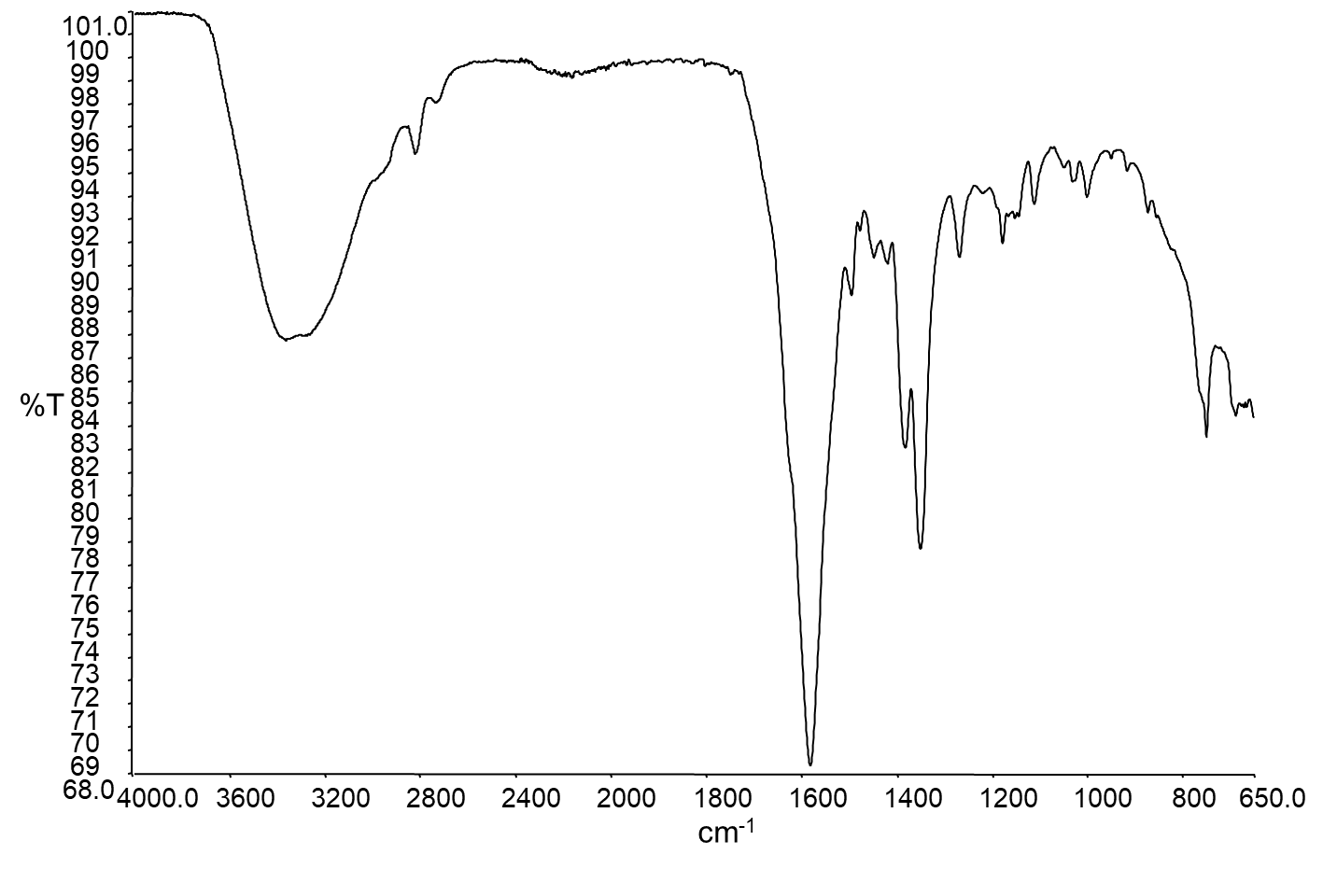
IR spectrum of synthetic 1
¹H NMR spectra of natural (upper) and synthetic (lower) 1 (500 MHz, DMSO-d₆)
¹³C NMR spectra of natural (upper) and synthetic (lower) 1 (125 MHz, DMSO-d₆)
.
COSY spectrum of natural 1 (500 MHz, DMSO-d₆).

HSQC spectrum of natural 1 (500 MHz, DMSO-d₆)
HMBC spectrum of natural 1 (500 MHz, DMSO-d₆)

COSY spectrum of synthetic 1 (500 MHz, DMSO-d₆).
HSQC spectrum of synthetic 1 (500 MHz, DMSO-d₆).

HMBC spectrum of synthetic 1 (500 MHz, DMSO-d₆).
UV spectrum of ethyl 2-methyl-3-oxo-3-(phenylamino) propanoic acid
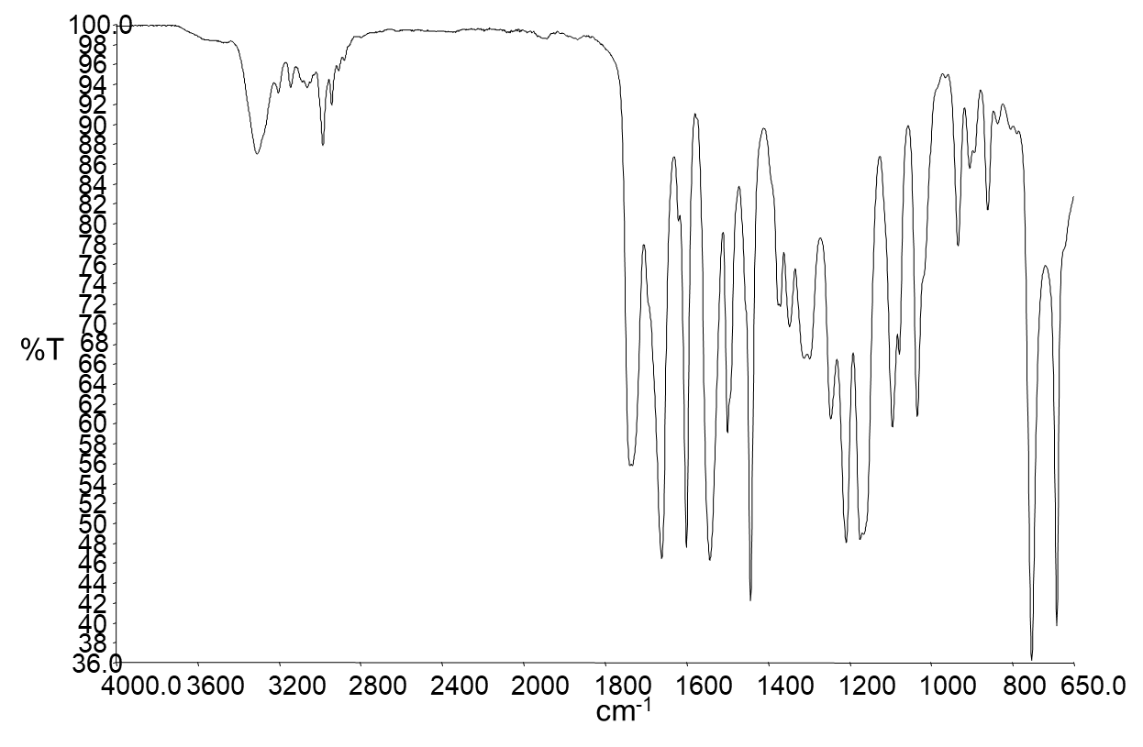
IR spectrum of ethyl 2-methyl-3-oxo-3-(phenylamino) propanoic acid

¹H NMR spectrum of ethyl 2-methyl-3-oxo-3-(phenylamino) propanoic acid (500 MHz, CDCl₃)

¹³C NMR spectrum of ethyl 2-methyl-3-oxo-3-(phenylamino) propanoic acid (125 MHz, CDCl₃)

UV spectrum of N-phenyl-2-methylmalonamic acid

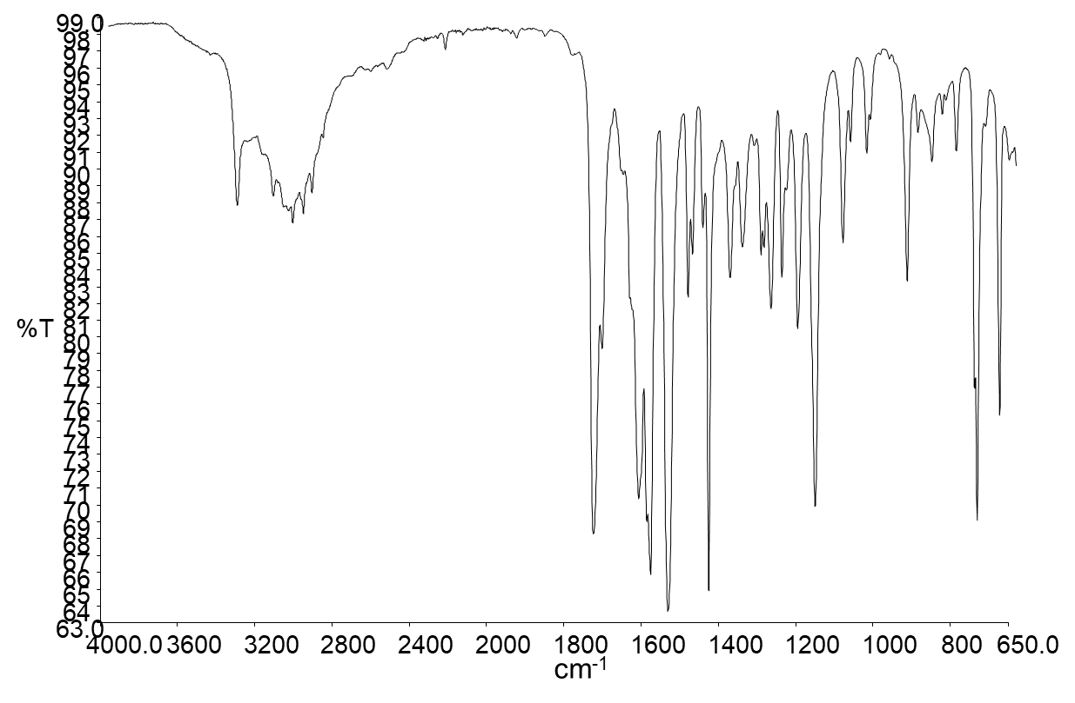
IR spectrum of N-phenyl-2-methylmalonamic acid

¹H NMR spectrum of N-phenyl-2-methylmalonamic acid (500 MHz, DMSO-d₆)

¹³C NMR spectrum of N-phenyl-2-methylmalonamic acid (125 MHz, DMSO-d₆)

