Supporting Information for
FERROCENYL SUBSTITUTED TETRAHYDROTHIOPHENES
VIA THE FORMAL (3+2)-CYCLOADDITION OF FERROCENYL THIOKETONES WITH DONOR-ACCEPTOR CYCLOPROPANES

Grzegorz Mlostoń,^{a)*} Mateusz Kowalczyk,^{a,b)} André U. Augustin,^{c)} Peter G. Jones,^{d)} and Daniel Werz^{c)*}

^{a)} University of Łódź, Department of Organic & Applied Chemistry, Tamka 12, 91-403 Łódź, Poland
^{b)} University of Łódź, PhD School of Exact Sciences
^{c)} Technische Universität Braunschweig, Institute of Organic Chemistry, Hagenring 30, 3106 Braunschweig, Germany
^{d)} Technische Universität Braunschweig, Institute of Inorganic and Analytical Chemistry, Hagenring 30, 3106 Braunschweig, Germany

Email:
grzegorz.mloston@chemia.uni.lodz.pl; d.werz@tu-braunschweig.de
* Corresponding authors

1. Experimental
For general information see the main manuscript, p. ….
1. 1. Experimental data for thioketone 8c

Ferrocenyl (2-naphthyl)methanthione (8c): Yield: 1.09 g (92%). Deep blue crystals; mp 127-128°C; ¹H-NMR (600 MHz, CDCl₃): δ 4.19 (s, 5HC(Fc)); 4.85 (s, 2HC(Fc)); 5.07 (s, 2HC(Fc)); 7.36-7.43 (m, 3 arom. HC); 7.47-7.54 (m, 2 arom. HC); 7.66-7.73 (m, 2 arom. HC); ¹³C-NMR (151 MHz, CDCl₃): δ 72.3, 72.9, 74.9 (for 9HC(Fc)), 89.6 (C(Fc)), 125.6, 126.0, 126.7, 127.3, 127.4, 127.7, 129.1 (7 arom. HC), 132.3, 134.2, 146.2 (3 arom. C), 238.1 (C=S); Anal. calcd for C₂₁H₁₆SFe (356.26): C 70.80; H 4.53; S 9.00; found C 70.67; H 4.69; S 9.02.

1. 2. Experimental data for tetrahydrothiophenes 9e-k,m-n
Dimethyl 2-ferrocenyl-5-phenyl-2-(n-propyl)tetrahydrothiophene-3,3-dicarboxylate (9e): Yield: 147 mg (97%); isolated chromatographically as a 52:48 mixture of isomers. Major component was isolated as a less polar fraction by repeated preparative thin layer chromatography on silica. Yellow crystals; mp 109-110°C; ¹H-NMR (600 MHz, CDCl₃) (major isomer): δ 1.12 (t, J = 7.2 Hz, 3H, CH₃(n-Pr)), 1.29 (t, J = 7.1 Hz, 2H, CH₂(n-Pr)), 2.75 (dd, J = 13.9, J = 11.1 Hz, 1H, HC(4)) 3.00 (dd, J = 13.9, J = 6.8 Hz, 1H, HC(4)) 3.41 (s, 3H, OCH₃), 3.67 (s, 3H, OCH₃), 4.15 (q, J = 14.3, J = 7.1 Hz, CH₂(n-Pr)), 4.18 (s, 6HC(Fc)), 4.20 (s, 1HC(Fc)), 4.38 (s, 1HC(Fc)), 4.57 (s, 1HC(Fc)), 5.43 (dd, J = 11.0, 6.8 Hz, 1H, HC(5)), 7.36-7.40 (m, 2 arom. HC), 7.53-7.56 (m, 2 arom. HC); ¹³C-NMR (151 MHz, CDCl₃) (major isomer): δ 15.1 (CH₃), 20.2 (CH₂CH₂CH₃), 44.2 (CH₂CH₂CH₃), 47.3 (C(4)) 48.9 (HC(5)), 52.2, 52.5 (2OCH₃), 65.5, 71.7 (C(2) and C(3)), 67.1, 68.1, 68.2, 69.3, 69.4 (for 9HC(Fc)), 91.5 (C(Fc)), 127.3, 127.7, 128.7 (for 5 arom. HC), 142.1 (1 arom. C), 169.2, 170.1 (2C=O); IR: ν 1731brs (2C=O), 1449m, 1431m, 1241s, 1209s, 1105m, 1051m, 818s, 762m, 697vs, 482vs cm⁻¹; HRMS (ESI⁺): calcd. for [C₂₇H₃₀O₄SFe]⁺, 506.1214; found, 506.1211.

Dimethyl 2-ferrocenyl-5-(2-naphthyl)-2-phenyltetrahydrothiophene-3,3-dicarboxylate (cis-9f): Yellow crystals, 22 mg (30%); mp 178-180°C. ¹H-NMR (600 MHz, CDCl₃): δ 2.73 (dd, J = 13.9, J = 4.3 Hz, 1H, HC(4)), 3.46 (s, 3H, OCH₃), 3.49 (s, 3H, OCH₃), 3.59-3.61 (m, 1HC(Fc)), 3.69 (dd, J = 13.7, J = 12.9 Hz, 1H, HC(4)), 4.02-4.04 (m, 1HC(Fc)), 4.07 (s, 5HC(Fc)), 4.30-4.31 (m, 1HC(Fc)), 4.73-4.75 (m, 1HC(Fc)), 5.00 (dd, J = 12.6, J = 4.3 Hz, 1H, HC), 7.33-7.39 (m, 1 arom. HC), 7.41-7.46 (m, 2 arom. HC), 7.51-7.56 (m, 2 arom. HC), 7.81-7.86 (m, 1 arom. HC), 7.89-7.91 (m, 2 arom. HC), 7.94-7.96 (m, 1 arom. HC), 8.00 (s, 1 arom. HC), 8.24-8.27 (m, 2 arom. HC); ¹³C-NMR (151 MHz, CDCl₃): δ 48.0 (C(4)), 48.2 (C(5)), 52.5, 52.6 (OCH₃), 67.8, 68.7, 69.1, 69.9, 71,1 (for 9HC(Fc)), 73.7 (for C(2) and C(3)), 96.9 (C(Fc)), 125.7, 126.1, 126.3, 126.6, 126.9, 127.1, 127.7, 127.8, 128.5, 128.8 (for 12 arom. HC), 133.1, 133.4, 136.1, 144.2 (4 arom. C), 168.9, 170.3 (2C=O); IR: ν 1744vs (2C=O), 1444m, 1427m, 1258m, 1239vs, 1187m, 1168m, 1051m, 814m, 723m, 698m, 480vs cm⁻¹; Anal calcd for C₃₄H₃₀FeO₄S (590.51): C 68.92 H 5.44, S 5.43; found: C 68.85, H 5.44, S 5.47.
Dimethyl 2,5-di(2-naphthyl)-2-ferrocenyltetrahydrothiophene-3,3-dicarboxylate (9g): Yield: 25 mg (31%); mp = 220°C (dec.). ¹H-NMR (600 MHz, CDCl₃): δ 2.78 (dd, J = 13.8, J = 4.3 Hz, 1H, HC(4)), 3.44 (s, 3H, OCH₃), 3.51 (s, 3H, OCH₃), 3.56-3.58 (m, 1HC(Fc)), 3.76 (dd, J = 13.7, J = 12.9 Hz, 1H, HC(4)), 4.00-4.02 (m, 1HC(Fc)), 4.07 (s, 5HC(Fc)), 4.31-4.33 (m, 1HC(Fc)), 4.78-4.80 (m, 1HC(Fc)), 5.05 (dd, J = 12.6, J = 4.3 Hz, 1H, HC(5)), 7.52-7.58 (m, 4 arom. HC), 7.85-7.94 (m, 5 arom. HC), 7.96-8.01 (m, 2 arom. HC), 8.04 (s, 1 arom. HC), 8.38-8.41 (m, 1 arom. HC), 8.77-8.78 (m, 1 arom. HC); ¹³C-NMR (151 MHz, CDCl₃): δ 48.1 (C(4)), 48.3 (C(5)), 52.5, 52,6 (2OCH₃), 67.8, 68.7, 69.2, 69.9, 71.2 (for 9HC(Fc)), 71.2, 73.5 (C(2) and C(3)), 97.3 (C(Fc)), 125.7, 125.8, 125.9, 126.1, 126.2, 126.3, 126.9, 127.3, 127.4, 127.7, 127.9, 128.0, 128.6, 128.7 (14 arom. HC), 132.1, 132.8, 133.1, 133.4, 136.1, 141.8 (6 arom. C), 168.9, 170.4 (2C=O); IR: ν 1723vs (2C=O), 1433m, 1299m, 1246s, 1217m, 1172m, 814s, 751s, 497m, 473vs cm⁻¹; Anal. calcd for C₃₈H₃₂FeO₄S (640.57): C 71.25 H 5.04, S 5.01; found: C 71.21, H 5.25, S 5.01.

Dimethyl 2-ferrocenyl-2-phenyl-5-(4-(methyl)phenyl)tetrahydrothiophene-3,3-dicarboxy-late (9h): Yield: 133 mg (85,1%). Yellow crystals; mp 146-148°C; ¹H-NMR (600 MHz, CDCl₃): δ 2.41 (s, 3H, CH₃), 2.62 (dd, J = 13.9, J = 4.3 Hz, 1H, HC(4)), 3.44 (s, 3H, OCH₃), 3.46 (s, 3H, OCH₃), 3.53-3.57 (dd, J = 13.6, J = 12.9 Hz, 1H, HC(4)), 3.57-3.58 (m, 1HC(Fc)), 4.00-4.02 (m, 1HC(Fc)), 4.06 (s, 5HC(Fc)), 4.27-4.29 (m, 1HC(Fc)), 4.68-4.70 (m, 1HC(Fc)), 4.78 (dd, J = 12.6, J = 4.3 Hz, 1H, HC(5)), 7.25, 7.52 (AB system, J = 8.0 Hz, 4 arom. HC), 7.33-7.34 (m, 1 arom. HC), 7.39-7.43 (m, 2 arom. HC), 8.21-8.24 (m, 2 arom. HC); ¹³C-NMR (151 MHz, CDCl₃): δ = 21.2 (CH₃), 47.8 (C(5)), 48.4 (C(4)), 52.4 (2OCH₃), 67.8, 68.7, 69.2, 69.9, 71.0 (for 9HC(Fc)), 70.9, 73.7 (C(2) and C(3)), 97.0 (C(Fc)), 126.6, 127.1, 127.9, 128.8, 129.5 (for 9 arom. HC), 135.8, 137.6, 144.3 (3 arom. C), 168.9, 170.4 (2C=O); IR: ν 1729brvs (2C=O), 1429m, 1254s, 1162s, 1023m, 935m, 814vs, 721s, 700s, 484m cm⁻¹; Anal. calcd for C₃₁H₃₀FeO₄S (554.48): C 67.15, H 5.45, S 5.78; found: C 67.13, H 5.61, S 5.73.
Dimethyl 2-ferrocenyl-2-phenyl-5-(4-(methoxyl)phenyl)tetrahydrothiophene-3,3-di-carboxylate (9i): Yield: 128 mg (79%). Yellow crystals; mp 138-140°C. ¹H-NMR (600 MHz, CDCl₃): δ 2.61 (dd, J = 13.9, J = 4.4 Hz, 1H, HC(4)), 3.44 (s, 3H, OCH₃), 3.45 (s, 3H, OCH₃), 3.54 (dd, J = 13.6, J = 12.9 Hz, 1H, HC(4)), 3.57-3.59 (m, 1HC(Fc)), 3.87 (s, 3H, OCH₃), 4.00-4.02 (m, 1HC(Fc)), 4.06 (s, 1HC(Fc)), 4.27-4.29 (m, 1HC(Fc)), 4.68-4.70 (m, 1HC(Fc)), 4.77 (dd, J = 12.6, J = 4.3 Hz, 1H, HC(5)), 6.98, 7.56 (AB system, J = 8.6 Hz, 4 arom. HC), 7.31-7.35 (m, 1 arom. HC), 7.39-7.44 (m, 2 arom. HC), 8.21-8.24 (m, 2 arom. HC); ¹³C-NMR (151 MHz, CDCl₃): δ 47.5 (C(5)), 48.5 (C(4)), 52.4, 55.3 (for 3OCH₃), 67.8, 68.7, 69.2, 69.9, 71.0 (for 9HC(Fc)), 70.8, 73.6 (C(2) and C(3)), 96.9 (C(Fc)), 114.2, 126.5, 127.0, 128.8, 129.1, (for 9 arom. HC), 130.6, 144.3, 159.2 (3 arom. C), 168.9, 170.3 (2C=O); IR: ν 1731brs (2C=O), 1515m, 1431m, 1250vs, 1157s, 1039m, 935m, 833m, 818m, 721m, 700m, 486s cm⁻¹; Anal. calcd for C₃₁H₃₀FeO₅S (570.48): C 65.27, H 5.30, S 5.62; found: C 65.35, H 5.42, S 5.61.
Dimethyl 2-ferrocenyl-2-phenyl-5-(4-(bromo)phenyl)tetrahydrothiophene-3,3-dicarboxy-late (9j): Yield: 128 mg (92,5%). Yellow crystals; mp 182-184°C. ¹H-NMR (600 MHz, CDCl₃): δ 2.63 (dd, J = 13.9, J = 4.4 Hz, 1H, HC(4)), 3.44 (s, 3H, OCH₃), 3.45 (s, 3H, OCH₃), 3.49 (dd, J = 13.9, J = 12.7 Hz, 1H, HC(4)), 3.57-3.59 (m, 1HC(Fc)), 4.00-4.02 (m, 1HC(Fc)), 4.06 (s, 5HC(Fc)), 4.27-4.29 (m, 1HC(Fc)), 4.61-4.63 (m, 1HC(Fc)), 4.76 (dd, J = 12.6, J = 4.3 Hz, 1H, HC(5)), 7.31-7.35 (m, 1 arom. HC), 7.39-7.43 (m, 2 arom. HC), 7.50, 7.56 (AB system, J = 8.4 Hz, 4 arom. HC), 8.20-8.22 (m, 2 arom. HC); ¹³C-NMR (151 MHz, CDCl₃): δ 47.4 (C(5)), 48.2 (C(4)), 52.4, 52.5 (2OCH₃), 67.8, 68.8, 69.2, 69.7, 71.1 (for 9HC(Fc)), 71.2, 73.5 (C(2) and C(3)), 96.7 (C(Fc)), 126.6, 127.1, 128.7, 129.7, 131.9 (for 9 arom. HC), 121.6, 138.0, 144.0 (3 arom. C), 168.7, 170.2 (2C=O); IR: ν 1729brs (2C=O), 1490m, 1440m, 1256s, 1162s, 1073m, 814s, 721m, 700m, 486m cm⁻¹; Anal. calcd for C₃₀H₂₇BrFeO₄S (619.35): C 58.18, H 4.39, S 5.18; found: C 58.11, H 4.41, S 5.13.
Dimethyl 2-ferrocenyl-2-phenyl-5-(4-(trifluoromethyl)phenyl)tetrahydro-thiophene-3,3-dicarboxylate (9k): Yield: 134 mg (95,1%). Yellow crystals; mp 168-170°C. ¹H-NMR (600 MHz, CDCl₃): δ 2.68 (dd, J = 13.9, J = 4.4 Hz, 1H, HC(4)), 3.45 (s, 3H, OCH₃), 3.47 (s, 3H, OCH₃), 3.53 (dd, J = 13.8, J = 12.7 Hz, 1H, HC(4)), 3.59-3.61 (m, 1HC(Fc)), 4.02-4.04 (m, 1HC(Fc)), 4.07 (s, 5HC(Fc)), 4.29-4.31 (m, 1HC(Fc)), 4.61-4.63 (m, 1HC(Fc)), 4.86 (dd, J = 12.6, J = 4.4 Hz, 1H, HC(5)), 7.33-7.37 (m, 1 arom. HC), 7.41-7.45 (m, 2 arom. HC), 7.70, 7.75 (AB system, J = 8.2 Hz, 4 arom. HC), 8.20-8.23 (m, 2 arom. HC); ¹³C-NMR (151 MHz, CDCl₃): δ 47.5 (C(5)), 48.2 (C(4)), 52.5, 52.6 (2OCH₃), 67.8, 68.8, 69.2, 69.7, 71.7 (for 9HC(Fc)), 71.3, 73.6 (C(2) and C(3)), 96.6 (C(Fc)), 125.7, 125.8, 126.7, 127.1, 128.4, 128.7 (for 9 arom. HC), 129.7, 129.9, 130.2, 130.4 (CF₃), 143.2, 143.9 (2 arom. C), 168.6, 170.1 (2C=O); IR: ν 1731brs (2C=O), 1429m, 1328m, 1258m, 1162s, 1116s, 1067s, 936m, 820m, 723m, 700m, 486m cm⁻¹; Anal. calcd for C₃₁H₂₇F₃FeO₄S (608.45): C 61.19, H 4.47, S 5.27; found: C 61.26, H 4.48, S 5.17.
Dimethyl 2-ferrocenyl-2-(2-furanyl)-5-phenyltetrahydrothiophene-3,3-dicarboxylate (9m): Yield: 152 mg (96%). Isolated chromatographically as a 60:40 mixture of isomers. Yellow crystals; mp 124-126°C. Major isomer (based on the registered spectrum of the mixture): ¹H-NMR: δ 3.04 (dd, J = 13.8, J = 6.4 Hz, 1H, HC(4)), 3.40 (dd, J = 11.2, J = 3.2 Hz, 1H, HC(4)), 3.49 (s, 3H, OCH₃), 3.59 (s, 3H, OCH₃), 5.24 (dd, J = 11.2, J = 6.4 Hz, 1H, HC(5)); Minor isomer (based on the registered spectrum of the mixture): ¹H-NMR: δ 2.74 (dd, J = 13.8, 5.2 Hz, 1H, HC(4)), 3.42 (dd, J = 12.1, J = 4.0 Hz, 1H, HC(4)), 3.48 (s, 3H, OCH₃), 3.64 (s, 3H, OCH₃), 4.79 (dd, J = 12.0, J = 5.2 Hz, 1H, HC(5)); Remaining signals registered for the mixture: ¹H-NMR δ 4.09 (s, 4HC(Fc)), 4.10-4.11 (s, 1HC(Fc)), 4.12 (s, 6HC(Fc)), 4.23-4.26 (m, 4HC(Fc)), 4.55-4.57 (m, 1HC(Fc)), 4.69-4.71 (m, 1HC(Fc)), 4.55-4.57 (m, 1HC(Fc)), 6.48-6.50 (m, 2 arom. HC), 6.84 (d, J = 3 Hz, 1 arom. HC), 7.16 (d, J = 3.1 Hz, 1 arom. HC), 7.34-7.38 (m, 3 arom. HC), 7.40-7.45 (m, 2 arom. HC), 7.47-7.49 (m, 1 arom. HC), 7.49-7.51 (m, 1 arom. HC), 7.52-7.55 (m, 3 arom. HC), 7.59-7.62 (m, 2 arom. HC); ¹³C-NMR (registered for the mixture): δ 46.2, 47.7 (2C(4)); 48.1, 49.5 (2HC(5)); 52.3, 52.4, 52.6, 52.8 (4OCH₃); 64.0, 64.2 (2C(2), 71.8, 72.0 (2C(3)); 66.8, 68.1, 68.4, 68.9, 69.3, 69.5, 69.9, 70.1, 70.4 71.9 (for 18HC(Fc)); 86.0, 92.5 (2C(Fc)); 108.1, 109.2, 110.5, 110.6, 140.5, 140.8 (6 arom. HC); 127.4, 127.8, 128.0, 128.1, 128.6, 128.7 (for 10 arom. HC), 138.9, 141.3, 156.3, 157.9 (4 arom. C), 168.4, 168.8, 169.0, 169.4 (4C=O); IR (registered for the mixture): ν 1731vs (2C=O), 1492m, 1429m, 1248s, 1146m, 816m, 732m, 698vs, 598m, 490vs cm⁻¹; HRMS (ESI⁺): calcd for [C₂₈H₂₆FeO₅S]⁺, 530.0850; found 530.0856.
Dimethyl 2-ferrocenyl-5-(phtalimid-1-yl)-2-phenyltetrahydrothiophene-3,3-dicarboxylate (9n): Yield: 48 mg (34,1%). Isolated chromatographically as a 60:40 mixture of isomers. Yellow crystals; mp ca. 170°C (dec.); Major isomer (based on the registered spectrum of the mixture): ¹H-NMR: δ 2.47 (dd, J = 13.7, J = 5.1 Hz, 1H, HC(4)), 3.44 (s, 3H, OCH₃), 3.46 (s, 3H, OCH₃), 4.66 (pseudo-dd, J = 13.5, J = 12.3 Hz, 1H, HC(4)), 6.31 (dd, J = 12.1, J = 5.1 Hz, 1H, HC(5)); Minor isomer (based on the registered spectrum of the mixture): ¹H-NMR: δ 3.22 (dd, J = 14.5, J = 7.7 Hz, 1H, HC(4)), 3.49 (s, 3H, OCH₃), 3.56 (s, 3H, OCH₃), 4.23 (pseudo-dd, J = 14.5 Hz, J = 7.5, Hz, 1H, HC(4)), 6.43 (pseudo-dd, J = 8.0, J = 7.4 Hz, 1H, HC(5)); Remaining signals registered for the mixture: δ 3.54 (s, 1HC(Fc)), 3.90 (s, 1HC(Fc)), 3.99 (s, 1HC(Fc)), 4.05 (s, 5HC(Fc)), 4.08 (s, 6HC(Fc)), 4.18 (s, 1HC(Fc)), 4.25-4.26 (m, 1HC(Fc)), 4.37 (s, 1HC(Fc)), 5.45 (s, 1HC(Fc)), 7.30-7.35 (m, 2 arom. HC), 7.37-7.44 (m, 3 arom. HC), 7.71-7.75 (m, 2 arom. HC), 7.79-7.83 (m, 2 arom. HC), 7.84-7.86 (m, 2 arom. HC), 7.94-7.98 (m, 2 arom. HC), 8.18-8.24 (m, 2 arom. HC); ¹³C-NMR (registered for the mixture): δ 39.2, 40.2 (2C(4)), 52.3, 52.5, 52.6, 52.7 (4OCH₃), 53.1, 55.7 (2HC(5)), 70.9, 71.7, 72.5 (for 2C(2) and 2C(3)), 67.6, 69.1, 69.4, 69.5, 70.1, 71.4 (for 18HC(Fc)), 97.1 (for 2C(Fc)), 123.4, 123.6, 126.7, 126.8, 127.0, 127.1, 128.8, 129.1, 134.2, 134.4 (for 18 arom. HC), 131.8, 131.9, 143.9 (for 6 arom. C), 167.5, 167.7, 168.1, 168.9, 169.2, 170.1 (for 8C=O); IR: 1736m, 1716vs (2C=O), 1431m, 1354m, 1241s, 1172m, 1107m, 967m, 818m, 713vs, 501s, 486s cm⁻¹; Anal. calcd for C₃₂H₂₇FeNO₆S (609.47): C 63.06, H 4.47, N 2.30, S 5.26; found: C 63.06, H 4.45, N 2.56, S 5.19.
2. Crystal Structure Determinations
Crystals were mounted in inert oil on nylon loops and transferred to the cold gas stream of the diffractometer (trans-9c: Oxford Diffraction Nova A using mirror-focussed Cu Kα radiation; cis-9d: Rigaku/Oxford XtaLAB Synergy using mirror-focussed Mo Kα radiation). Absorption corrections were implemented on the basis of multi-scans. The structures were refined anisotropically on F² using the program SHELXL-2017 [S1]. Hydrogen atoms were included using rigid methyl groups or a riding model starting from calculated positions.
Crystallographic data are summarized in Table S1. Additionally, complete data have been deposited with the Cambridge Crystallographic Data Centre under the numbers CCDC 1992864 & 1992865. Copies of the data can be obtained free of charge from www.ccdc.cam.ac.uk/data_request/cif.

Table S1.
Crystallographic data and structure refinement details for compounds trans-9c and cis-9d.
Compound | trans-9c | cis-9d
CCDC number | 1992864 | 1992865
Formula | C₂₅H₂₆FeO₄S | C₃₄H₃₀FeO₄S
M_{r} | 478.37 | 590.59
Crystal size (mm) | 0.2 x 0.03 x 0.01 | 0.15 x 0.1 x 0.05
Crystal system | monoclinic | triclinic
Space group | P2₁/c | P(-1)
Temperature (°C) | -173 | -170
a (Å) | 13.1715(5) | 9.6177(2)
b (Å) | 17.8170(5) | 11.0241(3)
c (Å) | 9.6616(4) | 14.8441(3)
α (°) | 90 | 71.105(2)
β (°) | 106.781(4) | 77.475(2)
γ (°) | 90 | 65.076(3)
V (Å³) | 2170.80 | 1344.43
Z | 4 | 2
D_{x} (Mg m⁻³) | 1.464 | 1.459
λ (Å) | 1.54184 | 0.71073
μ (mm⁻¹) | 6.7 | 0.68
Transmissions | 0.638 – 1.000 | 0.929 – 1.000
F(000) | 1000 | 616
2θ_{max} | 154.8 | 70.3
Refl. measured | 46122 | 97549
Refl. indep. | 4568 | 11091
R_{int} | 0.055 | 0.037
Parameters | 283 | 363
wR(F², all refl.) | 0.095 | 0.080
R(F, >4σ(F)) | 0.037 | 0.029
S | 1.04 | 1.06
Max. Δp (e Å⁻³) | 0.38, –0.51 | 0.57, –0.40

3. The ¹H and ¹³C NMR spectra
3. 1. The ¹H and ¹³C NMR spectra for ferrocenyl (naphth-2-yl) thioketone (8c)

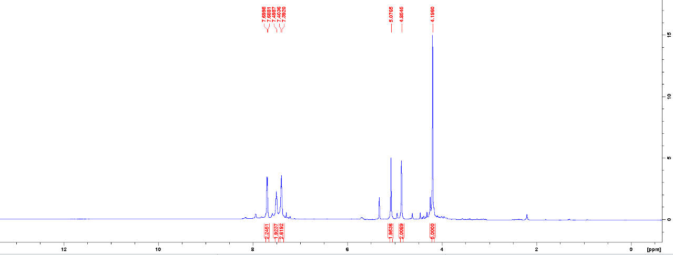
Fig. 1 The ¹H NMR spectrum for thioketone 8c.

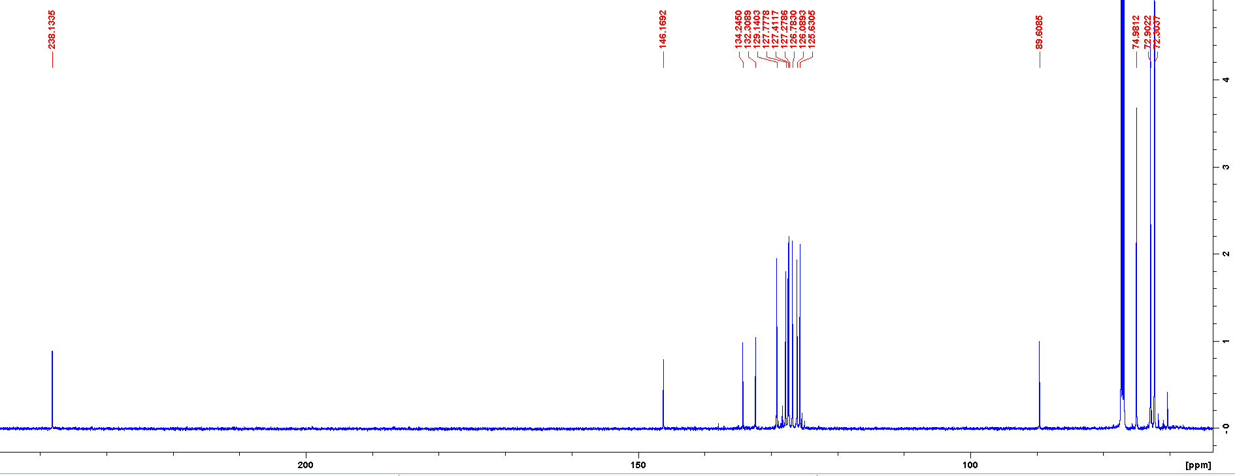

Fig. 2 The ¹³C NMR spectrum for thioketone 8c.

3.2. Collection of spectra for isolated tetrahydrothiophenes 9a-n
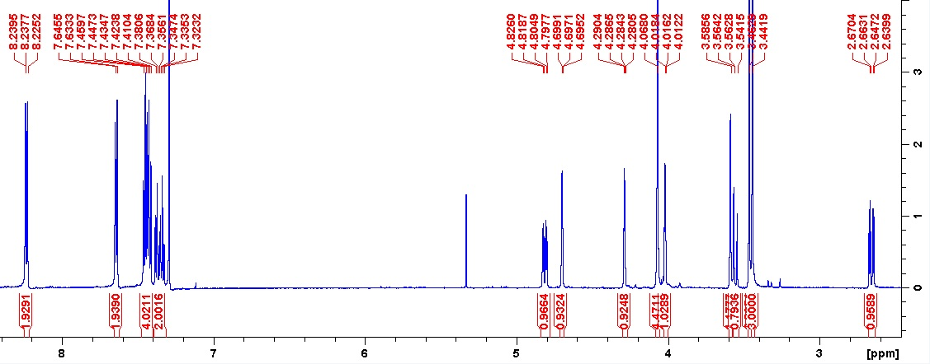
Fig. 3 The ¹H NMR spectrum for 9a.

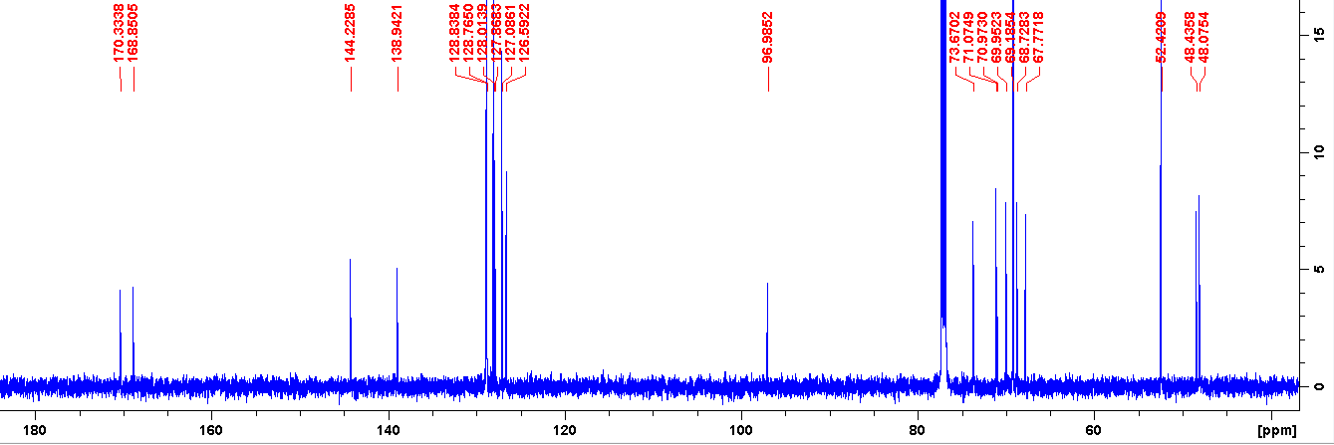
Fig. 4 The ¹³C NMR spectrum for 9a.
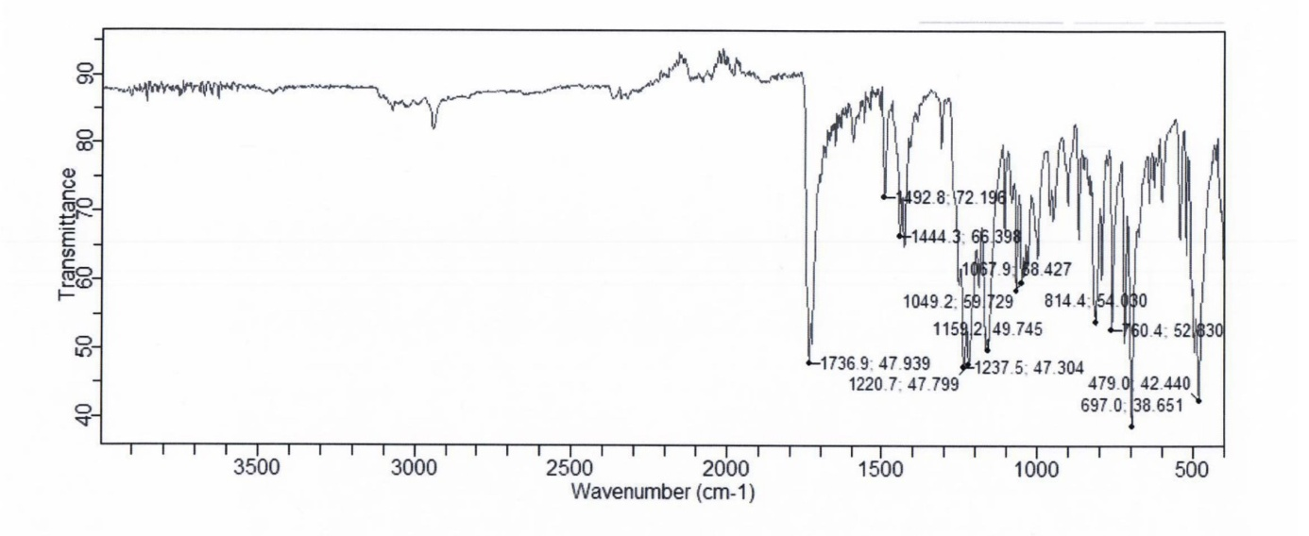
Fig. 5 The IR spectrum for 9a.
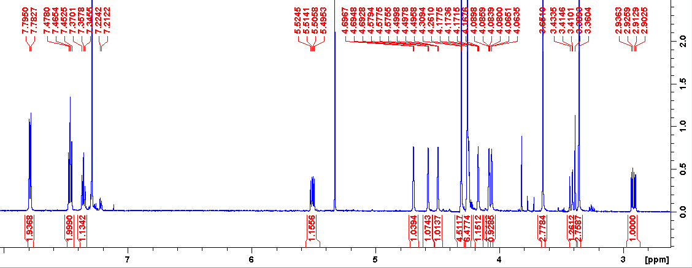
Fig. 6 The ¹H NMR spectrum for 9b.

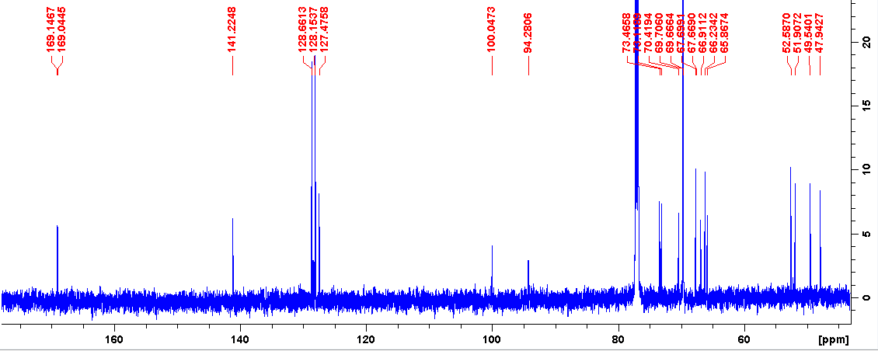
Fig. 7 The ¹³C NMR spectrum for 9b.

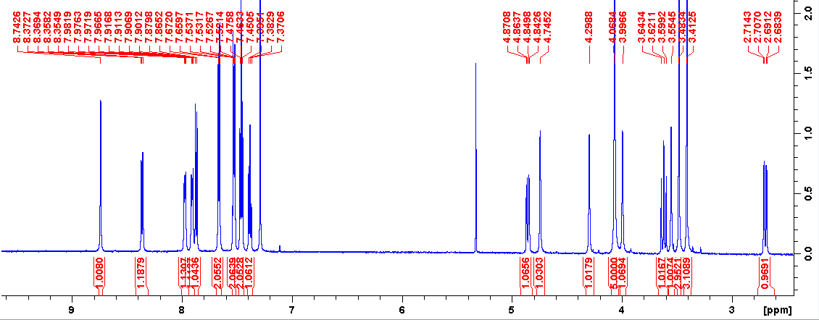
Fig. 8 The ¹H NMR spectrum for 9c.

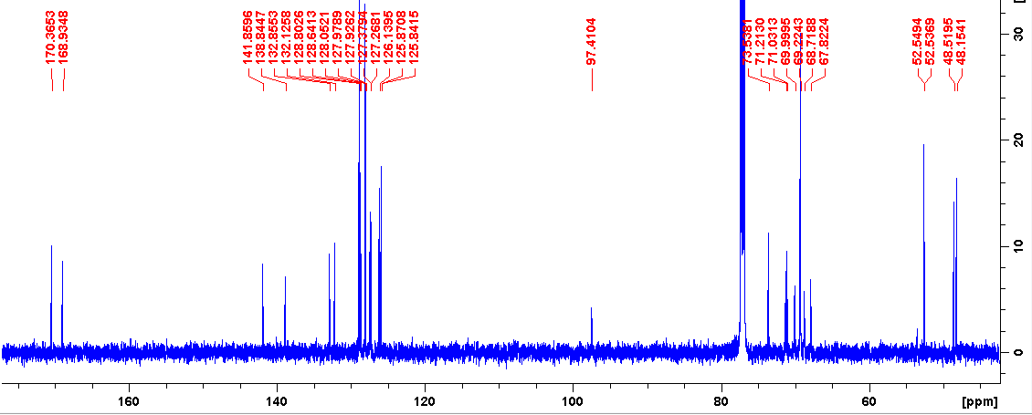
Fig. 9 The ¹³C NMR spectrum for 9c.

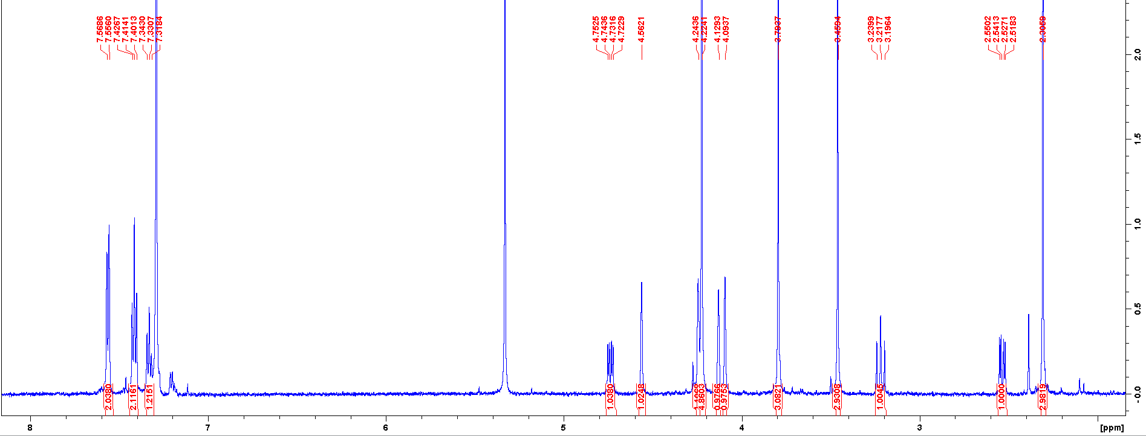
Fig. 10 The ¹H NMR spectrum for 9d (isomer cis).
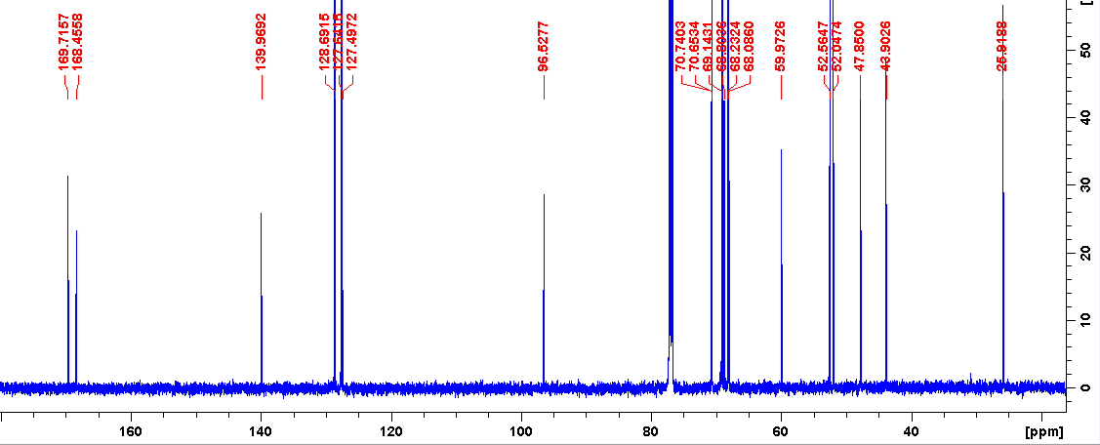
Fig. 11 The ¹³C NMR spectrum for 9d (isomer cis).
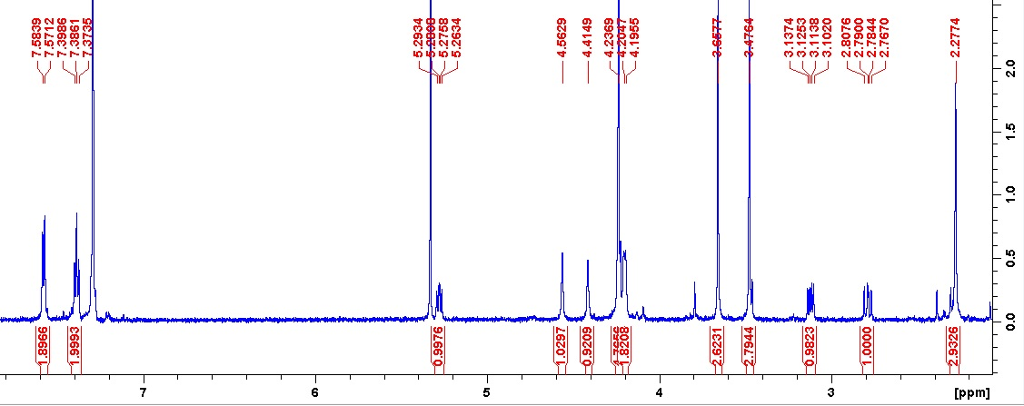
Fig. 12 The ¹H NMR spectrum for 9d (isomer trans).
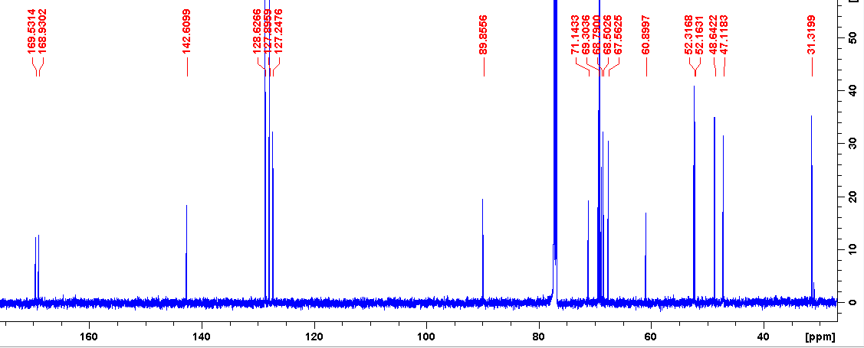
Fig. 13 The ¹³C NMR spectrum for 9d (isomer trans).
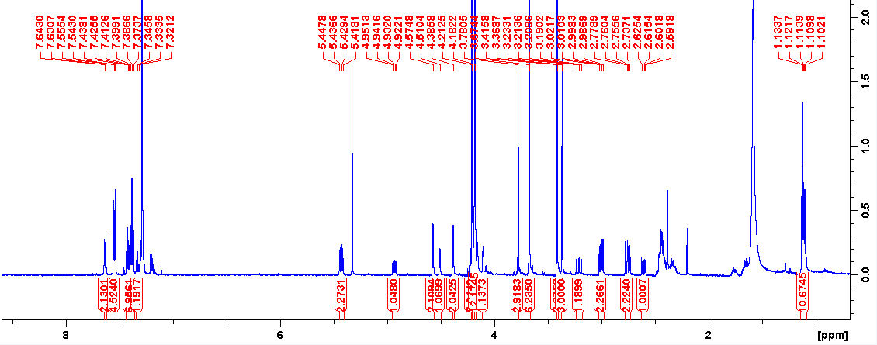
Fig. 14 The ¹H NMR spectrum for 9e (crude mixture)
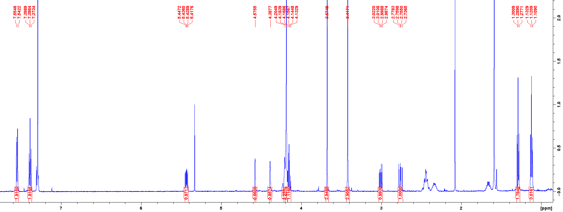
Fig. 15 The ¹H NMR spectrum for 9e (isomer trans).

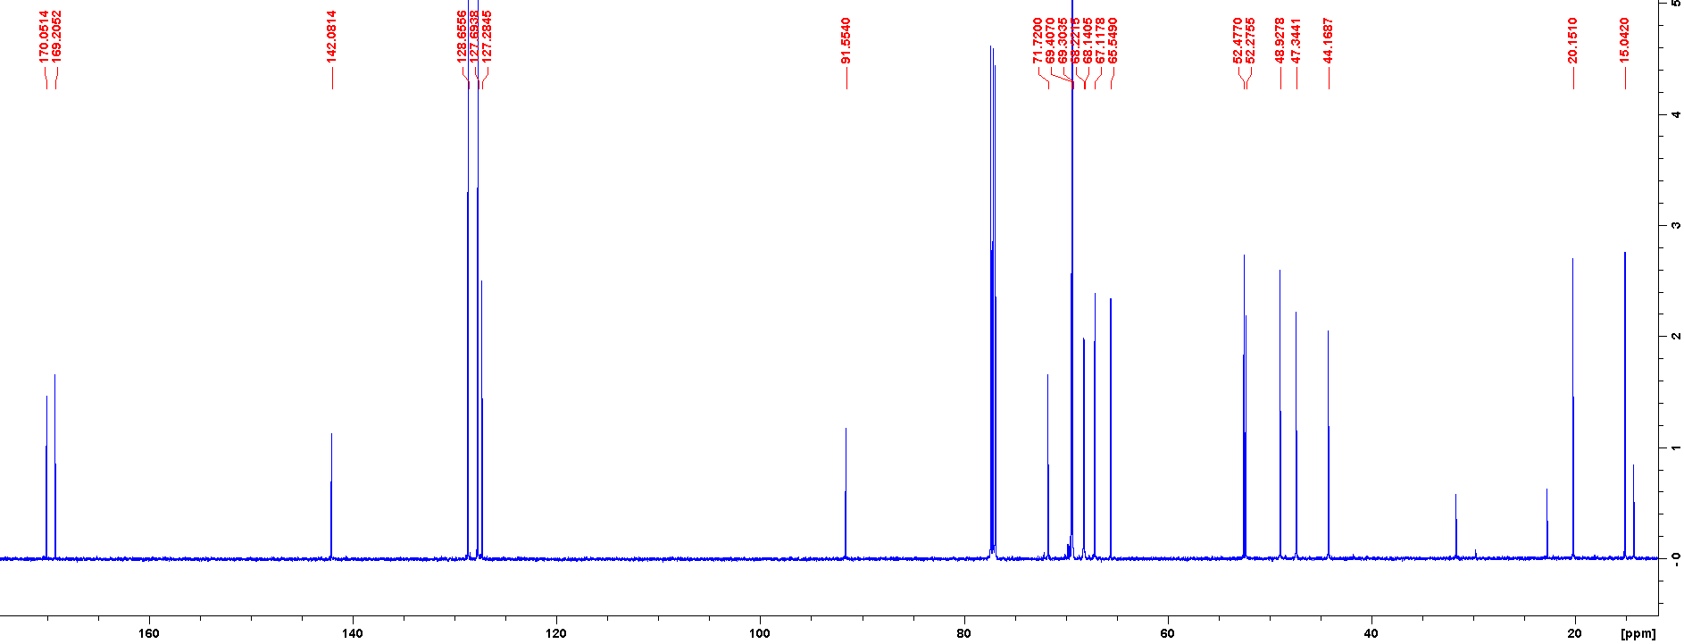
Fig. 16 The ¹³C NMR spectrum for 9e (isomer trans).
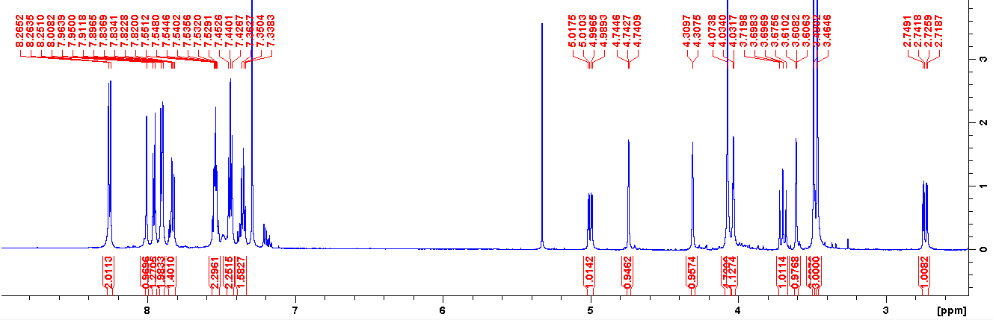
Fig. 17 The ¹H NMR spectrum for 9f.
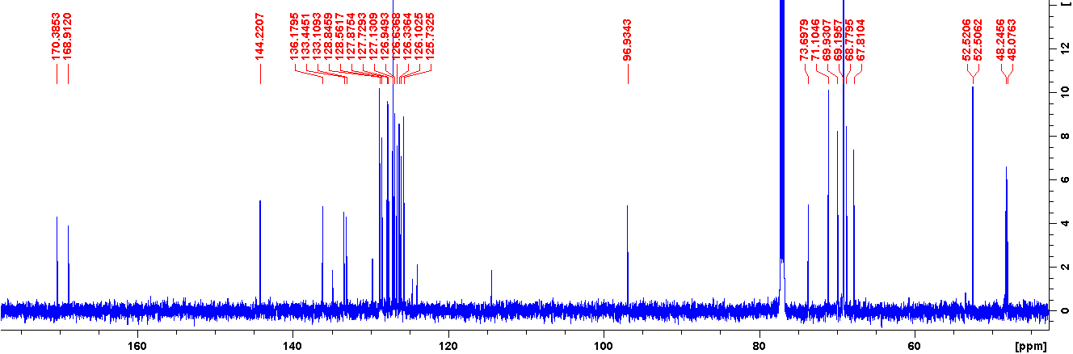
Fig. 18 The ¹³C NMR spectrum for 9f.

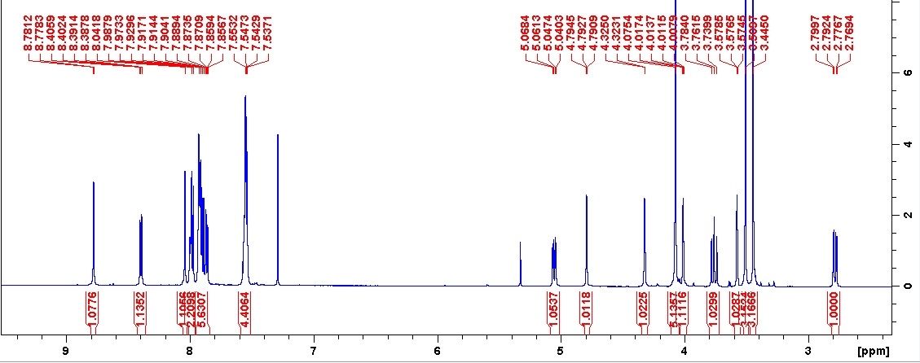
Fig. 19 The ¹H NMR spectrum for 9g.
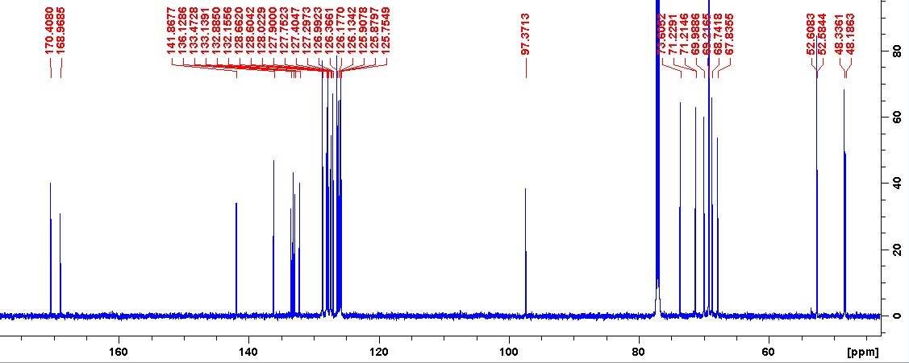
Fig. 20 The ¹³C NMR spectrum for 9g.
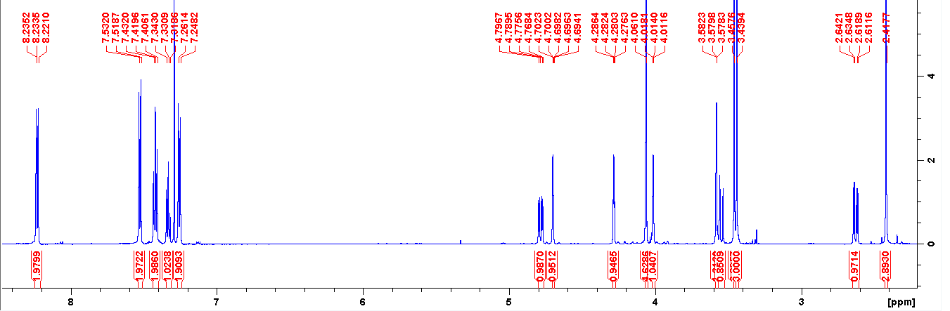
Fig. 21 The ¹H NMR spectrum for 9h.
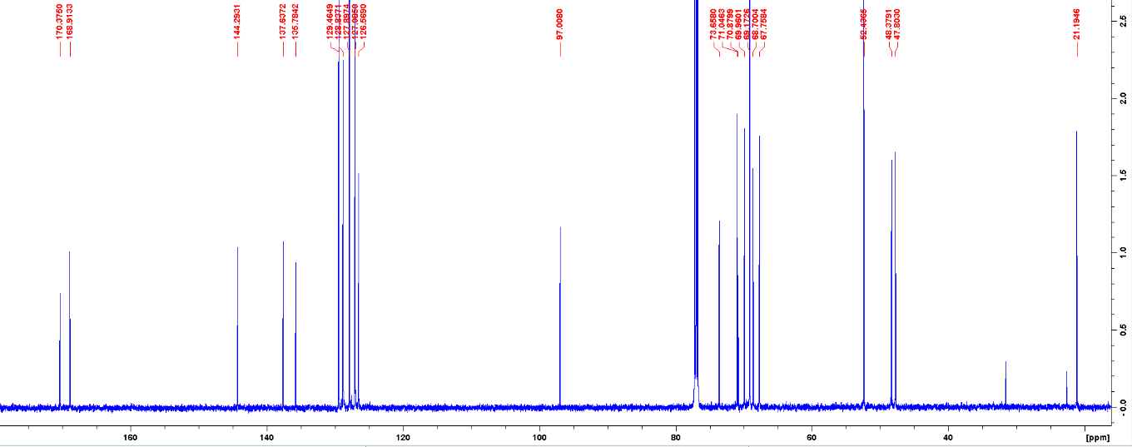
Fig. 22 The ¹³C NMR spectrum for 9h.
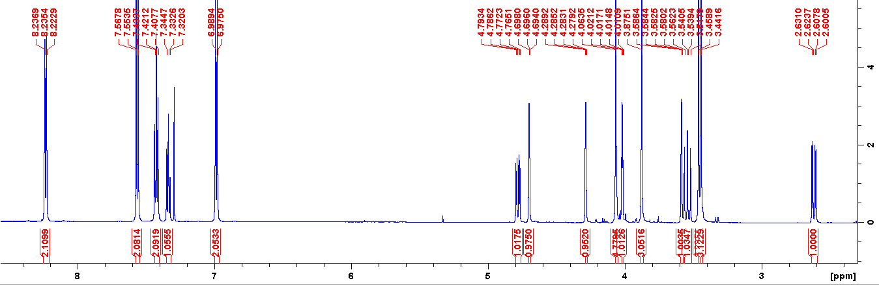
Fig. 23 The ¹H NMR spectrum for 9i.

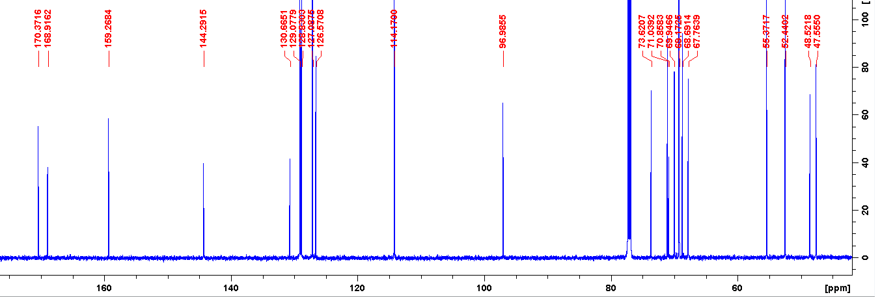
Fig. 24 The ¹³C NMR spectrum for 9i.

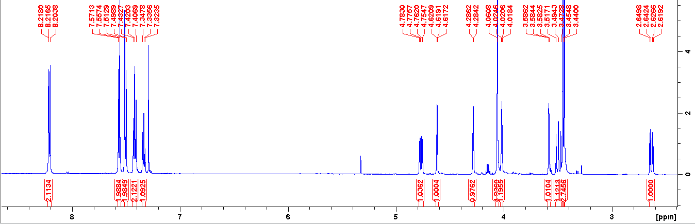
Fig. 25 The ¹H NMR spectrum for 9j.

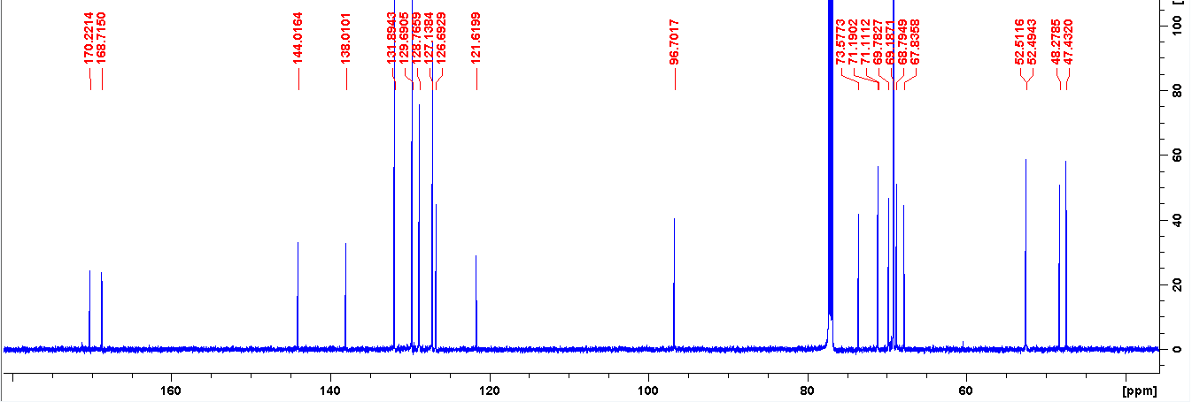
Fig. 26 The ¹³C NMR spectrum for 9j.

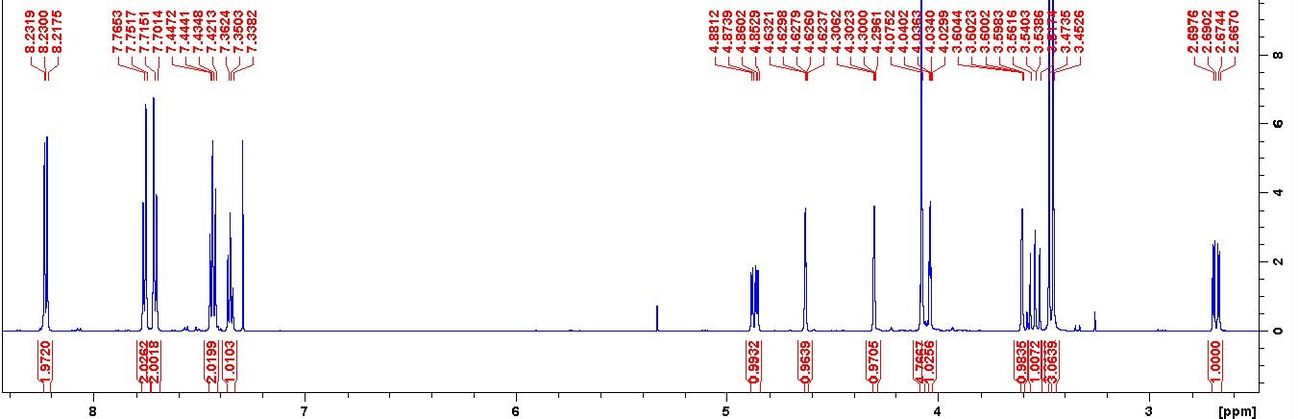 Fig. 27 The ¹H NMR spectrum for 9k.
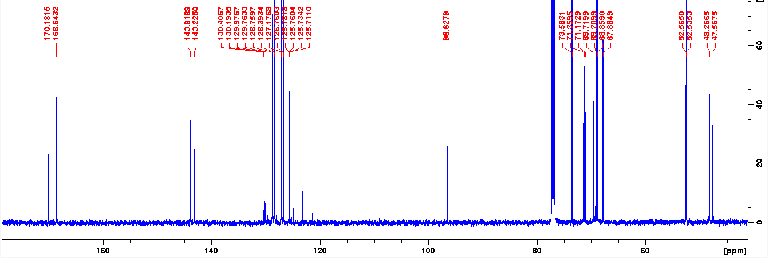
Fig. 28 The ¹³C NMR spectrum for 9k.
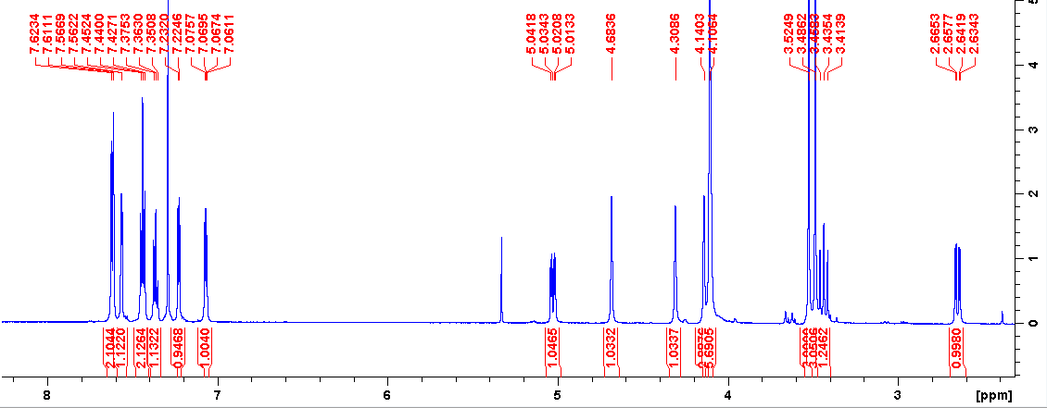
Fig. 29 The ¹H NMR spectrum for 9l.

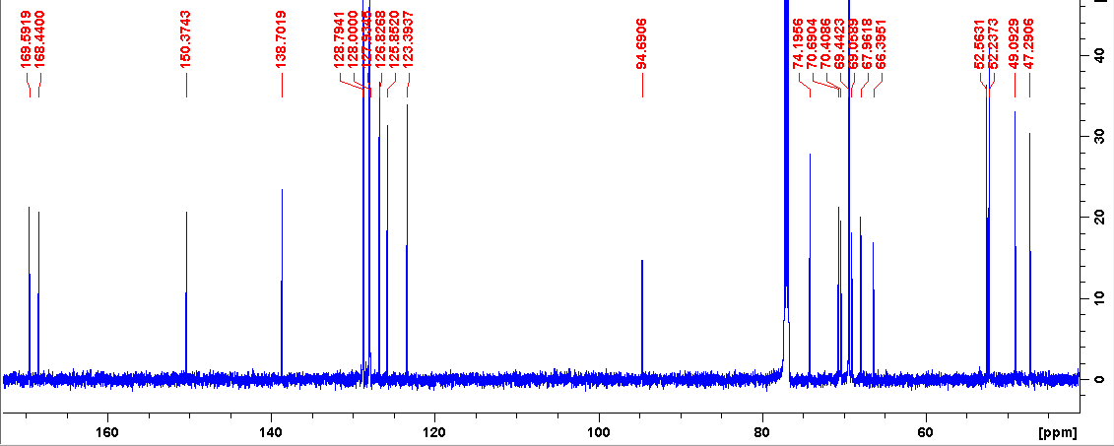
Fig. 30 The ¹³C NMR spectrum for 9l.
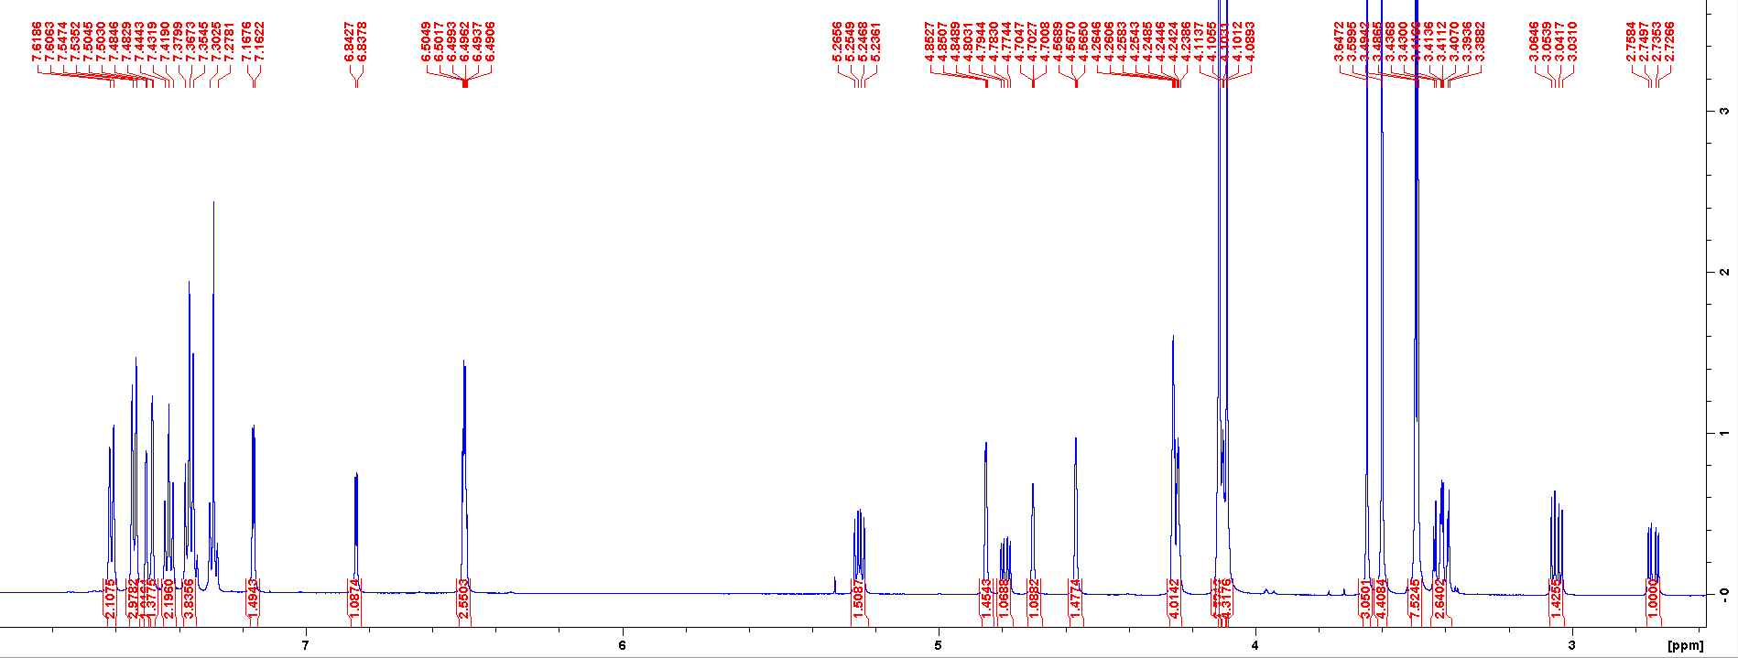
Fig. 31 The ¹H NMR spectrum for 9m.

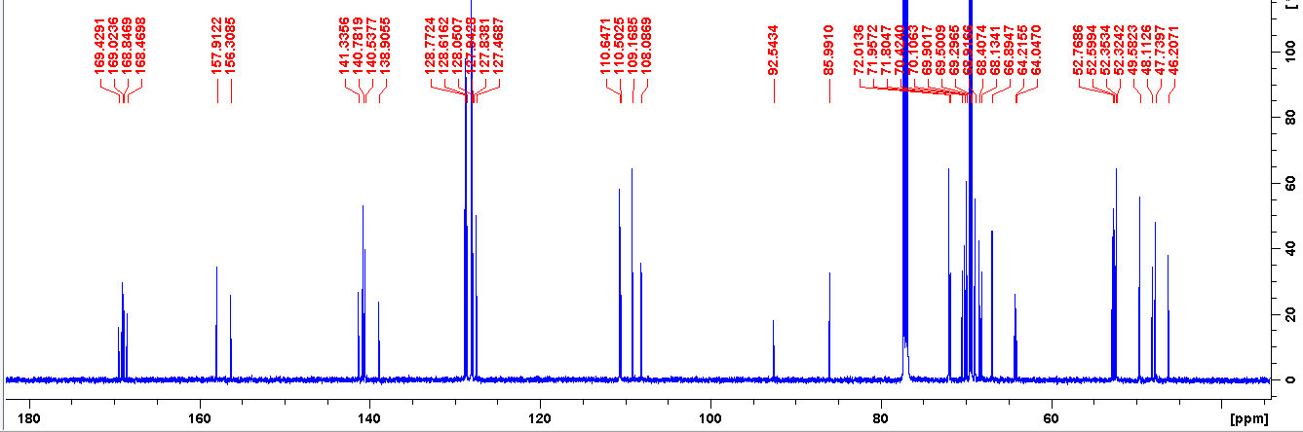
Fig. 32 The ¹³C NMR spectrum for 9m.

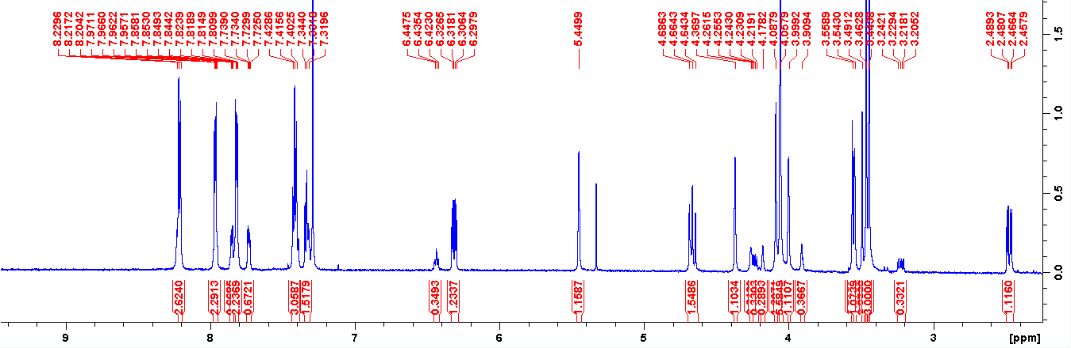
Fig. 33 The ¹H NMR spectrum for 9n.

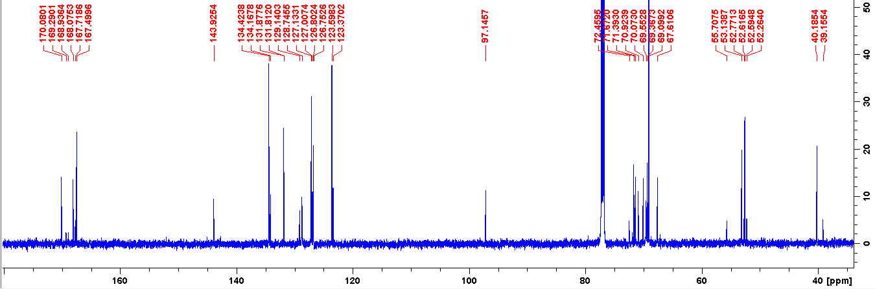
Fig. 34 The ¹³C NMR spectrum for 9n.

References
[S1] G. M. Sheldrick, Acta Cryst. C71, 3–8 (2015).

