Supporting Information
Solvent and catalyst free synthesis of imidazo[1,2-a]pyridines by grindstone chemistry

Kumar Godugu and Chinna Gangi Reddy Nallagondu*

Department of Chemistry, Green and Sustainable Synthetic Organic Chemistry Laboratory, Yogi Vemana University, Kadapa-516 005, Andhra Pradesh, India.

E-mail: ncgreddy@yogivemanauniversity.ac.in

Table of Contents
Contents Page No.
Experimental section S2
Physical and spectral data (¹H &¹³C NMR, HRMS and LCMS) S3-S7 of compounds (3a-3ad)
Copies of ¹H NMR and ¹³C NMR spectra of the synthesized compounds (3a-3ad) S8-S24
Copies of HRMS and LCMS spectra of the synthesized compounds (3a-3ad) S24-S33
Crystallographic data of compound 3u S34-S37
References S37

Experimental Section
General information
The ¹H (500 MHz) and ¹³C (125 MHz) NMR spectra were recorded on Bruker NMR spectrometer (500 MHz). Chemical shifts are reported in ppm with the internal TMS signal at 0.0 ppm as a standard. The data are reported as follows: chemical shift (ppm) and multiplicity (s = singlet, d = doublet, t = triplet, q = quartet, m = multiplet or unresolved, br s = broad singlet), coupling constant(s) in Hz, integration assignment. Mass Spectra were recorded on Shimadzu-LCMS-2010 A mass spectrometer. High-Resolution Mass Spectra were recorded on i) Bruker micrOTOF-QII mass spectrometer and ii) Micromass ESI-TOF MS. XRD pattern was recorded using a Bruker SMART APPEX III single crystal X-ray diffractometer. Thin layer chromatography was performed on 0.25 mm silica gel plates (Merck). Millipore double distilled water was used for the workup process. Melting points of compounds obtained were determined (uncorrected). All chemicals and solvents were purchased from Sigma Aldrich, Acros Organics Ltd., and Avra Chemicals Ltd., Hyderabad and were used as received. Millipore double distilled water was used for the workup process. All ω-bromomethylketones were prepared according to reported methods.¹
General procedure for the synthesis of imidazo[1,2-a]pyridines (3):
A mixture of 2-aminopyridine (1) (5.0 mmol) and ω-bromomethylketone (2) (5.0 mmol) was gently ground in a mortar until the reaction mixture was turned into a light yellow solid mass. After completion the reaction as indicated by TLC, the reaction mixture was washed with water twice (2 × 10 mL) and the obtained crude product (3) was purified by recrystallization using aqueous ethanol. The spectroscopic (¹H & ¹³C NMR, MRMS and LCMC spectral data) and single crystal XRD data of the synthesized compounds are in accordance with their proposed structures.

Procedure for gram-scale (25 g) synthesis of 2-(3-bromophenyl)-7-methylimidazo [1,2-a]pyridine (3u):
A mixture of 2-amino-4-methylpyridine (1b) (0.09 mol) and ω-bromo-3-bromoacetophenone (2f) (0.09 mol) was gently ground in a mortar until the reaction mixture was turned into a light yellow solid mass. After completion the reaction as indicated by TLC, the reaction mixture was washed with water twice (2 × 200 mL) and the obtained crude product (3u) was purified by recrystallization using aqueous ethanol.

Physical and spectral data (¹H & ¹³C NMR, HRMS and LCMS) of synthesized compounds (3a-3ad)

2-phenylimidazo [1,2-a]pyridine (3a):
White solid, yield: 99%. mp: 131-133°C. ¹H NMR (500 MHz, CDCl₃): 𝛿 8.06 (d, J =7.0 Hz, 1H, arom H), 7.93 (dd, J =8.5 Hz, J =1.5 Hz, 2H, arom H), 7.81 (s, 1H, arom H), 7.60 (d, J =9.0 Hz, 1H, arom H), 7.41 (t, J =7.5 Hz, 2H, arom H), 7.30 (t, J =7.5 Hz, 1H, arom H), 7.15-7.11 (m, 1H, arom H), 6.73 (td, J =7.0 Hz, J =1.0 Hz, 1H, arom H). ¹³C NMR (125 MHz, CDCl₃): 145.91, 145.83, 133.89, 128.90, 128.15, 126.21, 125.77, 124.85, 117.68, 112.60, 108.30. HRMS (ESI): Anal. Calcd. For C₁₃H₁₁N₂ [M+H]⁺ 195.0922; Found: 195.0882.

2-(p-tolyl)imidazo[1,2-a]pyridine (3b):
White solid, yield: 99%. mp: 144-146°C. ¹H NMR (500 MHz, CDCl₃): 𝛿 8.13 (d, J =6.5 Hz, 1H, arom H), 7.88 (s, 1H, arom H), 7.65 (d, J =9.0 Hz, 1H, arom H), 7.27 (d, J =8.5 Hz, 2H, arom H), 7.17 (t, J =8.0 Hz, 1H, arom H), 6.79 (t, J =6.5 Hz, 1H, arom H), 2.41 (s, 3H, -CH₃). HRMS (ESI): Anal. Calcd. For C₁₄H₁₃N₂ [M+H]⁺ 209.1079; Found: 209.1124.

2-(4-methoxyphenyl)imidazo[1,2-a]pyridine (3c):
White solid, yield: 99%. mp: 132-134°C. ¹H NMR (500 MHz, CDCl₃): 𝛿 8.05 (d, J =7.0 Hz, 1H, arom H), 7.85 (d, J =9.0 Hz, 2H, arom H), 7.73 (s, 1H, arom H), 7.57 (d, J =9.5 Hz, 1H, arom H), 7.12-7.09 (m, 1H, arom H), 6.93 (d, J =9.0 Hz, 2H, arom H), 6.71 (td, J =7.0 Hz, J =1.0 Hz, 1H, arom H). ¹³C NMR (125 MHz, CDCl₃): 159.74, 145.73, 145.69, 127.45, 126.52, 125.67, 124.71, 117.34, 114.29, 112.45, 107.43, 55.47. HRMS (ESI): Anal. Calcd. For C₁₄H₁₃N₂O [M+H]⁺ 225.1028; Found :225.1029.

2-(4-bromophenyl)imidazo[1,2-a]pyridine (3e):
White solid, yield: 99%. mp: 214-216°C. ¹H NMR (500 MHz, CDCl₃ & d₆-DMSO(few drops)): 𝛿 7.53 (s, 1H, arom H), 7.28 (dd, J =7.5 Hz, J =2.5 Hz, 1H, arom H), 7.15 (dd, J =8.5 Hz, J =2.0 Hz, 2H, arom H), 6.91 (d, J =9.0 Hz, 1H, arom H), 6.86 (dd, J =8.0 Hz, J =1.5 Hz, 2H, arom H), 6.55-6.50 (m, 1H, arom H), 6.15-6.13 (m, 1H, arom H). ¹³C NMR (125 MHz, CDCl₃): 144.97, 143.57, 132.21, 131.26, 127.06, 125.58, 124.81, 121.19, 116.63, 112.26, 108.15. HRMS (ESI): Anal. Calcd. For C₁₃H₁₀N₂Br [M+H]⁺ 273.0027; Found : 273.0028, [M+H+2]⁺ 275.0009.

2-(3-bromophenyl)imidazo[1,2-a]pyridine (3f):
White solid, yield: 96%. mp: 128-130°C. ¹H NMR (500 MHz, CDCl₃): 𝛿 8.14 (s, 1H, arom H), 8.11 (d, J =6.5 Hz, 1H, arom H), 7.87 (d, J =7.5 Hz, 1H, arom H), 7.85 (s, 1H, arom H), 7.63 (d, J =9.0 Hz, 1H, arom H), 7.46 (d, J =7.5 Hz, 1H, arom H), 7.30 (t, J =7.5 Hz, 1H, arom H), 7.19 (t, J =7.5 Hz, 1H, arom H), 6.80 (t, J =6.5 Hz, 1H, arom H). ¹³C NMR (125 MHz, CDCl₃): 145.88, 144.40, 136.05, 130.99, 130.43, 129.15, 125.86, 125.22, 124.69, 123.13, 117.79, 112.88, 108.71. HRMS (ESI): Anal. Calcd. For C₁₃H₁₀N₂Br [M+H]⁺ 273.0022; Found : 273.0020, [M+H+2]⁺ 275.0007

2-(4-chlorophenyl)imidazo[1,2-a]pyridine (3g):
White solid, yield: 99%. mp: 206-208°C. ¹H NMR (500 MHz, CDCl₃): 𝛿 8.10 (dt, J = 7.0 Hz, J = 1.0 Hz, 1H, arom H), 7.87 (d, J = 8.5 Hz, 2H, arom H), 7.82 (s, 1H, arom H), 7.61 (dd, J = 9.0 Hz, J = 0.5 Hz, 1H, arom H), 7.38 (d, J = 8.5 Hz, 2H, arom H), 7.18-7.15 (m, 1H, arom H), 6.77 (td, J = 7.0 Hz, J = 1.0 Hz, 1H, arom H). HRMS (ESI): Anal. Calcd. For C₁₃H₁₀N₂Cl [M+H]⁺ 229.0533; Found : 229.0583, [M+H+2]⁺ 231.0554.

2-(4-fluorophenyl)imidazo[1,2-a]pyridine (3i):
White solid, yield: 99%. mp: 114-116°C. ¹H NMR (500 MHz, CDCl₃): 𝛿 8.05 (d, J =6.5 Hz, 1H, arom H), 7.88 (t, J =7.0 Hz, 2H, arom H), 7.74 (s, 1H, arom H), 7.57 (d, J =9.0 Hz, 1H, arom H), 7.14-7.06 (m, 3H, arom H), 6.73 (t, J =6.5 Hz, 1H, arom H). ¹³C NMR (125 MHz, CDCl₃): 162.87 (d, ¹J_{C-F} = 245.25 Hz, 1C), 145.85, 144.08, 130.17(d, ⁴J_{C-F} =3.13 Hz, 1C), 127.86 (d, ³J_{C-F} = 8.0 Hz, 2C), 125.75, 124.95, 117.63, 115.81(d, ²J_{C-F} = 21.5 Hz, 2C), 112.65, 107.96, 21.57. HRMS (ESI): Anal. Calcd. For C₁₃H₁₀FN₂ [M+H]⁺ 213.0828; Found : 213.0873.

4-(imidazo[1,2-a]pyridin-2-yl)benzonitrile (3j):
White solid, yield: 99%. mp: 208-210°C. ¹H NMR (500 MHz, CDCl₃): 𝛿 8.08 (d, J =8.5 Hz, 1H, arom H), 7.99 (d, J =10.5 Hz, 2H, arom H), 7.89 (s, 1H, arom H), 7.65 (d, J =10.5 Hz, 2H, arom H), 7.59 (d, J =11.5 Hz, 1H, arom H), 7.18 (td, J =9.5 Hz, J =1.0 Hz, 1H, arom H), 6.78 (t, J =8.5 Hz, 1H, arom H). ¹³C NMR (125 MHz, CDCl₃): 146.08, 143.77, 138.42, 132.69, 126.49, 125.97, 125.67, 119.21, 117.94, 113.20, 111.17, 109.70. HRMS (ESI): Anal. Calcd. For C₁₄H₁₀N₃ [M+H]⁺ 220.0875; Found :220.0921.

2-(naphthalen-2-yl)imidazo[1,2-a]pyridine (3m):
White solid, yield: 99%. mp: 82-84°C. ¹H NMR (500 MHz, CDCl₃): 𝛿 8.49 (s, 1H, arom H), 8.04 (d, J =6.5 Hz, 1H, arom H), 7.96 (d, J =8.5 Hz, 1H, arom H), 7.90-7.80 (m, 4H, arom H), 7.63 (d, J =9.0 Hz, 1H, arom H), 7.48-7.42 (m, 2H, arom H), 7.13 (t, J =7.5 Hz, 1H, arom H), 6.71 (t, J =6.5 Hz, 1H, arom H). ¹³C NMR (125 MHz, CDCl₃): 145.96, 145.80, 133.89, 133.36, 131.19, 128.51, 128.47, 127.86, 126.45, 126.12, 125.79, 125.01, 124.89, 124.31, 117.62, 112.62, 108.76. HRMS (ESI): Anal. Calcd. For C₁₇H₁₃N₂ [M+H]⁺ 245.1079; Found : 245.1133.

3-(imidazo[1,2-a]pyridin-2-yl)-2H-chromen-2-one (3o):
Light yellow solid, yield: 98%. mp: 256-258°C. ¹H NMR (500 MHz, d₆-DMSO): 𝛿 8.29 (s, 1H, arom H), 8.06 (s, 1H, arom H), 7.75 (d, J =6.5 Hz, 1H, arom H), 7.17 (d, J =8.0 Hz, 1H, arom H), 7.09 (d, J =9.0 Hz, 1H, arom H), 7.05 (t, J =8.0 Hz, 1H, arom H), 6.89 (t, J =8.5 Hz, 1H, arom H), 6.84 (t, J =7.5 Hz, 1H, arom H), 6.75 (t, J =8.0 Hz, 1H, arom H), 6.34 (t, J =6.5 Hz, 1H, arom H). HRMS (ESI): Anal. Calcd. For C₁₆H₁₁N₂O₂ [M+H]⁺ 263.0821; Found : 263.0880.

7-methyl-2-phenylimidazo[1,2-a]pyridine (3p):
White solid, yield: 99%. mp: 162-164°C. ¹H NMR (500 MHz, CDCl₃): 𝛿 7.92-7.89 (m, 3H, arom H), 7.71 (s, 1H, arom H), 7.39 (t, J =7.5 Hz, 2H, arom H), 7.34 (s, 1H, arom H), 7.28 (tt, J =7.5 Hz, J =1.0 Hz, 1H, arom H), 6.54 (dd, J =7.0 Hz, J =1.5 Hz, 1H, arom H), 2.35 (s, 3H, -CH₃). ¹³C NMR (125 MHz, CDCl₃): 146.30, 145.63, 135.75, 134.09, 128.83, 127.94, 126.11, 124.93, 116.01, 115.18, 107.69, 21.54. HRMS (ESI): Anal. Calcd. For C₁₄H₁₃N₂ [M+H]⁺ 209.1079; Found : 209.1073.

7-methyl-2-(p-tolyl)imidazo[1,2-a]pyridine (3q):
White solid, yield: 99%. mp: 166-168°C. ¹H NMR (500 MHz, CDCl₃): 𝛿 8.36 (d, J =7.0 Hz, 1H, arom H), 8.22 (s, 1H, arom H), 7.83 (d, J =8.0 Hz, 2H, arom H), 7.33 (s, 1H, arom H), 7.22 (d, J =7.5 Hz, 2H, arom H), 6.71 (dd, J =7.0 Hz, J =1.0 Hz, 1H, arom H), 2.33 (s, 3H, -CH₃), 2.32 (s, 3H, -CH₃). ¹³C NMR (125 MHz, CDCl₃): 145.12, 144.20, 136.74, 135.16, 131.28, 129.19, 125.92, 125.39, 114.76, 114.56, 107.96, 20.80, 20.78. LCMS (ESI): [M+H]⁺ 223.10

2-(4-methoxyphenyl)-7-methylimidazo[1,2-a]pyridine (3r):
White solid, yield: 99%. mp: 159-160°C. ¹H NMR (500 MHz, CDCl₃ and d₆-DMSO (few drops)): 𝛿 8.10 (d, J =5.5 Hz, 1H, arom H), 7.80 (s, 1H, arom H), 7.61 (brs, 2H, arom H), 7.32 (brs, 1H, arom H), 6.70 (brs, 2H, arom H), 6.59 (brs, 1H, arom H), 3.59 (s, 3H, -OCH₃), 2.20 (s, 3H, -CH₃). ¹³C NMR (125 MHz, CDCl₃): 159.97, 142.97, 140.63, 139.56, 127.29, 125.81, 122.41, 116.73, 114.09, 113.07, 107.32, 55.04, 21.19. LCMS (ESI): [M+H]⁺ 239.15

2-(4-bromophenyl)-7-methylimidazo[1,2-a]pyridine (3t):
White solid, yield: 98%. mp: 206-208 °C. ¹H NMR (500 MHz, CDCl₃): 𝛿 7.91 (d, J =8.5 Hz, 1H, arom H), 7.75 (d, J =10.0 Hz, 2H, arom H), 7.69 (s, 1H, arom H), 7.49 (t, J =10.5 Hz, 2H, arom H), 7.32 (s, 1H, arom H), 6.56 (d, J =8.0 Hz, 1H, arom H), 2.35 (s, 3H, -CH₃). ¹³C NMR (125 MHz, CDCl₃): 146.36, 144.53, 136.10, 133.12, 131.93, 127.63, 124.96, 121.80, 116.04, 115.41, 107.82, 21.58. HRMS (ESI): Anal. Calcd. For C₁₄H₁₂N₂Br [M+H]⁺ 287.0184; Found : 287.0182, [M+H+2]⁺ 289.0162.

2-(3-bromophenyl)-7-methylimidazo[1,2-a]pyridine (3u):
White solid, yield: 96%. mp: 152-154 °C. ¹H NMR (500 MHz, CDCl₃): 𝛿 8.07 (s, 1H, arom H), 7.96 (d, J =8.5 Hz, 1H, arom H), 7.82 (d, J =9.5 Hz, 1H, arom H), 7.74 (s, 1H, arom H), 7.41 (d, J =10.0 Hz, 1H, arom H), 7.35 (s, 1H, arom H), 7.27 (d, J =10.0 Hz, 1H, arom H), 6.60 (dd, J =8.5 Hz, J =1.0 Hz, 1H, arom H), 2.38 (s, 3H, -CH₃). LCMS (ESI): [M+H]⁺ 287.05

2-(4-chlorophenyl)-7-methylimidazo[1,2-a]pyridine (3v):
White solid, yield: 99%. mp: 238-240 °C. ¹H NMR (500 MHz, CDCl₃): 𝛿 7.92 (d, J =7.0 Hz, 1H, arom H), 7.82 (d, J =8.5 Hz, 2H, arom H), 7.69 (s, 1H, arom H), 7.34 (d, J =8.5 Hz, 2H, arom H), 7.33 (s, 1H, arom H), 6.57 (d, J =6.0 Hz, 1H, arom H), 2.36 (s, 3H, -CH₃). ¹³C NMR (125 MHz, CDCl₃): 146.38, 144.59, 136.07, 133.65, 132.70, 129.01, 127.36, 124.97, 116.08, 115.40, 107.78, 21.57. HRMS (ESI): Anal. Calcd. For C₁₄H₁₂N₂Cl [M+H]⁺ 243.0684; Found: 243.0681, [M+H+2]⁺ 245.0660

2-(4-fluorophenyl)-7-methylimidazo[1,2-a]pyridine (3x):
White solid, yield: 99%. mp: 118-120 °C. ¹H NMR (500 MHz, CDCl₃): 𝛿 8.09 (d, J =8.5 Hz, 1H, arom H), 7.86 (s, 1H, arom H), 7.64-7.63 (m, 2H, arom H), 7.26 (s, 1H, arom H), 6.85-6.81 (m, 2H, arom H), 6.56 (d, J =7.5 Hz, 1H, arom H), 2.16 (s, 3H, -CH₃). HRMS (ESI): Anal. Calcd. For C₁₄H₁₂FN₂ [M+H]⁺ 227.0985; Found : [M+H]⁺ 227.0989.

4-(7-methylimidazo[1,2-a]pyridin-2-yl)benzonitrile (3y):
White solid, yield: 99%. mp: 201-203°C. ¹H NMR (500 MHz, d₆-DMSO): 𝛿 8.46 (s, 1H, arom H), 8.41 (d, J =8.0 Hz, 1H, arom H), 8.08 (d, J =9.5 Hz, 2H, arom H), 7.85 (d, J =9.5 Hz, 2H, arom H), 7.36 (s, 1H, arom H), 6.78 (d, J =8.0 Hz, 1H, arom H), 2.34 (s, 3H, -CH₃). ¹³C NMR (125 MHz, d₆-DMSO): 145.22, 141.62, 138.18, 136.76, 132.66, 126.39, 125.99, 119.01, 115.51, 114.78, 110.65, 109.68, 20.86. LCMS (ESI): [M-H]⁺ 232.00

7-methyl-2-(naphthalen-2-yl)imidazo[1,2-a]pyridine (3ab):
White solid, yield: 99%. mp: 188-190 °C. ¹H NMR (500 MHz, CDCl₃): 𝛿 8.48 (s, 1H, arom H), 7.99 (d, J =7.0 Hz, 1H, arom H), 7.96 (dd, J =8.5 Hz, J =1.5 Hz, 1H, arom H), 7.90 (d, J =8.0 Hz, 1H, arom H), 7.88-7.85 (m, 2H, arom H), 7.81 (d, J =7.5 Hz, 1H, arom H), 7.48-7.42 (m, 2H, arom H), 7.40 (s, 1H, arom H), 6.60 (dd, J =7.0 Hz, J =1.0 Hz, 1H, arom H), 2.39 (s, 3H, -CH₃). LCMS (ESI): [M+H]⁺ 259.10

3-(7-methylimidazo[1,2-a]pyridin-2-yl)-2H-chromen-2-one (3ad):
Light yellow solid, yield: 97%. mp: 264-266 °C. ¹H NMR (500 MHz, CDCl₃): 𝛿 8.77 (s, 1H, arom H), 8.43 (s, 1H, arom H), 8.0 (d, J =6.5 Hz, 1H, arom H), 7.62 (dd, J =7.5 Hz, J =1.0 Hz, 1H, arom H), 7.49 (td, J =7.5 Hz, J =2.0 Hz, 1H, arom H), 7.35-7.32 (m, 2H, arom H), 7.33 (s, 1H, arom H), 7.27 (td, J =7.5 Hz, J =1.0 Hz, 1H, arom H), 6.63 (dd, J =7.0 Hz, J =1.5 Hz, 1H, arom H), 2.38 (s, 3H, -CH₃). LCMS (ESI): [M+H]⁺ 276.95

Copies of ¹H & ¹³C NMR spectra of the synthesized compounds (3a-3ad)
Figure S1-1. ¹H NMR Spectrum of 3a

Figure S1-2. ¹³C NMR Spectrum of 3a

Figure S1-3. ¹H NMR Spectrum of 3b

Figure S1-4. ¹H NMR Spectrum of 3c

Figure S1-5. ¹³C NMR Spectrum of 3c

Figure S1-6. ¹H NMR Spectrum of 3e

Figure S1-7. ¹³C NMR Spectrum of 3e

Figure S1-8. ¹H NMR Spectrum of 3f

Figure S1-9. ¹³C NMR Spectrum of 3f

Figure S1-10. ¹H NMR Spectrum of 3g

Figure S1-11. ¹H NMR Spectrum of 3i

Figure S1-12. ¹³C NMR Spectrum of 3i

Figure S1-13. ¹H NMR Spectrum of 3j

Figure S1-13. ¹³C NMR Spectrum of 3j

Figure S1-14. ¹H NMR Spectrum of 3m

Figure S1-15. ¹³C NMR Spectrum of 3m

Figure S1-16. ¹H NMR Spectrum of 3o
Figure S1-17. ¹H NMR Spectrum of 3p

Figure S1-18. ¹³C NMR Spectrum of 3p

Figure S1-19. ¹H NMR Spectrum of 3q

Figure S1-20. ¹³C NMR Spectrum of 3q

Figure S1-21. ¹H NMR Spectrum of 3r

Figure S1-22. ¹³C NMR Spectrum of 3r

Figure S1-23. ¹H NMR Spectrum of 3t

Figure S1-24. ¹³C NMR Spectrum of 3t

Figure S1-25. ¹H NMR Spectrum of 3u

Figure S1-26. ¹H NMR Spectrum of 3v
Figure S1-27. ¹³C NMR Spectrum of 3v

Figure S1-28. ¹H NMR Spectrum of 3x

Figure S1-29. ¹H NMR Spectrum of 3y

Figure S1-30. ¹³C NMR Spectrum of 3y

Figure S1-31. ¹H NMR Spectrum of 3ab

Figure S1-32. ¹H NMR Spectrum of 3ad

Copies of HRMS and Mass spectra of the synthesized compounds (3a-3ad)

Figure S2-1. HRMS Spectrum of 3a

Figure S2-2. HRMS Spectrum of 3b

Figure S2-3. HRMS Spectrum of 3c

Figure S2-4. HRMS Spectrum of 3e

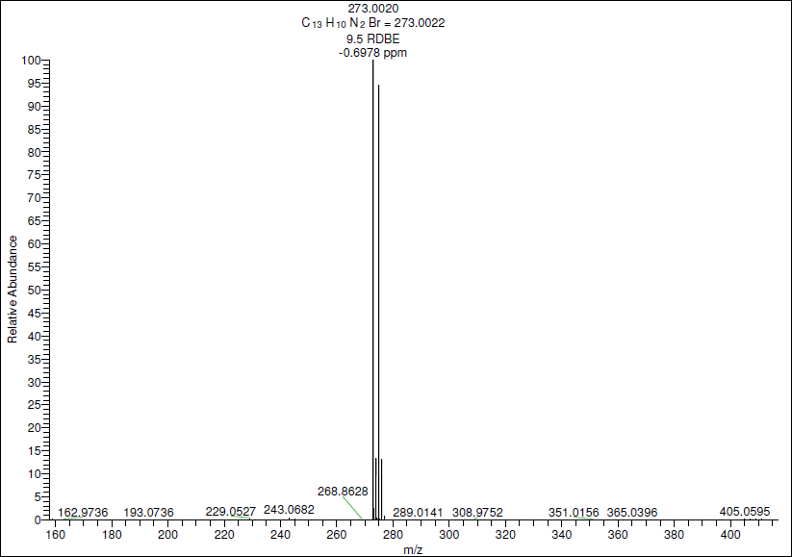
Figure S2-5. HRMS Spectrum of 3f

Figure S2-6. HRMS Spectrum of 3g

Figure S2-7. HRMS Spectrum of 3i

Figure S2-8. HRMS Spectrum of 3j

Figure S2-9. HRMS Spectrum of 3m

Figure S2-10. HRMS Spectrum of 3o

Figure S2-11. HRMS Spectrum of 3p

Figure S2-12. LCMS Spectrum of 3q

Figure S2-13. LCMS Spectrum of 3r

Figure S2-14. HRMS Spectrum of 3t

Figure S2-15. LCMS Spectrum of 3u

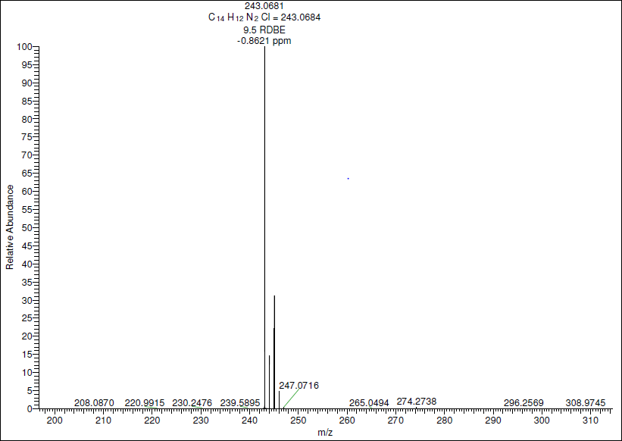
Figure S2-16. HRMS Spectrum of 3v

Figure S2-17. HRMS Spectrum of 3x
Figure S2-18. LCMS Spectrum of 3y

Figure S2-19. LCMS Spectrum of 3ab

Figure S2-20. LCMS Spectrum of 3ad
Crystallographic data of 2-(3-bromophenyl)-7-methylimidazo[1,2-a]pyridine (3u) :
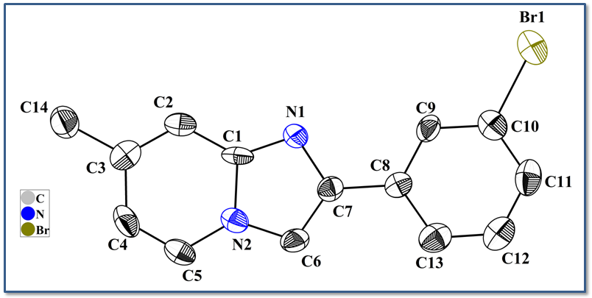Figure S3: ORTEP diagram of 3u (50 % probability).
Table S1. Crystal data and structure refinement for compound 3u.
Identification code tr1
Empirical formula C14 H11 Br N2
Formula weight 287.16
Temperature 300(2) K
Wavelength 0.71073 Å
Crystal system Monoclinic
Space group P2(1)/c
Unit cell dimensions a = 3.9980(8) Å α= 90°.
b = 10.759(2) Å β= 90.18(3)°.
c = 26.867(5) Å γ = 90°.
Volume 1155.7(4) Å3
Z 4
Density (calculated) 1.650 Mg/m3
Absorption coefficient 3.533 mm-1
F(000) 576
Crystal size 0.25 x 0.24 x 0.22 mm3
Theta range for data collection 2.43 to 25.00°.
Index ranges -4<=h<=4, -12<=k<=12, -31<=l<=31
Reflections collected 12707
Independent reflections 2014 [R(int) = 0.2066]
Completeness to theta = 25.00° 99.3 %
Absorption correction None
Refinement method Full-matrix least-squares on F2
Data / restraints / parameters 2014 / 0 / 155
Goodness-of-fit on F2 1.016
Final R indices [I>2sigma(I)] R1 = 0.0646, wR2 = 0.0993
R indices (all data) R1 = 0.1371, wR2 = 0.1168
Largest diff. peak and hole 0.378 and -0.517 e.Å-3

Table S2. Atomic coordinates ( x104) and equivalent isotropic displacement parameters (Å2x 103) for tr1. U(eq) is defined as one third of the trace of the orthogonalized Uij tensor.
___________________________________________________________________________
x y z U(eq)
___________________________________________________________________________
Br(1) 1591(2) 6359(1) 4712(1) 57(1)
C(11) -1456(17) 8708(6) 4590(2) 47(2)
C(10) 262(16) 7786(6) 4347(2) 38(2)
C(6) 660(15) 10041(5) 2757(2) 33(2)
N(1) 2622(13) 8091(4) 2814(2) 33(1)
C(9) 1111(15) 7887(5) 3854(2) 33(2)
C(8) 164(15) 8926(5) 3583(2) 30(2)
C(7) 1080(15) 9038(5) 3058(2) 30(2)
C(1) 3133(15) 8509(5) 2360(2) 30(1)
C(3) 4866(15) 8590(6) 1506(2) 35(2)
N(2) 1953(13) 9716(4) 2307(2) 33(1)
C(2) 4622(15) 7973(6) 1940(2) 33(2)
C(5) 2256(16) 10370(6) 1876(2) 38(2)
C(4) 3635(17) 9831(6) 1481(2) 43(2)
C(12) -2381(18) 9738(6) 4322(3) 52(2)
C(13) -1605(16) 9842(6) 3827(2) 43(2)
C(14) 6388(17) 8025(6) 1053(2) 48(2)
___________________________________________________________________________

Table S3. Bond lengths [Å] and angles [°] for tr1.
_____________________________________________________
Br(1)-C(10) 1.897(6)
C(11)-C(12) 1.372(9)
C(11)-C(10) 1.373(8)
C(10)-C(9) 1.372(8)
C(6)-C(7) 1.359(7)
C(6)-N(2) 1.362(7)
N(1)-C(1) 1.316(7)
N(1)-C(7) 1.360(7)
C(9)-C(8) 1.386(7)
C(8)-C(13) 1.380(7)
C(8)-C(7) 1.464(7)
C(1)-N(2) 1.389(7)
C(1)-C(2) 1.401(8)
C(3)-C(2) 1.347(8)
C(3)-C(4) 1.425(8)
C(3)-C(14) 1.491(8)
N(2)-C(5) 1.362(7)
C(5)-C(4) 1.329(8)
C(12)-C(13) 1.370(8)
C(12)-C(11)-C(10) 117.9(6)
C(9)-C(10)-C(11) 121.9(6)
C(9)-C(10)-Br(1) 119.6(5)
C(11)-C(10)-Br(1) 118.5(5)
C(7)-C(6)-N(2) 106.1(5)
C(1)-N(1)-C(7) 105.2(5)
C(10)-C(9)-C(8) 120.2(6)
C(13)-C(8)-C(9) 117.7(5)
C(13)-C(8)-C(7) 122.0(5)
C(9)-C(8)-C(7) 120.3(5)
C(6)-C(7)-N(1) 111.3(5)
C(6)-C(7)-C(8) 127.4(5)
N(1)-C(7)-C(8) 121.2(5)
N(1)-C(1)-N(2) 111.1(5)
N(1)-C(1)-C(2) 132.3(5)
N(2)-C(1)-C(2) 116.6(5)
C(2)-C(3)-C(4) 118.4(6)
C(2)-C(3)-C(14) 122.5(6)
C(4)-C(3)-C(14) 119.1(6)
C(6)-N(2)-C(5) 131.1(5)
C(6)-N(2)-C(1) 106.2(5)
C(5)-N(2)-C(1) 122.6(5)
C(3)-C(2)-C(1) 121.8(6)
C(4)-C(5)-N(2) 119.4(6)
C(5)-C(4)-C(3) 121.1(6)
C(13)-C(12)-C(11) 120.9(6)
C(12)-C(13)-C(8) 121.4(6)
_____________________________________________________________
Symmetry transformations used to generate equivalent atoms:

Table S4. Anisotropic displacement parameters (Å2x 103)for tr1. The anisotropic
displacement factor exponent takes the form: -2π2[ h2a*2U11 + ... + 2 h k a* b* U12 ]
___________________________________________________________________________
U11 U22 U33 U23 U13 U12
___________________________________________________________________________
Br(1) 68(1) 59(1) 43(1) 13(1) 4(1) 2(1)
C(11) 46(5) 56(5) 38(4) -7(4) 9(3) -12(4)
C(10) 36(4) 40(4) 39(4) -1(3) -9(3) -11(3)
C(6) 40(4) 23(3) 36(4) -8(3) -2(3) 2(3)
N(1) 41(4) 26(3) 32(3) 5(2) 5(3) 2(3)
C(9) 41(4) 27(3) 31(3) -7(3) 2(3) -5(3)
C(8) 30(4) 26(4) 33(3) -8(3) -3(3) -7(3)
C(7) 23(4) 30(4) 37(3) -2(3) -1(3) -3(3)
C(1) 32(4) 18(3) 41(4) 4(3) -9(3) 2(3)
C(3) 25(4) 37(4) 43(4) -6(3) -3(3) -5(3)
N(2) 39(4) 23(3) 35(3) 3(2) -6(3) -6(3)
C(2) 25(4) 29(3) 46(4) -1(3) -4(3) 0(3)
C(5) 44(5) 26(4) 44(4) 13(3) -2(4) -4(3)
C(4) 50(5) 41(4) 38(4) 14(3) -1(4) -8(4)
C(12) 57(6) 45(5) 54(5) -9(4) 10(4) 4(4)
C(13) 40(5) 34(4) 53(4) -3(3) 4(4) -7(3)
C(14) 49(5) 53(4) 43(4) 2(3) -1(4) -1(4)
___________________________________________________________________________

References:
- B. M. Reddy, V. V. R. Kumar, N. C. Gangi Reddy, S. M. Rao, Chin. Chem. Lett. 2014, 25, 179-182.

