Supplementary Material
Table of content:
- Reagents
- Oligonucleotides used in the study
- Bioinformatics analysis
- Assembling of SDB
- Cleavage assay
- Fluorescence measurements
- Limit of detection
- Selectivity
- Reagents
DNAse/RNAse-free water was purchased from Thermo Fisher Scientific, Inc. (Pittsburgh, PA) and used for all the stock solutions of oligonucleotides and buffers. Fluorescein substrate (F_sub) was synthesised and HPLC purified by TriLink BioTechnologies, Inc. (San Diego, CA). All other oligonucleotides, including fluorescein labelled RNA (see Table S1 for sequences) were purchased from DNA Synthesis (Moscow, Russian Federation). The oligonucleotides were dissolved in DNAse/RNAse-free water and stored at −20 ºC.
Malachite Green oxalate salt was purchased from Sigma-Aldrcich (St. Louis, Missouri, United States). Other chemicals as KCl, NaCl, HEPES (4-(2-hydroxyethyl)-1-piperazineethanesulfonic acid), MgCl₂, urea, acrylamide and N,N'-Methylenebisacrylamide, boric acid, ammonium persulfate (APS), tris-(hydroxymethyl)-aminomethane (Tris), tetramethylethylenediamine (TEMED), agarose for molecular biology, ethylenediaminetetraacetic acid (EDTA), were purchased from VWR Life Science AMRESCO (Radnor, PA) and SYBR™ Gold Nucleic Acid Gel Stain from Invitrogen Corp. (Carlsbad, California).
- Oligonucleotides used in the study
Table S1: Oligonucleotides
Name | Sequence, from 5’to 3’ termini
60-AR_RNA | agcagcagcagcagcagggugaggaugguucuccccaagcccaucguagaggccccacag
FAM-60-AR_RNA | ªFAM-agcagcagcagcagcagggugaggaugguucuccccaagcccaucguagaggccccacag
T1 | CCTCAGGCTAGCTACAACGACCTGCTGCT/^{b}HEG/CGCGAGTGCG
T2 | ccagguaacgaauggauuaaccauTTTTTTCACGGCCCCC
T3 | GGGACCGGGCTTTTTTuggggaguuucccgacugg
T4 | GCGTCGCGCGTTTTTTGGGGCCTCTAGGCTAGCTACAACGAGATGGGCT
T5 | CGCGCGACGCGCCCGGTCCCGGGGGCCGTGCGCACTCGCG
^{c}Dz_1 | CCTCAGGCTAGCTACAACGACCTGCTGCT
Dz_2 | GGGGCCTCTAGGCTAGCTACAACGAGATGGGCTT
62-RNA | augagcaagaaaaagucuuacauaaacagaacagguacauuugaauucacaaguuuuuucag
46-RNA | guacuugagcuccacuccgcagcgucugaaguugcuggacgcguac
FAM-62-RNA | FAM-augagcaagaaaaagucuuacauaaacagaacagguacauuugaauucacaaguuuuuucag
FAM-46-RNA | FAM-guacuugagcuccacuccgcagcgucugaaguugcuggacgcguac
ªFAM – 6-fluorescein amidite
^{b}HEG – hexoethylene glycol linker
^{c} Dz – deoxyribozyme
^{d} Uppercase letters indicate DNA chains, lowercase – RNA
- Bioinformatics analysis
The list of the most clinically important alternatively spliced AR transcripts with known nucleotide sequences has been compiled from [Wach S. et al, 2019] (Table S2). Based on this list, we used the sequences of spliced variants available in the NCBI RefSeq (https://www.ncbi.nlm.nih.gov/refseq/) and GenBank databases (https: //www.ncbi. nlm.nih.gov/nuccore/).
To identify mRNA regions that are homologous to the largest number of alternative transcripts, the multiple alignment method was used using the ClustalW algorithm (http://www.clustal.org/clustal2/) as a part of the Unipro UGENE software (UniPro, Russia) (Fig.S1), and the content of single nucleotide polymorphisms was analyzed using the NCBI dbSNP database (https://www.ncbi.nlm.nih.gov/snp/).
The sequence NM_000044.6 (NCBI Reference Sequence) was used to select the most suitable target site of AR mRNA for our study (60-AR_RNA).
Table S2: AR transcripts, used to selection of potential mRNA target region for SDB
Variant names | Transcription features | Source
AR-FL (AR1) | Ligand-dependent | NM_000044.6  (NCBI Reference Sequence)
AR45 (AR2) | Regulated | NM_001011645.3  (NCBI Reference Sequence)
AR-V7 (AR3) | Constitutive | NM_001348061.1  (NCBI Reference Sequence)
AR-V1 (AR4) | Regulated | NM_001348063.1  (NCBI Reference Sequence)
AR-V3 | Constitutive | sequence is not available
AR-V4 | Constitutive | sequence is not available
AR-V9 | Regulated | sequence is not available
AR-V12 (AR567es) | Constitutive | GU208210.1  (GenBank)
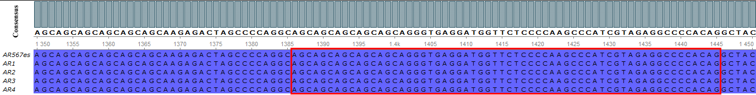
Figure S1. Sequence alignment of AR alternatively spliced variants. Red square indicates sequence of 60-AR_RNA used as a target RNA in the study
- Assembling of SDB
Assembling of SDB was performed by heating the mix of T1–T5 oligonucleotides (2.5 μM for each strand) for 5 min at +95 °C, followed by cooling down to +4 °C with increments in temperature decrease of 0.5 °C/min. Annealing underwent in a buffer, containing 50 mM MgCl₂, 140 mM NaCl, 5 mM KCl, 50 mM HEPES, pH 7.4. The efficiency of SDB assembling process was checked by agarose gel-electrophoresis in 2% gel prepared on 1х TBE buffer (89 mM Tris, 89 mM H₃BO₃, 2 mM Na₂EDTA, pH 8.0). The obtained results were visualized using ChemiDoc Imaging System (Bio-Rad Laboratories Inc., California, USA) after staining with SYBR™ Gold Nucleic Acid Gel Stain.
- Cleavage assay
For proving that Dz_1, Dz_2 retain their functions in the composition of SDB, both Dz_1 and Dz_2, as well as complete assembled SDB were incubated in the presence of FAM-60-AR_RNA target molecule at 37 °C in the reaction buffer (50 mM MgCl₂, 140 mM NaCl, 5 mM KCl, 50 mM HEPES, 0.25% DMSO, pH 7.4) for 6 hrs. Then the samples were taken out and put into the denaturing gel-loading buffer (8 M urea in 1x TBE). After that collected probes were run in the denaturing PAGE (17.5%, 7M urea) at 80 V for 150 min. Results of cleavage is presented in Fig.S2.
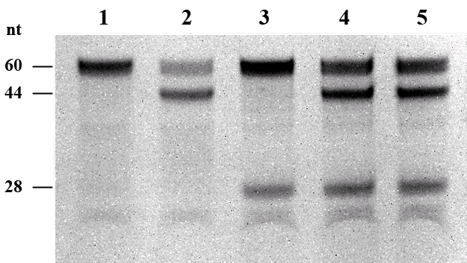
Figure S2. Assay of Dz_1 and Dz_2 cleavage activity. Lane 1: Single FAM-60-AR_RNA after 6 hrs of incubation. Lane 2: FAM-60-AR_RNA incubated with Dz_1. Lane 3: FAM-60-AR_RNA incubated with Dz_2. Lane 4: FAM-60-AR_RNA incubated with both Dz_1 and Dz_2. Lane 5: FAM-60-AR_RNA incubated with assembled SDB
Assay of cleavage activity of SDB and its unassembled tiles (Fig.3B) was performed using the same parameters of incubation and electrophoresis. One of the sample containing assembled SDB and FAM-60-AR_RNA was incubated in the buffer described above with additional 25 μM of malachite green dye. Percentages of the cleaved products were calculated from obtained images. An efficiency of SDB assembly and a catalytic activity against the FAM-labeled 60-AR_RNA were evaluated by electrophoresis followed by bands densitometry analysis (ImageLab software, Bio-Rad Laboratories Inc., California, USA).
- Fluorescence measurements
The modified malachite green RNA aptamer (MGA) was chosen to detecting a fluorescence signal (610/648 nm) of the complex formed by the target mRNA, two aptamer split strands and malachite green dye. SDB were incubated in the presence of 60-AR_RNA at 37 °C in the reaction buffer (50 mM MgCl₂, 140 mM NaCl, 5 mM KCl, 50 mM HEPES, 0.25% DMSO, pH 7.4) for 6 hrs. The concentration of all oligonucleotides in the reaction mix, including 60-AR_RNA, was 100 nM, and the concentration of malachite green dye was 25 μM. Then samples was taken out and cooled for 1 hr in +4 °C. After cooling samples were removed, and the fluorescent signal was measured with Agilent Cary Eclipse Fluorescence Spectrophotometer (Santa Clara, California, United States) on 648 nm wavelength (excitation wavelength at 610 nm). The data of three independent experiments were averaged and plotted using OriginPro 2015.
- Limit of detection.
The same set of strands was incubated for determination of limit of detection (LOD) for SDB in the same buffer (50 mM MgCl₂, 140 mM NaCl, 5 mM KCl, 50 mM HEPES, 0.25% DMSO, pH 7.4) in the presence of 25 μM malachite green dye and different concentrations of 60-AR_RNA (1 nM, 5 nM, 10 nM, 20 nM, 50 nM and 100 nM). After 6 hrs of incubation and cooling, samples were removed, and the fluorescent signal was measured with Agilent Cary Eclipse Fluorescence Spectrophotometer (Santa Clara, California, United States) on 648 nm wavelength (excitation wavelength at 610 nm). The data of three independent experiments were plotted using OriginPro 2015. LOD was calculated as concentrations producing fluorescence, that is 3 standard deviations above the background.
- Selectivity
Selectivity of SDB was tested with two random RNA sequences (Control-1 and Control-2) with length and secondary structure similar to 60-AR_RNA. Both of these sequences contain a GU site for deoxyribozyme 10-23 cleavage, but are not complementary to any of the components of the SDB. Fluorescence of such samples was measured, as it described in c.7 and did not exceed the threshold value (data not shown). Each sample contained 1 μM RNA and incubated for 6 hours in a buffer (50 mM MgCl2, 140 mM NaCl, 5 mM KCl, 50 mM HEPES, 0.25% DMSO, pH 7.4) with 25 μM malachite green dye. Verification of cleavage for similar samples, but with 5’-FAM labeled RNA (FAM-Control-1 and FAM-Control-2) was performed as in s.5 by 17.5% PAGE (Fig.3S).
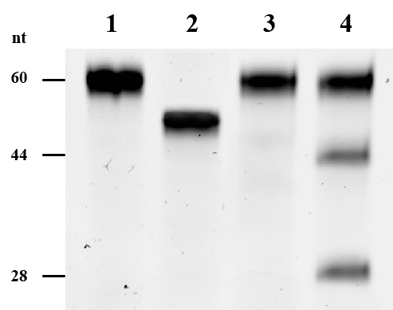
Figure 3S. Selectivity of SDB in PAGE. Lane 1: FAM-Control_1 incubated with SDB. Lane 2: FAM-Control_2 incubated with SDB. Lane 3: FAM-AR_RNA incubated without SDB. Lane 4: FAM-AR_RNA with SDB

