Supporting Information

Facile Metal-Free Direct Transformation of N-Allyl- and tert-Butyl-Protected Arylamines to Azacycles Using Phosphoryl Chloride and TBD
Van Hieu Tran^{1,2}, Wan Pyo Hong³, and Hee-Kwon Kim *^{1,2}

¹Department of Nuclear Medicine, Molecular Imaging & Therapeutic Medicine Research Center, Jeonbuk National University Medical School and Hospital, Jeonju, 54907, Republic of Korea, ²Research Institute of Clinical Medicine of Jeonbuk National University, Biomedical Research Institute of Jeonbuk National University Hospital, Jeonju, 54907, Republic of Korea, and ³Department of Advanced Materials and Chemical Engineering, Daegu Catholic University, 13-13, Hayang-ro, Hayang-eup, Gyeongsan-si, Gyeongbuk, 38430, Republic of Korea

* Corresponding author.
E-mail address: hkkim717@jbnu.ac.kr (H. Kim).

Table of Contents
1. General Information S2
2. Screening of reaction conditions for the preparation of azacycles S3
3. General procedure of the synthesis of azacycles S4
4. Characterization of azacycles 3a-3n; 4a - 4n and 6a-6h S5
5. ¹H and ¹³C NMR Spectra S13

1. General information
All reagents and solvents are commercially available and used without further purification. Reaction progress was monitored by thin-layer chromatography (TLC) analysis. TLC analysis was performed using an aluminum plate with silica gel 60 F₂₅₄, and TLC spots were visualized by UV light (254 nm) exposure. Flash chromatography was performed using 230–400 mesh silica gel and analytical grade solvent. Melting points were recorded using a Stuart SMP10 Melting Point Apparatus. ¹H and ¹³C NMR spectra were recorded on a 400 MHz & 100 MHz respectively Bruker Avance 400 MHz spectrometer. The chemical shifts were reported in δ units (ppm) relative to the residual protonated solvent resonance, and the coupling constants (J) quoted in Hz.

2. Screening of reaction conditions for the preparation of azacycles

Table S1. Screening of temperature for preparation of azacycles^{[a]}
Entry | Aniline  (equiv.) | THF  (equiv.) | POCl₃  (equiv.) | TBD  (equiv.) | Temp. | Yield^{[b]} (%)
1 | 1 | 25 | 1.4 | 1.5 | 150 ºC | 94
2 | 1 | 25 | 1.4 | 1.5 | 140 ºC | 94
3 | 1 | 25 | 1.4 | 1.5 | 130 ºC | 94
4 | 1 | 25 | 1.4 | 1.5 | 120 ºC | 94
5 | 1 | 25 | 1.4 | 1.5 | 110 ºC | 37
7 | 1 | 25 | 1.4 | 1.5 | 100 ºC | 3

- Reaction conditions: compound 1a (2.0 mmol), THF 2a (50 mmol), POCl₃ (2.8 mmol), TBD (3.0 mmol), 12 h
- Isolated yield after purification by flash column chromatography.

- General procedure of the synthesis of azacyles
3.1. General procedure of the synthesis of azacyles 3a-3n and 4a-4n
N-Allyl aniline (1a) (0.266 g, 2.00 mmol) and 1,5,7-triazabicyclo[4.4.0]dec-5-ene (TBD) (0.417 g, 3.00 mmol) was added to a viral 20 ml. The mixture was stirred at room temperature. POCl₃ (0.428 g, 2.80 mmol) was added dropwise to the mixture. Then, the mixture was heated at 90°C for 15 min. Tetrahydrofuran (4 mL, 50.00 mmol) were added to the reaction mixture and the vial was closed tightly with Teflon cap. The reaction mixture was stirred at 120 °C for 12 h. The reaction was cooled down to the ambient temperature, then saturated aqueous NaHCO₃ (10 mL) and brine (10 mL) were added to the mixture. The aqueous mixture was extracted with Et₂O (20 ml x 2) and the combined organic layer was dried over anhydrous sodium sulfate and subsequently concentrated under reduced pressure. The crude product was then purified by flash column chromatography on silica gel with 2% diethyl ether in n-hexane as eluent to afford the desired product 3a (0.281 g, 95%).
  - General procedure of the synthesis of azacyles 6a-6h
A mixture of N-tert butylamine (5a) (0.298 g, 2.00 mmol) and 1,5,7-triazabicyclo[4.4.0]dec-5-ene (TBD) (0.417 g, 3.00 mmol) in xylene (3 mL) was added to a viral 20 ml. The mixture was stirred at room temperature. POCl₃ (0.428 g, 2.80 mmol) was added dropwise to the mixture. Then, the mixture was heated at 90°C for 15 min. Tetrahydrofuran (4 mL, 50.00 mmol) were added to the reaction mixture and the vial was closed tightly with Teflon cap. The reaction mixture was stirred at 120 °C for 12 h. The reaction was cooled down to the ambient temperature, then saturated aqueous NaHCO₃ (10 mL) and brine (10 mL) were added to the mixture. The aqueous mixture was extracted with Et₂O (20 ml x 2) and the combined organic layer was dried over anhydrous sodium sulfate and subsequently concentrated under reduced pressure. The crude product was then purified by flash column chromatography on silica gel with 2% diethyl ether in n-hexane as eluent to afford the desired product 6a (0.260 g, 88%).

4. Characterization data for compounds

1-phenylpyrrolidine (3a):
Light yellow oil; ¹H NMR (400 MHz, CDCl₃) δ 7.305 – 7.25 (m, 2H), 6.71 (t, J = 7.2 Hz, 1H), 6.64 (d, J = 8.0 Hz, 2H), 3.33 (t, J = 6.8 Hz, 4H), 2.08 - 2.03 (m, 4H); ¹³C NMR (100 MHz, CDCl₃) δ 147.99, 129.17 (2C), 115.40, 111.69 (2C), 47.3 (2C), 25.52 (2C); HRMS (ESI) m/z (M+H)⁺ calcd for C₁₀H₁₄N = 148.1126; found 148.1129.
1-(4-chlorophenyl)pyrrolidine (3b):
Colorless oil; ¹H NMR (400 MHz, CDCl₃) δ 7.18- 7.14 (m, 2H), 6.48-6.45 (m, 2H), 3.27-3.23 (m, 4H), 2.04-1.98 (m, 4H); ¹³C NMR (100 MHz, CDCl₃) δ 146.52, 128.85 (2C), 120.08, 112.62 (2C), 47.75 (2C), 25.51 (2C); HRMS (ESI) m/z (M+H)⁺ calcd for C₁₀H₁₃ClN = 182.0737; found 182.0736.
1-(4-fluorophenyl)pyrrolidine (3c):
Colorless oil; ¹H NMR (400 MHz, CDCl₃) δ 6.98 - 6.93 (m, 2H), 6.52-6.47 (m, 2H), 3.27-3.24 (m, 4H), 2.05 - 2.00 (m, 4H); ¹³C NMR (100 MHz, CDCl₃) δ 155.98 & 153.66 (d, ¹J_{C-F} = 231.8 Hz, 1C), 144.84, 115.58 & 115.37 (d, ²J_{C-F} = 21.8 Hz, 2C), 112.11 & 112.04 (d, ³J_{C-F} = 7.2 Hz, 2C), 48.11 (2C), 25.51 (2C); HRMS (ESI) m/z (M+H)⁺ calcd for C₁₀H₁₃FN = 166.1032; found 166.1037.
1-(3,5-dichlorophenyl)pyrrolidine (3d):
Colorless oil; ¹H NMR (400 MHz, CDCl₃) δ 6.61 (t, J = 2.0 Hz, 1H), 6.39 (d, J = 1.6 Hz, 2H), 3.26-3.23 (m, 4H), 2.03-1.99 (m, 4H); ¹³C NMR (100 MHz, CDCl₃) δ 149.05, 135.27 (2C), 114.91, 109.84 (2C), 47.65 (2C), 25.42 (2C); HRMS (ESI) m/z (M+H)⁺ calcd for C₁₀H₁₂Cl₂N = 216.0347; found 216.0349.
1-(2,4-difluorophenyl)pyrrolidine (3e):
Colorless oil; ¹H NMR (400 MHz, CDCl₃) δ 6.81-6.71 (m, 2H), 6.64-6.58 (m, 1H), 3.33-3.28 (m, 4H), 1.98 -1.92 (m, 4H); ¹³C NMR (100 MHz, CDCl₃) δ 155.89, 153.15 & 150.71, (d, ¹J_{C-F} = 244.0 Hz, 1C), 134.27, 115.21, 110.52&110.34 (d, ²J_{C-F} = 18.3 Hz, 1C), 104.75 - 104.24 (t, ²J_{C-F} = 25.5 Hz, 1C), 50.05 (2C), 25.00 (2C); HRMS (ESI) m/z (M+H)⁺ calcd for C₁₀H₁₂F₂N = 184.0938; found 184.0940.
4-(pyrrolidin-1-yl)benzonitrile (3f):
White solid, m.p. 88-90 °C; ¹H NMR (400 MHz, CDCl₃) δ 7.50 - 7.43 (q, J = 12.4 Hz, 2H), 6.56 – 6.49 (d, J = 12.4 Hz, 2H), 3.37 (d, J = 19.6 Hz, 4H), 2.08 (d, J = 16.4 Hz, 4H); ¹³C NMR (100 MHz, CDCl₃) δ 150.03, 133.47 (2C), 121.04, 111.47 (2C), 96.59, 47.50 (2C), 25.44 (2C); HRMS (ESI) m/z (M+H)⁺ calcd for C₁₁H₁₃N₂ = 173.1079; found 173.1082
1-(4-nitrophenyl)pyrrolidine (3g):
Yellow solid, m.p. 167-168 °C; ¹H NMR (400 MHz, CDCl₃) δ 8.13- 8.10 (dt, J = 9.2 Hz, J = 3.2 Hz, 2H), 6.49 – 6.45 (dt, J = 9.2 Hz, J = 3.6 Hz, 2H), 3.43 – 3.39 (m, 4H), 2.09 – 2.06 (m, 4H); ¹³C NMR (100 MHz, CDCl₃) δ 151.86, 136.59, 126.35 (2C), 110.42 (2C), 47.93 (2C), 25.45 (2C); HRMS (ESI) m/z (M+H)⁺ calcd for C₁₀H₁₃N₂O₂ = 193.0977; found 193.0978.
1-p-tolylpyrrolidine (3h):
Light yellow oil; ¹H NMR (400 MHz, CDCl₃) δ 7.06 (d, J = 8.4 Hz, 2H), 6.52 (d, J = 8.0 Hz, 2H), 3.28-3.25 (m, 4H), 2.26 (s, 3H), 2.02-1.98 (m, 4H); ¹³C NMR (100 MHz, CDCl₃) δ 146.13, 129.64 (2C), 124.46, 111.80 (2C), 47.85 (2C), 25.49 (2C), 20.30; HRMS (ESI) m/z (M+H)⁺ calcd for C₁₁H₁₆N = 162.1283; found 162.1285.
1-(4-ethylphenyl)pyrrolidine (3i):
Pale yellow oil; ¹H NMR (400 MHz, CDCl₃) δ 7.11 (d, J = 8.4 Hz, 2H), 6.57 – 6.55 (d, J = 8.4 Hz, 2H), 3.29 (t, J = 6.0 Hz, 4H), 2.16 – 2.55 (q, J = 7.6 Hz, 2H), 2.04 – 1.98 (m, 4H), 1.23 (t, J = 7.6 Hz, 3H); ¹³C NMR (100 MHz, CDCl₃) δ 146.26, 131.22, 128.52 (2C), 111.82 (2C), 47.87 (2C), 27.94, 25.47 (2C), 16.19; HRMS (ESI) m/z (M+H)⁺ calcd for C₁₂H₁₈N = 176.1439; found found 176.1440.
1-m-tolylpyrrolidine (3j):
Colorless oil; ¹H NMR (400 MHz, CDCl₃) δ 7.16 (t, J = 8.8 Hz, 1H), 6.54 (d, J = 7.2 Hz, 1H), 6.44 (d, J = 5.6 Hz, 2H), 3.31 (t, J = 6.4 Hz, 4H), 2.36 (s,3H), 2.04-2.01 (m, 4H); ¹³C NMR (100 MHz, CDCl₃) δ 148.11, 138.82, 129.04, 116.40, 112.42, 108.94, 47.64 (2C), 25.50 (2C), 21.90; HRMS (ESI) m/z (M+H)⁺ calcd for C₁₁H₁₆N = 162.1283; found 162.1284.
1-(3,5-dimethylphenyl)pyrrolidine (3k):
Colorless oil; ¹H NMR (400 MHz, CDCl₃) δ 6.36 (s, 1H), 6.24 (s, 2H), 3.30-3.27 (m, 4H), 2.30 (d, J = 0.8 Hz, 6H), 2.01 - 1.98 (m, 4H); ¹³C NMR (100 MHz, CDCl₃) δ 148.22, 138.70 (2C), 117.54, 109.69 (2C), 47.66 (2C), 25.47 (2C), 21.75 (2C); HRMS (ESI) m/z (M+H)⁺ calcd for C₁₂H₁₈N = 176.1439; found 176.1441.
1-(2,6-dimethylphenyl)pyrrolidine (3l):
Colorless oil; ¹H NMR (400 MHz, CDCl₃) δ 7.06 – 6.97 (m, 3H), 3.22 – 3.18 (m, 4H), 2.28 (s, 6H), 2.01 – 1.98 (m, 4H); ¹³C NMR (100 MHz, CDCl₃) δ 145.48, 138.41 (2C), 128.54 (2C), 124.99, 50.05 (2C), 26.57 (2C), 18.73 (2C); HRMS (ESI) m/z (M+H)⁺ calcd for C₁₂H₁₈N = 176.1439; found 176.1435.
1-(4-methoxyphenyl)pyrrolidine (3m):
Colorless oil; ¹H NMR (400 MHz, CDCl₃) δ 6.87 – 6.84 (m, 2H), 6.55 (d, J = 8.4 Hz, 2H), 3.77 (s, 3H), 3.24 (t, J = 6.0 Hz, 4H), 2.01 - 1.98 (m, 4H); ¹³C NMR (100 MHz, CDCl₃) δ 150.98, 143.26, 115.04 (2C), 112.67 (2C), 56.02, 48.32 (2C), 25.37 (2C); HRMS (ESI) m/z (M+H)⁺ calcd for C₁₁H₁₆NO = 178.1232; found 178.1236.
1-(naphthalen-1-yl)pyrrolidine (3n):
Light yellow oil; ¹H NMR (400 MHz, CDCl₃) δ 8.25-8.22 (m, 1H), 7.84-7.81 (m, 1H), 7.49-7.36 (m, 3H), 7.38 (t, J = 8.4 Hz, 1H), 7.01 – 6.98 (dd, J = 7.6 Hz, J = 0.8 Hz 1H), 3.44 - 3.34 (m, 4H), 2.08 - 2.00 (m, 4H); ¹³C NMR (100 MHz, CDCl₃) δ 147.75, 135.00, 128.28, 128.21, 125.92, 125.53, 124.79, 124.30, 121.31, 111.44, 52.74 (2C), 24.82 (2C); HRMS (ESI) m/z (M+H)⁺ calcd for C₁₄H₁₆N = 198.1283; found 198.1285.

2-methyl-1-phenylpyrrolidine (4a):
Light yellow oil; ¹H NMR (400 MHz, CDCl₃) δ 7.28-7.23 (m, 2H), 6.66 (tt, J = 7.2 Hz, J = 0.8 Hz, 1H), 6.62 (d, J = 8.0 Hz, 2H), 3.95-3.88 (m, 1H), 3.48-3.44 (m, 1H), 3.23-3.17 (m, 1H), 2.13-1.99 (m, 3H), 1.75-1.70 (m, 1H), 1.22 (d, J = 6.4 Hz, 3H); ¹³C NMR (100 MHz, CDCl₃) δ 147.23, 129.17 (2C), 115.13, 111.77 (2C), 53.60, 48.17, 33.14, 23.32, 19.40; HRMS (ESI) m/z (M+H)⁺ calcd for C₁₁H₁₆N = 162.1283; found 162.1285.

1-(3-chlorophenyl)-2-methylpyrrolidine (4b):
Colorless oil; ¹H NMR (400 MHz, CDCl₃) δ 7.12 (t, J = 8.0 Hz, 1H), 6.62 – 6.59 (m, 1H), 6.55 (t, J = 2.4 Hz, 1H), 6.46 – 6.44 (dd, J = 8.0 Hz , J = 1.6 Hz, 1H), 3.88 – 3.82 (m, 1H), 3.43 – 3.38 (m, 1H), 3.19 – 3.12 (m, 1H), 2.09 – 1.98 (m, 3H), 1.74 – 1.68 (m, 1H), 1.17 (d, J = 6.4 Hz, 3H); ¹³C NMR (100 MHz, CDCl₃) δ 148.15, 134.99, 130.02, 114.92, 111.54, 110.00, 53.72, 48.13, 33.04, 23.21, 19.09; HRMS (ESI) m/z (M+H)⁺ calcd for C₁₁H₁₅ClN = 196.0893; found 196.0895.
2-methyl-1-p-tolylpyrrolidine (4c):
Colorless oil; ¹H NMR (400 MHz, CDCl₃) δ 7.07 (d, J = 8.4 Hz, 2H), 6.56 (d, J = 8.4 Hz, 2H), 3.88 - 3.84 (m, 1H), 3.46-3.41 (m, 1H), 3.19-3.13 (m, 1H), 2.28 (s, 3H), 2.09-1.96 (m, 3H), 1.75 - 1.68 (m, 1H), 1.20 (d, J = 6.4 Hz, 3H); ¹³C NMR (100 MHz, CDCl₃) δ 145.33, 129.70 (2C), 124.22, 111.90 (2C), 53.76, 48.48, 33.19, 23.38, 20.27, 19.55; HRMS (ESI) m/z (M+H)⁺ calcd for C₁₂H₁₈N = 176.1439; found 176.1438.
1-(3,5-dimethylphenyl)-2-methylpyrrolidine (4d):
Colorless oil; ¹H NMR (400 MHz, CDCl₃) δ 6.35 (s, 1H), 6.26 (s, 2H), 3.92 - 3.86 (m, 1H), 3.45 – 3.41 (m, 1H), 3.20 – 3.14 (m, 1H), 2.30 (s, 6H), 2.08 – 1.99 (m, 3H), 1.72 – 1.68 (m, 1H), 1.20 (d, J = 6.0 Hz, 3H); ¹³C NMR (100 MHz, CDCl₃) δ 147.43, 138.76 (2C), 117.29 (2C), 109.73, 53.57, 48.28, 33.11, 23.32, 21.83 (2C), 19.58; HRMS (ESI) m/z (M+H)⁺ calcd for C₁₃H₂₀N = 190.1596; found 190.1595.

1-phenylpiperidine (4e):
Colorless oil; ¹H NMR (400 MHz, CDCl₃) δ 7.30-7.25 (m, 2H), 6.98 (d, J = 8.0 Hz, 2H), 6.86 – 6.83 (tt, J = 7.2 Hz, J = 1.2 Hz, 1H), 3.18 (t, J = 5.6 Hz, 4H), 1.77-1.71 (m, 4H), 1.63-1.57 (m, 2H); ¹³C NMR (100 MHz, CDCl₃) δ 152.27, 129.00 (2C), 119.20, 116.55 (2C), 50.72 (2C), 25.89 (2C), 24.35; HRMS (ESI) m/z (M+H)⁺ calcd for C₁₁H₁₆N = 162.1283; found 162.1284.
2-phenylisoindoline (4f):
White solid; m.p. 171-173 °C; ¹H NMR (400 MHz, CDCl₃) δ 7.36 - 7.29 (m, 6H), 6.75 (t, J = 7.6 Hz, 1H), 6.70 (d, J = 8.0 Hz, 2H), 4.66 (s, 4H); ¹³C NMR (100 MHz, CDCl₃) δ 147.16, 137.95 (2C), 129.43 (2C), 127.20 (2C), 122.65 (2C), 116.72, 111.65 (2C), 53.83 (2C); HRMS (ESI) m/z (M+H)⁺ calcd for C₁₄H₁₄N = 196.1126; found 196.1129.
2-(3-chlorophenyl)isoindoline (4g):
White solid; m.p. 100 - 102 °C; ¹H NMR (400 MHz, CDCl₃) δ 7.36 – 7.31 (m, 4H) 7.21 (t, J = 8.4 Hz, 1H), 6.74 – 6.72 (dd, J = 8.0 Hz , J = 1.2 Hz, 1H), 6.66 (t, J = 2.0 Hz, 1H), 6.57 – 6.54 (dd, J = 8.0 Hz , J = 2.4 Hz, 1H), 4.66 (s, 4H); ¹³C NMR (100 MHz, CDCl₃) δ 148.10, 137.44 (2C), 135.24, 130.30, 127.37 (2C), 122.64 (2C), 116.08, 111.55, 109.84, 53.81 (2C); HRMS (ESI) m/z (M+H)⁺ calcd for C₁₄H₁₃ClN = 230,0737; found 230.0738
2-m-tolylisoindoline (4h):
White solid; m.p. 171-173 °C; ¹H NMR (400 MHz, CDCl₃) δ 7.37-7.29 (m, 4H), 7.23 – 7.19 (m, 1H), 6.61 (d, J = 7.6 Hz, 1H), 6.73 (d, J = 6.4 Hz, 2H), 4.66 (s, 4H), 2.38 (s, 3H); ¹³C NMR (100 MHz, CDCl₃) δ 147.23, 139.15, 138.00, 129.28 (2C), 127.15 (2C), 122.61 (2C), 117.27, 112.44, 108.90, 53.88 (2C), 21.91; HRMS (ESI) m/z (M+H)⁺ calcd for C₁₅H₁₆N = 210.1283; found 210.1285.
2-(2,6-dimethylphenyl)isoindoline (4i):
White solid; m.p. 60-62 °C; ¹H NMR (400 MHz, CDCl₃) δ 7.32 – 7.29 (m, 4H), 7.12-7.05 (m, 3H), 4.62 (s, 4H), 2.28 (s, 6H); ¹³C NMR (100 MHz, CDCl₃) δ 145.15, 140.14 (2C), 138.95 (2C), 128.67 (2C), 126.70 (2C), 125.89, 122.56 (2C), 57.25 (2C), 18.70 (2C); HRMS (ESI) m/z (M+H)⁺ calcd for C₁₆H₁₈N = 224.1439; found 224.1438.
2-phenyl-1,2,3,4-tetrahydroisoquinoline (4j):
White solid; m.p. 45-46 °C; ¹H NMR (400 MHz, CDCl₃) δ 7.33 – 7.28 (m, 2H), 7.23– 7.16m, 4H), 7.02 -6.98 (m, 2H), 6.87 – 6.83 (m, 1H), 4.43 (s,2H), 3.58 (t, J = 6.0 Hz, 2H) 3.01 (t, J = 5.6 Hz, 2H); ¹³C NMR (100 MHz, CDCl₃) δ 150.57, 134.89, 134.49, 129.22 (2C), 128.54, 126.55, 126.35, 126.05, 118.69, 115.18 (2C), 50.78, 46.56, 29.15; HRMS (ESI) m/z (M+H)⁺ calcd for C₁₅H₁₆N = 210.1283; found 210.1284.
2-(4-fluorophenyl)-1,2,3,4-tetrahydroisoquinoline (4k):
White solid; m.p. 80-82°C; ¹H NMR (400 MHz, CDCl₃) δ 7.21-7.14 (m, 4H), 7.02-6.93 (m, 4H), 4.34 (s, 2H), 3.49 (t, J = 5.6 Hz, 2H), 2.99 (t, J = 6.0 Hz, 2H); ¹³C NMR (100 MHz, CDCl₃) δ 157.94, 155.57, 147.39, 134.55, 134.30, 128.64, 126.51, 126.40, 126.05, 117.19 (d, J = 7.3 Hz, 1C), 115.70, 115.48, 51.93, 47.80, 29.05; HRMS (ESI) m/z (M+H)⁺ calcd for C₁₅H₁₅FN = 228.1189; found 228.1185.

2-(p-tolyl)-1,2,3,4-tetrahydroisoquinoline (4l):
White solid; m.p. 37-39°C; ¹H NMR (400 MHz, CDCl₃) δ 7.19 – 7.15 (m, 4H), 7.18 (d, J = 8.4 Hz, 2H), 6,92 (d, J = 8.4 Hz, 2H), 4.37 (s, 2H), 3.52 (t, J = 6.0 Hz, 2H), 2.99 (t, J = 6.0 Hz, 2H), 2.29 (s, 3H); ¹³C NMR (100 MHz, CDCl₃) δ 148.63, 134.75, 134.58, 129.72 (2C), 128.60, 126.53, 126.26, 125.95, 124.40, 115.87 (2C), 67.98, 65.41, 29.09, 20.41; HRMS (ESI) m/z (M+H)⁺ calcd for C₁₆H₁₈N = 224.1439; found 224.1440.
2-(3,5-dimethylphenyl)-1,2,3,4-tetrahydroisoquinoline (4n):
White solid; m.p. 49-51 °C; ¹H NMR (400 MHz, CDCl₃) δ 7.19-7.15 (m, 4H), 6.64 (s, 2H), 6.52 (s, 1H), 4.40 (s, 2H), 3.54 (t, J = 5.6 Hz, 2H), 3.00 (t, J = 6.0 Hz, 2H), 2.32 (s, 6H); ¹³C NMR (100 MHz, CDCl₃) δ 150.79, 138.74 (2C), 134.95, 134.66, 128.51, 126.53, 126.24, 125.96, 120.73, 113.17 (2C), 50.97, 46.65, 29.32, 21.76 (2C); HRMS (ESI) m/z (M+H)⁺ calcd for C₁₇H₂₀N = 238.1596; found 238.1597.
Allyl(phenyl)phosphoramidic dichloride (7):
Yellow oil. ¹H NMR (400 MHz, CDCl₃) δ 7.43 – 7.32 (m, 5H), 5.90 – 5.84 (m,1H), 5.20 – 5.13 (m, 2H), 4.30 – 4.25 (m, 2H); ¹³C NMR (100 MHz, CDCl₃) δ 139.09, 123.07, 129.67, 129.58, 129.17, 129.13, 128.45, 119.95, 55.07 (d, J = 15.8 Hz, 1C); ³¹P NMR (CDCl₃) δ 13.99; HRMS (ESI); Mass calcd for C₉H₁₁Cl₂NOP [M+H]⁺: 249.9955, found 249.9958.

5. ¹H and ¹³C NMR spectra of compounds
1-phenylpyrrolidine (3a)
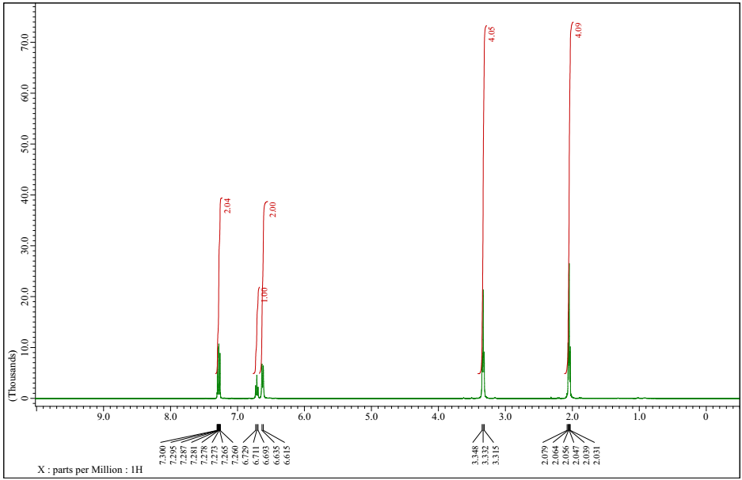
¹H NMR spectrum of 1-phenylpyrrolidine (3a)
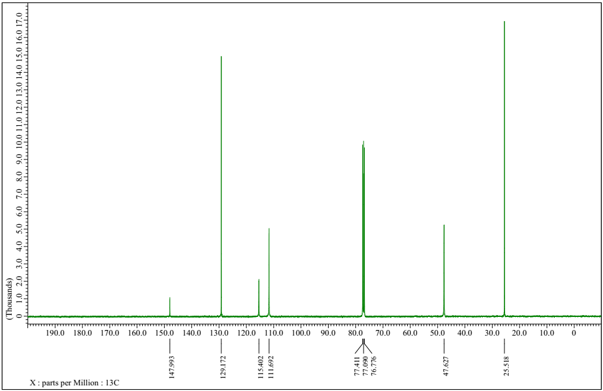
¹³C NMR spectrum of 1-phenylpyrrolidine (3a)
1-(4-chlorophenyl)pyrrolidine (3b)
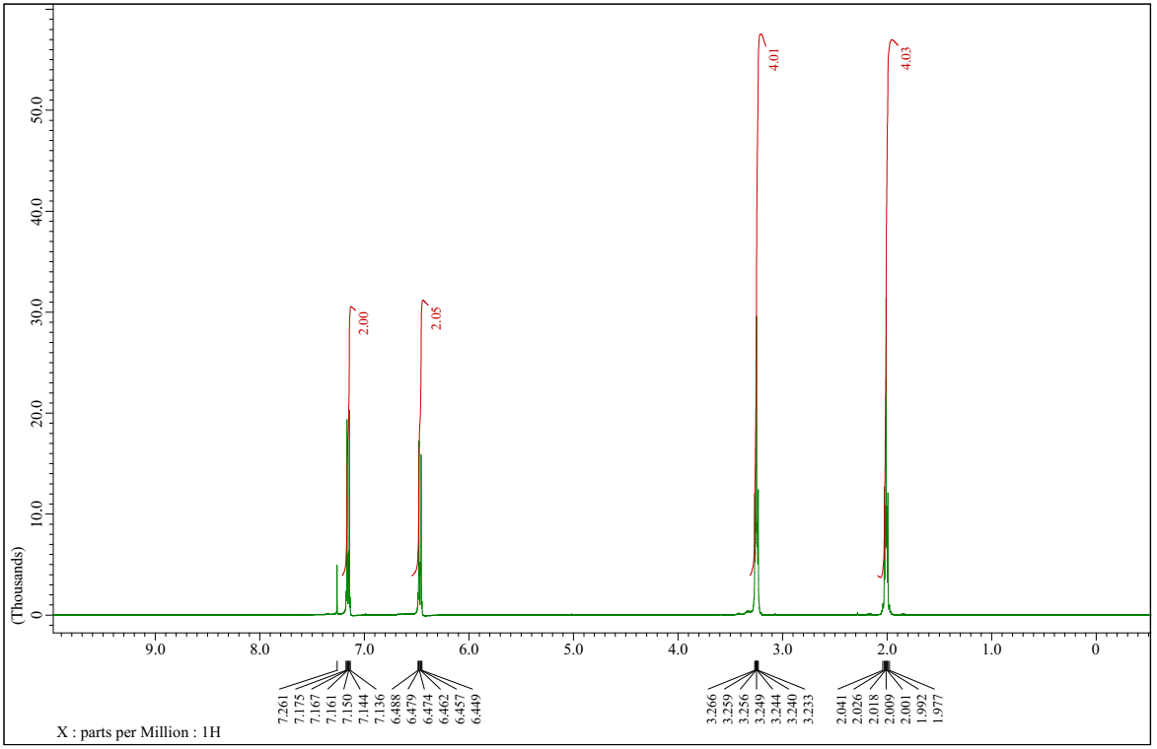
¹H NMR spectrum of 1-(4-chlorophenyl)pyrrolidine (3b)
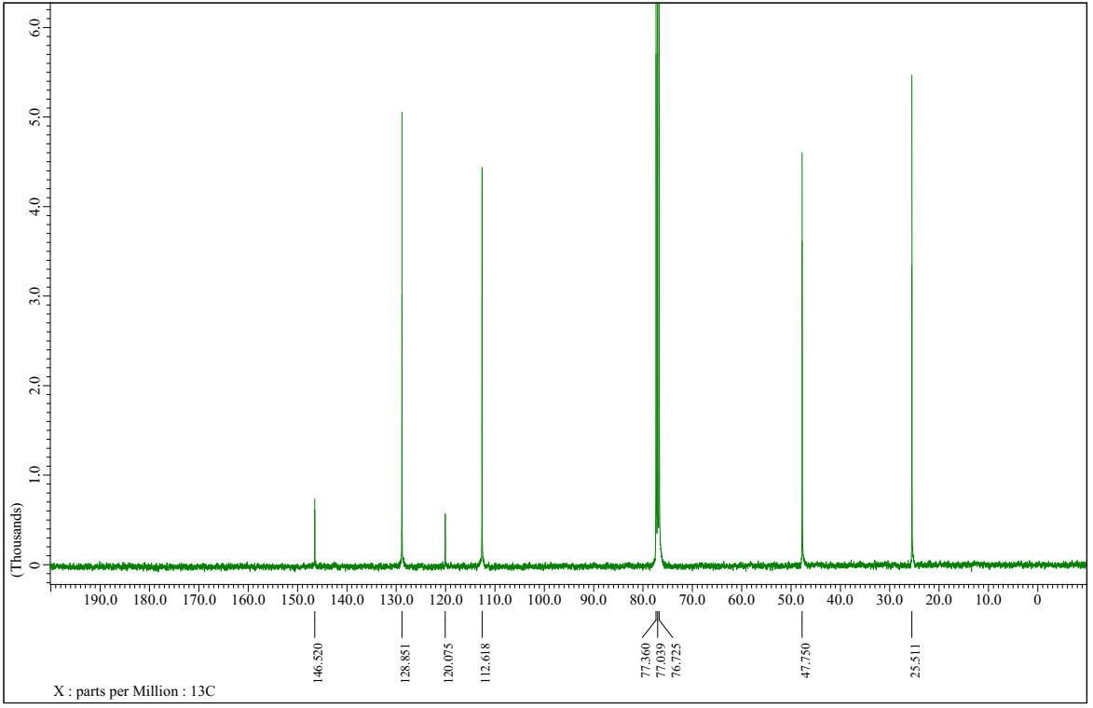
¹³C NMR spectrum of 1-(4-chlorophenyl)pyrrolidine (3b)
1-(4-fluorophenyl)pyrrolidine (3c)
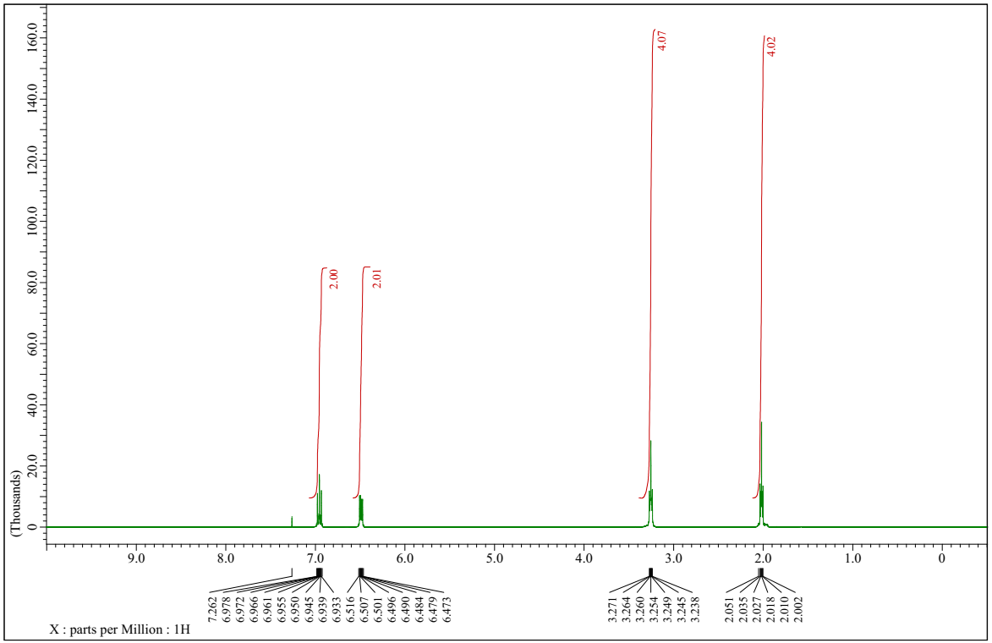
¹H NMR spectrum of 1-(4-fluorophenyl)pyrrolidine (3c)
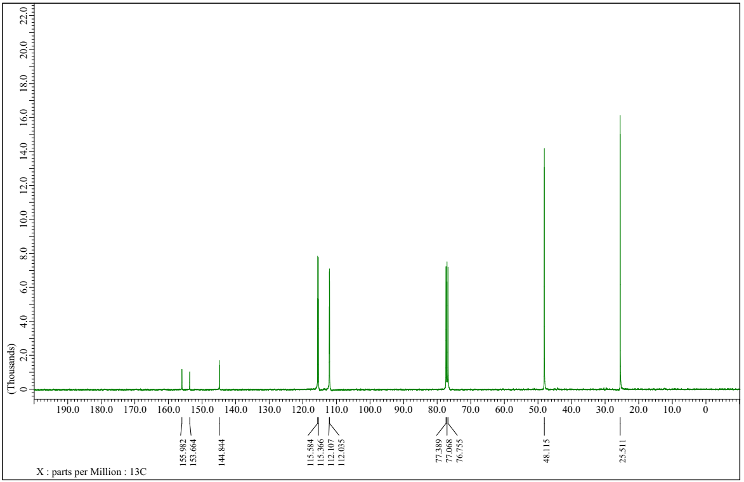
¹³C NMR spectrum of 1-(4-fluorophenyl)pyrrolidine (3c)
1-(3,5-dichlorophenyl)pyrrolidine (3d)
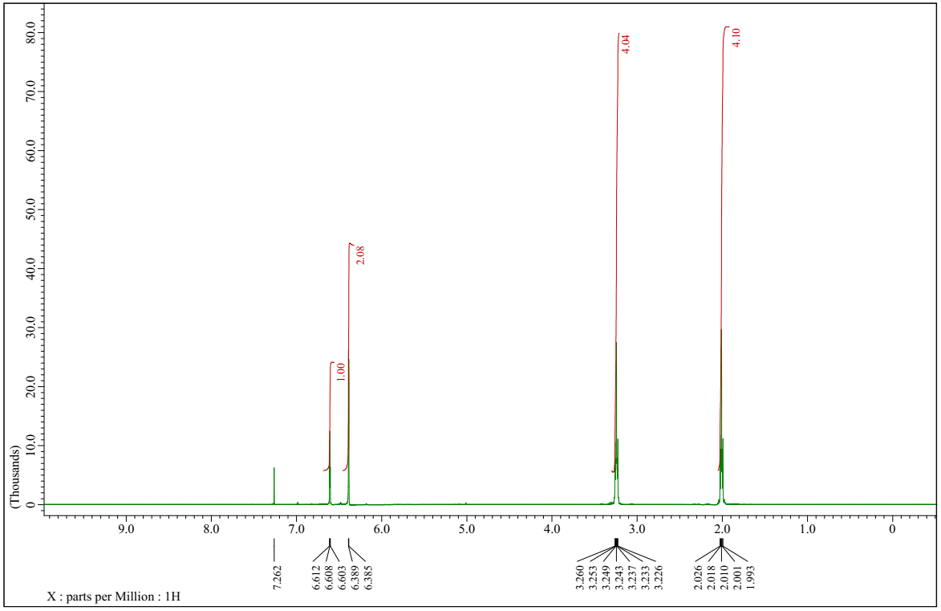¹H NMR spectrum of 1-(3,5-dichlorophenyl)pyrrolidine (3d)
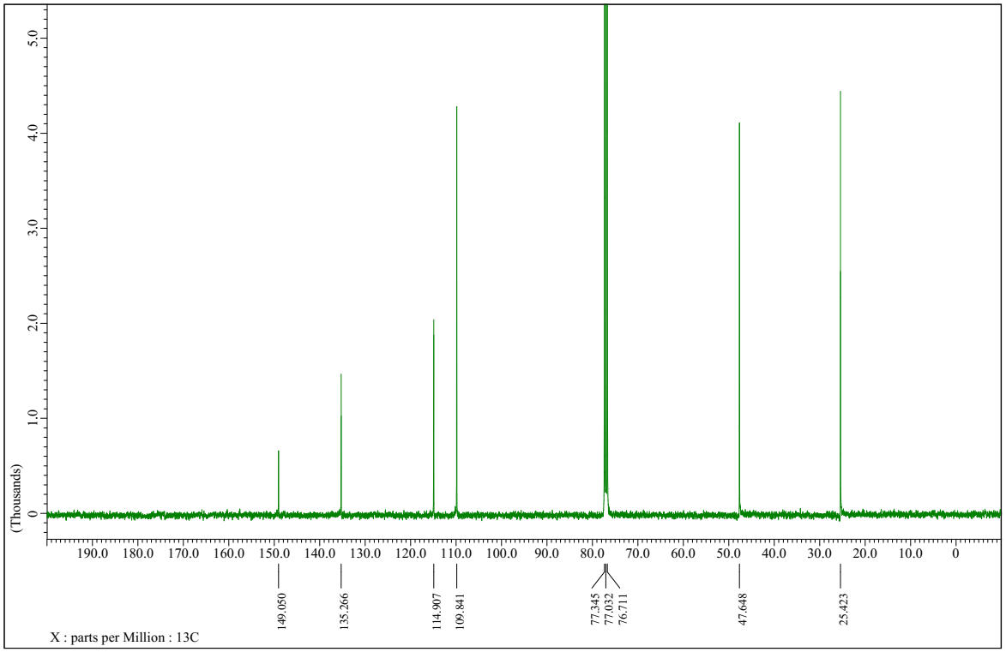
¹³C NMR spectrum of 1-(3,5-dichlorophenyl)pyrrolidine (3d)
1-(2,4-difluorophenyl)pyrrolidine (3e)
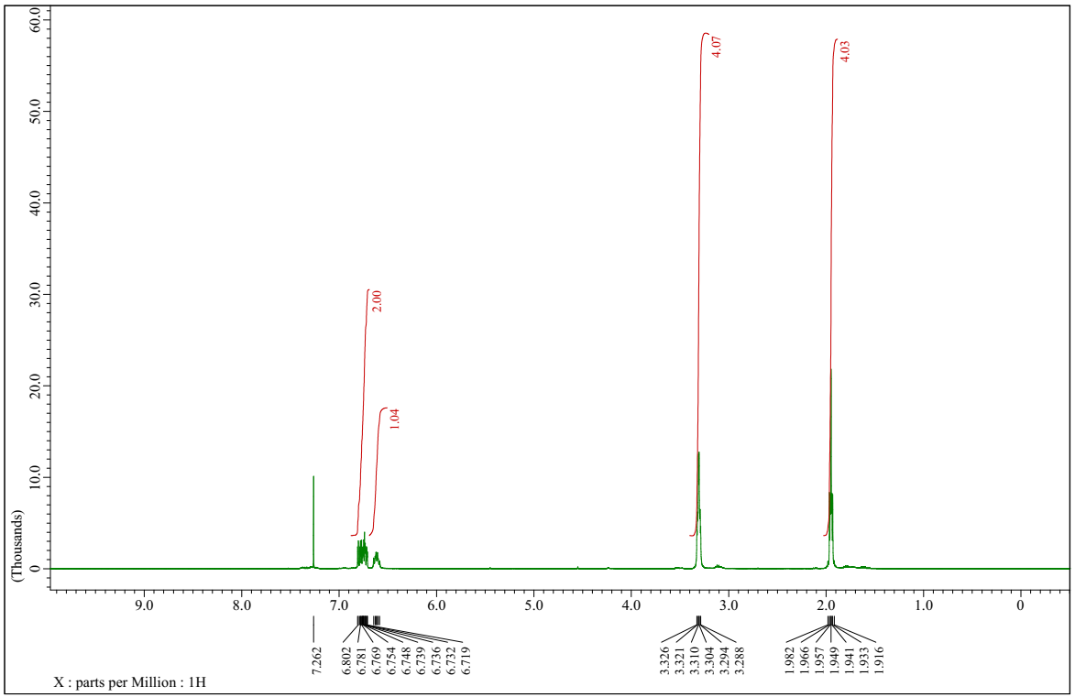
¹H NMR spectrum of 1-(2,4-difluorophenyl)pyrrolidine (3e)
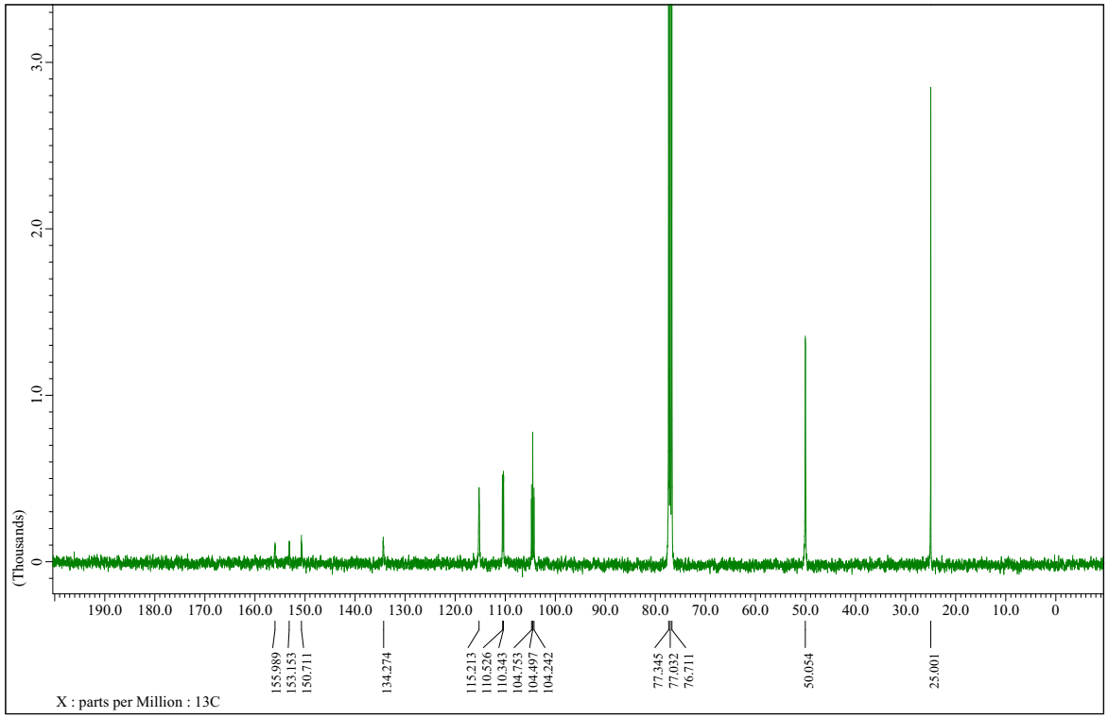
¹³C NMR spectrum of 1-(2,4-difluorophenyl)pyrrolidine (3e)
4-(pyrrolidin-1-yl)benzonitrile (3f)
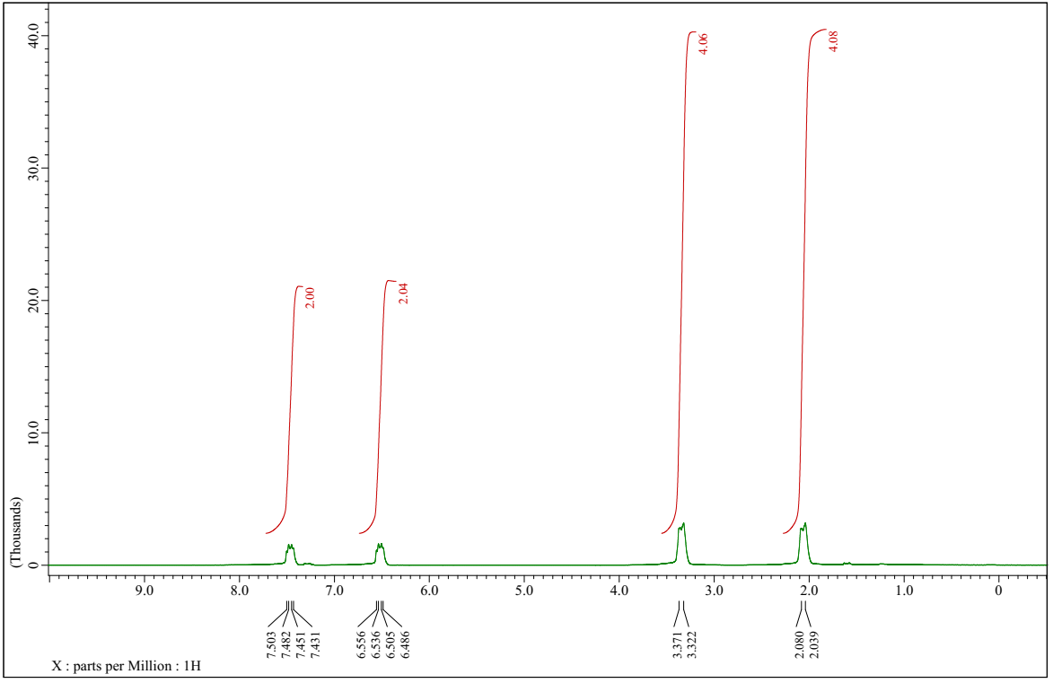
¹H NMR spectrum of 4-(pyrrolidin-1-yl)benzonitrile (3f)
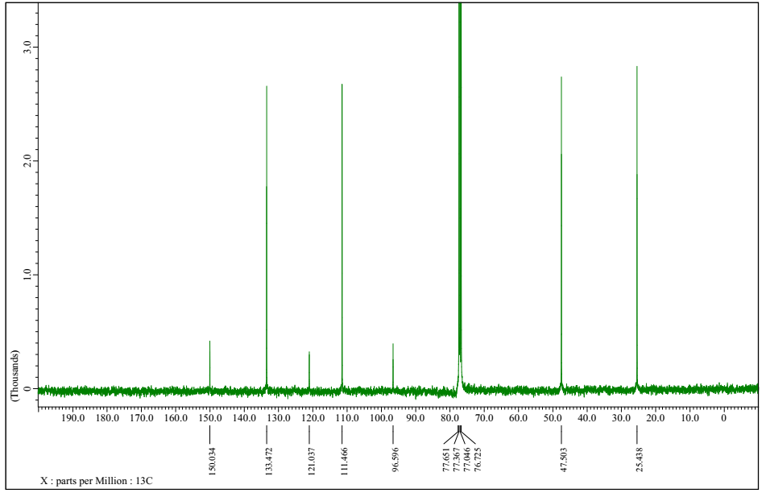
¹³C NMR spectrum of 4-(pyrrolidin-1-yl)benzonitrile (3f)
1-(4-nitrophenyl)pyrrolidine (3g)
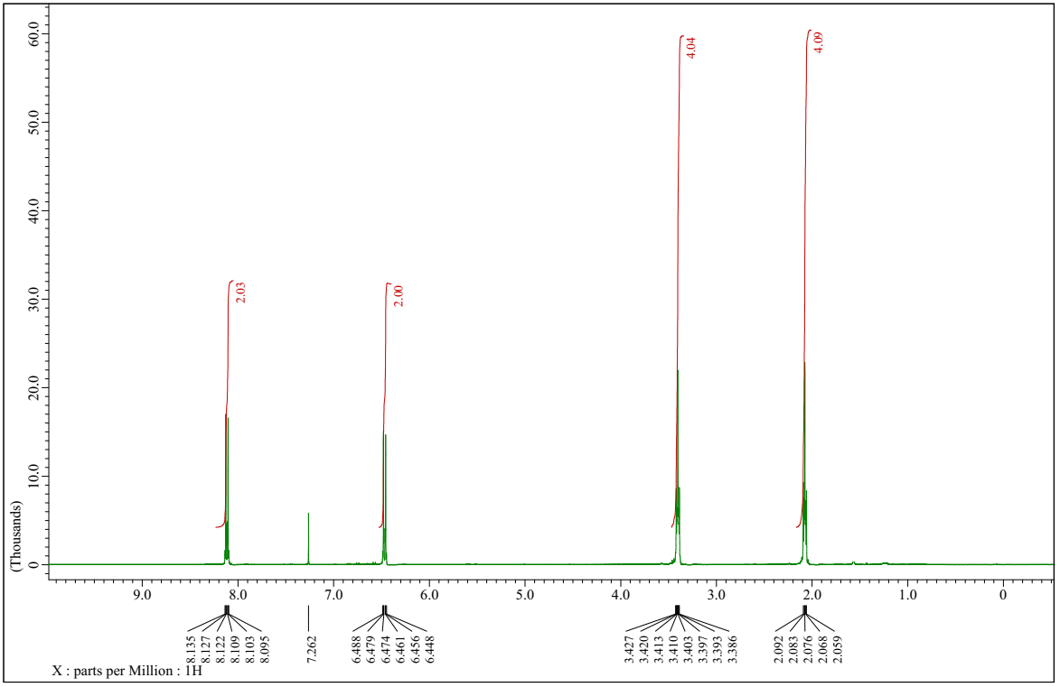
¹H NMR spectrum of 1-(4-nitrophenyl)pyrrolidine (3g)
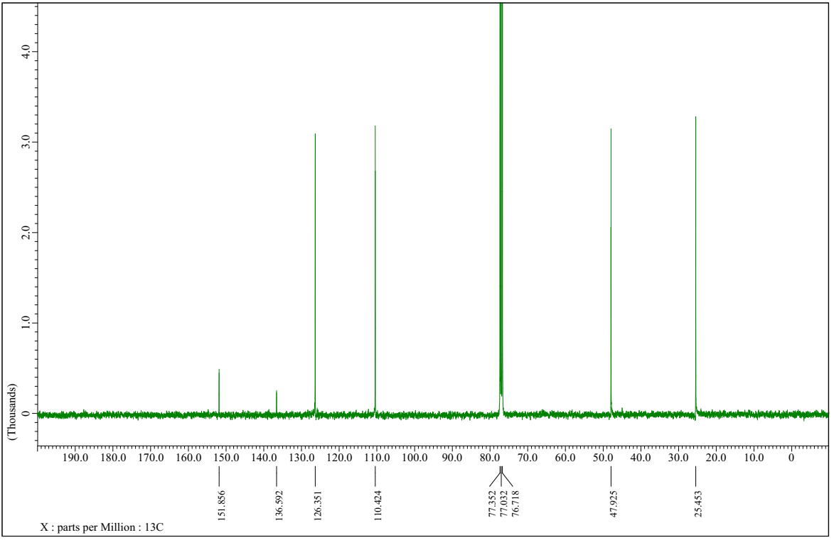
¹³C NMR spectrum of 1-(4-nitrophenyl)pyrrolidine (3g)
1-p-tolylpyrrolidine (3h)
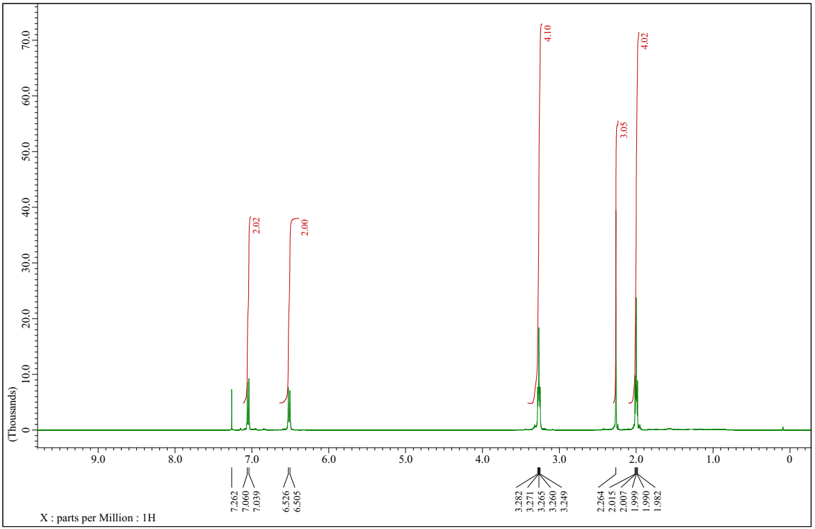
¹H NMR spectrum of 1-p-tolylpyrrolidine (3h)
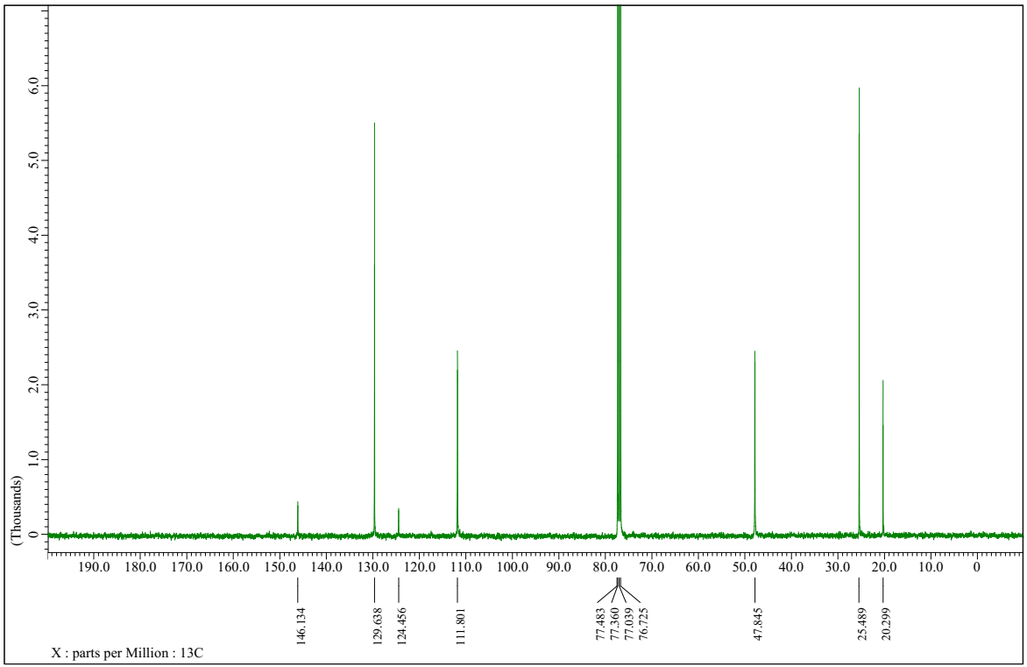
¹³C NMR spectrum of 1-p-tolylpyrrolidine (3h)
1-(4-ethylphenyl)pyrrolidine (3i)
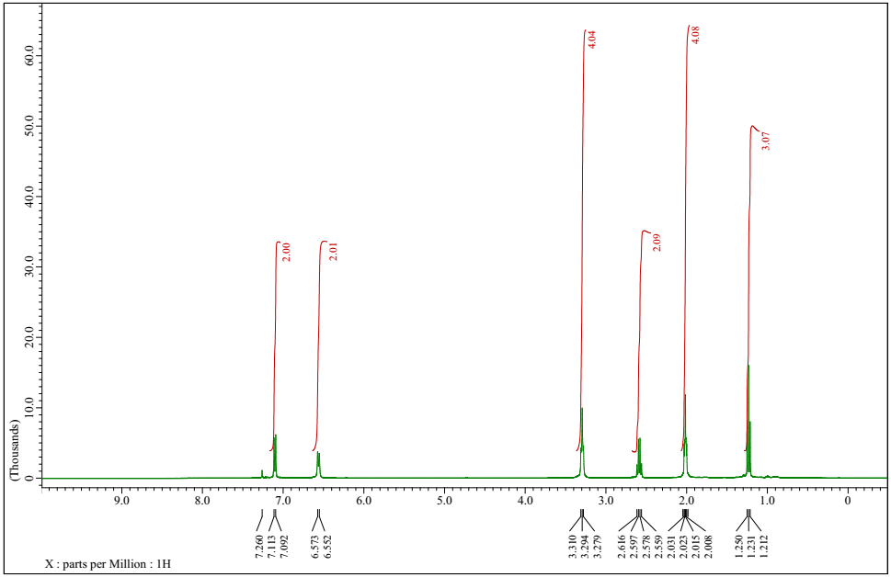
¹H NMR spectrum of 1-(4-ethylphenyl)pyrrolidine (3i)
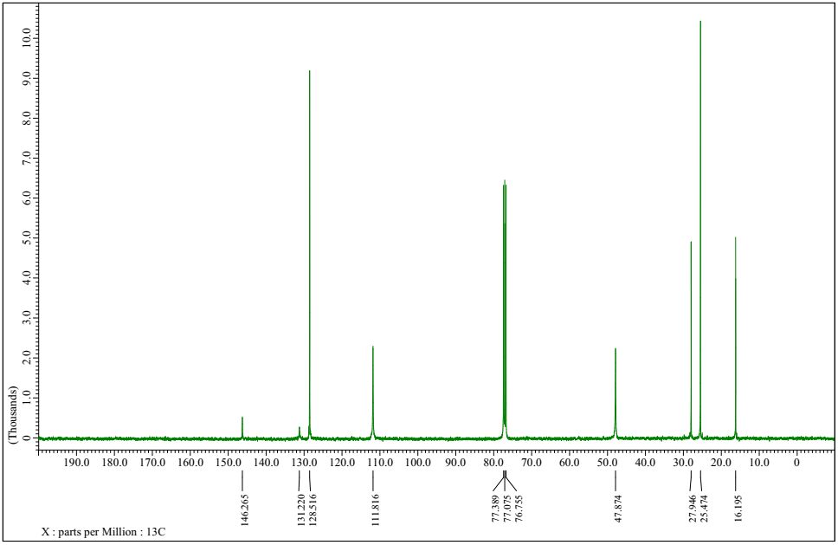
¹³C NMR spectrum of 1-(4-ethylphenyl)pyrrolidine (3i)
1-m-tolylpyrrolidine (3j)
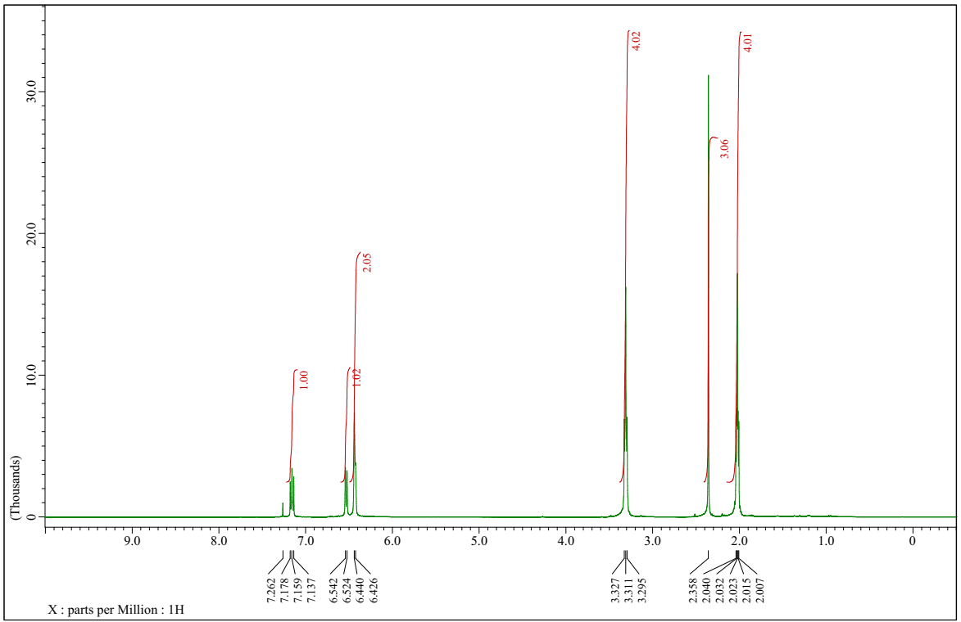¹H NMR spectrum of 1-m-tolylpyrrolidine (3j)
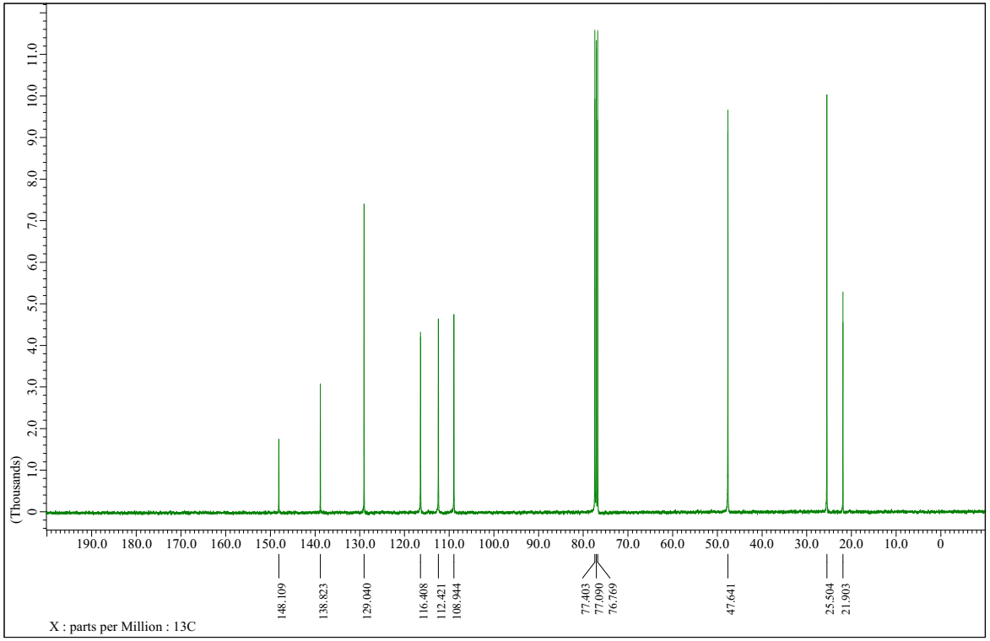
¹³C NMR spectrum of 1-m-tolylpyrrolidine (3j)
1-(3,5-dimethylphenyl)pyrrolidine (3k)
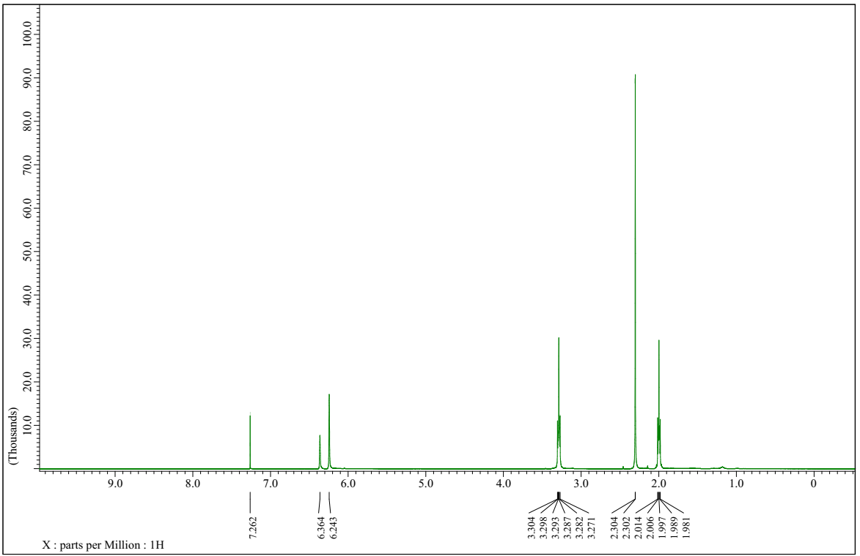¹H NMR spectrum of 1-(3,5-dimethylphenyl)pyrrolidine (3k)
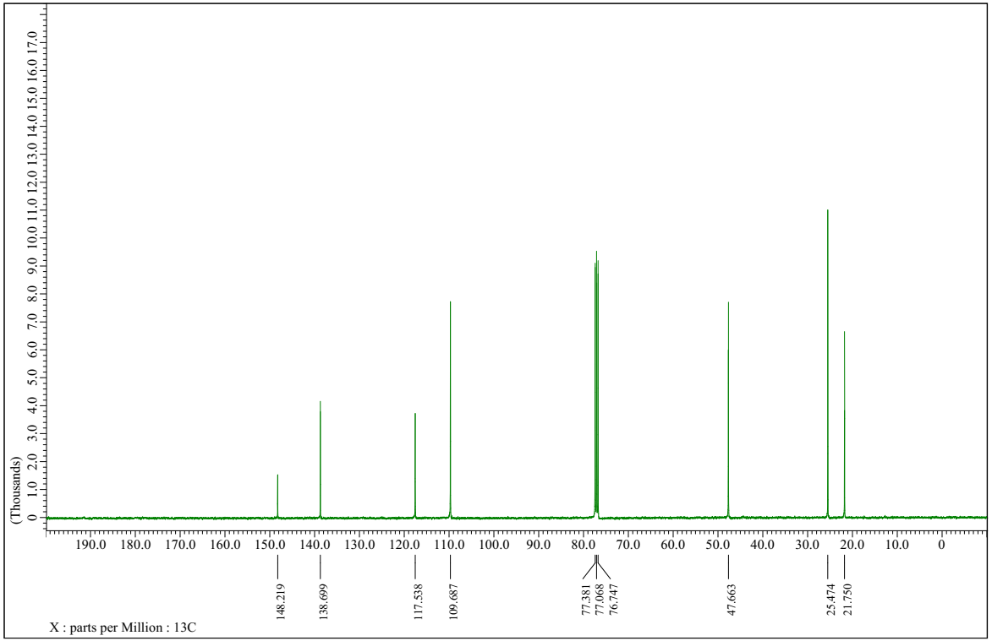
¹³C NMR spectrum of 1-(3,5-dimethylphenyl)pyrrolidine (3k)
1-(2,6-dimethylphenyl)pyrrolidine (3l)

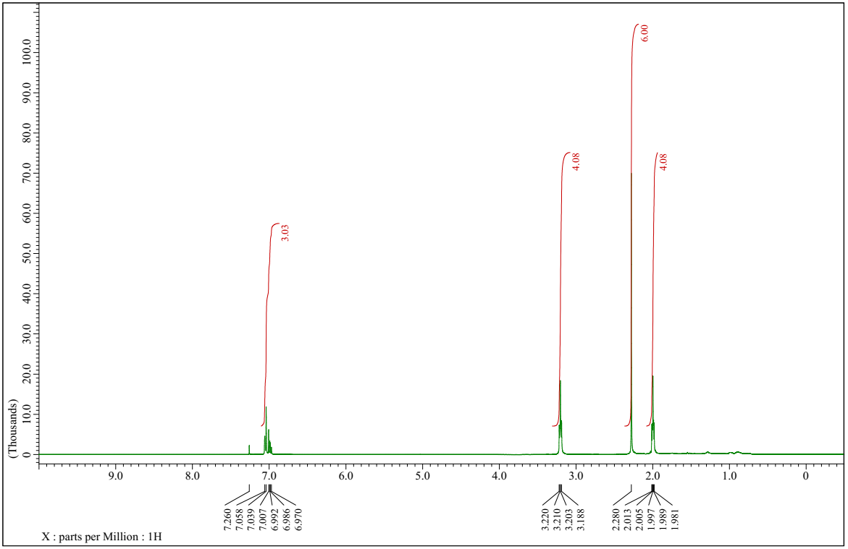
¹H NMR spectrum of 1-(2,6-dimethylphenyl)pyrrolidine (3l)
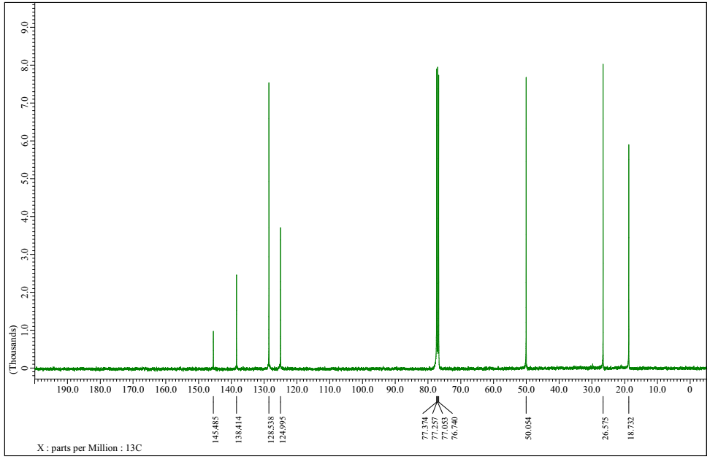
¹³C NMR spectrum of 1-(2,6-dimethylphenyl)pyrrolidine (3l)
1-(4-methoxyphenyl)pyrrolidine (3m)
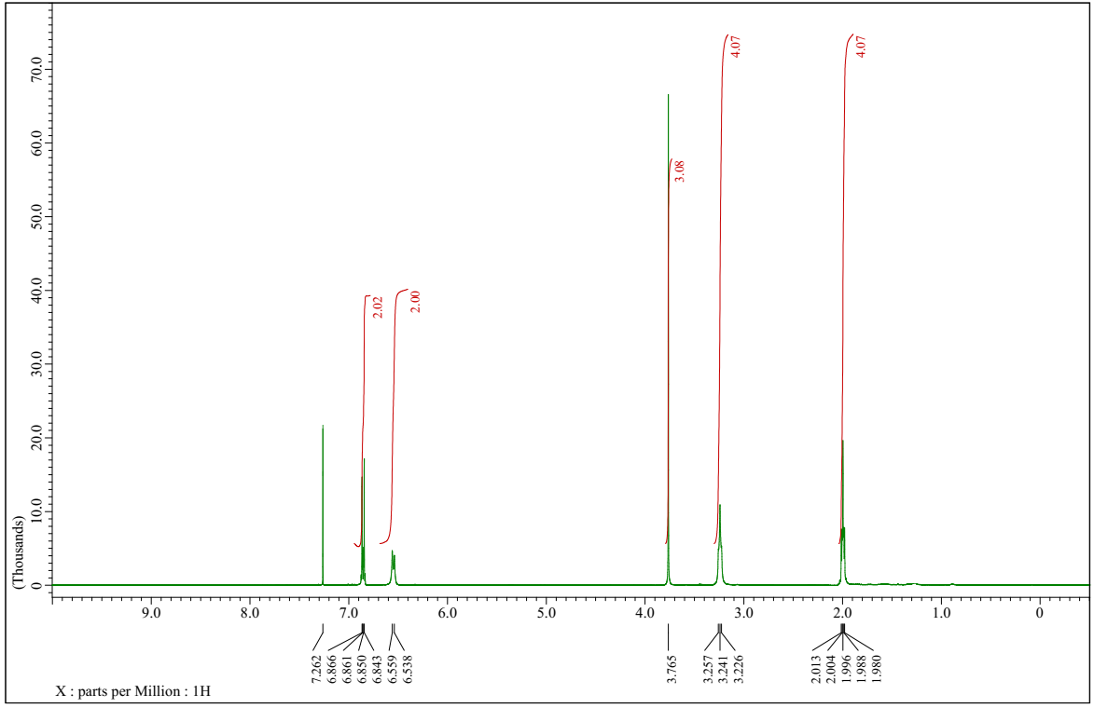
¹H NMR spectrum of 1-(4-methoxyphenyl)pyrrolidine (3m)
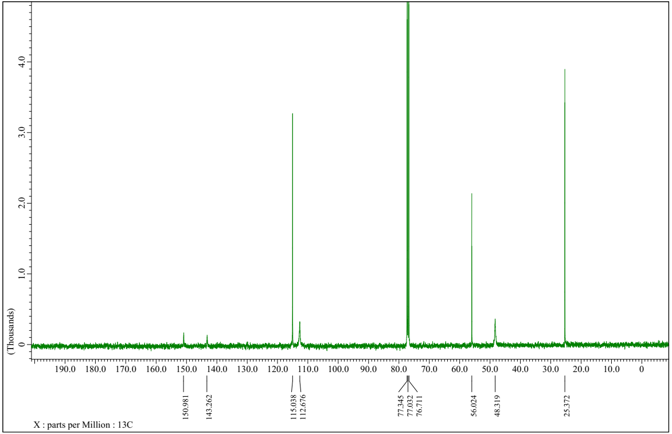
¹³C NMR spectrum of 1-(4-methoxyphenyl)pyrrolidine (3m)
1-(naphthalen-1-yl) pyrrolidine (3n)
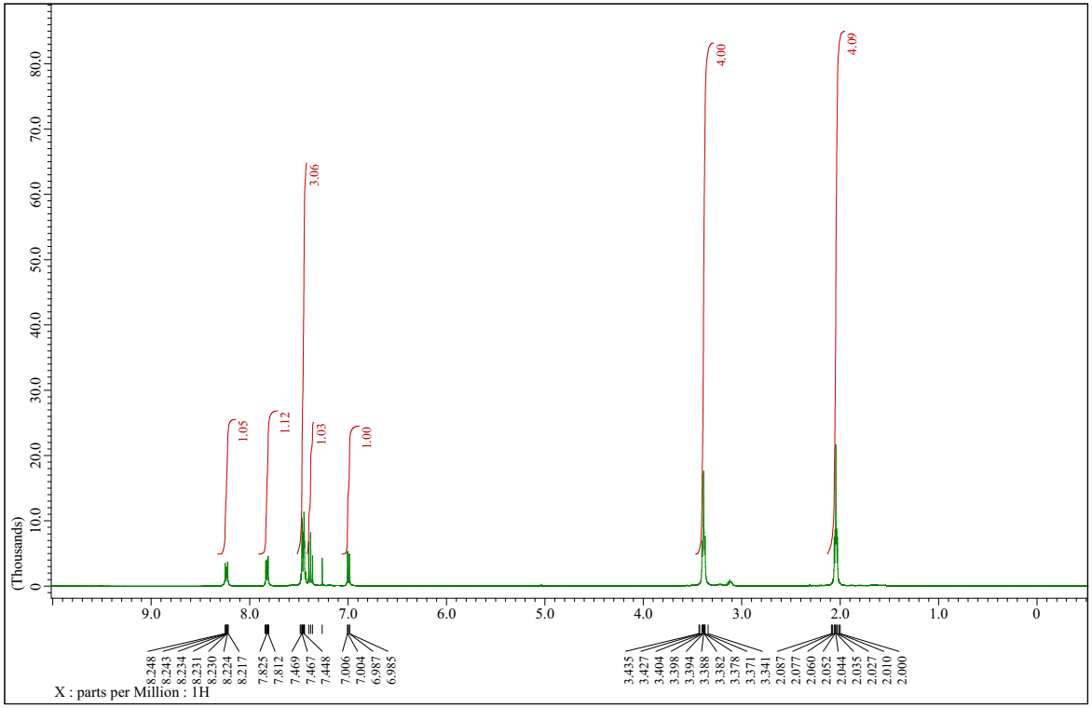
¹H NMR spectrum of 1-(naphthalen-1-yl) pyrrolidine (3n)
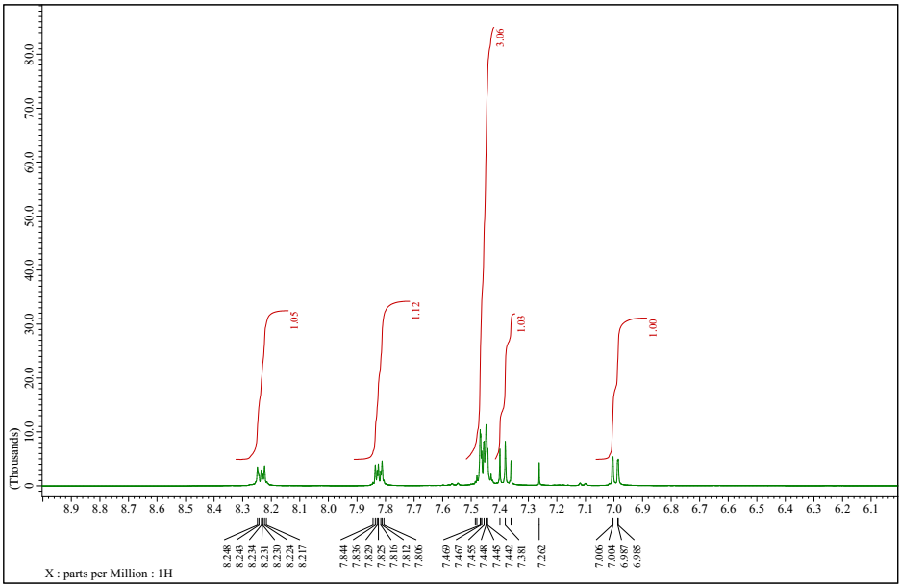
¹H NMR spectrum of 1-(naphthalen-1-yl) pyrrolidine (3n) (extra spectra)
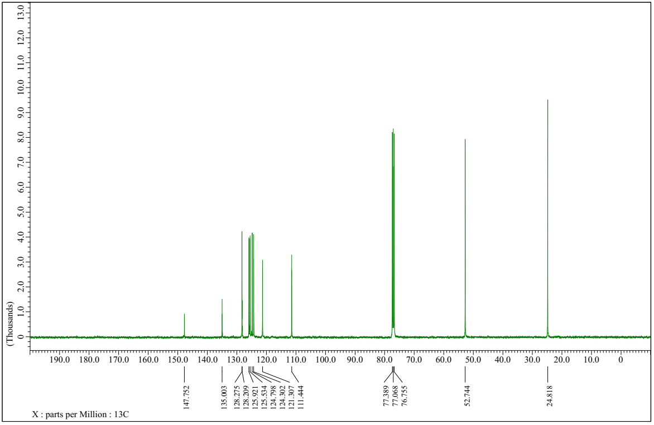
¹³C NMR spectrum of 1-(naphthalen-1-yl)pyrrolidine (3n)

2-methyl-1-phenylpyrrolidine (4a)
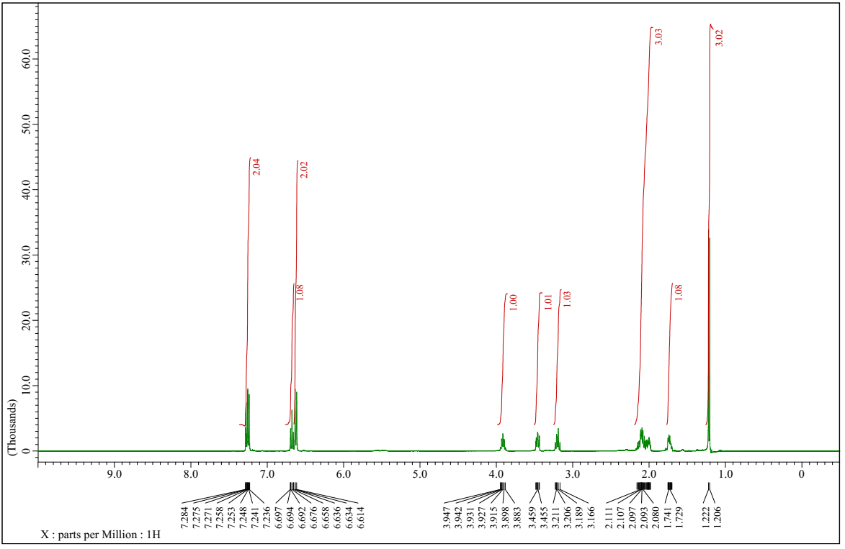
¹H NMR spectrum of 2-methyl-1-phenylpyrrolidine (4a)
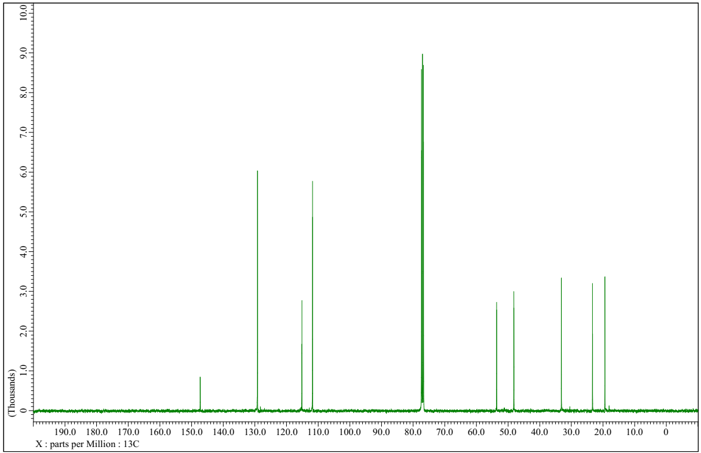
¹³C NMR spectrum of 2-methyl-1-phenylpyrrolidine (4a)
1-(3-chlorophenyl)-2-methylpyrrolidine (4b)
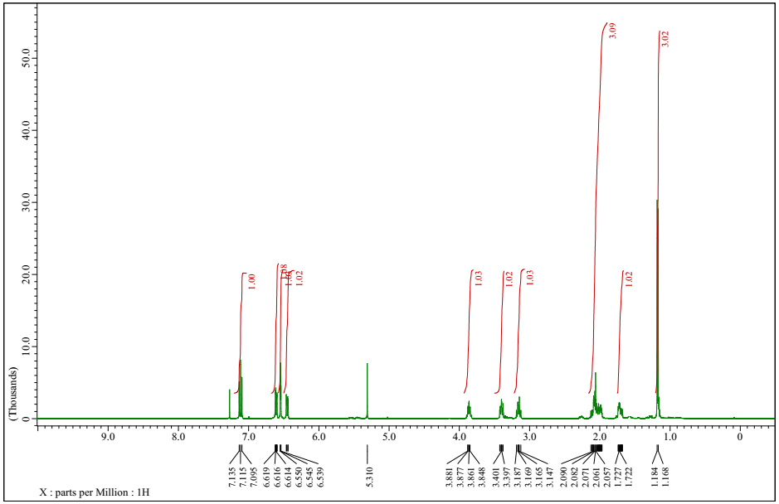
¹H NMR spectrum of 1-(3-chlorophenyl)-2-methylpyrrolidine (4b)
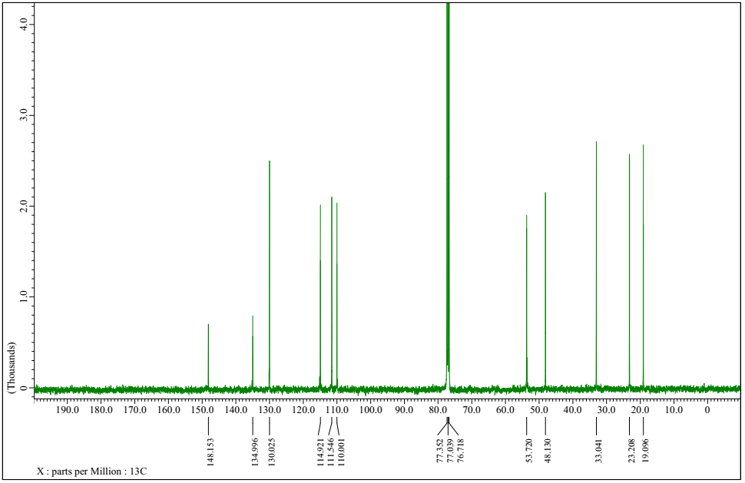
¹³C NMR spectrum of 1-(3-chlorophenyl)-2-methylpyrrolidine (4b)
2-methyl-1-p-tolylpyrrolidine (4c)
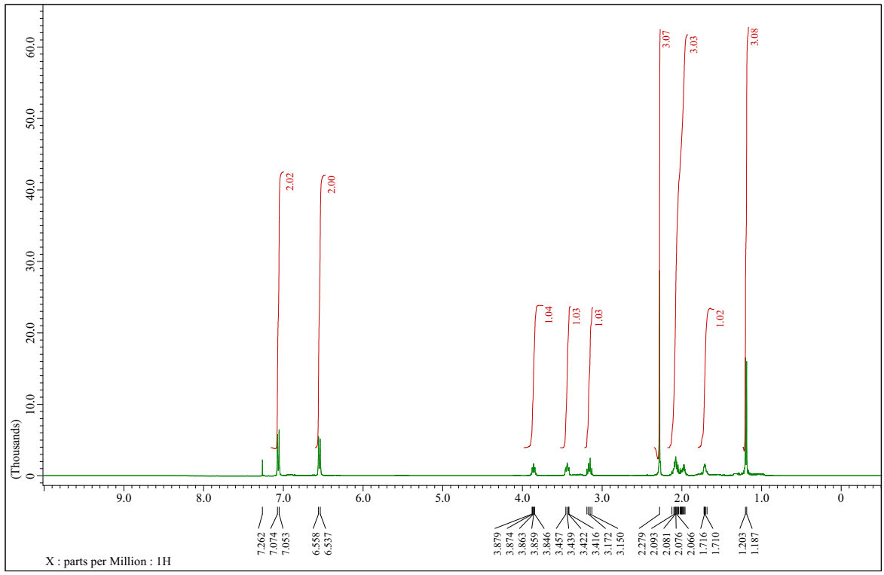
¹H NMR spectrum of 2-methyl-1-p-tolylpyrrolidine (4c)
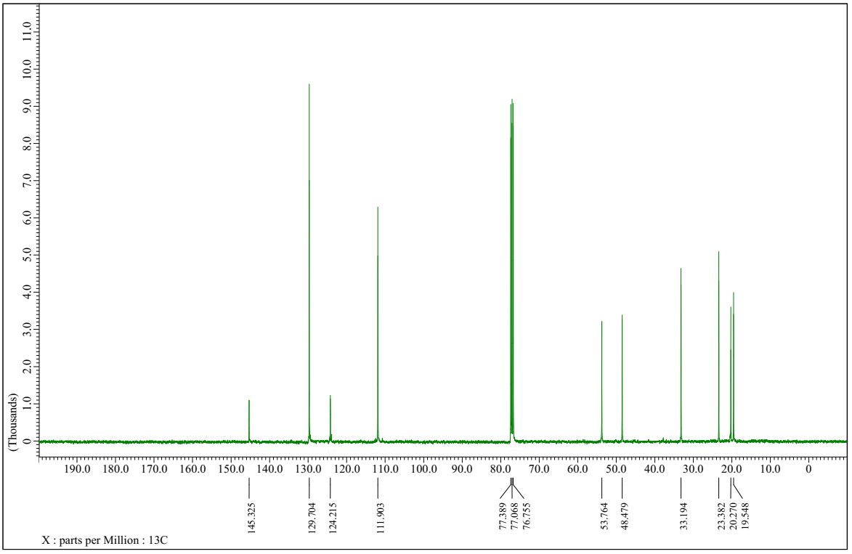
¹³C NMR spectrum of 2-methyl-1-p-tolylpyrrolidine (4c)
1-(3,5-dimethylphenyl)-2-methylpyrrolidine (4d)
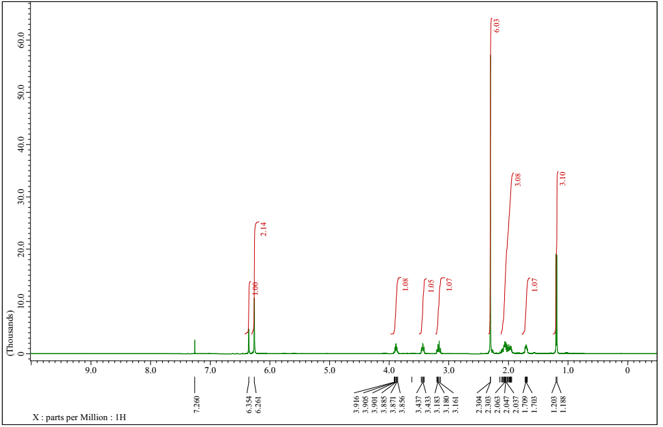
¹H NMR spectrum of 1-(3,5-dimethylphenyl)-2-methylpyrrolidine (4d)
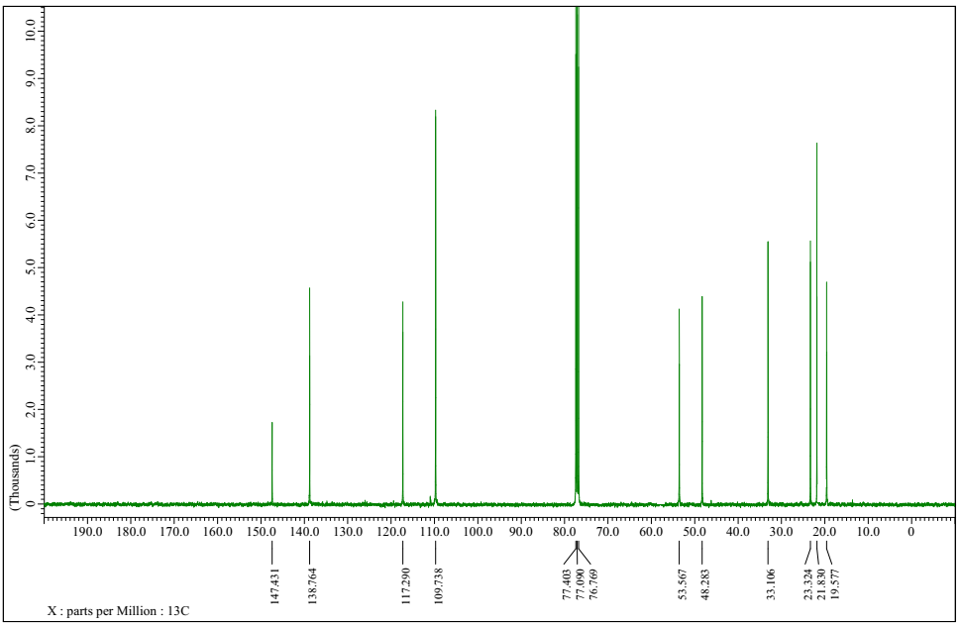
¹³C NMR spectrum of 1-(3,5-dimethylphenyl)-2-methylpyrrolidine (4d)
1-phenylpiperidine (4e)
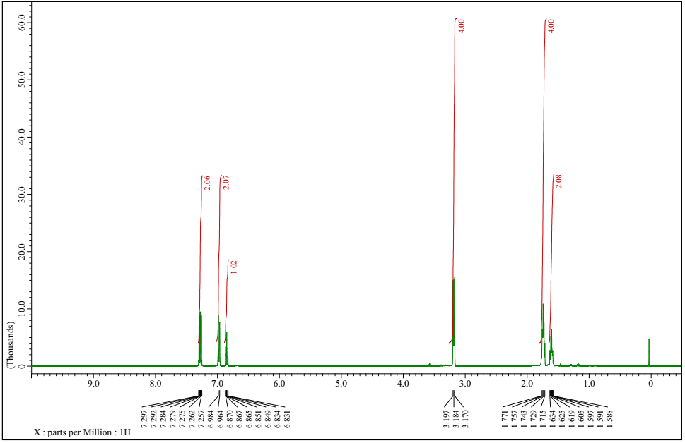
¹H NMR spectrum of 1-phenylpiperidine (4e)
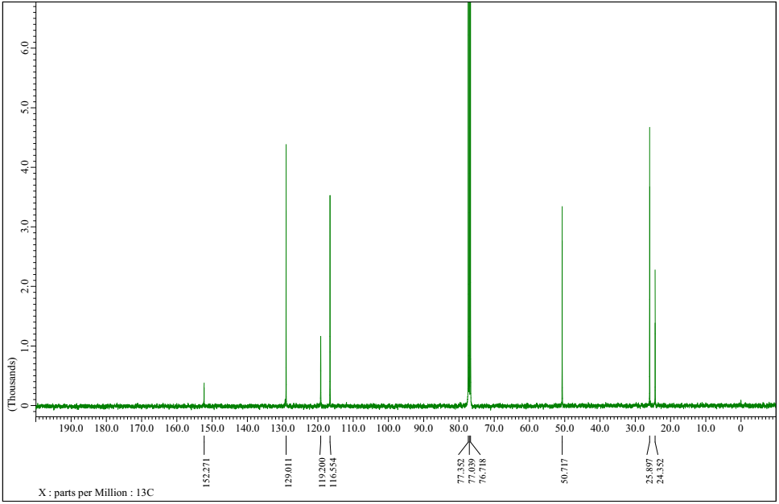
¹³C NMR spectrum of 1-phenylpiperidine (4e)
2-phenylisoindoline (4f)
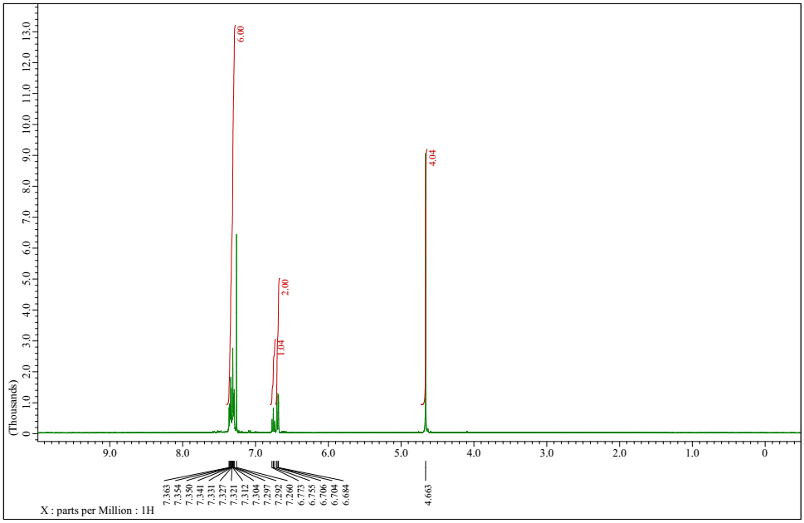¹H NMR spectrum of 2-phenylisoindoline (4f)
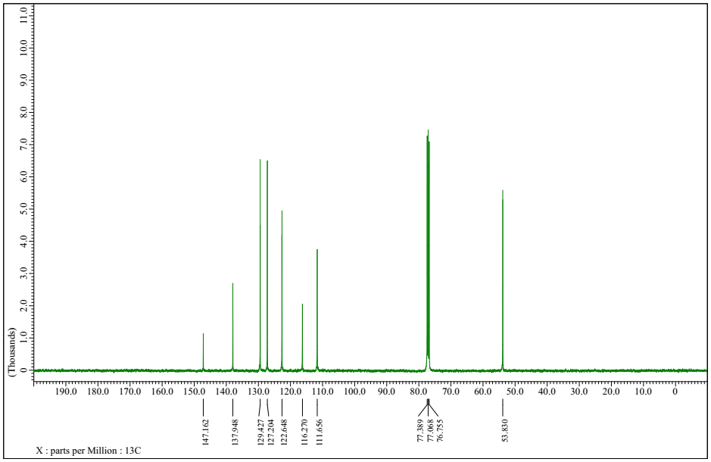
¹³C NMR spectrum of 2-phenylisoindoline (4f)
2-(3-chlorophenyl)isoindoline (4g)
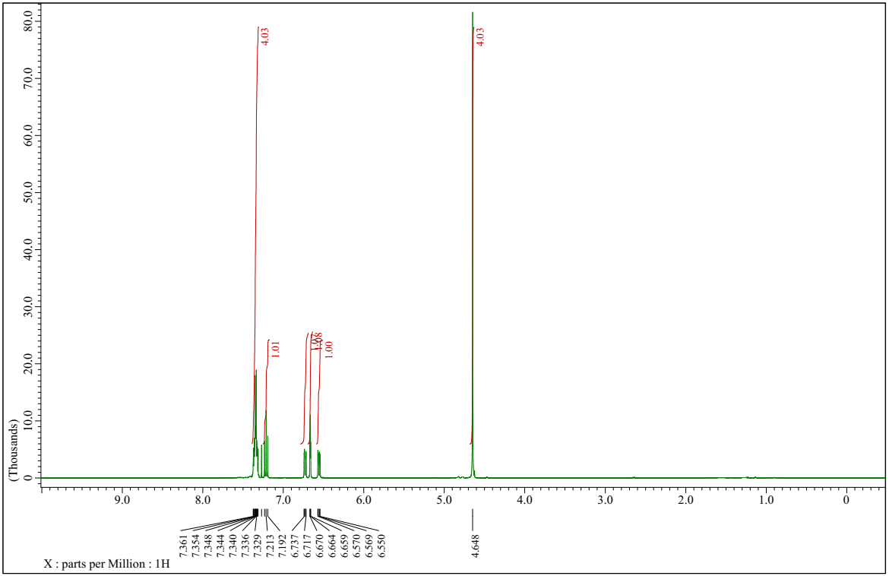
¹H NMR spectrum of 2-(3-chlorophenyl)isoindoline (4g)
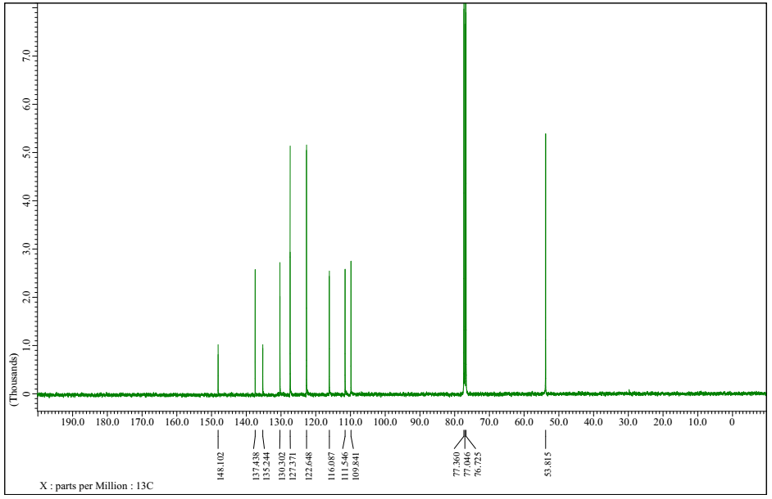
¹³C NMR spectrum of 2-(3-chlorophenyl)isoindoline (4g)
2-m-tolylisoindoline (4h)
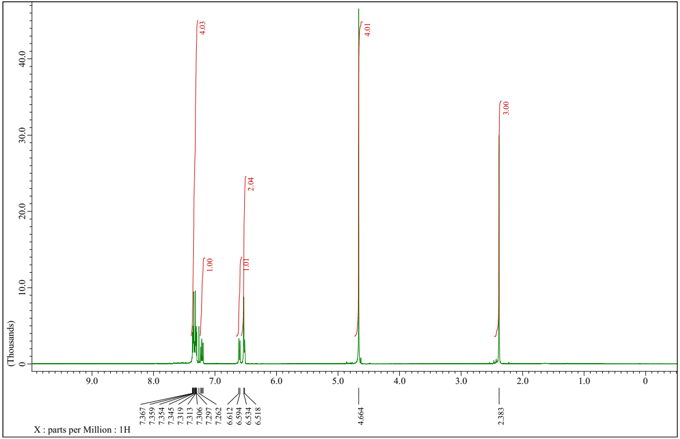
¹H NMR spectrum of 2-m-tolylisoindoline (4h)
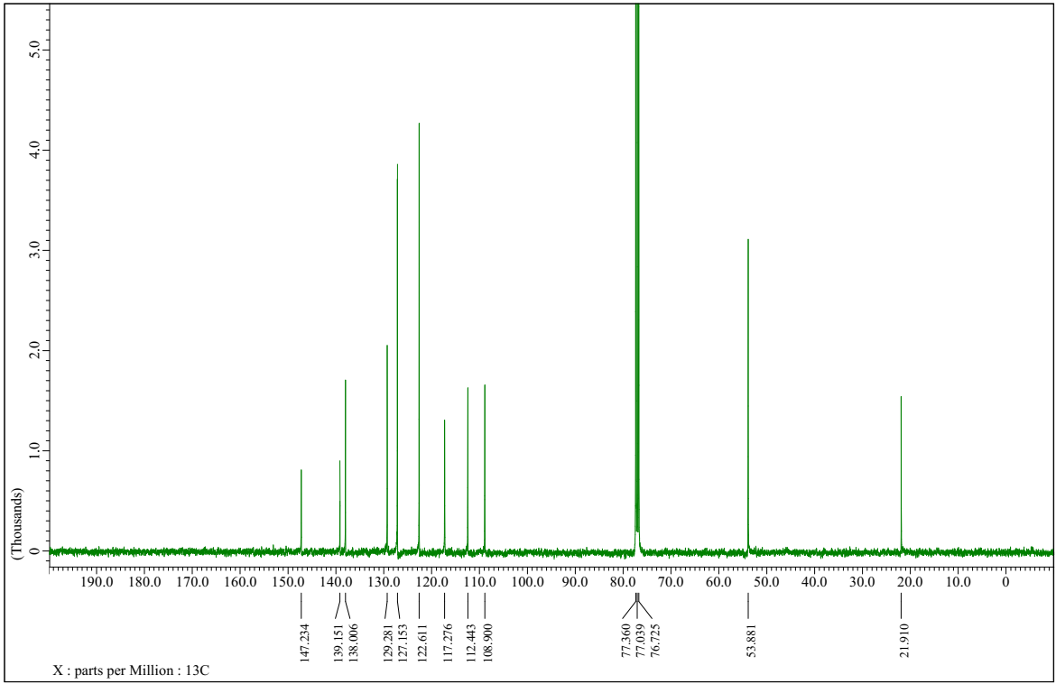
¹³C NMR spectrum of 2-m-tolylisoindoline (4h)
2-(2,6-dimethylphenyl)isoindoline (4i)
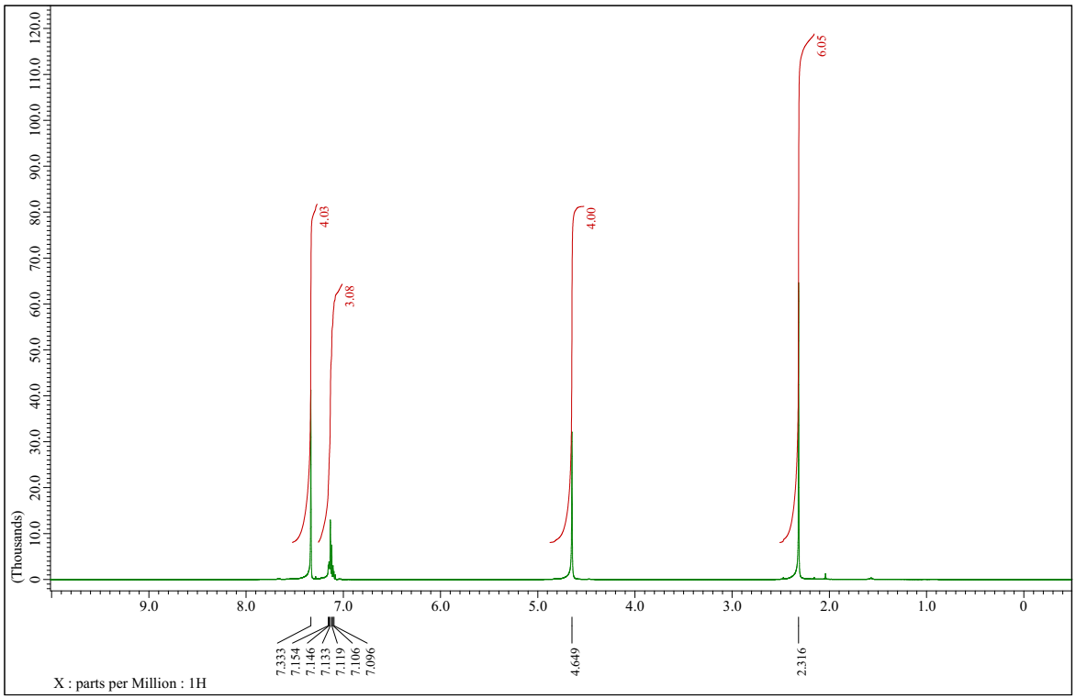
¹H NMR spectrum of 2-(2,6-dimethylphenyl)isoindoline (4i)
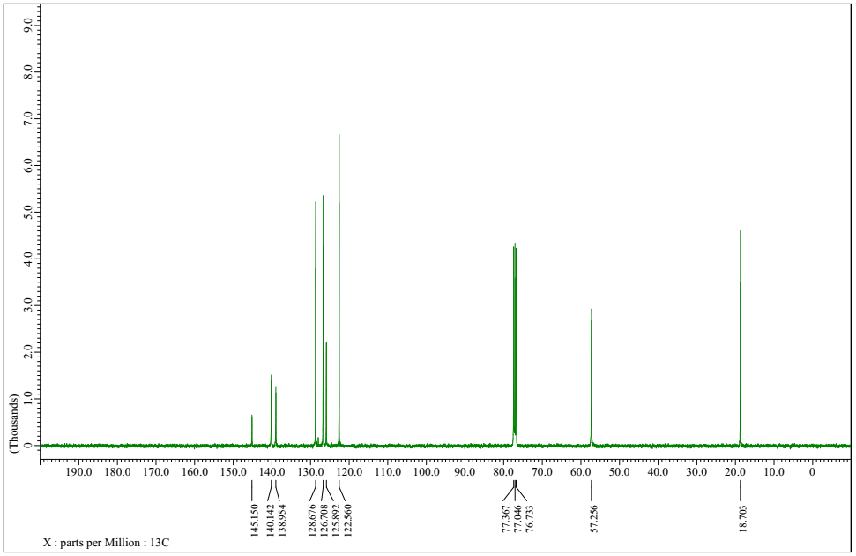
¹³C NMR spectrum of 2-(2,6-dimethylphenyl)isoindoline (4i)
2-phenyl-1,2,3,4-tetrahydroisoquinoline (4j)
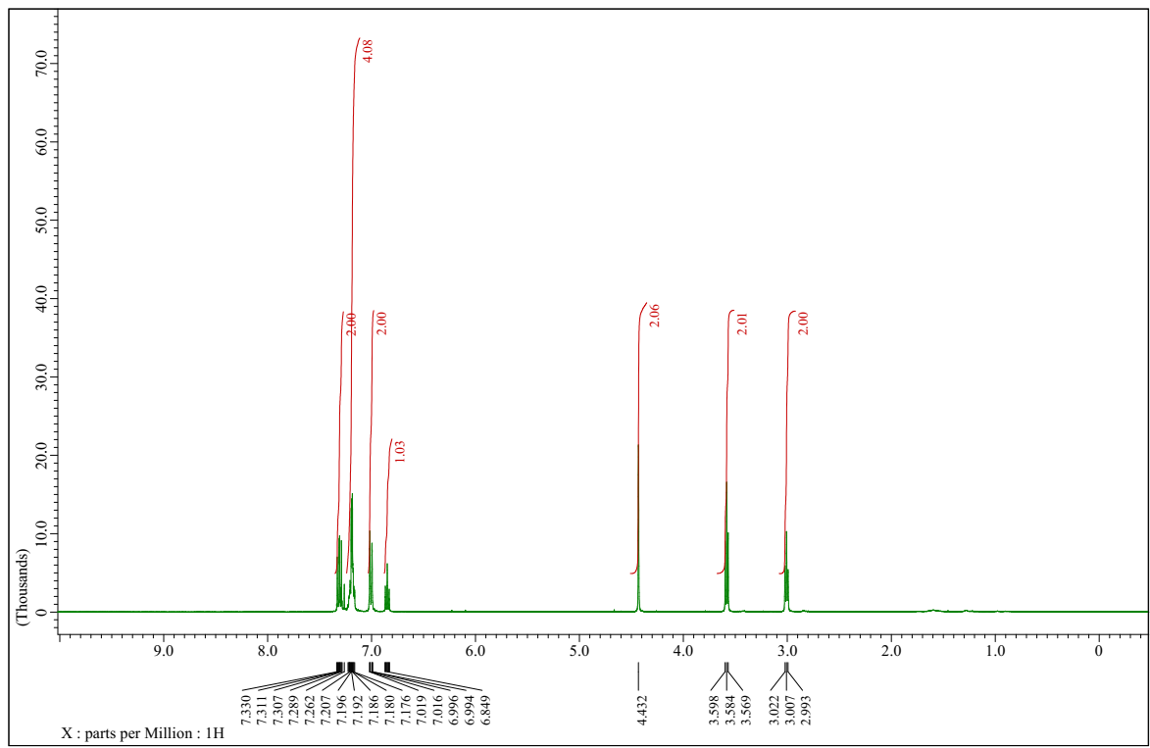
¹H NMR spectrum of 2-phenyl-1,2,3,4-tetrahydroisoquinoline (4j)
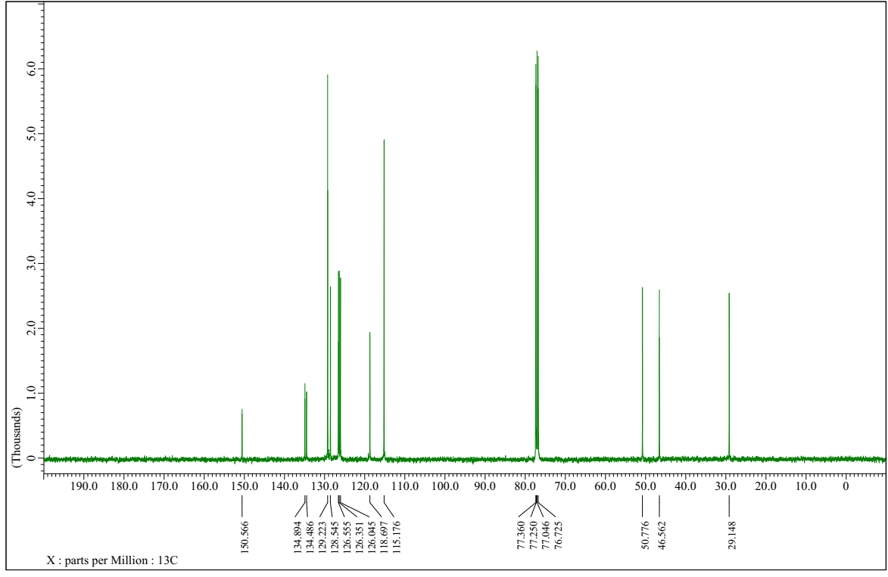
¹³C NMR spectrum of 2-phenyl-1,2,3,4-tetrahydroisoquinoline (4j)
2-(4-fluorophenyl)-1,2,3,4-tetrahydroisoquinoline (4k)
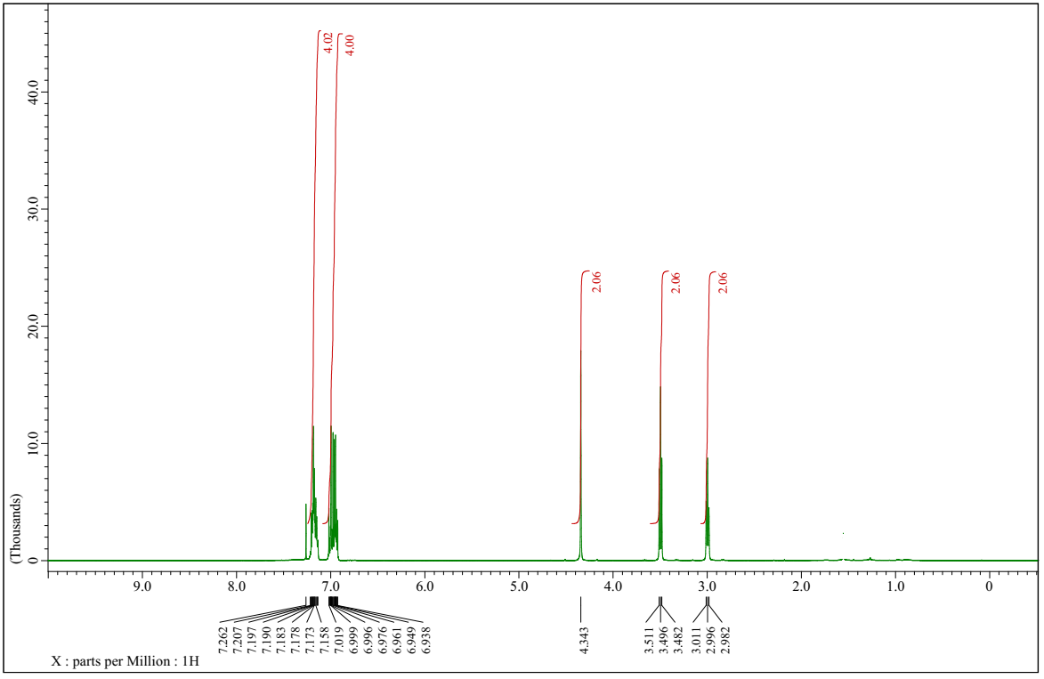
¹H NMR spectrum of 2-(4-fluorophenyl)-1,2,3,4-tetrahydroisoquinoline (4k)
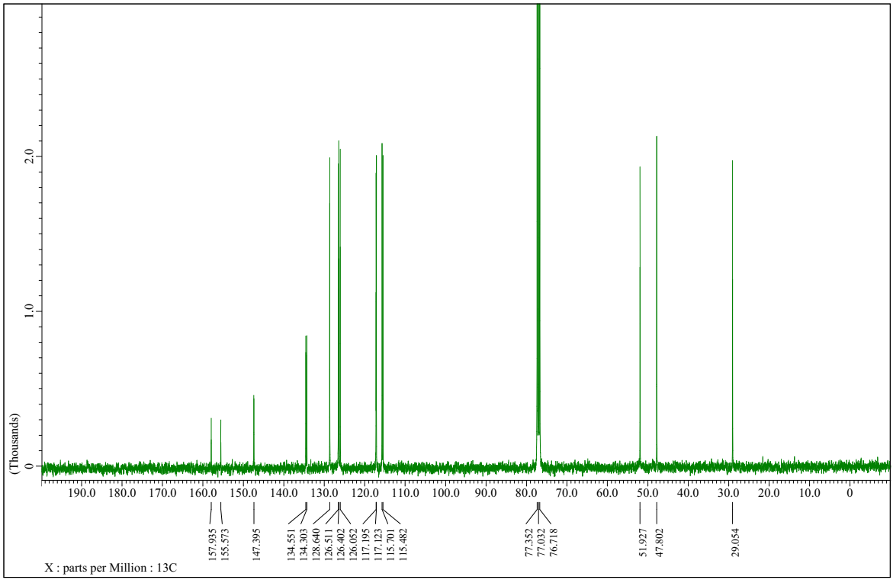
¹³C NMR spectrum of 2-(4-fluorophenyl)-1,2,3,4-tetrahydroisoquinoline (4k)
2-(p-tolyl)-1,2,3,4-tetrahydroisoquinoline (4l)
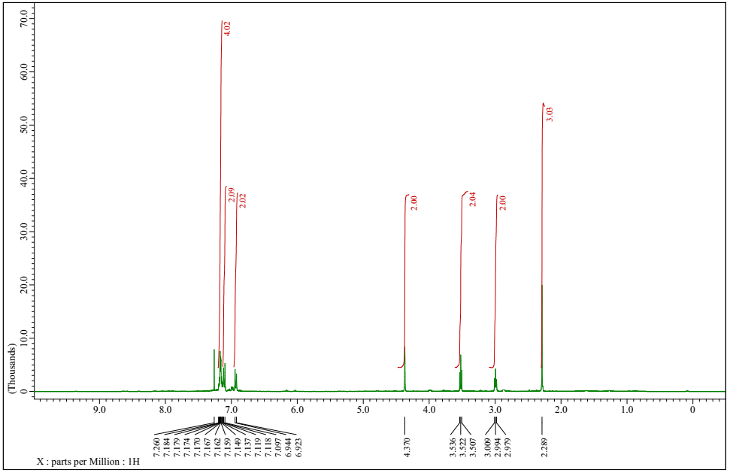
¹H NMR spectrum of 2-(p-tolyl)-1,2,3,4-tetrahydroisoquinoline (4l)
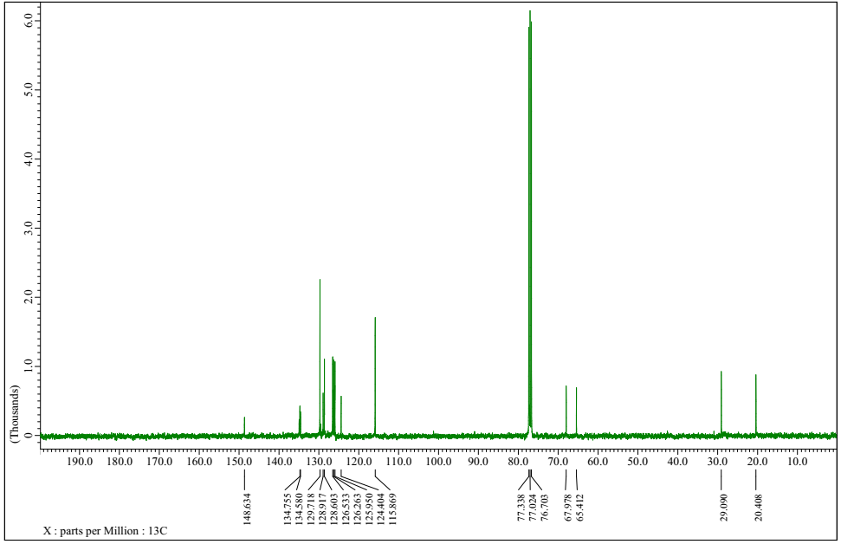
¹³C NMR spectrum of 2-(p-tolyl)-1,2,3,4-tetrahydroisoquinoline (4l)
2-(3,5-dimethylphenyl)-1,2,3,4-tetrahydroisoquinoline (4n)
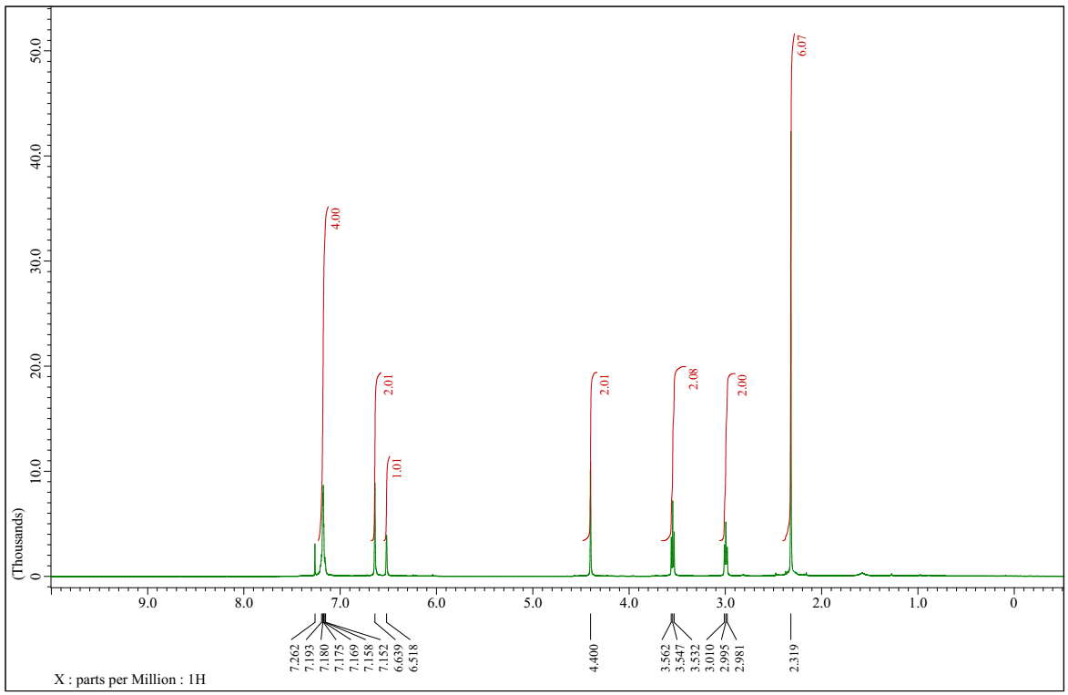
¹H NMR spectrum of 2-(3,5-dimethylphenyl)-1,2,3,4-tetrahydroisoquinoline (4n)
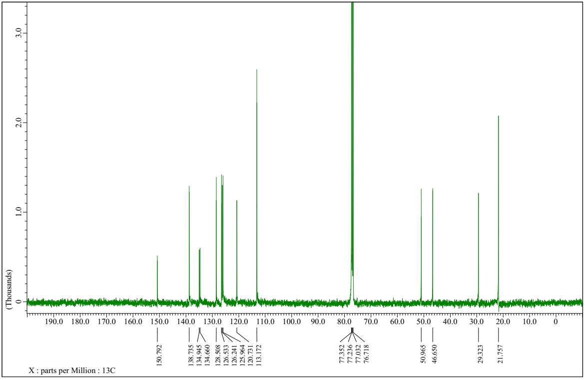
¹³C NMR spectrum of 2-(3,5-dimethylphenyl)-1,2,3,4-tetrahydroisoquinoline (4n)
Allyl(phenyl)phosphoramidic dichloride (7)
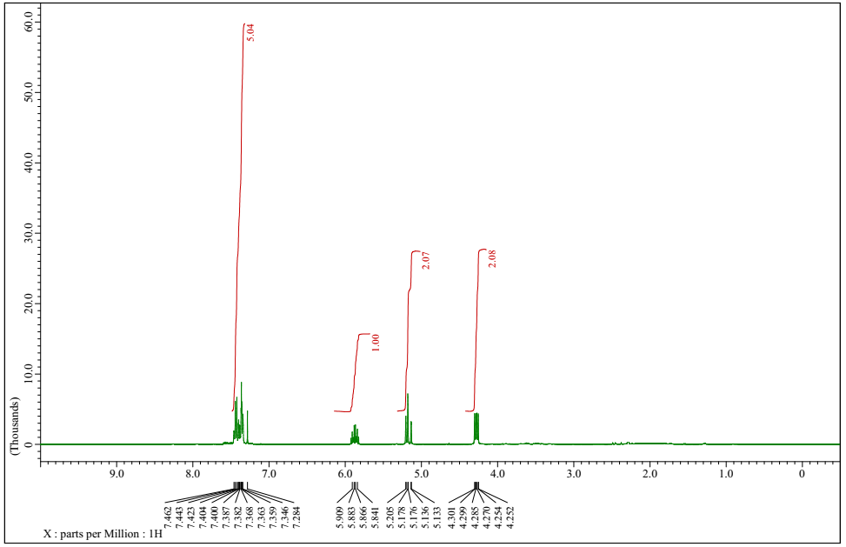
¹H NMR spectrum of allyl(phenyl)phosphoramidic dichloride (7)
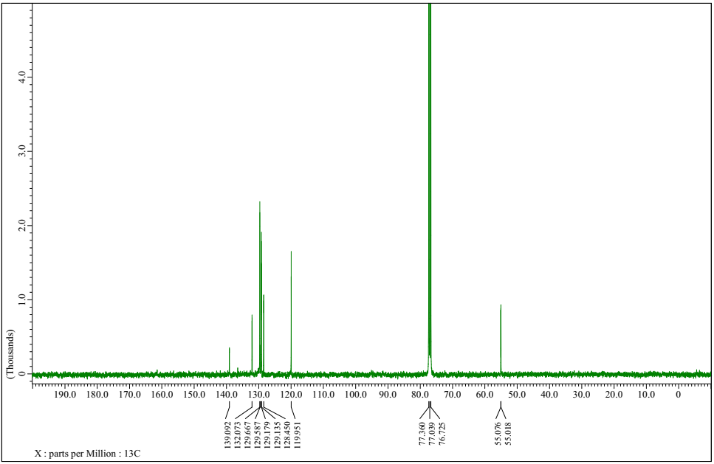
¹³C NMR spectrum of allyl(phenyl)phosphoramidic dichloride (7)
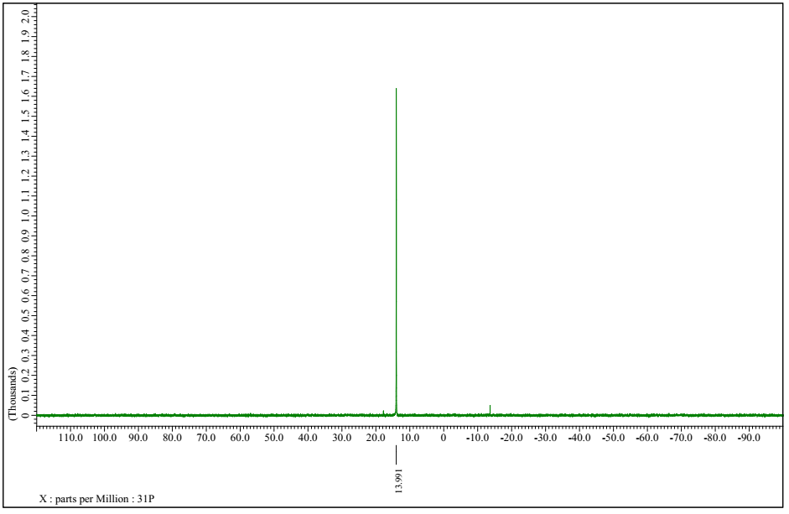
³¹P-NMR spectrum of allyl(phenyl)phosphoramidic dichloride (7)

