SUPPORTING INFORMATION
Bioactive specialized metabolites produced by the emerging pathogen Diplodia olivarum

Roberta Di Lecce,¹ Marco Masi,^{1,}* Benedetto Teodoro Linaldeddu,² Gennaro Pescitelli,³ Lucia Maddau,⁴ Antonio Evidente¹

¹Dipartimento di Scienze Chimiche, Università di Napoli Federico II, Complesso Universitario Monte Sant’Angelo, Via Cintia 4, 80126, Napoli, Italy.

²Dipartimento Territorio e Sistemi Agro-Forestali, Università̀ di Padova, Viale dell’Università̀ 16, Legnaro 35020, Italy

³Dipartimento di Chimica e Chimica Industriale, Università di Pisa, Via Moruzzi 3, 56124 Pisa, Italy

⁴Dipartimento di Agraria, Sezione di Patologia Vegetale ed Entomologia, Università degli Studi di Sassari, Viale Italia 39, 07100, Sassari, Italy

____________________________
*Corresponding author
E-mail address: marco.masi@unina.it

Supporting Information List

Page 3: Spectra 1. ¹H NMR spectrum of Olicleistanone (1) (CDCl₃, 400 MHz).
Page 3: Spectra 2. ¹³C NMR spectrum of Olicleistanone (1) (CDCl₃, 100 MHz).
Page 4: Spectra 3. HSQC spectrum of Olicleistanone (1) (CDCl₃, 400/100 MHz).
Page 4: Spectra 4. HMBC spectrum of Olicleistanone (1) (CDCl₃, 400/100 MHz).
Page 5: Spectra 5. COSY spectrum of Olicleistanone (1) (CDCl₃, 400 MHz).
Page 5: Spectra 6. NOESY spectrum of Olicleistanone (1) (CDCl3, 400 MHz).
Page 6: Spectra 7. HRESI-MS spectrum of Olicleistanone (1).
Page 6: Spectra 8. HRESI-MS spectrum of Sphaeropsidin A (2).
Page 7: Spectra 9. HRESI-MS spectrum of Sphaeropsidin C (3).

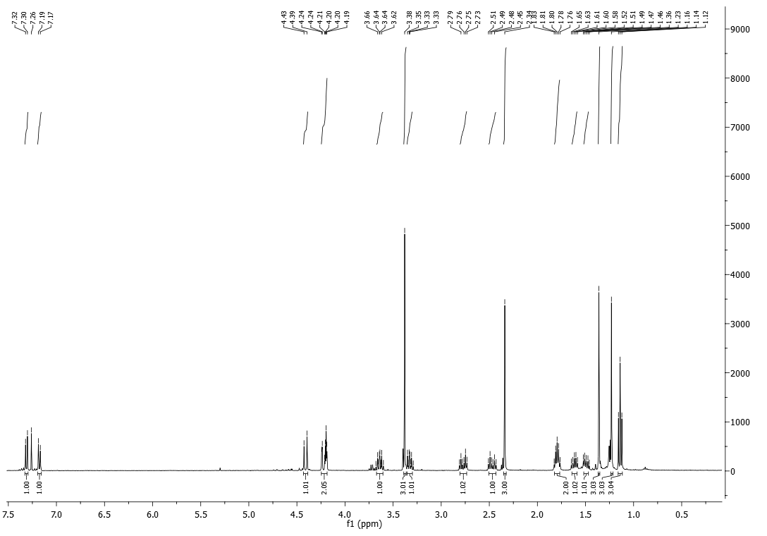
Spectra 1. ¹H NMR spectrum of Olicleistanone (1) (CDCl₃, 400 MHz).

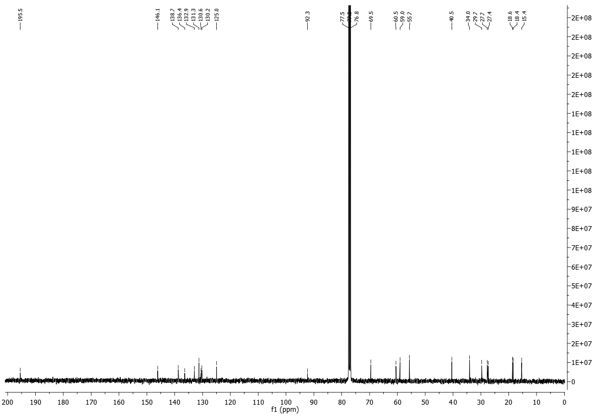
Spectra 2. ¹³C NMR spectrum of Olicleistanone (1) (CDCl₃, 100 MHz).
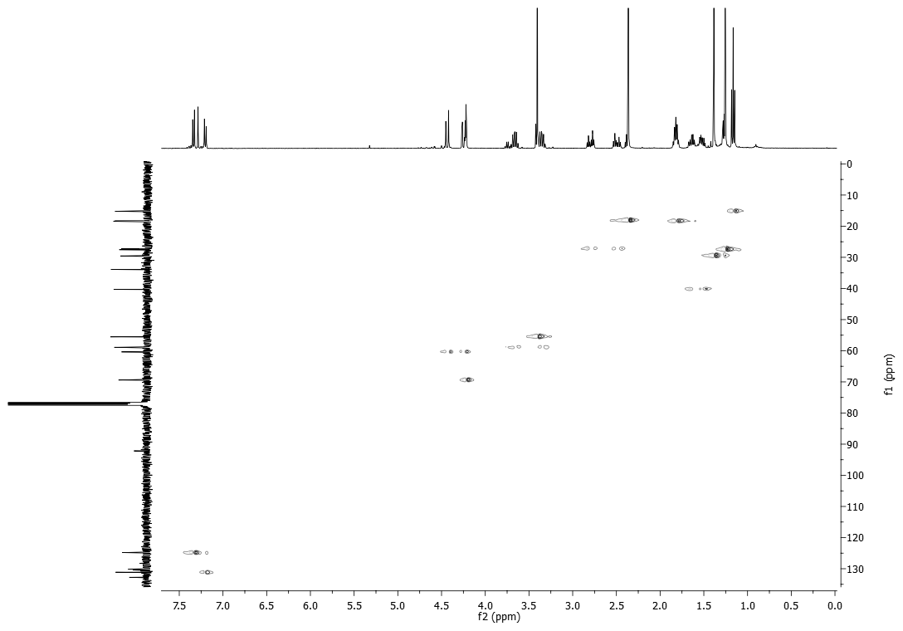
Spectra 3. HSQC spectrum of Olicleistanone (1) (CDCl₃, 400/100 MHz).

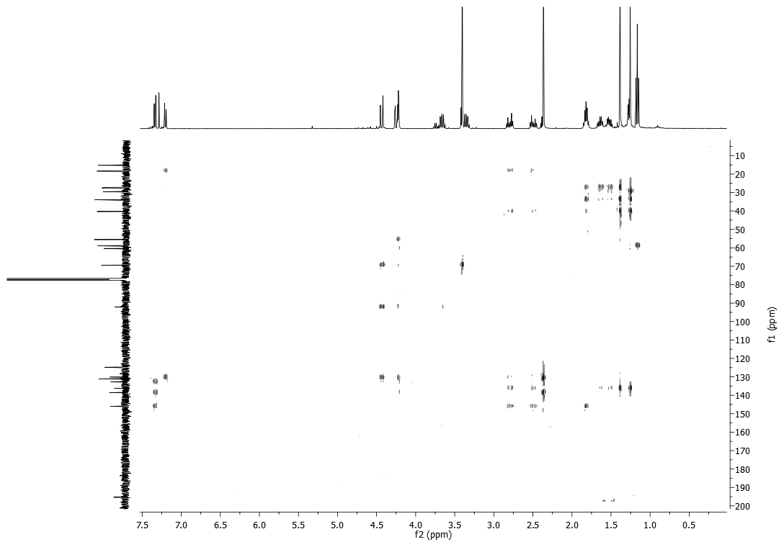
Spectra 4. HMBC spectrum of Olicleistanone (1) (CDCl₃, 400/100 MHz).
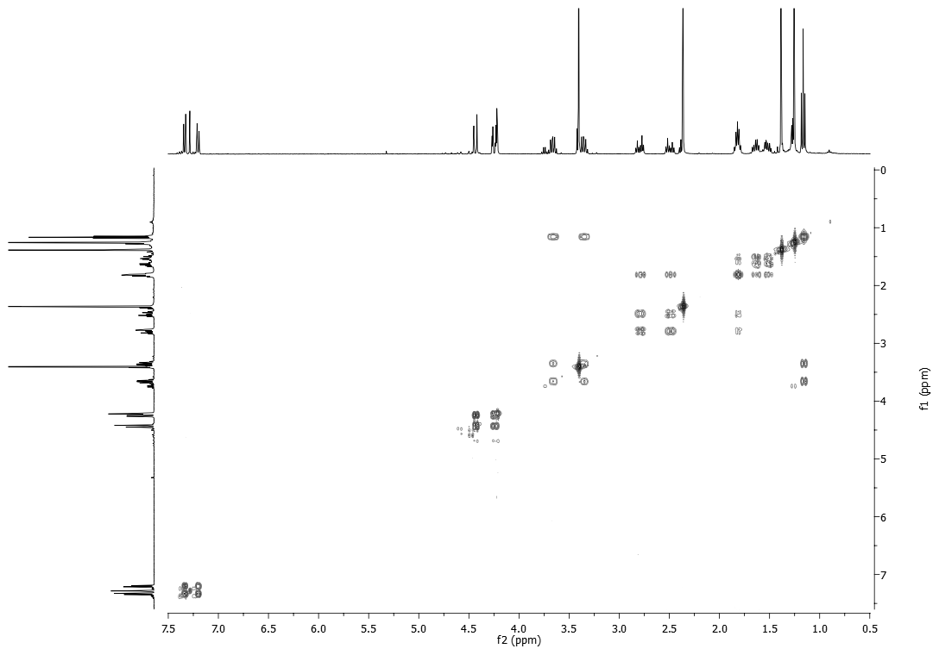
Spectra 5. COSY spectrum of Olicleistanone (1) (CDCl₃, 400 MHz).

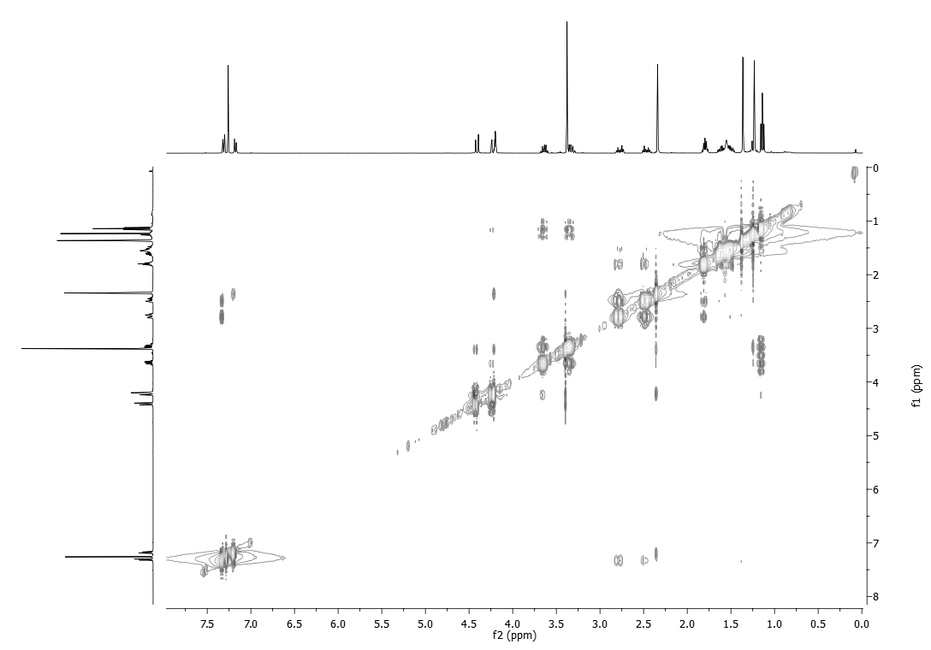
Spectra 6. NOESY spectrum of Olicleistanone (1) (CDCl3, 400 MHz).
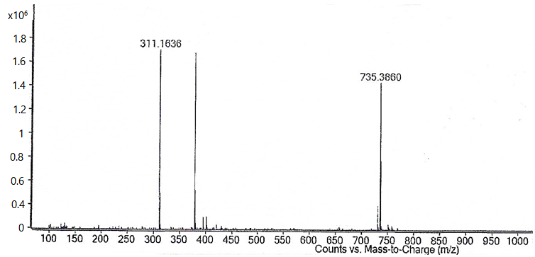
Spectra 7. HRESI-MS spectrum of Olicleistanone (1).

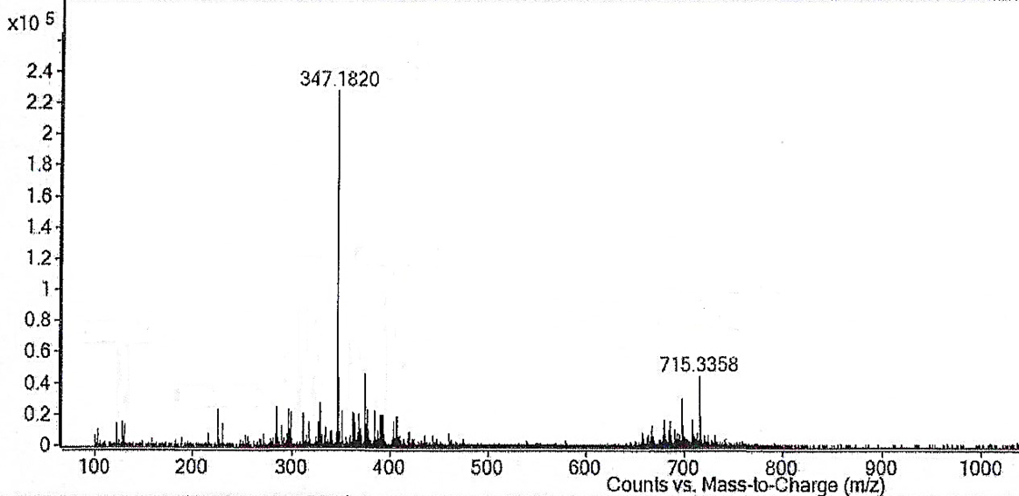
Spectra 8. HRESI-MS spectrum of Sphaeropsidin A (2).

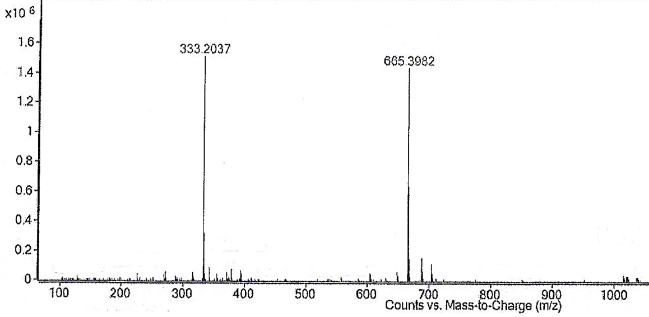
Spectra 9. HRESI-MS spectrum of Sphaeropsidin C (3).

