Outstanding fuel cell performance of a fully platinum-free electrocatalysts using a
cost-effective catalyst support material
Priji Chandran and Sundara Ramaprabhu*

Alternative Energy and Nanotechnology Laboratory (AENL), Nano-Functional Materials and Technology Centre (NFMTC), Department of Physics, Indian Institute of Technology Madras, Chennai, Tamil Nadu, 600036, India.
*Email: ramp@iitm.ac.in

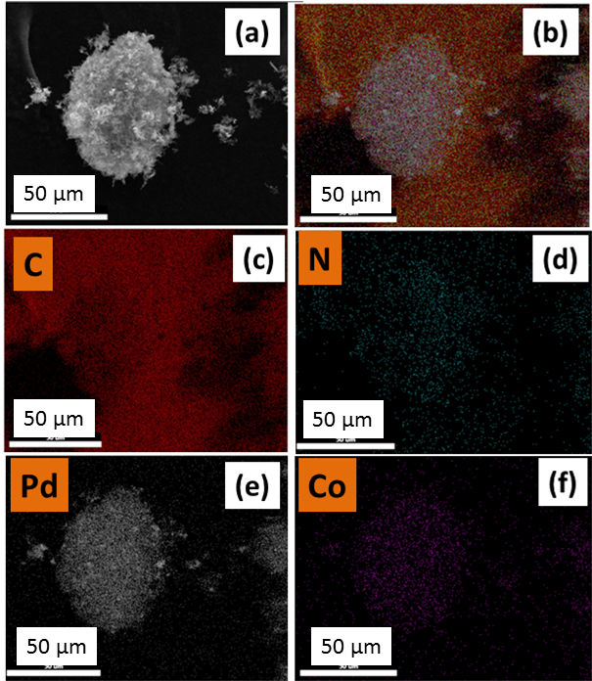
Figure S1: (a) SEM image and elemental mapping showing (b) overlay, (c-f) different elements present in the sample Pd₃Co/NCNS.

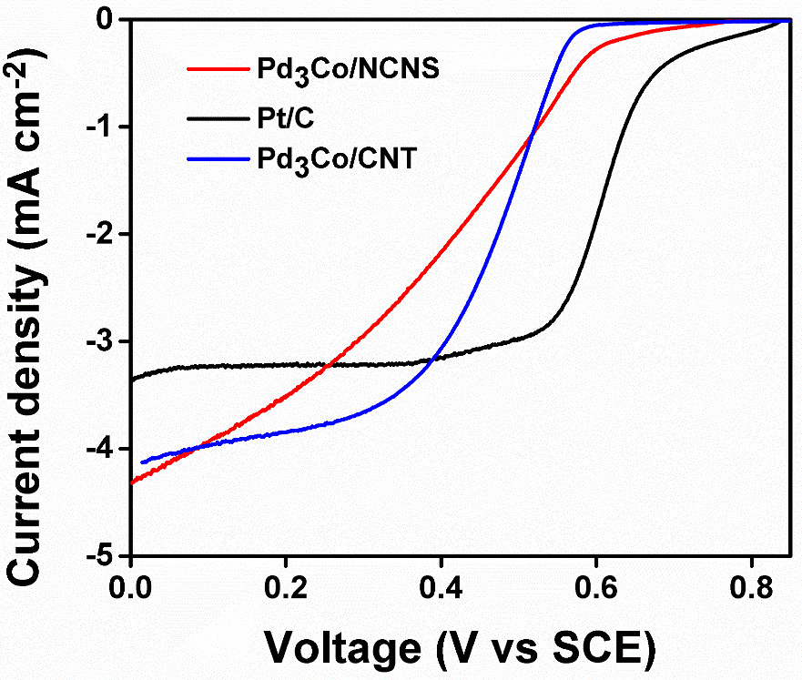
Figure S2: LSV curve of Pd₃Co/NCNS, Pd₃Co/CNT, Pt/C.

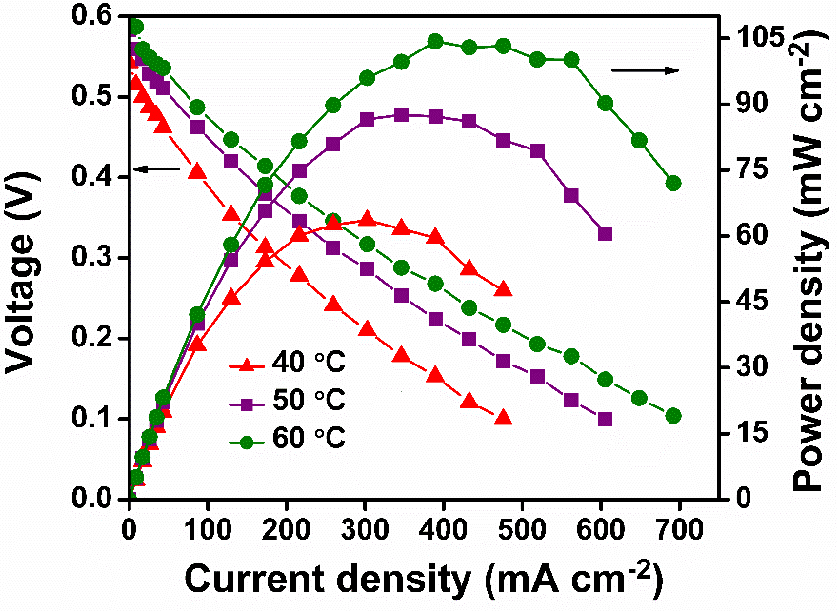
Figure S3: Polarization curves of Pd/NCNS as both anode and cathode electrocatalyst at 40 ⁰C,
50 ⁰C and 60 ⁰C temperature.

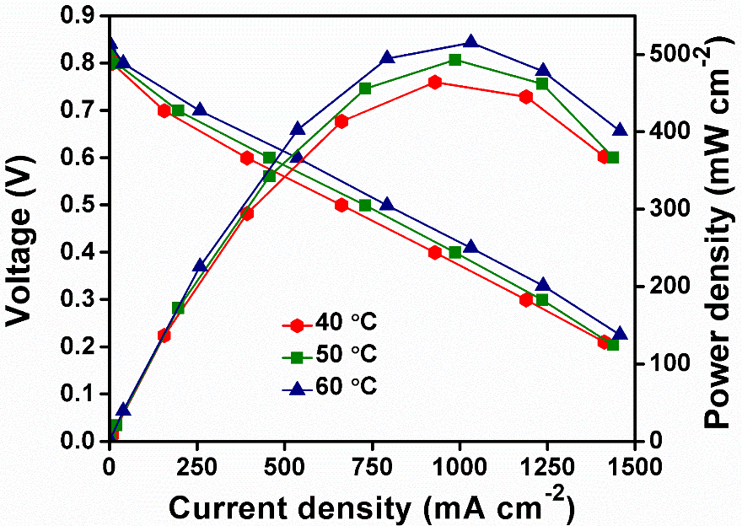
Figure S4: Polarization curves of Pt/C as both anode and cathode electrocatalyst at 40 ⁰C,
50 ⁰C and 60 ⁰C temperature.

