Efficient pyrazole moiety-containing ligands for Cu-catalyzed O-arylation of phenols

Yingying Zhao,ª Xiangyong Wang,ª Ryo Kaneyama,ª Koichi Kodama,ª and Takuji Hirose^{*a}

ªGraduate School of Science and Engineering, Saitama University, 255 Shimo-Okubo, Sakura-ku, Saitama 338-8570, Japan.
*Corresponding author. E-mail: hirose@apc.saitama-u.ac.jp;
Fax: +81 48-858-3522.

Experimental Section:

Materials
………………………………………S2
Physical Methods
………………………………………S2
General procedure for the CuI-catalyzed diaryl ether formation
………………………………………S2
Table S2: Table S1: Coupling of 4-iodotoluene with p-cresol under the assistance of various N₂- and N₃-ligands.
………………………………………S7
Figure S3: MWD (molecular weight distribution) curve for polymer/oligomer obtained using 4-bromostyrene and p-cresol as substrates under the optimized conditions.
………………………………………S7
References
………………………………………S8
¹H and ¹³C NMR spectral charts.
………………………………………S9
FTIR spectrum of new compounds
………………………………………S24
MS spectrum of new compounds
………………………………………S25

Experimental Section
Materials
All commercial materials were used as received unless otherwise noted. 2-(1-Pyrazolyl)pyridine (L1) (≥ 98.0%, Tokyo Chemical Industry Co., Ltd.) and 2-(1-pyrazolyl)pyridine (L2) (≥ 98.0%, Tokyo Chemical Industry Co., Ltd.) were purchased. On the other hand, tris(pyrazol-2-yl)methane, (L3), tris(pyridin-2-yl)methane (L4), 1,1,1-tris(pyridin-2-yl)ethane (L5), tris(2-pyridyl)carbinol (L6) and Tris(2-pyridyl)methoxymethane (L7) were synthesized as reported in the literature.^{[1-3]}
Physical Methods
¹H and ¹³C NMR spectra were recorded on Bruker AV-300 or AV-400 spectrometers. The chemical shifts of the products were reported in ppm with reference to Me₄Si as an internal standard in CDCl₃. IR spectra were recorded by a JASCO FTIR-400. Mass spectrometry were recorded on a Autoflex Ⅲ Bruker using MALDI mode.
General procedure for the CuI-catalyzed diaryl ether formation
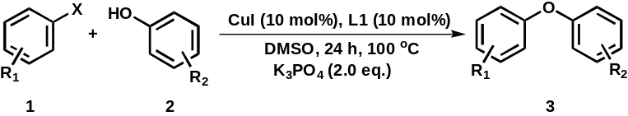
A 30 mL Schlenk flask equipped with a Teflon-coated magnetic stirring bar was evacuated and backfilled with nitrogen; this sequence was repeated three times. The equipment was then charged with CuI (19.0 mg, 0.1 mmol), ligand (0.1 mmol), K₃PO₄ (424.5 mg, 2.0 mmol), aryl halide (1.0 mmol), and phenol (1.5 mmol) in DMSO (7.0 mL) and the resulting solution was stirred at 100 °C for 24 h. After it had cooled to room temperature, the mixture was diluted with 20 mL of ethyl acetate and filtered. The filter cake was washed three times with ethyl acetate (3 × 10 mL) and filtered. The filtrate was collected and extracted with distilled water (3 × 20 mL). The organic layer was collected, dried over anhydrous Na₂SO₄, and concentrated under reduced pressure. The residue was purified using preparative thin layer chromatography (PTLC) (hexane : ethyl acetate = 50 : 1 unless otherwise specified) to afford the corresponding diaryl ether product.

All products gave the consistent spectroscopic data with those reported previously.^{[1-4]}
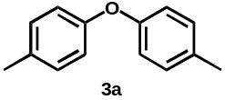
4, 4’-Dimethyldiphenyl ether
Following the general procedure, 3a was prepared from 4-iodotoluene and p-cresol as white solid (178.2 mg, 90% yield). ¹H NMR (400 MHz, CDCl₃) δ: 7.14-7.12 (d, J = 8.0 Hz, 4H_{ar}), 6.92-6.89 (d, J = 8.8 Hz, 4H_{ar}), 2.34 (s, 6H, CH₃) ppm. ¹³C NMR (100 MHz, CDCl₃) δ: 155.3, 132.4, 130.1, 118.6, 20.7.
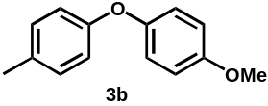
4-Methyl-4’-methoxydiphenyl ether
Following the general procedure, 3b was prepared from 4-iodotoluene and 4-methoxyphenol as white solid (188.5 mg, 88% yield). ¹H NMR (400 MHz, CDCl₃) δ: 7.12-7.10 (t, 2H_{ar}), 6.98-6.96 (d, J = 9.2 Hz, 2H_{ar}), 6.89-6.86 (m, 4H_{ar}), 3.81 (s, 3H, CH₃) 2.31 (s, 3H, CH₃) ppm. ¹³C NMR (100 MHz, CDCl₃) δ: 156.1, 155.6, 150.8, 132.0, 130.1, 120.3, 117.8, 114.8, 55.7, 20.6 ppm.
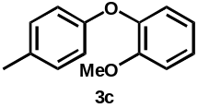
2-Methoxy-4’-methyldiphenyl ether
Following the general procedure, 3c was prepared from 4-iodotoluene and 2-methoxyphenol as white solid (193.3 mg, 90% yield). ¹H NMR (400 MHz, CDCl₃) δ: 7.13-7.09 (m, 3H_{ar}), 7.02-7.00 (m, 1H_{ar}), 6.95-6.93 (m, 2H_{ar}), 6.91-6.87 (m, 2H_{ar}), 3.87 (s, 3H, CH₃), 2.33 (s, 3H, CH₃) ppm. ¹³C NMR (100 MHz, CDCl₃) δ: 155.5, 151.3, 145.8, 132.1, 130.0, 124.3, 121.1, 120.4, 117.5, 112.8, 56.0, 20.6 ppm.
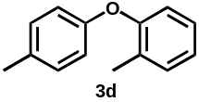
4, 2’-Dimethyldiphenyl ether
Following the general procedure, 3d was prepared from 2-methyl-1-iodobenzene and p-cresol as colorless oil (45.6 mg, 23% yield). ¹H NMR (400 MHz, CDCl₃) δ: 7.29-7.27 (d, J = 7.2 Hz, 1H_{ar}), 7.21-7.14 (m, 3H_{ar}), 7.10-7.06 (m, 1H_{ar}), 6.93 (d, J = 1.2 Hz, 1H_{ar}), 6.91-6.85 (m, 2H_{ar}), 2.37 (s, 3H, CH₃), 2.31 (s, 3H, CH₃) ppm. ¹³C NMR (100 MHz, CDCl₃) δ: 155.6, 155.0, 131.9, 131.4, 130.2, 129.7, 127.1, 123.6, 119.2, 117.5, 20.6, 16.2 ppm.
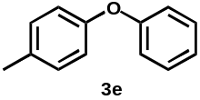
4-Methyldiphenyl ether
Following the general procedure, 3e was prepared from 4-iodotoluene and phenol as colorless oil (128.8 mg, 70% yield). ¹H NMR (400 MHz, CDCl₃) δ: 7.37-7.33 (m, 2H_{ar}), 7.27-7.16 (m, 2H_{ar}), 7.12-7.08 (m, 1H_{ar}), 7.04-7.03 (m, 2H_{ar}), 7.02-6.95 (m, 2H_{ar}), 2.37 (s, 3H, CH₃) ppm. ¹³C NMR (100 MHz, CDCl₃) δ: 157.9, 154.8, 132.9, 130.3, 129.7, 122.8, 119.2, 118.4, 20.7 ppm.
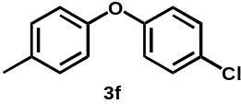
4-Methyl-4’-chlorodiphenyl ether
Following the general procedure, 3f was prepared from 4-chloro-1-iodobenzene and p-cresol as white solid (192.4 mg, 88% yield). ¹H NMR (400 MHz, CDCl₃) δ: 7.29-7.26 (m, 2H_{ar}), 7.17-7.15 (m, 2H_{ar}), 6.93-6.90 (m, 4H_{ar}), 2.35 (s, 3H, CH₃) ppm. ¹³C NMR (100 MHz, CDCl₃) δ: 156.5, 154.4, 133.4, 130.4, 129.6, 127.7, 119.5, 119.1, 20.7 ppm.
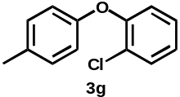
4-Methyl-2’-chlorodiphenyl ether
Following the general procedure, 3g was prepared from 2-chloro-1-iodobenzene and p-cresol as colorless oil (60.3 mg, 28% yield). ¹H NMR (400 MHz, CDCl₃) δ: 7.49-7.46 (m, 1H_{ar}), 7.24-7.15 (m, 3H_{ar}), 7.10-7.06 (m, 1H_{ar}), 6.98-6.96 (m, 1H_{ar}), 6.93-6.90 (m, 1H_{ar}), 2.36 (s, 3H, CH₃) ppm. ¹³C NMR (100 MHz, CDCl₃) δ: 154.6, 153.1, 133.0, 130.7, 130.3, 127.9, 125.5, 124.2, 120.2, 118.2, 20.7 ppm.
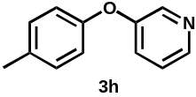
3-(4-Methylphenoxy)pyridine
Following the general procedure, 3h was prepared from 4-iodotoluene and 3-hydroxypyridine as pale brown oil (105.7 mg, 57% yield). ¹H NMR (400 MHz, CDCl₃) δ: 8.39 (s, 1H_{ar}), 8.35-8.33 (m, 1H_{ar}), 7.28-7.24 (m, 2H_{ar}), 7.19-7.17 (t 2H_{ar}), 6.95-6.93 (m, 2H_{ar}), 2.36 (s, 3H, CH₃) ppm. ¹³C NMR (100 MHz, CDCl₃) δ: 154.4, 153.8, 143.9, 141.0, 133.8, 130.5, 124.8, 124.0, 119.2, 20.7 ppm..
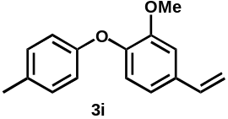
1-(4-Methylphenoxy)-2-methoxy-4-(1-ethenyl)benzene
Following the general procedure, 3i was prepared from 4-iodotoluene and, 4-ethenyl-2-methoxy-phenol as colorless oil (60.4 mg, 30% yield). ¹H NMR (400 MHz, CDCl₃) δ: 7.10 (d, J = 0.4 Hz, 2H_{ar}), 7.07 (d, J = 1.6 Hz, 1H_{ar}), 6.97-6.94 (m, 1H_{ar}), 6.90-6.87 (m, 3H_{ar}), 6.74-6.67 (m, 1H_{ar}), 5.72-5.22 (m, 2H, CH₂), 3.90 (s, 3H, CH₃), 2.33 (s, 3H, CH₃) ppm. ¹³C NMR (100 MHz, CDCl₃) δ: 155.4, 151.1, 145.7, 136.4, 134.0, 132.2, 130.0, 120.1, 119.3, 117.6, 113.1, 110.2, 56.0, 20.6 ppm. FTIR (cm⁻¹) : 3003, 2934, 1696, 1612, 1596, 1504, 1463, 1413, 1250, 1123, 1034, 907, 860, 816, 804, 500. EI-MS: calcd for C₁₆H₁₆O₂ [M+H]⁺ 241.12, found 241.13.
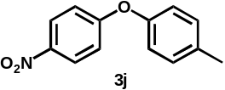
4-Methyl-4’-nitrodiphenyl ether
Following the general procedure, 3j was prepared from 4-nitro-1-iodobenzene and p-cresol as yellow oil (203.5 mg, 89% yield). ¹H NMR (400 MHz, CDCl₃) δ: 8.18-8.16 (m, 2H_{ar}), 7.23-7.21 (d, J = 8.4 Hz, 2H_{ar}), 6.99-6.97 (m, 4H_{ar}), 2.38 (s, 3H, CH₃), ppm. ¹³C NMR (100 MHz, CDCl₃) δ: 163.8, 152.3, 142.5, 135.2, 130.8, 125.9, 120.5, 116.8, 20.8 ppm.
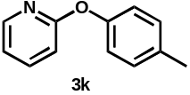
2-(4-Methylphenoxy)pyridine
Following the general procedure, 3k was prepared from 2-iodopyridine and p-cresol as pale yellow oil (175.8 mg, 95% yield). ¹H NMR (400 MHz, CDCl₃) δ: 8.22-8.20 (m, 1H_{ar}), 7.69-7.65 (m, 1H_{ar}), 7.23-7.21 (d, J = 8.0 Hz, 2H_{ar}), 7.07-7.04 (m, 2H_{ar}), 6.99-6.96 (m, 1H_{ar}), 6.91-6.89 (m, 1H_{ar}), 2.38 (s, 3H, CH₃) ppm. ¹³C NMR (100 MHz, CDCl₃) δ: 164.1, 151.8, 147.8, 139.3, 134.3, 130.2, 121.1, 118.2, 111.3, 20.9 ppm.
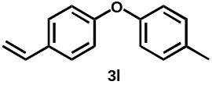
1-Ethenyl-4-(4-methylphenoxy)benzene
A 30 mL Schlenk flask equipped with a Teflon-coated magnetic stirring bar was evacuated and backfilled with nitrogen (this sequence was repeated three times). The equipment was then charged with CuI (19.0 mg, 0.1 mmol), L1 (14.5 mg, 0.1 mmol), K₃PO₄ (424.5 mg, 2.0 mmol), 4-bromostyrene (183.1 mg, 1.0 mmol) and p-cresol (162.2 mg, 1.5 mmol) in DMSO (7.0 mL) was stirred at 100 ºC for 24 h. After cooling to room temperature, the mixture was poured into distilled water (50 mL) and some black solid precipitated. After filtration using PTFE membrane filter (H050A047A, Advantec, Tokyo), the filtered brown solid was washed with MeOH and THF. The combined organic layer was dried over anhydrous Na₂SO₄ and concentrated, and the residue was subjected to GPC analysis (Figure S1).
The filtrate was concentrated to 20 mL under reduced pressure and extracted with ethyl acetate (3×10 mL). The organic layer was collected, dried over anhydrous Na₂SO₄, and concentrated under reduced pressure. The residue was purified by preparative thin layer chromatography (PTLC) (hexane:ethyl acetate = 50:1) and got the product as a white solid (27.7 mg, 13% yield). ¹H NMR (400 MHz, CDCl₃) δ: 7.37-7.34 (d, J = 8.4 Hz, 2H_{ar}), 7.15-7.13 (d, J = 8.0 Hz, 2H_{ar}), 6.94-6.91 (m, 4H_{ar}), 6.72-6.64 (m, 1H_{ar}), 5.67-5.62 (m, 2H, CH₂), 2.34 (s, 3H, CH₃) ppm. ¹³C NMR (100 MHz, CDCl₃) δ: 157.6, 154.6, 136.1, 133.0, 132.5, 130.2, 127.5, 119.1, 118.3, 112.6, 20.7 ppm. FTIR (cm⁻¹): 3065, 3032, 2975, 2934, 1630, 1591, 1507, 1242, 1200, 1111, 991, 901, 848, 822, 500. EI-MS: calcd for C₁₅H₁₄O [M+H]⁺ 211.11, found 211.13.
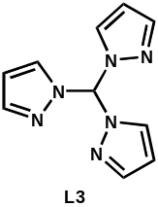
¹H NMR (400 MHz, CDCl₃) δ: 8.43 (s, 1H_{ar}), 7.69 (d, J = 1.2 Hz, 3H_{ar}), 7.60 (d, J = 2.8 Hz, 3H_{ar}), 6.39-6.38 (m, 3H_{ar}) ppm.
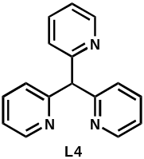
¹H NMR (300 MHz, CDCl₃) δ: 8.60-8.58 (m, 3H_{ar} ), 7.66-7.60 (m, 3H_{ar}), 7.34-7.31 (d, J = 10.4 Hz, 3H_{ar}), 7.17-7.13 (m, 3H_{ar}), 6.00 (s, 1H, CH).
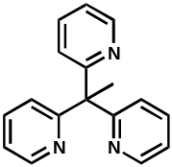
¹H NMR (300 MHz, CDCl₃) δ: 8.61-8.58 (m, 3H_{ar} ), 7.61-7.55 (m, 3H_{ar}), 7.15-7.07 (m, 6H_{ar}), 2.34 (s, 3H, CH).
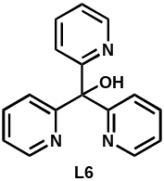
¹H NMR (300 MHz, CDCl₃) δ: 8.56-8.53 (m, 3H_{ar}), 7.75-7.64 (m, 6H_{ar}), 7.25 (s, 1H, OH), 7.21-7.16 (m, 3H_{ar}).
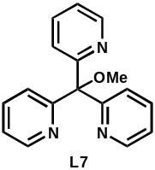
¹H NMR (300 MHz, CDCl₃) δ: 8.60-8.58 (m, 3H_{ar}), 7.73-7.64 (m, 6H_{ar}), 7.17-7.13 (m, 3H_{ar}), 3.28 (s, 3H, OCH₃ )

Table S2: Coupling of 4-iodotoluene with p-cresol under the assistance of various N₂- and N₃-ligands.ª
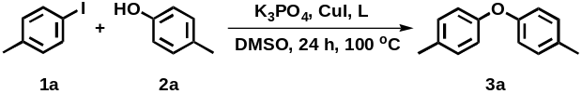
Entry | Ligand | Yield (%)^{b}
1 | No ligand | 55
2 | L1 | 90
3^{c} | L1 | 89
4 | L2 | 63
5 | L3 | 81
6 | L4 | 68
7 | L5 | 71
8 | L6 | 74
9 | L7 | 69
10 | L8 | 67
ªReaction conditions: 1a (1 mmol), 2a (1.5 mmol), CuI (0.1 mmol), ligand (0.1 mmol), K₃PO₄ (2.0 mmol), DMSO (7 mL), reaction time (24 h) and temperature (100 °C). ^{b}Isolated yield. ^{c}[CuI·L1]₂ 0.05 mmol.

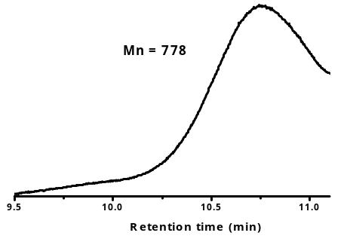
Figure S3: MWD (molecular weight distribution) curve for polymer/oligomer obtained using 4-bromostyrene and p-cresol as substrates under the optimized conditions.

References
- Niesel, J.; Pinto, A.; N’Dongo, H. W. P.; Merz, K.; Ott, I.; Gustb, R.; Schatzschneider U. Chem. Commun. 2008, 1798–1800.
- Maleckis, A.; Kampf, J. W.; Sanford, M. S. J. Am. Chem. Soc. 2013, 135, 6618−6625.
- Jonas R. T.; StackInorg, T. D. P. Inorg. Chem. 1998, 37, 6615−6629.
- Zhao, Y.; Wang, X.; Kodama, K.; Hirose, T. ChemistrySelect 2018, 3, 12620−12624.

¹H and ¹³C NMR spectral charts.
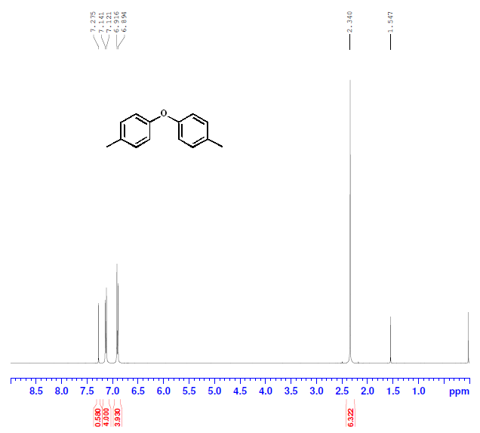
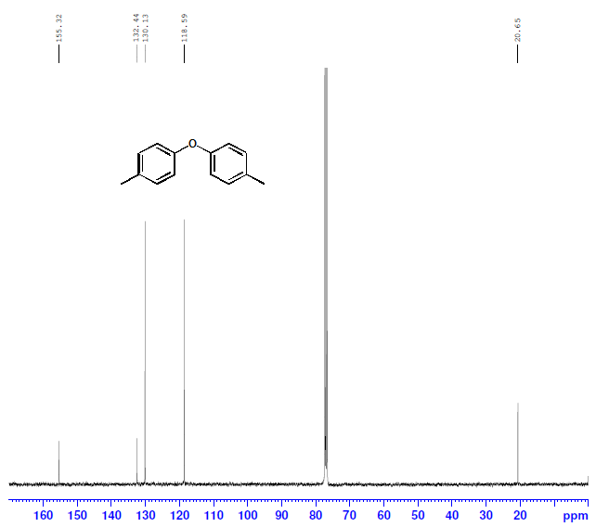
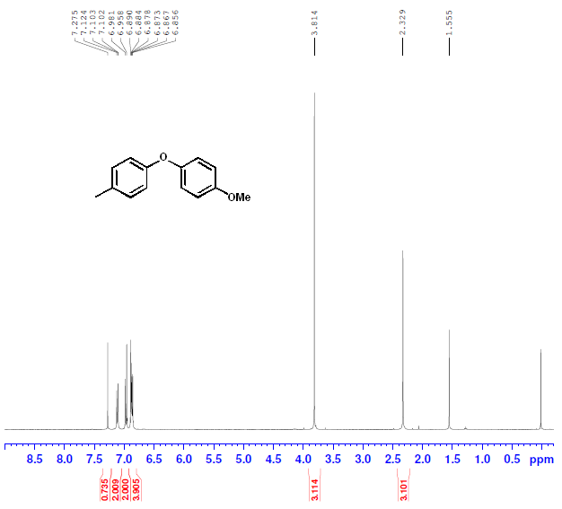
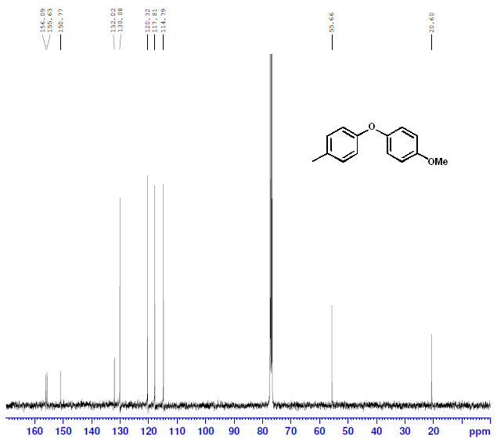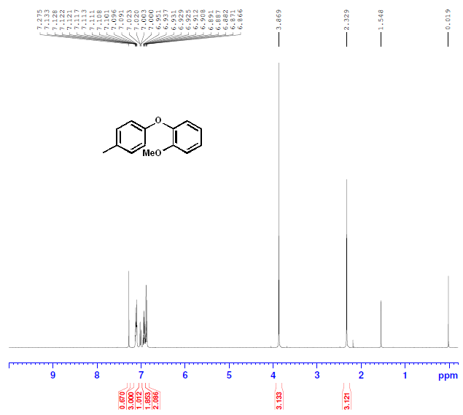
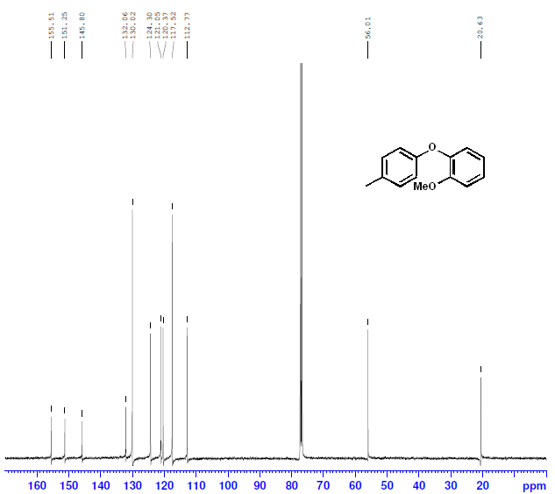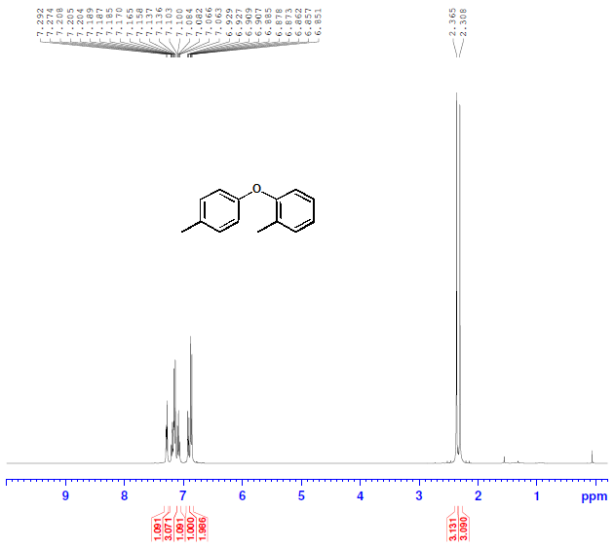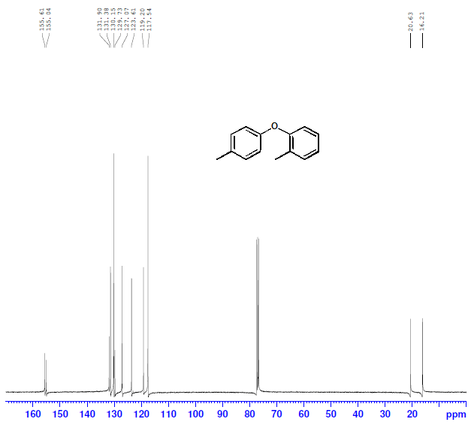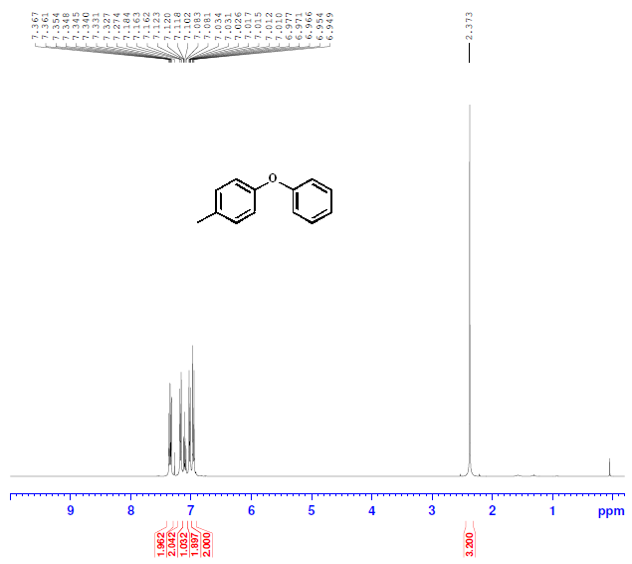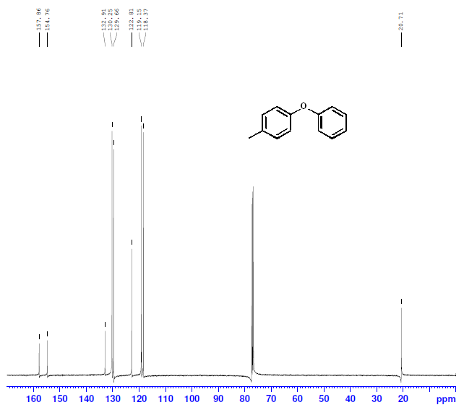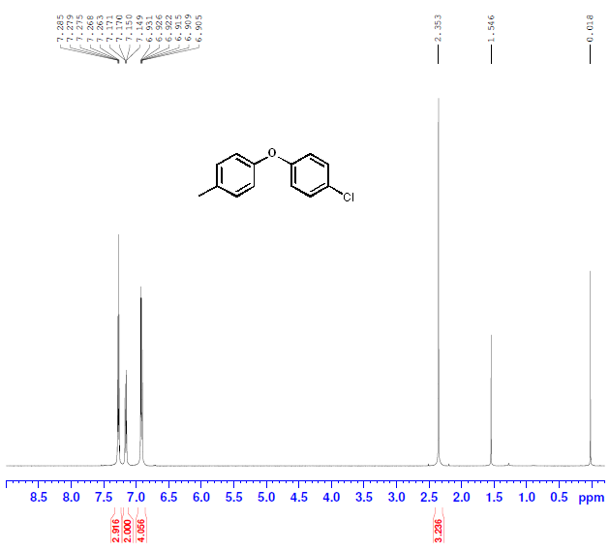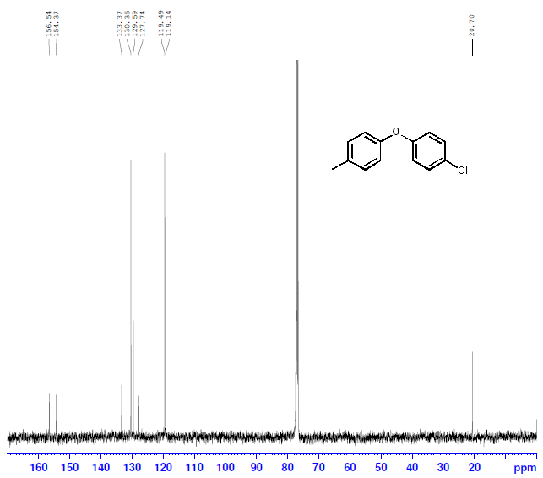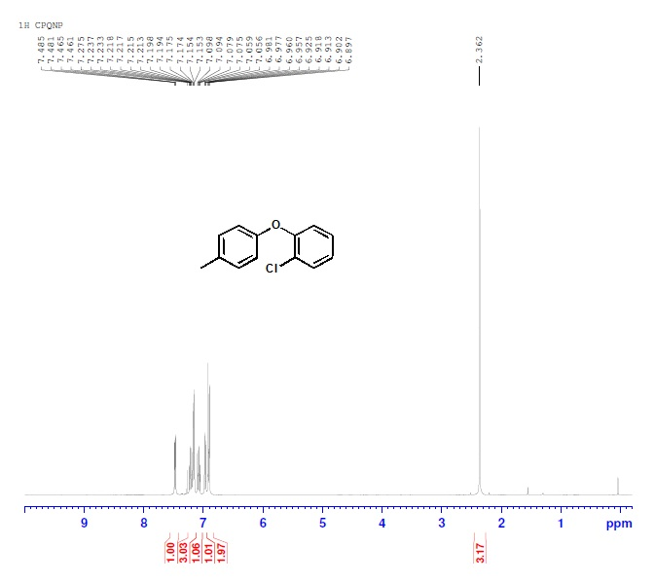
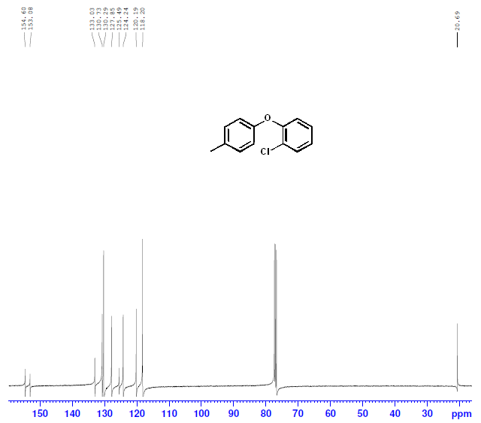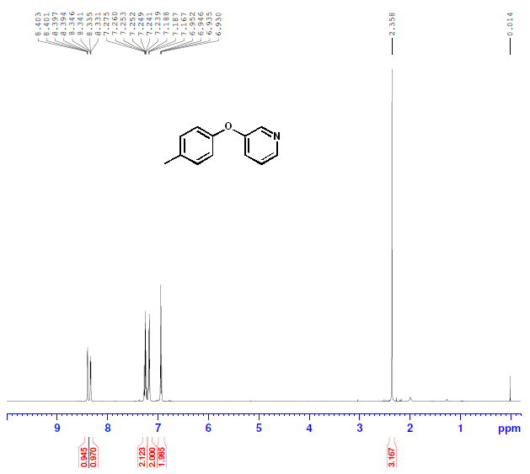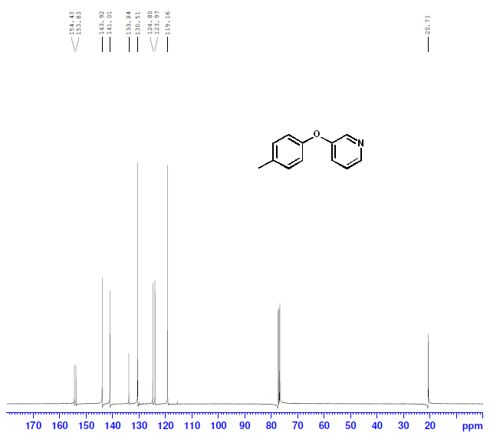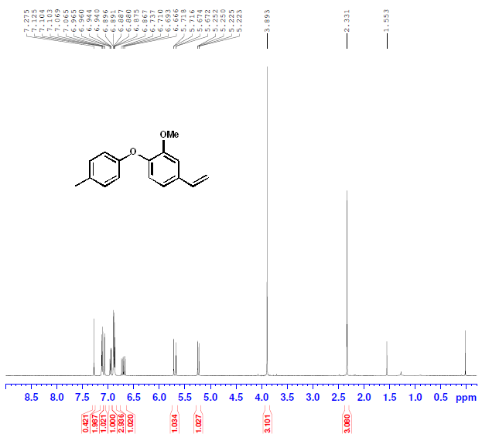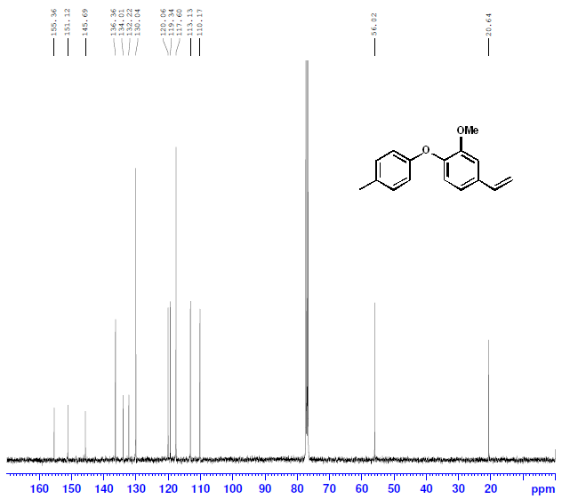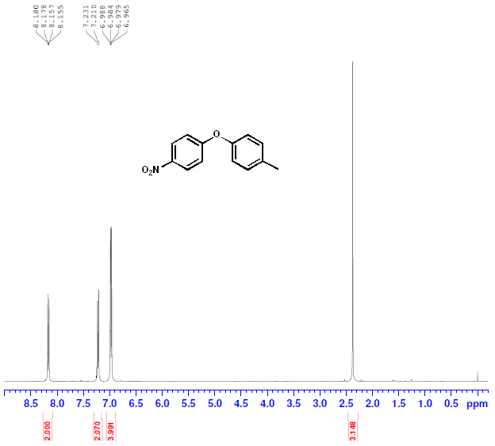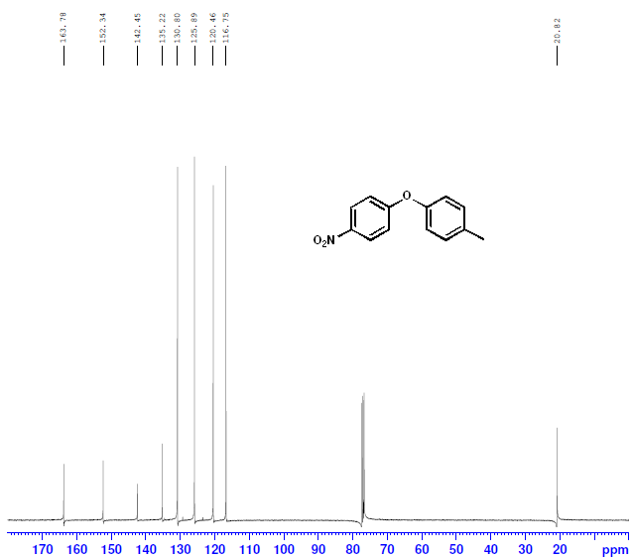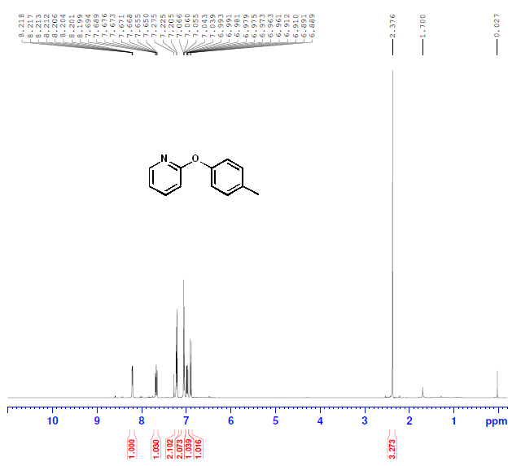
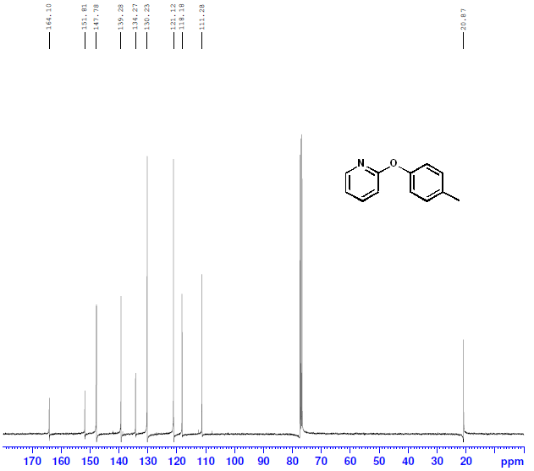
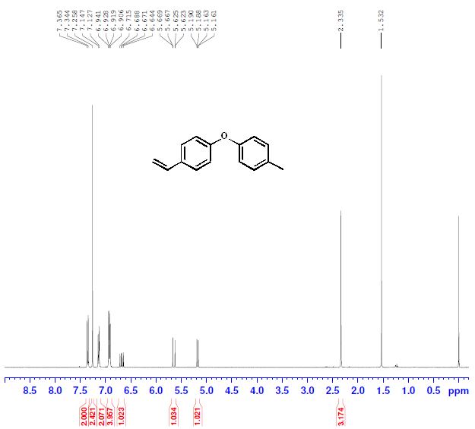
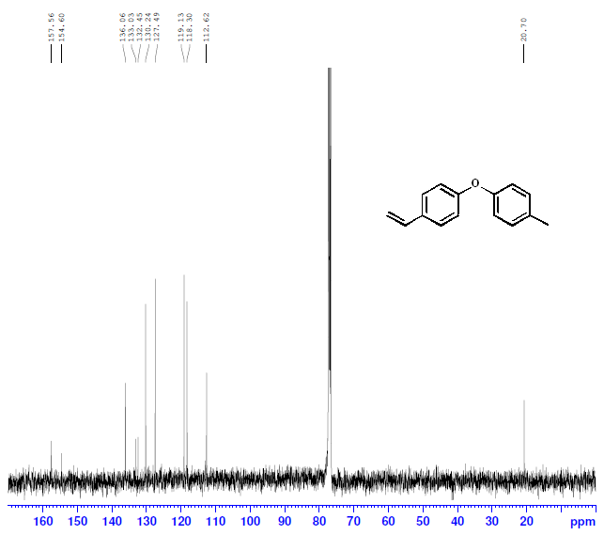
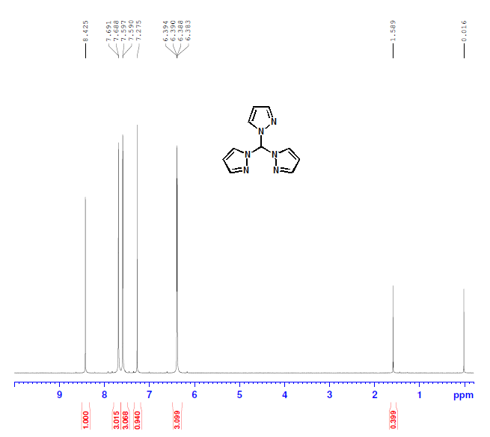

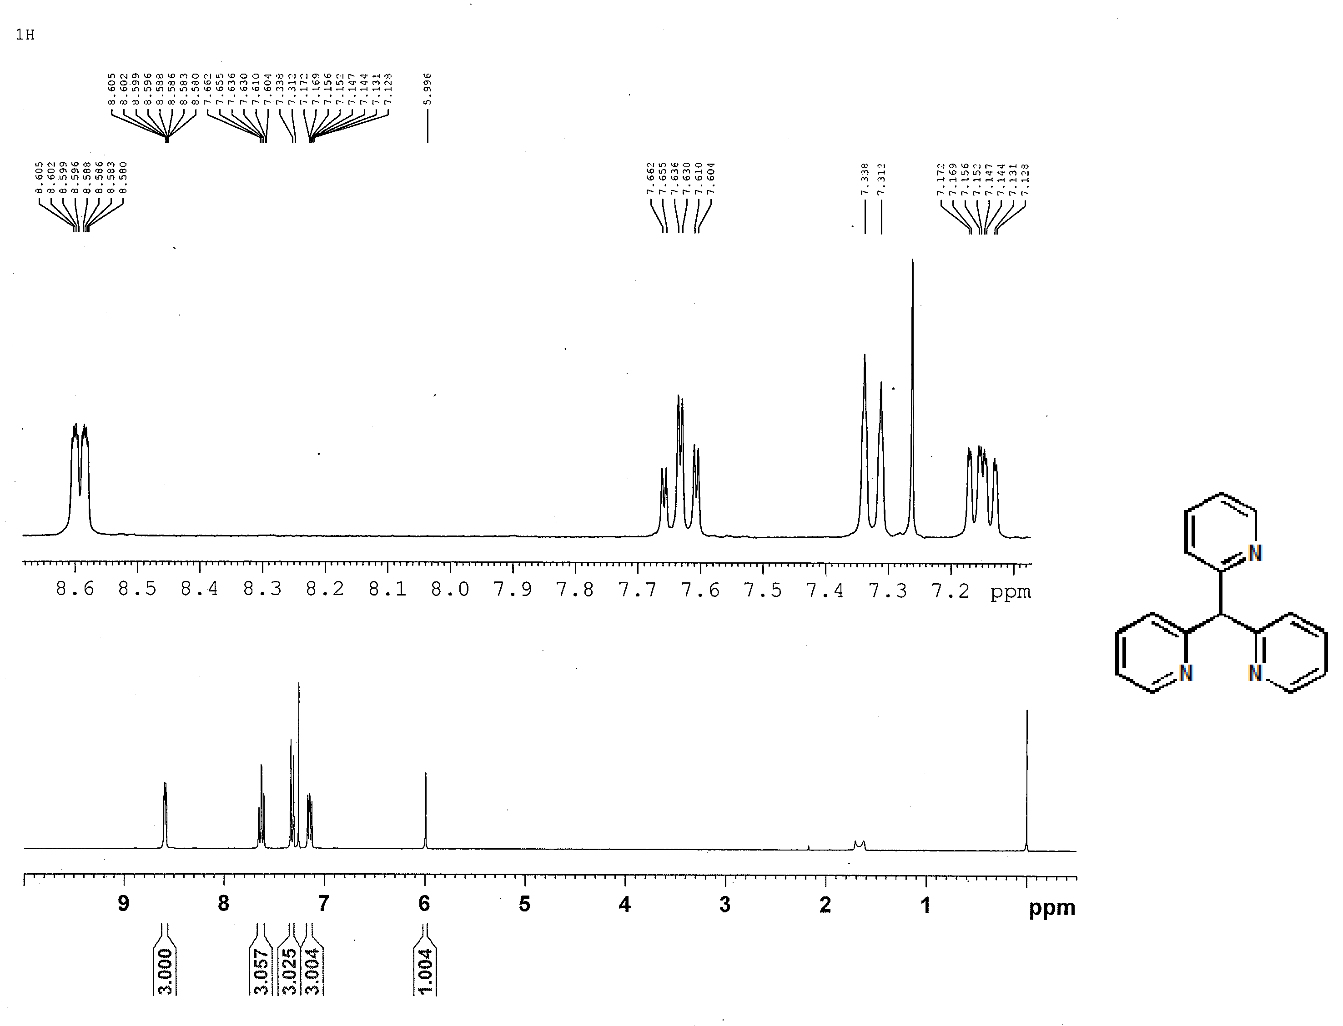
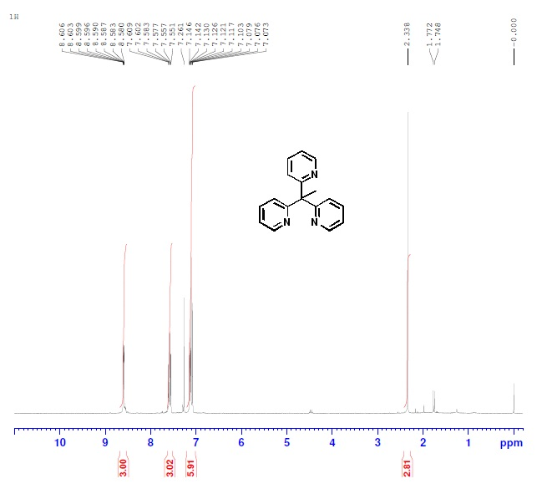
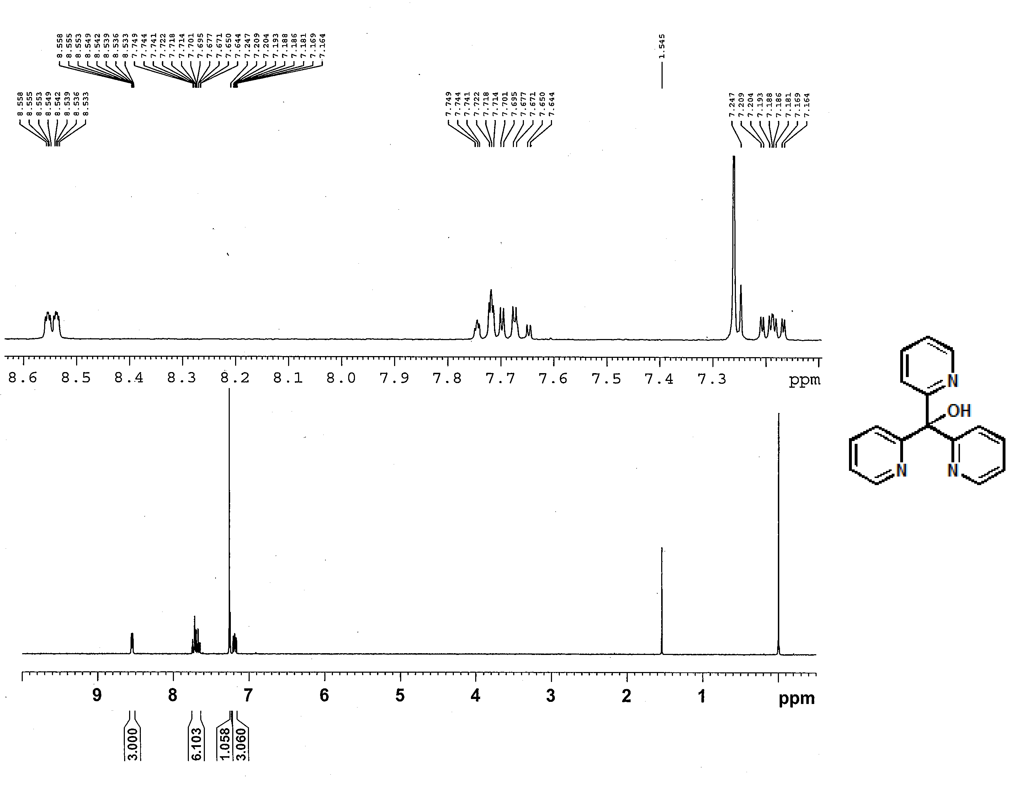
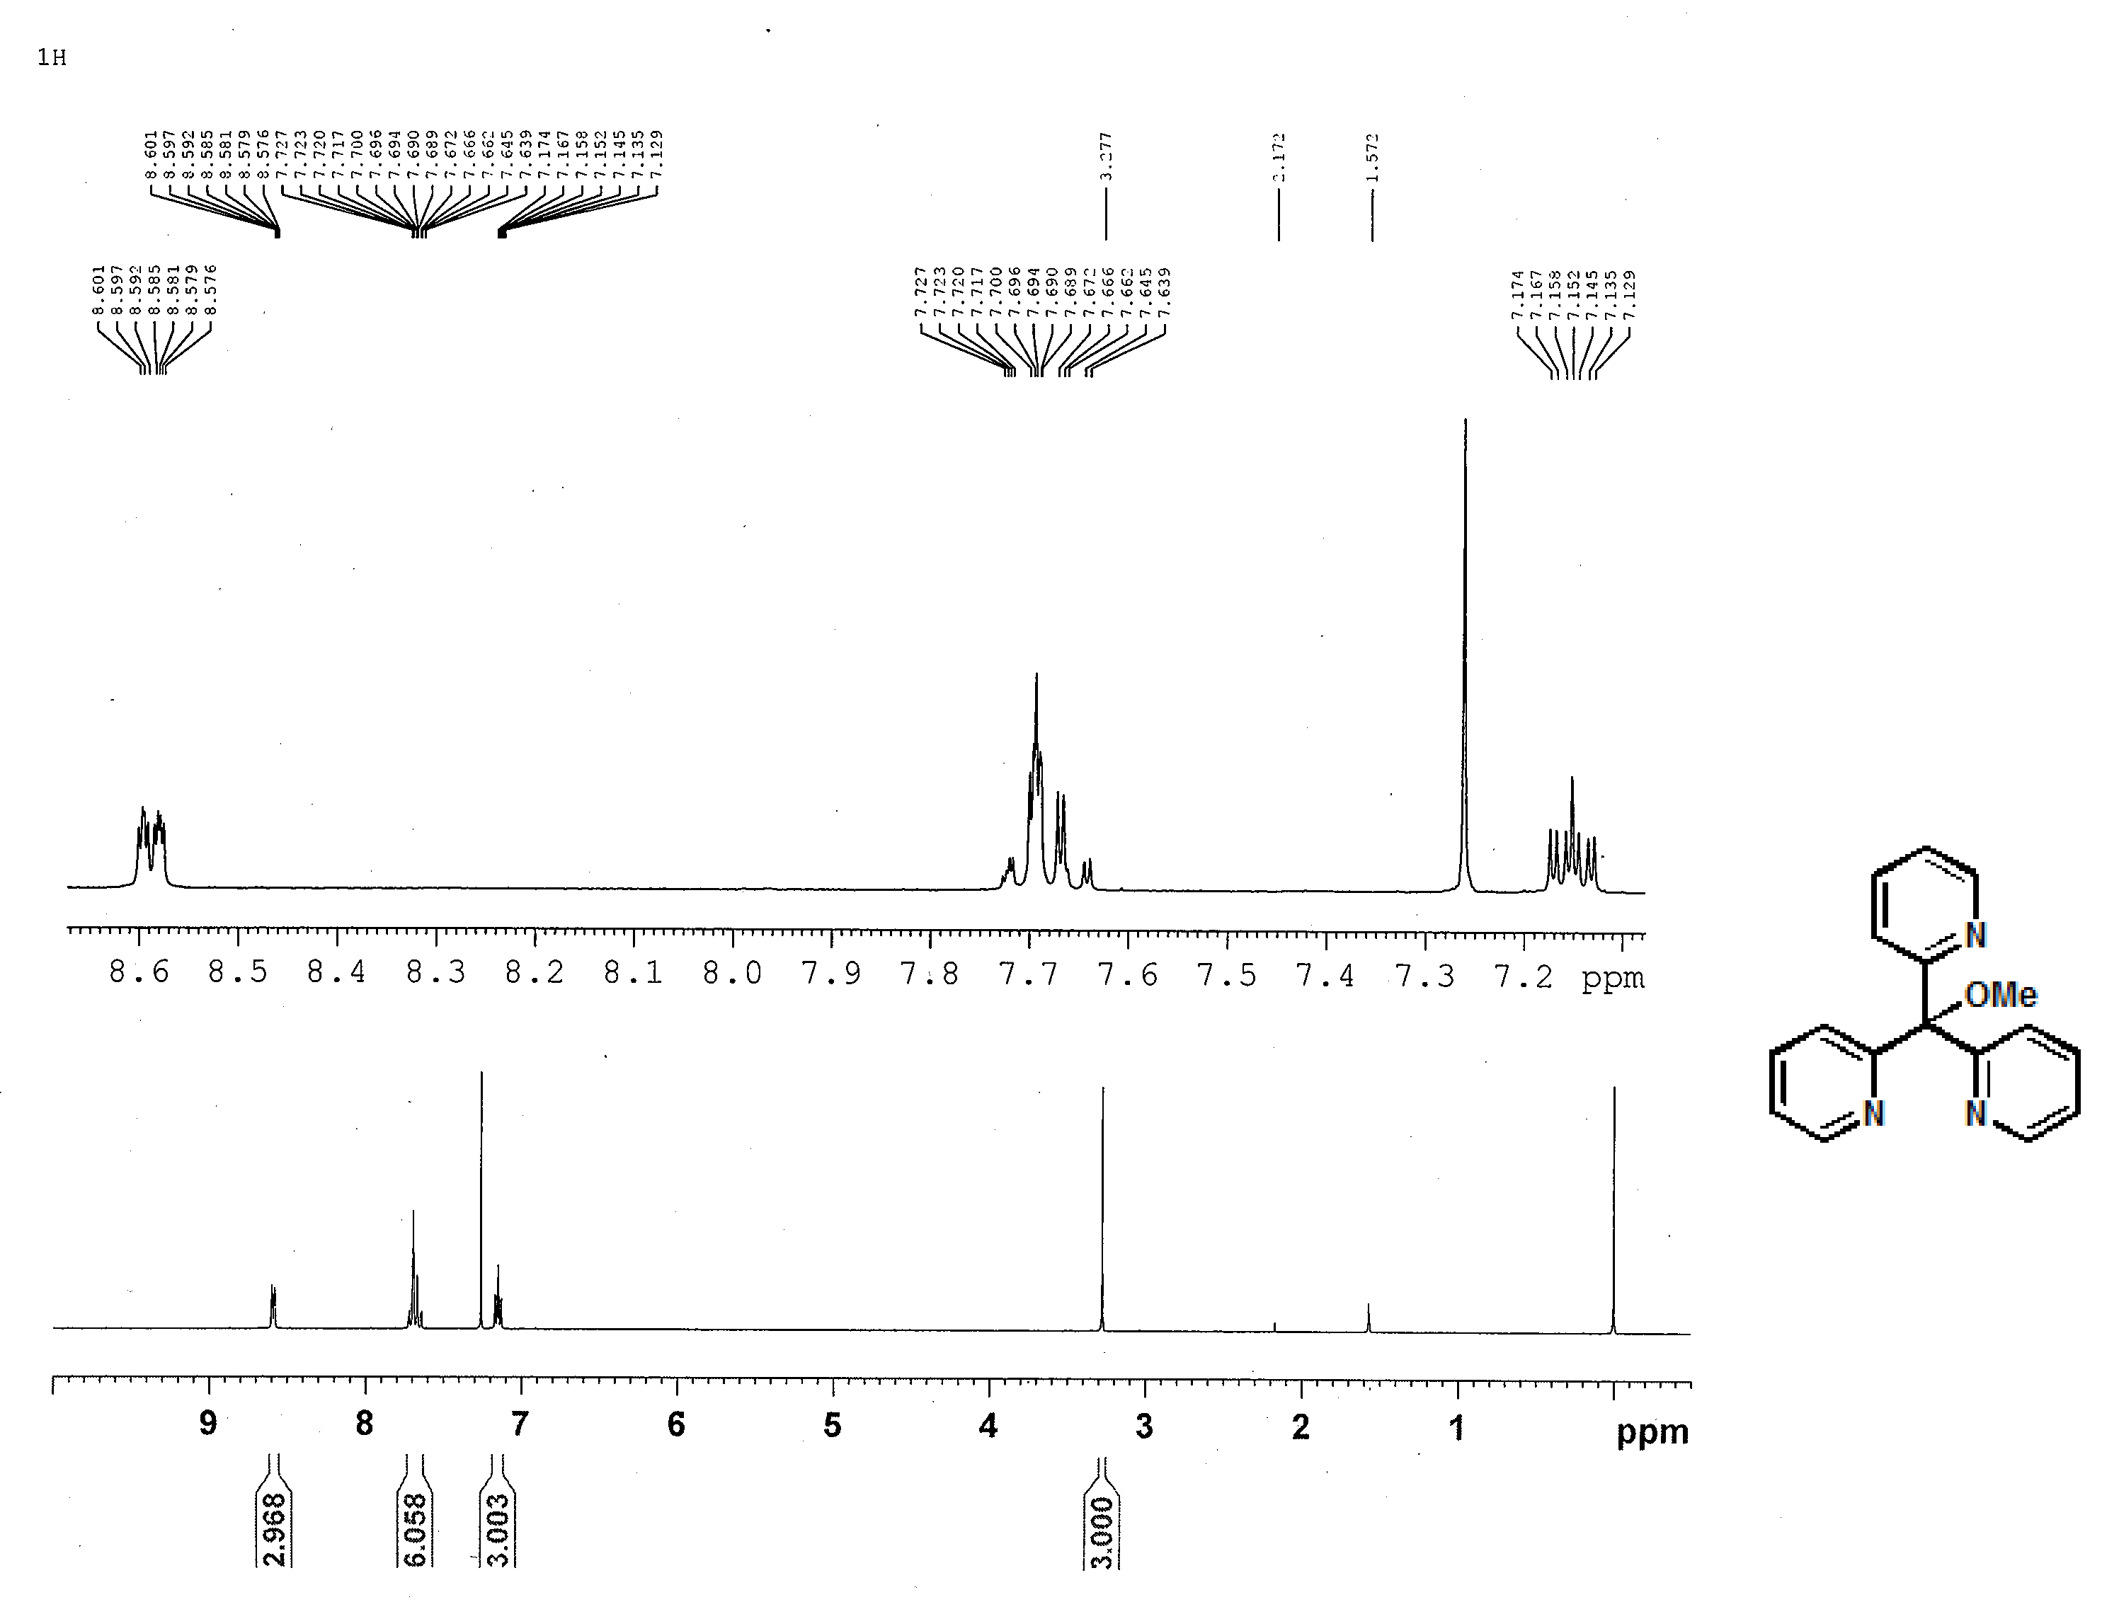

FTIR spectrum of new compounds
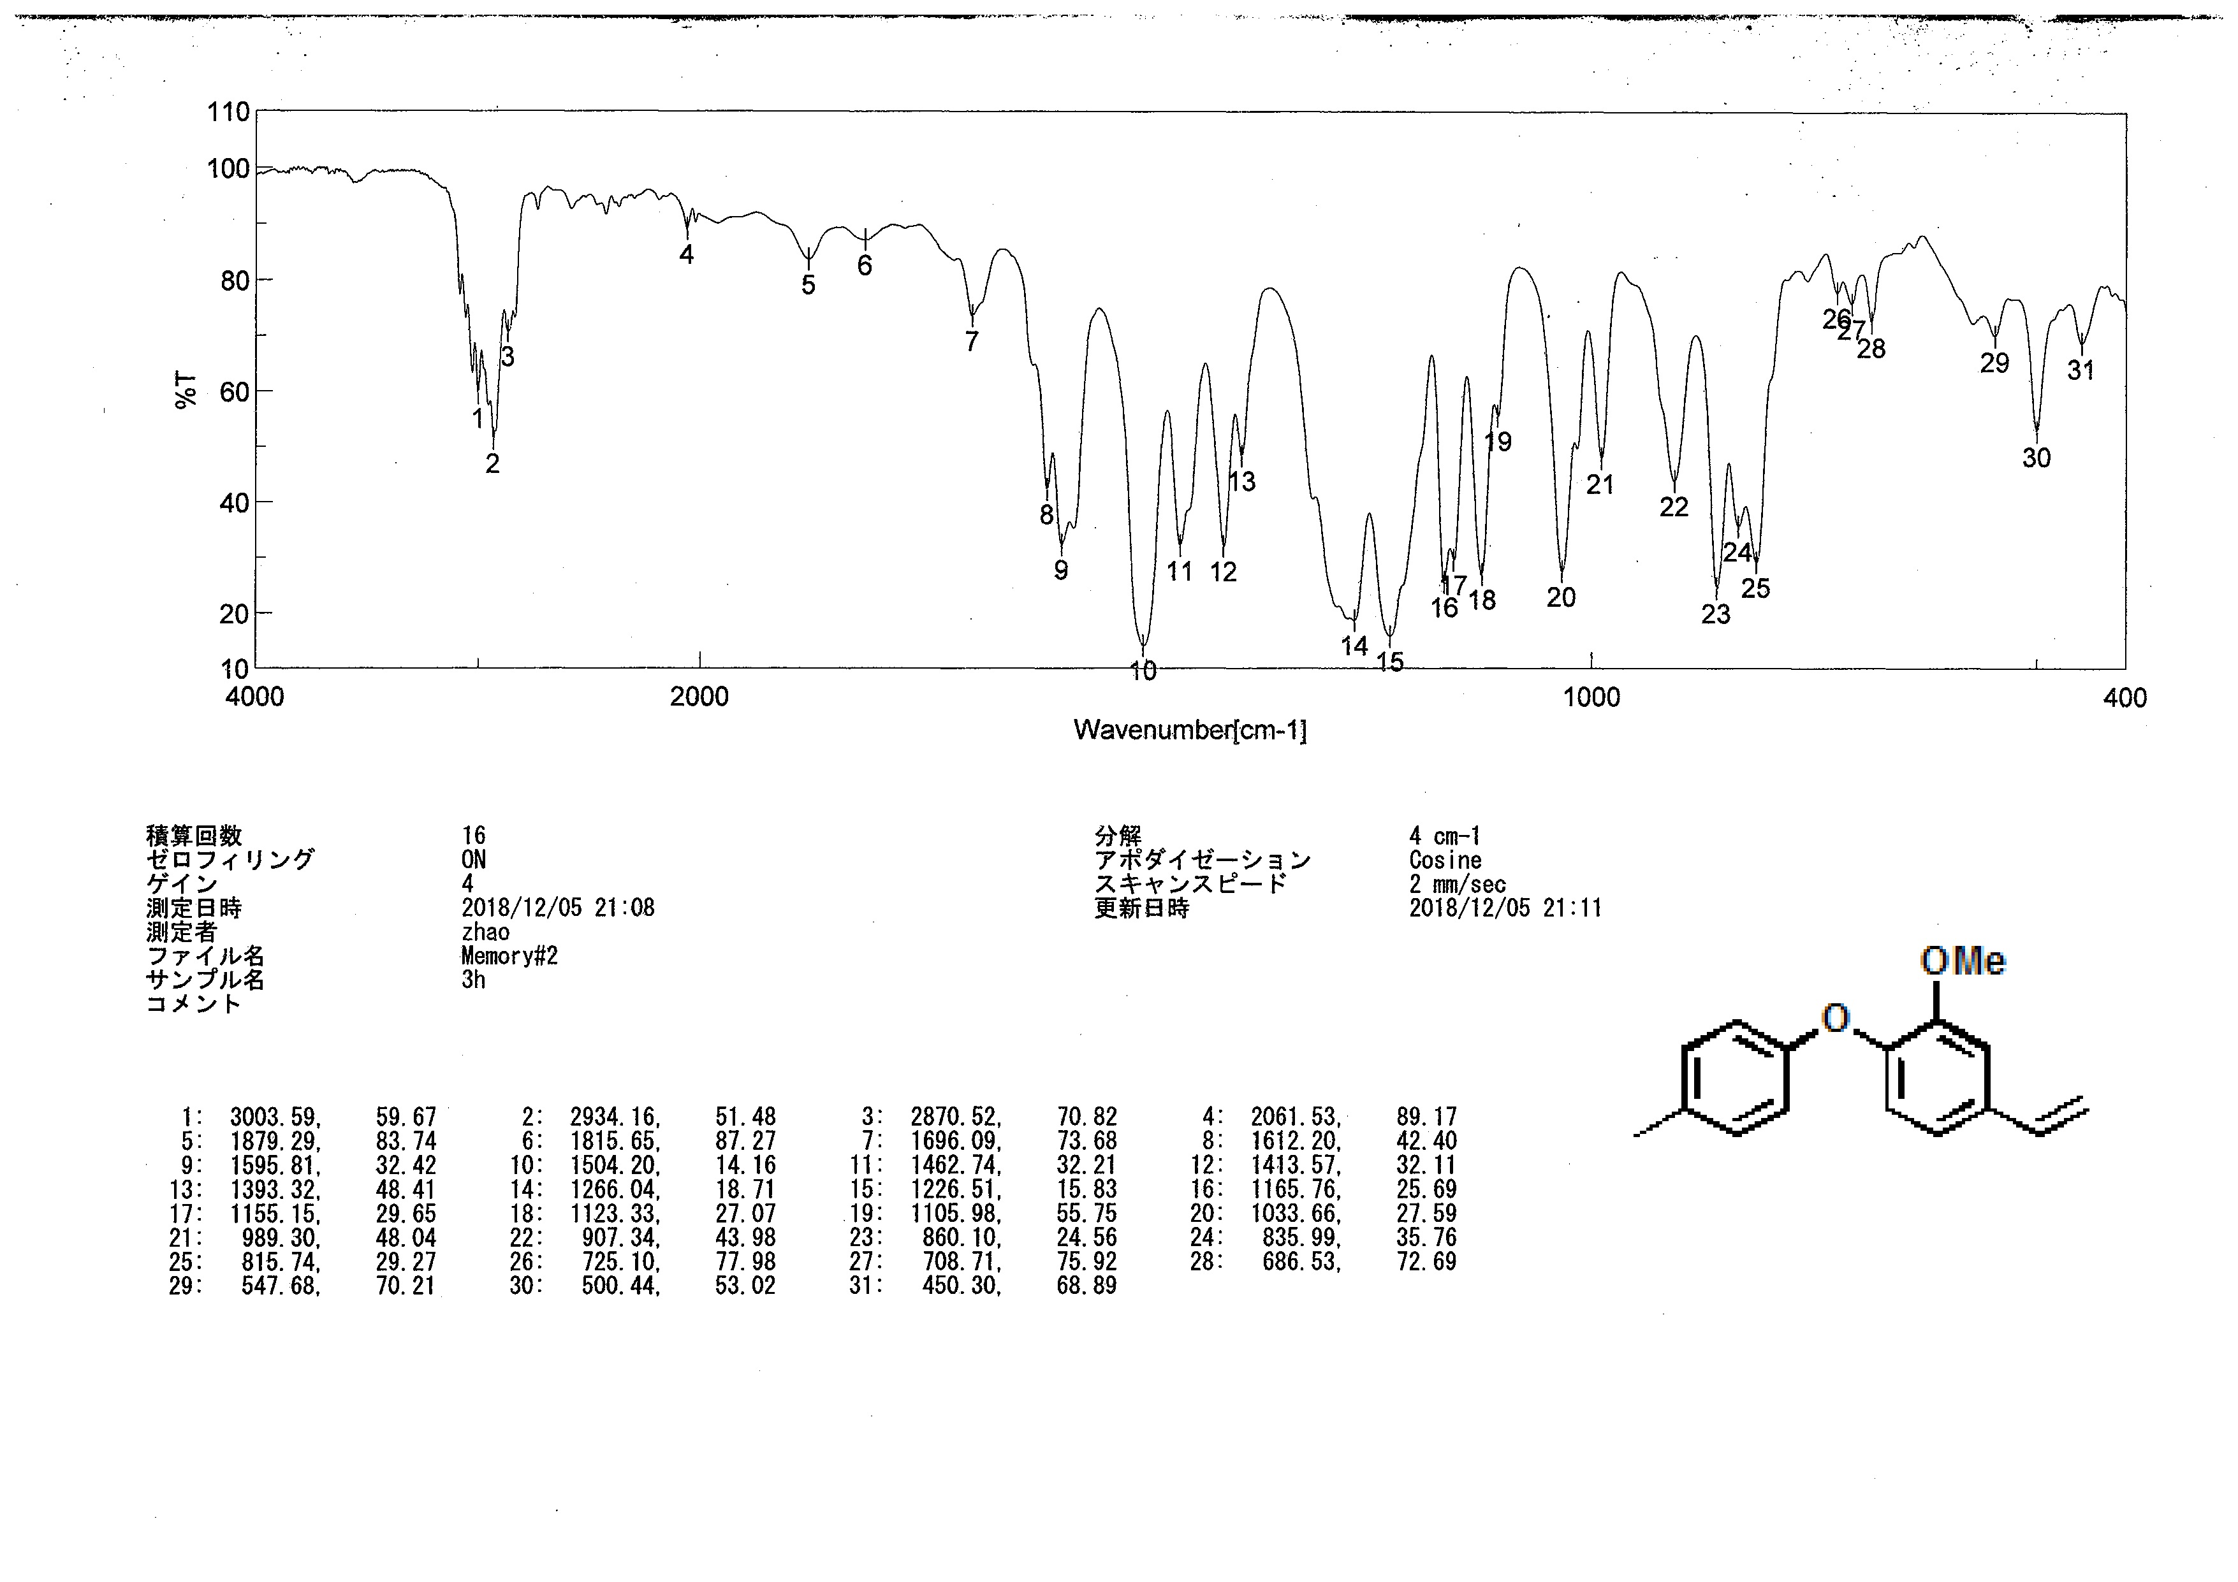
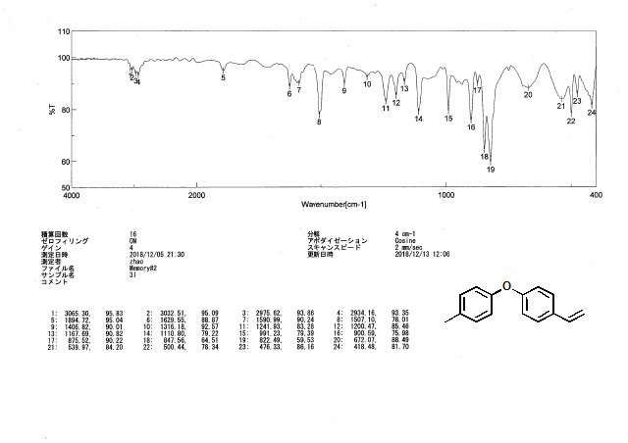

MS spectrum of new compounds
MALDI-MS


