Electronic Supplementary Information

Non-labeled and highly sensitive probe detection with novel hierarchical SERS substrates fabricated by nanoindentation and chemical reaction methods
Jingran Zhang^{*1}, Tianqi Jia^{*1}, Yongda Yan², Li Wang³, Peng Miao⁴, Yimin Han^{*5}, Xinming Zhang¹, Guangfeng Shi¹, Yanquan Geng², Zhankun Weng¹, Daniel Laipple³, Zuobin Wang¹
¹ Ministry of Education Key Laboratory for Cross-Scale Micro and Nano Manufacturing, Changchun University of Science and Technology, Changchun 130022, China
² The Key Laboratory of Micro-systems and Micro-structures Manufacturing of
Ministry of Education, Harbin Institute of Technology, Harbin, Heilongjiang 150080, P.R. China
³ Institute of Materials Research, Helmholtz-Zentrum Geesthacht, Max-Planck-Strasse 1, Geesthacht, D-21502, Germany
⁴ School of Chemistry and Chemical Engineering, Harbin Institute of Technology, Harbin, Heilongjiang 150010, P.R. China
⁵ Department of Gynaecology, No. 3 Subsidiary Hospital, Harbin Medical University, Harbin, Heilongjiang, 150040, P. R. China
* Corresponding author. Tel.: +86-0451-86298932
E-mail address: hanyimin@163.com (Y.M. Han)
* Corresponding author. Tel.: +86-0431-85582420
E-mail address: zhangjingran@cust.edu.cn (J. R. Zhang)
Supplementary Figures and Tables
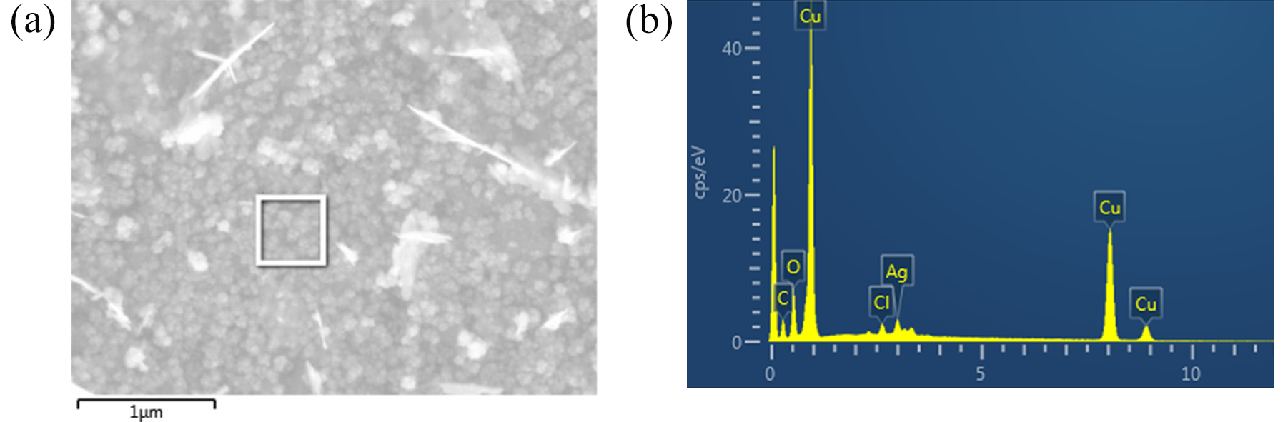
Figure S1 (a)SEM image of Ag/Cu surface in AgNO₃ solution with 5 minutes (b) EDS image of Ag/Cu surface in AgNO₃ solution with 5 minutes.
Table S1 the table of elements consitute of Ag/Cu surface
Element | Quality percentage (%) | Molecular percentage(%)
C | 5.95 | 19.72
O | 11.73 | 29.17
Cl | 1.01 | 1.13
Cu | 80.65 | 49.63
Ag | 0.66 | 0.35
total | 100 | 100

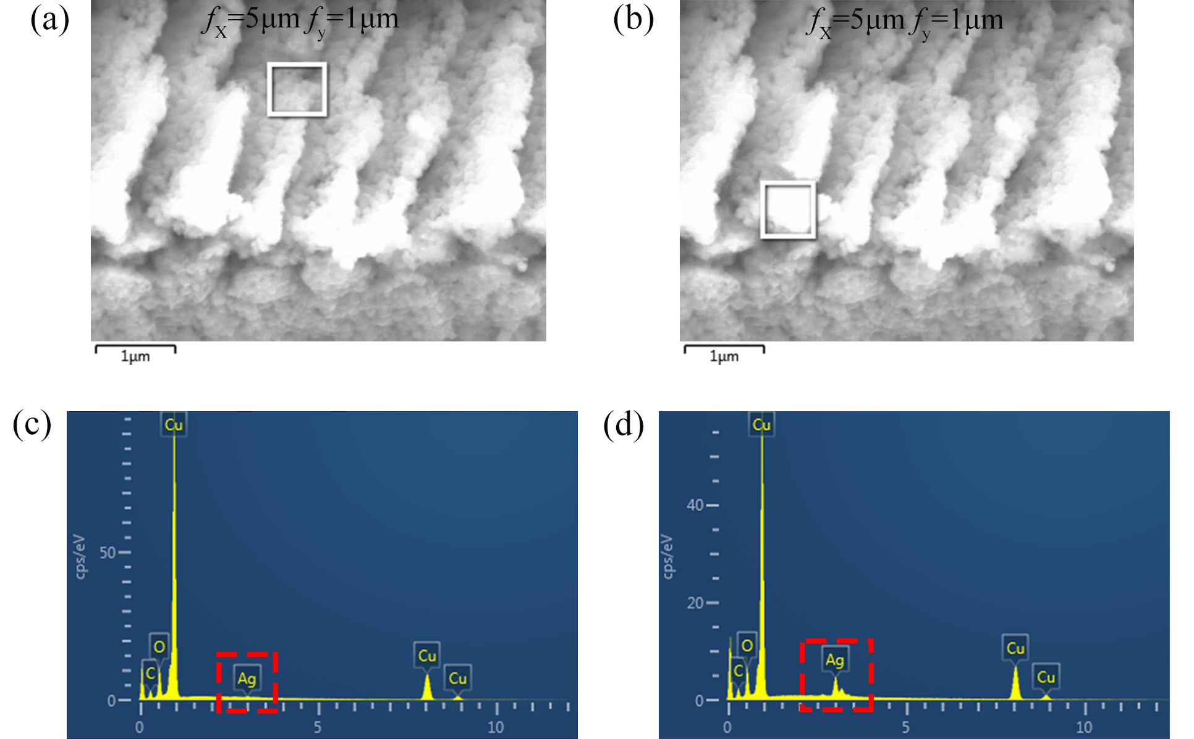
Figure S2 (a)SEM image of the arrayed triangular cavities with f_{x}=5μm、f_{y}=1μm in AgNO₃ solution with 5 minutes (b)SEM image of the plie-ups of cavities with f_{x}=5μm、f_{y}=1μm in AgNO₃ solution with 5 minutes (c)EDS image of the arrayed cavities with f_{x}=5μm、f_{y}=1μm (d) EDS image of the plie-ups of cavities with f_{x}=5μm、f_{y}=1μm.
Table S2 The table of elements consitute of internal cavities for the hierarchical SERS substrate with the machining feed of f_{x}=5μm、f_{y}=1μm
Element | Quality percentage(%) | Molecular percentage(%)
C | 8.93 | 29.29
O | 7.80 | 19.21
Cu | 82.65 | 51.27
Ag | 0.62 | 0.23
total | 100 | 100

Table S3 The table of elements consitute of pile-ups of cavities for the hierarchical substrates with the machining feed of f_{x}=5μm、f_{y}=1μm
Element | Quality percentage(%) | Molecular percentage(%)
C | 7.51 | 26.60
O | 7.21 | 19.18
Cu | 74.84 | 50.11
Ag | 10.43 | 4.11
total | 100 | 100

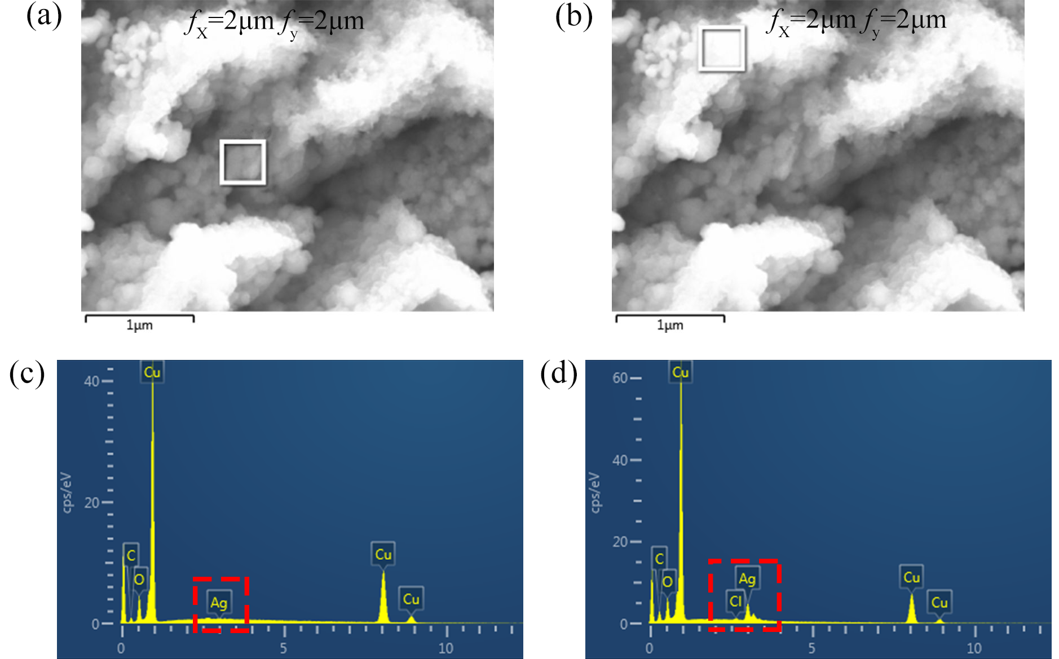
Figure S3 (a)SEM image of the arrayed triangular cavities with f_{x}=2μm、f_{y}=2μm in AgNO₃ solution with 5 minutes (b)SEM image of the plie-ups of pyramid cavities with f_{x}=2μm、f_{y}=2μm in AgNO₃ solution with 5 minutes (c)EDS image of the arrayed triangular cavities with f_{x}=2μm、f_{y}=2μm (d) EDS image of the plie-ups of pyramid cavities with f_{x}=2μm、f_{y}=2μm.

Table S4 The table of elements consitute of internal cavities for the hierarchical SERS substrate with the machining feed of f_{x}=2μm、f_{y}=2μm
Element | Quality percentage(%) | Molecular percentage(%)
C | 6.57 | 23.07
O | 7.63 | 20.12
Cu | 85.16 | 56.56
Ag | 0.64 | 0.25
Total | 100 | 100

Table S5 The table of elements consitute of pile-up of cavities for the hierarchical SERS substrate with the machining feed of f_{x}=2μm、f_{y}=2μm
Element | Quality percentage(%) | Molecular percentage(%)
C | 7.36 | 23.07
O | 6.41 | 20.12
Cl | 0.18 | 0.22
Cu | 75.79 | 51.71
Ag | 10.25 | 4.12
total | 100 | 100

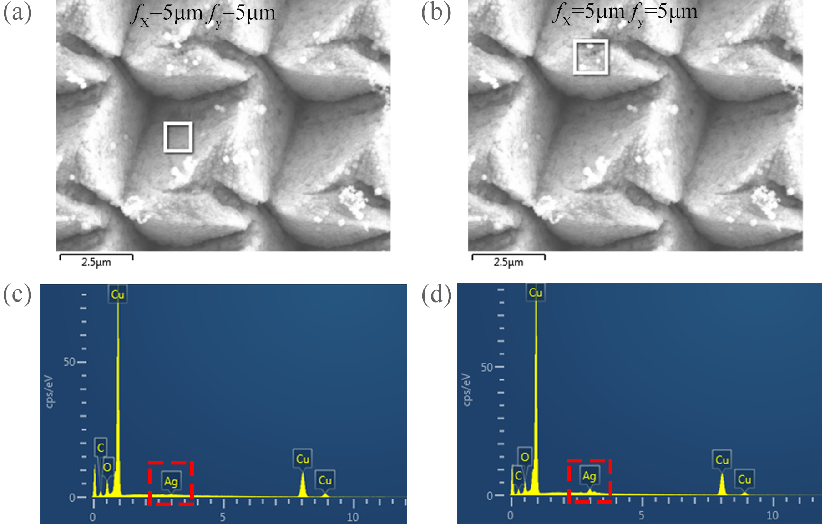
Figure S4 (a)SEM image of the arrayed triangular cavities with f_{x}=5μm、f_{y}=5μm in AgNO₃ solution with 5 minutes (b)SEM image of the plie-ups of pyramid cavities with f_{x}=5μm、f_{y}=5μm in AgNO₃ solution with 5 minutes (c)EDS image of the arrayed triangular cavities with f_{x}=2μm、f_{y}=2μm (d) EDS image of the plie-ups of pyramid cavities with f_{x}=5μm、f_{y}=5μm.

Table S6 The table of elements consitute of internal cavities for hierarchical SERS substrate with the machining feed of f_{x}=5μm、f_{y}=5μm
Element | Quality percentage(%) | Molecular percentage(%)
C | 7.98 | 28.07
O | 5.54 | 14.62
Cu | 85.72 | 57.01
Ag | 0.77 | 0.3
total | 100 | 100

Table S7 The table of elements consitute of pile-up of cavities for hierarchical SERS substrate with the machining feed of f_{x}=5μm、f_{y}=5μm
Element | Quality percentage (%) | Molecular percentage (%)
C | 7.49 | 27.61
O | 4.38 | 12.12
Cu | 84.11 | 58.62
Ag | 4.03 | 1.65
total | 100 | 100

Table S8. Parameters of the feeds in the X-Y directions for fabrcating micro/nanostructures on the Cu(110) surface
 | (1) | (2) | (3) | (4) | (5) | (6) | (7) | (8) | (9) | (10)
f_{x}(μm) | 10 | 5 | 5 | 5 | 5 | 5 | 2 | 2 | 2 | 2
f_{y}(μm) | 10 | 5 | 4 | 3 | 2 | 1 | 4 | 3 | 2 | 1

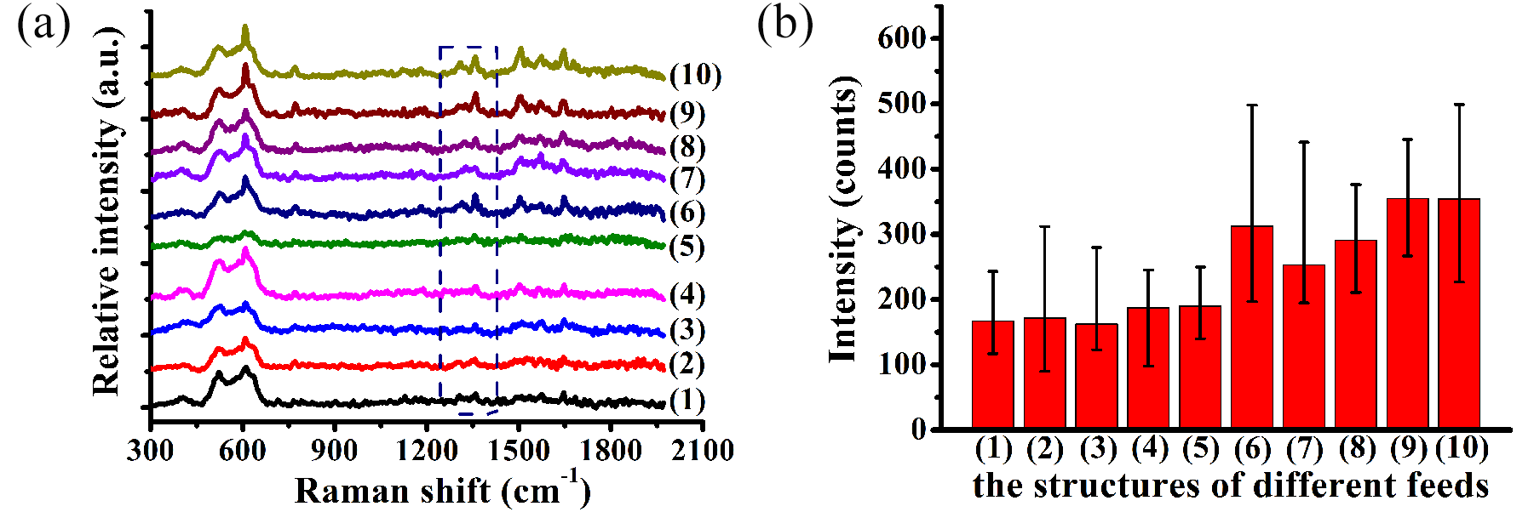
Figure S5 (a) Raman spectrum of R6G molecules of 10⁻⁸mol/L with different feeds on the Ag/Cu substrates with the corrosion time of 5minues (b) Average Raman intensity of R6G of the 1362cm⁻¹ peak for the structured Ag/Cu substrates with different feeds.
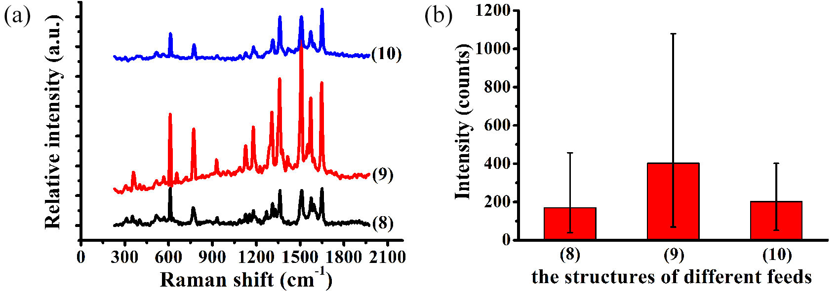
Figure S6 (a) Raman spectra of R6G molecules of 10⁻⁸mol/L with different feeds on Ag/Cu substrates with the corrosion time of 10minues. (b) Average Raman intensity of R6G of the 1362cm⁻¹ peak for the Ag/Cu substrates with different feeds.

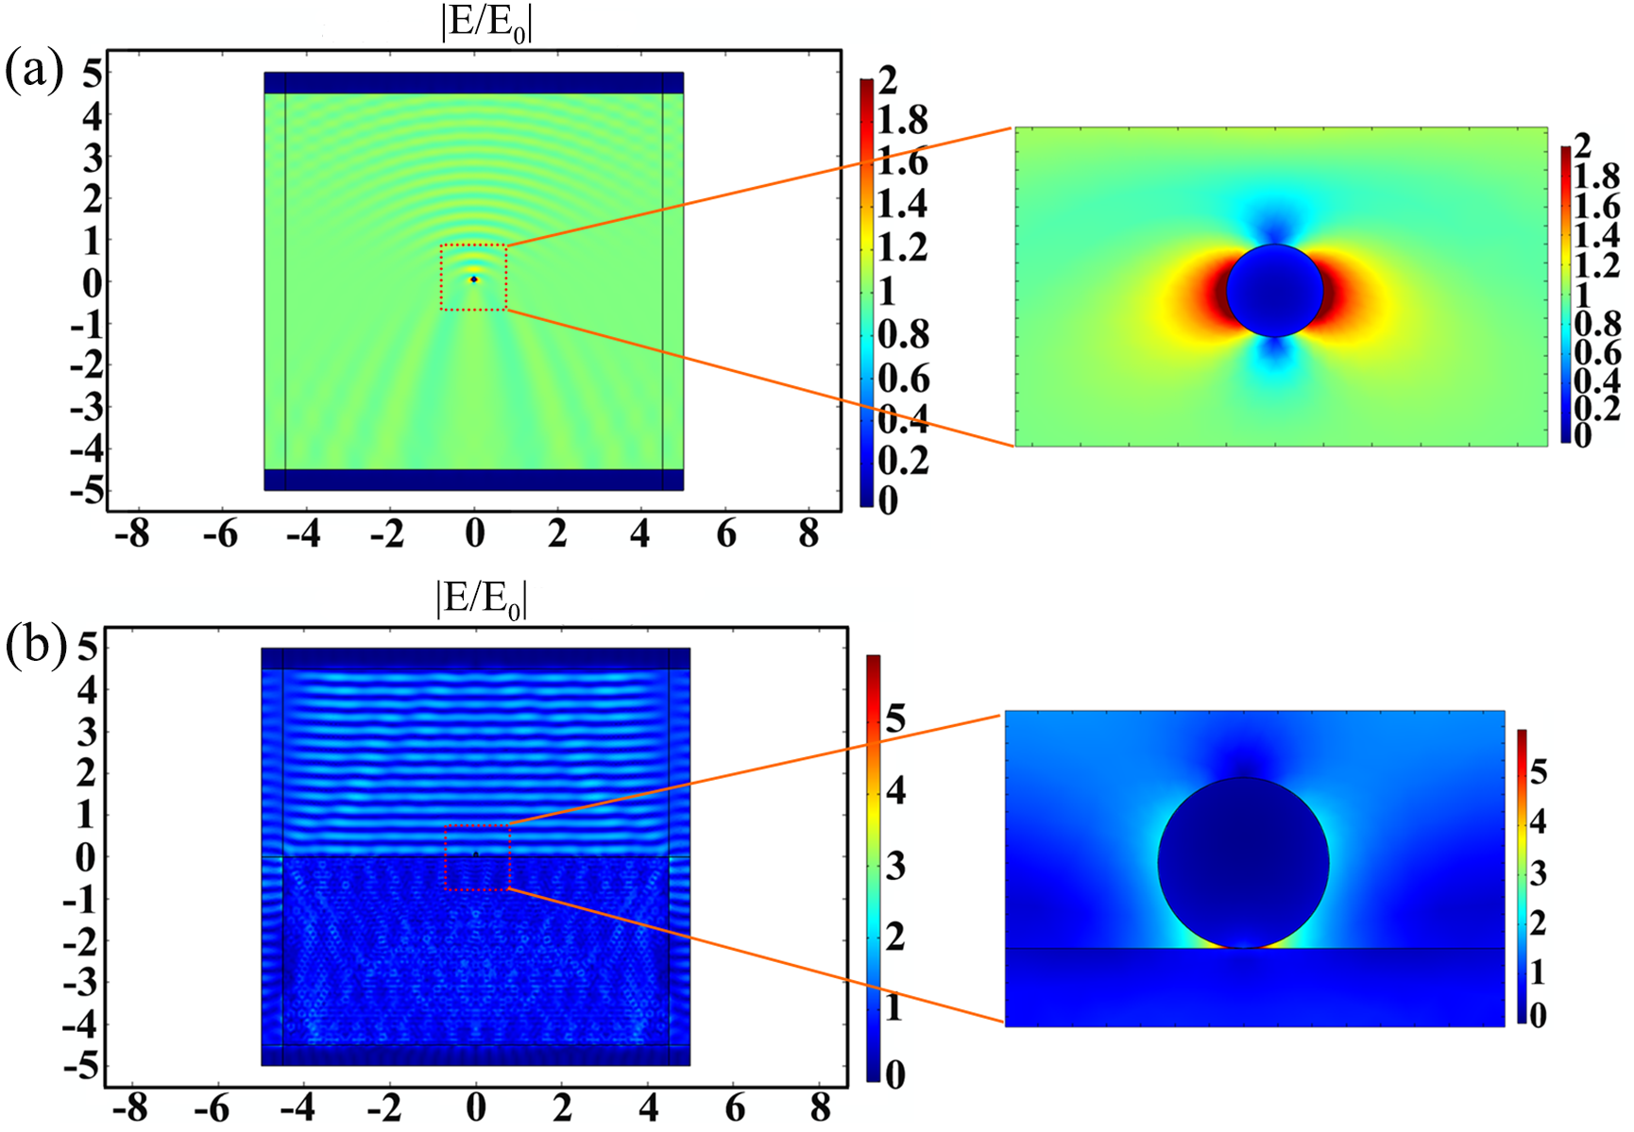
Figure S7(a) Electric field distribution of a Ag nanoparticle with a radius of 100nm on the air (b) Electric field distribution of a Ag nanoparticle with a radius of 100nm on substrate.

