Unexpected one-pot formation of 1H-6a,8a-epiminotricyclopenta[a,c,e][8]annulene system from cyclopentanone, ammonia and dimethyl fumarate. Synthesis of highly strained polycyclic nitroxide and EPR study.
Sergey A. Dobrynin, ^{1,3*} Igor A. Kirilyuk,^{1,3} Yuri V. Gatilov,¹ Andrey A. Kuzhelev,^{1,3} Olesya A. Krumkacheva,^{2,3} Matvey V. Fedin,^{2,3} Michael K. Bowman^{1,4}, Elena G. Bagryanskaya^{1,3}

¹N. N. Vorozhtsov Novosibirsk Institute of Organic Chemistry SB RAS, Lavrentiev Ave. 9, Novosibirsk, 630090, Russia; dobrynin@nioch.nsc.ru
²International Tomography Center SB RAS, Institutskaya Str. 3a, Novosibirsk, 630090, Russia
³Novosibirsk State University, Pirogova Str. 2, Novosibirsk, 630090, Russia
⁴University of Alabama, Tuscaloosa, Alabama 35487-0336, United States

Supporting Information

1. X-ray analysis data 2
Table S1 Crystallographic data and structure refinement parameters of the dimethyl 2,3,3a,3b,4,5,6,7,8,9,10,11-dodecahydro-1H-6a,8a-epiminotricyclopenta[a,c,e][8]annulene-7,8-dicarboxylate (1) and 3a-hydroxy-7,8-bis(methoxycarbonyl)-2,3,3a,3b,4,5,6,7,8,9,10,11-dodecahydro-1H-6a,8a-epiminotricyclopenta[a,c,e][8]annulene N-oxyl (6). 2
2. NMR spectra 3
¹Н NMR (400 MHz, CDCl₃) of dimethyl 2,3,3a,3b,4,5,6,7,8,9,10,11-dodecahydro-1H-6a,8a-epiminotricyclopenta [a,c,e][8]annulene-7,8-dicarboxylate (1) 3
¹³C{¹H} NMR (100 MHz, CDCl₃) of dimethyl 2,3,3a,3b,4,5,6,7,8,9,10,11-dodecahydro-1H-6a,8a-epiminotricyclopenta [a,c,e][8]annulene-7,8-dicarboxylate (1) 3
HMBC(600 MHz, CDCl₃) of of dimethyl 2,3,3a,3b,4,5,6,7,8,9,10,11-dodecahydro-1H-6a,8a-epiminotricyclopenta [a,c,e][8]annulene-7,8-dicarboxylate (1) 4
HSQC(600 MHz, CDCl₃) of of dimethyl 2,3,3a,3b,4,5,6,7,8,9,10,11-dodecahydro-1H-6a,8a-epiminotricyclopenta [a,c,e][8]annulene-7,8-dicarboxylate (1) 4
3. IR spectra 6
IR (KBr) of dimethyl 2,3,3a,3b,4,5,6,7,8,9,10,11-dodecahydro-1H-6a,8a-epiminotricyclopenta [a,c,e][8]annulene-7,8-dicarboxylate (1) 6
IR (KBr) of 3a-hydroxy-7,8-bis(methoxycarbonyl)-2,3,3a,3b,4,5,6,7,8,9,10,11-dodecahydro-1H-6a,8a-epiminotricyclopenta[a,c,e][8]annulene N-oxyl (6). 6

X-ray analysis data
X-ray diffraction experiments for the 1 and 6 compounds were performed on a Bruker KAPPA APEX II diffractometer (MoKα radiation, CCD detector, ω-ϕ scanning, 296 K). The absorption corrections were introduced with the SADABS program [1]. The structures were solved by direct methods and refined anisotropically (except H atoms) using the SHELX2014 programs [2]. The hydrogen atom positions were calculated geometrically and refined in riding model. Н atoms at N1 (1) and O6 (6) were located from difference maps and refined isotropically.
1. Sheldrick G. M., SADABS V. 2.01, Bruker AXS Inc. Madison, Wisconsin, USA. 2004.
2. Sheldrick G. M. SHELXT–Integrated space-group and crystal-structure determination. Acta Crystallogr., Sect. A: Found. Adv. 2015, 71, 3-8.

Table S1 Crystallographic data and structure refinement parameters of the dimethyl 2,3,3a,3b,4,5,6,7,8,9,10,11-dodecahydro-1H-6a,8a-epiminotricyclopenta[a,c,e][8]annulene-7,8-dicarboxylate (1) and 3a-hydroxy-7,8-bis(methoxycarbonyl)-2,3,3a,3b,4,5,6,7,8,9,10,11-dodecahydro-1H-6a,8a-epiminotricyclopenta[a,c,e][8]annulene N-oxyl (6).

Parameter | 1 | 6
Chemical formula | C₂₁H₂₉NO₄ | C₂₁H₂₈NO₆
Formula weight | 359.45 | 390.44
Temperature (K) | 296 | 296
Crystal system | Triclinic | Triclinic
Space group | P-1 | P-1
a (Å) | 6.2467(4) | 8.2240(5)
b (Å) | 9.2039(8) | 10.9423(6)
c (Å) | 16.7575(15) | 11.4515(8)
α (deg) | 98.858(4) | 83.440(3)
β (deg) | 94.176(3) | 75.611(3)
γ (deg) | 95.362(3) | 83.119(2)
Cell volume (Å³) | 944.07(13) | 987.17(11)
Z | 2 | 2
d_{calc} (g cm⁻³) | 1.264 | 1.314
µ (mm⁻¹) | 0.087 | 0.096
Crystal dimensions (mm) | 0.14×0.27×0.57 | 0.31×0.47×0.59
θ max (deg) | 27.27 | 27.29
Reflections collected/ unique | 20324/4168 | 25779
R (int) | 0.0429 | 0.0375
Reflections with I > 2σ(I) | 3234 | 3451
Parameters | 241 | 258
Final R₁ (I >2σ(I)) | 0.0602 | 0.0439
Final wR₂ (I >2σ(I)) | 0.1696 | 0.1215
Final R₁ (all data) | 0.0784 | 0.0585
Final wR₂ (all data) | 0.2013 | 0.1390
Goodness-of-fit on F² | 1.030 | 1.011
CCDC number | 1947797 | 1947798

NMR spectra

¹Н NMR (400 MHz, CDCl₃) of dimethyl 2,3,3a,3b,4,5,6,7,8,9,10,11-dodecahydro-1H-6a,8a-epiminotricyclopenta [a,c,e][8]annulene-7,8-dicarboxylate (1)
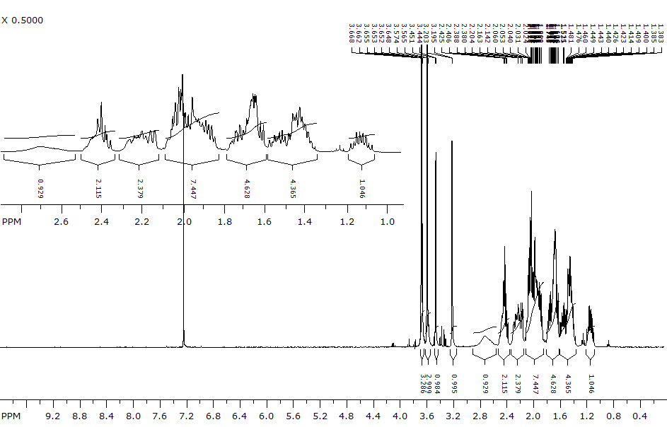

¹³C{¹H} NMR (100 MHz, CDCl₃) of dimethyl 2,3,3a,3b,4,5,6,7,8,9,10,11-dodecahydro-1H-6a,8a-epiminotricyclopenta [a,c,e][8]annulene-7,8-dicarboxylate (1)
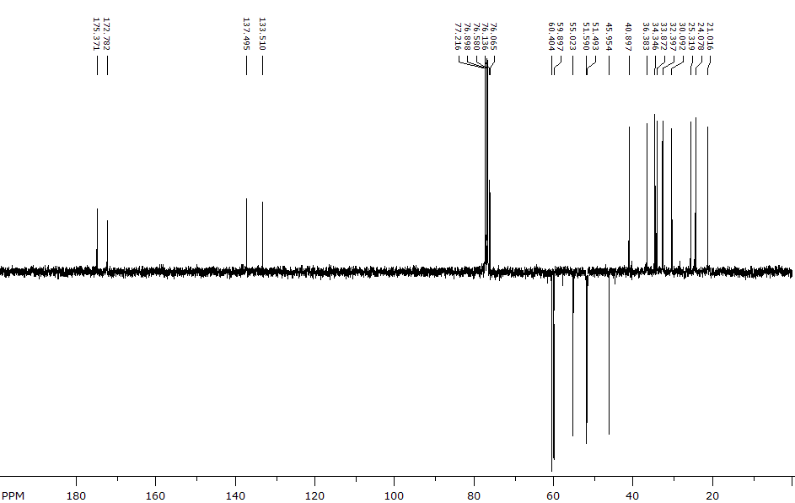

HMBC(600 MHz, CDCl₃) of of dimethyl 2,3,3a,3b,4,5,6,7,8,9,10,11-dodecahydro-1H-6a,8a-epiminotricyclopenta [a,c,e][8]annulene-7,8-dicarboxylate (1)
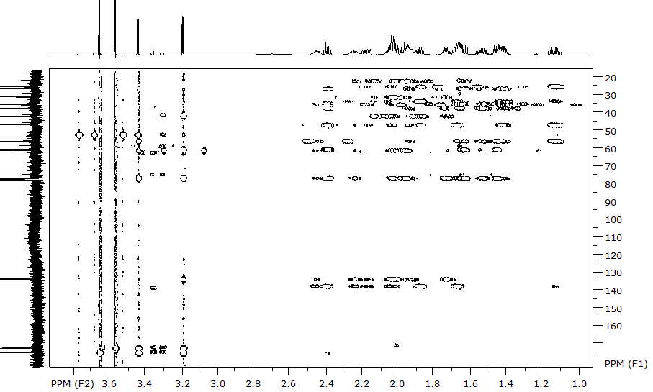

HSQC(600 MHz, CDCl₃) of of dimethyl 2,3,3a,3b,4,5,6,7,8,9,10,11-dodecahydro-1H-6a,8a-epiminotricyclopenta [a,c,e][8]annulene-7,8-dicarboxylate (1)
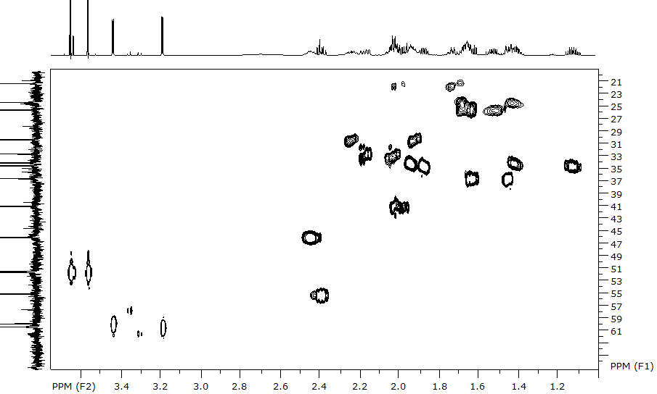
COSY(600 MHz, CDCl₃) of of dimethyl 2,3,3a,3b,4,5,6,7,8,9,10,11-dodecahydro-1H-6a,8a-epiminotricyclopenta [a,c,e][8]annulene-7,8-dicarboxylate (1)
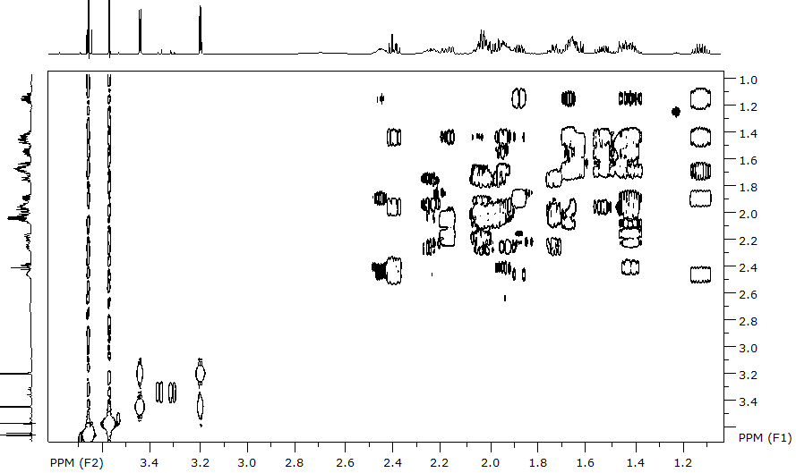

IR spectra

IR (KBr) of dimethyl 2,3,3a,3b,4,5,6,7,8,9,10,11-dodecahydro-1H-6a,8a-epiminotricyclopenta [a,c,e][8]annulene-7,8-dicarboxylate (1)

IR (KBr) of 3a-hydroxy-7,8-bis(methoxycarbonyl)-2,3,3a,3b,4,5,6,7,8,9,10,11-dodecahydro-1H-6a,8a-epiminotricyclopenta[a,c,e][8]annulene N-oxyl (6).

