Synthesis of racemic pheromones: adjacent methyl-branched alcohols and ketones
Van-Dung Le^{1,2}, Chi-Hien Dang^{1,3*}, Cong-Hao Nguyen³, Van-Su Dang⁴ and Thanh-Danh Nguyen^{2,3}*
¹Graduate University of Science and Technology, Vietnam Academy of Science and Technology, 18 Hoang Quoc Viet, Cau Giay, Hanoi, Vietnam.
²Institute of Research and Development, Duy Tan University, Da Nang City, Vietnam
³Institute of Chemical Technology, Vietnam Academy of Science and Technology, 1 Mac Dinh Chi Street, District 1, Ho Chi Minh City, Vietnam.
⁴Department of chemical Technology, Ho Chi Minh City University of Food industry, Ho Chi Minh City, Viet Nam.
*Correspondence: dangchihien@gmail.com (C.H. Dang), danh5463bd@yahoo.com (T.D. Nguyen)

^{Supplementary Data}

- Experimental
  - General Methods
All manipulations were performed under a dry nitrogen atmosphere using Schlenk techniques. All of the materials were purchased from Acros (Belgium) or Sigma-Aldrich. Diethyl ether was dried with Na/benzophenone and freshly distilled prior to use. The other solvents were purchased from Fluka and used without further purification. Column chromatography was performed with Merck Kieselgel 60. Synthesis of ketones using IBX was carried out under microwave-assisted in SANYO EM-D9553N. GC-MS analyses were carried out using an Agilent Technologies 6890N (USA). ¹H (500 MHz) and ¹³C (125 MHz) NMR were determined on a Bruker AVANCE 500 NMR spectrometer using CDCl₃ as solvent and tetramethylsilane (TMS) as internal standard. Chemical shifts are reported in δ relative to TMS.
1.2. General procedure for synthesis of alcohols by Grignard reactions (1a-12a)
To a 250 mL round bottom flask equipped with a reflux condenser was added magnesium shavings (60.0 mmol, 1440.0 mg). After alkyl bromides (48.0 mmol) in anhydrous diethyl ether (70 mL) is added slowly dropwise via cannula to the solution. After addition of the bromides was completed, the reaction mixture was stirred and refluxed for 1h in nitrogen atmosphere. A solution of α-methyl aldehydes (40.0 mmol) in anhydrous diethyl ether (70 mL) was then added slowly to the solution of Grignard reagent cooled at 0ºC and stirred for 1h. The mixture was stirred at ambient temperature for an additional 1h and poured into an aqueous solution of NH₄Cl. The organic layer was extracted with diethyl ether (30 mL x 3) and then washed with an aqueous solution of NaHCO₃, water, brine and dried with anhydrous MgSO₄. The solvent was removed and followed by column chromatography of the residue (n-hexane: Et₂O = 8:2) or distillation to afford the alcohols.
1.3. General procedure for reduction of ketones by LiAlH₄ (1c – 12c)
Ketones (40.0 mmol) in dry diethyl ether (100 mL) were added through a dropping funnel to LiAlH₄ (80.0 mmol) in dry diethyl ether (100 mL) at 0ºC. The solution was allowed to warm to room temperature for 1h under stirring. The reaction was monitored by TLC. The mixture was poured to cold HCl acid (10%) and extracted with diethyl ether (3 x 30 mL). The organic layer was dried by anhydrous MgSO₄ and organic solvent evaporated. The crude product was purified by distillation or chromatography column (n-hexane: Et₂O = 8: 2) to afford alcohols.
(±)-4-methyl-3-hexanol (1a): 75 ºC/60 mmHg; GC-MS, m/z 87, 69, 59 (100), 55, 53, 45, 43, 41, 39, 31, 27; ¹H NMR (500 MHz, CDCl₃): δ 3.44 (m, 2 H), 3.43 (m, ∼ 1,17 H), 1.18-1.56 (m, ∼ 24 H), 0.86-0.98 (m, ∼ 32 H); ¹³C NMR (125 MHz, CDCl₃): δ 77.3, 76.4, 40.2, 39.6, 27.3, 26.3, 26.1, 24.6, 14.8, 14.1, 13.1, 11.8, 11.6, 10.5, 10.3.
(±)-3-methyl-4-heptanol (2a): 85 ºC/60 mmHg; GC-MS, m/z 87, 73, 69, 57, 55 (100), 45, 41, 39, 31, 29; ¹H NMR (500 MHz, CDCl₃): δ 3.53 (m, 2 H), 3.45 (m, ∼ 1,11 H), 1.13-1.55 (m, ∼ 37 H), 0.84-0.97 (m, ∼ 35 H); ¹³C NMR (125 MHz, CDCl₃): δ 75.5, 74.7, 40.6, 40.0, 36.7, 35.7, 26.0, 24.6, 19.4, 19.2, 14.8, 14.1, 14.1, 13.2, 11.9, 11.7.
(±)-3-methyl-4-octanol (3a): 91ºC/60 mmHg; GC-MS, m/z 126, 111, 87, 85, 69 (100), 57, 55, 45, 43, 41, 39, 31, 29; ¹H NMR (500 MHz, CDCl₃): δ 3.50 (m, 1 H), 3.42 (m, ∼ 0.56 H), 1.12-1.56 (m, ∼ 15 H), 0.86-0.93 (m, ∼ 14.9 H); ¹³C NMR (125 MHz, CDCl₃): δ 75.8, 74.9, 40.5, 39.9, 34.2, 33.1, 28.5, 28.3, 26.0, 24.6, 22.8, 22.8, 14.8, 14.0, 13.1, 11.8, 11.7.
(±)-3-methyl-4-decanol (4a): 82ºC/5 mmHg; GC-MS, m/z 115, 97, 87, 85, 81, 69, 57, 55 (100), 53, 45, 41, 39, 31, 29, 27; ¹H NMR (500 MHz, CDCl₃): δ 3.51 (m, 2H), 3.43 (m, ∼ 1.18 H), 1.13-1.54 (m, ∼ 46 H), 0.86-0.93 (m, ∼ 29 H); ¹³C NMR (125 MHz, CDCl₃): δ 75.8, 75.0, 40.6, 40.0, 34.6, 33.5, 31.9, 29.4, 29.4, 26.2, 26.1, 24.6, 22.6, 14.8, 14.0, 13.2, 11.9, 11.7.
(±)-3-methyl-4-undecanol (5a): 102ºC/5 mmHg; GC-MS, m/z 129, 111, 97, 83, 73, 69 (100), 57, 55, 41, 39, 29; ¹H NMR (500 MHz, CDCl₃): δ 3.51 (m, 2H), 3.44 (m, ∼ 1.06 H), 1.15-1.52 (m, ∼ 51.4 H), 0.86-0.94 (m, ∼ 28.2 H); ¹³C NMR (125 MHz, CDCl₃): δ 75.8, 75.0, 40.6, 40.0, 34.6, 33.5, 31.9, 29.7, 29.7, 29.3, 26.3, 26.1, 26.1, 24.6, 22.6, 14.8, 14.1, 13.2, 11.9, 11.7.
(±)-3-methyl-4-dodecanol (6a): 128ºC/5 mmHg; GC-MS, m/z 182, 143, 125, 111, 97, 87, 83, 69 (100), 55, 41, 29; ¹H NMR (500 MHz, CDCl₃): δ 3.51 (m, 2 H), 3.44 (m, 1 H), 1.17-1.51 (m, ∼ 58.2 H), 0.86-0.93 (m, ∼ 28.4 H); ¹³C NMR (125 MHz, CDCl₃): δ 75.8, 74.9, 40.6, 40.0, 34.6, 33.5, 31.9, 29.8, 29.8, 29.6, 29.3, 26.3, 26.1, 26.1, 24.6, 22.7, 14.8, 14.1, 13.2, 11.9, 11.7.
(±)-4-methyl-3-heptanol (7a): 87ºC/60 mmHg; GC-MS, m/z 101, 86, 83, 70, 59 (100), 55, 45, 41, 39, 39, 31, 27; ¹H NMR (500 MHz, CDCl₃): δ 3.41 (m, 2 H), 3.35 (m, 1.15 H), 1.16-1.55 (m, ∼ 27.4 H), 0.86-0.98 (m, ∼ 30 H); ¹³C NMR (125 MHz, CDCl₃): δ 77.6, 76.7, 38.2, 37.5, 35.7, 34.1, 27.2, 26.2, 20.4, 20.4, 15.3, 14.3, 14.3, 13.4, 10.5, 10.3.
(±)-5-methyl-4-octanol (8a): 90ºC/60 mmHg; GC-MS, m/z 126, 101, 83, 73, 57, 55 (100), 45, 43, 41, 39, 31, 27; ¹H NMR (500 MHz, CDCl₃): δ 3.51 (m, 2.14 H), 3.45 (m, 1 H), 1.10-1.55 (m, ∼ 35 H), 0.86-0.95 (m, ∼ 30 H); ¹³C NMR (125 MHz, CDCl₃): δ 75.8, 75.0, 38.6, 38.0, 36.7, 35.6, 35.6, 34.2, 20.5, 20.4, 19.4, 19.3, 15.2, 14.4, 14.3, 14.2, 13.6.
(±)-4-methyl-5-nonanol (9a). [1] 99ºC/30 mmHg; GC-MS, m/z 140, 111, 101, 87, 83, 69 (100), 67, 59, 55, 53, 45, 43, 41, 39, 31, 29, 27.
(±)-4-methyl-5-undecanol (10a): 110ºC/5 mmHg; GC-MS, m/z 168, 140, 128, 115, 101, 97, 83, 69, 55 (100), 43, 29; ¹H NMR (500 MHz, CDCl₃): δ 3.49 (m, 2 H), 3.43 (m, 1.07 H), 1.09-1.52 (m, ∼ 52 H), 0.86-0.92 (m, ∼ 28.1 H); ¹³C NMR (125 MHz, CDCl₃): δ 76.1, 75.2, 38.6, 37.9, 35.6, 34.5, 34.2, 33.4, 31.9, 29.4, 29.4, 26.3, 26.1, 22.6, 20.5, 20.4, 15.3, 14.4, 14.3, 14.1, 13.5.
(±)-4-methyl-5-dodecanol (11a): 130ºC/5 mmHg; GC-MS, m/z 129, 111, 97, 83, 73, 69 (100), 57, 55, 41, 39, 31, 29; ¹H NMR (500 MHz, CDCl₃): δ 3.49 (m, 2 H), 3.43 (m, 1.15 H), 1.09-1.51 (m, ∼ 62 H), 0.85-0.92 (m, ∼ 30.5 H); ¹³C NMR (125 MHz, CDCl₃): δ 76.1, 75.2, 38.6, 37.9, 35.7, 34.5, 34.2, 33.4, 31.9, 29.7, 29.7, 29.3, 26.3, 26.2, 22.7, 20.5, 20.4, 15.3, 14.4, 14.3, 14.1, 13.5.
(±)-4-methyl-5-tridecanol (12a): 140ºC/2 mmHg; GC-MS, m/z 196, 143, 125, 111, 101, 97, 83 (100), 69, 55, 41, 29; ¹H NMR (500 MHz, CDCl₃): δ 3.48 (m, 2 H), 3.43 (m, 1.10 H), 1.08-1.53 (m, ∼ 63.3 H), 0.85-0.92 (m, ∼ 28 H); ¹³C NMR (125 MHz, CDCl₃): δ 76.1, 75.2, 37.6, 37.9, 35.6, 34.5, 34.1, 33.4, 31.9, 29.8, 29.8. 29.6, 29.3, 26.3, 26.1, 22.7, 20.5, 20.4, 15.3, 14.4, 14.3, 14.1, 13.5.
1.4. General procedure for synthesis of ketones under microwave-assistance (1b-12b)
o-iodoxybenzoic acid (IBX) (30.0 mmol) was dissolved in CH₃CN (30 mL) in a thick-walled Pyrex screw-cap tube. After addition of the alcohols (20.0 mmol, 1a-12a) in CH₃CN (30 mL) was completed, the reaction mixture was carried out in microwave for 20 min. The reaction mixture was poured into HCl solution (10%, 30 mL) and extracted with Et₂O (3x 30 mL). The organic layer was washed with NaHCO₃ solution, dried with anhydrous MgSO₄ and the solvent evaporated. The crude product was purified by distillation or flash chromatography (n-hexane:EtOAc= 9:1) to give ketones (1b-12b).
4-methyl-3-hexanone (1b) [2]. Yield: 65%; 60ºC/30 mmHg; GC-MS, m/z 114, 99, 85, 57 (100), 43, 41, 39, 29, 27.
3-methyl-4-heptanone (2b). Yield: 62%; 75ºC/30 mmHg; GC-MS, m/z 128, 113, 100, 85, 71 (100), 57, 43, 41, 39, 29.
3-methyl-4-octanone (3b): Yield: 66%; 80ºC/30 mmHg; GC-MS, m/z 142, 85, 71, 57 (100), 43, 41, 39, 29, 27, 15; ¹H NMR (500 MHz, CDCl₃): 2.40-2.47 (m, 3 H), 1.65-1.7 (m, 2 H), 1.52-1.58 (m, 2H), 1.27-1.40 (m, 2 H), 1.06 (d, J = 7 Hz, 3 H), 0.89-0.92 (t, J = 7 Hz, 3 H), 0.86-0.88 (t, J = 7.5 Hz, 3 H); ¹³C NMR (125 MHz, CDCl₃): δ 215, 47.9, 40.9, 25.9, 25.8, 22.4, 15.9, 13.9, 11.7.
3-methyl-4-decanone (4b): Yield: 60%; 75ºC/5 mmHg; GC-MS, m/z 170, 155, 141, 127, 113 (100), 99, 85, 71, 57, 43; ¹H NMR (500 MHz, CDCl₃, δppm): 2.34-2.46 (m, 3H); 1.54-1.7 (m, 4H); 1.26 -1.40 (m, 6H); 1.05 (d, J = 7 Hz, 3H); 0.89 (t, J = 6.5 Hz, 3H); 0.87 (t, J = 7.5 Hz, 3H); ¹³C NMR (125 MHz, CDCl₃, δppm): 215.0, 47.9, 41.2, 31.6, 29.0, 25.9, 23.7, 22.5, 15.9, 14.0, 11.7.
3-methyl-4-undecanone (5b): Yield: 72%; 90ºC/5 mmHg; GC-MS, m/z 184, 169, 142, 127, 109, 86, 72, 57 (100), 41; ¹H NMR (500 MHz, CDCl₃, δppm): 2.39-2.46 (m, 3 H), 164-1.70 (m, 2 H), 1.53-1.58 (m, 2 H), 1.24-1.40 (m, 8 H), 1.05 (t, J = 7 Hz, 3H), 0.88 (t, J = 7 Hz, 3H), 0.86 (t, J = 7.5 Hz, 3H); ¹³C NMR (125 MHz, CDCl₃, δppm): 215.0, 47.9, 41.2, 31.7, 29.1, 29.3, 26.0, 23.7, 22.6, 15.9, 14.0, 11.7.
3-methyl-4-dodecanone (6b): Yield: 83%; 110ºC/5 mmHg; GC-MS, m/z 198, 183, 169, 155, 141 (100), 123, 101, 85, 71, 57, 41, 29; ¹H NMR (500 MHz, CDCl₃, δppm): 2.39-2.46 (m, 3 H), 1.64-1.70 (m, 2 H), 1.54-1.57 (m, 2 H), 1.25-1.40 (m, 10 H), 1.05 (d, J = 7 Hz, 3 H), 0.88 (t, J = 7 Hz, 3 H), 0.86 (t, J = 7 Hz, 3 H); ¹³C NMR (125 MHz, CDCl₃, δppm): 215.0, 47.9, 41.2, 31.8, 29.4, 29.3, 29.2, 26.0, 23.7, 22.6, 16.0, 14.1, 11.7.
4-methyl-3-heptanone (7b): Yield: 68%; 74ºC/40 mmHg; GC-MS, m/z 128, 99, 86, 71, 57 (100), 55, 53, 43, 41, 39, 29, 27, 15; ¹H NMR (500 MHz, CDCl₃, δppm): 2.43-2.56 (m, 3 H), 1.60-1.63 (m, 2 H), 1.25-1.29 (m, 2 H), 1.06 (d, J = 7 Hz, 3 H), 0.89 (t, J = 6 Hz, 3 H), 0.88 (t, J = 7.3 H); ¹³C NMR (125 MHz, CDCl₃, δppm): 215.4, 45.9, 35.3, 34.2, 20.5, 16.4, 14.1, 7.8.
5-methyl-4-octanone (8b): 80ºC/40 mmHg; GC-MS, m/z 142, 100, 71 (100), 69, 55, 43, 41, 39, 29, 27, 15; ¹H NMR (500 MHz, CDCl₃, δppm): 2.50-2.52 (m, 1 H), 2.39-2.42 (m, 2 H), 1.54-1.61 (m, 2 H), 1.24-1.31 (m, 4 H), 1.05 (d, J = 7 Hz, 3 H), 0.91 (t, J = 7 Hz, 3 H), 0.89 (t, J = 6 Hz, 3 H); ¹³C NMR (125 MHz, CDCl₃, δppm): 215.0, 46.1, 43.1, 35.2, 20.5, 17.1, 16.3, 14.1, 13.8.
4-methyl-5-nonanone (9b). [Dang et al. 2017]
4-methyl-5-undecanone (10b): 90ºC/5 mmHg; GC-MS, m/z 184, 170, 156, 142, 127, 113 (100), 99, 85, 71, 57, 43, 29; ¹H NMR (500 MHz, CDCl₃, δppm): 2.50-2.55 (m, 1 H), 2.40-2.43 (m, 2 H); 1.61-1.63 (m, 2 H), 1.54-1.57 (m, 2 H), 1.24-1.33 (m, 8 H), 1.05 (d, J = 7 Hz, 3 H), 0.90 (t, J = 7 Hz, 3 H), 0.87 (t, J = 7 Hz, 3 H); ¹³C NMR (125 MHz, CDCl₃, δppm): 215.1, 46.1, 41.2, 35.2, 31.7, 29.0, 23.7, 22.5, 20.5, 16.4, 14.1, 14.0.
4-methyl-5-dodecanone (11b): 112ºC/5 mmHg; GC-MS, m/z 198, 184, 170, 156, 141, 127, 113, 99, 85, 71, 57 (100), 43; ¹H NMR (500 MHz, CDCl₃, δppm): 2.50-2.54 (m, 1 H), 2.40-2.43 (m, 2 H), 1.61-1.63 (m, 2 H), 1.54-1.58 (m, 2 H), 1.26-1.31 (m, 10 H), 1.05 (d, J = 7 Hz, 3 H), 0.90 (t, J = 7 Hz, 3 H), 0.87 (t, J = 7.5 Hz, 3 H); ¹³C NMR (125 MHz, CDCl₃, δppm): 215.0, 46.1, 41.1, 35.2, 31.7, 29.3, 29.1, 23.7, 22.6, 20.5, 16.3, 14.1, 14.0.
4-methyl-5-tridecanone (12b): 120ºC/2 mmHg; GC-MS, m/z 212, 198, 184, 170, 155, 141, 123, 99, 85, 71 (100), 57, 43, 29; ¹H NMR (500 MHz, CDCl₃, δppm): 2.50-2.54 (m, 1H), 2.39-2.43 (m, 2H), 1.54-1.64 (m, 4 H), 1.24-1.33 (m, 12 H), 1.05 (d, J = 6.5 Hz, 3H), 0.90 (t, J = 7 Hz, 3H), 0.87 (t, J = 7.5 Hz, 3 H); ¹³C NMR (125 MHz, CDCl₃, δppm): 215.1, 46.1, 41.1, 35.2, 31.8, 29.4, 29.3, 29.1, 23.7, 22.6, 20.5, 16.3, 14.1, 14.1.
- Spectra and diastereomer rates
Figure S1. ¹H NMR spectrum of 1a (CDCl₃)
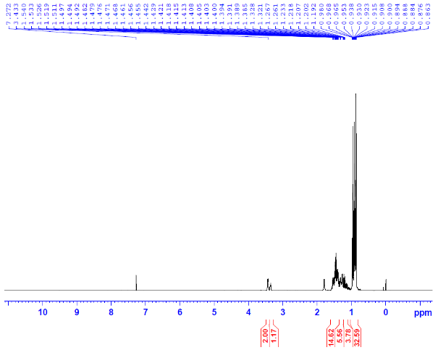
Figure S2. ¹³C NMR spectrum of 1a (CDCl₃)
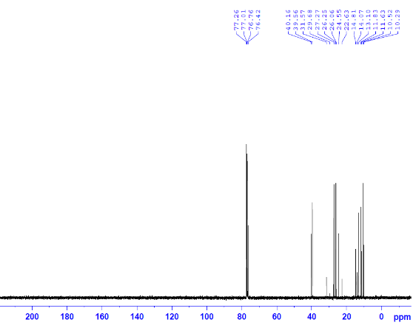

Figure S3. ¹H NMR spectrum of 2a (CDCl₃)
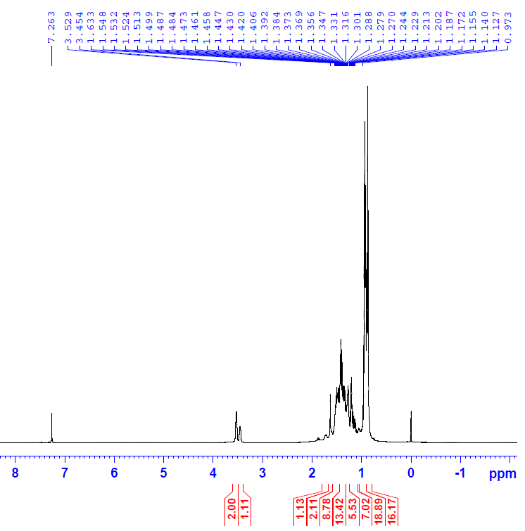
Figure S4. ¹³C NMR spectrum of 2a (CDCl₃)
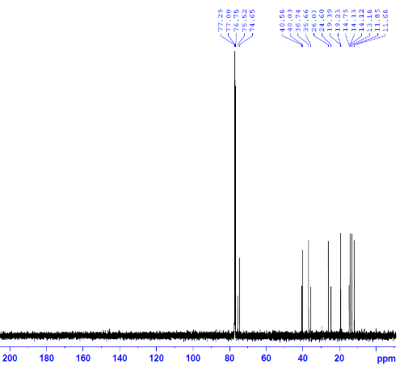
Figure S5. ¹H NMR spectrum of 3a (CDCl₃)
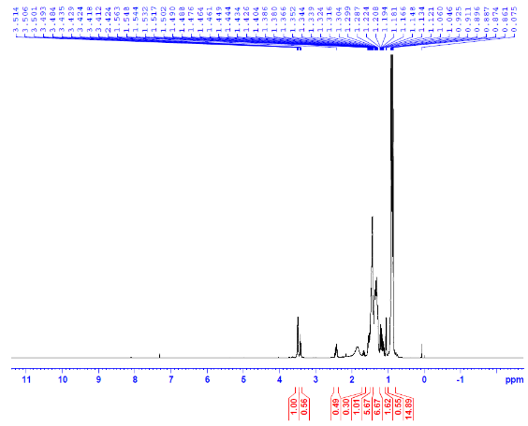
Figure S6. ¹³C NMR spectrum of 3a (CDCl₃)
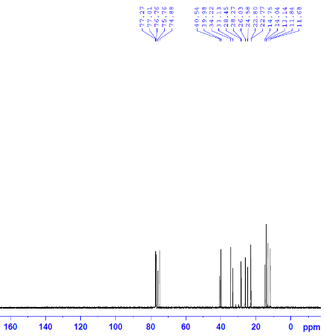
Figure S7. ¹H NMR spectrum of 4a (CDCl₃)
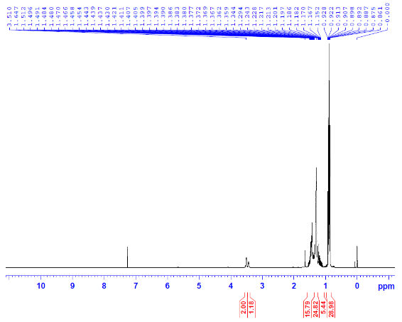
Figure S8. ¹³C NMR spectrum of 4a (CDCl₃)
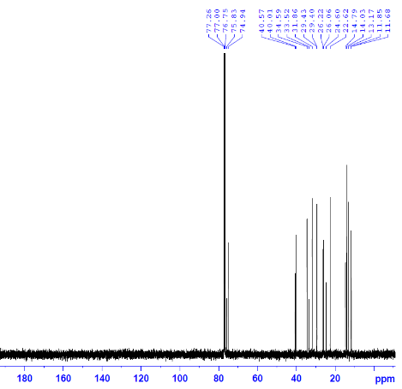
Figure S9. ¹H NMR spectrum of 5a (CDCl₃)
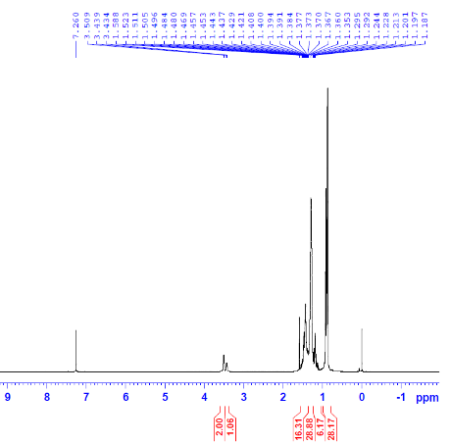
Figure S10. ¹³C NMR spectrum of 5a (CDCl₃)
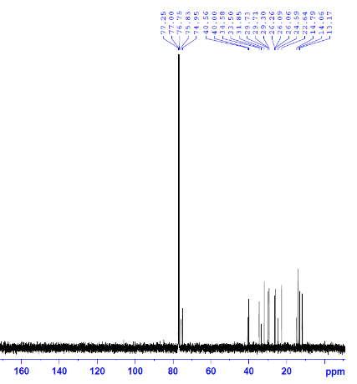
Figure S11. ¹H NMR spectrum of 6a (CDCl₃)
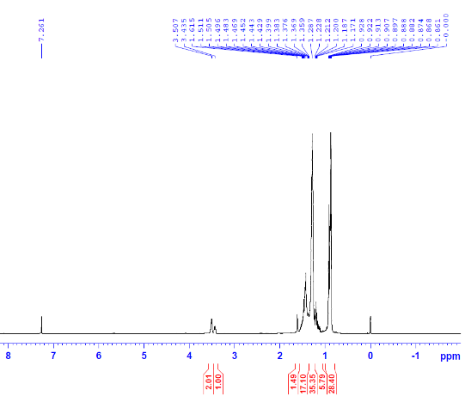
Figure S12. ¹³C NMR spectrum of 6a (CDCl₃)
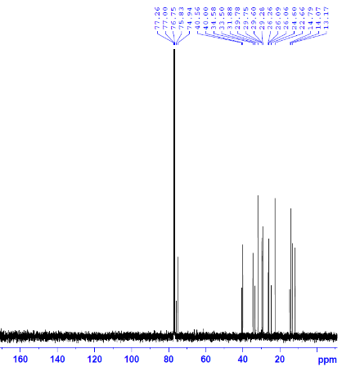
Figure S13. ¹H NMR spectrum of 7a (CDCl₃)
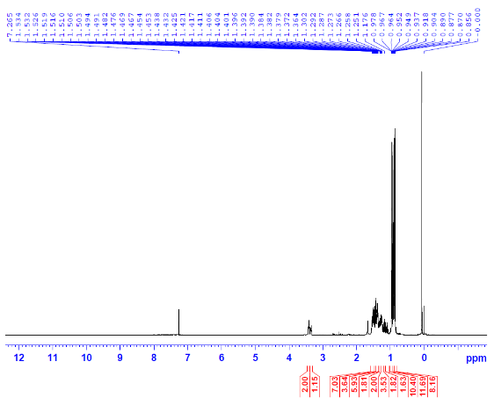
Figure S14. ¹³C NMR spectrum of 7a (CDCl₃)
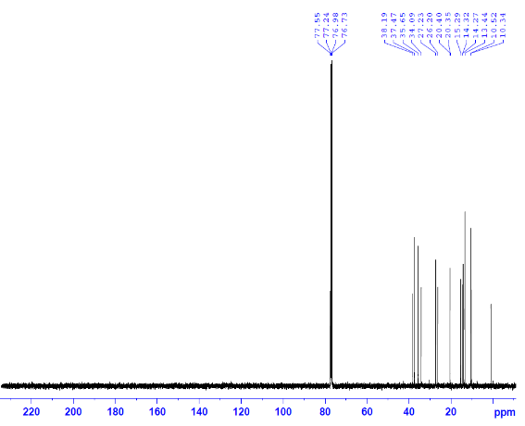
Figure S15. ¹H NMR spectrum of 8a (CDCl₃)
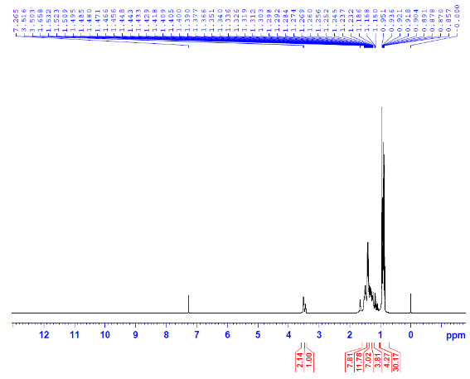
Figure S16. ¹³C NMR spectrum of 8a (CDCl₃)
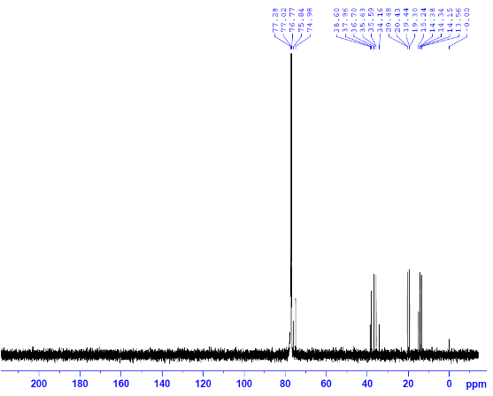
Figure S17. ¹H NMR spectrum of 10a (CDCl₃)
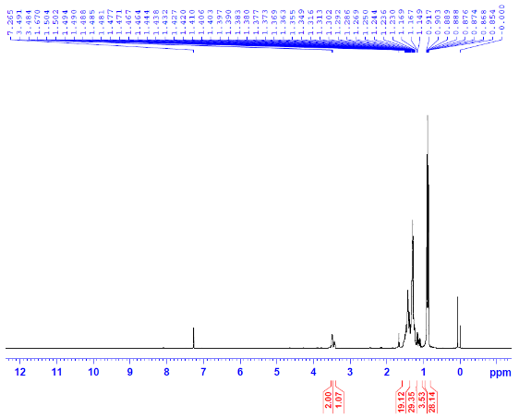
Figure S18. ¹³C NMR spectrum of 10a (CDCl₃)
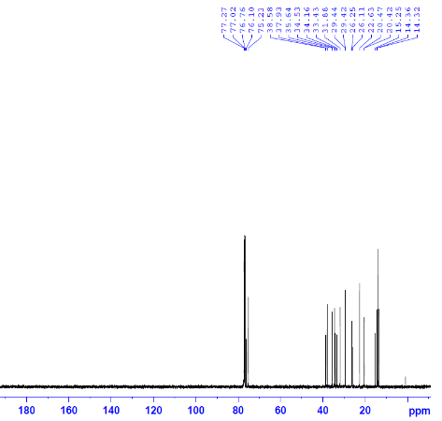
Figure S19. ¹H NMR spectrum of 11a (CDCl₃)
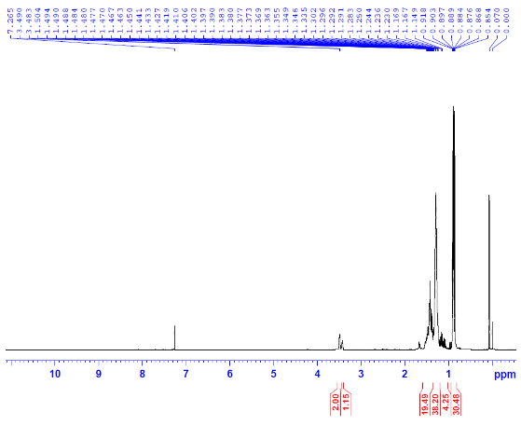
Figure S20. ¹³C NMR spectrum of 11a (CDCl₃)
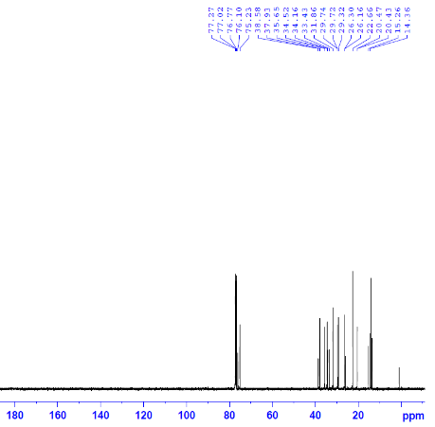
Figure S21. ¹H NMR spectrum of 12a (CDCl₃)
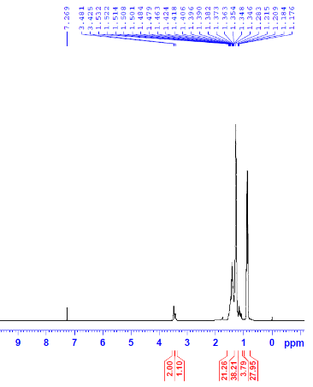
Figure S22. ¹³C NMR spectrum of 12a (CDCl₃)
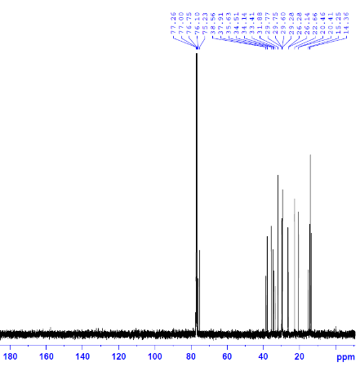

Figure S23. Diastereomer ratios of 1a-12a and 1c-12c

Figure S24. ¹H NMR spectrum of 3b (CDCl₃)
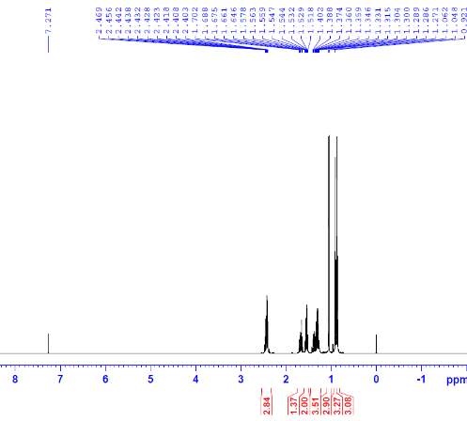

Figure S25. ¹³C NMR spectrum of 3b (CDCl₃)

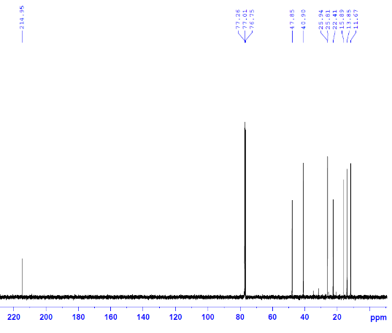
Figure S26. ¹H NMR spectrum of 4b (CDCl₃)
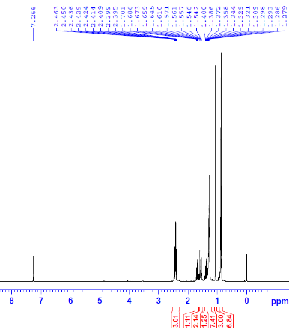
Figure S27. ¹³C NMR spectrum of 4b (CDCl₃)
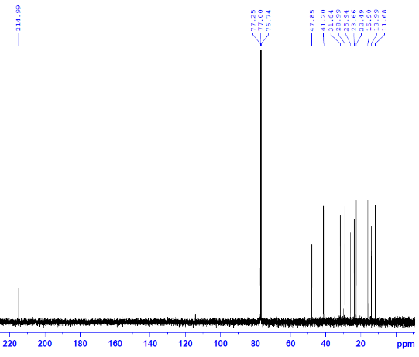
Figure S27. ¹H NMR spectrum of 5b (CDCl₃)
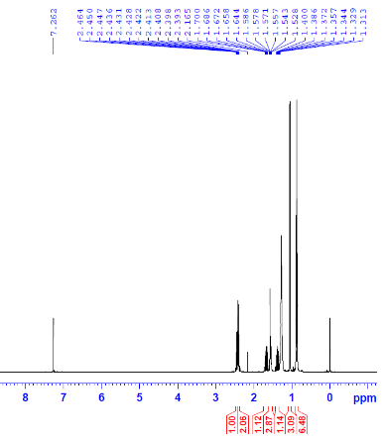
Figure S28. ¹³C NMR spectrum of 5b (CDCl₃)
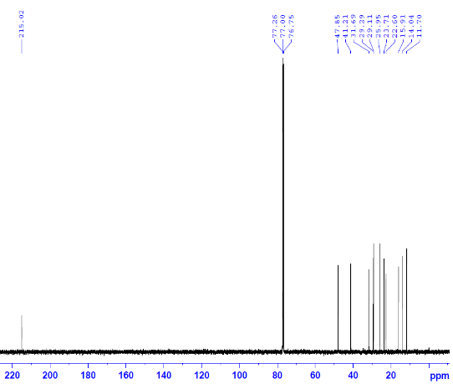
Figure S29. ¹H NMR spectrum of 6b (CDCl₃)
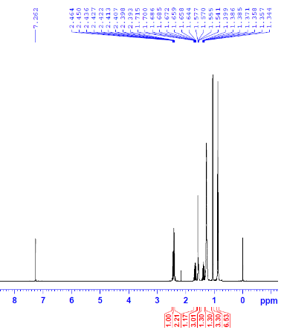
Figure S30. ¹³C NMR spectrum of 6b (CDCl₃)
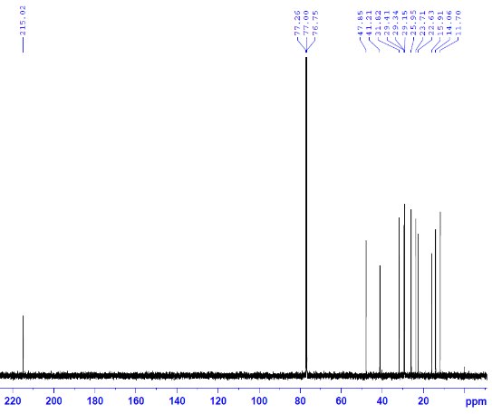
Figure S31. ¹H NMR spectrum of 7b (CDCl₃)
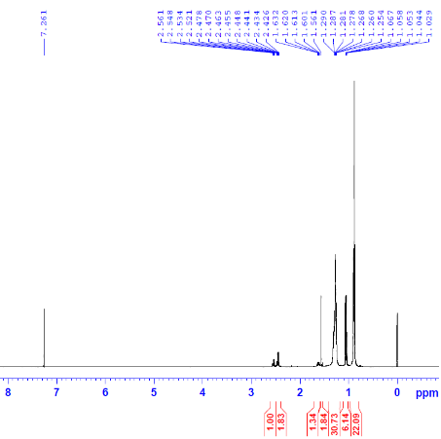
Figure S32. ¹³C NMR spectrum of 7b (CDCl₃)
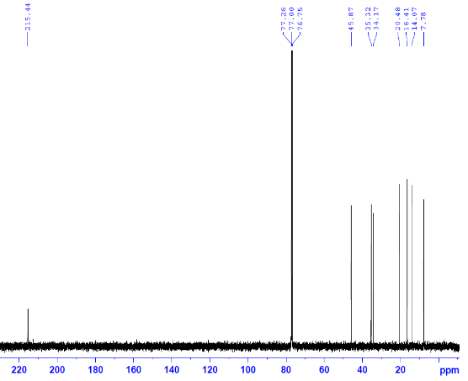
Figure S33. ¹H NMR spectrum of 8b (CDCl₃)
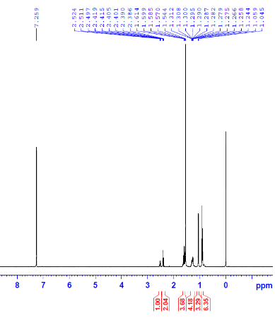
Figure S34. ¹H NMR spectrum of 9b (CDCl₃)
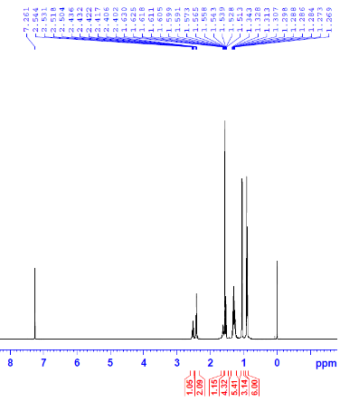
Figure S35. ¹³C NMR spectrum of 9b (CDCl₃)
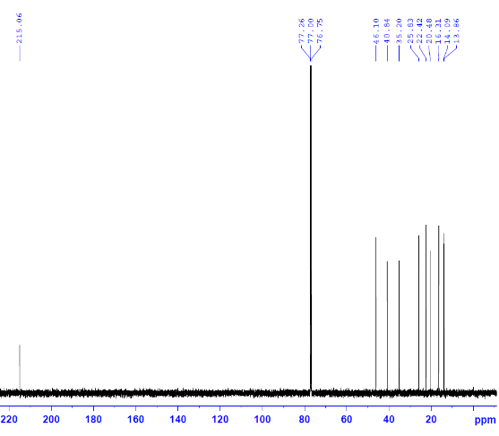
Figure S36. ¹H NMR spectrum of 10b (CDCl₃)
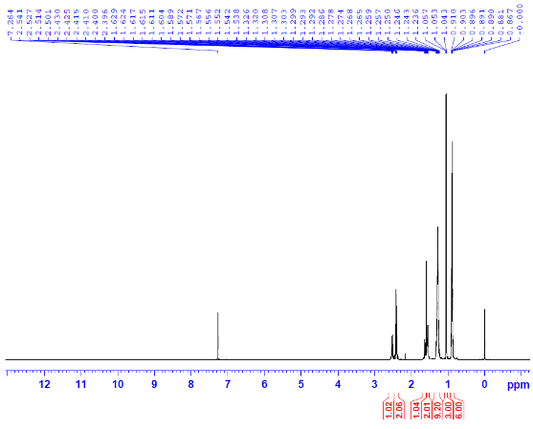
Figure S37. ¹³C NMR spectrum of 10b (CDCl₃)
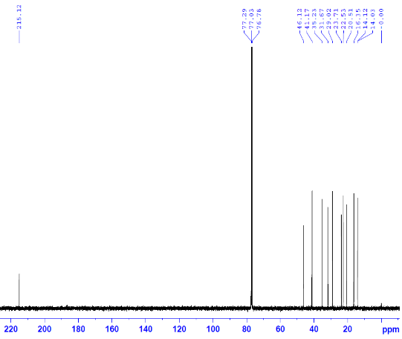
Figure S38. ¹H NMR spectrum of 11b (CDCl₃)
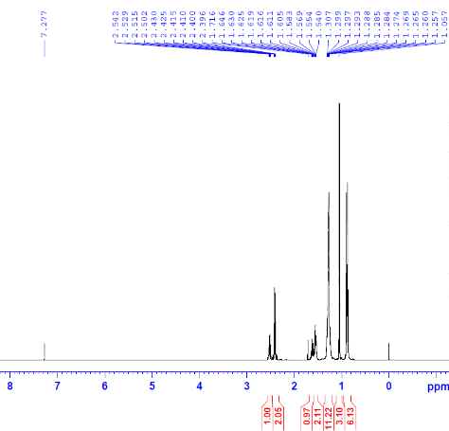
Figure S39. ¹³C NMR spectrum of 11b (CDCl₃)
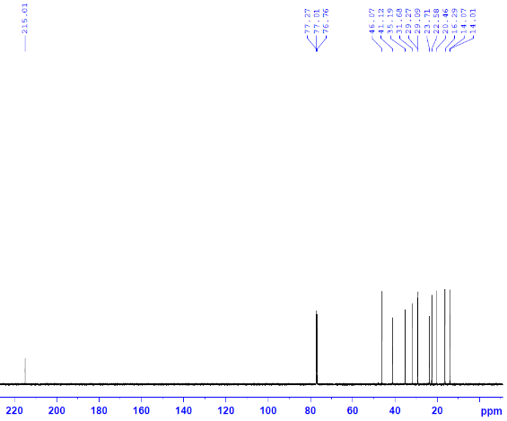
Figure S40. ¹H NMR spectrum of 12b (CDCl₃)
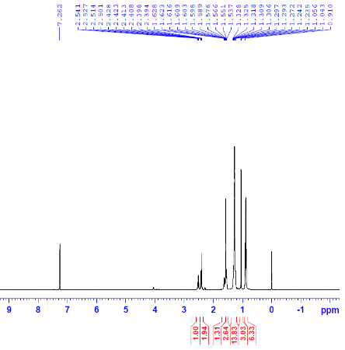
Figure S41. ¹³C NMR spectrum of 12b (CDCl₃)
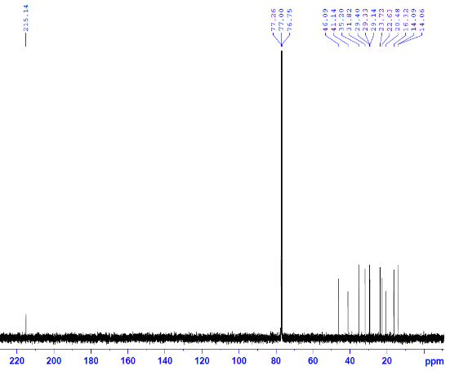

            - Dang, C.H.; Le, V.D.; Nguyen, C.H.; Nguyen T.D. Arkivoc, 2017, 2017 (v), 187-195. Doi: 10.24820/ark.5550190.p010.271
            - Jones, T. H.; Meinwald, J.; Hicks, K.; Eisner, T. Proc. Natl. Acad. Sci., 1977, 74, 419-422. Doi: 10.1073/pnas.74.2.419

