Supporting Information
Microbubbles Decorated with Dendronized Magnetic Nanoparticles for Biomedical Imaging. Effective Stabilization via Fluorous Interactions
Da Shi, Justine Wallyn, Dinh-Vu Nguyen, Francis Perton, Delphine Felder-Flesch, Sylvie Bégin-Colin, Mounir Maaloum, Marie Pierre Krafft*

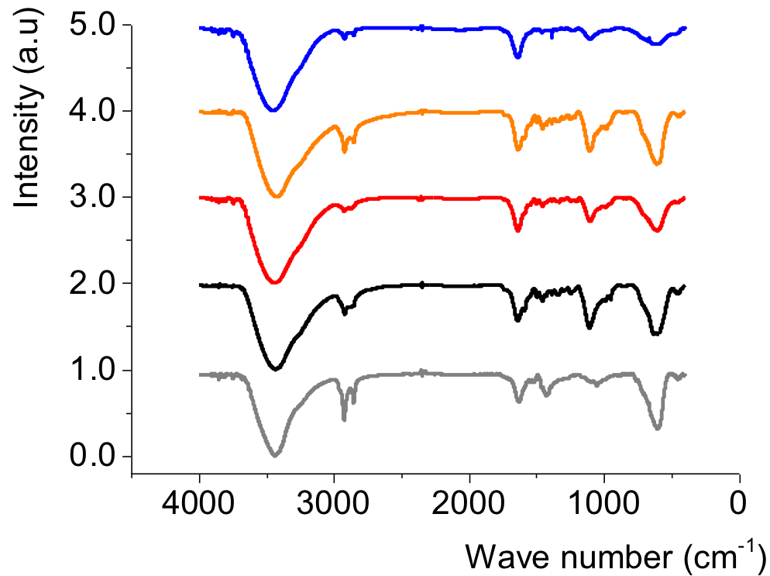

Figure S1. Infrared spectra of IONPs covered by oleic acid (grey), or dendronized with C₂H₅OEG₈Den (black), C₂F₅OEG₈Den (red), C₄H₉OEG₈Den (orange) and C₄F₉OEG₈Den (blue).

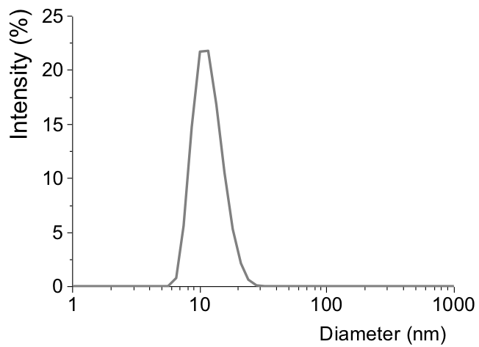

Figure S2. Hydrodynamic diameter distributions of IONPs covered with oleic acid (10 ± 1 nm), in suspension in THF aqueous dispersions (0.05 mg mL⁻¹).
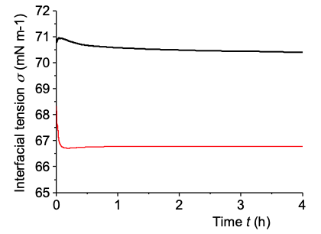

Figure S3. Variation of the interfacial tension σ of the gas/aqueous phase interface as a function of time under air (black) and under F-hexane-saturated air (red). Temperature was 25°C.

