Contents

1. Procedure for the synthesis of diaryl sulfide 1………………………………………………...…2
2. Procedure for the synthesis of thioxanthylium salt 4……………………………………………….3
3. Computational data……………………………………………………....…………………….4
4. Reference………………………………………………..…………………………………………….7
5. UV-vis spectrum of 3 and 4……………………………....………………………………………...…8
6. Cyclic voltammograms of 3 and 4…………………………………...…...……….……………………26
7. ¹H-NMR and ¹³C-NMR data……………………………………………………………….29

1. Procedure for the synthesis of diaryl sulfide 1
For the synthesis of bis(dimethoxyphenyl)sulfide
Bis(3,5-dimethoxtphenyl)sulfide and bis(3,4-dimethoxyphenyl)sulfide were prepared according to published methods from 3,5-dimethoxyaniline and 3,4-dimethoxyaniline.^{1,2}
Bis(3,5-dimethoxtphenyl)sulfide. White solid (0.7748 g, 63% yield). ¹H NMR (300 MHz, CDCl₃): δ 6.85 (d, J = 2.3 Hz, 2H), 6.40 (t, J = 2.3 Hz, 1H), 3.76 (s, 6H). The spectroscopic data were agreement with literature values.¹
Bis(3,4-dimethoxyphenyl)sulfide. White solid (0.6092 g, 60% yield). ¹H NMR (500 MHz, CDCl₃): δ 6.97-6.86 (m, 4H), 6.86-6.77 (m, 2H), 3.88 (s, 6H), 3.82 (s, 6H). The spectroscopic data were agreement with literature values.³

For the synthesis of bis(3,5-diethoxyphenyl)sulfide
1)^{1,2,4} 1-Iodo-3,5-dimethoxybenzene were prepared according to published methods from 3,5-dimethoxyaniline.² To a solution of 1-iodo-3,5-dimethoxybenzene (0.6824 g, 2.5 mmol) in CH₂Cl₂ (2.5 mL) was placed in a 50 mL recovery flask under N₂. Boron tribromide (10.0 mL, 1.0 M in CH₂Cl₂, 10 mmol) was added slowly at 0 °C. The reaction was warmed to room temperature and stirred overnight. Then, it was cooled to -78 °C, quenched with methanol and concentrated in vacuo. The crude mixture was redissolved in ethyl acetate, washed with H₂O, dried over sodium sulfate, filtered and concentrated in vacuo. The crude product 5-iodobenzene-1,3-diol was used in the subsequent step without further purification.

2)⁴ To an oil of 5-iodobenzene-1,3-diol (2.5 mmol) and potassium carbonate (1.3847 g, 10.0 mmol) in DMF (10 mL) were placed in a 100 mL recovery flask under N₂. Bromoethane (0.746 mL, 10.0 mmol) was then added and the reaction heated to 60 °C for 20 h. The reaction was cooled, diluted in ethyl acetate, washed with H₂O, dried over sodium sulfate, filtered and concentrated in vacuo. The crude mixture was purified by column chromatography on silica gel (hexane / ethyl acetate = 20 / 1) to provide 1,3-diethoxy-5-iodobenzene (0.6014 g, 82 % yield) as a brown oil. ¹H NMR (500 MHz, CDCl₃): δ 6.83 (d, J = 2.4 Hz, 2H), 6.39 (t, J = 2.0 Hz, 1H), 3.97 (q, J = 6.9 Hz, 4H), 1.38 (t, J = 7.2 Hz, 6H); ¹³C NMR (126 MHz, CDCl₃): δ 160.4, 116.2, 101.4, 94.0, 63.7, 14.7; IR (ATR): 1591, 1434, 1169, 1047, 802, 676 cm⁻¹; LRMS (ESI+) m/z calcd for C₁₀H₁₄O₂I ([M+H]⁺) : 293.00, found: 293.09.

3)¹ To a mixture of 1,3-diethoxy-5-iodobenzene (0.4857 g, 1.7 mmol), carbon disulfide (0.100 mL, 1.7 mmol), CuI (0.0356 g, 0.17 mmol), and DBU (0.496 mL, 3.3 mmol) in toluene (3.0 mL) was stirred at reflux under N₂ for 16 h. After H₂O was added, the mixture was extracted with CH₂Cl₂. The organic layer was dried over MgSO₄ and concentrated in vacuo. The crude mixture was purified by column chromatography on silica gel (hexane / ethyl acetate = 30 / 1) to provide bis(3,5-diethoxyphenyl)sulfane (0.0727 g, 39% yield) as a yellow oil.
¹H NMR (500 MHz, CDCl₃): δ 6.49 (d, J = 2.3 Hz, 4H), 6.33 (t, J = 2.3 Hz, 2H), 3.96 (q, J = 6.9 Hz, 8H), 1.37 (t, J = 6.9 Hz, 12H); ¹³C NMR (126 MHz, CDCl₃): δ 160.3, 136.9, 109.3, 100.6, 63.6, 14.7; IR (ATR): 1577, 1430, 1389, 1278, 1166, 1050, 815, 681 cm⁻¹; HRMS (ESI+) m/z calcd for C₂₀H₂₇O₄S ([M+H]⁺) : 363.1625, found: 363.1639.

2. Procedure for the synthesis of thioxanthylium salt 4
1)⁵ To a solution of 2-bromotoluene (0.897 mL, 7.5 mmol) in dioxane (17.0 mL) and THF (28.0 mL) was placed in a 100 mL recovery flask under N₂. n-BuLi (5.16 mL, 1.6 M in hexane, 8.26 mmol) was added at -78 °C, and the reaction was stirred for 1 h at -78 °C. Thioxanthone (1.0644 g, 5.0 mmol) in dioxane was added, and the reaction was stirred for 24 h at room temperature. The reaction was quenched with sat. diammonium phosphate and extract with CH₂Cl₂. It was concentrated in vacuo. To the organic layer was added hexane, and the mixture was cooled to -30 °C to give white solid. The mixture was filtered and dried in vacuo, affording the desired 9-(2-methylphenyl)-9-thioxanthenol (0.6863 g, 45% yield) as a white solid. ¹H NMR (500 MHz, CDCl₃) δ 8.18 (d, J = 7.7 Hz, 1H), 7.43-7.36 (m, 3H), 7.32 (t, J = 7.4 Hz, 1H), 7.26-7.23 (m, 2H), 7.12-7.04 (m, 5H), 2.51 (d, J = 2.9 Hz, 1H), 1.55 (s, 3H). The spectroscopic data were agreement with literature values.⁵
2)⁵ To a solution of 9-(2-methylphenyl)-9-thioxanthenol (0.3048 g, 1.0 mmol) in Et₂O (5.0 mL) was placed in a 50 mL recovery flask under N₂. Trifluoromethanesulfonic acid (0.177 mL, 2.0 mmol) was slowly added to precipitate a solid. After stirred for 1 h, the mixture was filtered. The solid was washed with Et₂O and dried in vacuo, affording the desired thioxanthylium salt 4 (0.3473 g, 80% yield). Red solid. ¹H NMR (500 MHz, CDCl₃): δ 8.91 (d, J = 8.6 Hz, 2H), 8.43 (ddd, J = 8.3, 6.9, 1.4 Hz, 2H), 8.16 (d, J = 8.6 Hz, 2H), 8.07 (ddd, J = 8.5, 7.0, 1.2 Hz, 2H), 7.71-7.66 (m, 1H), 7.61-7.53 (m, 2H), 7.33-7.29 (m, 1H), 1.91 (s, 3H); ¹³C NMR (126 MHz, CDCl₃): δ 171.3, 148.1, 137.9, 135.5, 134.5, 133.7, 131.6, 131.0, 131.0, 129.7, 128.8, 128.3, 126.4, 19.7; ¹⁹F NMR (471 MHz, CDCl₃): δ -81.4; IR (ATR): 1547, 1449, 1373, 1260, 1142, 1029, 736, 634 cm⁻¹; HRMS (ESI+) m/z calcd for C₂₀H₁₅S [M]⁺: 287.0889, found: 287.0879.
3. Computational data

Structure optimizations and frequency analyses of cations 3a and 4a were carried out at the B3LYP level of density functional theory (DFT) with the 6-31G(d,p) basis set on the ORCA program package.⁶

9-Phenyl-1,3,6,8-tetramethoxythioxanthylium cation
atom type | x | y | z
C | 0.098289 | 0.212300 | -1.259567
C | -0.048430 | 1.637149 | -1.378192
C | -0.186286 | 2.306630 | -2.592329
C | -0.119796 | 1.574514 | -3.781309
C | 0.151294 | 0.193490 | -3.741241
C | 0.302373 | -0.475146 | -2.540210
C | -0.000172 | -0.460670 | 0.000080
C | -0.098675 | 0.211989 | 1.259956
C | 0.048120 | 1.636846 | 1.378826
S | -0.000139 | 2.693604 | 0.000423
C | -0.302955 | -0.475562 | 2.540575
C | -0.151790 | 0.192919 | 3.741679
C | 0.119541 | 1.573877 | 3.781928
C | 0.186088 | 2.306135 | 2.593051
C | 0.000200 | -1.961032 | -0.000366
C | 1.156660 | -2.662899 | 0.361318
C | 1.156940 | -4.057529 | 0.352482
C | 0.001028 | -4.759099 | -0.001674
C | -1.155263 | -4.057882 | -0.355283
C | -1.155778 | -2.663242 | -0.362910
O | -0.667038 | -1.760043 | 2.494520
O | 0.665809 | -1.759825 | -2.494120
O | -0.258582 | 2.093560 | -5.004712
O | 0.258367 | 2.092753 | 5.005398
C | -0.865079 | -2.501778 | 3.702304
C | 0.863396 | -2.501759 | -3.701854
C | 0.512693 | 3.495491 | 5.160825
C | -0.512713 | 3.496352 | -5.159959
H | -0.324325 | 3.381135 | -2.600956
H | 0.266673 | -0.315514 | -4.688717
H | -0.267378 | -0.316162 | 4.689094
H | 0.324224 | 3.380627 | 2.601827
H | 2.056687 | -2.120362 | 0.638908
H | 2.060648 | -4.596207 | 0.624789
H | 0.001345 | -5.845936 | -0.002171
H | -2.058632 | -4.596838 | -0.628159
H | -2.056077 | -2.120977 | -0.640150
H | -1.149078 | -3.501501 | 3.375429
H | -1.669374 | -2.062156 | 4.302908
H | 0.059428 | -2.550035 | 4.288427
H | 1.146890 | -3.501606 | -3.374917
H | 1.667892 | -2.062607 | -4.302532
H | -0.061165 | -2.549581 | -4.287927
H | 0.604156 | 3.655430 | 6.234780
H | -0.321808 | 4.088171 | 4.769363
H | 1.446889 | 3.779068 | 4.663824
H | -0.604154 | 3.656443 | -6.233893
H | 0.321868 | 4.088869 | -4.768422
H | -1.446870 | 3.779995 | -4.662921
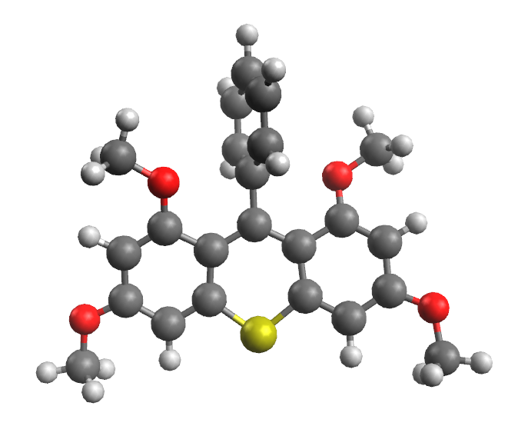
Total Energy: -1587.13327102 hartree
Imaginary Frequencies: 0

9-Phenylthioxanthylium cation
atom type | x | y | z
C | 0.012766 | -1.262464 | 0.390821
C | -0.013433 | -1.376506 | 1.819830
C | -0.027469 | -2.637633 | 2.445485
C | 0.004556 | -3.788733 | 1.680883
C | 0.070917 | -3.710651 | 0.273252
C | 0.081039 | -2.485682 | -0.351445
C | 0.002161 | -0.001927 | -0.283219
C | -0.007121 | 1.253571 | 0.400184
C | 0.021920 | 1.356969 | 1.829933
S | 0.005312 | -0.013698 | 2.885260
C | -0.076875 | 2.482279 | -0.332817
C | -0.065479 | 3.702563 | 0.300969
C | 0.003715 | 3.770176 | 1.709005
C | 0.037236 | 2.613398 | 2.464933
C | 0.000773 | 0.003640 | -1.772225
C | 1.117101 | 0.483200 | -2.481241
C | 1.116962 | 0.473661 | -3.875672
C | -0.001963 | 0.014655 | -4.575388
C | -1.119498 | -0.449897 | -3.877117
C | -1.116914 | -0.470398 | -2.482804
H | -0.149117 | 2.437877 | -1.411587
H | 0.151000 | -2.433155 | -1.429995
H | -0.004855 | -4.757405 | 2.171275
H | 0.014137 | 4.735158 | 2.206593
H | -0.056602 | -2.700380 | 3.529520
H | 0.124918 | -4.619712 | -0.316437
H | -0.120675 | 4.615985 | -0.281847
H | 0.068557 | 2.668066 | 3.549349
H | 1.988954 | 0.841032 | -1.941344
H | 1.990884 | 0.827526 | -4.414024
H | -0.003056 | 0.019015 | -5.661318
H | -1.994473 | -0.799519 | -4.416525
H | -1.987748 | -0.832423 | -1.944042
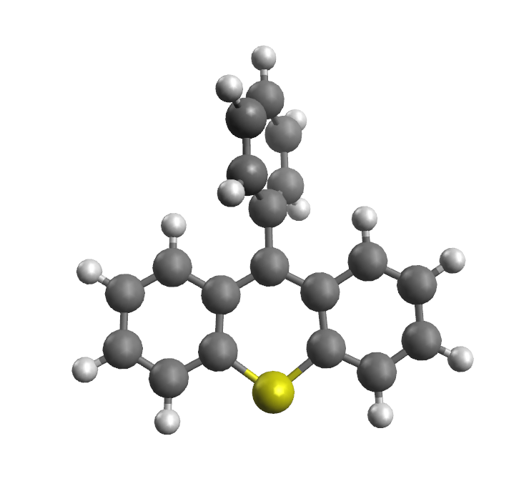
Total Energy: -1129.58253481 hartree
Imaginary Frequencies: 0

4. Reference
1. K. Tanaka, M. Sukekawa, M. Kishimoto, Y. Hoshino, K. Honda, Tetrahedron Lett., 2018, 59, 3361.
2. W. Mao, T. Wang, H. Zeng, Z. Wang, J. Chen, J. Shen, Bioorg. Med. Chem. Lett. 2009, 19, 4570.
3. S. Trosien, P. Bottger, S. R. Waldvogel, Org. Lett. 2014, 16, 402.
4. A. A. Szymaniak, C. Zhang, J. R. Coombs, J. P. Morken, ACS Catal. 2018, 8, 2897.
5. T. Erabi, M. Asahara, M. Miyamoto, K. Goto, M. Wada, Bull. Chem. Soc. Jpn. 2002, 75, 1325.
6. For the ORCA program system; a) F. Neese, Wiley Interdiscip. Rev.: Comput. Mol. Sci. 2012, 2, 73. b) F. Neese, Wiley Interdiscip. Rev.: Comput. Mol. Sci. 2017, 8, e1327.

6. UV-vis spectrum of 3 and 4
UV-vis spectrum of 3 and 4 (10 μM) in CH₃CN.

3a
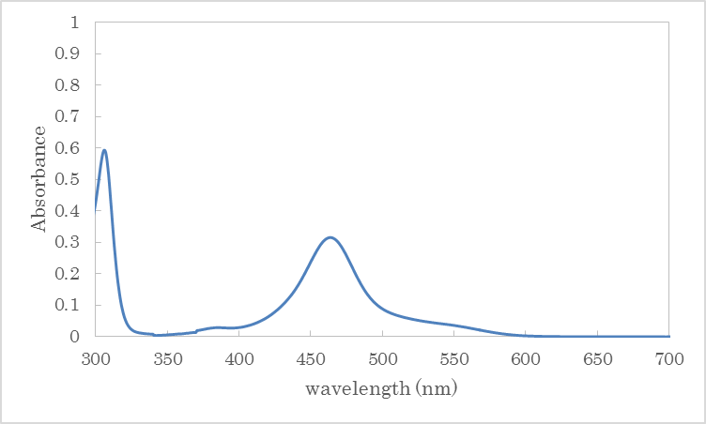

3b
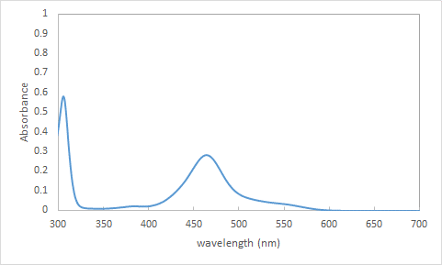

3c
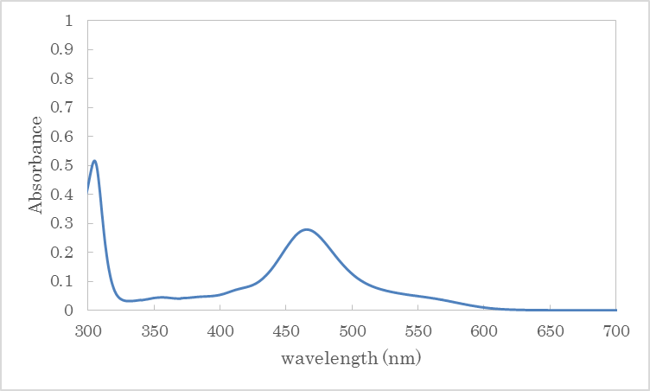

3d
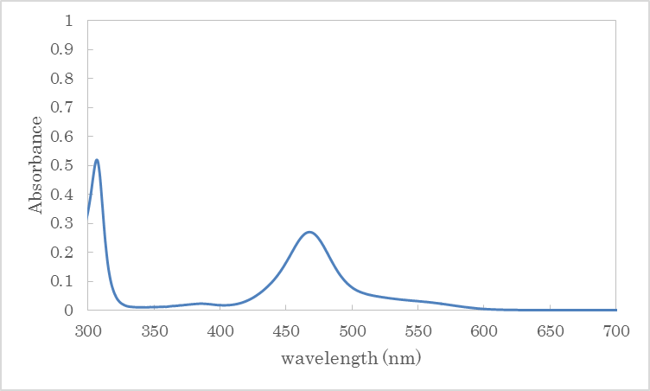

3e
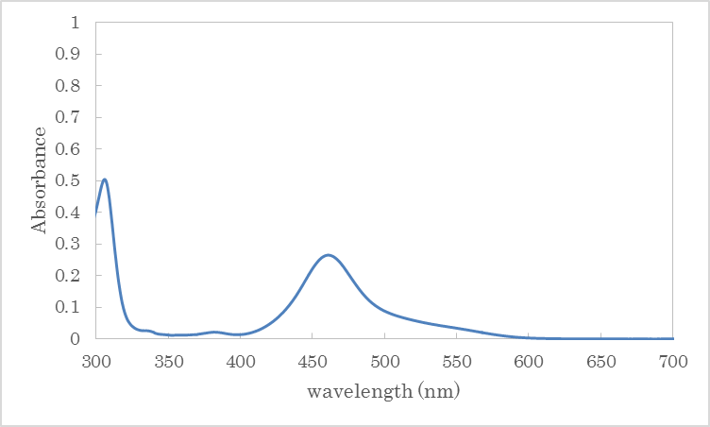

3f
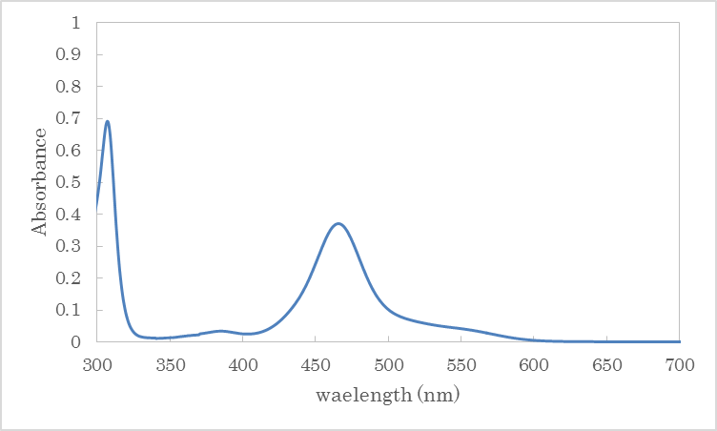

3g
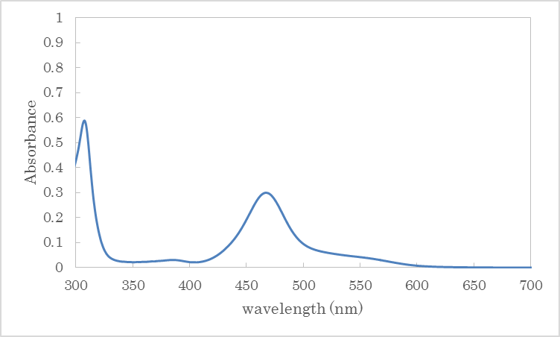

3h
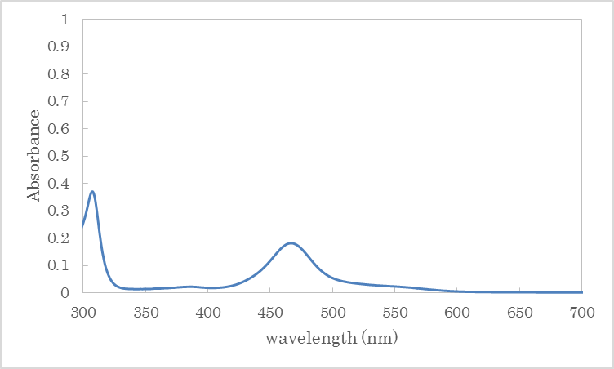

3i
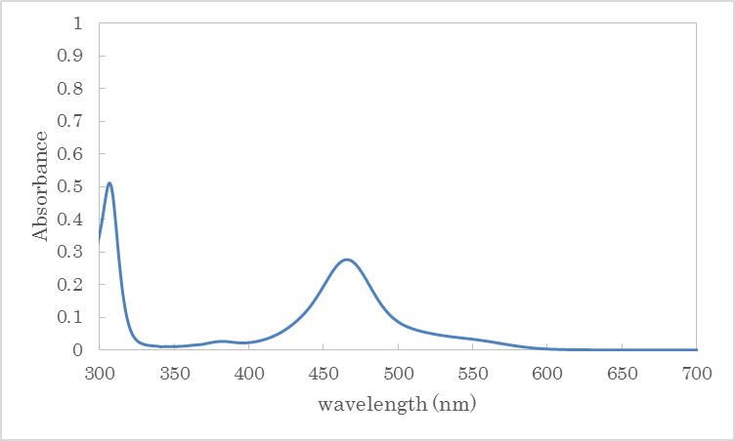

3j
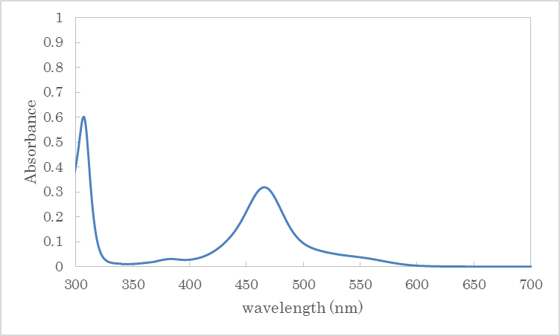

3k
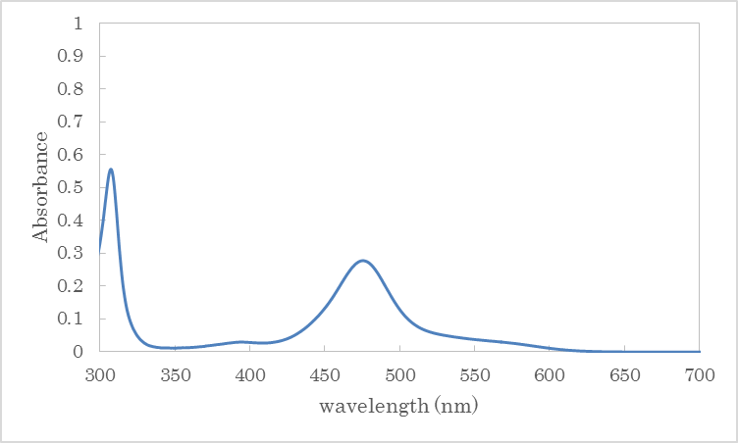

3l
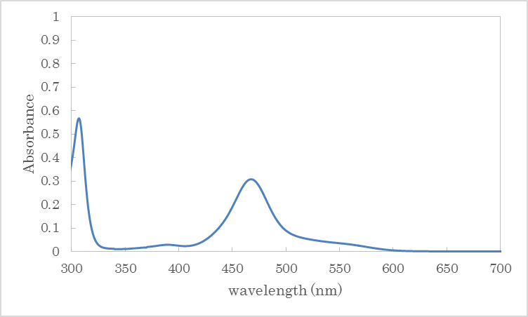

3m
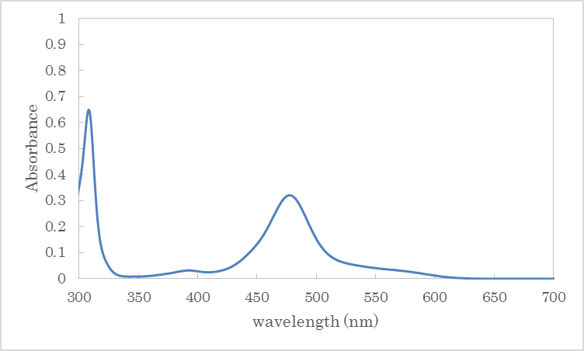

3n
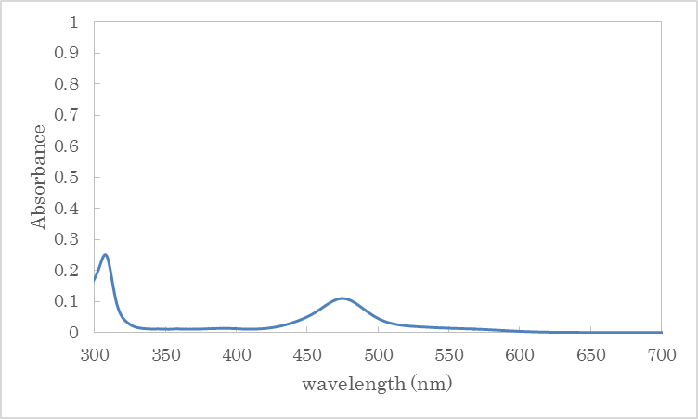

3o
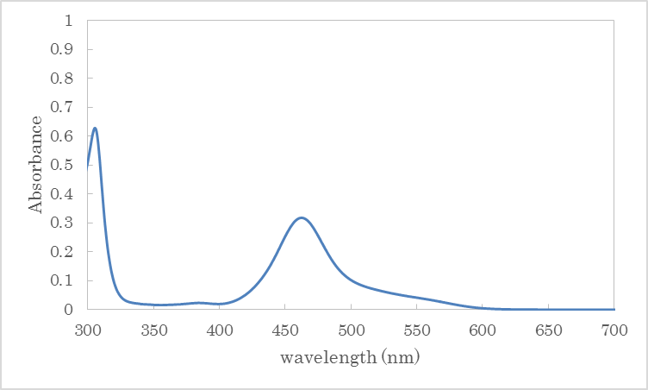

3p
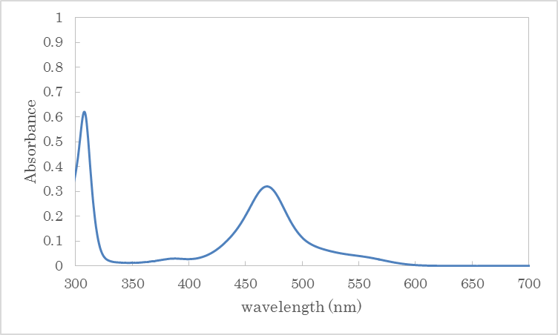

3q
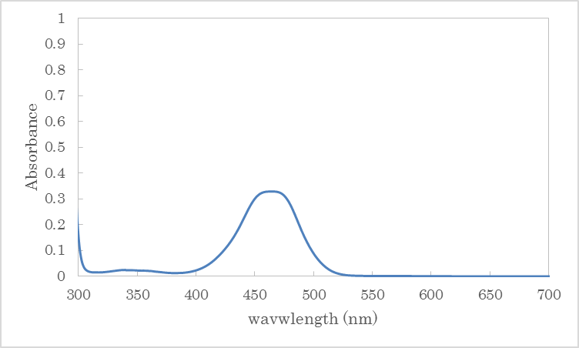

4b
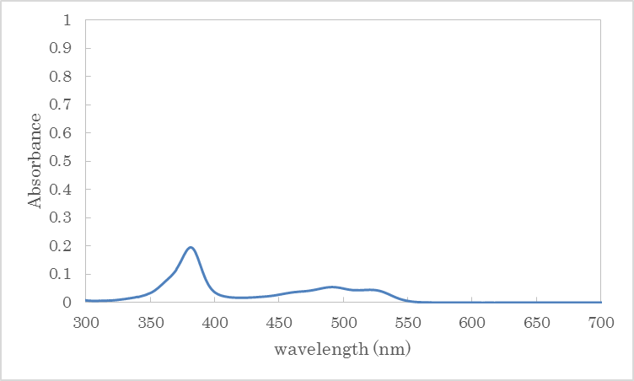

6. Cyclic voltammograms of 3 and 4
Samples for electrochemical measurements were prepared with 10 mL of a 0.01 M tetra-n-butylammonium tetrafluoroborate solution in dry CH₃CN and 0.01 mmol of thioxanthylium salt. Cyclic voltammetry measurements were carried out with a computer-controlled potentiostat Model 660C (ALS Co., Ltd.). Cyclic Voltammetry was recorded using an undivided cell equipped with a working electrode (Pt disk electrode, φ 3 mm), a counter electrode (Pt wire), and a reference electrode (Ag wire). The ferrocene / ferrocenium couple (Fc/Fc⁺) was also measured in the same electrochemical system, and the electrode potential was reported as values referred to the apparent standard potential of the system. A scan rate was used 1.0 V/s.

3b
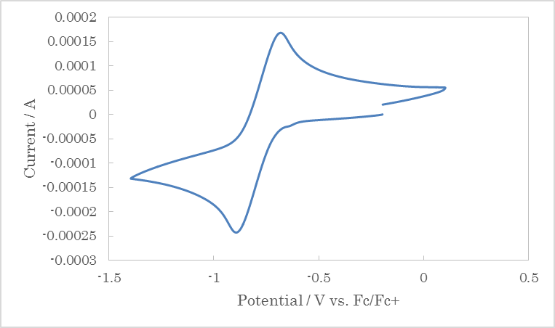

3q
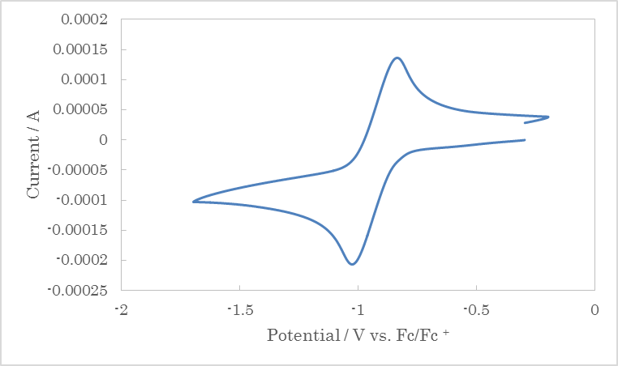

4b
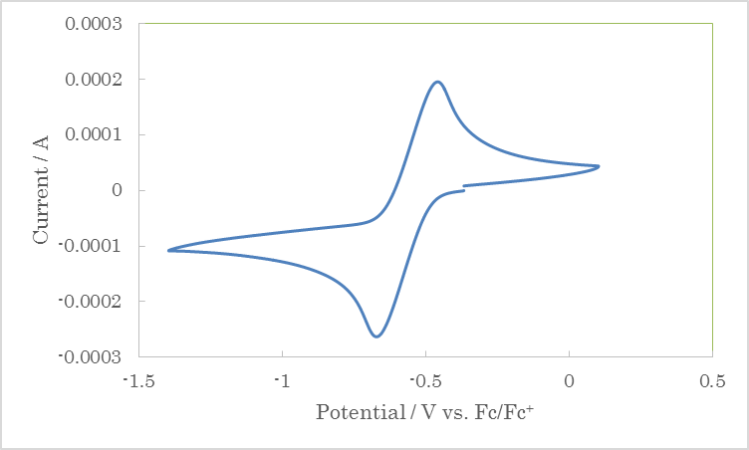

7. ¹H NMR and ¹³C NMR spectrum data

