Supporting information

for

Synthesis of 1-azaspiro[4.4]nonan-1-oxyls via Intramolecular 1,3-Dipolar Cycloaddition
Yulia V. Khoroshunova, Denis A. Morozov, Andrey I. Taratayko, Polina D. Gladkikh, Yuri I. Glazachev and Igor A. Kirilyuk

Experimental section, NMR spectra data and EPR measurements

Table of contents
- Experimental section and NMR data for the new compounds.............................3
- EPR experiments................................................................................................28
- References..........................................................................................................31

All commercially available solvents and reagents were of highest quality and used without further purification. Nitrone 5a was prepared according to the literature protocols [9, 10]. ¹H NMR spectra were recorded at 300, 400, 500 or 600 MHz on BRUKER Avance AV 300, AV 400, DRX 500 and AV 600 spectrometers. ¹³C NMR spectra were recorded at 75, 100, or 150 MHz on BRUKER Avance AV 300, AV 400 and AV 600 spectrometers, as indicated next to each NMR analysis. ¹H and ¹³C chemical shifts (δ) were internally referenced to the residual solvent peak. The IR spectra were acquired on a FT-IR spectrometer in KBr or neat. The UV spectra were recorded in EtOH (10⁻⁴ M solutions). The progress of the reactions was monitored by TLC and carried out using UV light at 254 nm, 1% aqueous potassium permanganate, and/or Dragendorff reagent as visualizing agents. Column chromatography was performed on silica gel 60 (70−230 mesh). HRMS were recorded on double-focusing, high-resolution mass spectrometer equipped with a high-performance toroidal ESA and quadrupole time-of-flight mass spectrometer.

3-Nitropentane and nitrocyclohexane were prepared from pentane-3-one oxime and cyclohexanone oxime according to literature protocols [1].

Nitroaldehydes 3b,c (General procedure). A solution of nitroalkane 2b,c (50 mmol) in CH₃OH (25 mL) was added dropwise to a freshly prepared solution of CH₃ONa (54 mg, 1 mmol) in CH₃OH (10 mL) at 10 °C. The resulting pale yellow solution was stirred at room temperature for 15 minutes and then cooled to 2 °C. Freshly distilled acrolein was added dropwise to reaction mixture maintaining temperature 2-4 °C. Then AcOH (0.06 ml, 1 mmol) was added and CH₃OH was evaporated under reduced pressure. The crude residue was dissolved in CHCl₃ (50ml), washed with brine (3x40 ml) and dried with Na₂SO₄. After evaporation of the chloroform, the crude residue was purified via column chromatography (silica gel, CHCl₃).

3-(1-Nitrocyclohexyl)propanal (3b):
Yield : 70%, colorless liquid which solidifies when cooled to -20ºC.
Spectroscopic data are identical to previously published [2].
¹H NMR (500 MHz, CDCl₃): 1.17-1.36 (m, 3H)(cyclohexane); 1.42-1.57 (m, 5H)(cyclohexane); 2.02-2.07 (m, 2H)(³CH₂); 2.24-2.32 (m, 2H)(cyclohexane; 2.34-2.40 (m, 2H) (²CH₂); 9.64 (t, J_{t}=0.9, 1H)(HC=O).
¹³C NMR (125 MHz, CDCl₃): 21.9, 24.3, 31.6, 33.7, 37.6, 90.2 (C-NO₂), 199.6 (HC=O).

4-Ethyl-4-nitrohexanal (3c):
Yield : 25%, colorless liquid.
IR (neat) ν, cm⁻¹: 2977, 2946, 2887, 2836, 2730, 1726, 1535, 1456, 1388, 1358, 1311, 849, 827.
¹H NMR (500 MHz, CDCl₃): 0.83 (t, J_{t}=7.5, 6H)(2×CH₃); 1.83-2.03 (m, 4H)(⁵CH₂); 2.14-2.24 (m, 2H)(³CH₂); 2.36-2.44 (m, 2H)(²CH₂); 9.74 (t, J_{t}=1,1H)(HC=O).
¹³C NMR (125 MHz, CDCl₃): 7.8 (2×CH₃), 26.6, 27.8, 38.1, 94.3 (C-NO₂), 199.7 (HC=O).
Anal. calcd for С₈Н₁₅NO₃: C 55.47; H 8.73; N 8.09. Found: C 55.68; H 8.54; N 8.15.
Nitrodioxolanes 4b,c (General procedure).
A mixture of nitroaldehyde 3b,c (120 mmol), ethylene glycol (8 ml, 144 mmol), TsOH (190 mg, 1.1 mmol) and C₆H₆ (40 mL) was stirred under reflux with Dean-Stark apparatus until water separation finished. The reaction mixture was washed with NaHCO₃ saturated solution (2×40 ml) and H₂O (2×40 mL), dried with Na₂SO₄. After evaporation of the solvent under reduced pressure, the crude residue was purified via column chromatography (silica gel, CHCl₃) to give 4b,c.

2-(2-(1-Nitrocyclohexyl)ethyl)-1,3-dioxolane (4b):
Yield : 85%, colorless liquid.
IR (neat) ν, cm⁻¹: 2939, 2868, 2763, 1535, 1450, 1427, 1412, 1348, 1230, 1141, 1036, 985, 943, 912, 864, 842
¹H NMR (500 MHz, CDCl₃): 1.16-1.39 (m, 3H)(cyclohexane); 1.44-1.60 (m, 7H)(cyclohexane); 1.82-1.89 (m, 2H)(³CH₂); 2.27-2.37 (m, 2H)(²CH₂); 3.70-3.90 (m, 4H)(2×⁴CH₂); 4.75 (t, J_{t}=4.5, 1H)(¹CH).
¹³C NMR (125 MHz, CDCl₃): 22.1, 24.6, 27.5, 33.8, 34.0, 64.7 (2×⁴CH₂), 90.7 (C-NO₂), 103.2 (¹CH).
Anal. calcd for С₁₁Н₁₉NO₄: C 57.63; H 8.35; N 6.11. Found: C 57.36; H 8.24; N 6.08.

2-(3-Ethyl-3-nitropentyl)-1,3-dioxolane (4c):
Yield : 61%, colorless liquid which solidifies when cooled to -20ºC.
IR (neat) ν, cm⁻¹: 2976, 2947, 2885, 1537, 1456, 1412, 1389, 1362, 1311, 1228, 1144, 1076, 1038, 943, 914, 860, 827.
¹H NMR (500 MHz, CDCl₃): 0.79 (t, J_{t}=7.5, 6H)(2×⁶CH₃); 1.47-1.53 (m, 2H)(³CH₂); 1.88 (dq, J_{d}=2.7 J_{q}=7.5, 4H)(2×⁵CH₂); 1.94-1.99 (m, 2H)(²CH₂); 3.76-3.83 (m, 2H)(⁴CH₂); 3.87-3.92 (m, 2H)(⁴CH₂); 4.81 (t, J_{t}=4.4, 1H)(¹CH).
¹³C NMR (125 MHz, CDCl₃): 7.78 (2×⁶CH₃), 27.8, 27.9, 28.0, 64.8 (2×⁴CH₂), 94.8 (C-NO₂), 103.4 (¹CH).
Anal. calcd for С₁₀Н₁₉NO₄: C 55.28; H 8.82; N 6.45. Found: C 55.53; H 8.74; N 6.20.

Nitrones 5b,c (General procedure).
A solution of nitrodioxolane 4b,c and NH₄Cl (3.1 g, 58 mmol) in H₂O/THF (2:1) mixture (60 ml) was cooled to 3 °C and Zn dust (13.0 g, 202 mmol) was added by small portions at vigorous stirring maintaining temperature in the range 3-6 °C. The reaction mixture was stirred for 2 hours at 10 °C, the inorganic precipitate was filtered off and washed with warm THF (60 °C, 150 mL). The combined filtrate was evaporated (temperature did not exceed 25 °C). The crude residue was dissolved in 80 mL of 5% HCl and stirred at 70 °C for 2 hours. Then the reaction mixture was cooled to 10 °C and neutralized to pH = 5 with NaHCO₃. The resulting solution was extracted with CH₂Cl₂ (3×50 ml), the combined extract was washed with brine (1×50 mL) and dried with Na₂SO₄. Methylene chloride was evaporated and the crude residue was purified via column chromatography (silica gel, CHCl₃/CH₃OH).

1-Azaspiro[4.5]dec-1-ene 1-oxide (5b):
Yield : 60%, white solid, m.p 76-77 ºC (Et₂O).
IR (neat) ν, cm⁻¹: 2927, 2854, 1623, 1448, 1313, 1149, 114, 1070, 946, 920, 901, 848, 793.
¹H NMR (500 MHz, CDCl₃): 0.98-1.19 (m, 3H)(cyclohexane); 1.30-1.38 (m, 2H)(cyclohexane); 1.42-1.50 (m, 1H)(cyclohexane); 1.58-1.67 (m, 2H)(cyclohexane); 1.83-1.90 (m, 2H)(cyclohexane); 1.93 (t, J_{t}=7.6, 2H)(⁴CH₂); 2.37 (dt, J_{d}=2.7 J_{t}=7.6, 2H)(³CH₂); 6.60 (t, J_{t}=2.7, 1H)(²CH).
¹³C NMR (125 MHz, CDCl₃): 22.6, 24.1, 24.3, 29.4, 32.8, 76.7 (⁵C), 131.4 (²CH).
Anal. calcd for С₉Н₁₅NO: C 70.55; H 9.87; N 9.14. Found: C 70.87; H 9.91; N 9.31.

2,2-Diethyl-3,4-dihydro-2H-pyrrole 1-oxide (5c):
Yield : 70 %, pale yellow liquid.
IR (neat) ν, cm⁻¹: 2969, 2937, 2881, 1650, 1591, 1463, 1382, 1357, 1214, 1143, 1027, 1001, 930, 920, 833, 791.
¹H NMR (500 MHz, CDCl₃): 0.79 (t, J_{t}=7.4, 6H)(2×⁷CH₃); 1.44-1.54 (m, 2H)(⁶CH₂); 1.73-1.84 (m, 2H)(⁶CH₂); 1.99 (t, J_{t}=7.7, 2H)(⁴CH₂); 2.41 (dt, J_{d}= 2.7 J_{t}=7.7, 2H)(³CH₂), 6.77 (t, J_{t}=2.7, 1H)(¹CH).
¹³C NMR (125 MHz, CDCl₃): 7.3 (2×⁷CH₃), 24.9, 25.8, 29.8, 79.8 (⁵C), 133.2 (²CH).
Anal. calcd for С₈Н₁₅NO: C 68.04; H 10.71; N 9.92. Found: C68.43; H 10.65; N 9.78.
Pent-4-enyl nitrones 7a-c synthesis (General procedure). A solution of pent-4-enylmagnesium bromide was prepared under argon via slow addition of a solution of 5-bromopentene-1 (1.4 g, 9.4 mmol) in dry Et₂O (15 mL) to a suspension of Mg chips (0.26 g, 11 mmol) in dry Et₂O (15 mL). Then a solution of nitrone 5a-c (13.3 mmol) in a mixture of dry Et₂O (20 ml) and dry benzene (20 mL) was added dropwise. The reaction mixture was stirred for 3-5 h at +35°С, quenched with H₂O (5 mL) and filtered. The filtrate was evaporated under reduced pressure, The residue containing crude 6a-c was dissolved in MeOH (50 ml) and copper (II) - ammonium complex was added (prepared via mixing of solution of CuSO₄·5H₂O (3-5 mg) in water (1 mL) with 25% aqueous NH₃ (1 mL)). Air was bubbled through the reaction mixture until conversion of starting material was complete (1 h), the progress of the reaction was monitored by TLC (silica gel, CHCl₃/MeOH 25:1, visualization with 1% aq KMnO₄). The solution was evaporated in vacuum, and the residue was dissolved in CHCl₃ (40 mL) and washed with a saturated solution of NaCl with the addition of 25% aqueous NH₃ (5 mL). The organic phase was evaporated under reduced pressure. The alkenyl nitrones 7a-c were purified via column chromatography (silica gel, CHCl₃/MeOH 35:1).

5,5-Dimethyl-2-(pent-4-enyl)-3,4-dihydro-5H-pyrrole-1-oxide (7a)
Yield : 96%, colorless oil.
UV (EtOH), λ_{max} (log ε): 237 (3.92).
IR (neat) ν, cm⁻¹: 3426, 3075, 2970, 2931, 2864, 1640, 1590, 1458, 1366, 912, 990.
¹H NMR (400 MHz, CDCl₃): 1.18 (s, 6H); 1.43 (quintet, J=7.7, 2H)(⁷СН₂); 1.79 (t, J_{t}=7.5, 2H)(⁴СН₂); 1.90 (dt, J_{d}=6.9Гц, J_{t}=7.1, 2H)(⁸СН₂); 2.28 (t, J_{t}=7.9, 2H)(⁶СН₂); 2.38 (t, J_{t}=7.4, 2H)(³СН₂); 4.76 (d, J_{d}=10, 1H)(^{10a}CH₂); 4.82 (d, J_{d}=17, 1H)(^{10b}CH₂); 5.59 (tdd, J_{t}=6.8, J_{d1}=10, J_{d2}=17) (⁹CH).
¹³C NMR (100 MHz, CDCl₃): 20.09 (2*CH₃); 23.99 (⁷CH₂); 26.11 (⁶CH₂); 27.08 (³CH₂); 31.95 (⁴CH₂); 33.31 (⁸CH₂); 73.07 (⁵C); 114.97 (¹⁰CH₂); 137.40 (⁹CH); 144.16 (²C).
Anal. calcd for C₁₁H₁₉NO: C 72.88; H 10.56; N 7.73. Found: C 72.59; H 10.45; N 7.73.

2-(Pent-4-en-1-yl)-1-azaspiro[4.5]dec-1-ene 1-oxide (7b)
Yield : 99%, colorless oil.
UV (EtOH), λ_{max} (log ε): 235 (3.94).
IR (neat) ν, cm⁻¹: 3423, 3074, 2931, 2858, 1639, 1589, 1452, 1387, 1344, 1323, 1276, 1253, 1230, 1205, 1176, 1122, 1070, 993, 904, 852, 738, 709, 634, 567, 505.
¹H NMR (400 MHz, CDCl₃): δ =1.12-1.29 (m, 3H), 1.33-1.41 (m, 2H), 1.50-1.58 (m, 1H), 1.67-1.76 (m, 2H), 1.97-2.08 (m, 4H) (5×CH₂ spirocyclohexane and ⁸CH₂); 1,53 (quintet, J=8, 2H)(⁷CH₂); 1.89 (t J_{t}=7.5, 2H)(⁴CH₂); 2.41 (t J_{t}=8, 2H)(⁶CH₂); 2.49 (t J_{t}=7.2, 2H)(³CH₂); 4.87 (ddt J_{d1}=10 J_{d2}=1.9 J_{t}=1.2, 1H)(^{10a}CH); 4.93 (ddt J_{d1}=17 J_{d2}=1.9 J_{t}=1.5, 1H)(^{10b}CH); 5.70 (ddt J_{d1}=17 J_{d2}=10 J_{t}=6.8, 1H)(⁹CH).
¹³C NMR (100 MHz, CDCl₃): 22.58, 23.46, 25.26, 25.93, 29.65, 32.49, 33.33, 33.58, 38.33, 41.34 (³CH₂, ⁴CH₂, ⁶CH₂, ⁷CH₂, ⁸CH₂ and 5×CH₂ spirocyclohexane), 58.21 (⁹CH), 70.48 (⁵C), 71.49 (¹⁰CH₂-O), 82.37 (²C-N).
Anal. calcd for C₁₄H₂₃NO: C 75.97; H 10.47; N 6.33. Found: C 75.90; H 10.43; N 6.29.

5,5-Diethyl-2-(pent-4-enyl)-3,4-dihydro-5H-pyrrole-1-oxide (7c)
Yield : 94%, colorless oil.
UV (EtOH), λ_{max} (log ε): 235 (3.94).
IR (neat) ν, cm⁻¹: 3076, 2970, 2927, 2881, 2858, 1641, 1598, 1459, 1440, 1378, 1276, 1220, 1145, 1066, 1037, 995, 910, 790, 738, 707, 630, 570.
¹H NMR (500 MHz, CDCl₃): 0.73 (t, J_{t}=7.4, 6Н)(¹²СН₂ and ¹⁴СН₂); 1.47 (qd Jq=7.4 Jd=13.9, 2Н)(one from each group ¹¹СН₂ и ¹³СН₂); 1.53 (tt J_{t1}=7.5 J_{t2}=7.7, 2Н)(⁷СН₂); 1.81 (qd J_{q}=7.4 J_{д}=13.9, 2Н)(one from each group ¹¹СН₂ и ¹³СН₂); 1.85 (t J_{t}=7.9, 2Н)(⁴СН₂); 2.01 (dddt J_{d1}=1.2 J_{d2}=1.6 J_{d3}=6.7 J_{t}=7.5, 2Н)(⁸СН₂); 2.40 (tt J_{t1}=1.3 J_{t2}=7.9, 2Н)(³СН₂); 2.44 (tt J_{t1}=1.28 J_{t2}=7.7, 2Н)(⁶СН₂); 4.87 (ddt J_{d1}=1.9 J_{d2}=10.2 J_{t}=1.2, 1Н)(^{10а}СН); 4.92 (ddt J_{d1}=1.9 J_{d2}=17.1 J_{t}=1.6, 1Н)(^{10b}CH); 5.7 (ddt J_{d1}=10.2 J_{d2}=17.1 J_{t}=6.7, 1Н)(⁹СН).
¹³C NMR (125 MHz, CDCl₃): 7.69 (¹²CH₃ and ¹⁴СН₃), 24.17, 24.34, 26.19, 28.45, 30.29 (¹¹СН₂ and ¹³СН₂), 33.65, 79.96 (⁵С), 115.20 (¹⁰СН₂=), 137.68 (⁹СН=), 146.03 (²С=N).
Anal. calcd for C₁₃H₂₃NO: C 74.59; H 11.08; N 6.69. Found: C 74.37; H 11.07; N 6.32.

Intramolecular 1,3-dipolar cycloaddition of nitrones (General procedure). TEMPO (2-3 mg) was added to a solution of alkenyl nitrone 7a-c (7.2 mmol) in toluene (20 ml) and the mixture was bubbled with Ar, and then it was heated under microwave irradiation at 145°C for 30-60 minutes. After evaporation of the solvent, the crude residue was purified via column chromatography (silica gel, Et₂O/C₆H₁₄ 4:3) to give 8a-c.

3,3-Dimethylhexahydro-1H,6H-cyclopenta[c]pyrrolo[1,2-b]isoxazole (8a).
Yield : 92%. colorless oil.
IR (neat) ν, cm⁻¹: 3382, 2953, 2866, 1465, 1380, 1364, 1310, 1251.
¹H NMR (400 MHz, CDCl₃): δ = 1.05 (s, 3H); 1.44 (s, 3Н); 1.44-1.56 (m, 3Н); 1.56-1.66 (m, 2Н); 1.69-1.77 (m, 1Н); 1.82-1.95 (m, 3Н); 1.99-2.06 (m, 1Н); 2.52-2.59 (m, 1Н, ⁹СН); 3.25 (t, J=8.5, 1Н)(¹⁰СН₂); 3.95 (t, J=8.5, 1Н)(¹⁰СН₂).
¹³C NMR (100 MHz, CDCl₃): δ = 24.24, 25.73 (2*CH₃); 25.22 (⁷CH₂); 29.61 (⁸CH₂); 36.42 (³CH₂); 39.02 (⁴CH₂); 41.54 (⁶CH₂); 58.28 (⁹CH); 67.24 (⁵C); 71.41 (¹⁰CH₂); 83.24 (²C).
Anal. calcd for C₁₁H₁₉NO: C 72.88; H 10.56; N 7.73; Found: C 72.68; H 10.49; N 7.80.
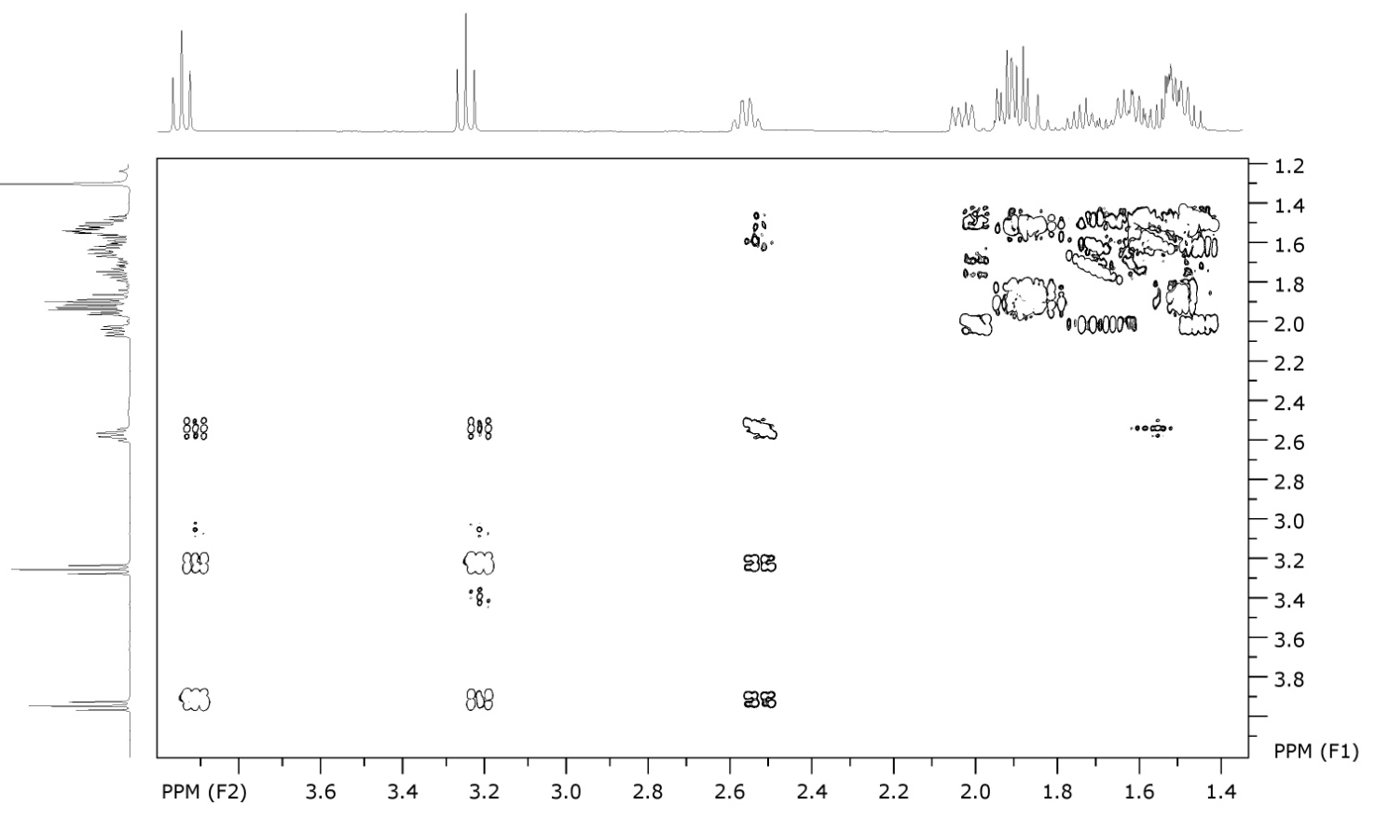
Figure 1SI: COSY ¹H-¹H of cycloadduct 8a.

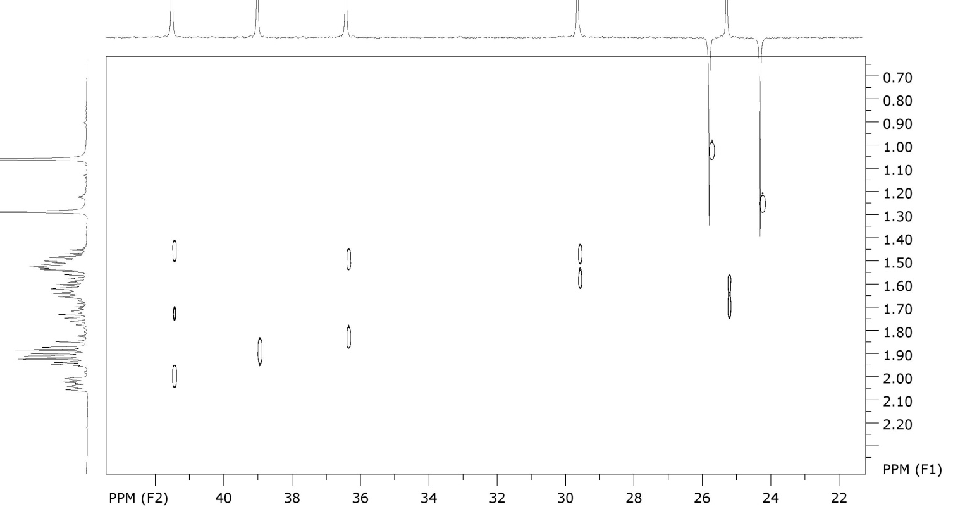
Figure 2SI: HSQC ¹H-¹³C of cycloadduct 8a.

Hexahydro-6'H-spiro[cyclohexane-1,3'-cyclopenta[c]pyrrolo[1,2-b]isoxazole] (8b).
Yield: 98%, colorless oil.
IR (neat) ν, cm⁻¹: 2935, 2856, 1448, 1351, 1305, 1296, 1259, 1228, 1174, 1151, 1108, 1054, 1041, 987, 975, 918, 910, 854, 802, 769, 626.
¹H NMR (500 MHz, CDCl₃): δ = 1.17-1.30 (m, 5H); 1.38-1.45 (m, 2H); 1.45-1.51 (m, 2H); 1.54-1.63 (m, 3H); 1.63-1.69 (m, 3H); 1.69-1.77 (m, 3H); 1.79-1.87 (m, 1H); 1.87-1.94 (m, 1H); 1.95-2.01 (m, 1H), 2.49-2.56 (m, 1H)(⁹CH), 3.23 (t J_{t}=8.5, 1H)(¹⁰CH₂); 3.90 (t J_{t}=8.5, 1H)(¹⁰CH₂).
¹³C NMR (125 MHz, CDCl₃): 22.58, 23.46, 25.26, 25.93, 29.65, 32.49, 33.33, 33.58, 38.33, 41.34 (³CH₂, ⁴CH₂, ⁶CH₂, ⁷CH₂, ⁸CH₂ and 5×CH₂ spirocyclohexane), 58.21 (⁹CH), 70.48 (⁵C), 71.49 (¹⁰CH₂-O), 82.37 (²C-N).
Anal. calcd for C₁₄H₂₃NO: C 75.97; H 10.47; N 6.33. Found: C 76.09; H 10.52; N 6.17.

3,3-Diethylhexahydro-1H,6H-cyclopenta[c]pyrrolo[1,2-b]isoxazole (8c).
Yield : 63%, colorless oil.
IR (neat) ν, cm⁻¹: 2958, 2875, 2865, 1461, 1377, 1353, 1303, 1296, 1286, 1174, 1139, 1054, 1043, 972, 950, 916, 856, 813, 790, 759, 626, 576, 559, 524, 495.
¹H NMR (500 MHz, CDCl₃): 0.84 (t, J_{t}=7.5, 3Н) и 0.90 (t, J_{t}=7.5, 3Н)(¹²СН₃ and ¹⁴СН₃); 1.24-1.33 (m, 1Н); 1.41-1.54 (m, 3Н); 1.55-1.60 (m, 1Н); 1.60-1.70 (m, 4Н); 1.72-1.80 (m, 2Н); 1.80-1.86 (m, 1Н); 1.89-1.94 (m, 1Н); 1.99-2.05 (m, 1Н); 2.50-2.56 (m, 1Н)(⁹СН); 3.29 (t, J_{t}=8, 1Н)(¹⁰СН₂); 3.91 (t, J_{t}=8, 1Н)(¹⁰СН₂).
¹³C NMR (125 MHz, CDCl₃): 8.25 and 9.29 (¹²СН₃ and ¹⁴СН₃), 25.46, 25.53, 25.79, 30.14, 34.09, 38.70, 41.72 (³СН₂, ⁴СН₂, ⁶СН₂, ⁷СН₂, ⁸СН₂, ¹¹СН₂, ¹³СН₂), 58.54 (⁹СН), 72.08 (¹⁰СН₂), 73.92 (⁵С), 83.36 (²С).
Anal. calcd for С₁₃Н₂₃NO: C 74.59; H 11.08; N 6.69. Found: C 74.39; H 11.16; N 6.70.

General procedure for isoxazolidine ring opening (9a-c synthesis). Zn powder (3.11 g, 47.8 mmol) was added in one portion to a warm (60 ºC) stirred solution containing isoxazolidine 8a-c (4.78 mmol), EtOH (9 mL), 10 M AcOH (30 mL) and EDTA disodium salt (8 g). The reaction mixture was stirred at 60 ºC for 3 h and then cooled down to r.t. The mixture was basified to pH 10 with 25% NH₃ solution and extracted with EtOAc. The organic extract was dried with Na₂CO₃. After evaporation of the solvent, the crude residue was purified via column chromatography (silica gel EtOAc/MeOH 5:1) to give aminoalcohols 9a-c.

(2,2-Dimethyl-1-azaspiro[4.4]nonan-6-yl)methanol (9a).
Yield : 90%, colorless oil.
IR (neat) ν, cm⁻¹: 3289, 2954, 2868, 1460, 1379, 1364.
¹H NMR (600 MHz, CDCl₃): 1.15 (s, 3H); 1.19 (s, 3Н); 1.29-1.39 (m, 1Н); 1.48-1.64 (m, 5Н); 1.66-1.86 (m, 5Н); 3.58 (d, J_{d}=5.7)(¹⁰CH₂).
¹³C NMR (150 MHz, CDCl₃): 29.56, 29.99 (2*CH₃), 21.43 (⁷CH₂), 26.06 (⁸CH₂), 38.54 (³CH₂), 38.91 (⁶CH₂), 39.92 (⁴CH₂), 47.87 (⁹CH), 64.83 (¹⁰CH₂), 59.26 (⁵C), 72.98 (²C).
Anal. calcd for C₁₁H₂₁NO: C 72.08; H 11.55; N 7.64. Found: C 72.26; H 8.12; N 11.92.

(6-Azadispiro[4.1.5⁷.2⁵]tetradecan-1-yl)methanol (19b).
Yield : 99%, colorless crystals; m.p. 37.8-39.6 (EtOAc/MeOH).
IR (KBr) ν, cm⁻¹: 3247, 3105, 2931, 2854, 1446, 1338, 1321, 1255, 1191, 1176, 1134, 1107, 1093, 1037, 997, 937, 914, 891, 848, 808, 783, 761.
¹H NMR (600 MHz, CDCl₃): 1.22-1.41 (m, 7H); 1.41-1.52 (m, 6H); 1.52-1.61 (m, 3H); 1.63-1.71 (m, 4H); 1.71-1.77 (m, 1H); 3.55 (d J_{d}=5.4, 2H)(¹⁰CH₂).
¹³C NMR (150 MHz, CDCl₃): 21.49, 23.48, 23.74, 25.51, 26.00, 35.76, 37.46, 38.69, 39.50, 40.21(³CH₂, ⁴CH₂, ⁶CH₂, ⁷CH₂, ⁸CH₂ and 5×CH₂ spirocyclohexane), 47.47 (⁹CH), 61.64 (⁵C), 64.58 (¹⁰CH₂-O), 71.95 (²C-N).
Anal. calcd for C₁₄H₂₅NO: C 75.28; H 11.28; N 6.07. Found: C 75.75; H 10.94; N 6.22.

(2,2-Diethyl-1-azaspiro[4.4]nonan-6-yl)methanol (9c).
Yield : 85%, colorless oil.
IR (neat) ν, cm⁻¹ : 3295, 2958, 2875, 1458, 1377, 1336, 1299, 1213, 1188, 1170, 1141, 1097, 1081, 1064, 1039, 979, 950, 916, 877, 831, 796, 736, 673, 663, 553.
¹H NMR (300 MHz, CDCl₃): 0.78 (t, J_{t}=7.5, 3Н) and 0.80 (t, J_{t}=7.5, 3Н)(¹²СН₃ and ¹⁴СН₃); 1.26-1.36 (m, 1Н); 1.36-1.48 (m, 4Н); 1.51-1.66 (m, 6Н); 1.67-1.80 (m, 4Н); 3.57 (d, J_{d}=5.7, 2H)(¹⁰СН₂).
¹³C NMR (125 MHz, CDCl₃): 8.90 and 9.10 (¹²СН₃ and ¹⁴СН₃), 21.81, 26.34, 31.19, 31.35, 35.27, 38.06, 40.32, 47.84 (⁹СН), 65.03 (¹⁰СН₂), 65.12 (⁵С), 72.61 (²С).
Anal. calcd for C₁₃H₂₅NO: C 73.88; H 11.92; N 6.63. Found: C 73.16; H 11.97; N 6.49.

Acetylation of aminoalcohols 9a-c, 19 (General procedure). Acetic anhydride (0.56 g; 5.5 mmol or 1.12 g; 11 mmol for 19) was added to a solution of aminoalcohol 9a-c, 19 (3.1 mmol) in dry chloroform (15 mL) and the mixture was refluxed until the reaction was complete. The progress of the reaction was monitored by TLC (silica gel, C₆H₁₄/EtOAc 5:1, visualization with 1% aq KMnO₄). The reaction mixture was washed with a saturated solution of Na₂CO₃ and dried with Na₂SO₄. After evaporation of the solvent, the crude residue was purified via column chromatography (silica gel, C₆H₁₄/EtOAc 5:1) to give 10a-c, 20.

(2,2-Dimethyl-1-azaspiro[4.4]nonan-6-yl)methyl acetate (10a).
Yield : 92 %, colorless oil.
IR (neat) ν, cm⁻¹: 3454, 3350, 2956, 2867, 1737, 1459, 1377, 1363, 1241, 1192, 1162, 1031, 971.
¹H NMR (400 MHz, CDCl₃): 1.08 (s, 3H); 1.15 (s, 3H); 1.36-1.44 (m, 1H); 1.47-1.54 (m, 1H); 1.55-1.63 (m, 5H), 1.70-1.79 (m, 2H); 1.80-1.89 (m, 2H); 2.01 (s. 3H)(¹²CH₃); 3.97 (dd J_{d1}=11 J_{d2}=7.6, 1H)(¹⁰CH₂); 4.25 (dd J_{d1}=11 J_{d2}=6, 1H)(¹⁰CH₂).
¹³C NMR (125 MHz, CDCl₃): 21.16, 30.64 and 30.81 (3*CH₃), 21.24, 27.88, 38.32, 39.55, 41.87 (³СН₂, ⁴СН₂, ⁶СН₂, ⁷СН₂, ⁸СН₂), 47.07 (⁹СН), 59.05 (⁵С), 66.34 (¹⁰СН₂О), 71.13 (²С), 171.25 (¹¹С=О).
Anal. calcd for C₁₃H₂₃NO₂: C 69.29; H 10.29; N 6.22. Found: C 69.45; H 10.35; N 6.35.

(6-Azadispiro[4.1.5⁷.2⁵]tetradecan-1-yl) methyl acetate (10b).
Yield : 87%, colorless oil.
IR (neat) ν, cm⁻¹: 3454, 3349, 2927, 2856, 1737, 1448, 1384, 1365, 1238, 1172, 1135, 1087, 1031, 972.
¹H NMR (500 MHz, CDCl₃): 1.20-1.44 (m, 8H); 1.44-1.63 (m, 9H); 1.63-1.68 (m, 1H); 1.71-1.79 (m, 2H); 1.80-1.88 (m, 1H); 2.01 (s, 3H)(¹²CH₃); 3.96 (dd J_{d1}=11 J_{d2}=7.9, 1H)(¹⁰CH₂); 4.26 (dd J_{d1}=11 J_{d2}=5.7, 1H)(¹⁰CH₂).
¹³C NMR (125 MHz, CDCl₃): 21.03 (¹²CH₃), 21.18, 23.77, 23.97, 25.70, 27.83, 36.09, 37.39, 39.62, 40.19, 41.78 (³CH₂, ⁴CH₂, ⁶CH₂, ⁷CH₂, ⁸CH₂ и 5×CH₂ spirocyclohexane), 46.67 (⁹CH), 61.38 (⁵C), 66.42 (¹⁰CH₂O), 70.00 (²C-N), 171.20 (¹¹C=O).
Anal. calcd for C₁₆H₂₇NO₂: C 72.41; H 10.25; N 5.28. Found: C 72.66; H 10.26; N 5.27.

(2,2-Diethyl-1-azaspiro[4.4]nonan-6-yl)methyl acetate (10c).
Yield: 71%, colorless oil.
IR (neat) ν, cm⁻¹: 3457, 3357, 2958, 2875, 1739, 1458, 1419, 1382, 1365, 1313, 1240, 1180, 1157, 1145, 1074, 1031, 973.
¹H NMR (300 MHz, CDCl₃): 0.77 (t, J_{t}=7.5, 6Н)(¹²СН₃ and ¹⁴СН₃); 1.25-1.45 (m, 5Н); 1.45-1.69 (m, 7Н); 1.69-1.88 (3Н); 1.99 (с, 3Н)(¹⁶СН₃); 3.96 (dd, J_{d1}=7.8 J_{d2}=10.9, 1Н)(¹⁰СН₂); 4.26 (dd, J_{d1}=5.7 J_{d2}=10.9, 1Н)(¹⁰СН₂).
¹³C NMR (75 MHz, CDCl₃): 8.23 and 9.25 (¹²СН₃ and ¹⁴СН₃), 21.23 (¹⁶СН₃), 21.48, 28.08, 31.78, 32.11, 35.62, 37.87, 41.94, 47.10 (⁹СН), 64.52 (⁵С), 66.71 (¹⁰СН₂), 70.50 (²С), 171.41 (¹⁵С=О).
Anal. calcd for C₁₅H₂₇NO₂: C 71.10; H 10.74; N 5.53. Found: C 71.46; H 10.74; N 5.70.

((1R,5S,7S,8R,12S,13S)-12,13-di-tert-butoxy-6-azadispiro[4.1.4⁷.2⁵]tridecane-1,8-diyl)bis(methylene) diacetate (20).
Yield: 90 %, colorless oil.
¹H NMR (500 MHz, CDCl₃): 1.20 (s, 18H); 1.34-1.41 (m, 4H); 1.44-1.51 (m, 2H); 1.57-1.64 (m, 2H); 1.66-1.73 (2H); 1.95-2.02 (m, 2H); 2.03 (s, 3H); 2.04 (s, 3H); 2.24-2.31 (m, 2H); 3.77 (s, 2H); 4.03 (ABd, J₁=6.7, J₂=11.3, 2H); 4.24 (ABd, J₁=6.3, J₂=11.3, 2H); 6.44 (br s, 1H).
¹³C NMR (125 MHz, CDCl₃): 20.10 (cyclopentane), 20.90 (CH₃), 27.12 (cyclopentane), 29.29 (CH₃, ^{t}Bu), 34.78 (cyclopentane), 42.21 (CH, cyclopentane), 65.10 (CH₂O), 69.02 (C, ^{t}Bu), 73.49 (C-N), 78.61 (CH-O), 170.99 (C=O).
Anal. calcd for C₂₆H₄₅NO₆: C 66.78; H 9.70; N 3.00. Found: C 66.58; H 9.56; N 3.17.

Nitroxides 11a-c, 17, 21 synthesis (General procedure). A solution of amine 10a-c, 20 (0.38 mmol) in CHCl₃ (4 mL) was cooled to -10ºC and m-CPBA (98 mg, 0.57 mmol or 196 mg, 1.14 mmol for 20) was added portionwise upon stirring. The mixture was stirred at 0 ºC until the reaction was complete (control by TLC, silica gel Et₂O/hexane 1:1). After evaporation of the solvent, the crude residue was purified via column chromatography (silica gel, Et₂O/C₆H₁₄ 1:1).

6-(Acetoxymethyl)-2,2-dimethyl-1-azaspiro[4.4]nonan 1-oxyl (11a).
Yield: 70%, yellow oil.
UV (EtOH), λ_{max} (log ε): 240 (3.28).
IR (neat) ν, cm⁻¹: 2968, 2873, 1741, 1461, 1434, 1388, 1365, 1321, 1238, 1128, 1033, 752, 700, 644, 605,.
Anal. calcd for C₁₃H₂₂NO₃: C 64.97; H 9.23; N 5.83. Found: C 64.75; H 9.29; N 5.99.

1-(Acetoxymethyl)-6-azadispiro[4.1.5⁷.2⁵]tetradecan 6-oxyl (11b).
Yield: 99%, yellow oil.
UV (EtOH), λ_{max} (log ε): 232 (3.41).
IR (neat) ν, cm⁻¹: 2935, 2858, 1739, 1450, 1388, 1365, 1236, 1184, 1033, 914, 605.
Anal. calcd for C₁₆H₂₆NO₃: C 68.54; H 9.35; N 5.00. Found: C 68.79; H 9.37; N 4.83.

6-(Acetoxymethyl)-2,2-diethyl-1-azaspiro[4.4]nonan 1-oxyl (11c).
Yield: 82%, yellow oil.
UV (EtOH), λ_{max} (log ε): 240 (3.23).
IR (neat) ν, cm⁻¹: 2964, 2879, 1741, 1461, 1404, 1384, 1365, 1274, 1238, 1182, 1122, 1108, 1033, 973, 923, 873, 646, 605, 555.
Anal. calcd for C₁₅H₂₆NO₃: C 67.13; H 9.77; N 5.22. Found: C 67.21; H 9.47; N 5.51.

9-(acetoxymethyl)-2,2-dimethyl-1-azaspiro[4.4]non-6-en 1-oxyl (17).
Yield: 22%, yellow oil.
UV (EtOH), λ_{max} (log ε): 228 (3.40).
IR (neat) ν, cm⁻¹: 3054, 2970, 2933, 2875, 1741, 1620, 1573, 1539, 1459, 1386, 1365, 1324, 1234, 1134, 1080, 1070, 1031, 973, 962, 896, 856, 835, 744, 698, 669, 646, 605, 582.

(1R,5S,7S,8R,12S,13S)-1,8-bis(acetoxymethyl)-12,13-di-tert-butoxy-6-azadispiro[4.1.47.25]tridecan 6-oxyl (21).
Yield: 75 %, yellow oil.
UV (EtOH), λ_{max} (log ε): 229 (3.39).
IR (neat) ν, cm⁻¹: 2972, 2959, 2871, 1736, 1470, 1393, ,1366, 1256, 1192, 1124, 1076, 1028, 997, 930, 910,750, 719.
Anal. calcd for C₂₆H₄₄NO₇: C 64.70; H 9.19; N 2.90. Found: C 64.80; H 9.26; N 3.11.

Synthesis of nitroxides 1, 12a-c (General procedure). Aqueous NH₃ (15 mL) was added to a solution of nitroxide 11a-c, 21 (3.6 mmol) in MeOH (30 mL), and allowed to stand at +20..+40 ºC until the reaction was complete (up to 12 hours). The progress of the reaction was monitored by TLC (silica gel, Et₂O/C₆H₁₄ 2:1, visualization with 1% aq KMnO₄). The solution was evaporated under reduced pressure. The residue was dissolved in the saturated solution of NaCl and extracted with CHCl₃ (3×10 mL). The extract was dried with Na₂SO₄. After evaporation of the solvent, the crude residue was purified via column chromatography (silica gel, Et₂O/C₆H₁₄ 2:1).

6-(Hydroxymethyl)-2,2-dimethyl-1-azaspiro[4.4]nonan 1-oxyl (12a).
Yield: 85%, yellow crystals, m.p. 41.5-43 ºC (hexane).
UV (EtOH), λ_{max} (log ε): 246 (3.16).
IR (KBr) ν, cm⁻¹: 3319, 2966, 2931, 2867, 1461, 1409, 1370, 1359, 1319, 1249, 1236, 1182, 1098, 1034, 1022.
Anal. calcd for C₁₁H₂₀NO₂: C 66.63: H 10.17: N 7.06: Found: C 66.45: H 10.01: N 7.10.

1-(Hydroxymethyl)- 6-azadispiro[4.1.5⁷.2⁵]tetradecan 6-oxyl (12b).
Yield : 88%, yellow crystals, m.p. 38.9-39.4 ºC (hexane/Et₂O).
UV (EtOH), λ_{max} (log ε): 238 (3.29).
IR (KBr) ν, cm⁻¹: 3301, 2933, 2858, 1635, 1452, 1404, 1326, 1311, 1242, 1170, 1085, 1039.
Anal. calcd for C₁₄H₂₄NO₂: C 70.55; H 10.15; N 5.88. Found: C 70.38; H 10.12; N 5.86.

6-(Hydroxymethyl)-2,2-dimethyl-1-azaspiro[4.4]nonan 1-oxyl (12c).
Yield : 94%, yellow oil.
UV (EtOH), λ_{max} (log ε): 240 (3.26).
IR (neat) ν, cm⁻¹: 3421, 2964, 2877, 1461, 1404, 1380, 1326, 1307, 1242, 1232, 1197, 1168, 1087, 1033, 1004.
Anal. calcd for C₁₃H₂₄NO₂: C 68.99; H 10.69; N 6.09. Found: C 69.22; H 10.42; N 6.09.

6-Formyl-2,2-dimethyl-1-azaspiro[4.4]nonan 1-oxyl (15). A solution of 9a (90 mg, 0.5 mmol) in dry CHCl₃ (4 mL) was cooled to -10ºC and m-CPBA (140 mg, 0.75 mmol) was added in one portion. The solution was stirred at 0ºC for 3 hours, then one more portion of m-CPBA (280 mg, 1.5 mmol) was added. The solution was stirred at 0ºC for 2 hours and 10 hours at room temperature. The reaction mixture was washed with saturated Na₂CO₃, the organic layer dried with Na₂CO₃. After evaporation of the solvent, the crude residue was purified via short flash column chromatography (silica gel, EtOAc).
Yield : 73%, yellow oil.
UV (EtOH), λ_{max} (log ε): 230 (3.37).
IR (neat) ν, cm⁻¹: 2966, 1725, 1657, 1630, 1538, 1457, 1437, 1386, 1256.
Anal. calcd for C₁₁H₁₈NO₂: C 67.32; H 9.24; N 7.14. Found: C 67.69; H 9.45; N 7.50.

Alkoxyamines 16a-c synthesis (General procedure).
Alkoxyamines were prepared using the method developed by Matyashevsky [3]. Nitroxide 11a-c (2.02 mmol), dissolved in dry benzene (15 mL), benzyl bromide (0.449 g; 2.63 mmol), copper (II) triflate (0.033 g; 0.1 mmol), 4,4'-di-tert-butyl-2,2'-bipyridyl (0.027 g; 0.1 mmol), Cu (fine powder; 1.9 g; 30.3 mmol) were placed in a Schlenk flask and degassed by three times repeated freeze-pump-thaw procedure. The mixture was stirred for 48 hours at 60 °C. The precipitate was filtered off, the filtrate was washed with a saturated ammonia solution (3×15 mL) and dried with Na₂SO₄. After evaporation of the solvent, the crude residue was purified via column chromatography (silica gel, Et₂O/C₆H₁₄ 1:5).

(1-(Benzyloxy)-2,2-dimethyl-1-azaspiro[4.4]nonan-6-yl)methyl acetate (16a).
Yield: 74%, colorless oil.
IR (neat) ν, cm⁻¹: 3089, 3064, 3031, 2958, 2871, 1737, 1610, 1496, 1451, 1363, 1317, 1238, 1191, 1172, 1139, 1081, 1029, 975, 946, 908, 842, 752, 734, 696, 607, 530.
¹H NMR (400 MHz, CDCl₃): 1.15 and 1.24 (s both, 2×3Н)(¹¹СН₃ and ¹²СН₃); 1.38-1.56 (m, 5Н); 1.67-1.75 (m, 1Н); 1.79-1.88 (m, 3Н); 1.93-2.02 (m, 1Н); 2.05 (s, 3Н)(²¹СН₃); 2.43-2.55 (m, 1Н)(⁹СН); 4.21 (dd, J_{d1}=8.4 J_{d2}=11.0, 1Н)(¹⁰СН₂); 4.47 (dd, J_{д1}=5.5 J_{d2}=11.0, 1Н)(¹⁰СН₂); 4.72 (d, J=10.8, 1Н)(¹³СН₂); 4.77 (d, J=10.8, 1Н)(¹³СН₂); 7.25-7.35 (m, 5Н)(СН_{ar}).
¹³C NMR (100 MHz, CDCl₃): 21.30 and 22.40 (¹¹СН₃ and ¹²СН₃), 30.24 (²¹СН₃), 23.23, 29.74, 35.08, 35.58, 35.92 (³СН₂, ⁴СН₂, ⁶СН₂, ⁷СН₂, ⁸СН₂), 49.59 (⁹СН), 65.50 (⁵С), 66.51 (¹⁰СН₂), 75.17 (²С), 76.62 (¹³СН₂), 127.61 (¹⁷СН), 128.04 (¹⁵СН и ¹⁹СН), 128.38 (¹⁶СН and ¹⁸СН), 137.92 (¹⁴С), 171.53 (²⁰С=О).
Anal. calcd for C₂₀H₂₉NO₃: C 72.47; H 8.82; N 4.23. Found: C 72.19; H 8.40; N 4.00.

(6-(Benzyloxy)-6-azadispiro[4.1.5⁷.2⁵]tetradecan-1-yl)methyl acetate (16b).
Yield : 95%, colorless oil.
IR (neat) ν, cm⁻¹: 3089, 3064, 3031, 2933, 2858, 1737, 1608, 1496, 1450, 1386, 1365, 1324, 1309, 1236, 1180, 1157, 1105, 1080, 1029, 970, 918, 842, 752, 734, 696, 648, 605, 551, 513, 462.
¹H NMR (500 MHz, CDCl₃): 1.10 (tdd, J_{т}=3.6 J_{d1}= J_{d2}=12.9, 1Н); 1.21-1.33 (m, 3Н); 1.40-1.54 (m, 4Н); 1.54-1.62 (m, 3Н); 1.62-1.76 (m, 6Н); 1.76-1.79 (m, 1Н); 1.79-1.87 (m, 2Н); 1.94-2.01 (m, 1Н); 2.04 (s, 3Н)(¹⁹СН₃); 2.40-2.52 (m, 1Н)(⁹СН); 4.20 (dd, J_{d1}=8.7 J_{d2}=11.0, 1H)(¹⁰CH₂); 4.47 (dd, J_{d1}=5.3 J_{d2}=11.0, 1Н)(¹⁰СН₂); 4.76 (d, J_{d}=10.9)(¹¹СН₂); 4.79 (d, J_{d}=10.9, 1Н)(¹¹СН₂); 7.23-7.28 (m, 1Н)(СН_{ar}); 7.30-7.33 (m, 4Н)(СН_{ar}).
¹³C NMR (125 MHz, CDCl₃): 21.25 (¹⁹CH₃), 23.44, 23.86, 24.93, 26.14, 30.02, 31.03, 31.80, 35.04, 35.35, 39.49 (³CH₂, ⁴CH₂, ⁶CH₂, ⁷CH₂, ⁸CH₂ and 5×CH₂ cyclohexane), 49.07 (⁹CH), 66.56 (¹⁰CH₂), 69.11 (⁵C), 75.06 (²C), 76.72 (¹¹CH₂), 127.55 (¹⁵CH), 127.93 and 128.38 (¹⁷СН, ²¹СН and ¹⁸СН, ²⁰СН), 138.02 (¹²C), 171.42 (¹⁸C=O).
Anal. calcd for C₂₃H₃₃NO₃: C 74.36; H 8.95; N 3.77. Found: C 75.77; H 9.35; N 3.86.

(1-(Benzyloxy)-2,2-diethyl-1-azaspiro[4.4]nonan-6-yl)methyl acetate (16c).
Yield: 70%, colorless oil.
IR (neat) ν, cm⁻¹: 3108, 3089, 3064, 3031, 2960, 2877, 1739, 1608, 1587, 1496, 1461, 1452, 1382, 1365, 1307, 1236, 1102, 1155, 1122, 1080, 1029, 973, 927, 910, 883, 846, 783, 752, 734, 696, 669, 605, 489, 464.
¹H NMR (500 MHz, CDCl₃): 0.86 (t, J_{t}=7.6, 3Н) and 0.99 (t, J_{t}=7.4, 3Н)(¹²СН₃ and ¹⁴СН₃); 1.39-1.54 (m, 5Н); 1.54-1.64 (m, 3Н); 1.64-1.74 (m, 2Н); 1.74-1.84 (m, 3Н); 1.96-2.02 (m, 1Н); 2.03 (s, 3Н)(²³СН₃); 2.43-2.53 (m, 1Н)(⁹СН); 4.23 (dd, J_{d1}=8.6 J_{d2}=10.8, 1Н)(¹⁰СН₂); 4.51 (dd J_{d1}=5.5 J_{d2}=10.8, 1Н)(¹⁰СН₂); 4.70 (d, J_{d}=10.6, 1Н)(¹⁵СН₂); 4.74 (d, J_{d}=10.6, 1Н)(¹⁵СН₂); 7.22-7.27 (m, 1Н)(СН_{ar}); 7.27-7.33 (m, 4Н)(СН_{ar}).
¹³C NMR (125 MHz, CDCl₃): 8.78 and 9.57 (¹²СН₃ and ¹⁴СН₃), 21.24 (²³СН₃), 23.31, 28.10, 29.95, 30.38, 30.63 34.77, 35.53 (³СН₂, ⁴СН₂, ⁶СН₂, ⁷СН₂, ⁸СН₂, ¹¹СН₂, ¹³СН₂), 49.02 (⁹СН), 66.53 (¹⁰СН₂), 70.88 (⁵С), 75.67 (²С), 75.83 (¹⁵СН₂), 127.57 (¹⁹СН), 128.01 and 128.37 (¹⁷СН, ²¹СН and ¹⁸СН, ²⁰СН), 137.92 (¹⁶С), 171.39 (²²С=О).
Anal. calcd for C₂₂H₃₃NO₃: C 73.50; H 9.25; N 3.90. Found: C 73.64; H 9.38; N 4.13.

(1-Methoxy-2,2-dimethyl-1-azaspiro[4.4]non-8-en-6-yl)methyl acetate (18). In analogy to literature method,[20] the mixture of 17 (0.3 g; 1.26 mmol), acetone (2 mL) and 30% aqueous H₂O₂ ( 0.9 mL, 8.44 mmol) was cooled to 0ºC in the ice bath and CuCl (9 mg, 0.0088 mmol) was added upon vigorous stirring. The reaction mixture was stirred for 15 minutes at 0ºC and allowed to warm up to room temperature. The stirring was continued until nitroxide 17 disappeared. The progress of the reaction was monitored by TLC (silica gel, Et₂O/C₆H₁₄ 1:5, visualization with 1% aq KMnO₄). Then the aqueous solution of ascorbic acid (0.3 g in 5 mL) was added in one portion and the resulted mixture was extracted with EtOAc (2×5 mL). The organic layer was dried with Na₂SO_{4.} After evaporation of the solvent, the crude residue was purified via column chromatography (silica gel, Et₂O/C₆H₁₄ 1:5).
Yield: 40%, yellow oil.
IR (neat) ν, cm⁻¹: 3054, 2964, 2937, 2808, 1741, 1616, 1458, 1377, 1363, 1319, 1236, 1174, 1087, 1047, 1031, 970, 891, 858, 831, 748, 730, 723, 700, 661, 605, 549.
¹H NMR (600 MHz, CDCl₃): 1.07 and 1.18 (s both, 2×3H)(¹¹СН₃ and ¹²СН₃); 1.56 (dd, J_{d1}=6.5 J_{d2}=8.5, 2Н)(⁴СН₂); 1.77 (dd, J_{d1}=6.5 J_{d2}=13.0, 1H)(³CH₂); 1.93 (dd, J_{d1}=8.5 J_{d2}=13.0, 1Н)(³CH₂); 2.02 (s, 3H)(¹⁵CH₃); 2.11 (dddd, J_{d1}=1.9 J_{d2}=2.6 J_{d3}=8.1 J_{d4}=15.3, 1H)(⁸CH₂); 2.26 (dddd, J_{d1}=6.2 J_{d2}=7.7 J_{d3}=8.1 J_{d4}=8.3, 1H)(⁹CH); 2.36 (dddd, J_{d1}=1.7 J_{d2}=2.9 J_{d3}=7.7 J_{d4}=15.3, 1H)(⁸CH₂); 3.49 (s, 3H)(¹³CH₃); 4.14 (dd, J_{d1}=8.3 J_{d2}=10.9, 1Н)(¹⁰CH₂); 4.45 (dd, J_{d1}=6.2 J_{d2}=10.9, 1H)(¹⁰CH₂); 5.64 (ddd, J_{d1}=1.7 J_{d2}=2.6 J_{d3}=6.1, 1H)(⁶CH=); 5.86 (ddd, J_{d1}=1.9 J_{d2}=2.9 J_{d3}=6.1, 1H)(⁷CH=)
¹³C NMR (150 MHz, CDCl₃): 20.94 and 22.33 (¹¹СН₃ and ¹²СН₃), 29.79 (¹⁵СН₃), 34.35, 35.50, 35.60 (³СН₂, ⁴СН₂, ⁸СН₂), 47.41 (⁹СН), 62.78 (¹³СН₃), 64.78 (⁵С), 65.97 (¹⁰СН₂), 78.16 (²С), 131.12 (⁷СН=), 135.30 (⁶СН=), 171.06 (¹⁴С=О).
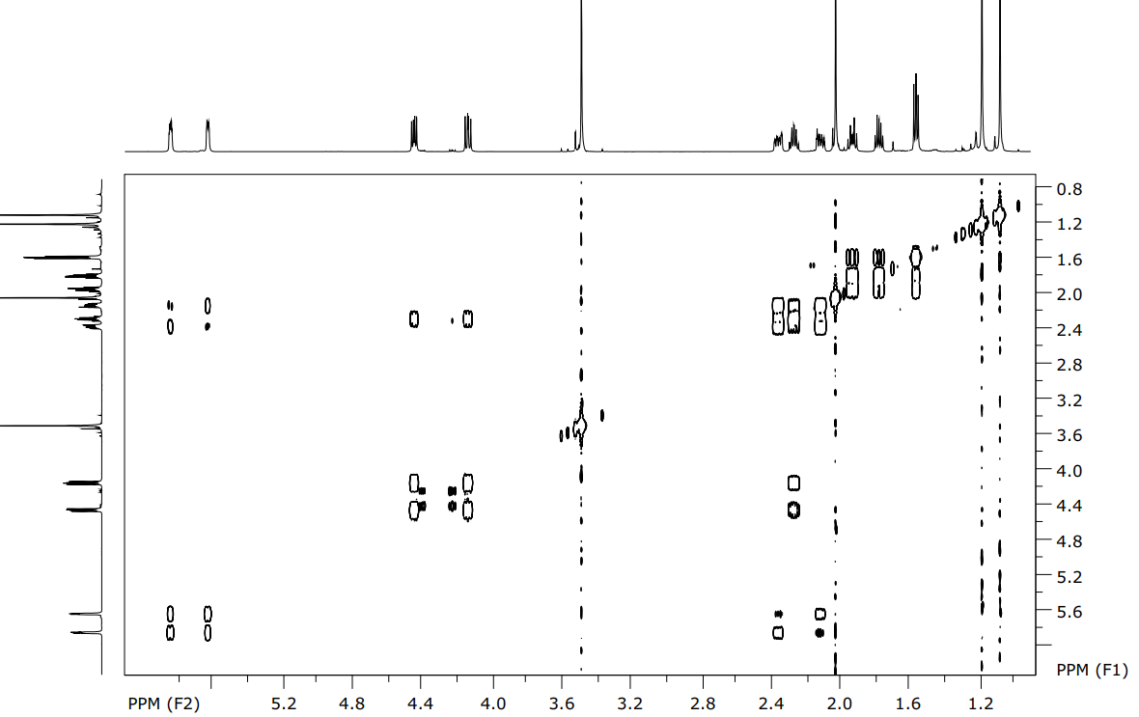
Figure 3SI: COSY ¹H-¹H of alkoxyamine 18.
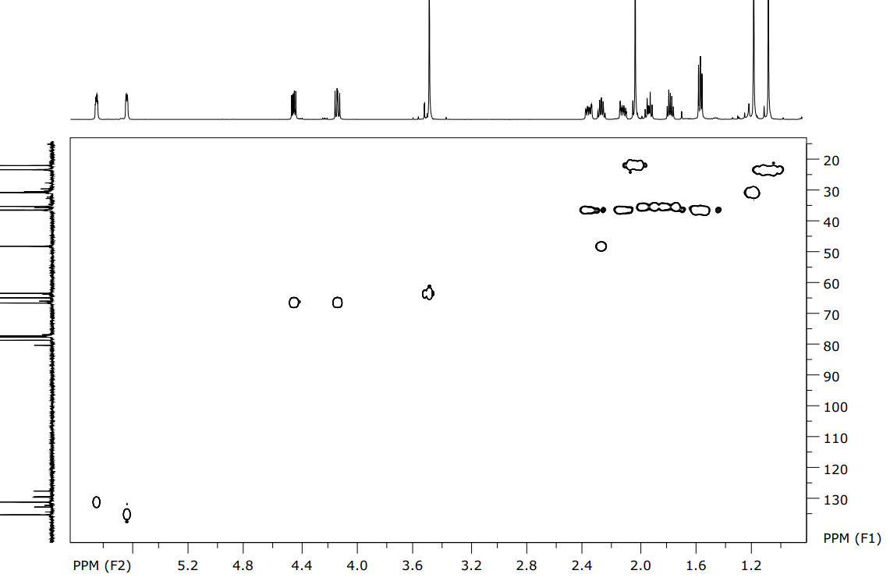
Figure 4SI: HSQC ¹H-¹³C of alkoxyamine 18.
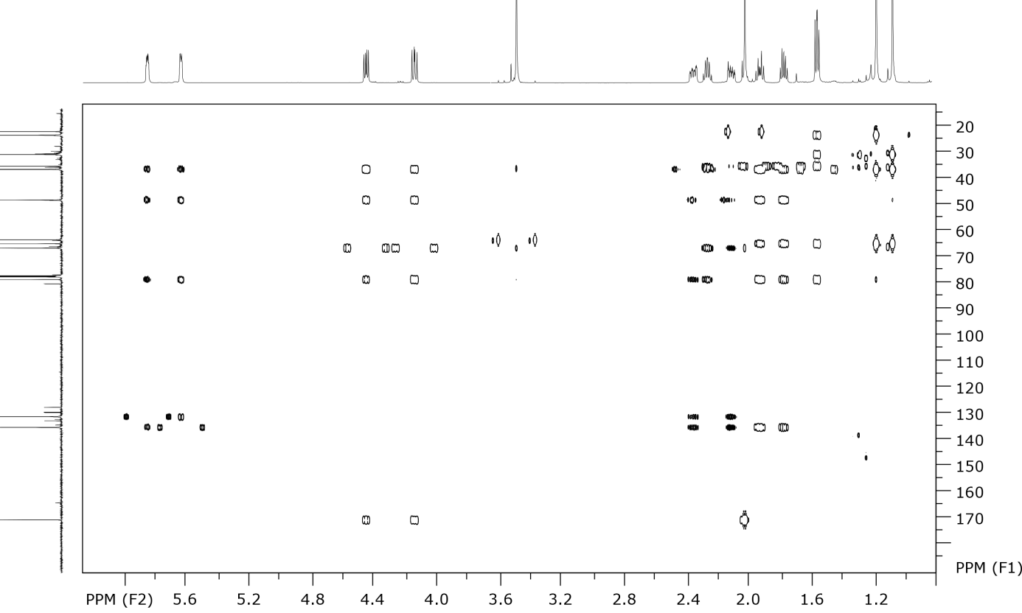
Figure 5SI: HMBC ¹H-¹³C of alkoxyamine 18.

EPR experiments were performed on CW EPR X-band spectrometer Bruker ER-200D (9.87 GHz). Spectra were acquired in oxygen-free conditions using following settings: microwave power, 10 mW, modulations amplitude, 1 or 2 G; time constant 100 ms; conversion time, 50.12 ms. Spectral parameters of radicals, a_{N} and ΔB_{p-p} were calculated using home-made software, g-factors were calculated using LiF:Li (g = 2.002293) as a reference.
For kinetic measurements stock solutions of ascorbic acid (1 M) and of GSH (100 mM) in PBS buffer (1 mM) were prepared and pH was adjusted to 7.4-7.5 with NaOH Nitroxides were dissolved in phosphate-citrate-borate buffer, 3×50 mM, pH=7.5) and diluted to a concentration of 0.2-0.3 mM. All solutions were deoxygenated with argon, carefully and quickly mixed in a small tube and placed into EPR capillary (50 μL). Oxygen-free conditions were kept permanently. Capillary was sealed from both sides and placed into EPR resonator. The decay of amplitude of low field component of the EPR spectrum was followed in kinetics measurements. Kinetics of decay was fitted with monoexponential function to calculate the first order rate constants. Then these constants were divided into the concentration of ascorbic acid to calculate the second-order reaction constants.
Calculation of Lipophilicity. Lipophilicity was calculated as the partition coefficient of radical in the water-octanol mixture. For this purpose, the amplitude of the EPR spectrum of radical in water was recorded at different portions of added octanol. After addition of octanol, the mixture was extensively shaked, then shortly centrifuged to separate the water-octanol fractions.

Figure 6SI. Calculation of lipophilicity of radicals. S – amplitude of radical in water at different portions of octanol, S0 – signal in water without octanol. The absolute slope of the dependences are partition/lipophilicity coefficients that derives from theoretical equation: (S₀-S)/S=k*V_{octanol}/V_{water}.

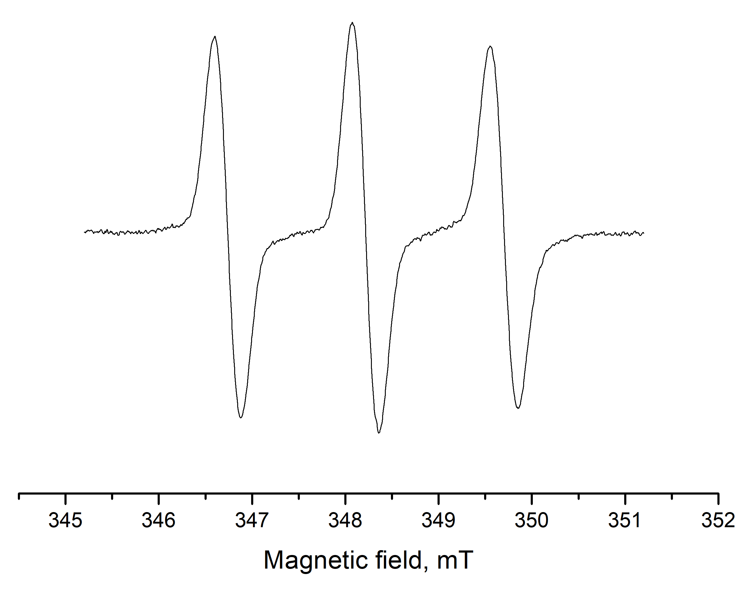
Figure 7SI: EPR spectra of radical 1.

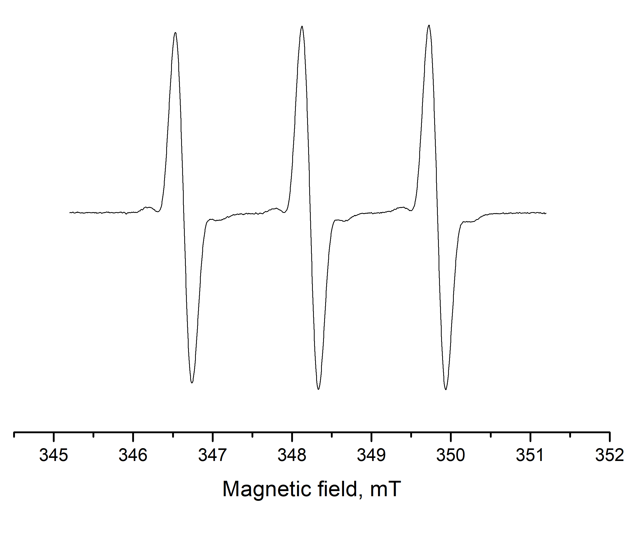
Figure 8SI: EPR spectra of radical 12a.

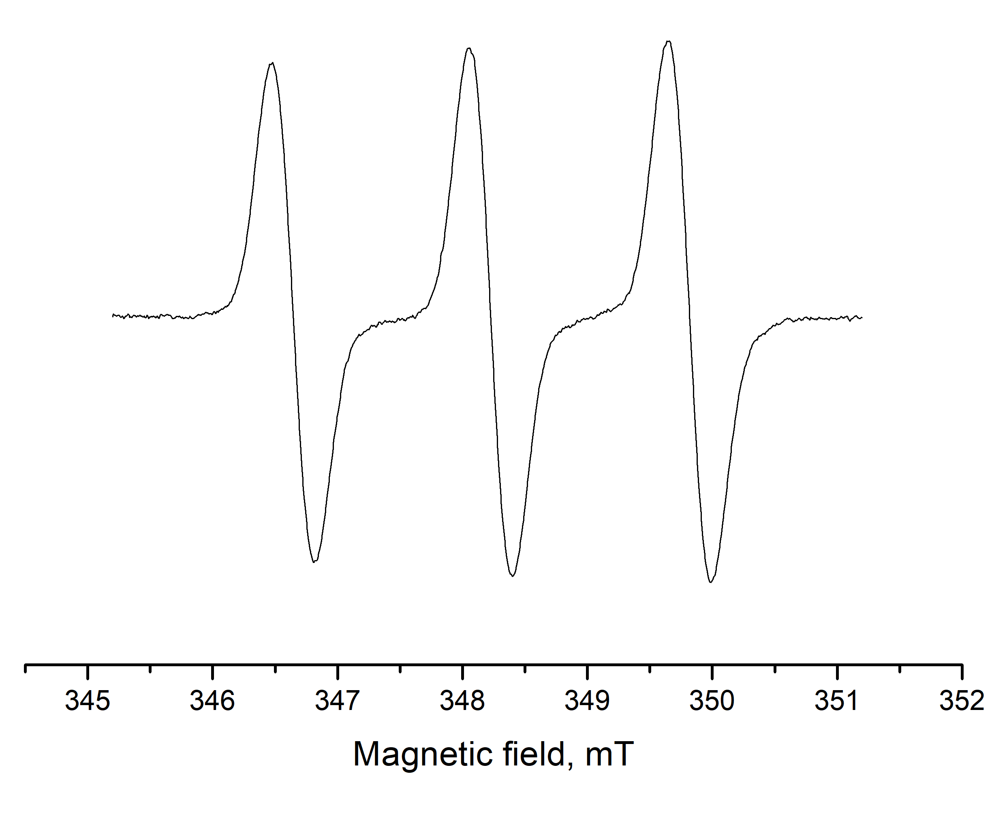
Figure 9SI: EPR spectra of radical 12b.

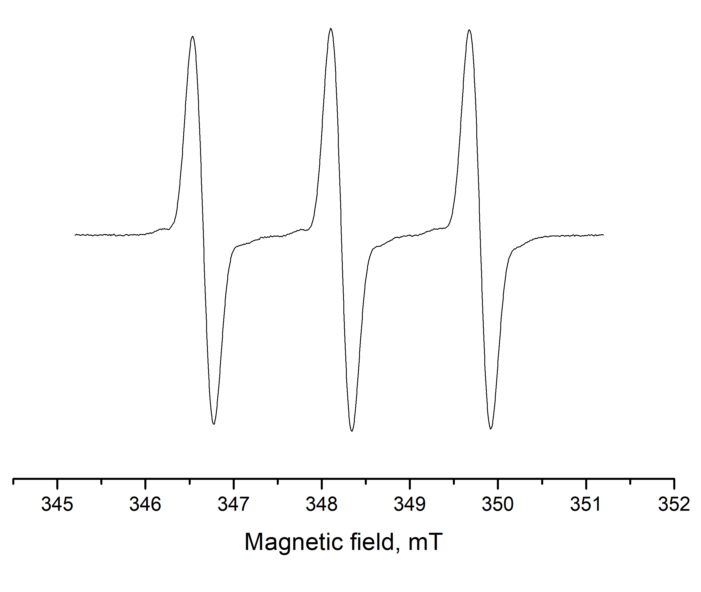
Figure 10SI: EPR spectra of radical 12c.

References:
1. Corey, E. J.; Estreicher H. Tetrahedron Lett. 1980, 21, 1117–1120.
2. Chen, Yao-Jung; Wang Chi-Ying; Lin Wen-Yuan Tetrahedron, 1996, 52 (41), 13181–13188.
3. Matyjaszewski, K.; Woodworth, B. E.; Zhang, X.; Gaynor, S. G.; Metzner, Z. Macromolecules, 1998, 31, 5955–5957.

