Installation of sulfonyl fluorides onto primary amides
Jing Liu, Shi-Meng Wang and Hua Li Qin*

State Key Laboratory of Silicate Materials for Architectures; and School of Chemistry, Chemical Engineering and Life Science, Wuhan University of Technology, 205 Luoshi Road, Wuhan, 430070, China

E-mail: qinhuali@whut.edu.cn

Table of Contents
1. General information SI-2
2. Screening the optimized reaction conditions SI-3
3. General Procedure for the synthesis of different amide SI-4
4. Procedure for the synthesis of 2a-2x SI-4
5. Characterization of substrates SI-5
6. References SI-14
7. ¹H, ¹⁹F, ¹³C NMR spectra SI-15
8. Single crystal data of 4e SI-42

1. General information
All reactions were carried out in dried glassware. All reagents were purchased from commercial sources and used without further purification. Unless otherwise specified, NMR spectra were recorded in CDCl₃ or DMSO-d₆ on a 500 MHz (for ¹H), 471 MHz (for ¹⁹F), 126 MHz (for ¹³C) spectrometer. All chemical shifts were reported in ppm relative to TMS (¹H NMR, 0 ppm) as internal standards. Some of the amides was prepared according to literature. Melting points of the products were measured on a micro melting point apparatus (SGW X-4) and uncorrected. HRMS experiments were performed on a TOF-Q ESI or CI/EI instrument. The coupling constants were reported in Hertz (Hz). The following abbreviations were used to explain the multiplicities: s = singlet, d = doublet, t = triplet, q = quartet, m = multiplet.

2. Screening the optimized reaction conditions
Table 1 Screening the Baseª
Entry | Base | Solvent | Temperature (ºC) | Yield (2a, %)^{b}
1 | Cs₂CO₃ | DMSO | 50 | 25
2 | K₂CO₃ | DMSO | 50 | 13
3 | KOH | DMSO | 50 | 19
4 | NaOH | DMSO | 50 | 15
5 | DBU | DMSO | 50 | 99
6 | Et₃N | DMSO | 50 | ND ^{c}
7 | DIPEA | DMSO | 50 | ND
ª Reaction conditions: Benzoyl amide 1a (1 mmol, 1 eq.), base (5 eq.), and DMSO (1 mL) stirred with a SO₂F₂ balloon at 50 ºC for 12h. ^{b} Isolated yields. ^{c} ND = Not Detected.

Table 2 Screening the Solvents ª
Entry | Base | Solvent | Temperature (ºC) | Yield (2a, %)^{b}
1 | DBU | DMSO | 50 | 99
2 | DBU | NMP | 50 | 81
3 | DBU | MeCN | 50 | 75
4 | DBU | Toluene | 50 | 87
5 | DBU | dioxane | 50 | 60
6 | DBU | THF | 50 | 79
ª Reaction conditions: Benzoyl amide 1a (1 mmol, 1 eq.), DBU (5 eq.), and solvent (1 mL) stirred with a SO₂F₂ balloon at 50 ºC for 12h. ^{b} Isolated yields.

Table 3 Screening the Reaction Temperature and DBU Loading ª
Entry | Base | Solvent | Temperature (ºC) | Yield (2a, %)^{b}
1 | DBU (5eq.) | DMSO | 50 | 99
2 | DBU (5eq.) | DMSO | 40 | 82
3 | DBU (5eq.) | DMSO | R.T. | 51
4 | DBU (4eq.) | DMSO | 50 | 69
ª Reaction conditions: Benzoyl amide 1a (1 mmol, 1 eq.), DBU (5 eq.), and DMSO (1 mL) stirred with a SO₂F₂ balloon for 12 h. ^{b} Isolated yields.

3. General Procedure for the synthesis of different amides.
The amides of 1a-e, 1j, 1k, 1m, 1n, 1m, and 1x-1z were purchased from commercial sources and used without further purification. The amides of 1f, 1g, 1h, 1i, 1l, and 1o-1w were prepared according to the literatures. ^{[1, 2, 3, 4]} All the homemade starting materials are identical to those reported regarding the ¹H and ¹³C NMR and melting points (if applicable).

4. Procedure for the synthesis of 2a-2z.
A mixture of amides 1 (1 mmol, 1 eq.), DBU (5 mmol, 5 eq., 761.2 mg, 0.75 mL), and DMSO (1 mL) was allowed to stir at 50 ºC under the atmosphere of a SO₂F₂ balloon overnight (monitored by TLC until complete consumption of amide starting materials).
The reaction mixture was quenched by 2 M HCl. Then the reaction mixture was extracted with ethyl acetate (3×20 mL) and the extracts were washed with water, and concentrated to dryness under reduced pressure. The residue was purified by column chromatography on silica gel using ethyl acetate as eluents to give the desired product (2).

5. Characterization of substrates
Benzoylsulfamoyl fluoride(2a). Light orange oil (200.0 mg, isolated yield 99%). ¹H NMR (500 MHz, DMSO-d₆) δ 7.94 (d, J = 8.4 Hz, 2H), 7.46 (t, J = 7.4 Hz, 1H), 7.38 (t, J = 7.5 Hz, 2H). ¹⁹F NMR (471 MHz, DMSO-d₆) δ 50.7 (s, 1F). ¹³C NMR (126 MHz, DMSO-d₆) δ 170.4, 137.6, 130.9, 128.5, 127.8. HRMS ESI (m/z): [M+H]⁺ calcd for C₇H₇FNO₃S: 204.0125, found: 204.0121.

(4-Fluorobenzoyl)sulfamoyl fluoride (2b). Light orange oil (216.8 mg, isolated yield 98%). ¹H NMR (500 MHz, DMSO-d₆) δ 7.99 (dd, J = 5.8, J = 8.8 Hz, 2H), 7.17 (t, J = 9.0 Hz, 2H). ¹⁹F NMR (471 MHz, DMSO-d₆) δ 50.6 (s, 1F), ﹣110.4-﹣110.5 (m, 1F). ¹³C NMR (126 MHz, DMSO-d₆) δ 169.4, 164.0 (d, J = 248.0 Hz), 134.1, 131.1 (d, J = 9.1 Hz), 114.6 (d, J = 21.8 Hz). HRMS ESI (m/z): [M+H]⁺ calcd for C₇H₆F₂NO₃S: 222,0031, found: 222.0028.

(4-Chlorobenzoyl)sulfamoyl fluoride (2c). Yellow soild (181.1 mg, isolated yield 76%). ¹H NMR (500 MHz, DMSO-d₆) δ 7.94 (dd, J = 1.2, J = 8.4 Hz, 2H), 7.43 (d, J = 8.5 Hz, 2H). ¹⁹F NMR (471 MHz, DMSO-d₆) δ 50.6 (s, 1F). ¹³C NMR (126 MHz, DMSO-d₆) δ 167.0, 135.9, 133.1, 129.5, 128.4. Mp 138-139 °C. HRMS ESI (m/z): [M+H]⁺ calcd for C₇H₆ClFNO₃S: 237.9735, found: 237.9731.

(4-Bromobenzoyl)sulfamoyl fluoride (2d). Orange oil (236.0 mg, isolated yield 84%). ¹H NMR (500 MHz, DMSO-d₆) δ 7.87 (d, J = 8.5 Hz, 2H), 7.57 (d, J = 8.6 Hz, 2H). ¹⁹F NMR (471 MHz, DMSO-d₆) δ 50.6 (s, 1F). ¹³C NMR (126 MHz, DMSO-d₆) δ 169.6, 136.8 (d, J = 4.6 Hz), 130.9, 130.7, 124.8. HRMS ESI (m/z): [M+H]⁺ calcd for C₇H₆BrFNO₃S: 281.9230, found: 281.9228.

(4-Nitrobenzoyl)sulfamoyl fluoride (2e). Yellow solid (245.5 mg, isolated yield 99%). ¹H NMR (500 MHz, DMSO-d₆) δ 8.23 (d, J = 8.9 Hz, 2H), 8.15 (d, J = 9.0 Hz, 2H). ¹⁹F NMR (471 MHz, DMSO-d₆) δ 50.4 (s, 1F). ¹³C NMR (126 MHz, DMSO-d₆) δ 168.3, 148.9, 143.3 (d, J = 3.6 Hz), 129.7, 123.1. Mp 117-119 °C. HRMS ESI (m/z): [M+H]⁺ calcd for C₇H₆FN₂O₅S: 248.9976, found: 248.9972.

(4-(Trifluoromethyl)benzoyl)sulfamoyl fluoride (2f). Light orange oil (236.9 mg, isolated yield 87%). ¹H NMR (500 MHz, DMSO-d₆) δ 8.14 (d, J = 8.1 Hz, 2H), 7.73 (d, J = 8.2 Hz, 2H). ¹⁹F NMR (471 MHz, DMSO-d₆) δ 50.4 (s, 1F), ﹣61.4 (s, 3F). ¹³C NMR (126 MHz, DMSO-d₆) δ 169.2, 141.4 (d, J = 3.6 Hz), 131.0 (q, J = 31.8 Hz), 129.3, 124.9 (q, J = 3.7 Hz), 124.3 (q, J = 272.5 Hz), 125.0-124.9 (m). HRMS ESI (m/z): [M+H]⁺ calcd for C₈H₆F₄NO₃S: 271.9999, found: 271.9993.

(4-Methylbenzoyl)sulfamoyl fluoride (2g). Light orange oil (136.0 mg, isolated yield 63%). ¹H NMR (500 MHz, DMSO-d₆) δ 7.84 (d, J = 8.1 Hz, 2H), 7.17 (d, J = 8.1 Hz, 2H), 2.31 (s, 3H). ¹⁹F NMR (471 MHz, DMSO-d₆) δ 50.8 (s, 1F). ¹³C NMR (126 MHz, DMSO-d₆) δ 170.4 (d, J = 2.7 Hz), 140.5, 132.1, 130.1, 128.5 (d, J = 33.7 Hz), 21.0. HRMS ESI (m/z): [M+H]⁺ calcd for C₈H₉FNO₃S: 218.0282, found: 218.0275.

(4-(Tert-butyl)benzoyl)sulfamoyl fluoride (2h). Light orange oil (206.2 mg, isolated yield 80%). ¹H NMR (500 MHz, DMSO-d₆) δ 7.88 (d, J = 8.2 Hz, 2H), 7.38 (d, J = 8.4 Hz, 2H), 1.28 (s, 9H). ¹⁹F NMR (471 MHz, DMSO-d₆) δ 50.9 (s, 1F). ¹³C NMR (126 MHz, DMSO-d₆) δ 170.4, 153.6, 135.0 (d, J = 4.5 Hz), 128.5, 124.5, 34.5, 31.1. HRMS ESI (m/z): [M+H]⁺ calcd for C₁₁H₁₅FNO₃S: 260.0751, found: 260.0746.

(2-Naphthoyl)sulfamoyl fluoride (2i). Light orange oil (237.8 mg, isolated yield 94%). ¹H NMR (500 MHz, DMSO-d₆) δ 8.56 (s, 1H), 8.07-7.89 (m, 4H), 7.57-7.54 (m, 2H). ¹⁹F NMR (471 MHz, DMSO-d₆) δ 51.1 (s, 1F). ¹³C NMR (126 MHz, DMSO-d₆) δ 168.3, 134.5-134.4 (m), 132.3, 131.7, 128.9, 128.0-127.9 (m), 127.7-127.6 (m), 127.4-127.3 (m), 126.7, 126.34-126.32 (m), 124.5. HRMS ESI (m/z): [M+H]⁺ calcd for C₁₁H₉FNO₃S: 254.0282, found: 254.0277.

(3-Bromobenzoyl)sulfamoyl fluoride (2j). Orange oil (215.1 mg, isolated yield 76%). ¹H NMR (500 MHz, DMSO-d₆) δ 8.01 (s, 1H), 7.88 (d, J = 7.6 Hz, 1H), 7.61 (d, J = 1.1 Hz, 1H), 7.33 (t, J = 7.9 Hz, 1H). ¹⁹F NMR (471 MHz, DMSO-d₆) δ 50.5 (s, 1F). ¹³C NMR (126 MHz, DMSO-d₆) δ 168.9, 139.9 (d, J = 4.6 Hz), 133.6, 131.2, 130.2, 127.5, 121.3. HRMS ESI (m/z): [M+H]⁺ calcd for C₇H₆BrFNO₃S: 281.9230, found: 281.9228.

(3-Nitrobenzoyl)sulfamoyl fluoride (2k). Yellow soild (160.6 mg, isolated yield 65%). ¹H NMR (500 MHz, DMSO-d₆) δ 8.67 (s, 1H), 8.33 (t, J = 7.8 Hz, 2H), 7.70 (t, J = 8.0 Hz, 1H). ¹⁹F NMR (471 MHz, DMSO-d₆) δ 50.5 (s, 1F). ¹³C NMR (126 MHz, DMSO-d₆) δ 167.9, 147.6, 139.2 (d, J = 4.5 Hz), 134.6, 129.7, 125.4, 122.9. Mp 94-96 °C. HRMS ESI (m/z): [M+H]⁺ calcd for C₇H₆FN₂O₅S: 248.9976, found: 248.9972.

(3-Methylbenzoyl)sulfamoyl fluoride (2l). Light orange oil (210.5 mg, isolated yield 97%). ¹H NMR (500 MHz, DMSO-d₆) δ 7.79 (s, 1H), 7.76-7.75 (m, 1H), 7.27-7.24 (m, 2H), 2.31 (s, 3H). ¹⁹F NMR (471 MHz, DMSO-d₆) δ 50.8 (s, 1F). ¹³C NMR (126 MHz, DMSO-d₆) δ 170.9, 137.7 (d, J = 3.6 Hz), 137.0, 131.6, 129.3, 127.8, 125.9, 20.8. HRMS ESI (m/z): [M+H]⁺ calcd for C₈H₉FNO₃S: 218.0282, found: 218.0275.

(2-Bromobenzoyl)sulfamoyl fluoride (2m). Light orange oil (279.2 mg, isolated yield 99%). ¹H NMR (500 MHz, DMSO-d₆) δ 7.54 (d, J = 7.9 Hz, 1H), 7.51 (dd, J = 7.6, J = 1.5 Hz, 1H), 7.34 (t, J=7.4, 1H), 7.24 (td, J = 7.7, J = 1.5 Hz, 1H). ¹⁹F NMR (471 MHz, DMSO-d₆) δ 50.5 (s, 1F). ¹³C NMR (126 MHz, DMSO-d₆) δ 172.0, 141.1 (d, J = 4.5 Hz), 133.1, 130.3, 129.6, 127.3, 119.1. HRMS ESI (m/z): [M+H]⁺ calcd for C₇H₆BrFNO₃S: 281.9230, found: 281.9228.

(2-Chlorobenzoyl)sulfamoyl fluoride (2n). Light orange oil (169.1 mg, isolated yield 71%). ¹H NMR (500 MHz, DMSO-d₆) δ 7.54 (dd, J = 7.3, J = 1.6 Hz, 1H), 7.39-7.37 (m, 1H), 7.35-7.28 (m, 2H). ¹⁹F NMR (471 MHz, DMSO-d₆) δ 50.5 (s, 1F). ¹³C NMR (126 MHz, DMSO-d₆) δ 171.1, 139.1 (d, J = 4.5 Hz), 130.3, 130.1, 129.9, 129.6, 126.7. HRMS ESI (m/z): [M+H]⁺ calcd for C₇H₆ClFNO₃S: 237.9735, found: 237.9731.

(2-Methylbenzoyl)sulfamoyl fluoride (2o). Light orange oil (130.2 mg, isolated yield 60%). ¹H NMR (500 MHz, DMSO-d₆) δ 7.63 (d, J = 7.4 Hz, 1H), 7.24-7.22 (m, 1H), 7.16-7.13 (m, 2H), 2.44 (s, 3H). ¹⁹F NMR (471 MHz, DMSO-d₆) δ 50.5 (s, 1F). ¹³C NMR (126 MHz, DMSO-d₆) δ 173.5, 138.6 (d, J = 4.5 Hz), 136.6, 130.8, 129.1, 129.0, 125.2, 20.8. HRMS ESI (m/z): [M+H]⁺ calcd for C₈H₉FNO₃S: 218.0282, found: 218.0275.

(3,5-Dimethylbenzoyl)sulfamoyl fluoride (2p). Light orange oil (182.6 mg, isolated yield 79%). ¹H NMR (500 MHz, DMSO-d₆) δ 7.55 (s, 2H), 7.07 (s, 1H), 2.28 (s, 6H). ¹⁹F NMR (471 MHz, DMSO-d₆) δ 50.8 (s, 1F). ¹³C NMR (126 MHz, DMSO-d₆) δ 170.6, 136.6, 132.1, 126.4, 20.8. HRMS ESI (m/z): [M+H]⁺ calcd for C₉H₁₁FNO₃S: 232.0438, found: 232.0432.

(3,5-Dichlorobenzoyl)sulfamoyl fluoride (2q). Light orange oil (205.6 mg, isolated yield 76%). ¹H NMR (500 MHz, DMSO-d₆) δ 7.85 (d, J = 1.7 Hz, 2H), 7.61 (s, 1H). ¹⁹F NMR (471 MHz, DMSO-d₆) δ 50.4 (s, 1F). ¹³C NMR (126 MHz, DMSO-d₆) δ 167.6, 141.2 (d, J = 4.6 Hz), 134.0, 130.2, 127.1. HRMS ESI (m/z): [M+H]⁺ calcd for C₇H₅Cl₂FNO₃S: 271.9346, found: 271.9341.

(Furan-2-carbonyl)sulfamoyl fluoride (2r). Light yellow soild (131.7 mg, isolated yield 68%). ¹H NMR (500 MHz, DMSO-d₆) δ 7.70 (s, 1H), 6.89 (d, J = 3.4 Hz, 1H), 6.50 (q, J = 1.7 Hz, 1H). ¹⁹F NMR (471 MHz, DMSO-d₆) δ 51.8 (s, 1F). ¹³C NMR (126 MHz, DMSO-d₆) δ 162.3, 145.0, 144.7, 114.0, 111.4. Mp 68-69 °C. HRMS ESI (m/z): [M+H]⁺ calcd for C₅H₅FNO₄S: 193.9918, found: 193.9915.

(Thiophene-2-carbonyl)sulfamoyl fluoride (2s). Yellow soild (188.1 mg, isolated yield 90%). ¹H NMR (500 MHz, DMSO-d₆) δ 7.60 (dd, J = 4.9, J = 1.1 Hz, 1H), 7.52 (d, J = 3.5 Hz, 1H), 7.05 (dd, J = 3.7, J = 4.9 Hz, 1H). ¹⁹F NMR (471 MHz, DMSO-d₆) δ 56.2 (d, J = 5.7 Hz, 1F). ¹³C NMR (126 MHz, DMSO-d₆) δ 163.0, 140.3, 131.0, 130.0, 128.8. HRMS ESI (m/z): [M+H]⁺ calcd for C₅H₅FNO₃S₂: 209.9689, found: 209.9687.

(Benzofuran-2-carbonyl)sulfamoyl fluoride (2t). Light orange oil (136.0 mg, isolated yield 56%). ¹H NMR (500 MHz, DMSO-d₆) δ 7.71 (d, J = 7.8 Hz, 1H), 7.61 (d, J = 8.4 Hz, 1H), 7.41-7.36 (m, 2H), 7.27 (t, J=7.5, 1H). ¹⁹F NMR (471 MHz, DMSO-d₆) δ 51.6 (s, 1F). ¹³C NMR (126 MHz, DMSO-d₆) δ 163.2, 154.7, 152.9, 127.6, 126.3, 123.4, 122.6, 111.8, 109.9. HRMS ESI (m/z): [M+H]⁺ calcd for C₉H₇FNO₄S: 244.0074, found: 244.0070.

(Benzo[b]thiophene-2-carbonyl)sulfamoyl fluoride (2u). Light orange oil (220.4 mg, isolated yield 85%). ¹H NMR (500 MHz, DMSO-d₆) δ 7.93-7.89 (m, 3H), 7.41-7.35 (m, 2H). ¹⁹F NMR (471 MHz, DMSO-d₆) δ 51.2 (s, 1F). ¹³C NMR (126 MHz, DMSO-d₆) δ 166.3, 143.7 (d, J = 5.5 Hz), 141.1, 139.4, 126.7, 126.0, 125.2, 124.6, 122.8. HRMS ESI (m/z): [M+H]⁺ calcd for C₉H₇FNO₃S₂: 259.9846, found: 259.9842.

(2-Phenylacetyl)sulfamoyl fluoride (2v). Light orange oil (197.9 mg, isolated yield 91%). ¹H NMR (500 MHz, DMSO-d₆) δ 7.28-7.25 (m, 2H), 7.22 (d, J = 6.9 Hz, 2H), 7.18 (t, J=7.1 Hz, 1H), 3.36 (s, 2H). ¹⁹F NMR (471 MHz, DMSO-d₆) δ 50.2 (s, 1F). ¹³C NMR (126 MHz, DMSO-d₆) δ 176.3, 137.4, 129.4, 128.0, 125.9, 46.1 (d, J = 4.5 Hz). HRMS ESI (m/z): [M+H]⁺ calcd for C₈H₉FNO₃S: 218.0282, found: 218.0275.

(3-Phenylpropanoyl)sulfamoyl fluoride (2w). Light orange oil (138.6 mg, isolated yield 60%). ¹H NMR (500 MHz, DMSO-d₆) δ 7.26-7.23 (m, 2H), 7.19 (d, J = 6.9 Hz, 2H), 7.16-7.13 (m, 1H), 2.77 (t, J = 7.9 Hz, 2H), 2.35 (t, J = 7.9 Hz, 2H). ¹⁹F NMR (471 MHz, DMSO-d₆) δ 50.8 (s, 1F). ¹³C NMR (126 MHz, DMSO-d₆) δ 176.8, 141.8, 128.4 (d, J = 5.5 Hz), 126.9, 126.0, 31.2, 30.7. HRMS ESI (m/z): [M+H]⁺ calcd for C₉H₁₁FNO₃S: 232.0438, found: 232.0432.

Acryloylsulfamoyl fluoride (2x). Light orange oil (129.6 mg, isolated yield 85%). ¹H NMR (500 MHz, DMSO-d₆) δ 6.01-6.00 (m, 2H), 5.49 (dd, J = 4.6, J = 7.8 Hz, 1H). ¹⁹F NMR (471 MHz, DMSO-d₆) δ 50.7 (s, 1F). ¹³C NMR (126 MHz, DMSO-d₆) δ 170.3, 136.8 (d, J = 4.5 Hz), 124.7. HRMS ESI (m/z): [M+H]⁺ calcd for C₃H₅FNO₃S: 153.9969, found:153.9961.

Acryloylsulfamoyl fluoride (2y). Orange oil (82.5 mg, isolated yield 65%). ¹H NMR (500 MHz, DMSO-d₆) δ 8.92 (s, 1H). ¹⁹F NMR (471 MHz, DMSO-d₆) δ 59.0 (s, 1F). ¹³C NMR (126 MHz, DMSO-d₆) δ 170.4. HRMS ESI (m/z): [M+H]⁺ calcd for CH₃FNO₃S: 127.9812, found: 127.9808.

Acryloylsulfamoyl fluoride (2z). Light orange oil (67.7 mg, isolated yield 48%). ¹H NMR (500 MHz, DMSO-d₆) δ 1.99 (s, 3H). ¹⁹F NMR (471 MHz, DMSO-d₆) δ 51.5 (s, 1F). ¹³C NMR (126 MHz, DMSO-d₆) δ 171.0, 24.4. HRMS ESI (m/z): [M+H]⁺ calcd for C₂H₅FNO₃S: 141.9969, found: 141.9965.

6. References
[1] Wu, Y.; Sun, P.; Zhang, K.; Yang, T.; Ya, H.; Lin, A. J. Org. Chem., 2016, 81, 2166-2173.
[2] Lei, P.; Xu, Y.; Du, J.; Yang, X.-L.; Yuan, H.-Z.; Xu, G.-F.; Ling, Y. Bioorg. Med. Chem. Lett., 2016, 26, 2544-2546.
[3] Gaspari, P.; Banerjee, T.; Malachowski, W. P.; Muller, A. J.; Prendergast, G. C.; DuHadaway, J.; Bennett, S.; Donovan, A. M. J. Med. Chem., 2006, 49, 684-692.
[4] Guo, W.; Huang, J.; Wu, H.; Liu, T.; Luo, Z.; Jian, J.; Zeng, Z. Org. Chem. Front., 2018, 5, 2950-2954.

7. ¹H, ¹⁹F, ¹³C NMR spectra
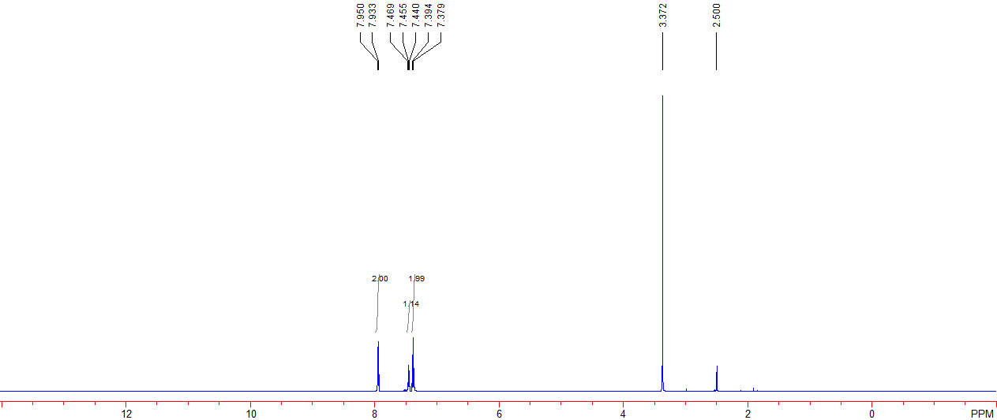

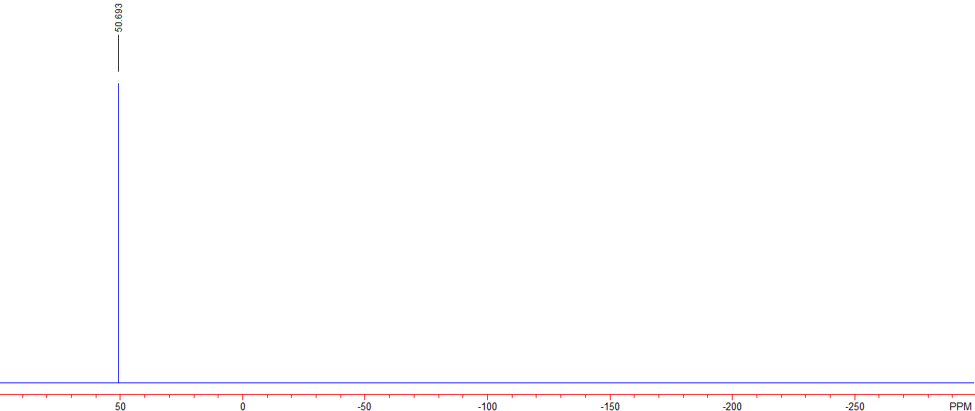

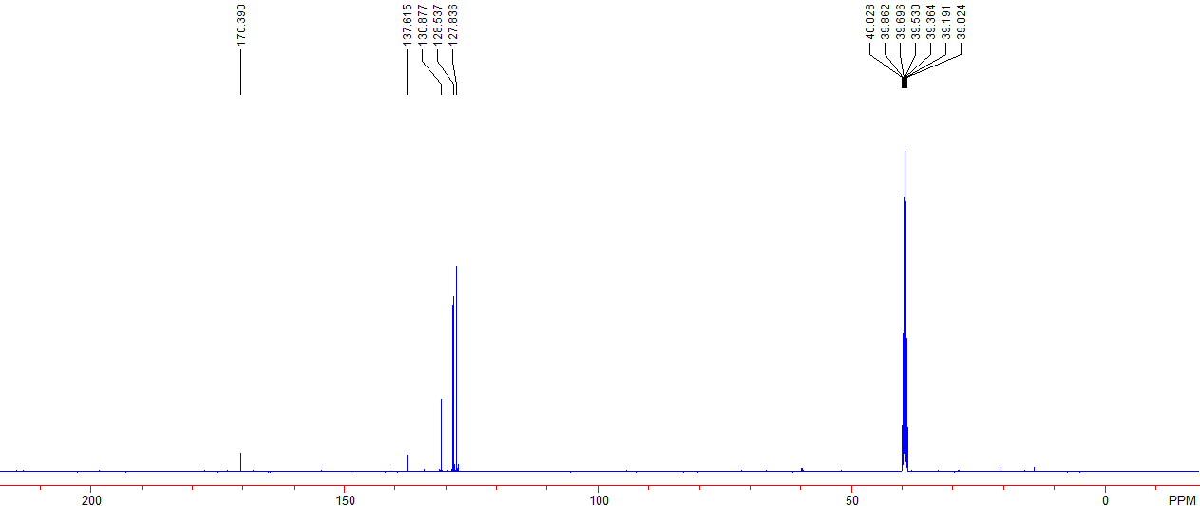

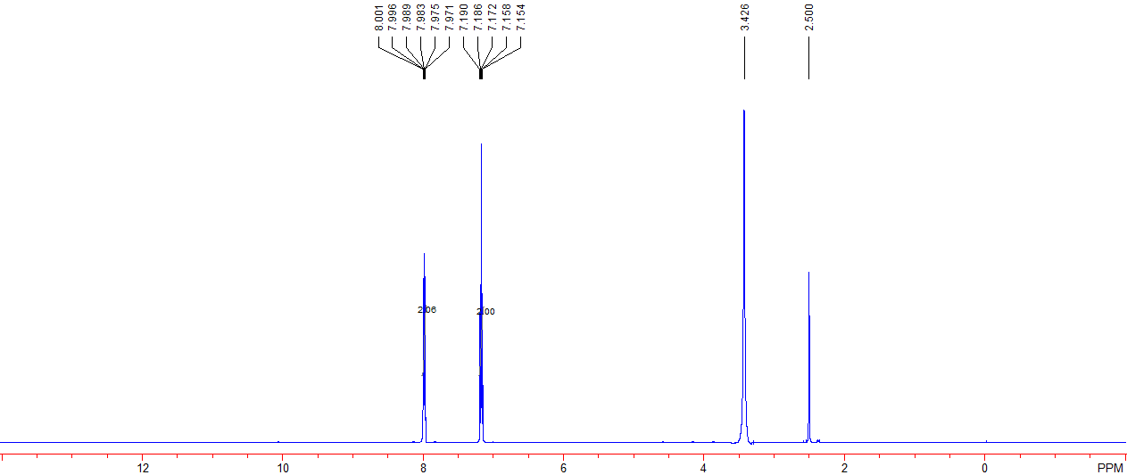

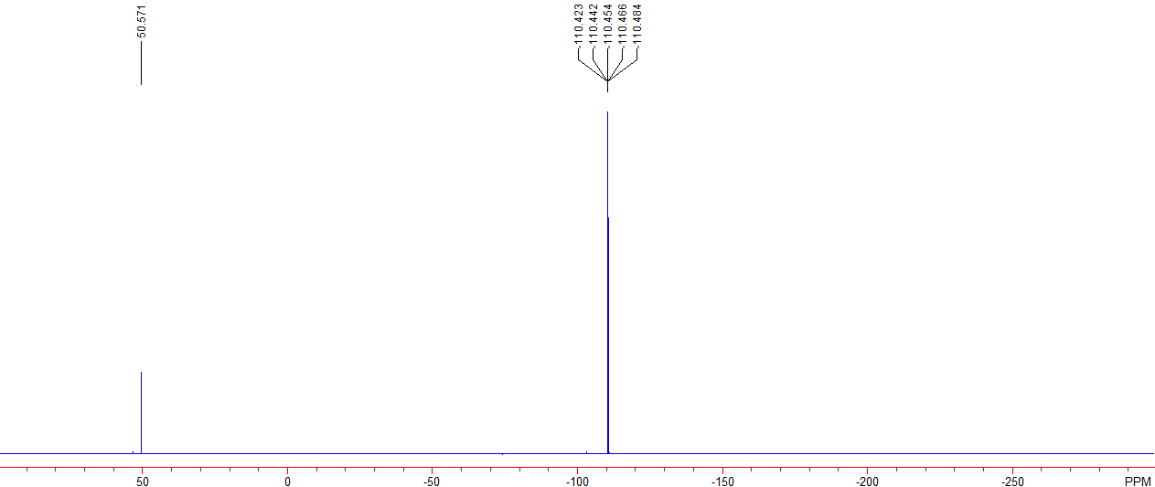

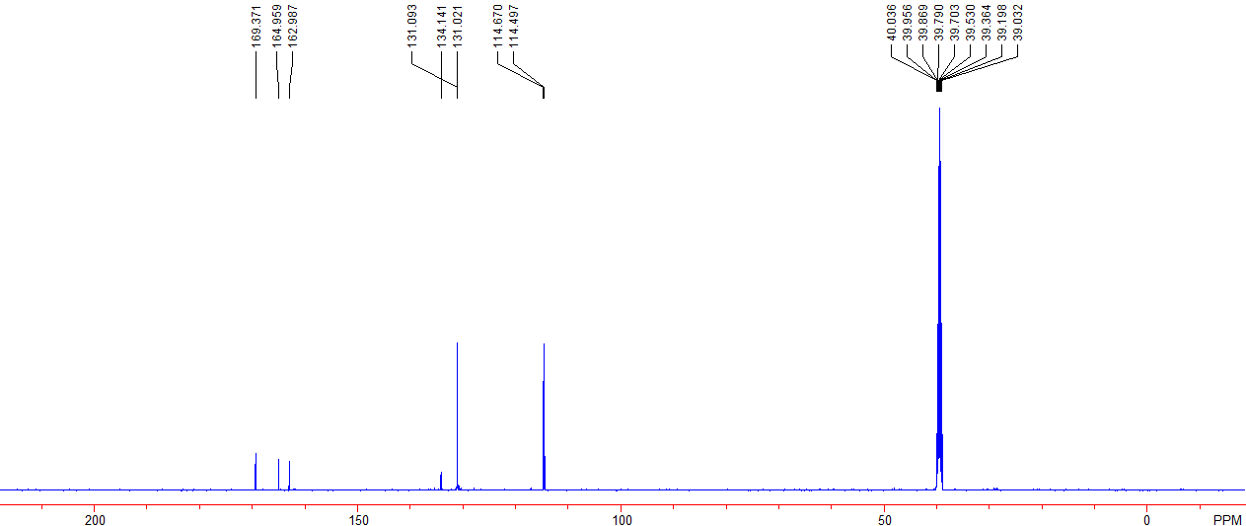
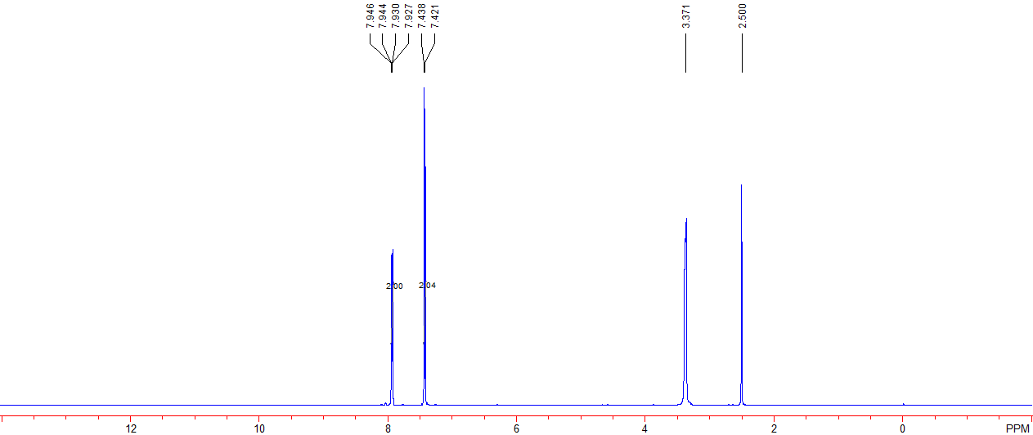

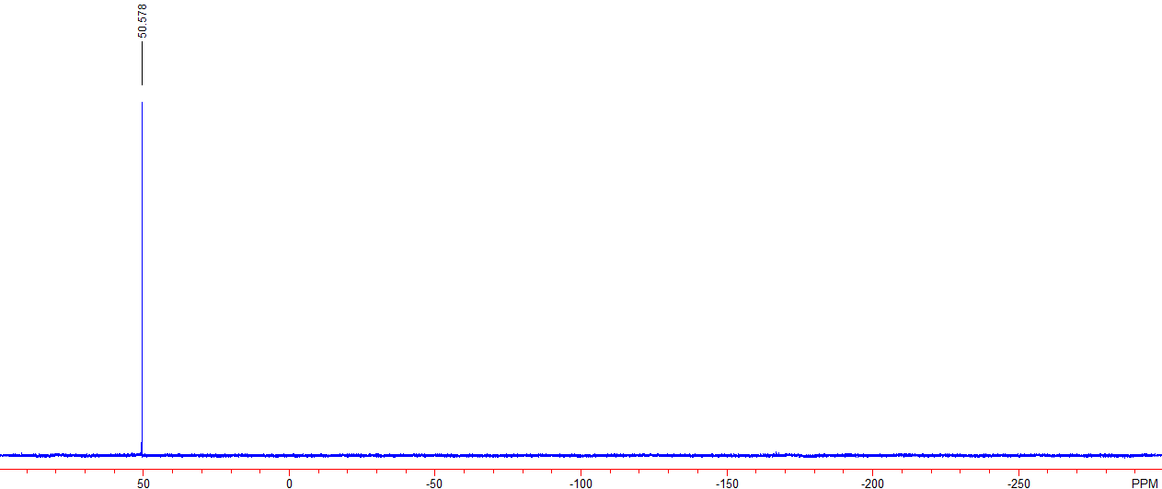

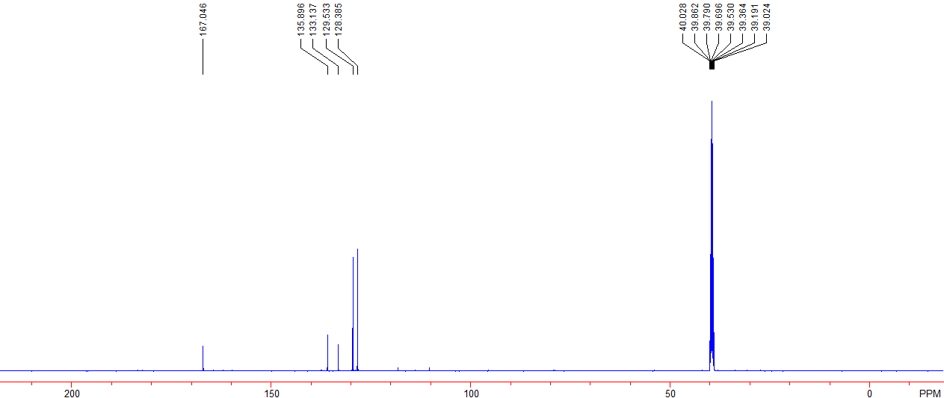

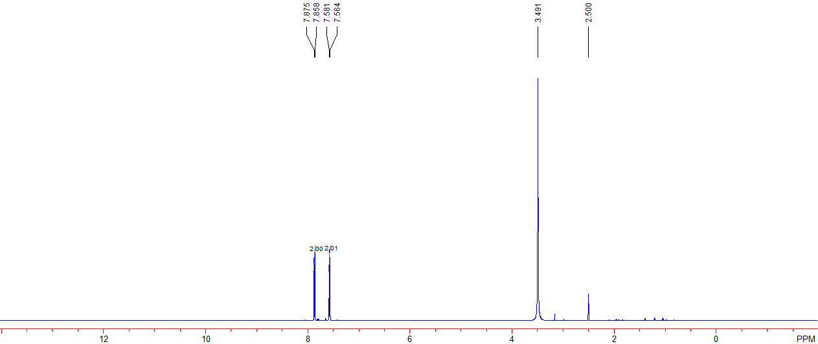

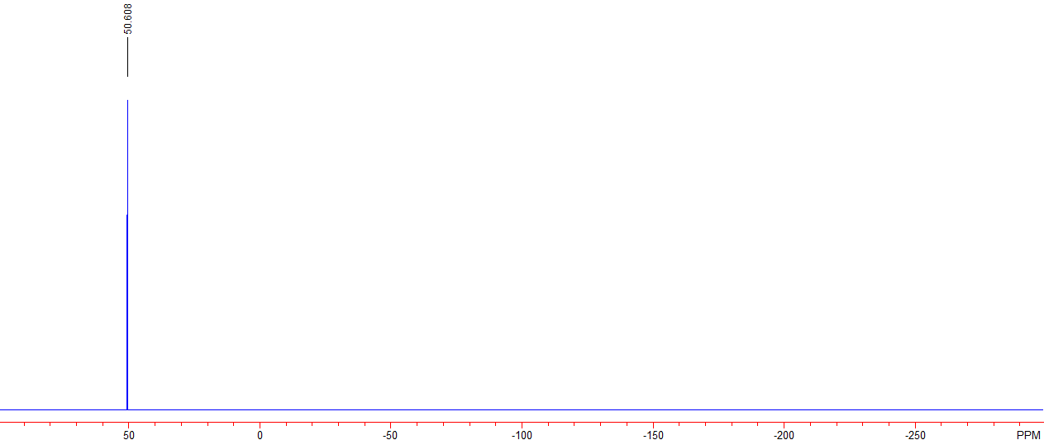

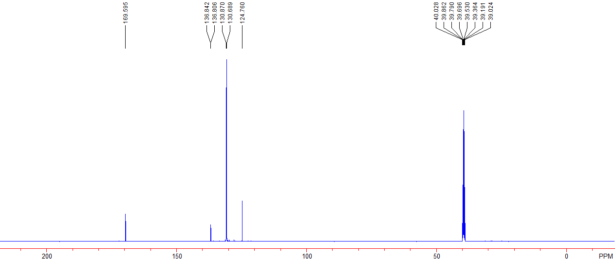

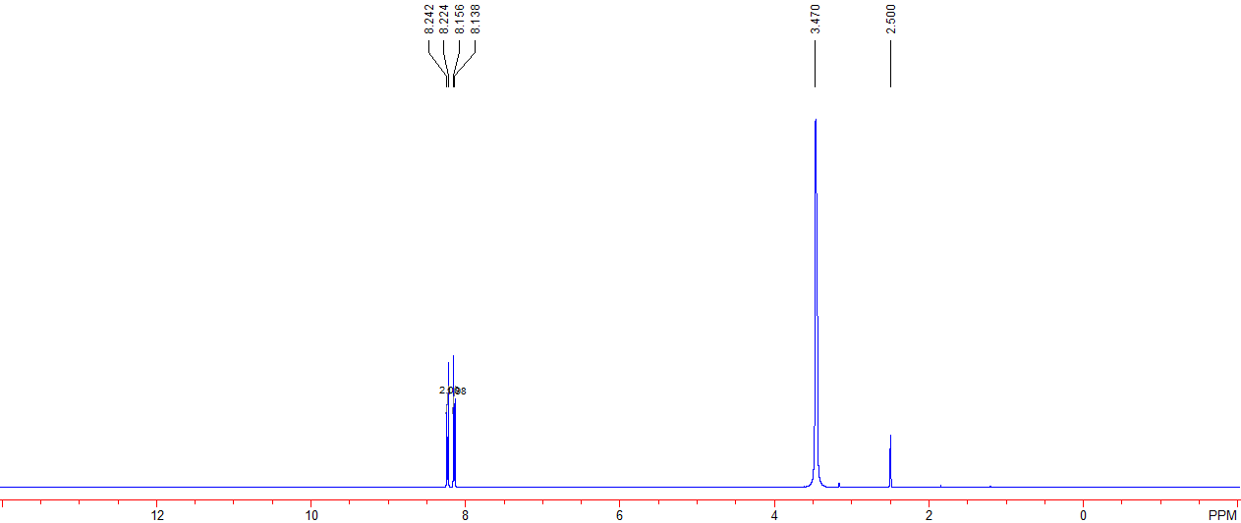

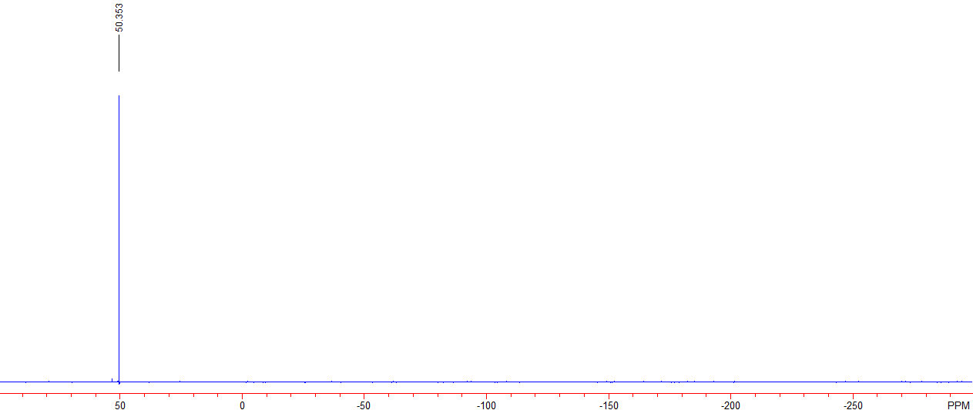

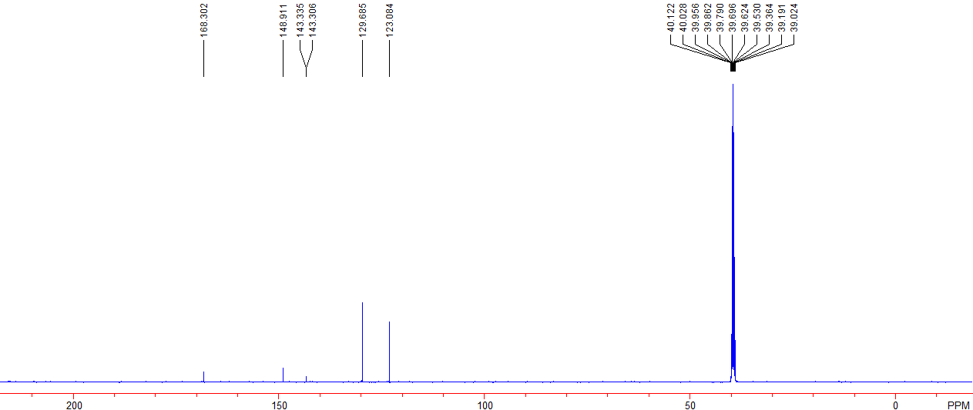

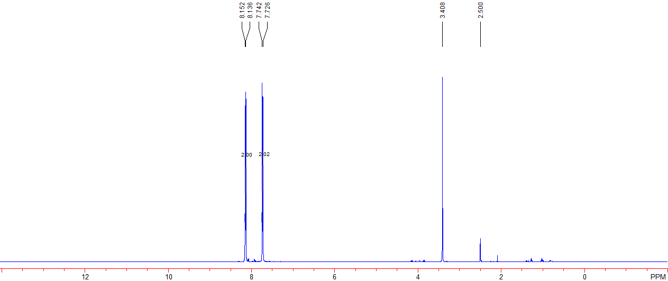

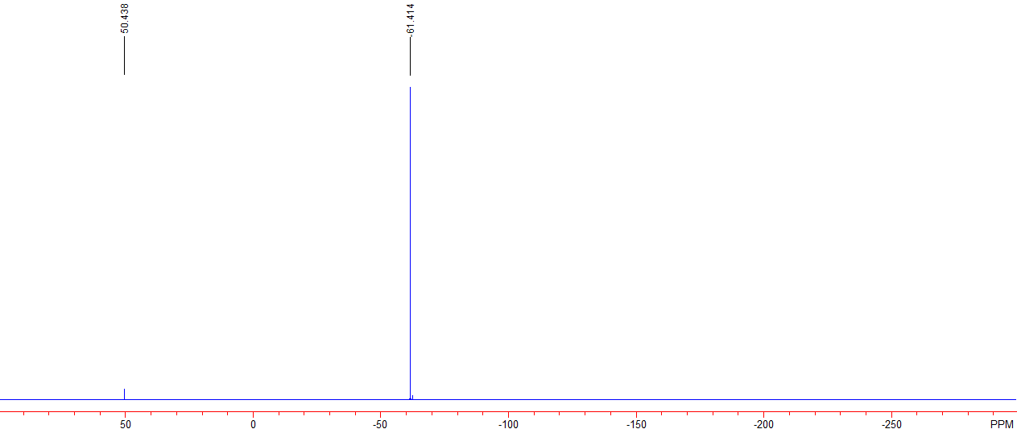

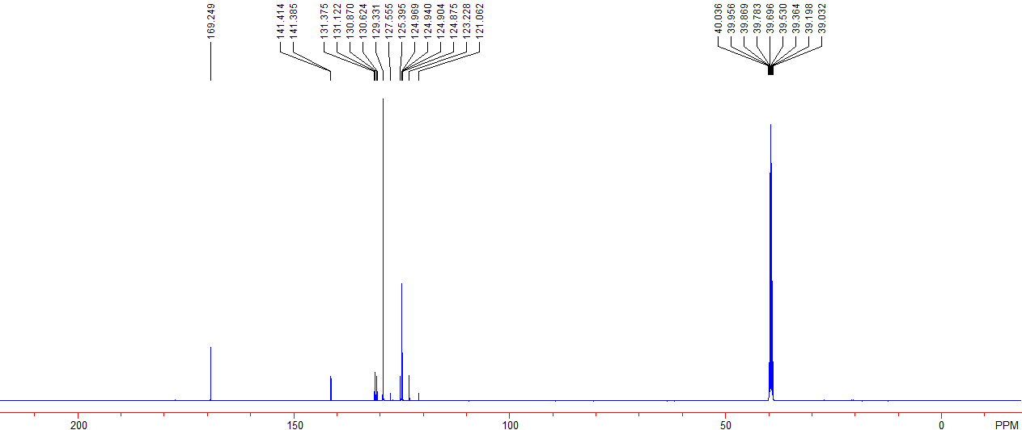

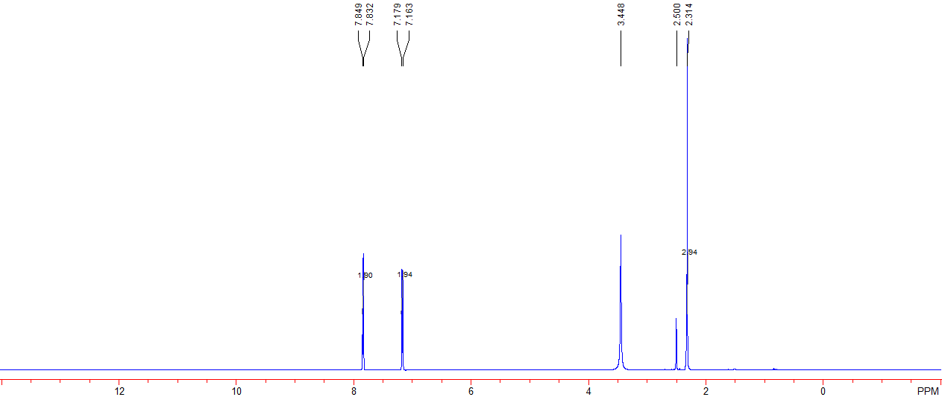

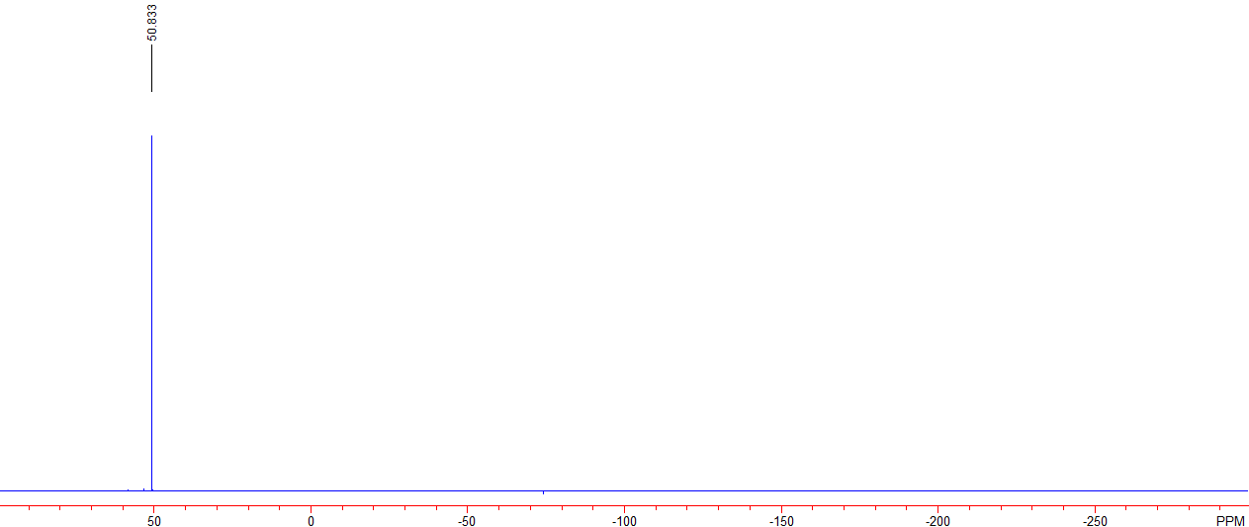

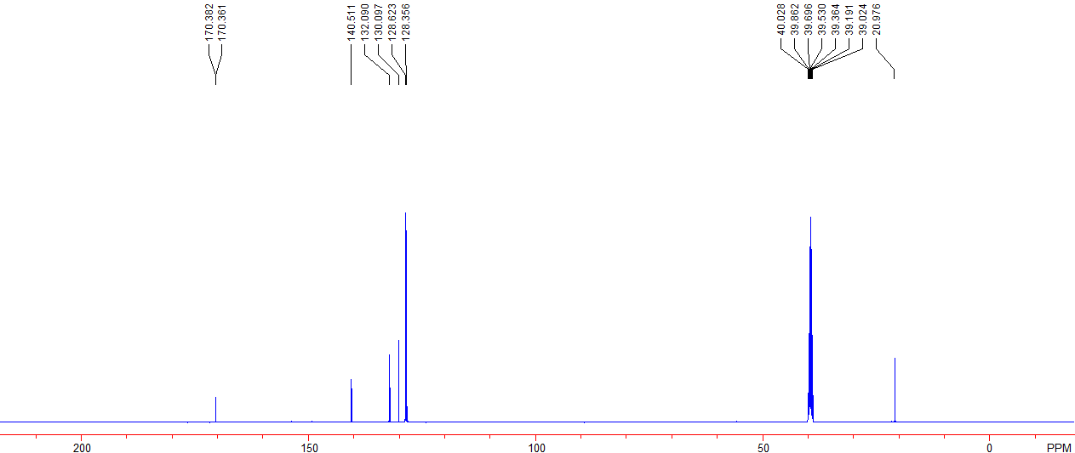

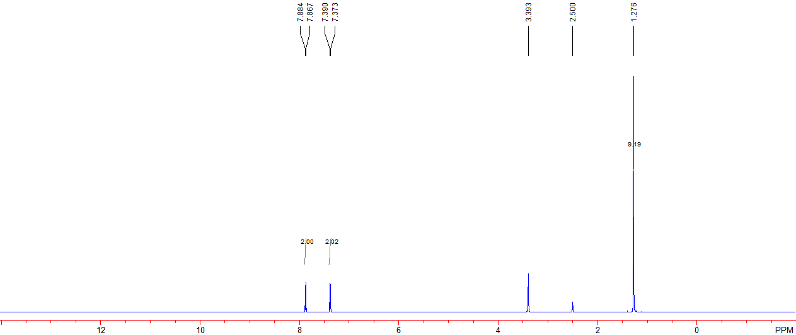

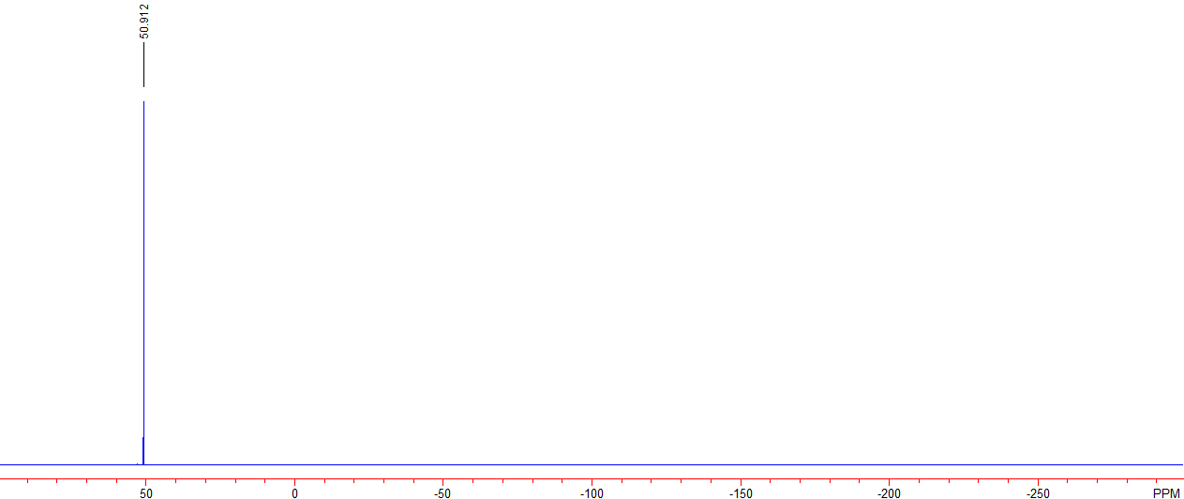

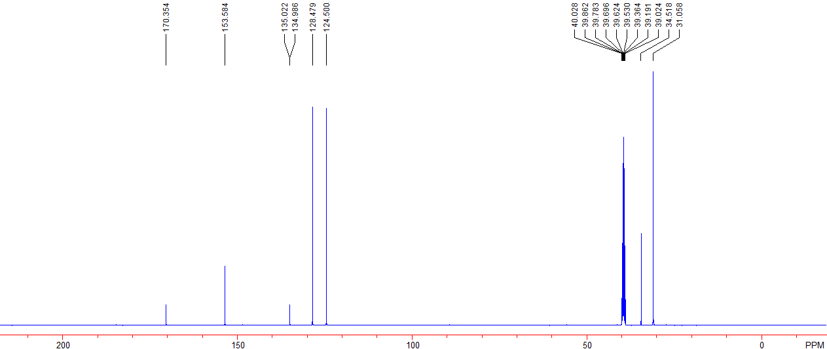

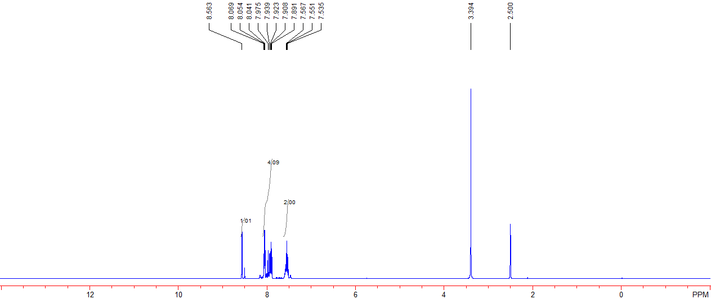

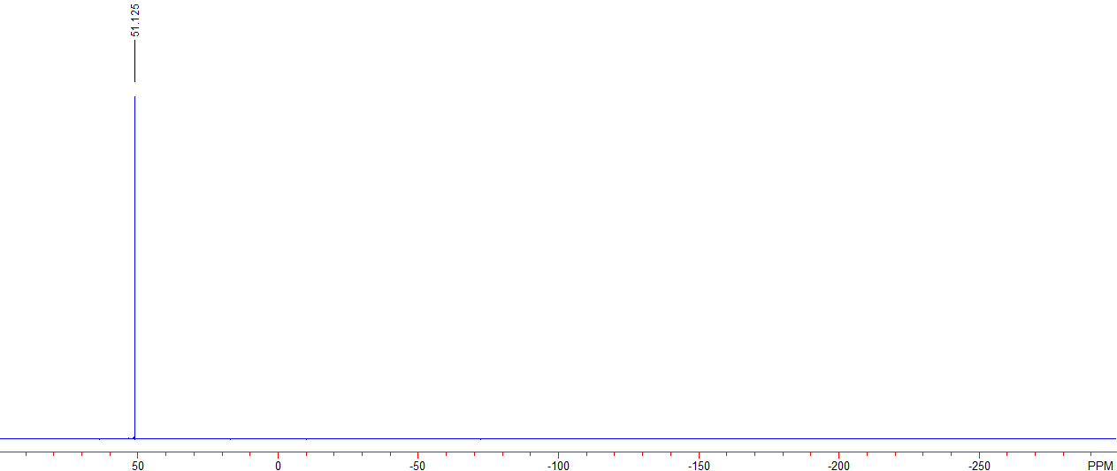

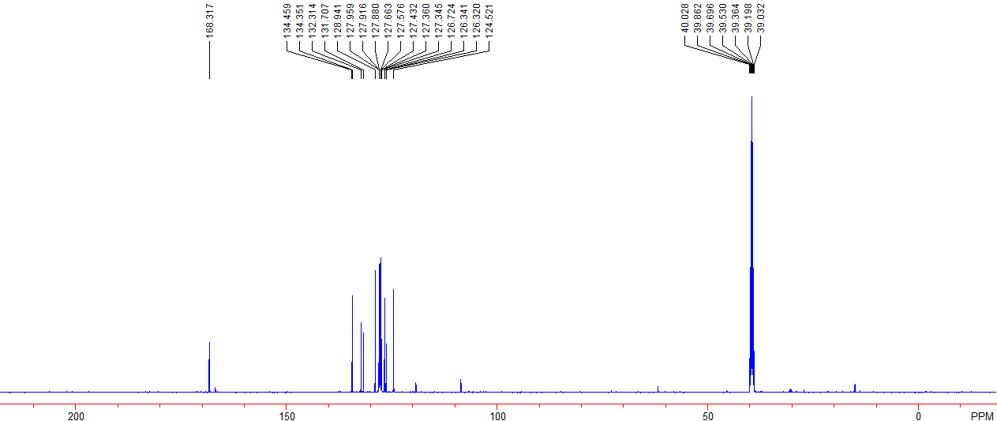

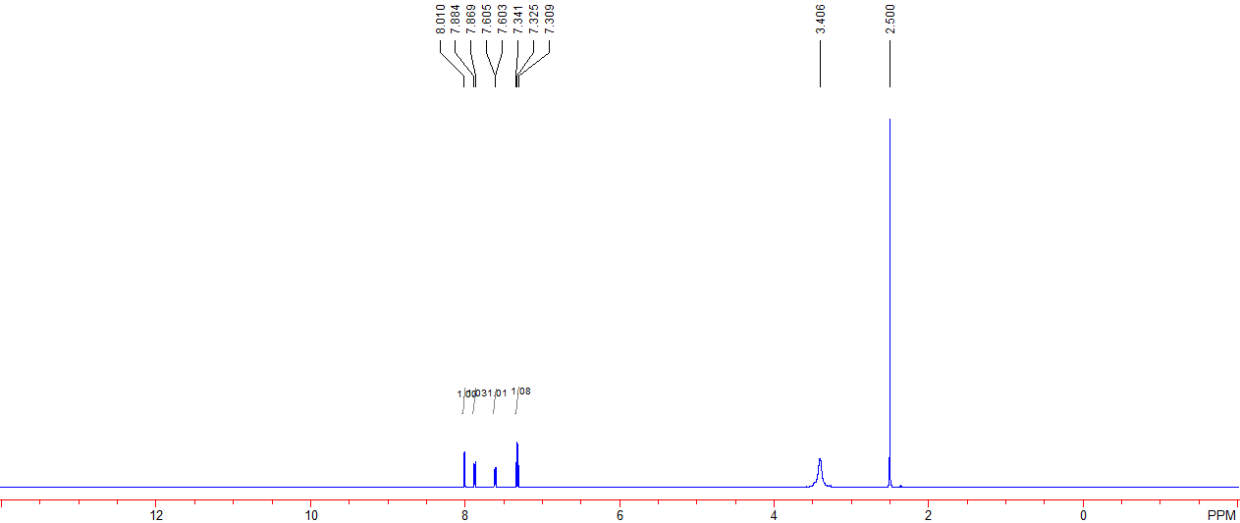

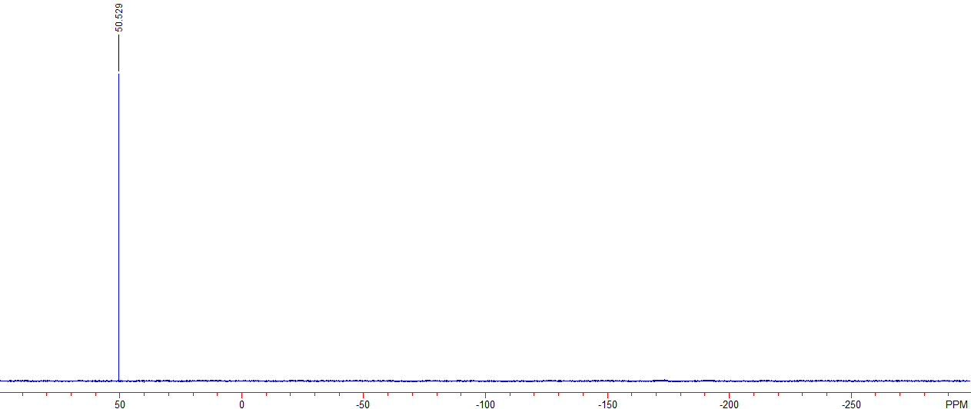

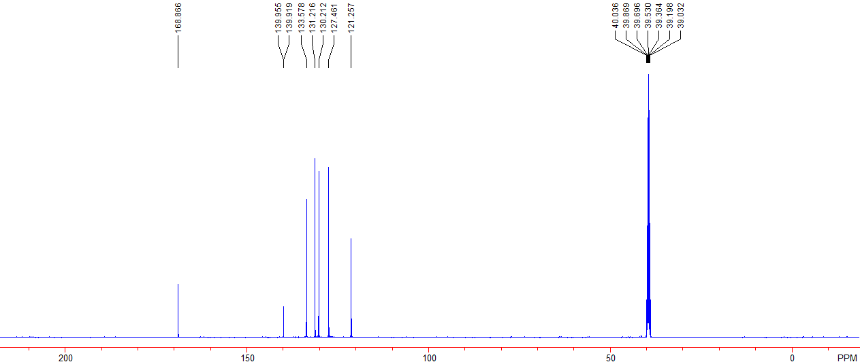

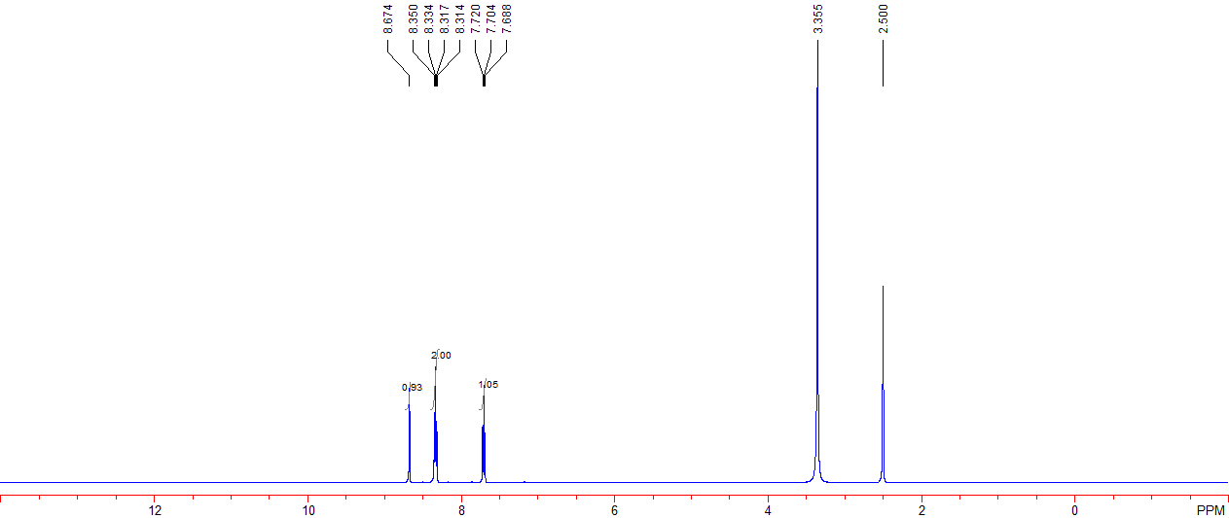
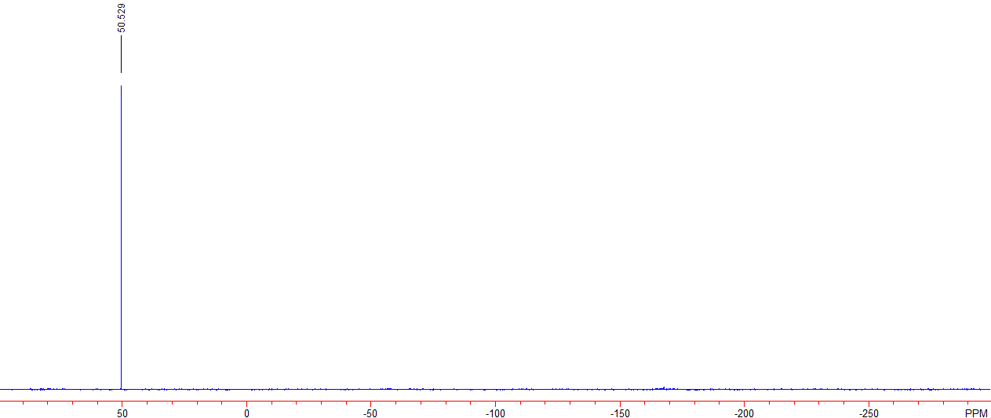

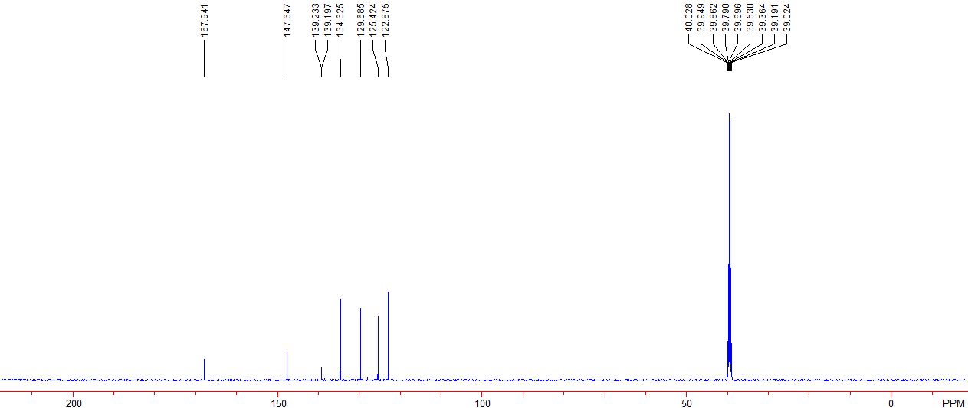

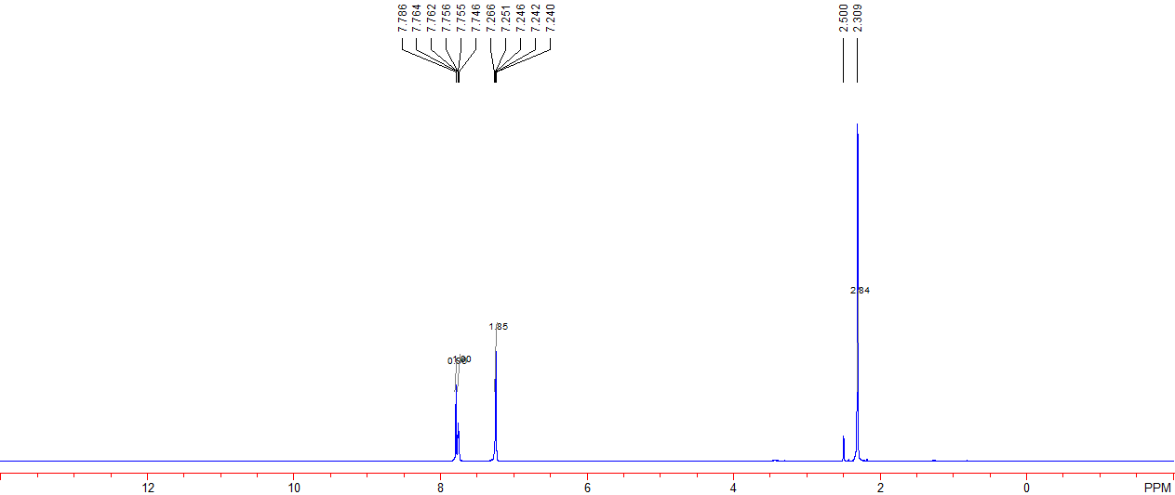

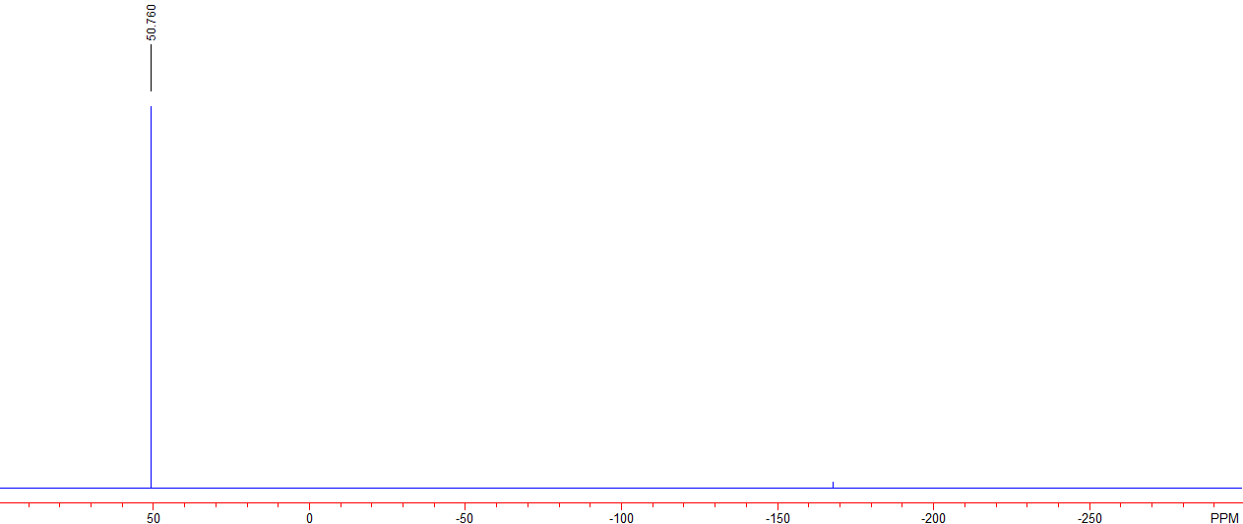

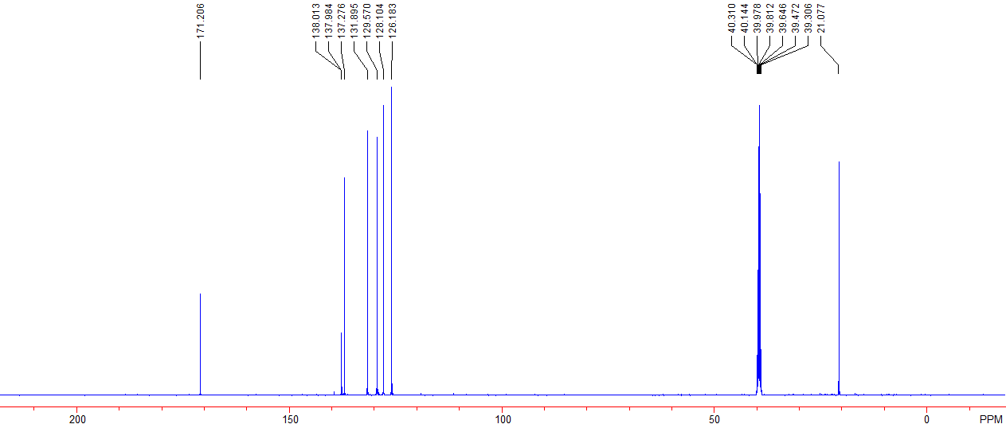

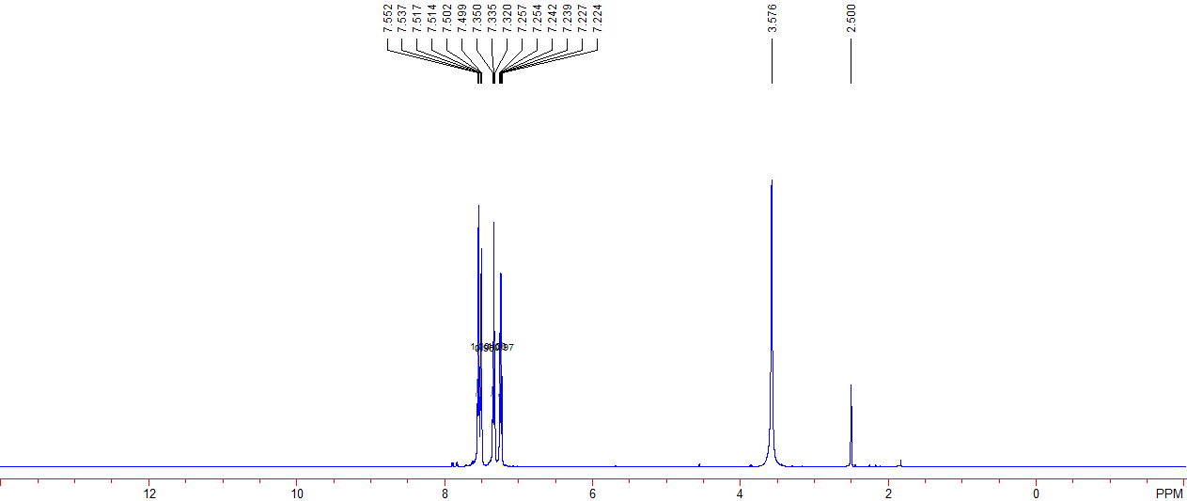

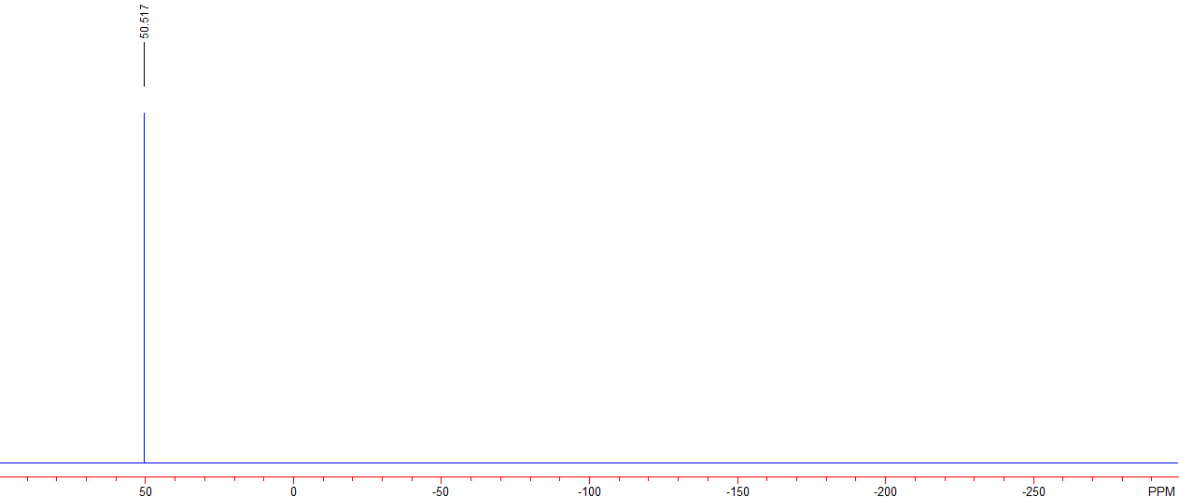

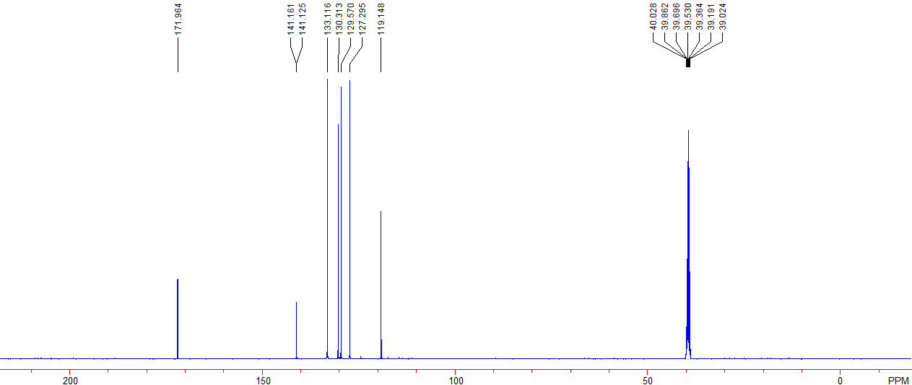

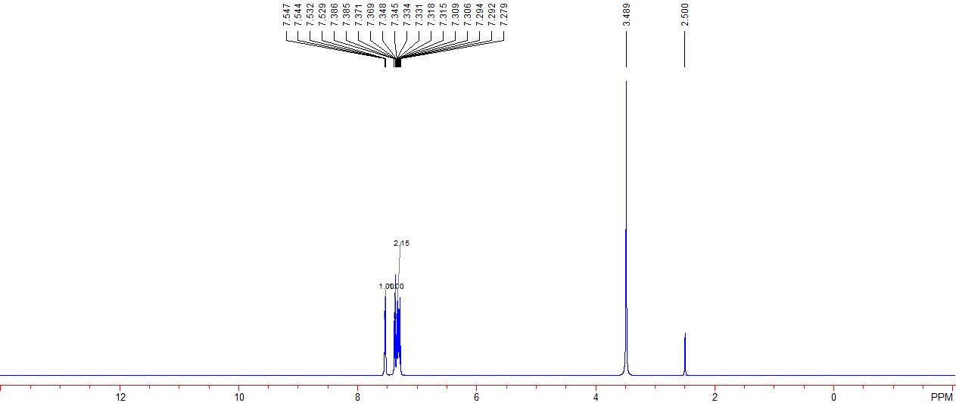

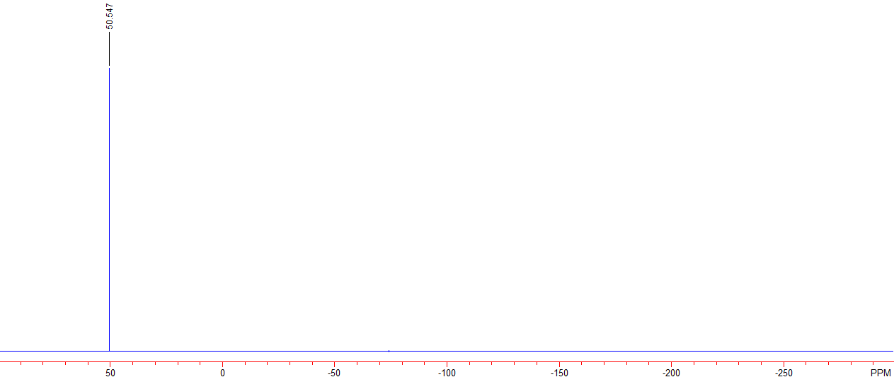

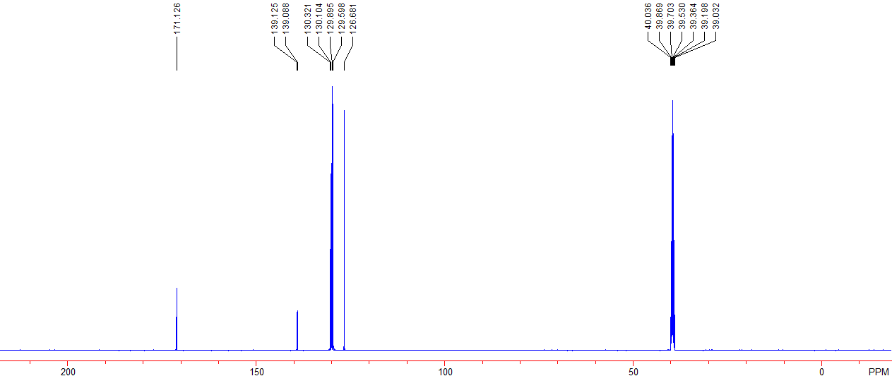

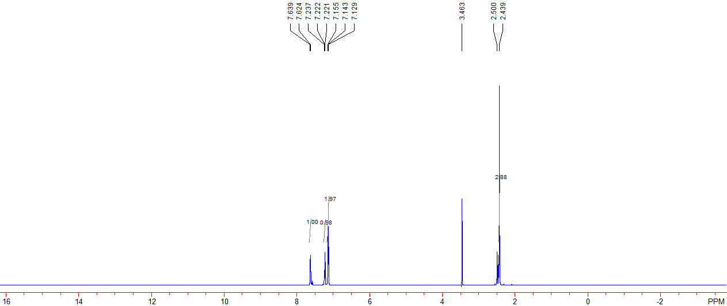

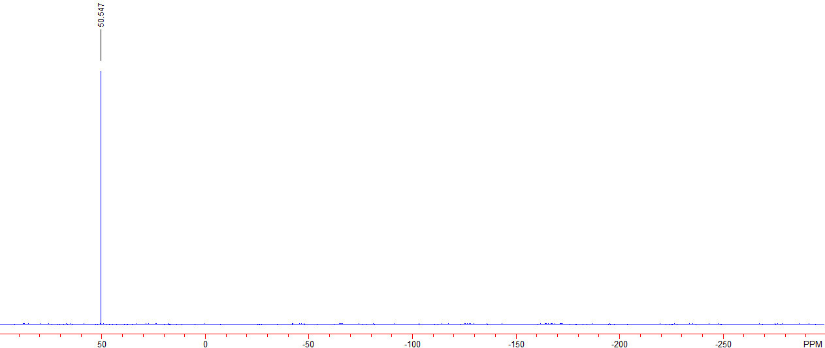

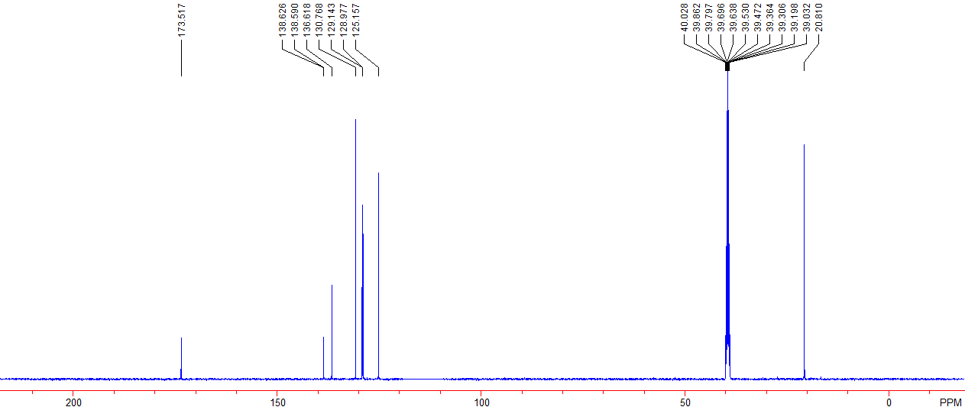

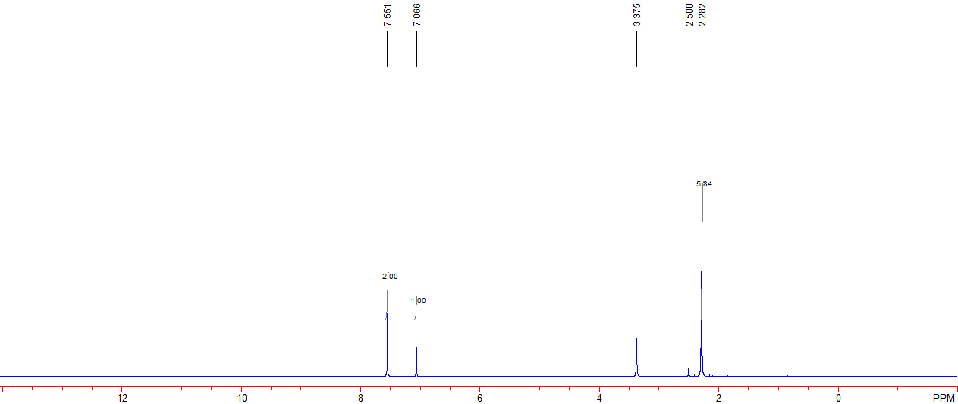

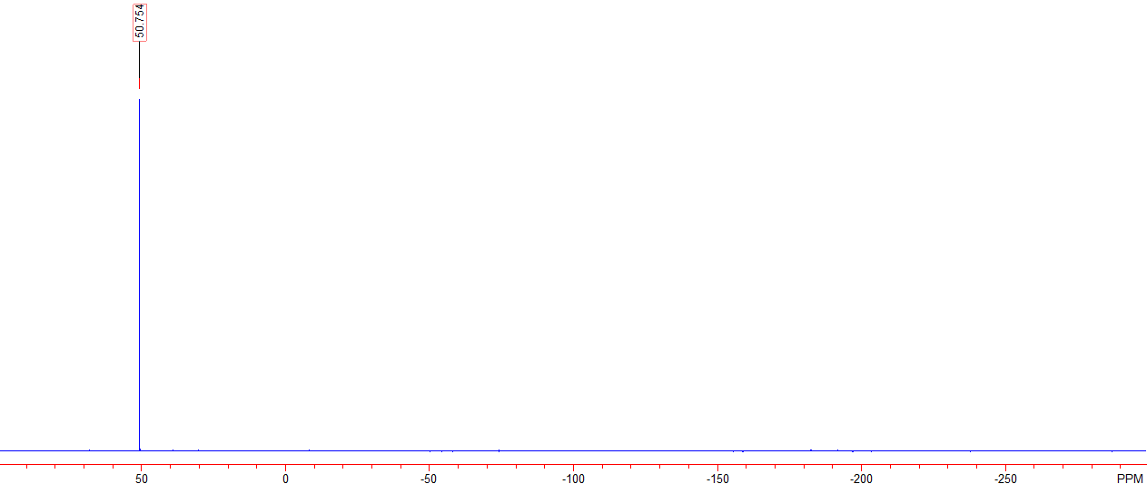

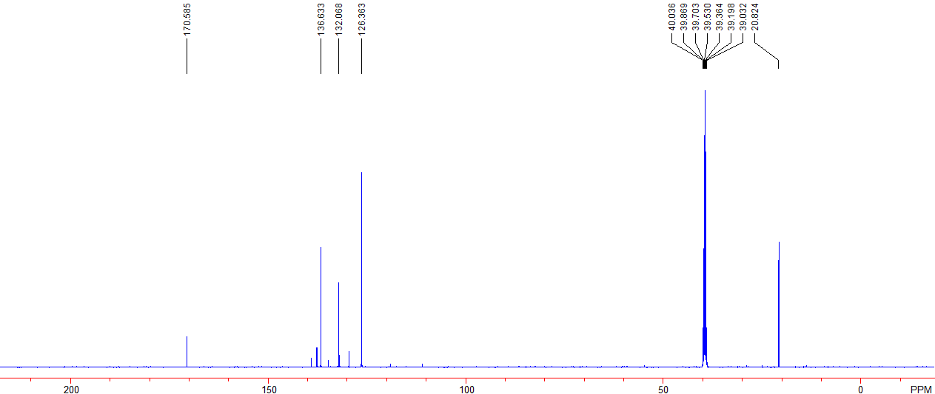

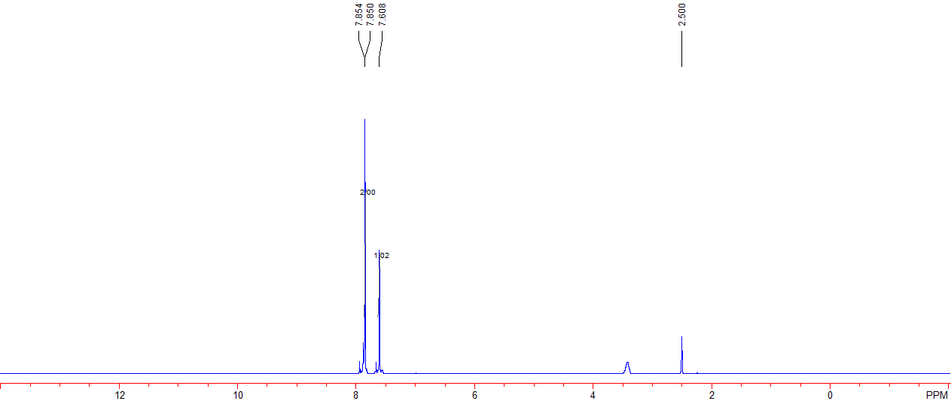

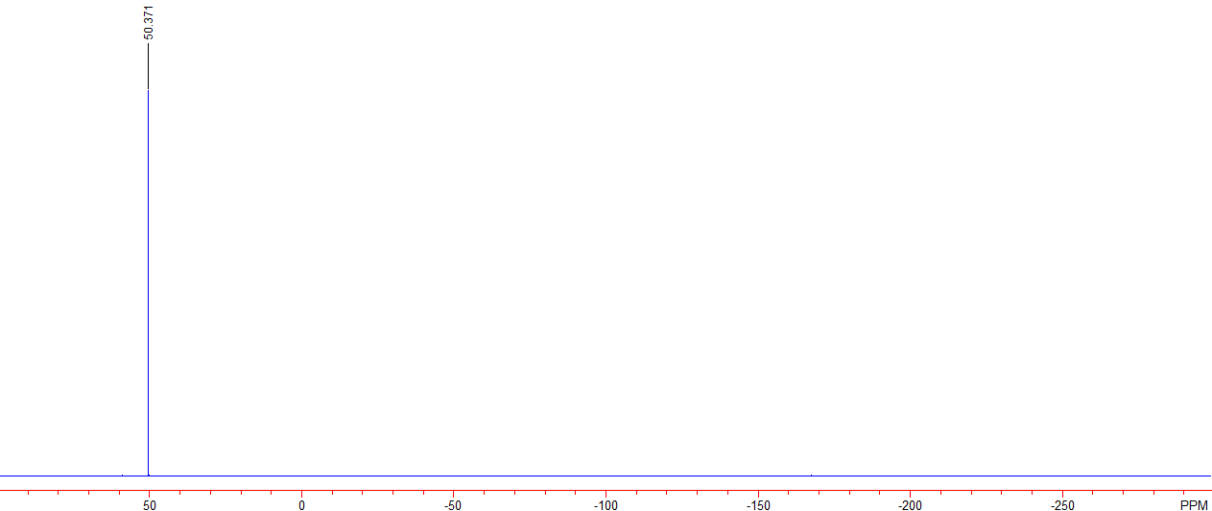

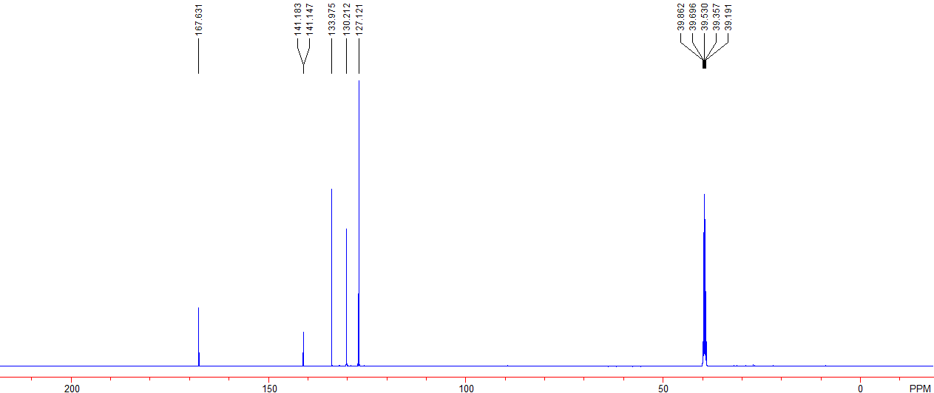

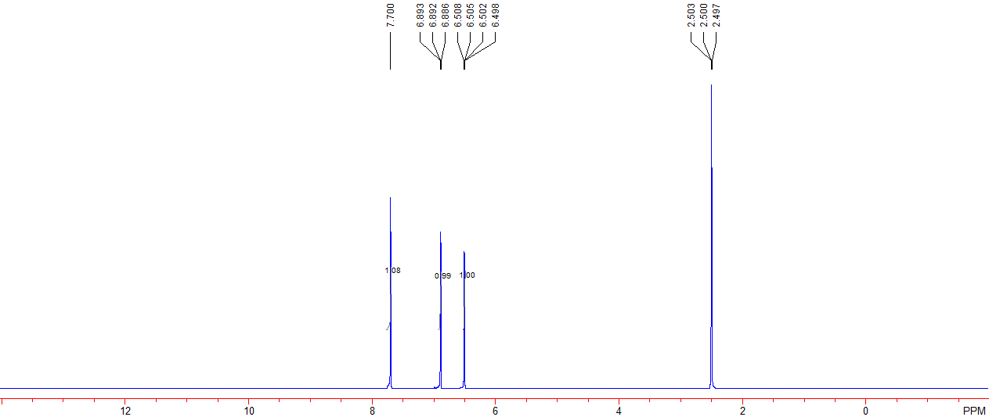

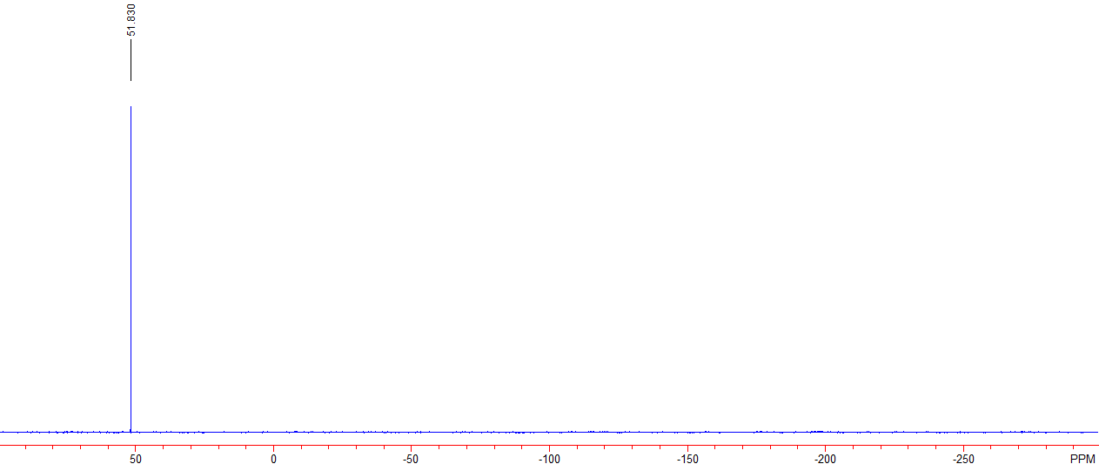

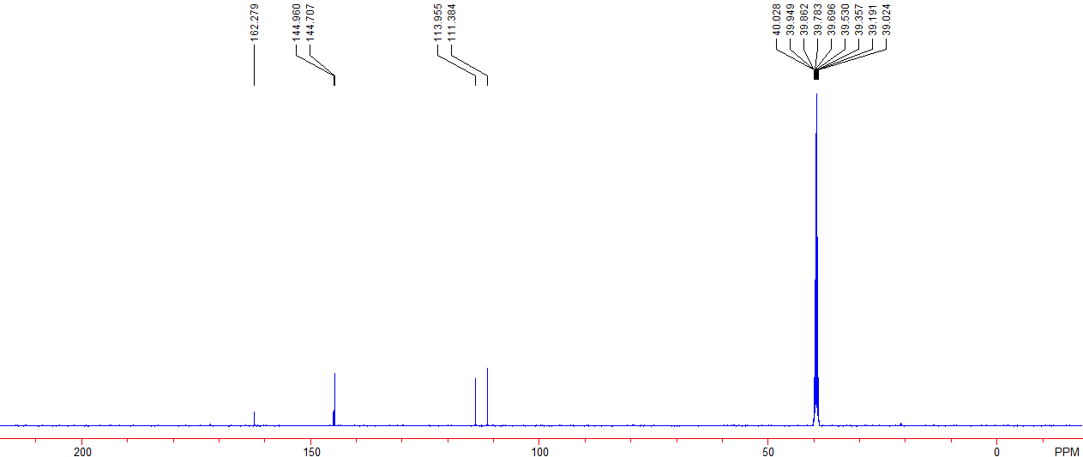

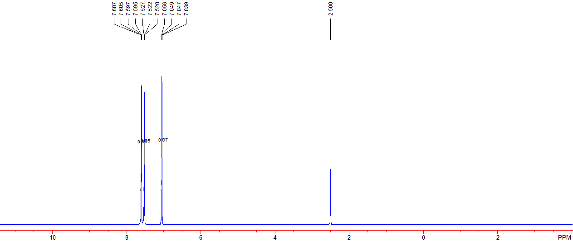

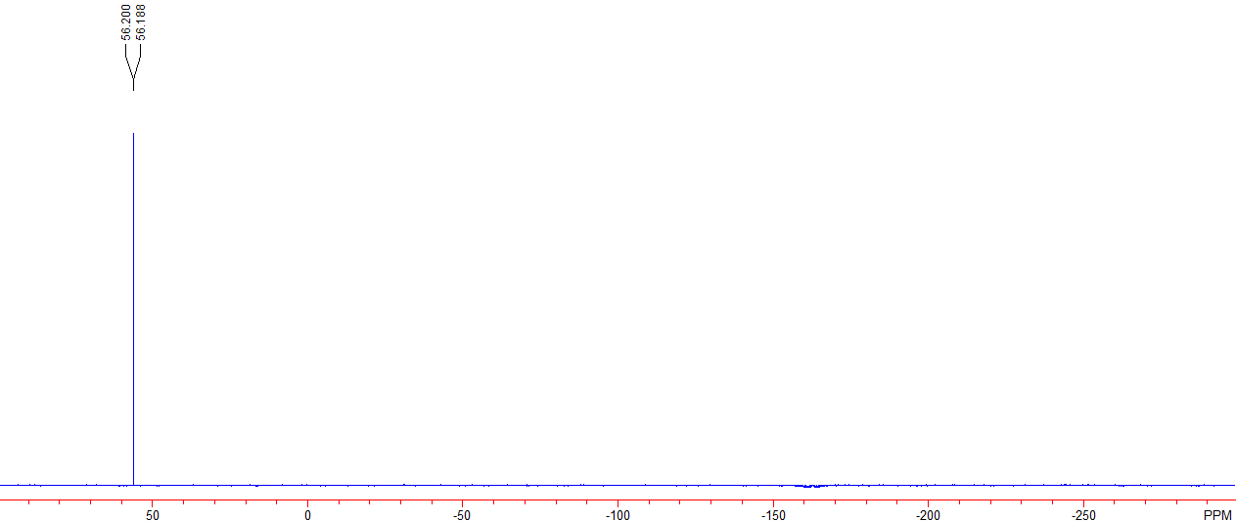

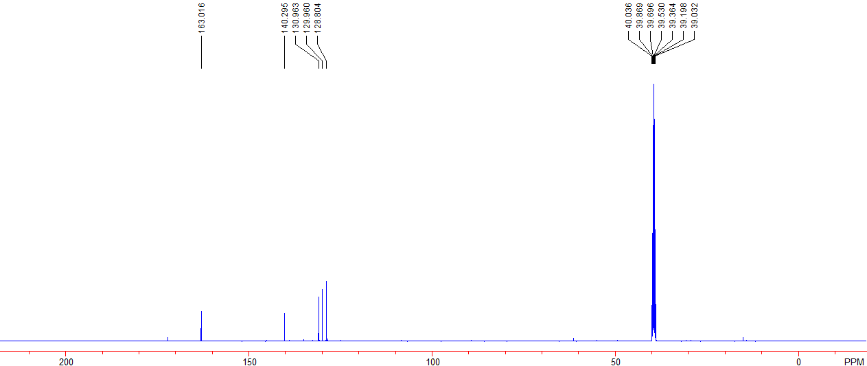

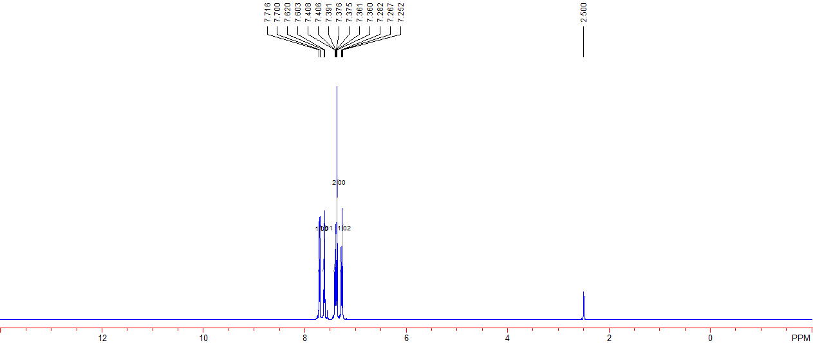

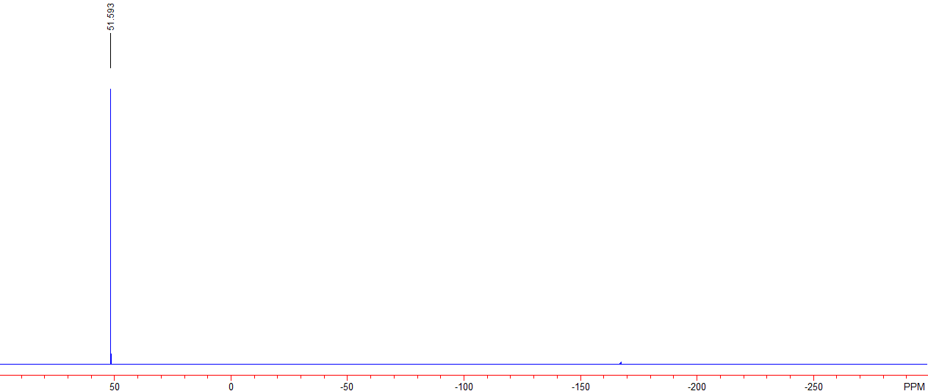

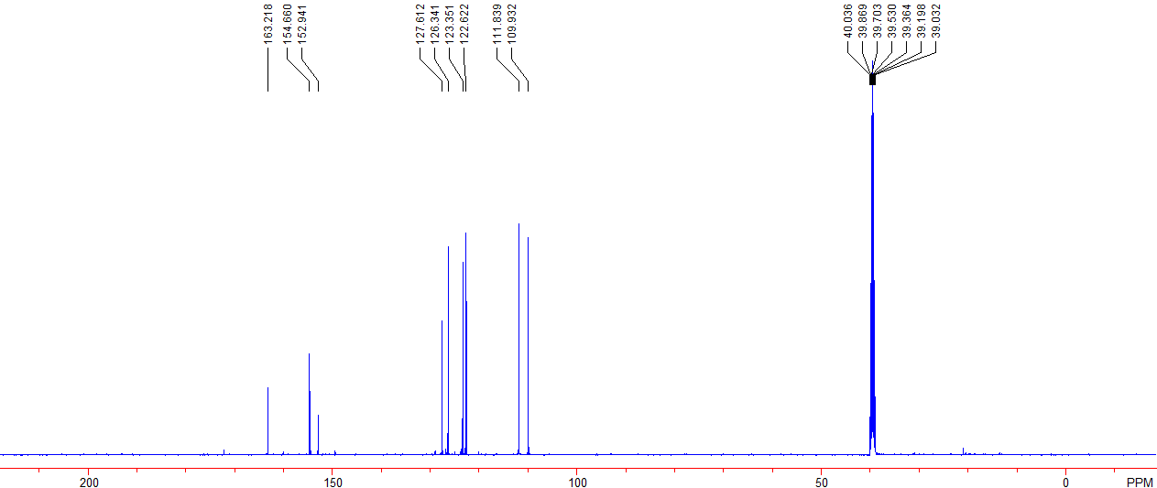

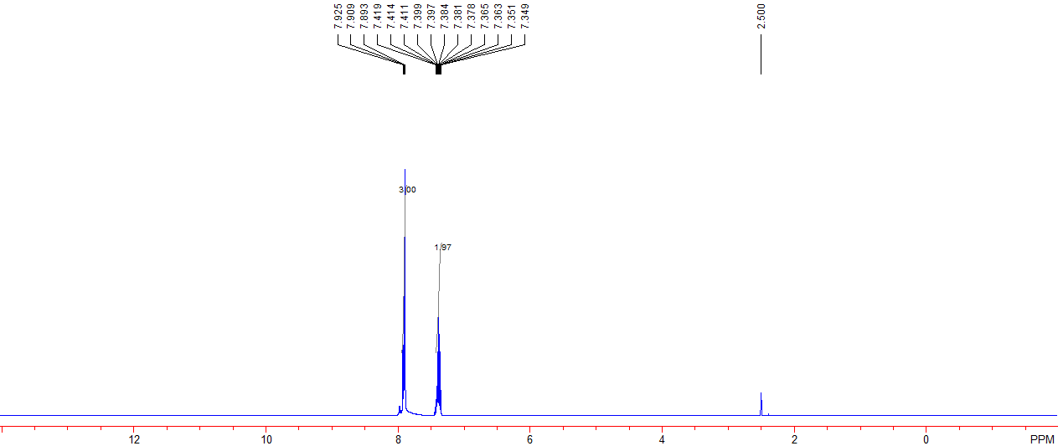

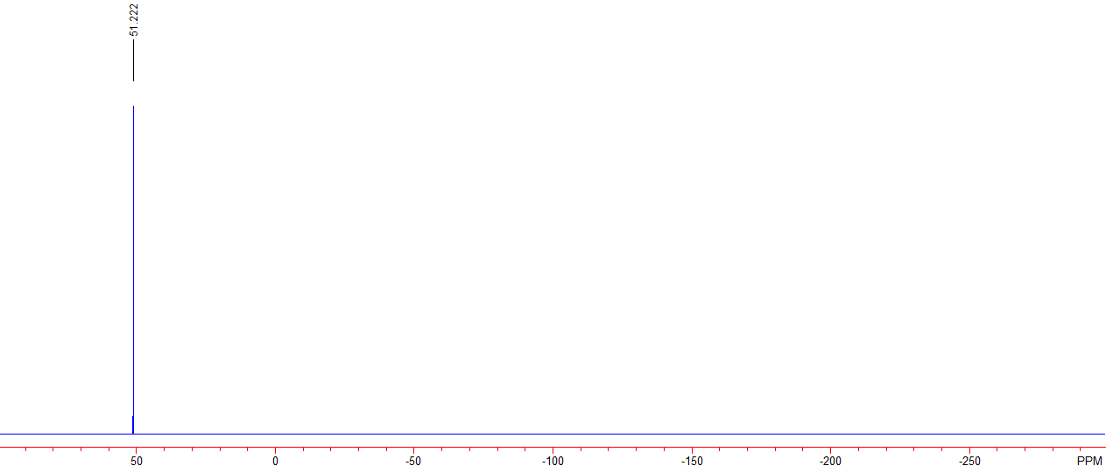

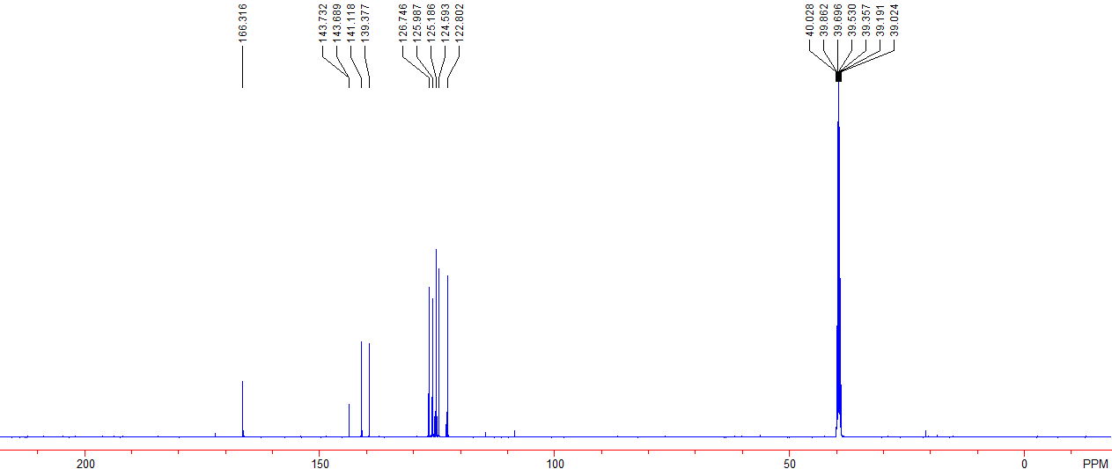

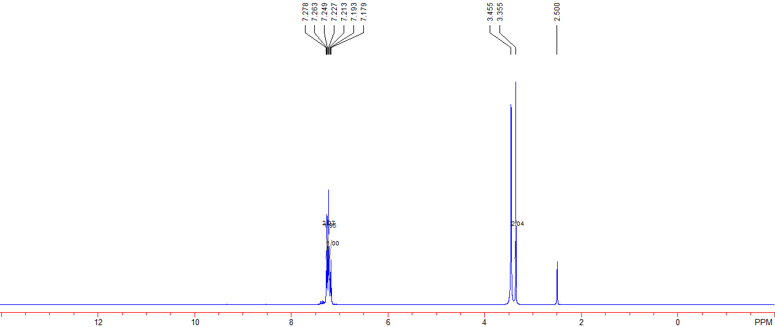

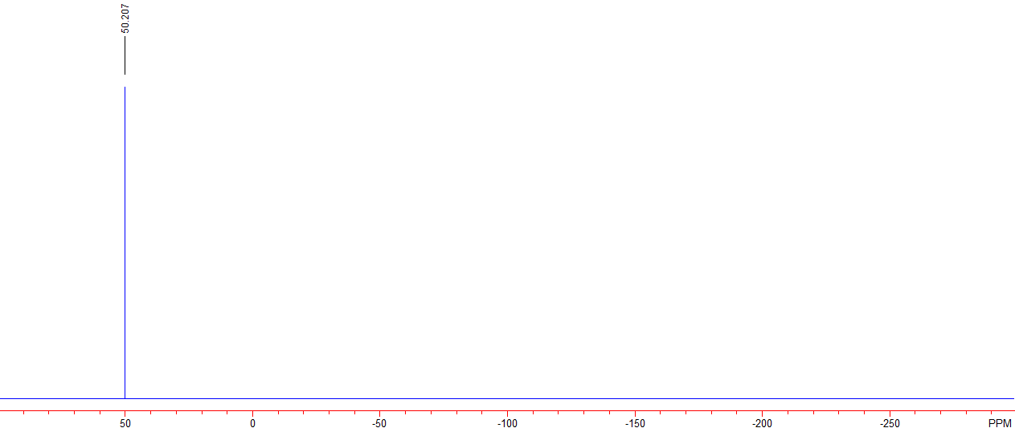

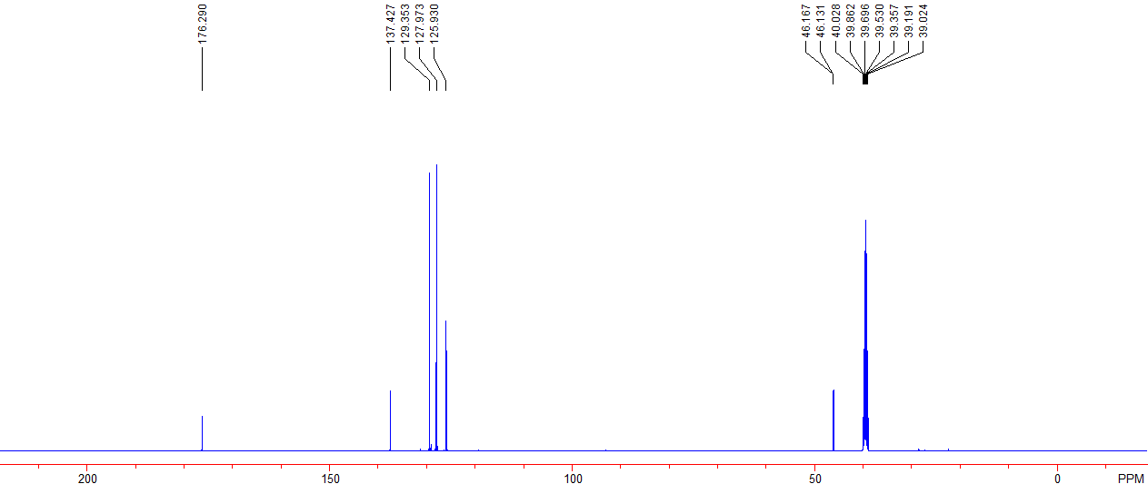

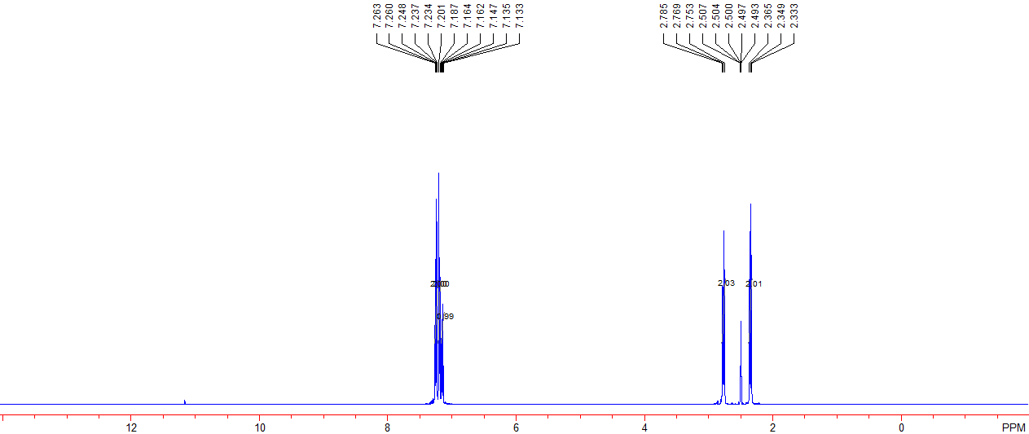

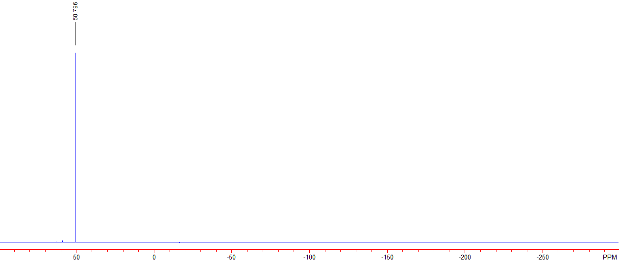

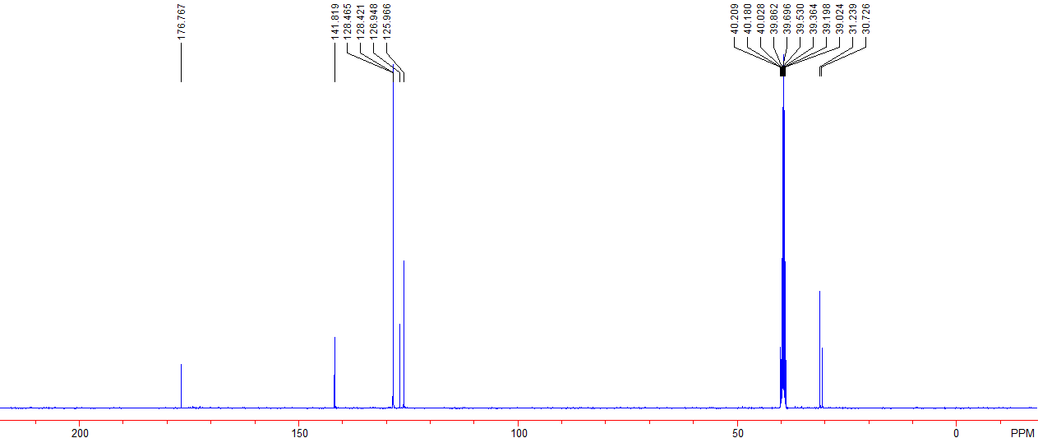

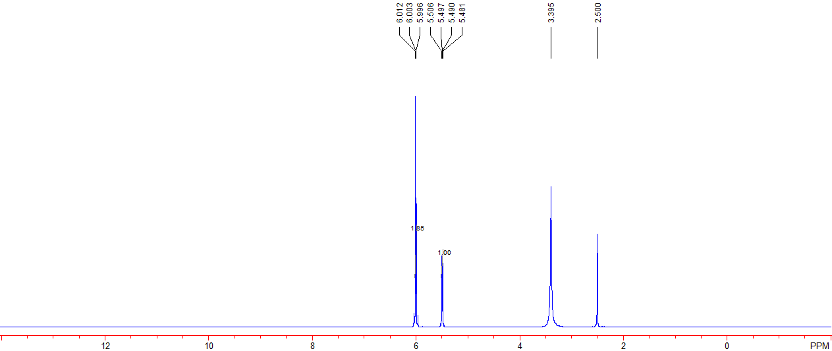

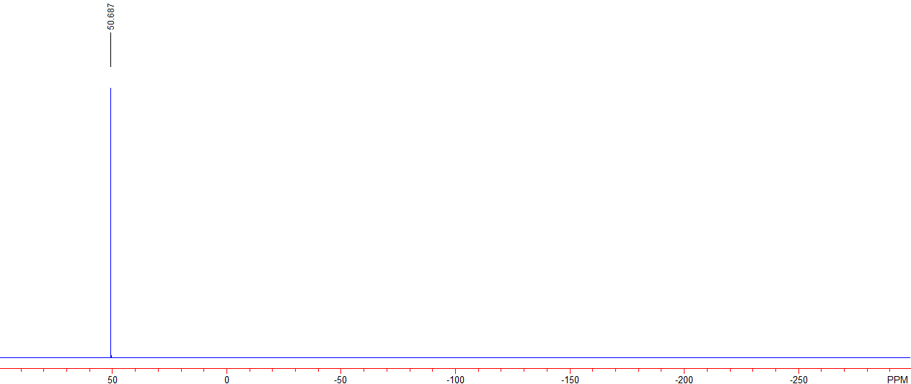

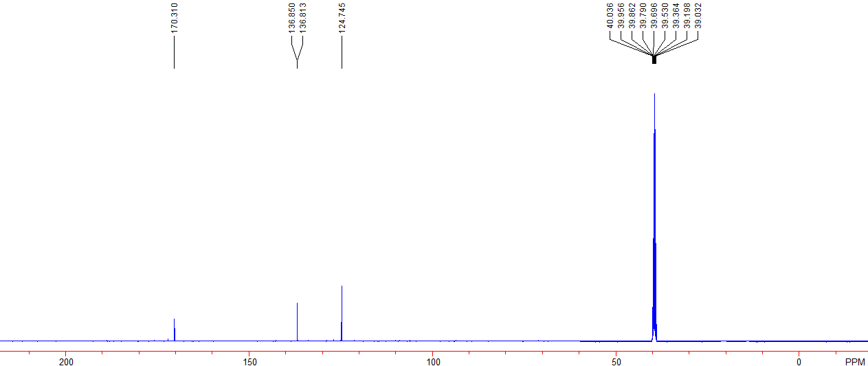

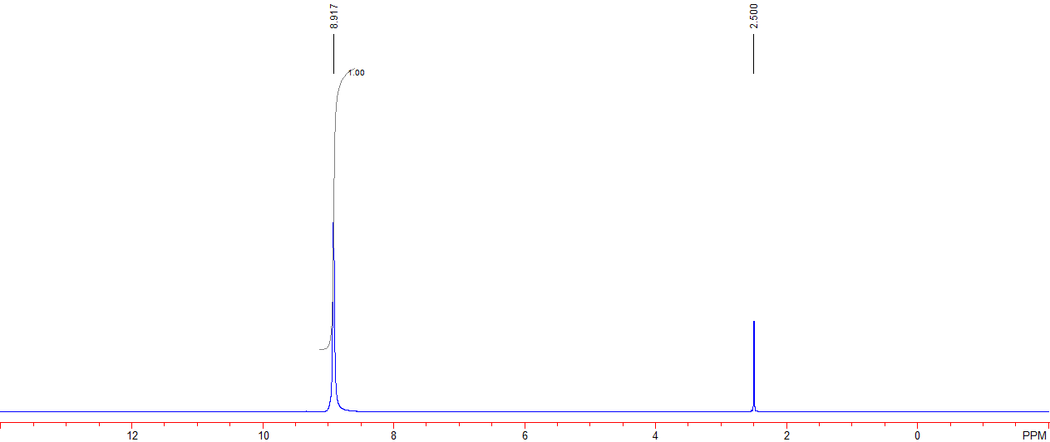

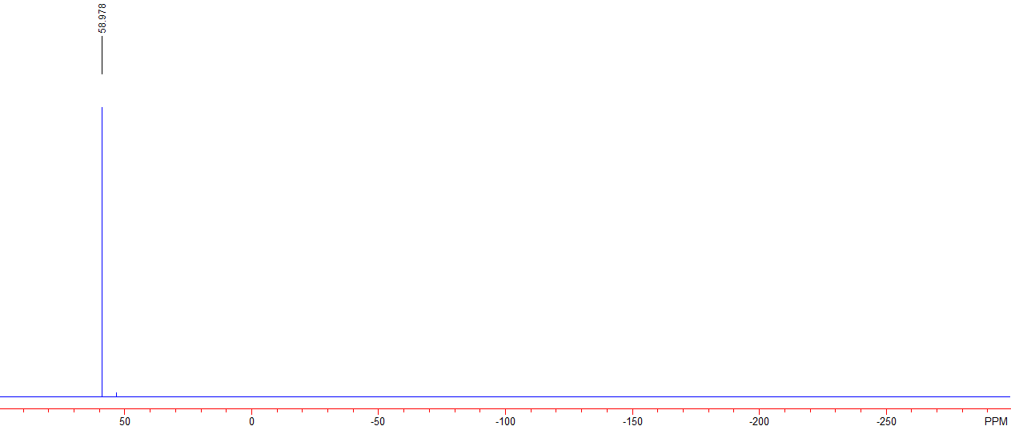

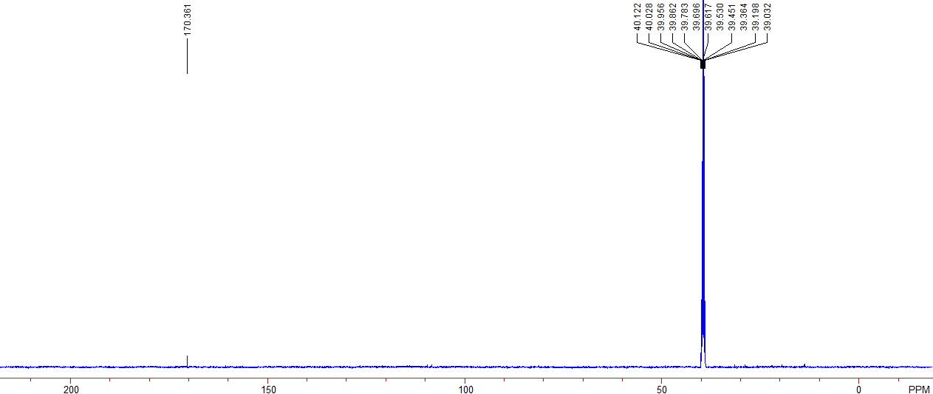

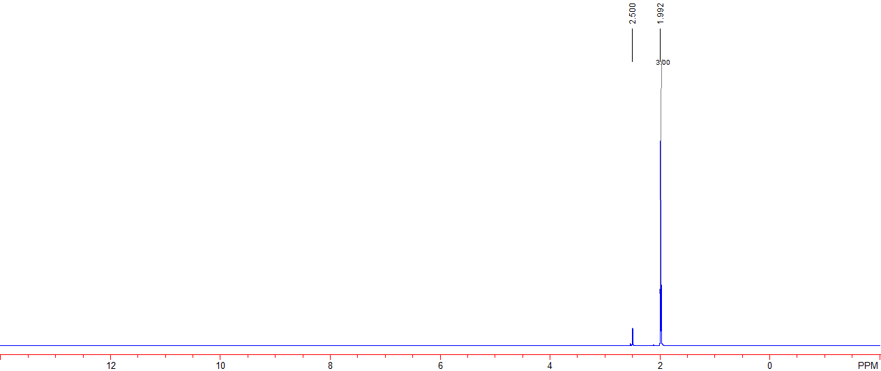

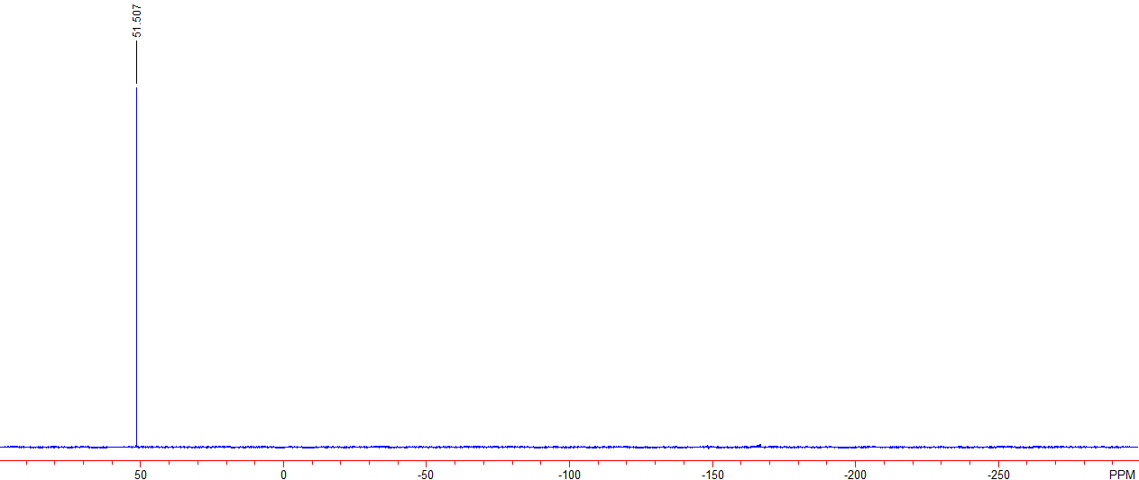

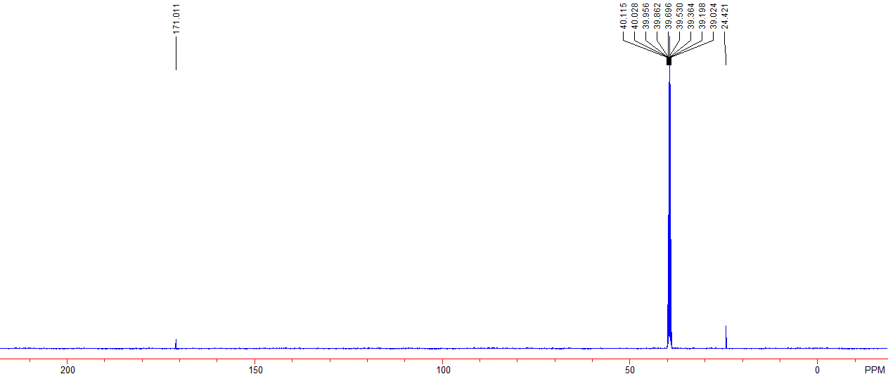

8. Single crystal data of 4e.
Table 1. Crystal data and structure refinement for 181108c.
Identification code 181108c
Empirical formula C7 H8 F N2 Na O7 S
Formula weight 306.20
Temperature 293(2) K
Wavelength 0.71073 A
Crystal system, space group Triclinic, P-1
Unit cell dimensions a = 5.7233(5) A alpha = 93.5580(10) deg.
b = 7.9155(7) A beta = 96.119(2) deg.
c = 12.9158(11) A gamma = 91.6400(10) deg.
Volume 580.30(9) A^3
Z, Calculated density 2, 1.752 Mg/m^3
Absorption coefficient 0.362 mm^-1
F(000) 312
Crystal size 0.47 x 0.35 x 0.18 mm
Theta range for data collection 2.58 to 25.00 deg.
Limiting indices -6<=h<=6, -9<=k<=9, -15<=l<=12
Reflections collected / unique 2959 / 2018 [R(int) = 0.0477]
Completeness to theta = 25.00 98.4 %
Absorption correction Semi-empirical from equivalents
Max. and min. transmission 0.9376 and 0.8481
Refinement method Full-matrix least-squares on F^2
Data / restraints / parameters 2018 / 0 / 172
Goodness-of-fit on F^2 1.106
Final R indices [I>2sigma(I)] R1 = 0.0782, wR2 = 0.1947
R indices (all data) R1 = 0.0929, wR2 = 0.2058
Largest diff. peak and hole 0.595 and -0.616 e.A^-3

Table 2. Atomic coordinates ( x 10^4) and equivalent isotropic
displacement parameters (A^2 x 10^3) for 181108c.
U(eq) is defined as one third of the trace of the orthogonalized
Uij tensor.

________________________________________________________________

x y z U(eq)
________________________________________________________________

Na(1) 7313(3) 8827(2) 4447(1) 45(1)
F(1) 2803(5) 4668(4) 4095(2) 66(1)
N(1) 1721(6) 5657(5) 2329(3) 44(1)
N(2) 6653(7) 8298(5) -1527(3) 51(1)
O(1) -96(6) 6673(4) 3955(3) 58(1)
O(2) -859(7) 3811(5) 3164(3) 67(1)
O(3) 4261(5) 7789(4) 3147(2) 52(1)
O(4) 5341(7) 7984(6) -2323(3) 80(1)
O(5) 8572(7) 8957(5) -1527(3) 73(1)
O(6) 10555(5) 10375(4) 3820(2) 50(1)
O(7) 4097(5) 8327(4) 5452(2) 46(1)
S(1) 674(2) 5267(1) 3358(1) 42(1)
C(1) 3437(7) 6902(5) 2374(3) 40(1)
C(2) 4266(7) 7195(5) 1327(3) 38(1)
C(3) 2945(7) 6645(5) 395(3) 44(1)
C(4) 3687(8) 7005(6) -552(3) 45(1)
C(5) 5820(7) 7859(5) -534(3) 40(1)
C(6) 7204(8) 8378(6) 376(3) 45(1)
C(7) 6396(7) 8030(6) 1311(3) 45(1)
________________________________________________________________

Table 3. Bond lengths [A] and angles [deg] for 181108c.
_____________________________________________________________

Na(1)-O(3) 2.380(3)
Na(1)-O(1)#1 2.392(3)
Na(1)-O(7) 2.400(3)
Na(1)-O(7)#2 2.415(3)
Na(1)-O(6) 2.432(3)
Na(1)-O(6)#3 2.470(3)
Na(1)-Na(1)#2 3.641(3)
Na(1)-Na(1)#3 3.655(3)
F(1)-S(1) 1.567(3)
N(1)-C(1) 1.365(5)
N(1)-S(1) 1.560(4)
N(2)-O(5) 1.203(5)
N(2)-O(4) 1.215(5)
N(2)-C(5) 1.472(5)
O(1)-S(1) 1.422(3)
O(1)-Na(1)#4 2.392(3)
O(2)-S(1) 1.421(3)
O(3)-C(1) 1.228(5)
O(6)-Na(1)#3 2.470(3)
O(6)-H(6A) 0.8500
O(6)-H(6B) 0.8499
O(7)-Na(1)#2 2.415(3)
O(7)-H(7A) 0.8500
O(7)-H(7B) 0.8500
C(1)-C(2) 1.508(6)
C(2)-C(7) 1.373(6)
C(2)-C(3) 1.391(5)
C(3)-C(4) 1.380(6)
C(3)-H(3) 0.9300
C(4)-C(5) 1.376(6)
C(4)-H(4) 0.9300
C(5)-C(6) 1.379(6)
C(6)-C(7) 1.379(6)
C(6)-H(6) 0.9300
C(7)-H(7) 0.9300

O(3)-Na(1)-O(1)#1 92.37(13)
O(3)-Na(1)-O(7) 77.52(11)
O(1)#1-Na(1)-O(7) 123.41(13)
O(3)-Na(1)-O(7)#2 94.46(12)
O(1)#1-Na(1)-O(7)#2 154.82(13)
O(7)-Na(1)-O(7)#2 81.75(12)
O(3)-Na(1)-O(6) 115.75(12)
O(1)#1-Na(1)-O(6) 75.73(11)
O(7)-Na(1)-O(6) 157.70(12)
O(7)#2-Na(1)-O(6) 79.47(11)
O(3)-Na(1)-O(6)#3 160.29(13)
O(1)#1-Na(1)-O(6)#3 96.48(12)
O(7)-Na(1)-O(6)#3 82.90(11)
O(7)#2-Na(1)-O(6)#3 84.95(11)
O(6)-Na(1)-O(6)#3 83.57(11)
O(3)-Na(1)-Na(1)#2 84.79(10)
O(1)#1-Na(1)-Na(1)#2 164.42(12)
O(7)-Na(1)-Na(1)#2 41.02(8)
O(7)#2-Na(1)-Na(1)#2 40.72(7)
O(6)-Na(1)-Na(1)#2 119.26(11)
O(6)#3-Na(1)-Na(1)#2 81.96(9)
O(3)-Na(1)-Na(1)#3 157.71(11)
O(1)#1-Na(1)-Na(1)#3 84.97(10)
O(7)-Na(1)-Na(1)#3 122.15(10)
O(7)#2-Na(1)-Na(1)#3 79.57(9)
O(6)-Na(1)-Na(1)#3 42.18(8)
O(6)#3-Na(1)-Na(1)#3 41.39(7)
Na(1)#2-Na(1)-Na(1)#3 103.34(8)
C(1)-N(1)-S(1) 118.2(3)
O(5)-N(2)-O(4) 122.3(4)
O(5)-N(2)-C(5) 119.7(4)
O(4)-N(2)-C(5) 117.9(4)
S(1)-O(1)-Na(1)#4 157.2(2)
C(1)-O(3)-Na(1) 154.5(3)
Na(1)-O(6)-Na(1)#3 96.43(11)
Na(1)-O(6)-H(6A) 112.4
Na(1)#3-O(6)-H(6A) 112.6
Na(1)-O(6)-H(6B) 112.4
Na(1)#3-O(6)-H(6B) 112.4
H(6A)-O(6)-H(6B) 110.1
Na(1)-O(7)-Na(1)#2 98.25(11)
Na(1)-O(7)-H(7A) 112.2
Na(1)#2-O(7)-H(7A) 112.1
Na(1)-O(7)-H(7B) 112.1
Na(1)#2-O(7)-H(7B) 112.1
H(7A)-O(7)-H(7B) 109.8
O(2)-S(1)-O(1) 117.8(2)
O(2)-S(1)-N(1) 109.0(2)
O(1)-S(1)-N(1) 116.6(2)
O(2)-S(1)-F(1) 104.3(2)
O(1)-S(1)-F(1) 102.28(18)
N(1)-S(1)-F(1) 104.93(18)
O(3)-C(1)-N(1) 127.0(4)
O(3)-C(1)-C(2) 119.6(4)
N(1)-C(1)-C(2) 113.4(3)
C(7)-C(2)-C(3) 119.9(4)
C(7)-C(2)-C(1) 118.1(3)
C(3)-C(2)-C(1) 122.0(4)
C(4)-C(3)-C(2) 120.8(4)
C(4)-C(3)-H(3) 119.6
C(2)-C(3)-H(3) 119.6
C(5)-C(4)-C(3) 117.4(4)
C(5)-C(4)-H(4) 121.3
C(3)-C(4)-H(4) 121.3
C(4)-C(5)-C(6) 123.2(4)
C(4)-C(5)-N(2) 119.1(4)
C(6)-C(5)-N(2) 117.7(4)
C(7)-C(6)-C(5) 118.1(4)
C(7)-C(6)-H(6) 120.9
C(5)-C(6)-H(6) 120.9
C(2)-C(7)-C(6) 120.5(4)
C(2)-C(7)-H(7) 119.7
C(6)-C(7)-H(7) 119.7
_____________________________________________________________

Symmetry transformations used to generate equivalent atoms:
#1 x+1,y,z #2 -x+1,-y+2,-z+1 #3 -x+2,-y+2,-z+1
#4 x-1,y,z

Table 4. Anisotropic displacement parameters (A^2 x 10^3) for 181108c.
The anisotropic displacement factor exponent takes the form:
-2 pi^2 [ h^2 a*^2 U11 + ... + 2 h k a* b* U12 ]

_______________________________________________________________________

U11 U22 U33 U23 U13 U12
_______________________________________________________________________

Na(1) 40(1) 46(1) 48(1) 2(1) 5(1) 2(1)
F(1) 70(2) 73(2) 58(2) 27(1) -4(1) 20(2)
N(1) 47(2) 45(2) 40(2) 6(2) 2(2) -10(2)
N(2) 60(2) 51(2) 44(2) 9(2) 6(2) 7(2)
O(1) 61(2) 47(2) 70(2) 8(2) 24(2) 9(2)
O(2) 77(2) 59(2) 65(2) 5(2) 12(2) -27(2)
O(3) 54(2) 63(2) 37(2) 0(1) 1(1) -17(2)
O(4) 89(3) 114(3) 37(2) 17(2) 1(2) -6(2)
O(5) 63(2) 95(3) 61(2) 12(2) 17(2) -19(2)
O(6) 49(2) 46(2) 58(2) 16(1) 11(1) 1(1)
O(7) 49(2) 46(2) 45(2) 11(1) 2(1) 1(1)
S(1) 46(1) 36(1) 46(1) 9(1) 5(1) 0(1)
C(1) 36(2) 41(2) 42(2) 5(2) 1(2) 4(2)
C(2) 39(2) 33(2) 41(2) 5(2) -1(2) 3(2)
C(3) 39(2) 45(3) 48(2) 9(2) 3(2) -2(2)
C(4) 49(2) 48(3) 37(2) 1(2) -4(2) 1(2)
C(5) 44(2) 40(2) 37(2) 10(2) 6(2) 6(2)
C(6) 42(2) 47(3) 48(2) 11(2) 4(2) -5(2)
C(7) 39(2) 55(3) 38(2) 5(2) -3(2) -2(2)
_______________________________________________________________________

Table 5. Hydrogen coordinates ( x 10^4) and isotropic
displacement parameters (A^2 x 10^3) for 181108c.

________________________________________________________________

x y z U(eq)
________________________________________________________________

H(6A) 10103 11230 3496 60
H(6B) 11349 9747 3441 60
H(7A) 4555 7994 6051 56
H(7B) 3072 7625 5135 56
H(3) 1543 6026 409 53
H(4) 2781 6683 -1178 55
H(6) 8643 8947 360 55
H(7) 7300 8364 1936 54
________________________________________________________________

Table 6. Torsion angles [deg] for 181108c.
________________________________________________________________

O(1)#1-Na(1)-O(3)-C(1) -10.7(7)
O(7)-Na(1)-O(3)-C(1) -134.4(7)
O(7)#2-Na(1)-O(3)-C(1) 145.1(7)
O(6)-Na(1)-O(3)-C(1) 64.6(7)
O(6)#3-Na(1)-O(3)-C(1) -127.4(7)
Na(1)#2-Na(1)-O(3)-C(1) -175.3(7)
Na(1)#3-Na(1)-O(3)-C(1) 71.8(8)
O(3)-Na(1)-O(6)-Na(1)#3 175.93(14)
O(1)#1-Na(1)-O(6)-Na(1)#3 -98.39(13)
O(7)-Na(1)-O(6)-Na(1)#3 53.0(3)
O(7)#2-Na(1)-O(6)-Na(1)#3 86.03(12)
O(6)#3-Na(1)-O(6)-Na(1)#3 0.0
Na(1)#2-Na(1)-O(6)-Na(1)#3 77.03(12)
O(3)-Na(1)-O(7)-Na(1)#2 -96.47(13)
O(1)#1-Na(1)-O(7)-Na(1)#2 179.00(14)
O(7)#2-Na(1)-O(7)-Na(1)#2 0.0
O(6)-Na(1)-O(7)-Na(1)#2 32.8(3)
O(6)#3-Na(1)-O(7)-Na(1)#2 85.90(12)
Na(1)#3-Na(1)-O(7)-Na(1)#2 72.11(13)
Na(1)#4-O(1)-S(1)-O(2) -51.3(6)
Na(1)#4-O(1)-S(1)-N(1) 81.2(5)
Na(1)#4-O(1)-S(1)-F(1) -165.0(5)
C(1)-N(1)-S(1)-O(2) -173.1(3)
C(1)-N(1)-S(1)-O(1) 50.5(4)
C(1)-N(1)-S(1)-F(1) -61.8(4)
Na(1)-O(3)-C(1)-N(1) 116.1(6)
Na(1)-O(3)-C(1)-C(2) -66.4(8)
S(1)-N(1)-C(1)-O(3) -0.9(6)
S(1)-N(1)-C(1)-C(2) -178.5(3)
O(3)-C(1)-C(2)-C(7) 20.8(6)
N(1)-C(1)-C(2)-C(7) -161.3(4)
O(3)-C(1)-C(2)-C(3) -159.3(4)
N(1)-C(1)-C(2)-C(3) 18.6(6)
C(7)-C(2)-C(3)-C(4) -3.4(6)
C(1)-C(2)-C(3)-C(4) 176.7(4)
C(2)-C(3)-C(4)-C(5) 2.7(6)
C(3)-C(4)-C(5)-C(6) -0.8(7)
C(3)-C(4)-C(5)-N(2) -178.8(4)
O(5)-N(2)-C(5)-C(4) -175.7(4)
O(4)-N(2)-C(5)-C(4) 4.8(6)
O(5)-N(2)-C(5)-C(6) 6.2(6)
O(4)-N(2)-C(5)-C(6) -173.2(4)
C(4)-C(5)-C(6)-C(7) -0.4(7)
N(2)-C(5)-C(6)-C(7) 177.6(4)
C(3)-C(2)-C(7)-C(6) 2.1(7)
C(1)-C(2)-C(7)-C(6) -178.0(4)
C(5)-C(6)-C(7)-C(2) -0.2(7)
________________________________________________________________

Symmetry transformations used to generate equivalent atoms:
#1 x+1,y,z #2 -x+1,-y+2,-z+1 #3 -x+2,-y+2,-z+1
#4 x-1,y,z

Table 7. Hydrogen bonds for 181108c [A and deg.].
____________________________________________________________________________

D-H d(D-H) d(H..A) <DHA d(D..A) A

O6-H6A 0.850 2.187 161.73 3.006 O2 [ x+1, y+1, z ]

O6-H6B 0.850 2.353 154.45 3.141 O3 [ x+1, y, z ]

O7-H7A 0.850 2.101 160.82 2.917 O4 [ x, y, z+1 ]
O7-H7A 0.850 2.637 111.27 3.050 F1 [ -x+1, -y+1, -z+1 ]

O7-H7B 0.850 2.317 157.46 3.119 O1
O7-H7B 0.850 2.618 139.96 3.314 F1

