Supporting Information
for

Synthesis and Photophysical and Electrochemical Properties of Pyridine-, Pyrazine- and Triazine-based (D-π-)₂A Fluorescent Dyes

Keiichi Imato, Toshiaki Enoki, Koji Uenaka and Yousuke Ooyama*

Address: Department of Applied Chemistry, Graduate School of Engineering, Hiroshima University, 1-4-1 Kagamiyama, Higashi-Hiroshima 739-8527, Japan.

Email: Yousuke Ooyama* - yooyama@hiroshima-u.ac.jp
* Corresponding author

(a)

(b)
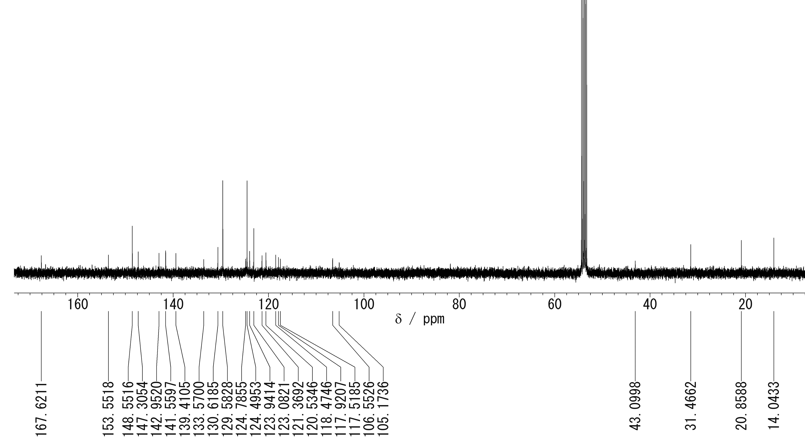

Figure S1: (a) ¹H HMR (400 MHz) and (b) ¹³C HMR (100 MHz) spectra of OUJ-2 in CD₂Cl₂.

