1. The ¹H NMR spectrum of 5-fluoro-1-hydroxy-3-methyl-9H-xanthen-9-one (acetone-D₆, 500 MHz)
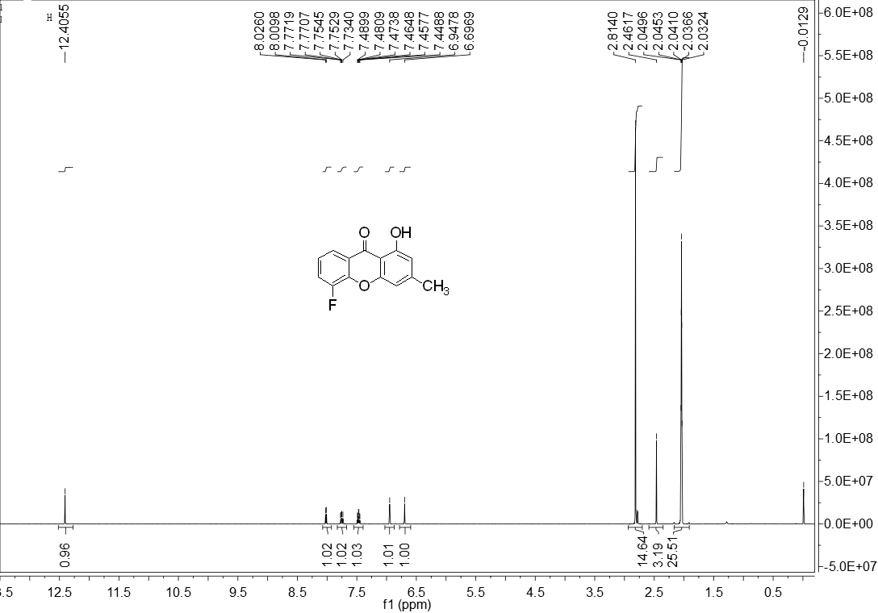
The ¹³C NMR spectrum of 5-fluoro-1-hydroxy-3-methyl-9H-xanthen-9-one (acetone-D₆, 125 MHz)
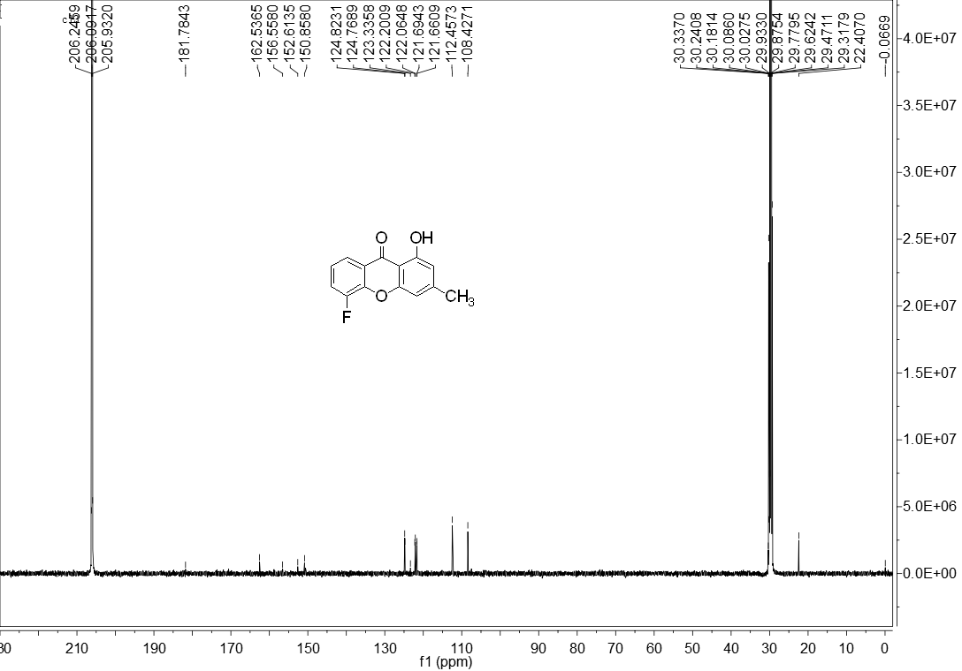

2. The ¹H NMR spectrum of 6-fluoro-1-hydroxy-3-methyl-9H-xanthen-9-one (acetone-D₆, 500 MHz)
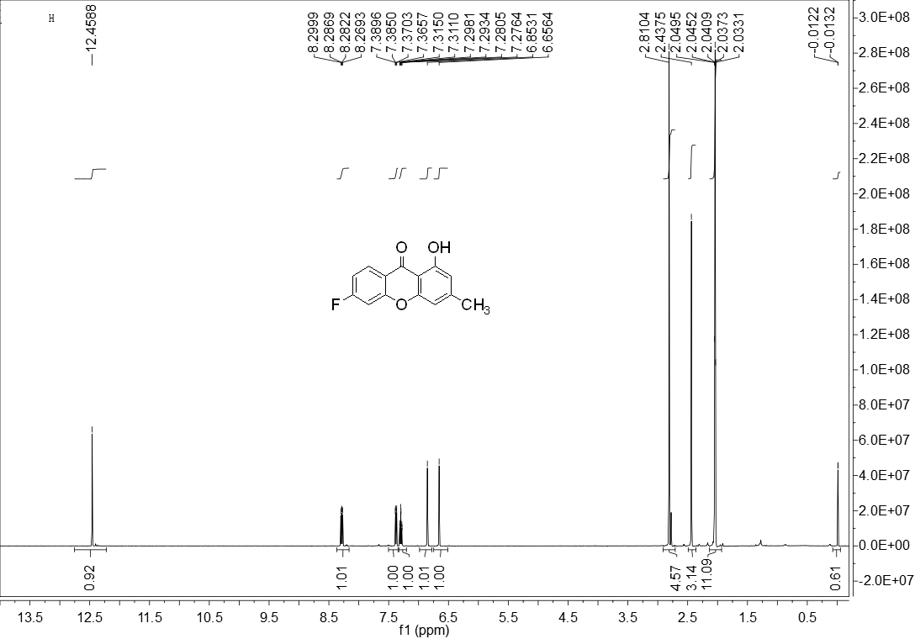
The ¹³C NMR spectrum of 6-fluoro-1-hydroxy-3-methyl-9H-xanthen-9-one (acetone-D₆, 125 MHz)
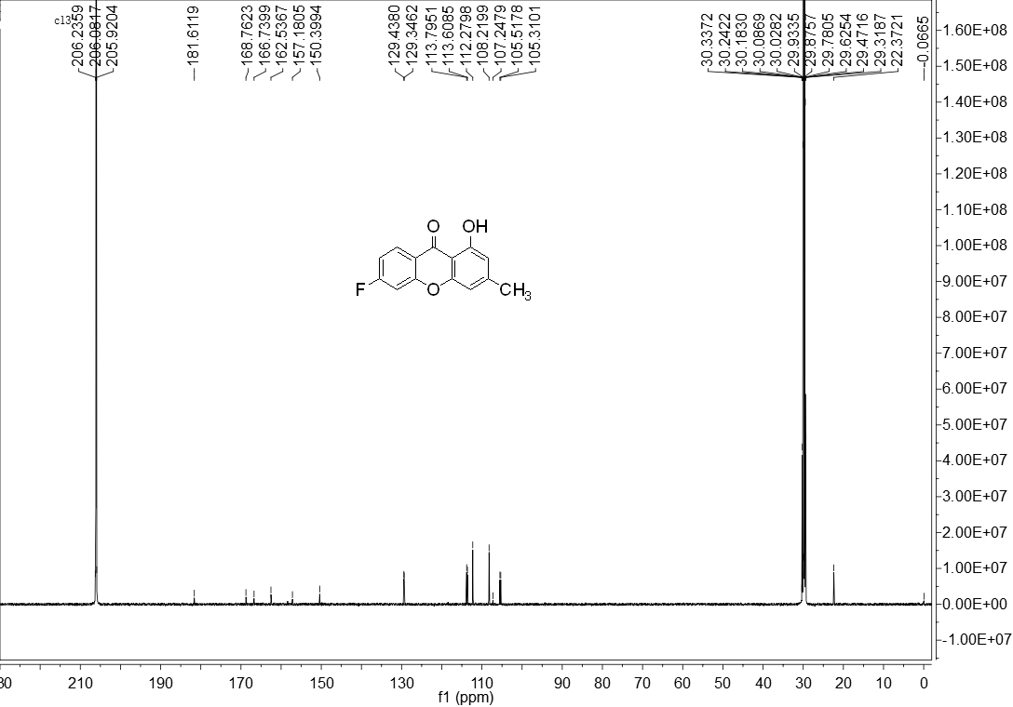

3. The ¹H NMR spectrum of 7-fluoro-1-hydroxy-3-methyl-9H-xanthen-9-one (acetone-D₆, 500 MHz)
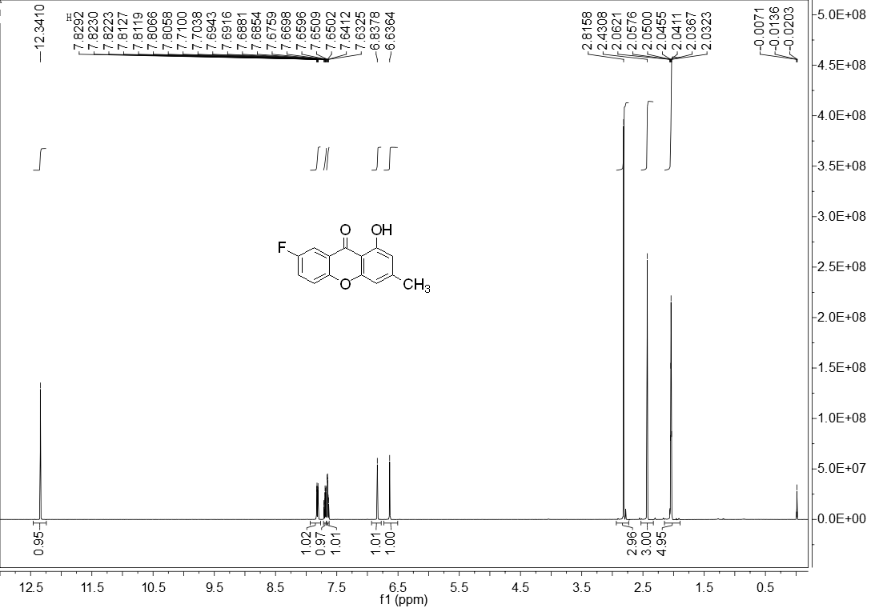
The ¹³C NMR spectrum of 7-fluoro-1-hydroxy-3-methyl-9H-xanthen-9-one (acetone-D₆, 125 MHz)
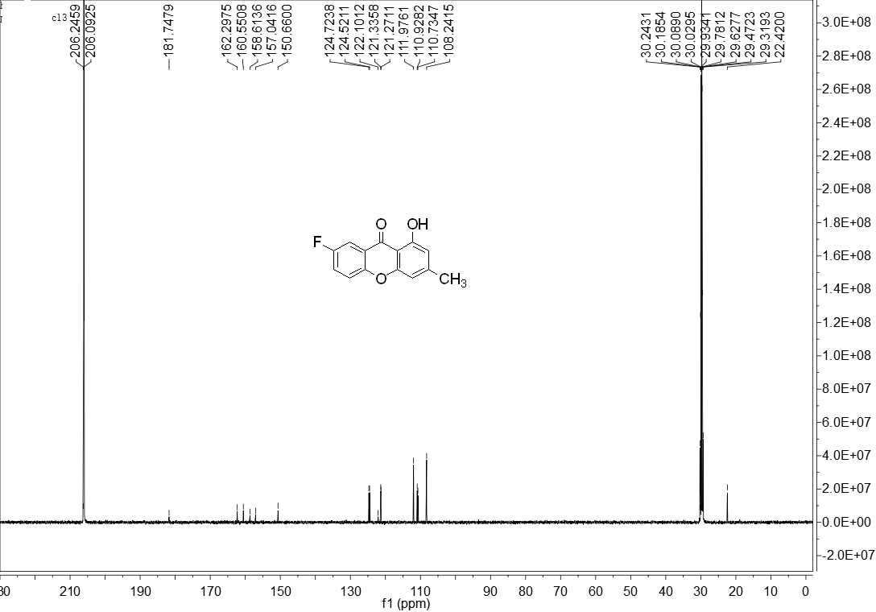

4. The ¹H NMR spectrum of 1,2-difluoro-8-hydroxy-6-methyl-9H-xanthen-9-one (acetone-D₆, 500 MHz)
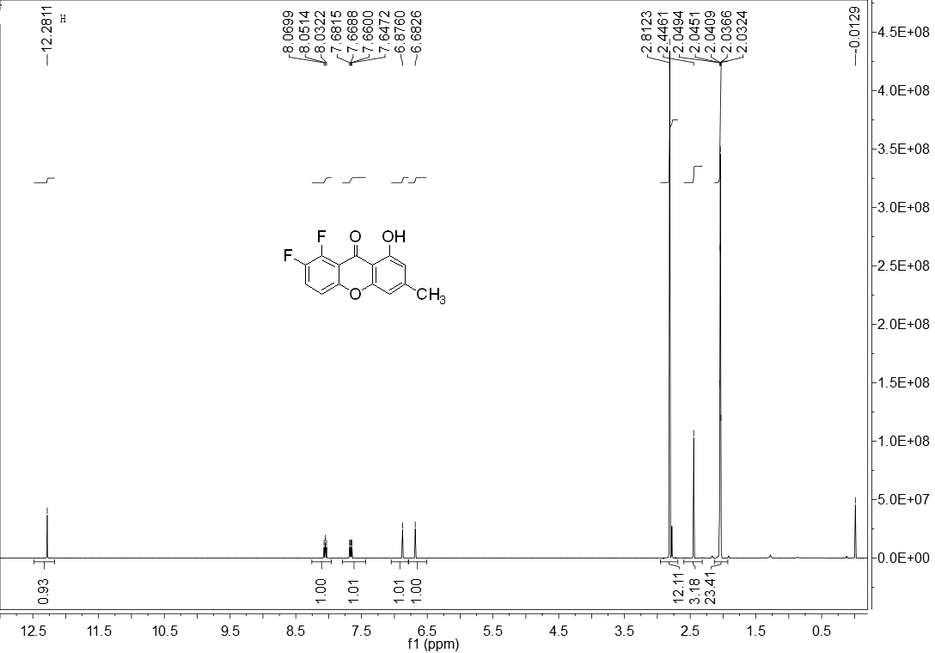
The ¹³C NMR spectrum of 1,2-difluoro-8-hydroxy-6-methyl-9H-xanthen-9-one (acetone-D₆, 125 MHz)
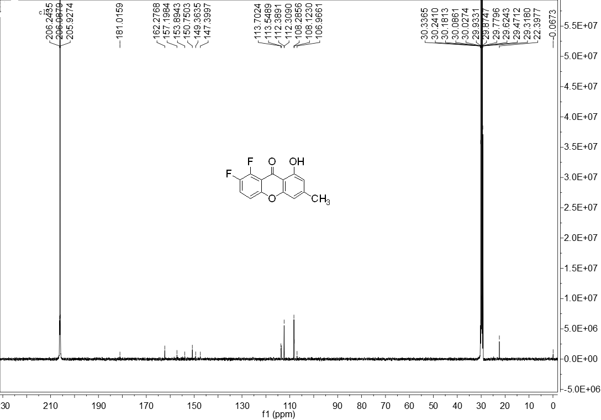

5. The ¹H NMR spectrum of 7-(2,4-difluorophenyl)-1-hydroxy-3-methyl-9H-xanthen-9-one (acetone-D₆, 500 MHz)
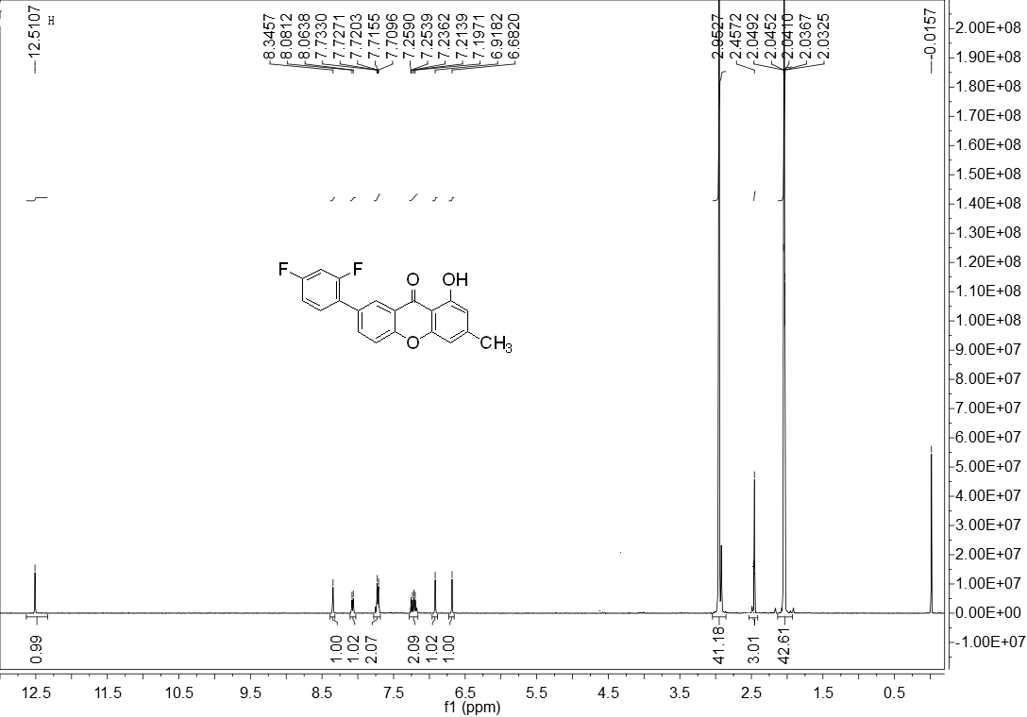
The ¹³C NMR spectrum of 7-(2,4-difluorophenyl)-1-hydroxy-3-methyl-9H-xanthen-9-one (acetone-D₆, 125 MHz)
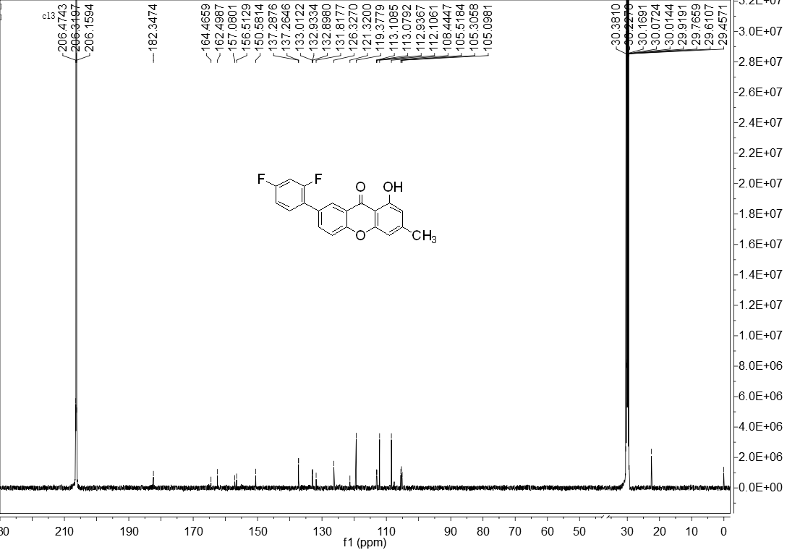

6. The ¹H NMR spectrum of 1-hydroxy-3-methyl-6-(trifluoromethyl)-9H-xanthen-9-one (acetone-D₆, 500 MHz)
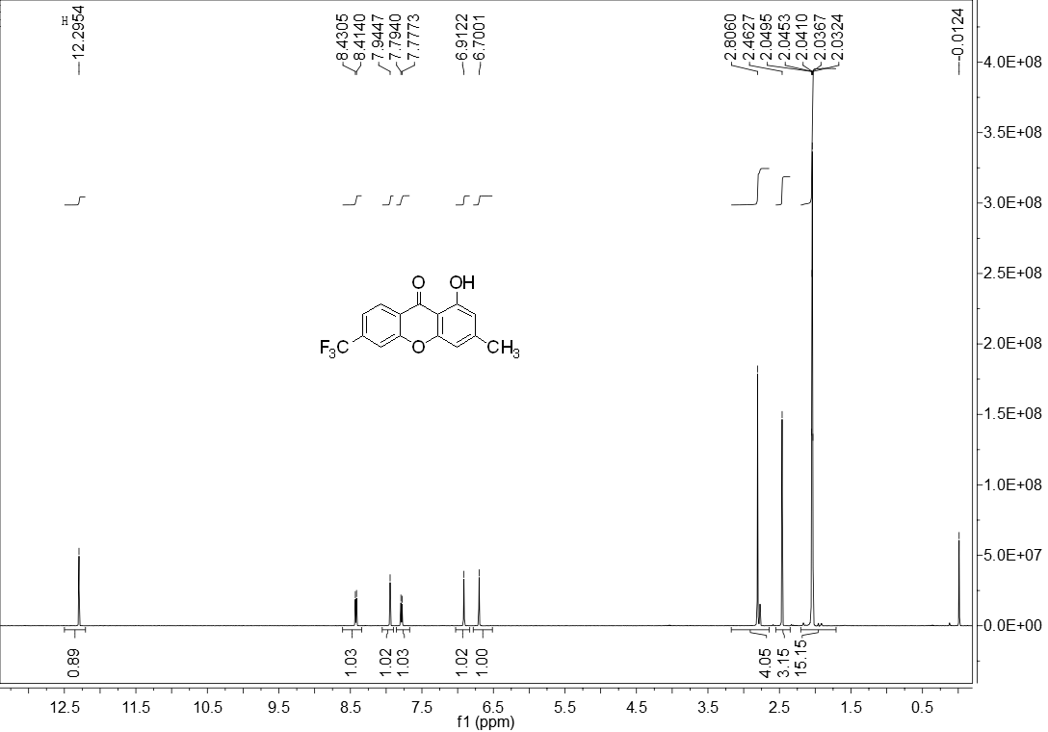
The ¹³C NMR spectrum of 1-hydroxy-3-methyl-6-(trifluoromethyl)-9H-xanthen-9-one (acetone-D₆, 125 MHz)
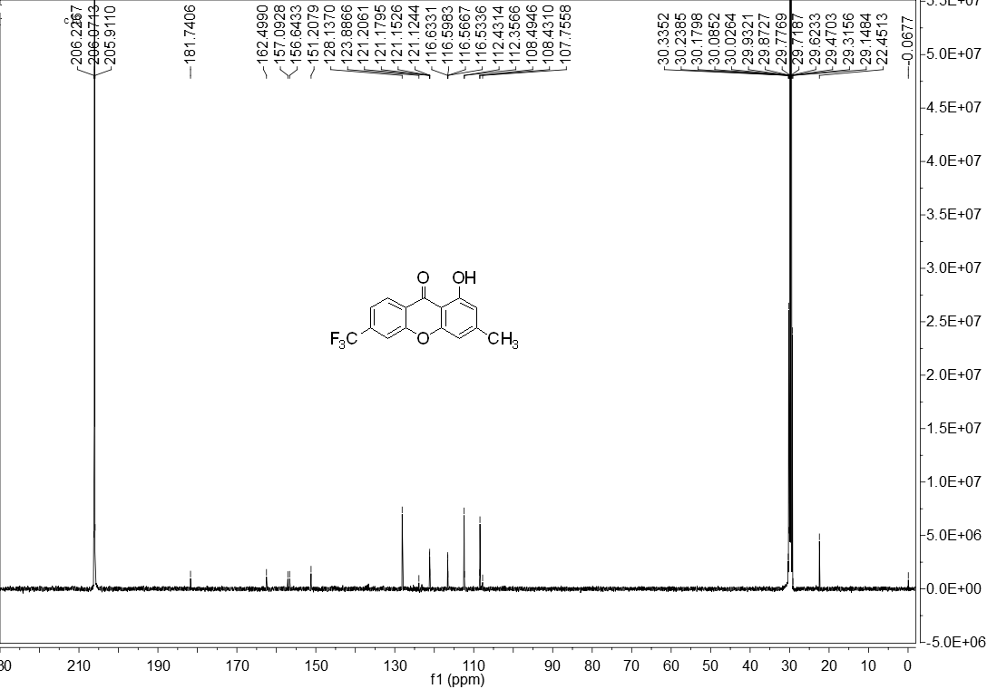

7. The ¹H NMR spectrum of 5-chloro-1-hydroxy-3-methyl-9H-xanthen-9-one (acetone-D₆, 500 MHz)
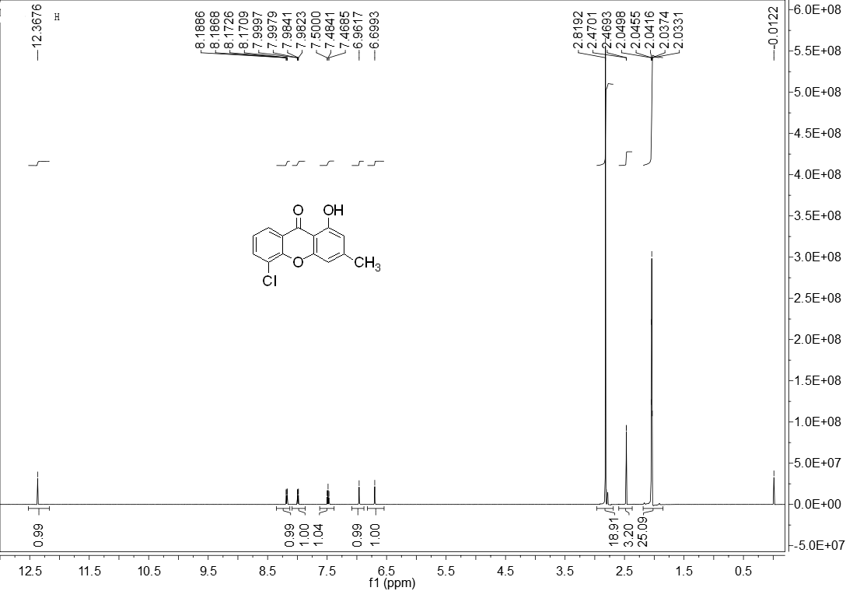
The ¹³C NMR spectrum of 5-chloro-1-hydroxy-3-methyl-9H-xanthen-9-one (acetone-D₆, 125 MHz)
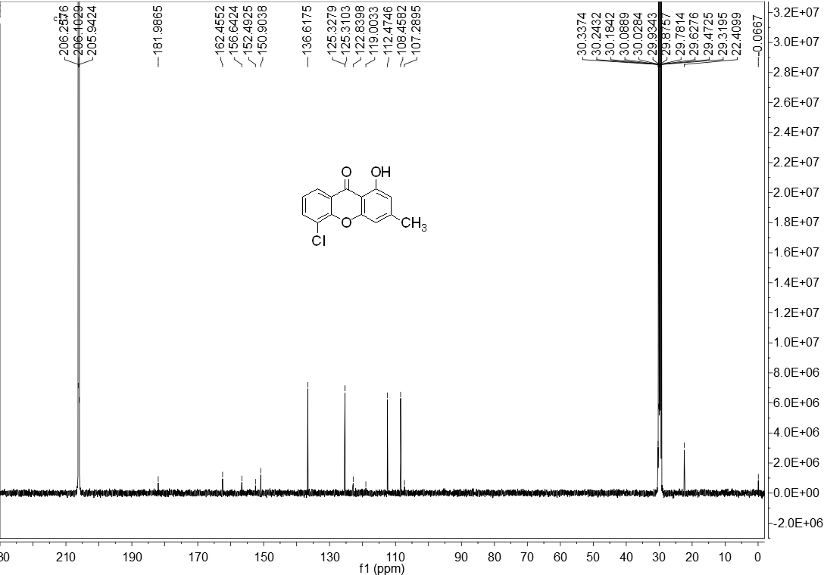

8. The ¹H NMR spectrum of 6-chloro-1-hydroxy-3-methyl-9H-xanthen-9-one (acetone-D₆, 500 MHz)
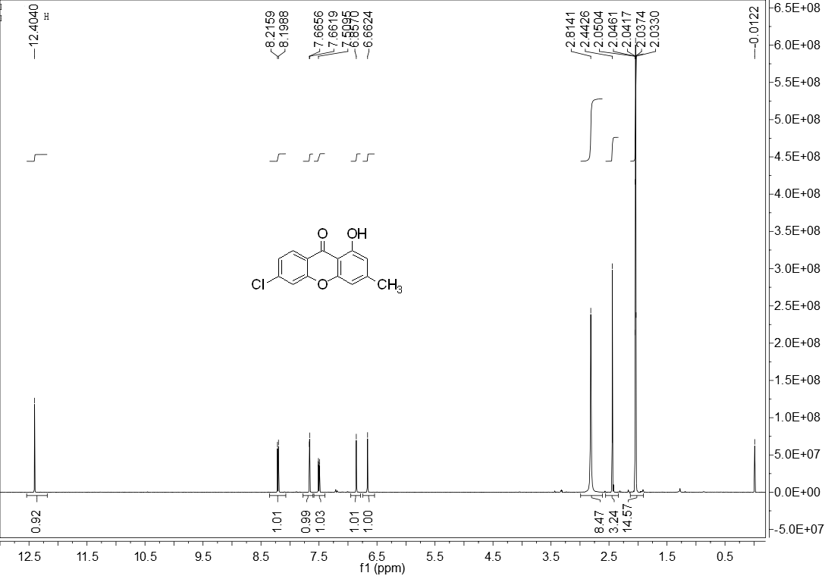
The ¹³C NMR spectrum of 6-chloro-1-hydroxy-3-methyl-9H-xanthen-9-one (acetone-D₆, 125 MHz)
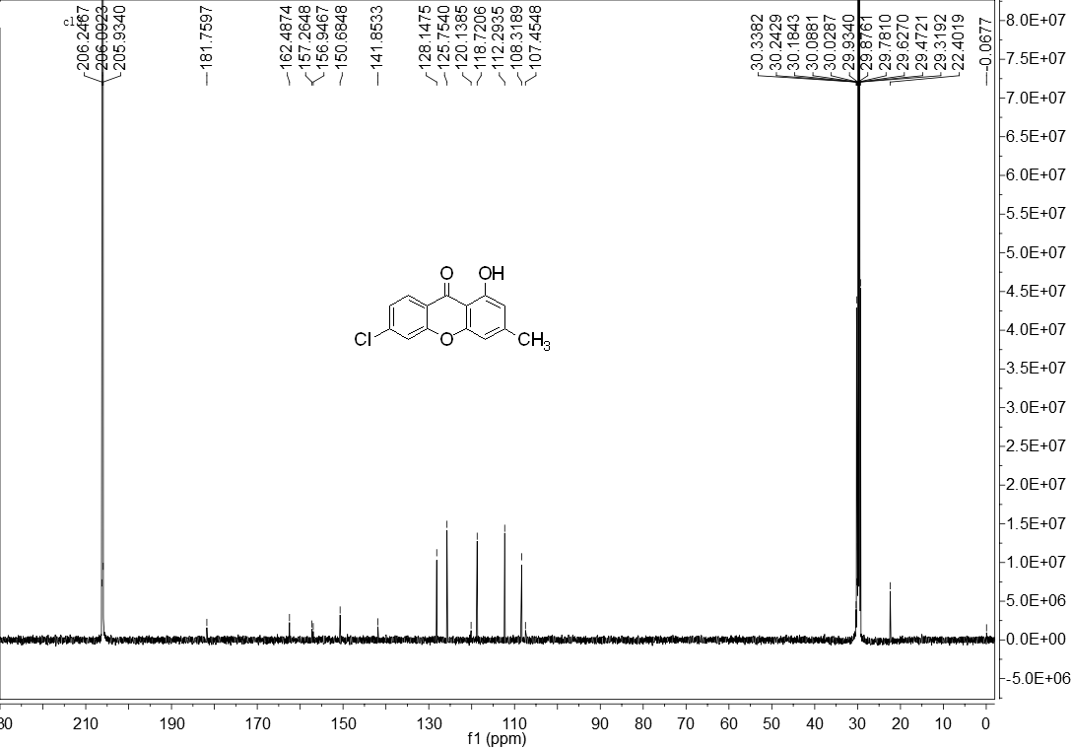

9. The ¹H NMR spectrum of 7-chloro-1-hydroxy-3-methyl-9H-xanthen-9-one (acetone-D₆, 500 MHz)
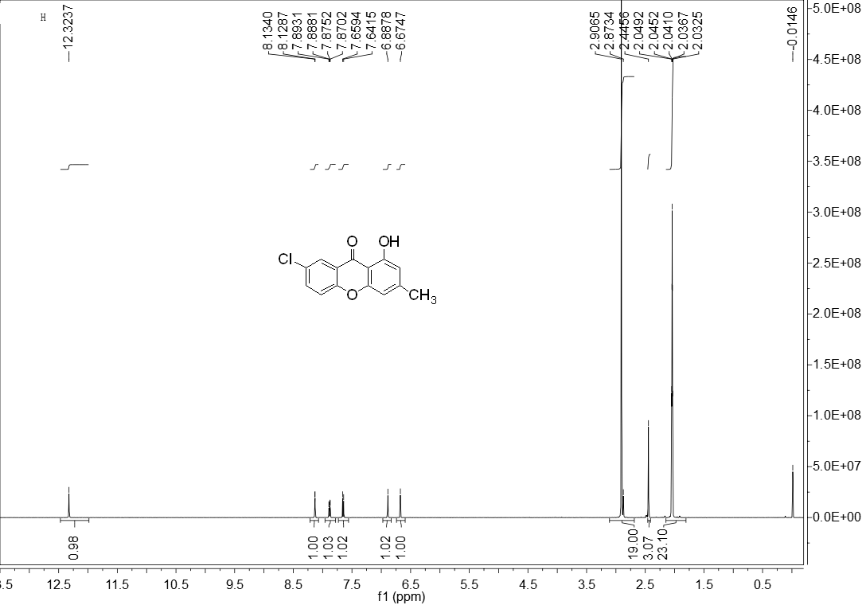
The ¹³C NMR spectrum of 7-chloro-1-hydroxy-3-methyl-9H-xanthen-9-one (acetone-D₆, 125 MHz)
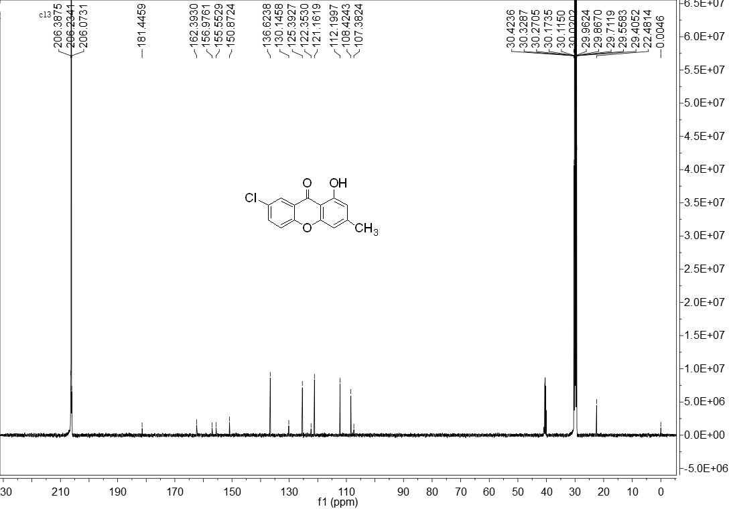

10. The ¹H NMR spectrum of 1,2,4-trichloro-8-hydroxy-6-methyl-9H-xanthen-9-one (acetone-D₆, 500 MHz)
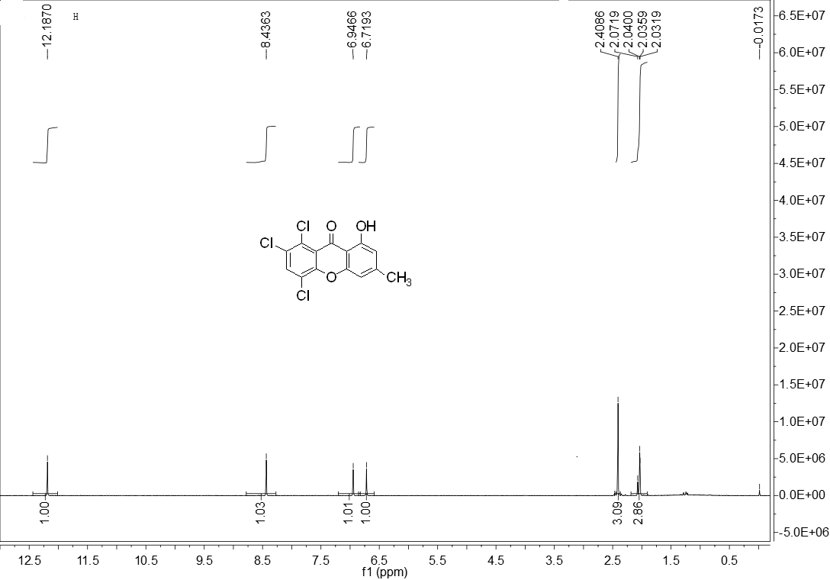
The ¹³C NMR spectrum of 1,2,4-trichloro-8-hydroxy-6-methyl-9H-xanthen-9-one (acetone-D₆, 125 MHz)
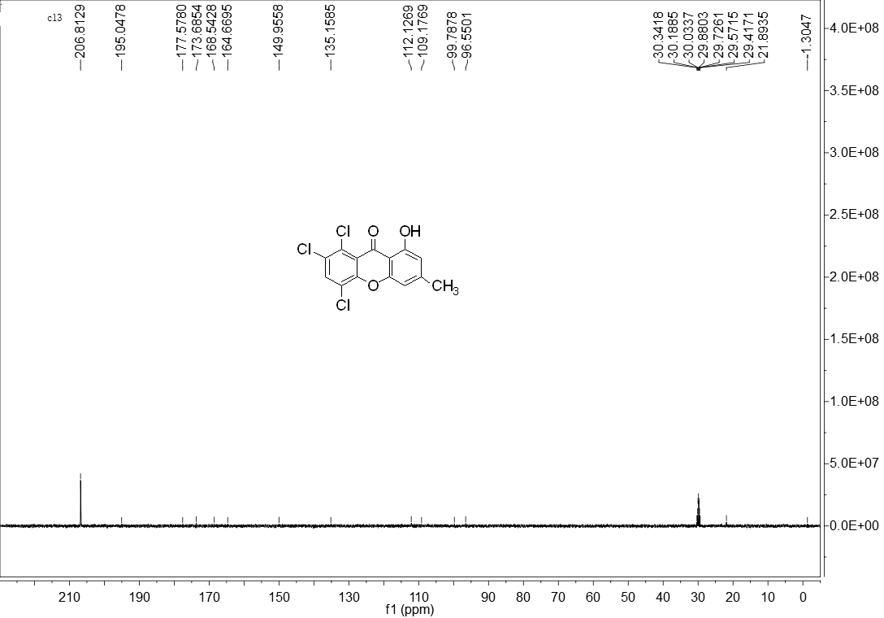

11. The ¹H NMR spectrum of 5,7-dibromo-1-hydroxy-3-methyl-9H-xanthen-9-one (acetone-D₆, 500 MHz)
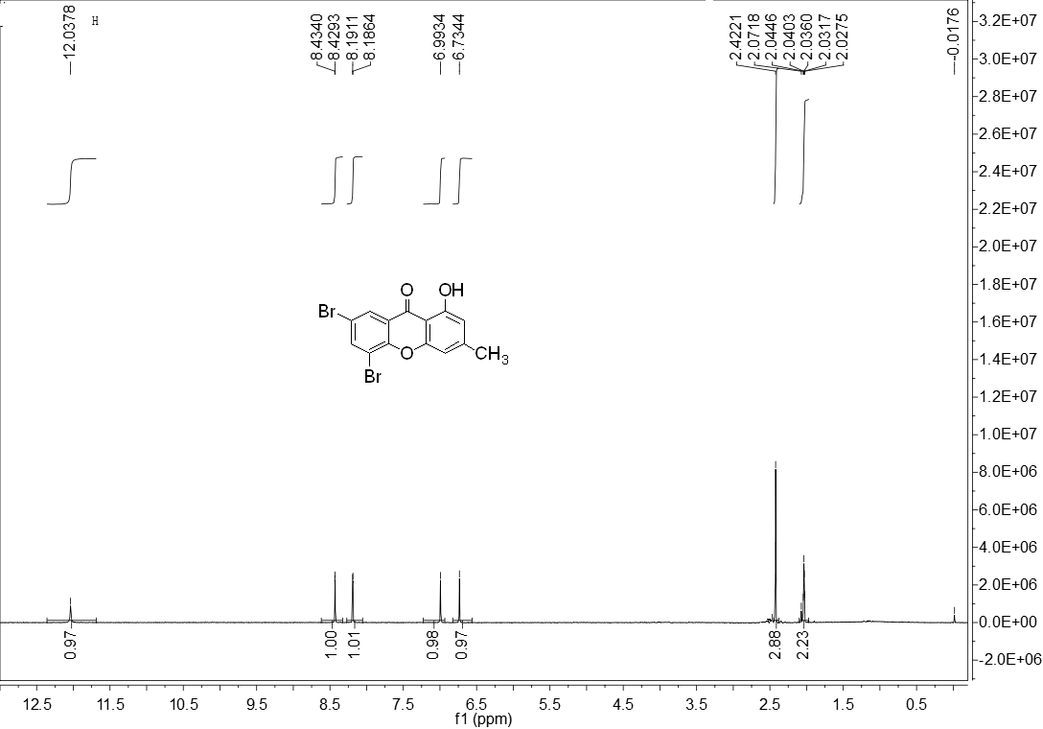
The ¹³C NMR spectrum of 5,7-dibromo-1-hydroxy-3-methyl-9H-xanthen-9-one (acetone-D₆, 125 MHz)
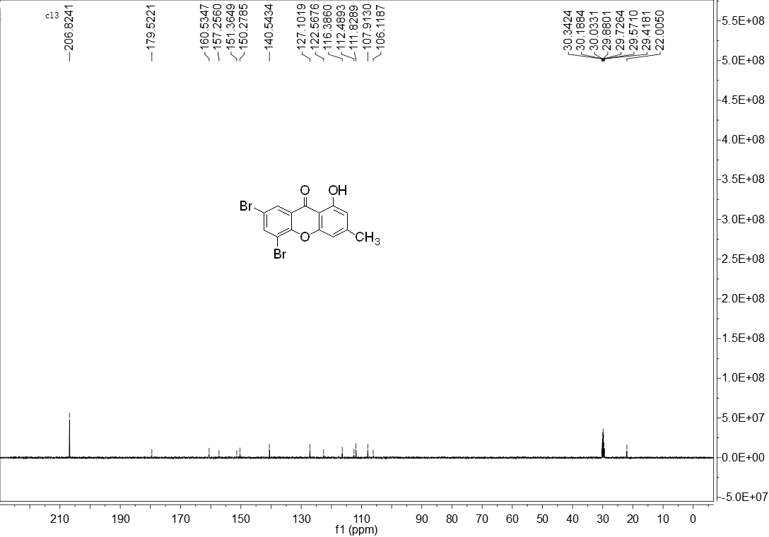

12. The ¹H NMR spectrum of 1-hydroxy-3-methyl-9H-xanthen-9-one (acetone-D₆, 500 MHz)
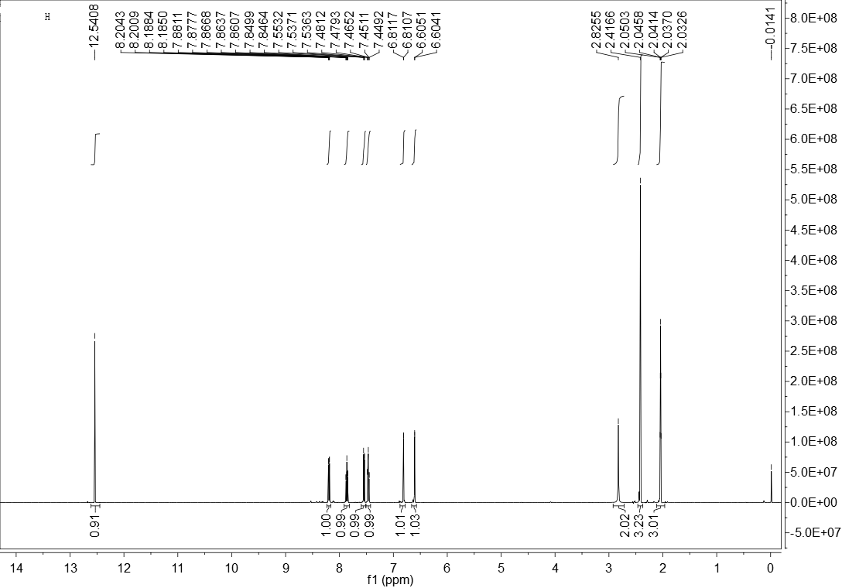
The ¹³C NMR spectrum of 1-hydroxy-3-methyl-9H-xanthen-9-one (acetone-D₆, 125 MHz)
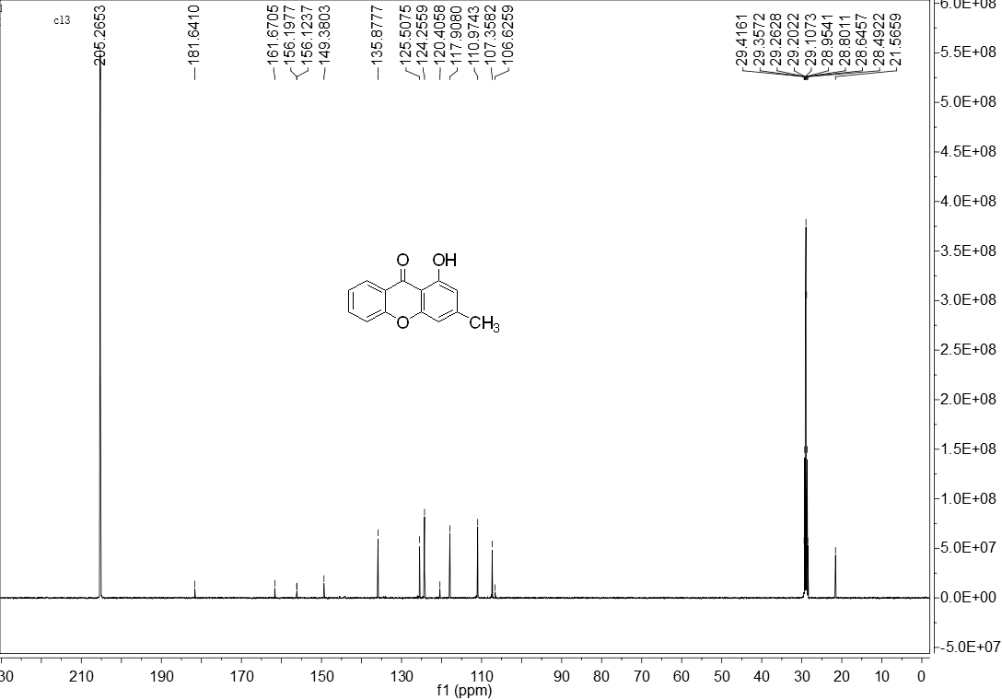

13. The ¹H NMR spectrum of 1-hydroxy-5-methoxy-3-methyl-9H-xanthen-9-one (acetone-D₆, 500 MHz)
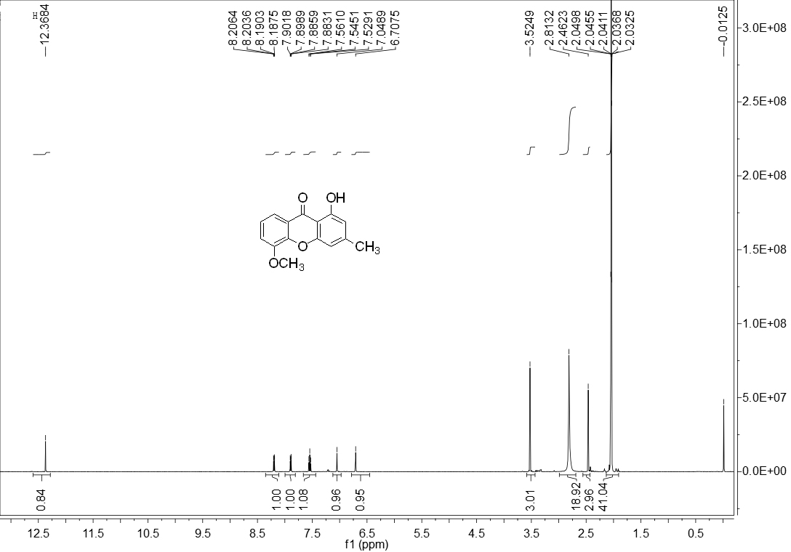
The ¹³C NMR spectrum of 1-hydroxy-5-methoxy-3-methyl-9H-xanthen-9-one (acetone-D₆, 125 MHz)
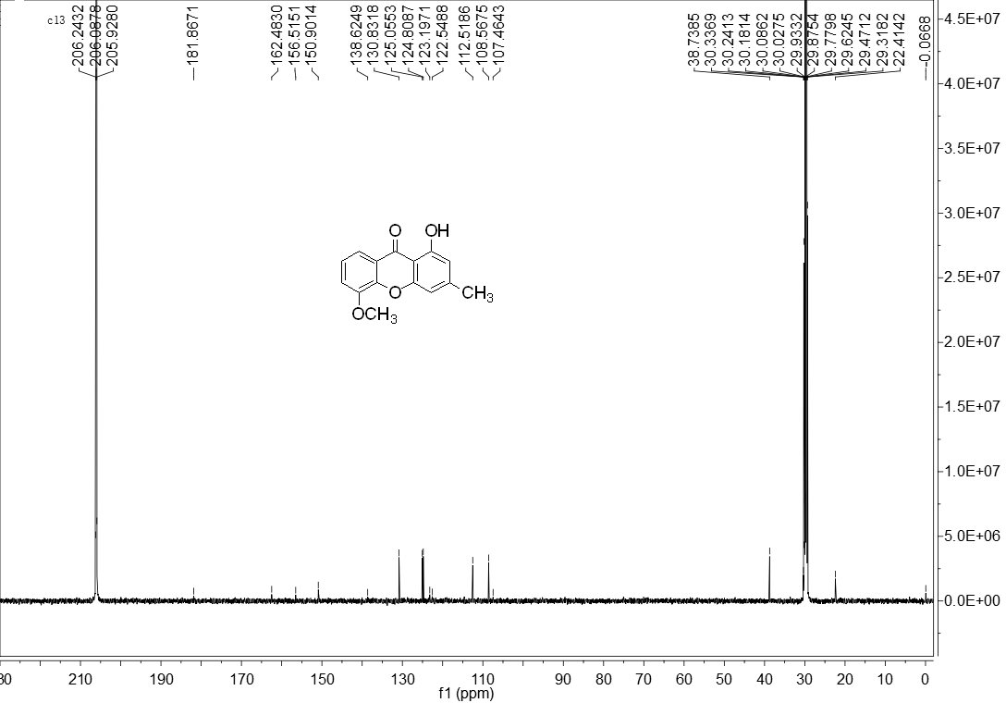

14. The ¹H NMR spectrum of 1-hydroxy-7-methoxy-3-methyl-9H-xanthen-9-one (acetone-D₆, 500 MHz)
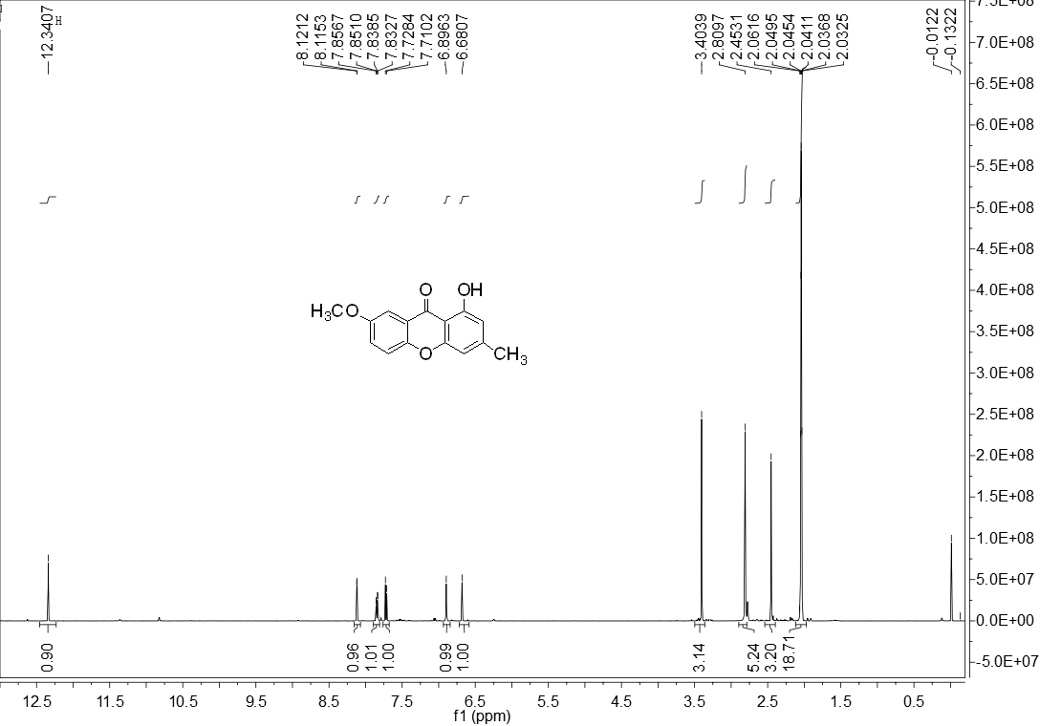
The ¹³C NMR spectrum of 1-hydroxy-7-methoxy-3-methyl-9H-xanthen-9-one (acetone-D₆, 125 MHz)
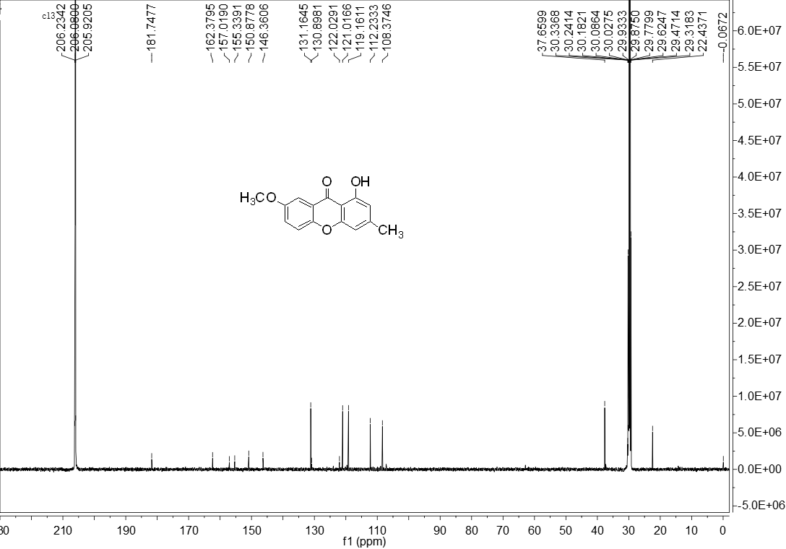

15. The ¹H NMR spectrum of 1,8-dihydroxy-3-methyl-9H-xanthen-9-one (acetone-D₆, 500 MHz)
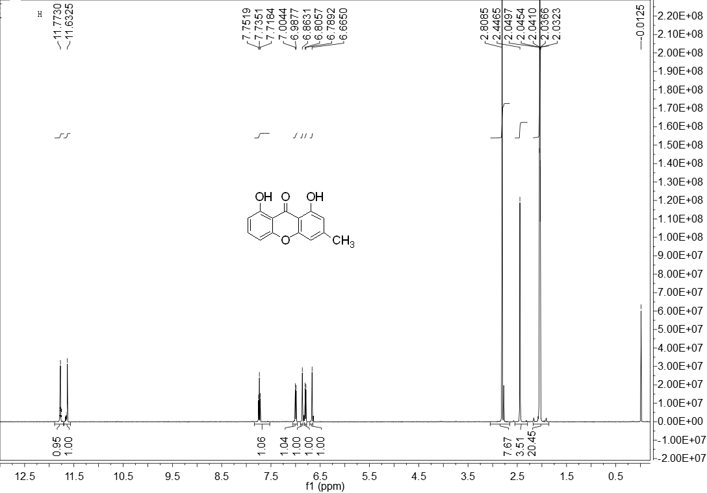
The ¹³C NMR spectrum of 1,8-dihydroxy-3-methyl-9H-xanthen-9-one (acetone-D₆, 125 MHz)
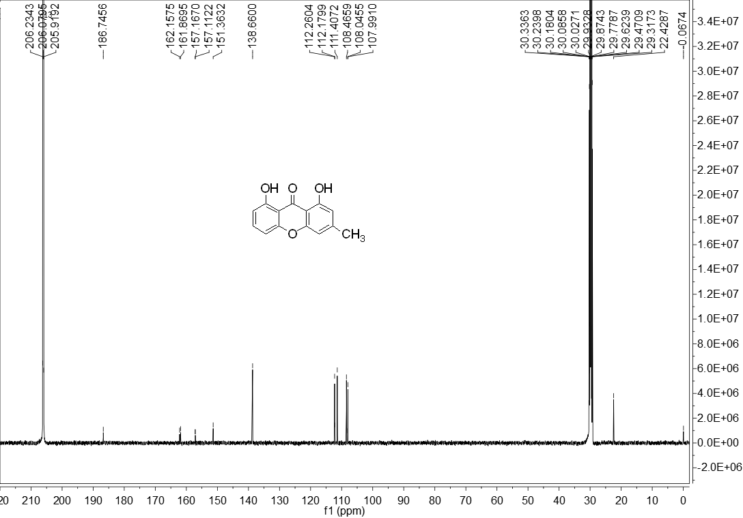

16. The ¹H NMR spectrum of 1,5,6-trihydroxy-3-methyl-9H-xanthen-9-one (acetone-D₆, 500 MHz)
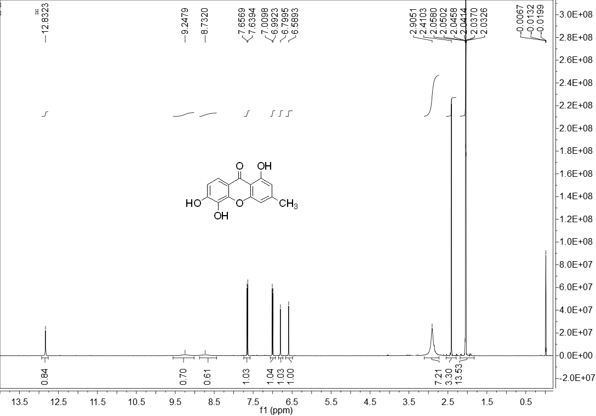
The ¹³C NMR spectrum of 1,5,6-trihydroxy-3-methyl-9H-xanthen-9-one (acetone-D₆, 125 MHz)
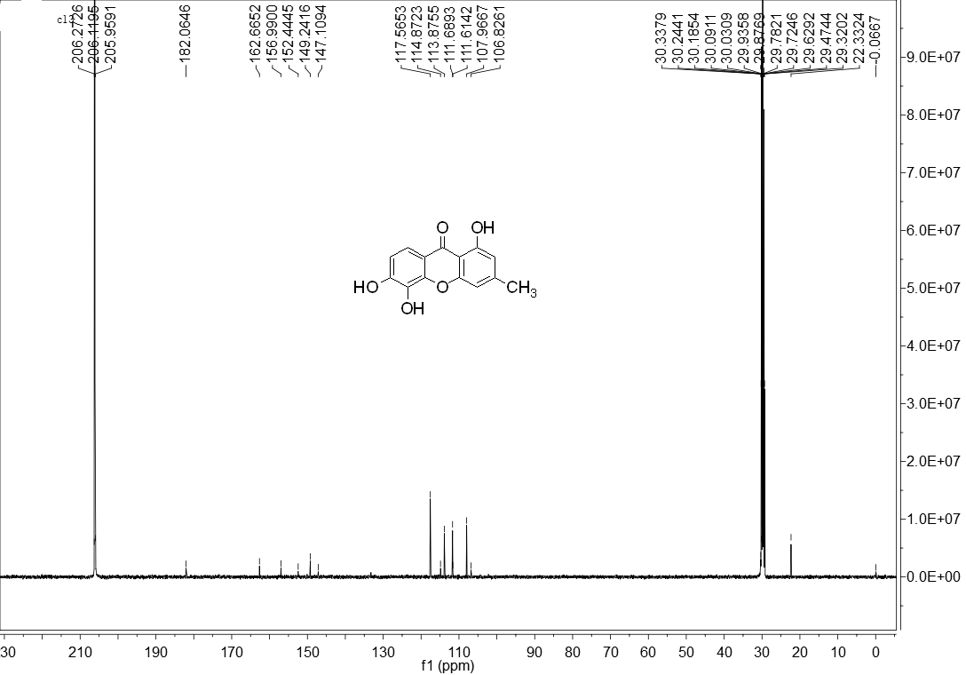

17. The ¹H NMR spectrum of 1,6-dihydroxy-5-methoxy-3-methyl-9H-xanthen-9-one (acetone-D₆, 500 MHz)
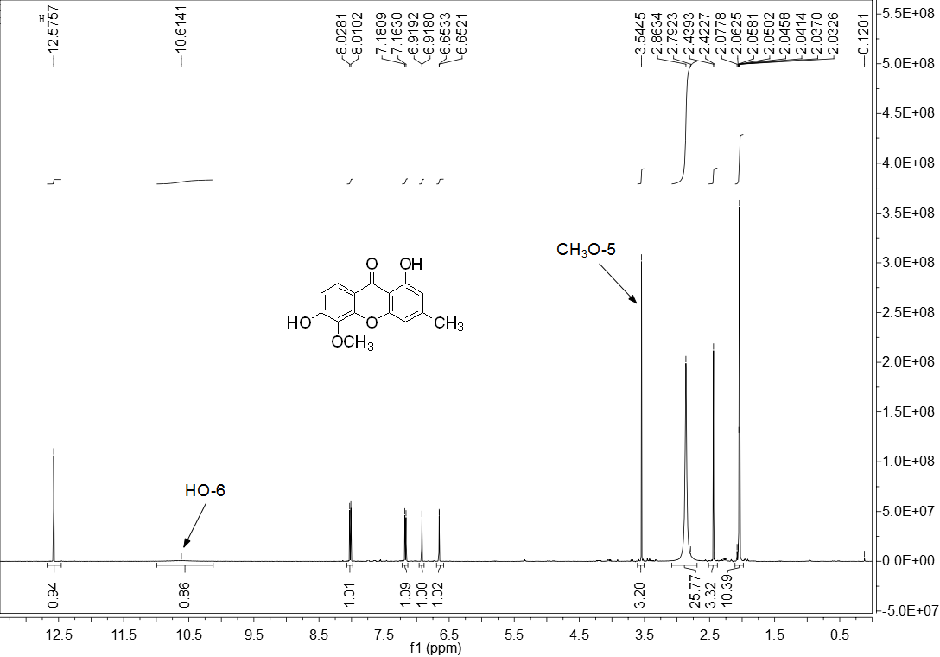
The ¹³C NMR spectrum of 1,6-dihydroxy-5-methoxy-3-methyl-9H-xanthen-9-one (acetone-D₆, 125 MHz)
