Non-covalent Li···H interaction in the synthesis of peri-disubstituted naphthalene proton sponges.
Alexander S. Antonov*¹

Address: ¹Institute of Chemistry, St. Petersburg State University, Universitetskii pr. 26, 198504 St. Petersburg, Russian Federation
Email: Alexander S. Antonov - aleksandr.antonov@spbu.ru

Supporting Information
Copies of ¹H and ¹³C NMR spectra S2

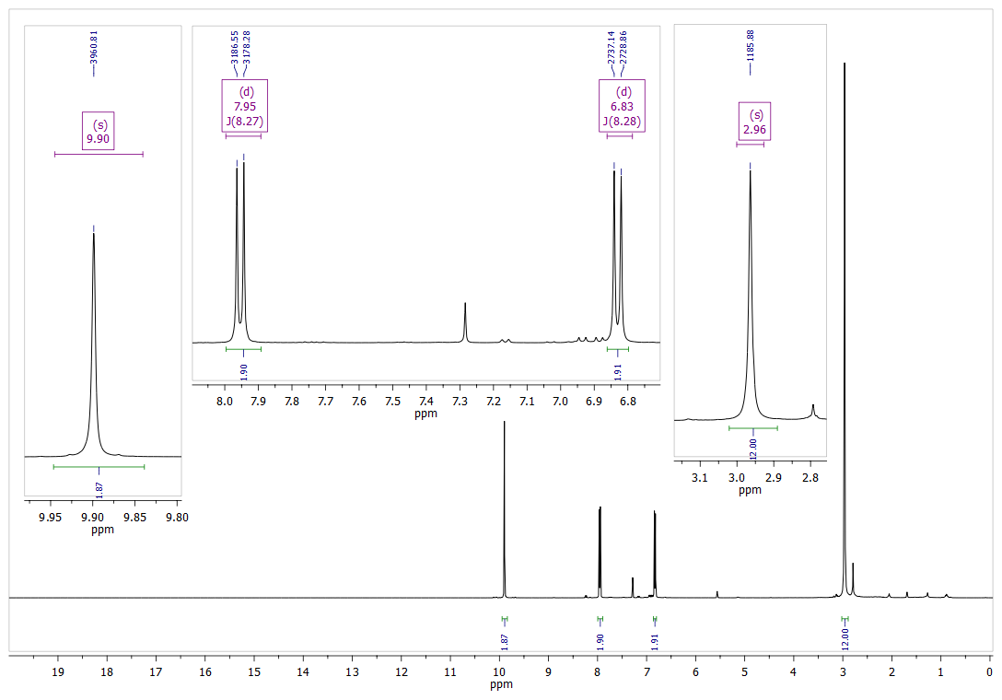
Figure S1: ¹H NMR spectrum of 11b (CDCl₃, 400 MHz).
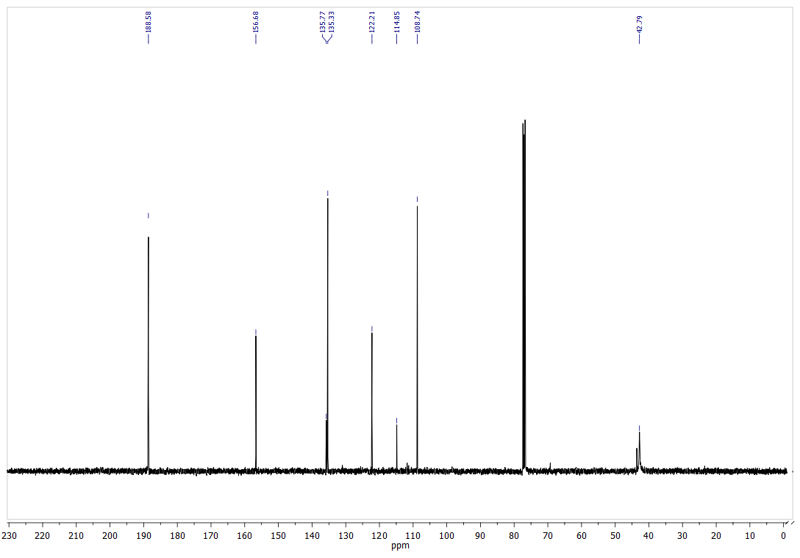
Figure S2: ¹³C NMR spectrum of 11b (CDCl₃, 100 MHz).
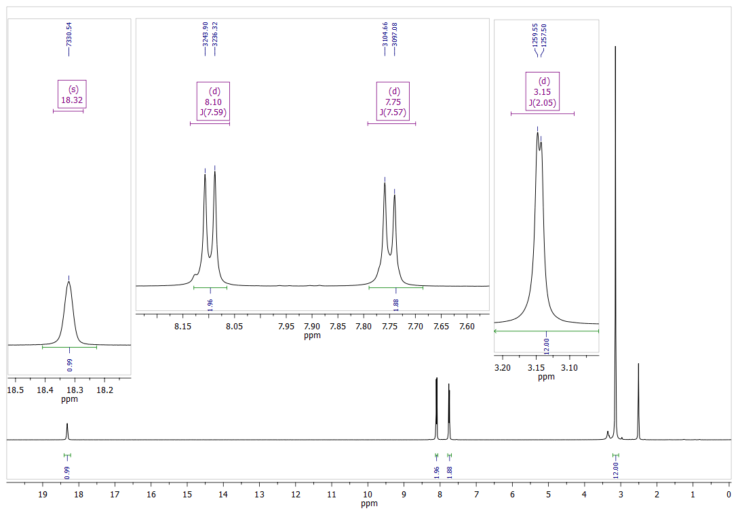
Figure S3: ¹H NMR spectrum of 13·HBF₄ (DMSO-d₆, 400 MHz).
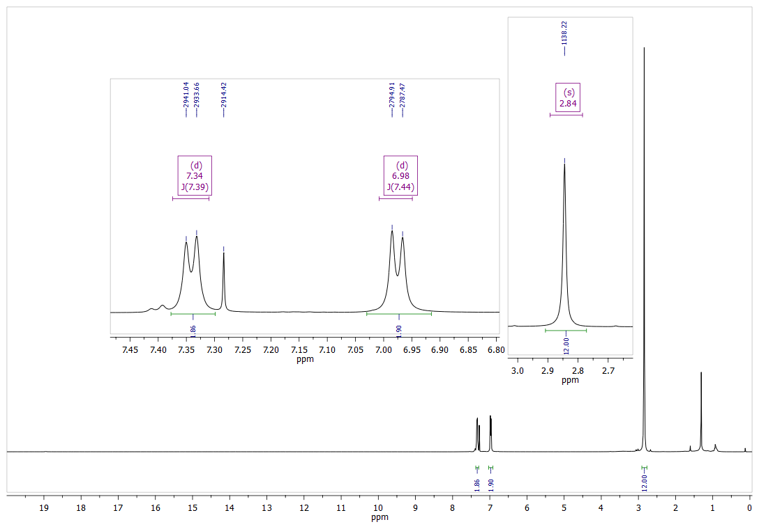
Figure S4: ¹H NMR spectrum of 13 (CDCl₃, 400 MHz).
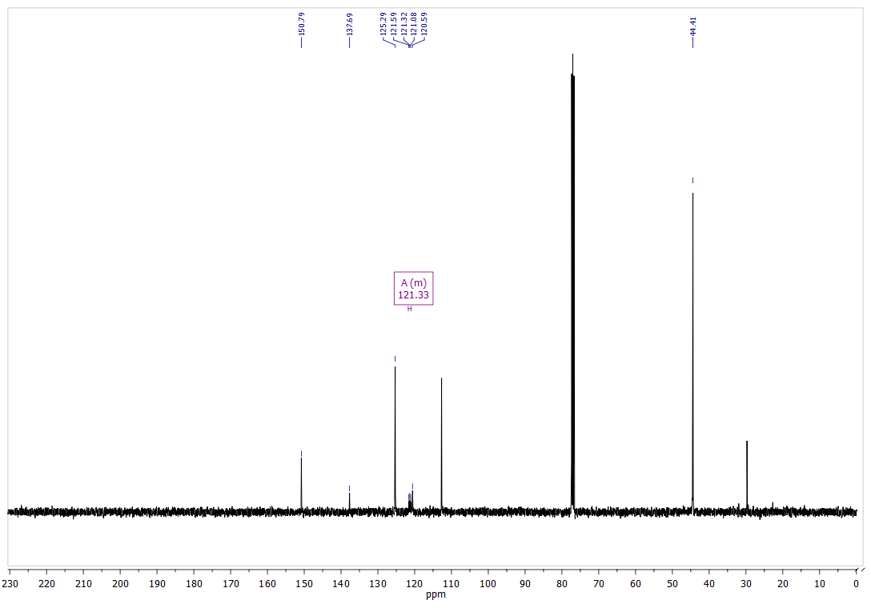
Figure S5: ¹³C NMR spectrum of 13 (CDCl₃, 100 MHz).
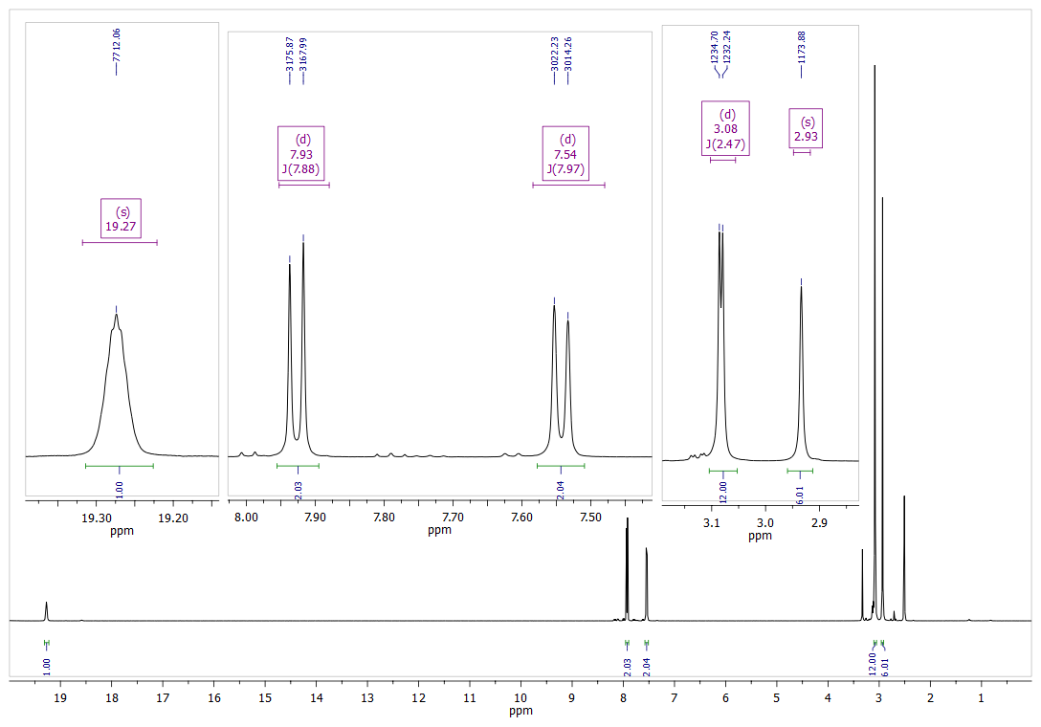
Figure S6: ¹H NMR spectrum of 14·HBF₄ (DMSO-d₆, 400 MHz).
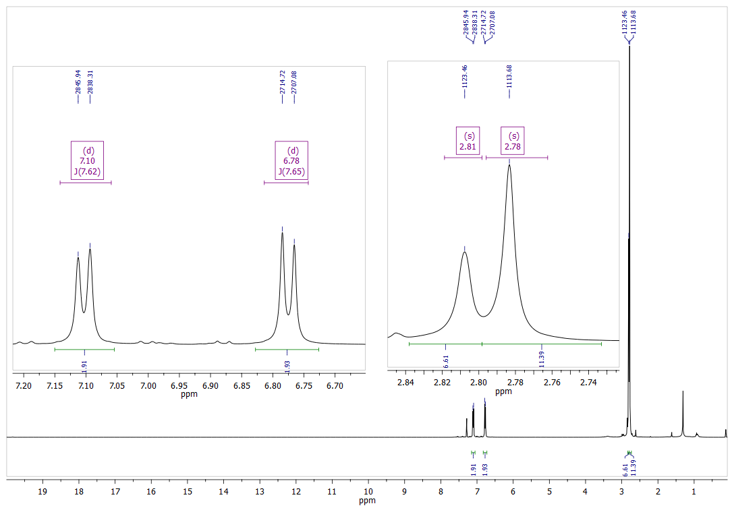
Figure S7: ¹H NMR spectrum of 14 (CDCl₃, 400 MHz). 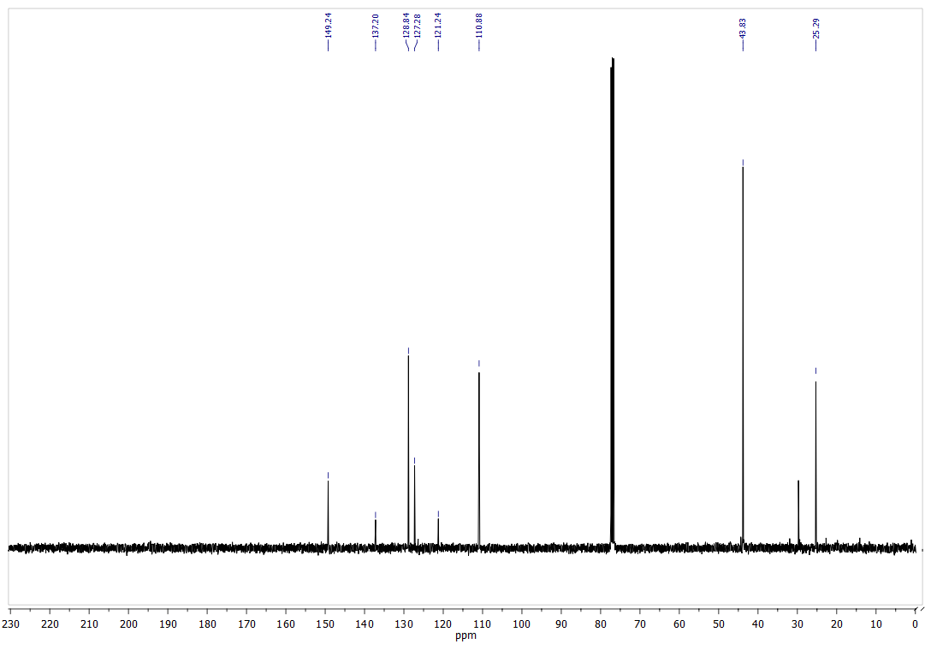
Figure S8: ¹³C NMR spectrum of 14 (CDCl₃, 100 MHz).

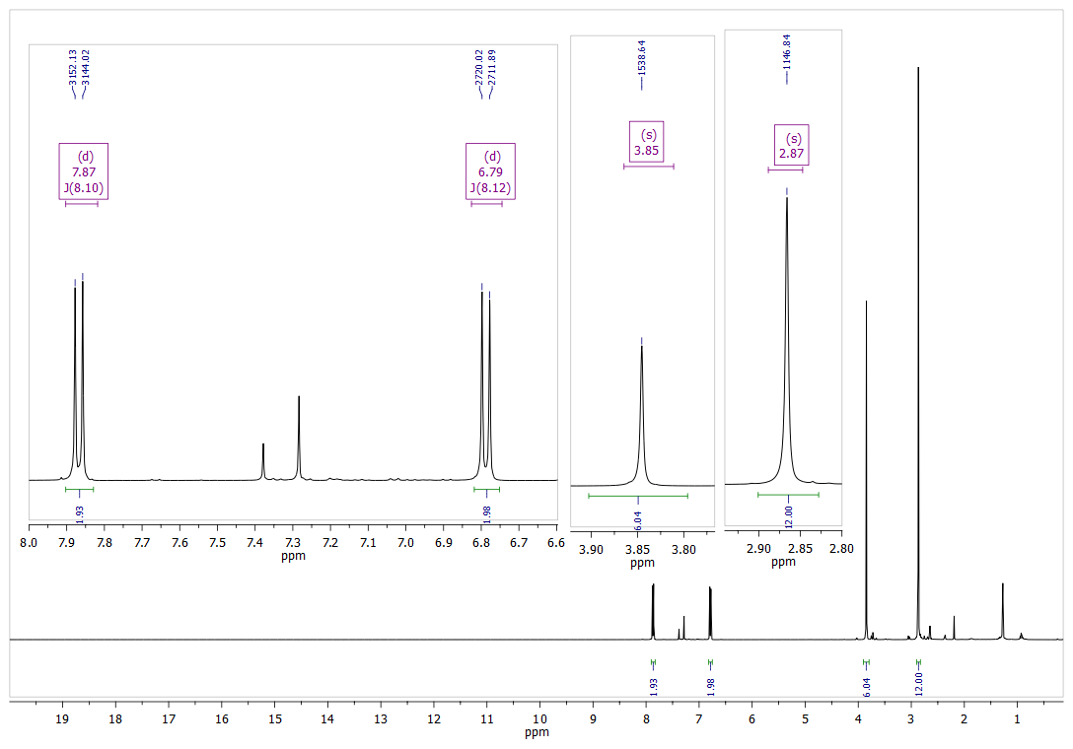
Figure S9: ¹H NMR spectrum of 15 (CDCl₃, 400 MHz).
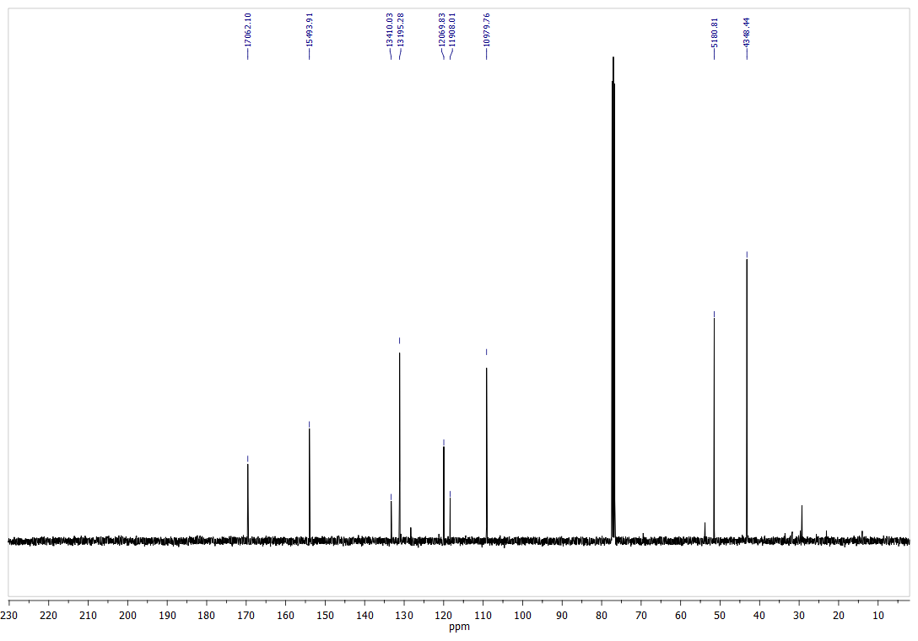
Figure S10: ¹³C NMR spectrum of 15 (CDCl₃, 100 MHz).
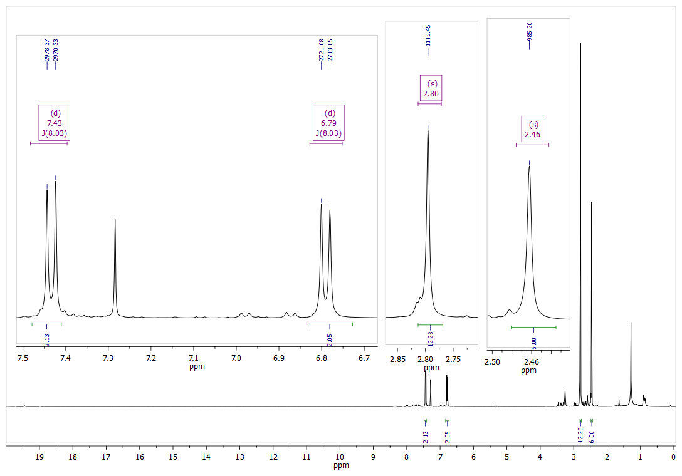
Figure S11: ¹H NMR spectrum of 16 (CDCl₃, 400 MHz).
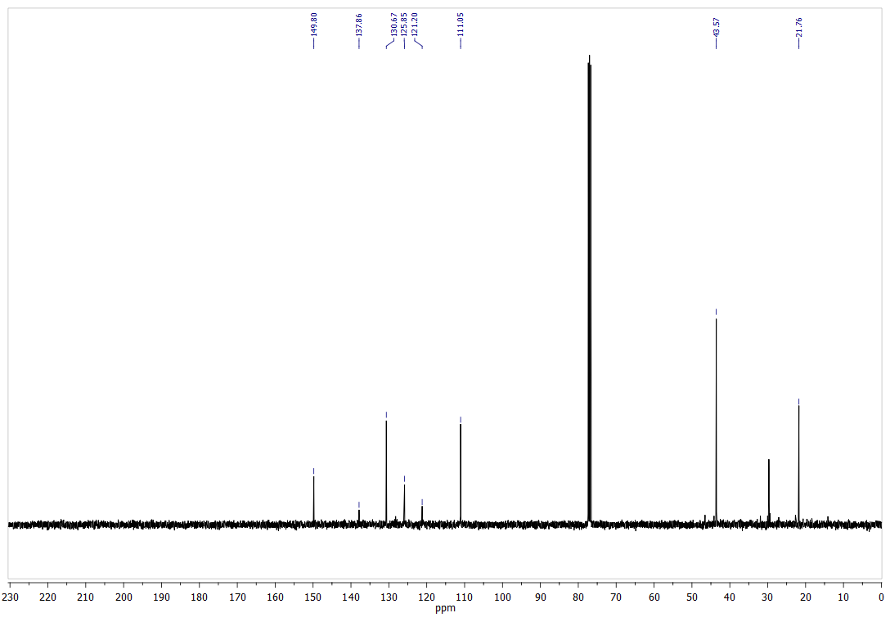
Figure S12: ¹³C NMR spectrum of 16 (CDCl₃, 100 MHz).
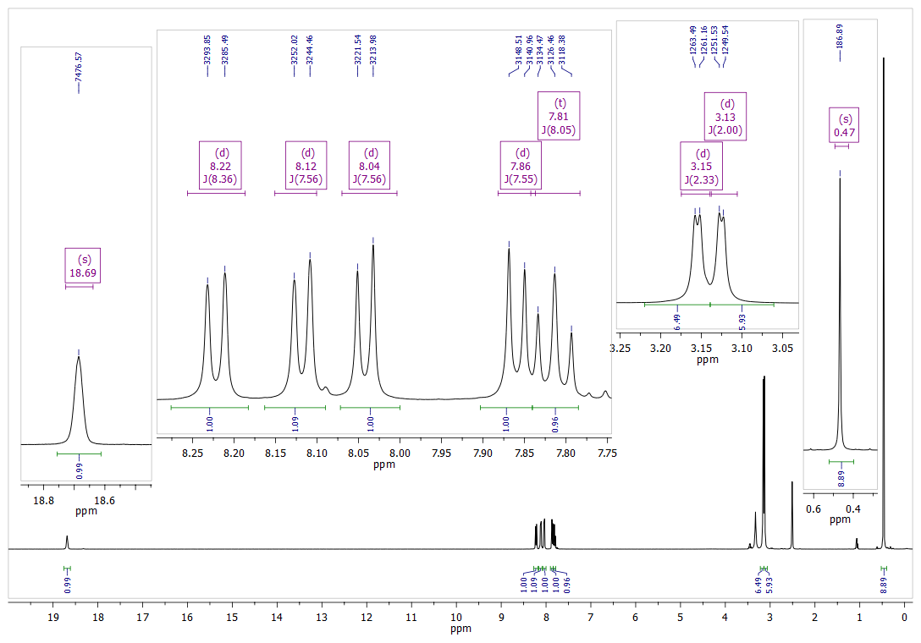
Figure S13: ¹H NMR spectrum of 17·HBF₄ (DMSO-d₆, 400 MHz).

