Supporting Information
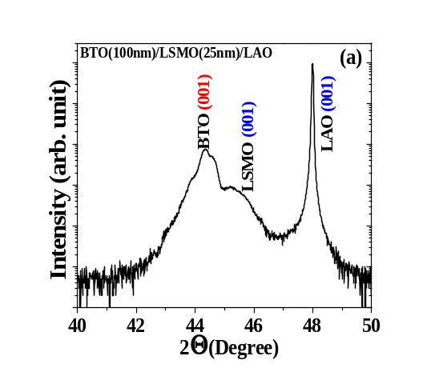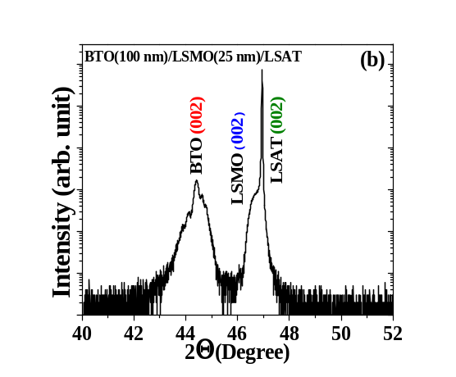
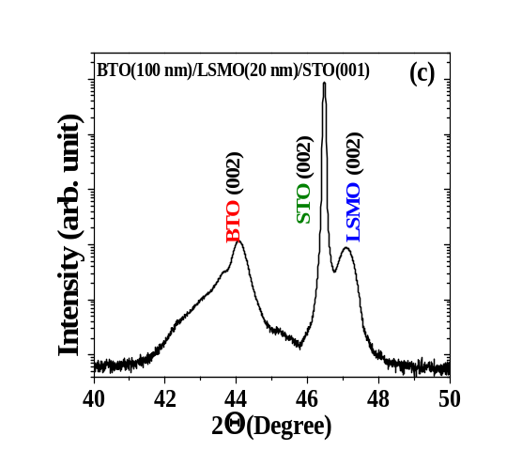
Scheme S1. -2 scans for simultaneously grown BTO (100 nm)/LSMO (25 nm) bilayers on (a) (001) LAO, (b) (001) LSAT and (c) (001) STO. Other phases is not identify.

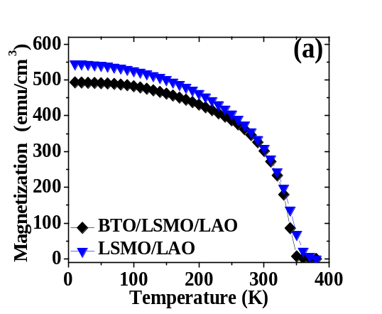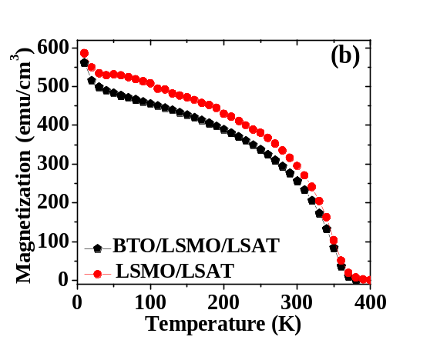
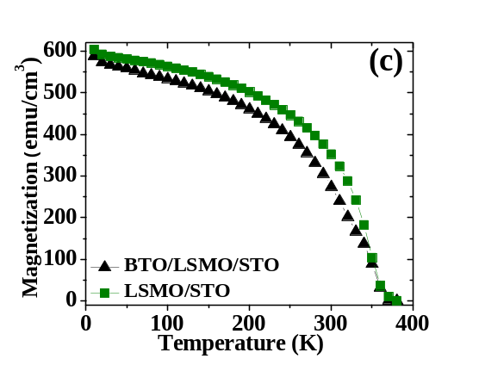
Scheme S2. Dependence of magnetization with temperature for BTO (100 nm)/LSMO (25 nm) measured with a field of 5 kOe applied in-plane. (a) LAO, (b) LSAT and (c) STO.

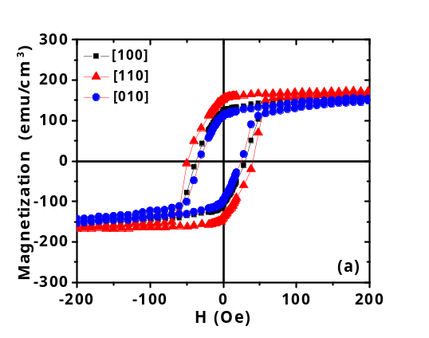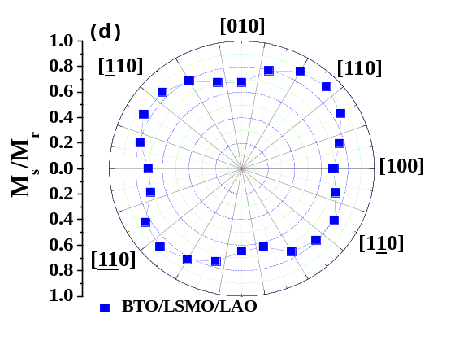
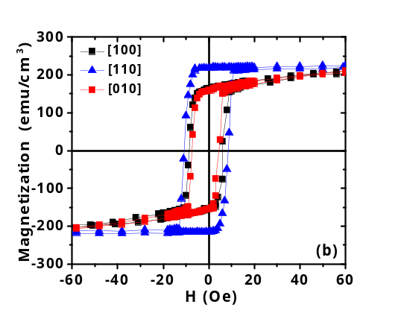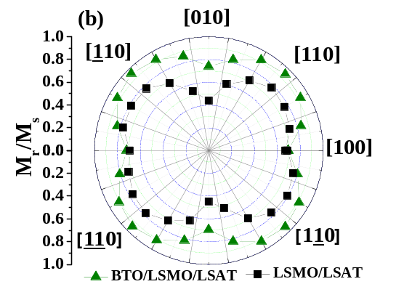
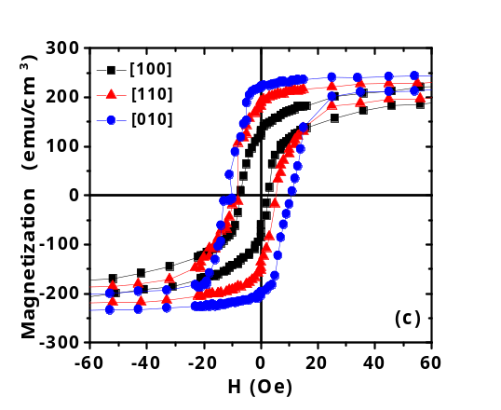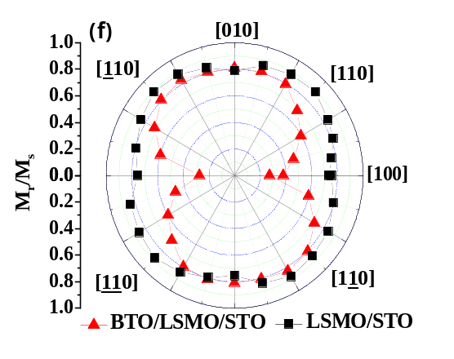
Scheme S3. Isothermal hysteresis loops on BTO(100 nm)/LSMO(25 nm) bilayer at 300 K. Black squares, red triangles and blue circles denote measurements with the field aligned with the [001], [110] and [010] direction, respectively. The bilayer was deposited on (a) LAO, (b) LSAT and (c) STO on (001) substrate. Polar plots display the remnant magnetization at 300 K for (d) LAO, (d) LSAT and (f) STO on (001) substrates.

