Identification of the physical-chemical properties that modulate the nanoparticles aggregation in blood

Ludovica Soddu, Duong N. Trinh , Eimear Dunne, Dermot Kenny, Giorgia Bernardini, Ida Kokalari, Arianna Marucco, Marco P Monopoli, and Ivana Fenoglio.

Supporting information

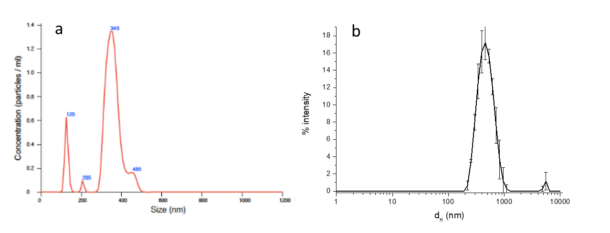

Figure S1. Representative size distribution measured by a) NTA and b) DLS of the sample SNP-L.

Figure S2. Effect of size on the composition of the protein corona. Panel a) and c) 10% human plasma, b) and d) 80% human plasma

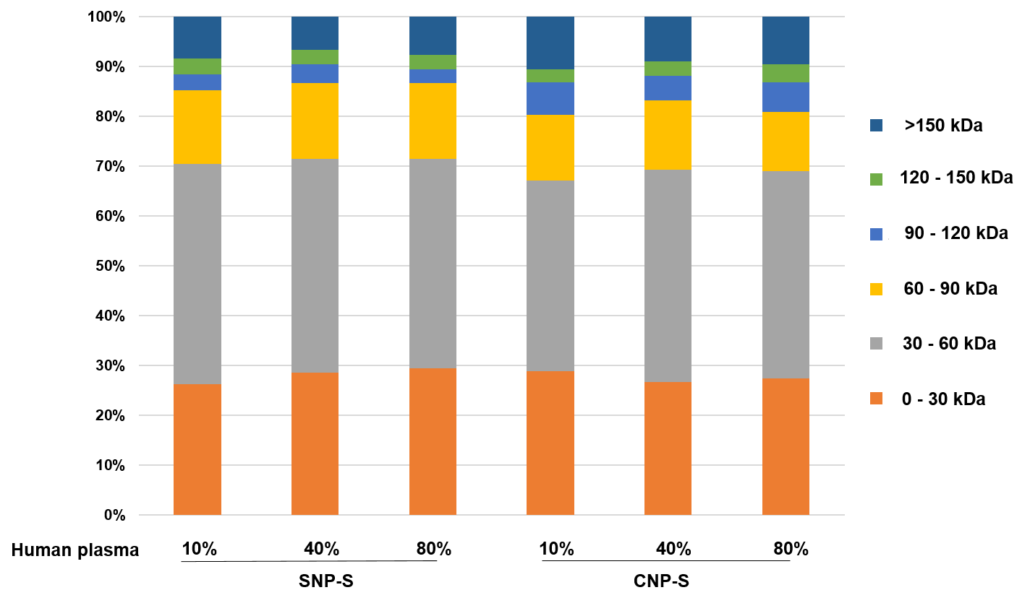

Figure S3. Classification of the human plasma corona proteins identified on small silica and carbon NPs by LC-MS according to the molecular weight (MW) at three plasma concentration.

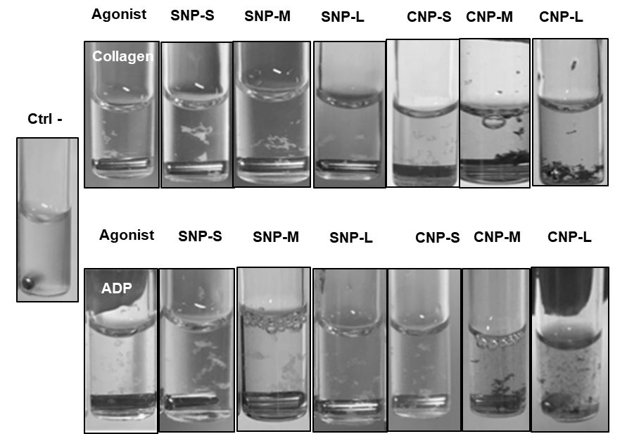

Figure S4. Images of PRP after addition of the activator and the nanoparticles.

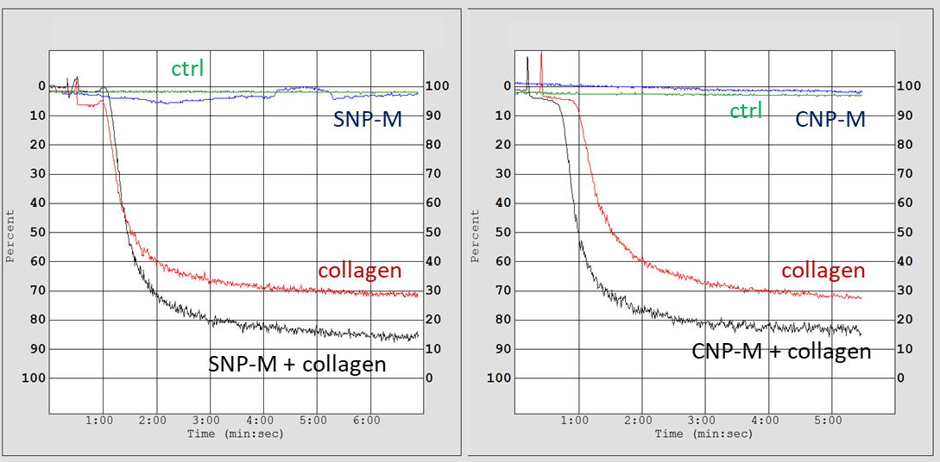

Figure S5. Representative plots of platelet aggregation. Effect of SNP-M and CNP-M on aggregation of platelets activated with collagen.

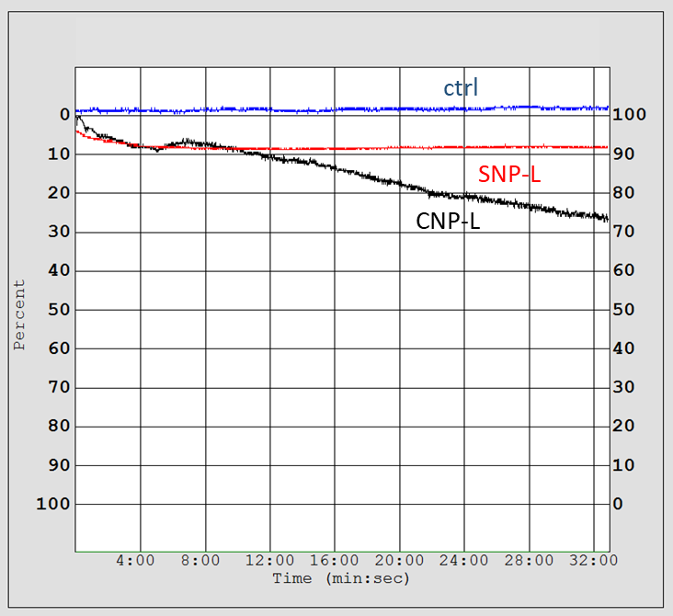

Figure S6. Effect of SNP-L and CNP-L on platelet aggregation in the absence of activators.

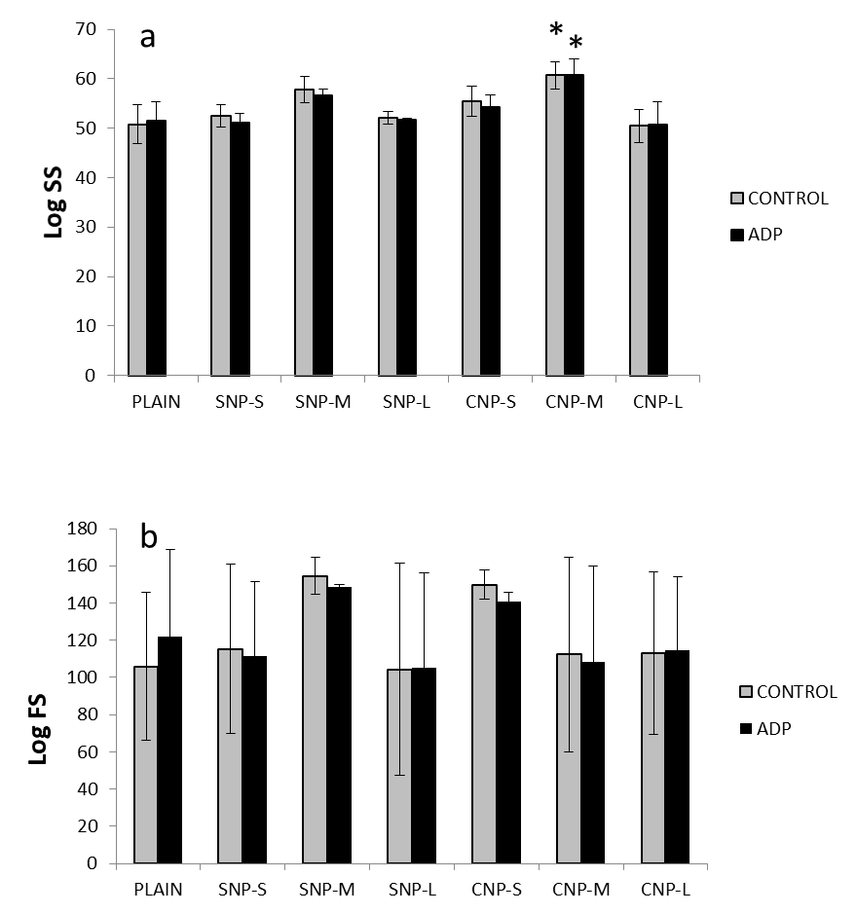

Figure S7. Effect of the nanoparticles on size and granularity of platelets evaluated by flow cytometry. a) Intensity of forward (FS) and b) side (SS) scattered light. * p < 0,05

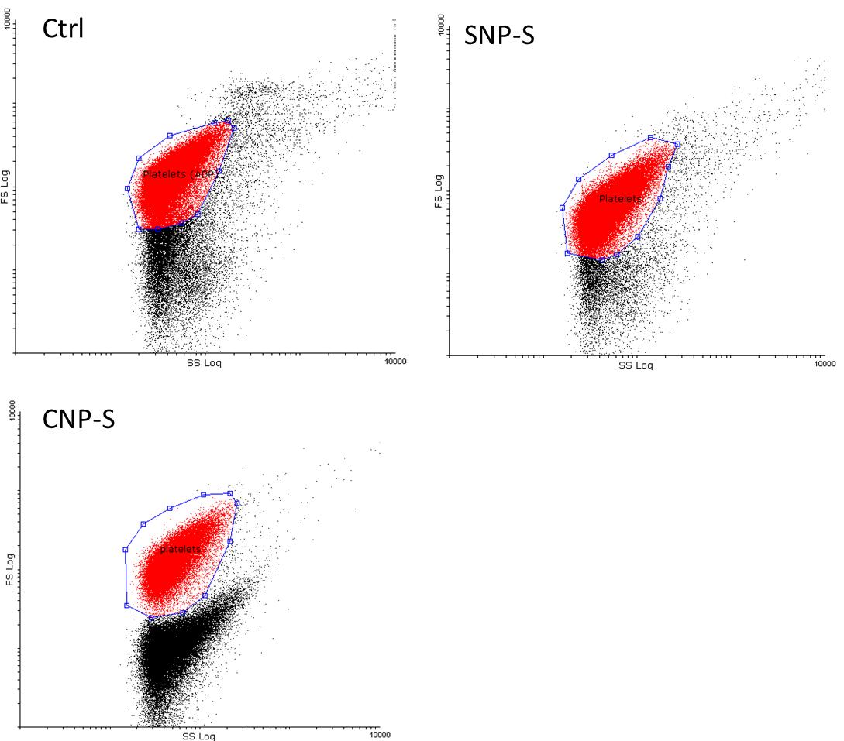

Figure S8. Representative FS/SS plot.

