Supporting Information:
Small protein sequences can induce cellular uptake of complex nanohybrids
Jan-Philip Merkl,*,¹⁻³ Malak Safi,¹, # Christian Schmidtke,³ Fadi Aldeek,¹, ¶ Johannes Ostermann,^{2,4} Tatiana Domitrovic, ⁵,& Sebastian Gärtner, ^{2,6} John E. Johnson, ⁶ Horst Weller,²⁻⁴ and Hedi Mattoussi.¹

Address: ¹Department of Chemistry and Biochemistry, Florida State University, 95 Chieftan Way, Tallahassee, Florida 32306 (United States)
²Institute of Physical Chemistry; University of Hamburg, Grindelallee 117, 20146 Hamburg
³The Hamburg Center for Ultrafast Imaging, University of Hamburg, Luruper Chaussee 149, 22761 Hamburg (Germany)
⁴Center for Applied Nanotechnology (CAN) GmbH, Grindelallee 117, 20146 Hamburg (Germany)
⁵The Scripps Research Institute, Department of Integrative Structural and Computational Biology, MB31, La Jolla, California 92037, (United States)
⁶ Universitätsklinikum Hamburg Eppendorf, 20246, Martinistraße 52, 20251 Hamburg (Germany)

¶current address: Altria Center for Research and Technology, 601 E Jackson Street, Richmond, VA, 23219 (United States).
#current address: Laboratoire Physique des Solides, UMR 8502, Université de Paris Sud bât 510, 91405 Orsay Cedex (France).
&current address: Instituto de Microbiologia Paulo de Goes, Universidade Federal do Rio de Janeiro, 310. Lab I014, 21941-902, Rio de Janeiro (Brazil)

Email: Jan-Philip Merkl – janphilip.merkl@gmail.com

Table of Contents
Hybrid Self-Assembly and Characterization 3
DLS characterization and stability 3
Autocorrelation function after cellular incubation 3
Biological assays, cellular incubation, Amylose column 4
Amylose affinity chromatography assay 4
Cell culture preparation and incubation protocol 4
Epifluorescence microscopy 5
Control experiments - Epifluorescence microscopy 6
Flow cytometry 6
Further Instrumentation 7

Hybrid Self-Assembly and Characterization
The synthesis of the quantum dots (QDs),^{1,2} zwitterion-capped gold nanoparticles (LA-ZW-AuNPs),^{3,4} the polymers^{2,5,6}, as well as the hybrid assemblies⁷ are discussed in detail in our previous works.²⁻⁸ Briefly, QDs synthesized in high boiling solvents,^{1,2} were transferred into water using ligand exchange with polyisprene-diethylentriamine (PI-DETA) followed by encapsulation within a functional amphiphilic polyisoprene-block-polyethylene oxide (PI-b-PEO-FG, FG = lipoic acid, amine, carboxylic acid)⁷ diblock copolymer.^{2,5,6} The AuNPs were synthesized in the presence of a lipoic zwitterion ligands.^{3,4} The hybrid design is similar to the one reported in reference,⁷ but the His-MBP-γ peptide used here, allows testing of intracellular uptake. Different PI-b-PEO-FG were used, however, the results presented in this paper rely on the use of PI-b-PEO-NH₂. Although the functional group influences the coupling between QD-FG and AuNP, no influence on the cellular behavior was observed.
To investigate the biological behavior of the nanocomposite, different Au/QD were used, as stated in the manuscript. QD-FG and Au NPs solutions (20 mM PBS buffer, pH 7.2) were mixed and kept for 30 min at RT in the dark, before incubation with HIS-MBP-(γ) (14 eq. per Au, final c(QD)~1 µM) for 30 min. For amylose column assay, the solution was loaded on the column and for cellular incubation, the stock solution was diluted in cellular DMEM culture media (final volume 500 µL). The concentrations refer to the QD-concentration, unless otherwise stated. No aggregation was observed, as reflected by the DLS measurements where mono-modal homogeneous autocorrelation functions were collected and only one average size for the dispersed hybrids was identified.

DLS characterization and stability

Autocorrelation function after cellular incubation
The hydrodynamic radius of the nanoparticles was measured using an ALV/CGS‐3 Compact Goniometer System equipped with an avalanche photodiode for signal detection and ALV photon correlator (Langen, Germany). The signal was collected at 90 degree scattering angle. Each scattered pattern was the average result of 3 acquisition periods of 10 seconds each. The intensity count rates were maintained at ~ 150 – 300 Hz, achieved through appropriate control over the NP concentrations for the various NPs and nanocomposites used. The resulting autocorrelation function was fitted to a cumulant series using ALV‐7004 software. The Laplace transform was then applied to obtain an intensity distribution function versus the hydrodynamic radius.
The hydrodynamic radius r_{hyd} of the desired nanocomposite [r_{hyd}(nanocomposite 1)~40-50 nm, intensity mean] is approximately the sum of the QD-NH₂ [r_{hyd}(QD-NH₂)~30 nm], the LA-ZW-AuNP [r_{hyd}(pp Au)~10 nm] and the His-MBP (~2.5 nm), therefore, we propose, that the nanocomposite formed contains one Au surrounded by few quantum dots or vice versa, following a statistical distribution. The nanocomposites were colloidal stable over several weeks in buffer media, and for at least 5 h in growth media (detailed in the Communication). To test this, the nanocomposite was self-assembled and then injected into cellular DMEM media. A more detailed DLS study can be found in the supporting information of 7.
We also tested the autocorrelation function of the hybrids before and after incubation with celluar culture media, which was exposed to the cells. No difference was found on time scales, as discussed in the paper (longer times not tested), as shown in Figure SI 1. This indicates absence of aggregation of the hybrid materials, due to secreted biomolecules or by pH changed. ⁸
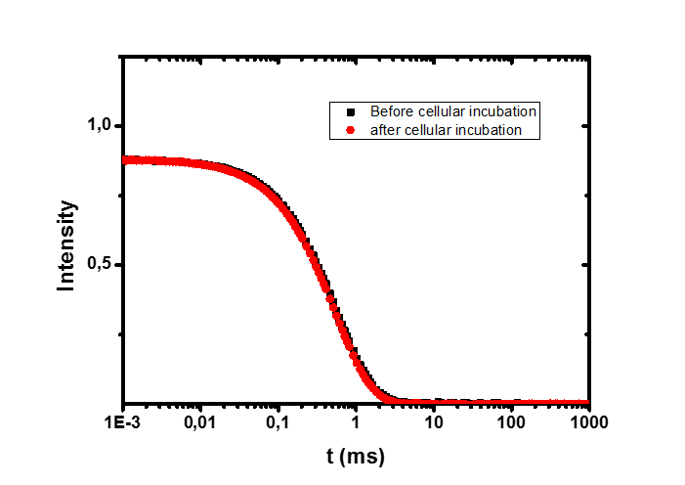
Figure SI 1: Autocorrelation function of the nanohybrids before (black) and after cellular incubation (red) time of 1 hour.

Biological assays, cellular incubation, Amylose column

Cellular uptake studies (sample preparation, cell cultivation and cellular uptake) were reproduced at least two times, without any change in the described features.

Amylose affinity chromatography assay
Expression of the fusion protein His₇-MBP-gamma-peptide (MBP-g) was detailed in reference.⁹ Binding of the fluorescent plasmonic assembly relied on a visual assay based on the specific binding of MBP to amylose. Therefore, 1.5- 2 mL of amylose stock gel was loaded onto a 10 mL capacity column, and washed several times with 10 mL of PBS buffer (20 mM, pH 7.2). After loading the dispersion (100 nM QDs in PBS buffer), the column was washed several times with buffer solution. Elution of the hybrids was achieved by adding a D-maltose solution (20 mM).³

Cell culture preparation and incubation protocol
HeLa cell lines were provided by the Florida State University (Tallahasse, FL, USA) cell culture facility. The cells were cultured in complete growth medium (Dulbecco’s Modified Eagle’s 15 Medium, DMEM, Corning Cellgro) supplemented with 4.5 g/L glucose, L-glutamine, sodium pyruvate, 1% (v/v) antibiotic-antimycotic 100x (Gibco), 1% (v/v) non-essential amino-acid solution 100x (Sigma), and 10% (v/v) fetal bovine serum (FBS, from Gibco). The cells were grown as a monolayer in a T25-flask at 37°C under a humidified 5% CO₂ atmosphere. A subculture was performed every 2-4 days, depending on the type of cells using trypsin-EDTA (Invitrogen).
HeLa cells (~8 x 10⁴) were seeded onto 18 mm circle micro-cover glasses placed into 24-well microtiter plates (CellStar, VWR), and the plates were placed in an incubator (37 °C, humidified 5% CO₂ atmosphere) overnight to allow attachment and recovery. After 24h, the different nanocomposites, diluted into culture medium (DMEM without phenol red, Invitrogen), were added to the cell culture. Cultures were then incubated at 37 °C for 1 h. Cy5-transferrin marker (at 40 μg/mL) was added to the culture to specifically identify the late endosomal/lysosomal compartments (detailed synthesis available in ⁹). Excess unbound QD reagents and Cy5 were removed by washing three times with phosphate-buffered saline (PBS, pH 7.4). The cells were fixed with paraformaldehyde (3% solution, 12 minutes at room temperature, washed and mounted in ProLong Antifade mounting media containing DAPI dye (Invitrogen) for nuclear staining, then imaged.

Epifluorescence microscopy
Epifluorescence images of the fixed cells were collected using a Nikon Ti-E inverted microscope equipped with an Intensilight C-HGFI illuminator and a Photometrics Cool Snap HQ2 camera (Photometrics). Images were collected using a 40x objective (Nikon) and a set of filter cubes purchased from Chroma Technology (Rockingham, VT). Excitation of all samples was provided by a Xe lamp. DAPI fluorescence was detected using a DAPI cube (D350/50x for excitation, dichroic 400DCLP, and D460/50m for detection). The QD fluorescence signal (peak at 575 nm) was detected using a GFP/EGFP cube (HQ470/40x for excitation, dichroic Q495lp, and HQ525/50m for detection), while the Cy5 emission was detected using Tx-Red cube (HQ560/55x for excitation, dichroic Q595lp, and HQ645/75 for detection). The images were analyzed and processed using NIS-Elements Advanced 16 Research (Nikon) and Photoshop Adobe (software). Differential interference contrast (DIC) images were collected using a bright light source.
An epifluorescence z-stack was applied to the HeLa sample, where very high cellular uptake was measured (Figure SI 2 from two different perspectives).
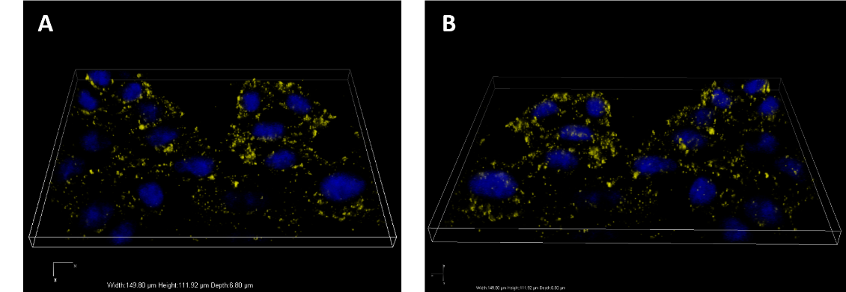
Figure SI 2: Epifluorescence z-stack of HeLa cells after cellular incubation of 1 hour, a nanohybrids concentration of 100 nM and 14 eq. His-MBP-y/AuNP. A and B show the very same picture but from two different perspectives. The displayed volume is 150 µm x 111 µm x 6.8 µm.

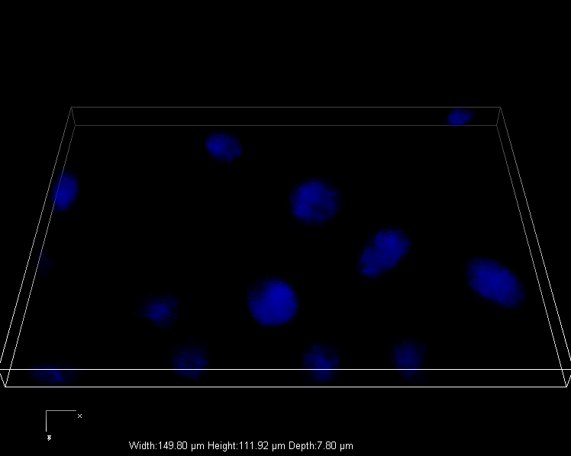
Figure SI 3: Epifluorescence z-stack of HeLa cells after cellular incubation of 1 hour, a nanohybrids concentration of 100 nM and 14 eq. His-MBP/AuNP. The displayed volume is 150 µm x 111 µm x 7.8 µm.

Control experiments - Epifluorescence microscopy
We performed various control experiments, to confirm that the His-MBP-γ bound to the AuNP surface introduced the cellular interaction.
As a control, the HeLa cells, incubated in the cellular growth media alone, which is shown in Figure SI 3 a). Figure SI 3 b) shows HeLa cells after incubation with just the QD-NH₂, indicating no cellular uptake. Figure SI 3 c) shows HeLa cells incubated with QD-NH₂ and the His-MBP-γ. No cellular uptake is observed, indicating that the His-MBP-γ does not interact with the encapsulated QDs, as expected and discussed before.²

Figure SI 4: Investigation of the cellular uptake behavior on HeLa cell- c(QD)=100 nM, t(incubation)=1 h. Merges image of DIC, DAPI channel (blue), Transferin-Cy5 Channel (red) and QD channel (yellow). a) control, HeLa cells, b) QD-NH₂ c) QD-NH₂ in the presence of 12 His-MBP-γ (not attached via AuNPs).

Flow cytometry
Cells were treated with a 500 mL total volume of different concentration of the nanocomposite with His-MBP-γ for 1 h. As a control His-MBP bearing nanocomposites were tested. After cellular incubation, cells were carefully washed with PBS buffer three times. After trypsinization, cells were centrifuged at 1200 rpm for 5 min and resuspended in cell culture medium and analyzed by flow cytometry. Forward scatter (FS), side scatters (SS), and fluorescence of individual cells were measured on a BD FACSAria (SORP) flow cytometer. Forward scatter FS and SS intensities (measured at 488 nm) were digitalized on both linear and logarithmic scale (4 decades). No propidium iodide was uses. Dead cells and living cells were identified by their forward scatter. Samples were excited with a 561 nm laser and emission was collected with a 585/40 bandpass emission filter. These experiments were performed under “lower uptake conditions” meaning a reduced QD to AuNP ratio of 1:1 and replacement of 50% of the His₇-MBP-γ with unreactive His₇-MBP. The flow cytometry data confirms that the cellular uptake is induced by the lytic γ-peptide.
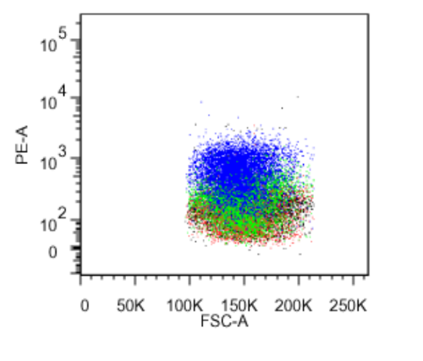
Figure SI 5 Flow cytometry data Forward scatter against 585/40 bandpass emission filter after a cellular incubation of 1 h. Black: HeLa cells, control. Red: Nanohybrid incubated with HIS₇-MBP, green and red, nanohybrids carrying His₇-MBP-γ: Green c(nanohybrids) 50 nM and blue c(nanohybrids) 100 nM.

REFERENCES
(1) Talapin, D. V.; Mekis, I.; Götzinger, S.; Kornowski, A.; Benson, O.; Weller, H. CdSe/CdS/ZnS and CdSe/ZnSe/ZnS Core-Shell-Shell Nanocrystals. J. Phys. Chem. B 2004, 108, 18826–18831.
(2) Ostermann, J.; Merkl, J.-P.; Flessau, S.; Wolter, C.; Kornowksi, A.; Schmidtke, C.; Pietsch, A.; Kloust, H.; Feld, A.; Weller, H. Controlling the Physical and Biological Properties of Highly Fluorescent Aqueous Quantum Dots Using Block Copolymers of Different Size and Shape. ACS Nano 2013, 7, 9156–9167.
(3) Aldeek, F.; Safi, M.; Zhan, N.; Palui, G.; Mattoussi, H. Understanding the Self-Assembly of Proteins onto Gold Nanoparticles and Quantum Dots Driven by Metal-Histidine Coordination. ACS Nano 2013, 7, 10197–10210.
(4) Aldeek, F.; Muhammed, M. A. H.; Palui, G.; Zhan, N.; Mattoussi, H. Growth of Highly Fluorescent Polyethylene Glycol- and Zwitterion-Functionalized Gold Nanoclusters. ACS Nano 2013, 7, 2509–2521.
(5) Pöselt, E.; Schmidtke, C.; Fischer, S.; Peldschus, K.; Salamon, J.; Kloust, H.; Tran, H.; Pietsch, A.; Heine, M.; Adam, G.; et al. Tailor-Made Quantum Dot and Iron Oxide Based Contrast Agents for in Vitro and in Vivo Tumor Imaging. ACS Nano 2012, 6, 3346–3355.
(6) Schmidtke, C.; Pöselt, E.; Ostermann, J.; Pietsch, A.; Kloust, H.; Tran, H.; Schotten, T.; Bastús, N. G.; Eggers, R.; Weller, H. Amphiphilic, Cross-Linkable Diblock Copolymers for Multifunctionalized Nanoparticles as Biological Probes. Nanoscale 2013, 5, 7433–7444.
(7) Merkl, J.-P.; Schmidtke, C.; Aldeek, F.; Safi, M.; Feld, A.; Kloust, H.; Mattoussi, H.; Lange, H.; Weller, H. Functional-Group-Dependent Formation of Bioactive Fluorescent-Plasmonic Nanohybrids. J. Phys. Chem. C 2016, 120, 25732–25741.
(8) Albanese, A.; Walkey, C. D.; Olsen, J. B.; Guo, H.; Emili, A.; Chan, W. C. W. Secreted Biomolecules Alter the Biological Identity and Cellular Interactions of Nanoparticles. ACS Nano 2014, 8, 5515–5526.
(9) Safi, M.; Domitrovic, T.; Kapur, A.; Zhan, N.; Aldeek, F.; Johnson, J. E.; Mattoussi, H. Intracellular Delivery of Luminescent Quantum Dots Mediated by a Virus-Derived Lytic Peptide. Bioconjug. Chem. 2017, 28, 64–74.

