The reaction of anthracyl-α-hydroxyphosphonate with anthracene: Facile Access to diverse (bis)-anthracylphosphonates as a suitable source for useful extensive π-conjugates
Moghal Zubair Khalid Baig, Banchanidhi Prusti, Shouvik Bhuin and Manab Chakravarty*

Contents
Emission spectra of 3a in different solvents S2
Emission spectra of 3a-d in MeCN S2
Normalized emission spectra of 3a-d S2
Absorption and emission spectra of 3a-c S3
Viscochromism study S3

Concentration-dependent fluorescence study S4
Reversibility studies S4
Attempts for the HWE reaction of compound A S4-S5
NMR Spectra S5-S13

Figure S1: Emission spectra of compound 3a (10 μM) in different water-miscible solvents. λ_{ex} = 405 nm.
Figure S2: Emission spectra of compound 3a-d (10 μM) in MeCN. λex = 405 nm.
Figure S3: Normalized emission spectra of compound 3a-d (10 μM) in MeCN. λex = 405 nm.

Figure S4: (a) absorption spectra (b) emission spectra (c) plot of f_{w} vs Fl. Int. for 3a 10 μM in acetonitrile. λ_{ex} = 405 nm.

Figure S5: (a) absorption spectra (b) emission spectra (c) f_{w} (v/v%) spectra of compound 3b 10 μM in acetonitrile. λ_{ex} = 405 nm.

Figure S6: (a) absorption spectra (b) emission spectra (c) f_{w} (v/v%) spectra of compound 3c 10 μM in acetonitrile. λ_{ex} = 405 nm.

Figure S7: Viscochromism study for probe 3d (10⁻⁵ M in MeOH and MeOH:Glycerol 1:1) (λ_{ex}= 405nm)

Figure S8: Concentration-dependent fluorescence study in MeCN (λ_{ex}= 405nm)

Table S1: Attempts for the Horner-Wadsworth-Emmons reaction of compound A with 4-bromobenzaldehyde with different bases at various conditions: NR: No reaction
Base | Time (hr) | Temp (ºC) | Conclusion
K₂CO₃ | 24 | 0 | NR
K₂CO₃ | 24 | 25 | NR
K₂CO₃ | 24 | 80 | NR
KO^{t}Bu | 24 | 0 | NR
KO^{t}Bu | 24 | 25 | NR
KO^{t}Bu | 24 | 80 | NR
NaH | 24 | 0 | NR
NaH | 24 | 25 | NR
NaH | 24 | 80 | NR
n-BuLi | 24 | 0 | NR
n-BuLi | 24 | 25 | NR
n-BuLi | 24 | 80 | NR

NMR spectra:

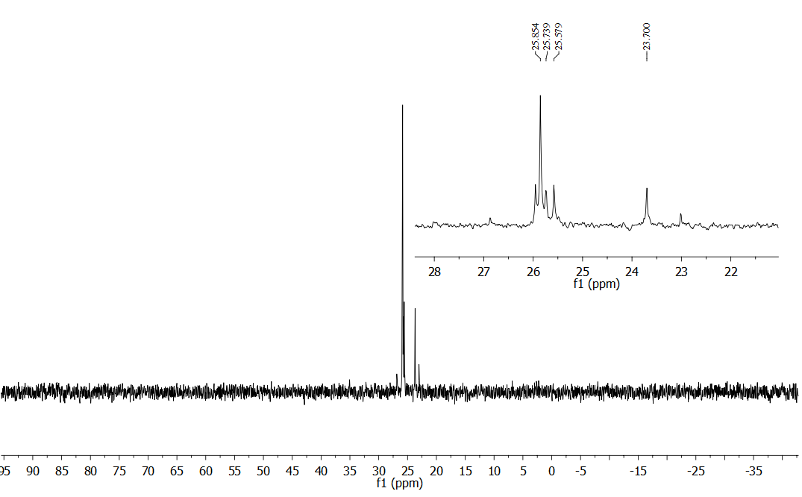
Figure S10: ³¹P-NMR spectrum of the reaction mixture; peak at δ23.7 corresponds to the starting material α-hydroxyphosphonate.
Figure S11: ¹H NMR spectrum of compound A
Figure S12: ¹³C NMR spectrum of compound A

Figure S13: ³¹PNMR spectrum of compound A

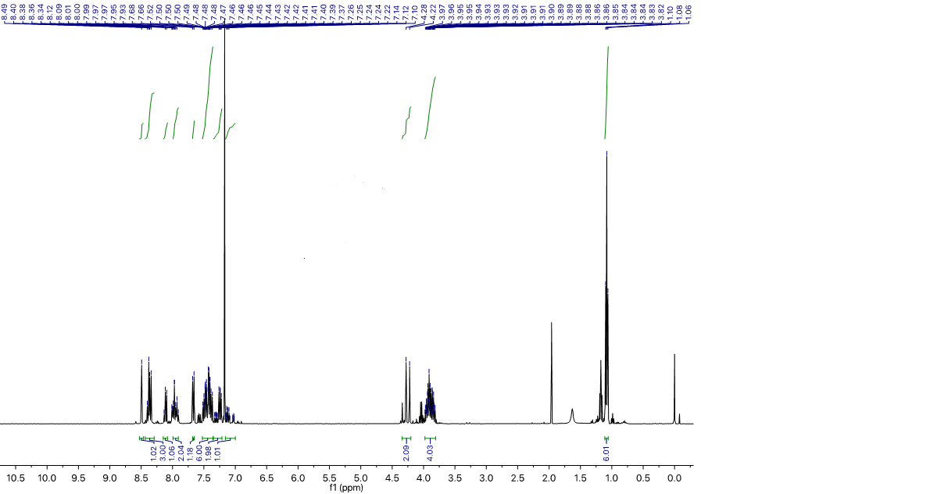
Figure S14: ¹H NMR spectrum of regioisomeric mixture of compound B (~25%) and C (~75%). The peak at δ1.97 is assigned for the solvent acetone as a small peak at ~ δ208.0 and 21.0 for Me₂CO are also observed in ¹³C NMR.
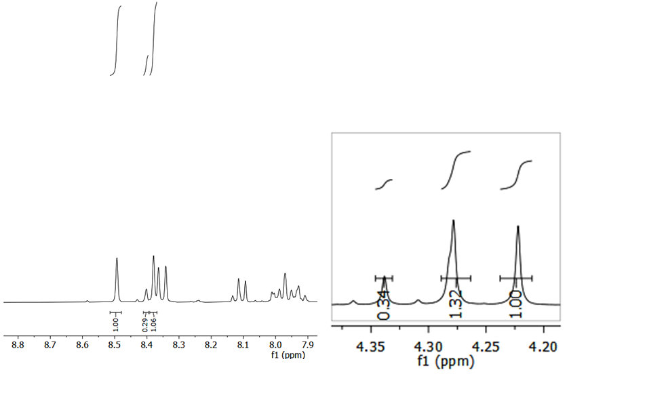
Figure S15: Partial ¹H NMR spectrum of compound B (~25%) and C (~75%) with extended part depicting the ratio of B/C. The peaks at δ8.49 and 8.38 are designated for compound C and the singlet at δ8.40 is designated for compound B. The doublet at δ 4.25 (J ~22 Hz for PCH₂) is accounted for compound C and doublet at δ 4.31 (J ~22 Hz for PCH₂; one peak is almost merged but signature is visible) originates from compound B.
Figure S16: ¹³C NMR NMR spectrum of regioisomeric mixture of compound B (~25%) and C (~75 %).
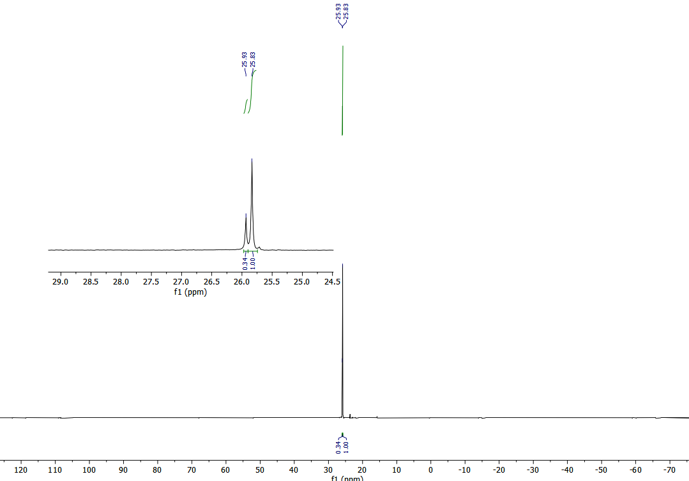
Figure S17: ³¹P NMR spectrum of regioisomeric mixture of compound B (~25%) and C (~75%).

Figure S18: ¹H NMR spectrum of compound 3a
Figure S19: ¹³C NMR spectrum of compound 3a
Figure S20: ¹H NMR spectrum of compound 3b
Figure S21: ¹³C NMR spectrum of compound 3b
Figure S22: ¹H NMR spectrum of compound 3c
Figure S23: ¹³C NMR spectrum of compound 3c
Figure S24: ¹H NMR spectrum of compound 3d
Figure S25: ¹³C NMR spectrum of compound 3d
--THE END--

