**Supporting information**

**Undescribed triterpenoids obtained from *Dictamnus dasycarpus* Turcz and their anti-proliferation activities**

Ye Sun1, Yan Liu1, Si-Yi Wang, Xu Yang, Jia-Tong Wu Juan Pan, Zhi-Chao Hao, Wei Guan, Zhen-Peng Xu, Yuan-Yuan Zhou, Shao-Wa Lv, Hai-Xue Kuang* and Bing-You Yang*

*Key Laboratory of Basic and Application Research of Beiyao (Heilongjiang University of Chinese Medicine), Ministry of Education, Harbin 150040, People's Republic of China*

**Corresponding Author:**

*Haixue Kuang, Email: hxkuang@yahoo.com, Tel.: +86-0451-87267188;

*Bingyou Yang, Email: ybywater@163.com, Tel.: +86-0451-87267038

**ABSTRACT**

Three new triterpenoids, named dictamtriterpenol B-D (**1-3**), along with ten known compounds (**4-13**), were isolated from *Dictamnus dasycarpus* Turcz. The structures of all compounds were characterized by spectroscopic methods, including IR, HR-ESI-MS, 1D and 2D NMR. Furthermore, HepG2 and A549 cell lines were used to evaluate their anti-proliferation activities, and compounds **1**, **5**and **8** (IC50 values in the range of 1.84±0.03 to 14.98±0.39 *μ*M) displayed significant anti-proliferation activity against HepG2 cells. As well as compounds **1**, **4**, **9**, **10** and **13** (IC50 values in the range of 1.63±0.04 to 8.56±1.46 *μ*M) displayed significant anti-proliferation activity against A549 cells.

**Keywords**

*Dictamnus dasycarpus* Turcz; Triterpenoids; Anti-proliferation

Contents

**Fig.S1-1.** 1H-NMR (600 MHz) spectrum of compound **1** in CD3OD

**Fig.S1-2.** 13C-NMR (150 MHz) spectrum of compound **1** in CD3OD

**Fig.S1-3.** DEPT 135 spectrum of compound **1** in CD3OD

**Fig.S1-4.** HSQC spectrum of compound **1** in CD3OD

**Fig.S1-5.** 1H-1H COSY spectrum of compound **1** in CD3OD

**Fig.S1-6.** HMBC spectrum of compound **1** in CD3OD

**Fig.S1-7.** NOESY spectrum of compound **1** in CD3OD

**Fig.S1-8.** HR-ESI-MS spectrum of compound **1**

**Fig.S1-9.** IR spectrum of compound **1**

**Fig.S2-1.** 1H-NMR (600 MHz) spectrum of compound **2** in CD3OD

**Fig.S2-2.** 13C-NMR (150 MHz) spectrum of compound **2** in CD3OD

**Fig.S2-3.** DEPT 135 spectrum of compound **2** in CD3OD

**Fig.S2-4.** HSQC spectrum of compound **2** in CD3OD

**Fig.S2-5.** 1H-1H COSY spectrum of compound **2** in CD3OD

**Fig.S2-6.** HMBC spectrum of compound **2** in CD3OD

**Fig.S2-7.** NOESY spectrum of compound **2** in CD3OD

**Fig.S2-8.** HR-ESI-MS spectrum of compound **2**

**Fig.S2-9.** IR spectrum of compound **2**

**Fig.S3-1.** 1H-NMR (600 MHz) spectrum of compound **3** in CD3OD

**Fig.S3-2.** 13C-NMR (150 MHz) spectrum of compound **3** in CD3OD

**Fig.S3-3.** DEPT 135 spectrum of compound **3** in CD3OD

**Fig.S3-4.** HSQC spectrum of compound **3** in CD3OD

**Fig.S3-5.** 1H-1H COSY spectrum of compound **3** in CD3OD

**Fig.S3-6.** HMBC spectrum of compound **3** in CD3OD

**Fig.S3-7.** NOESY spectrum of compound **3** in CD3OD

**Fig.S3-8.** HR-ESI-MS spectrum of compound **3**

**Fig.S3-9.** IR spectrum of compound **3**

**Table S1.** 13C NMR Data ofcompounds **4-13** (150MHz in 13C NMR, in CD3OD)

**Table S2.** Cytotoxic activities (IC50, μM) of all tested compounds on two human cancer cell lines

**Fig.S1-1.** 1H-NMR (600 MHz) spectrum of compound **1** in CD3OD

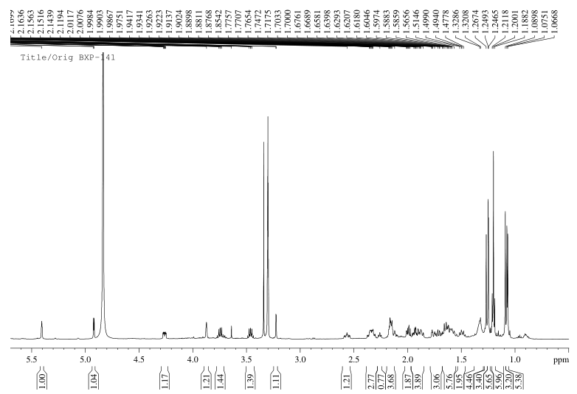

**Fig.S1-2.** 13C-NMR (150 MHz) spectrum of compound **1** in CD3OD

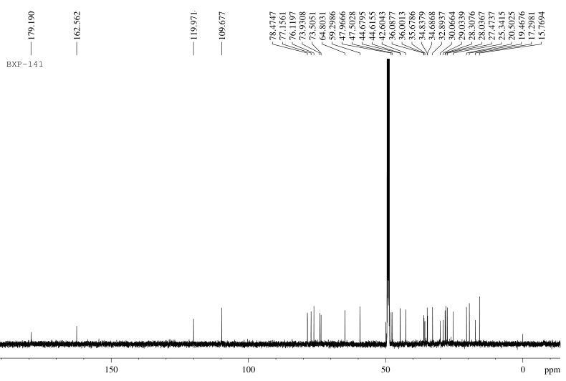

**Fig.S1-3.** DEPT 135 spectrum of compound **1** in CD3OD

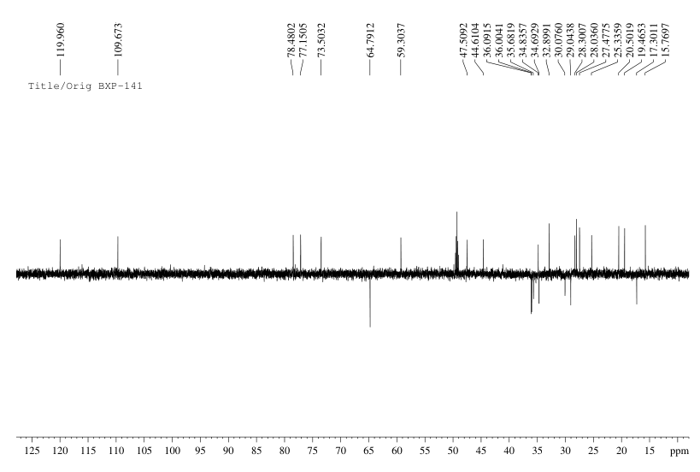

**Fig.S1-4.** HSQC spectrum of compound **1** in CD3OD

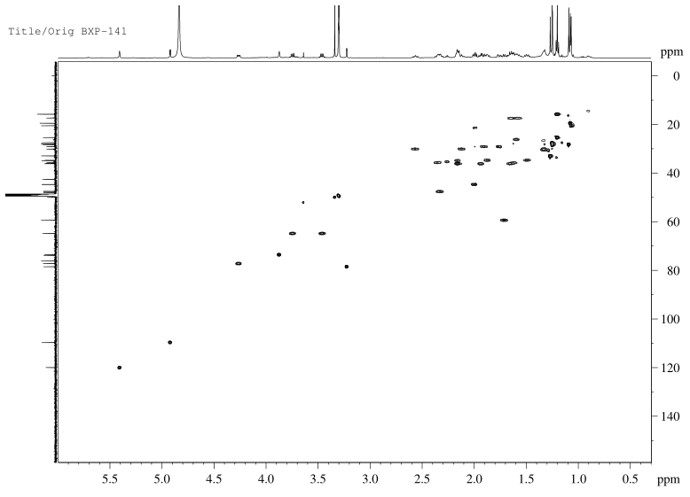

**Fig.S1-5.** 1H-1H COSY spectrum of compound **1** in CD3OD

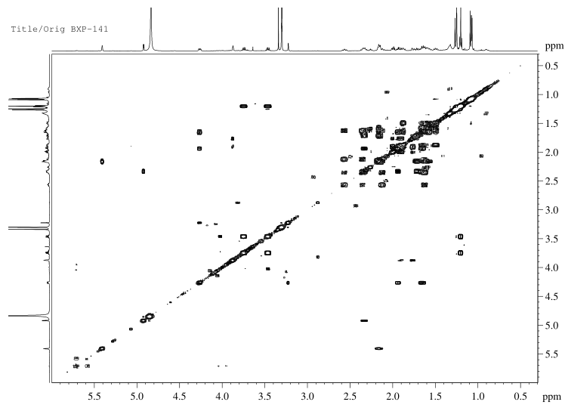

**Fig.S1-6.** HMBC spectrum of compound **1** in CD3OD

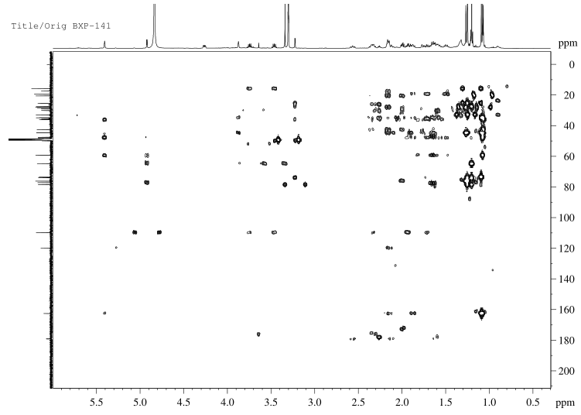

**Fig.S1-7.** NOESY spectrum of compound **1** in CD3OD

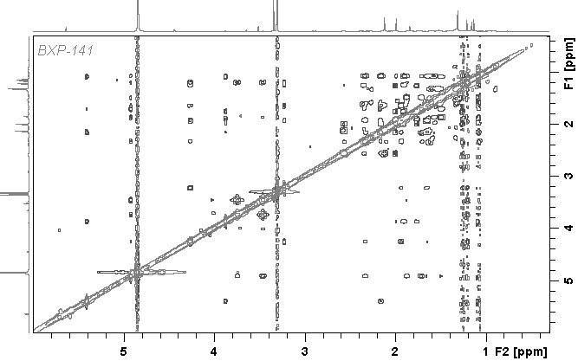

**Fig.S1-8.** HR-ESI-MS spectrum of compound **1**

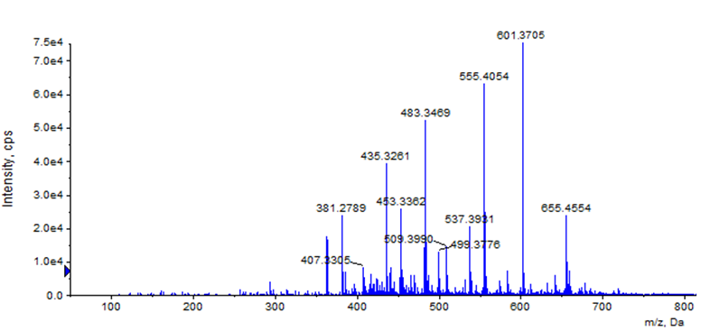

**Fig.S1-9.** IR spectrum of compound **1**



**Fig.S2-1.** 1H-NMR (600 MHz) spectrum of compound **2** in CD3OD

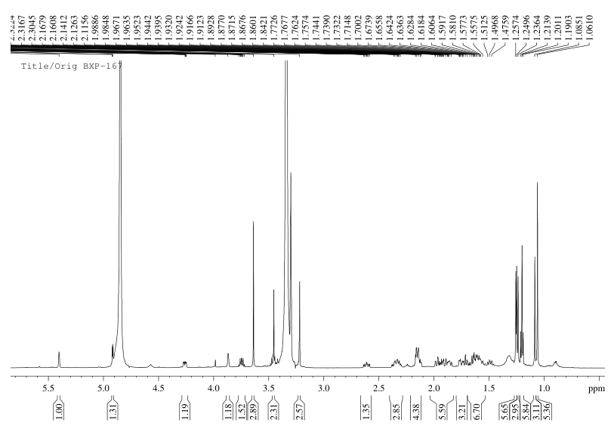

**Fig.S2-2.** 13C-NMR (150 MHz) spectrum of compound **2** in CD3OD

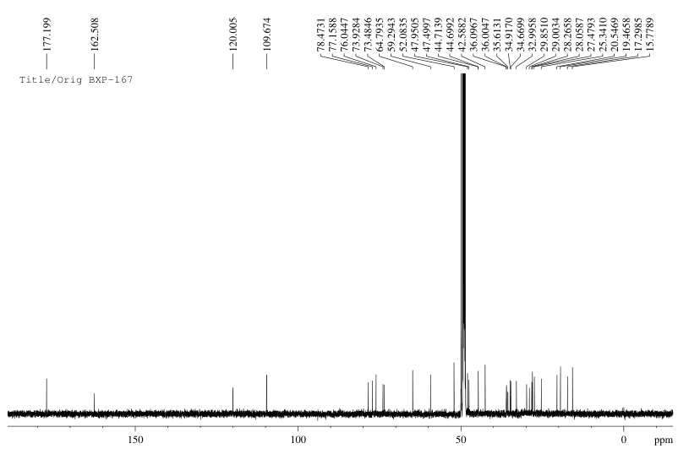

**Fig.S2-3.** DEPT 135 spectrum of compound **2** in CD3OD

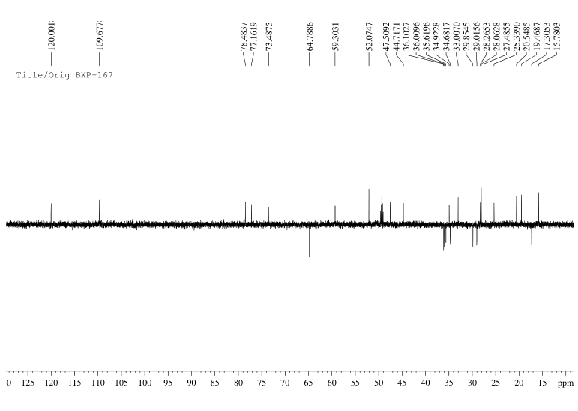

**Fig.S2-4.** HSQC spectrum of compound **2** in CD3OD

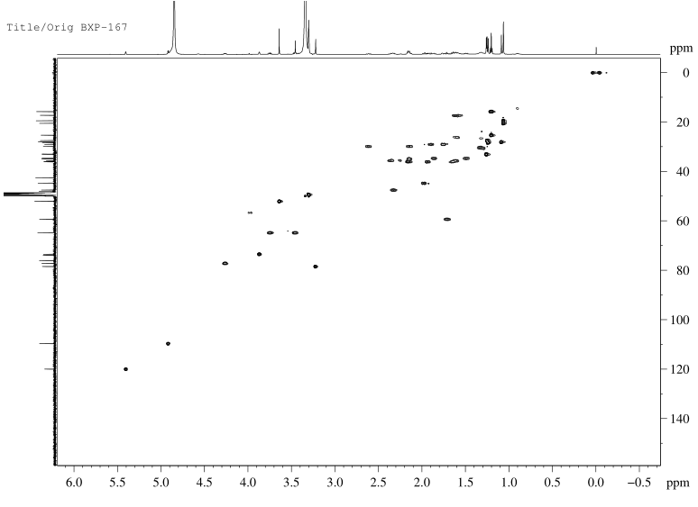

**Fig.S2-5.** 1H-1H COSY spectrum of compound **2** in CD3OD

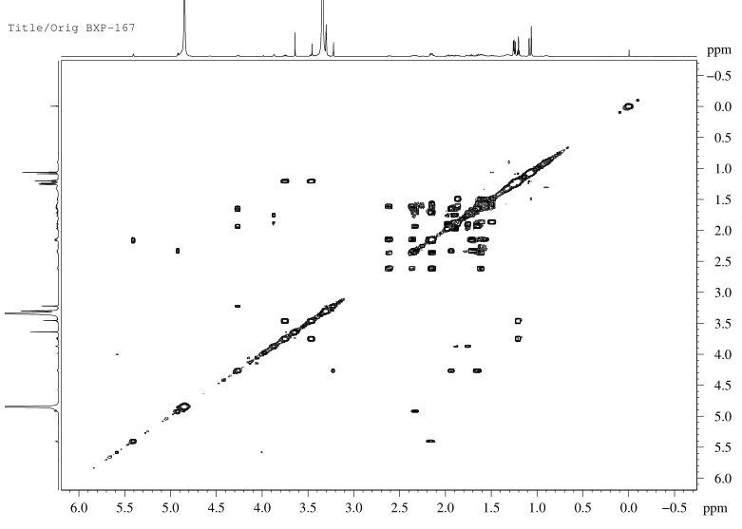

**Fig.S2-6.** HMBC spectrum of compound **2** in CD3OD

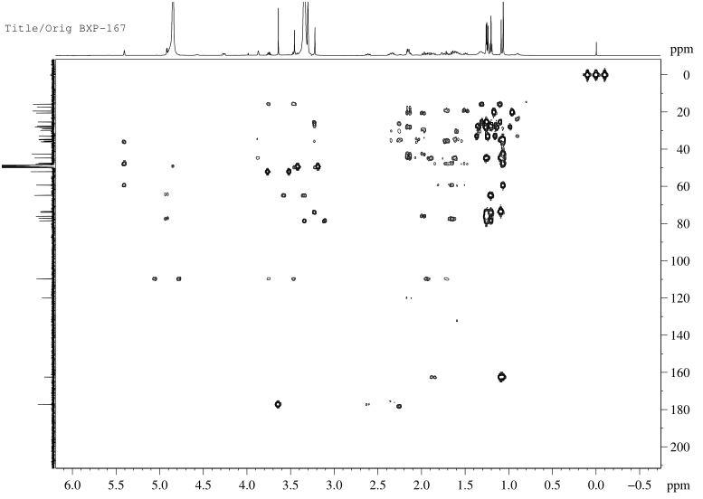

**Fig.S2-7.** NOESY spectrum of compound **2**

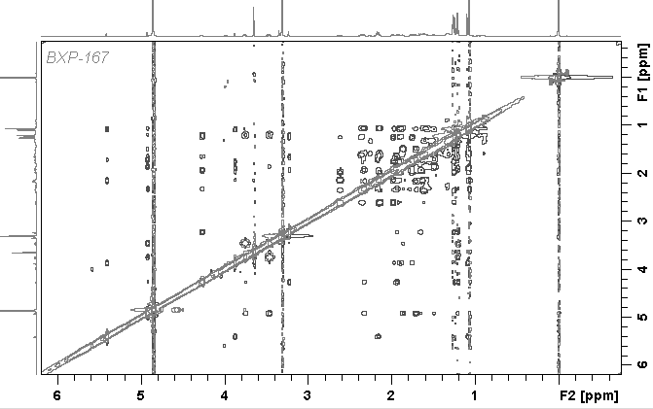

**Fig.S2-8.** HR-ESI-MS spectrum of compound **2**

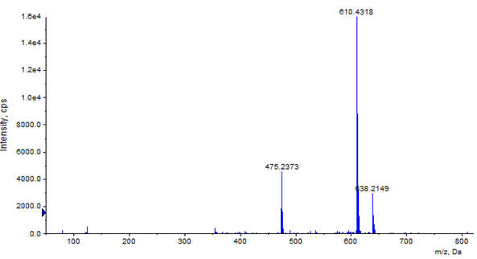

**Fig.S2-9.** IR spectrum of compound **2**



**Fig.S3-1.** 1H-NMR (600 MHz) spectrum of compound **3** in CD3OD

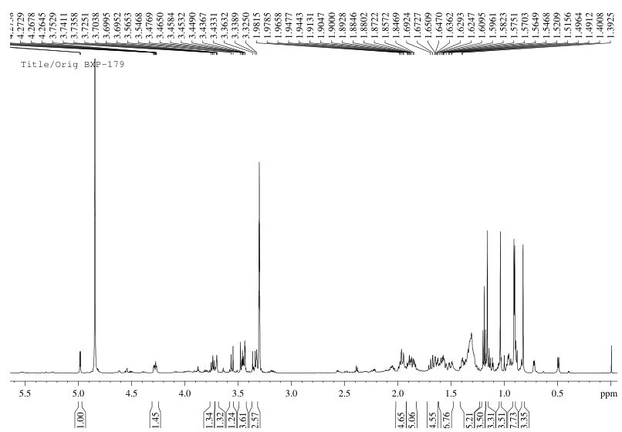

**Fig.S3-2.** 13C-NMR (150 MHz) spectrum of compound **3** in CD3OD

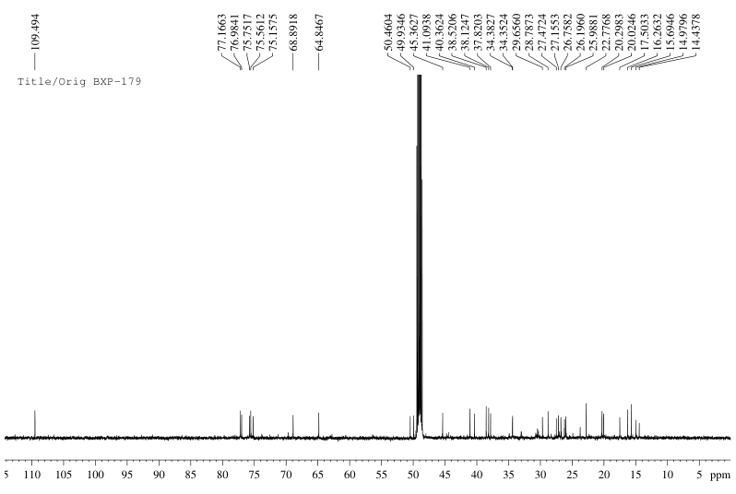

**Fig.S3-3.** DEPT 135 spectrum of compound **3** in CD3OD

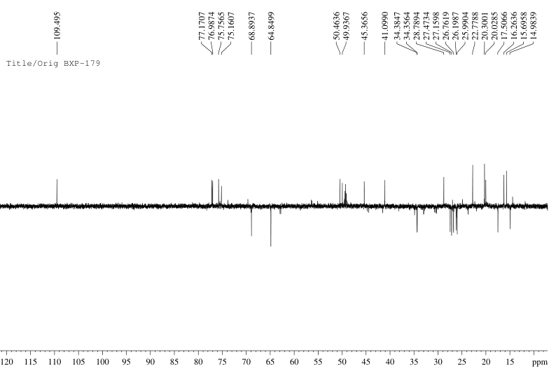

**Fig.S3-4.** HSQC spectrum of compound **3** in CD3OD

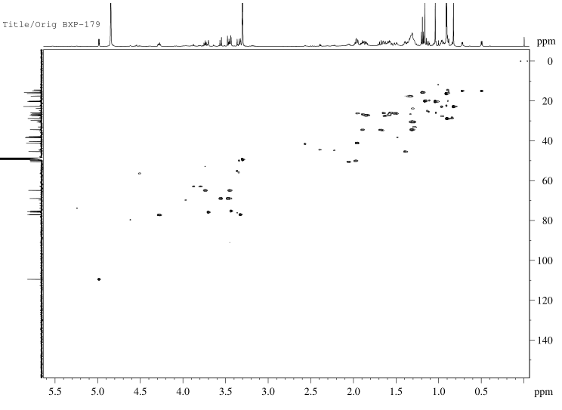

**Fig.S3-5.** 1H-1H COSY spectrum of compound **3** in CD3OD

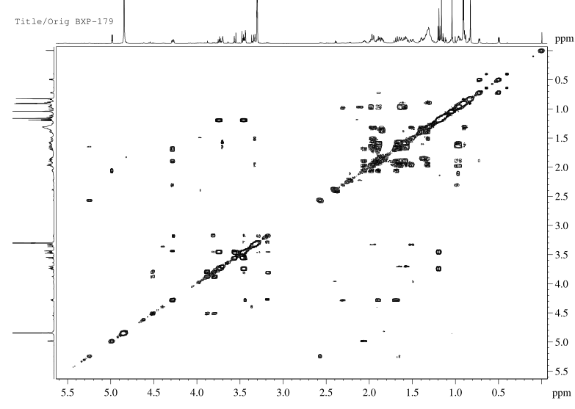

**Fig.S3-6.** HMBC spectrum of compound **3** in CD3OD

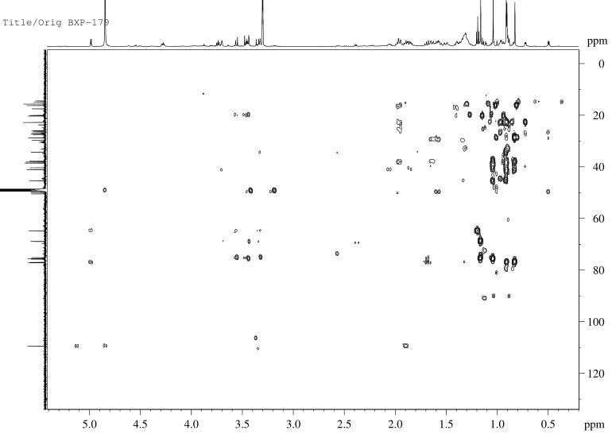

**Fig.S3-7.** NOESY spectrum of compound **3** in CD3OD

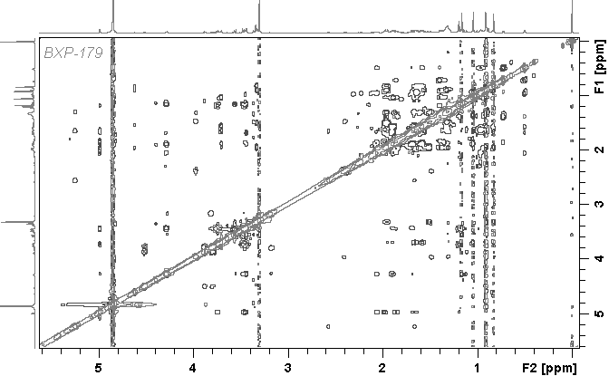

**Fig.S3-8.** HR-ESI-MS spectrum of compound **3**

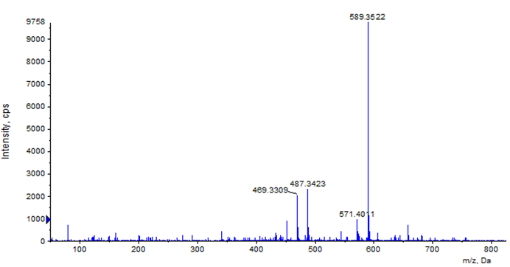

**Fig.S3-9.** IR spectrum of compound **3**



**Table S1.** 13C NMR Data ofcompounds **4-13** (150MHz in 13C NMR, in CD3OD)

|  |  |  |  |  |  |  |  |  |  |  |
| --- | --- | --- | --- | --- | --- | --- | --- | --- | --- | --- |
| **No** | **4** | **5** | **6** | **7** | **8** | **9** | **10** | **11** | **12** | **13** |
| **1** | 39.8 | 31.1 | 31.1 | 30.4 | 33.6 | 34.6 | 33.2 | 34.4 | 35.0 | 72.7 |
| **2** | 27.1 | 29.9 | 29.4 | 30.2 | 26.2 | 27.5 | 22.3 | 22.8 | 27.7 | 35.9 |
| **3** | 90.8 | 89.7 | 89.7 | 89.8 | 78.5 | 77.2 | 78.2 | 77.0 | 79.6 | 173.5 |
| **4** | 40.2 | 41.1 | 41.1 | 41.1 | 35.6 | 36.0 | 35.7 | 37.5 | 37.4 | 87.8 |
| **5** | 57.0 | 43.6 | 43.6 | 43.7 | 42.6 | 42.6 | 43.3 | 41.0 | 42.6 | 45.6 |
| **6** | 19.5 | 22.5 | 22.5 | 22.5 | 27.5 | 25.3 | 23.8 | 26.0 | 26.0 | 27.3 |
| **7** | 34.2 | 114.4 | 115.0 | 115.0 | 73.5 | 73.1 | 73.8 | 75.4 | 75.4 | 76.2 |
| **8** | 41.1 | 149.3 | 148.7 | 148.9 | 44.7 | 44.7 | 37.2 | 40.3 | 40.5 | 43.1 |
| **9** | 47.2 | 21.8 | 22.2 | 21.8 | 41.8 | 44.7 | 44.1 | 45.4 | 45.4 | 37.1 |
| **10** | 37.9 | 29.3 | 29.0 | 29.0 | 36.1 | 36.1 | 35.9 | 38.5 | 37.8 | 45.5 |
| **11** | 24.7 | 25.9 | 26.4 | 25.5 | 17.3 | 18.2 | 18.6 | 17.6 | 17.5 | 17.6 |
| **12** | 129.5 | 34.6 | 34.9 | 34.7 | 33.0 | 33.0 | 23.9 | 26.2 | 26.7 | 35.7 |
| **13** | 140.0 | 42.4 | 42.0 | 42.0 | 48.0 | 47.9 | 29.2 | 30.7 | 29.7 | 47.7 |
| **14** | 42.6 | 50.6 | 51.1 | 51.5 | 162.5 | 177.2 | 35.2 | 38.1 | 38.6 | 160.7 |
| **15** | 29.6 | 79.8 | 79.0 | 79.4 | 120.0 | 120.0 | 24.6 | 27.0 | 27.1 | 120.1 |
| **16** | 26.6 | 103.7 | 112.9 | 113.0 | 35.2 | 35.6 | 24.7 | 28.8 | 23.9 | 34.9 |
| **17** | 47.7 | 61.3 | 60.4 | 61.6 | 59.3 | 59.2 | 46.2 | 46.1 | 50.0 | 58.4 |
| **18** | 55.1 | 22.8 | 21.9 | 22.2 | 19.5 | 19.4 | 14.1 | 14.8 | 14.9 | 19.5 |
| **19** | 73.6 | 29.2 | 29.9 | 29.4 | 15.8 | 17.3 | 15.9 | 16.3 | 16.1 | 15.3 |
| **20** | 43.1 | 26.5 | 24.8 | 24.1 | 47.5 | 47.4 | 50.6 | 50.3 | 50.6 | 31.0 |
| **21** | 27.3 | 22.1 | 20.0 | 19.7 | 109.7 | 110.8 | 109.0 | 106.5 | 110.7 | 66.2 |
| **22** | 39.0 | 33.4 | 38.9 | 29.9 | 34.7 | 34.9 | 33.1 | 32.8 | 34.6 | 34.2 |
| **23** | 28.6 | 74.8 | 72.6 | 74.7 | 77.2 | 78.5 | 77.1 | 79.7 | 77.2 | 69.0 |
| **24** | 17.0 | 81.8 | 90.9 | 84.9 | 76.0 | 76.0 | 75.9 | 76.1 | 75.1 | 96.4 |
| **25** | 15.9 | 73.4 | 73.2 | 70.0 | 73.9 | 73.5 | 72.5 | 69.0 | 75.6 | 77.4 |
| **26** | 17.5 | 26.7 | 25.9 | 31.2 | 28.1 | 28.0 | 25.6 | 27.1 | 69.0 | 25.2 |
| **27** | 24.8 | 27.7 | 24.8 | 25.9 | 28.2 | 28.3 | 26.1 | 28.7 | 20.0 | 23.5 |
| **28** | 182.7 | 18.1 | 18.4 | 18.5 | 29.0 | 29.8 | 26.9 | 30.1 | 28.4 | 34.8 |
| **29** | 27.1 | 26.2 | 25.4 | 26.4 | 25.3 | 20.5 | 21.3 | 20.4 | 22.4 | 23.6 |
| **30** | 16.6 | 14.4 | 14.4 | 14.4 | 29.9 | 29.0 | 20.7 | 19.7 | 20.3 | 27.7 |
| **1'** | 107.2 | 107.2 | 107.2 | 107.3 |  |  |  |  | 174.7 |  |
| **2'** | 72.8 | 75.5 | 75.5 | 75.5 |  |  |  |  | 44.8 |  |
| **3'** | 74.4 | 78.0 | 78.0 | 78.0 |  |  |  |  | 27.0 |  |
| **4'** | 69.5 | 71.3 | 71.3 | 71.3 |  |  |  |  | 22.8 |  |
| **5'** | 66.4 | 69.0 | 66.7 | 66.7 |  |  |  |  | 22.8 |  |
| **OMe** |  |  |  |  |  | 55.7 | 54.4 | 55.1 | 55.9 |  |
| **OAc** |  | 172.2 |  |  | 177.2 |  |  |  |  | 171.3 |
| **OAc** |  | 21.0 |  |  | 20.5 |  |  |  |  | 20.8 |
| **OAc** |  |  |  |  |  |  |  |  |  | 171.9 |
| **OAc** |  |  |  |  |  |  |  |  |  | 21.2 |
| **OEt** |  |  |  |  | 64.8 |  |  |  |  |  |
| **OEt** |  |  |  |  | 16.3 |  |  |  |  |  |

**Table S2.** Cytotoxic activities (IC50, μM) of all tested compounds on two human cancer cell lines

|  |  |  |  |  |  |
| --- | --- | --- | --- | --- | --- |
| Sample | HepG2 | A549 | Sample | HepG2 | A549 |
| Compound **1** | 5.69±0.33 | 8.56±1.46 | Compound **8** | 1.84±0.03 | >20 |
| Compound **2** | >20 | >20 | Compound **9** | >20 | 1.63±0.04 |
| Compound **3** | >20 | >20 | Compound **10** | >20 | 4.33±0.73 |
| Compound **4** | >20 | 4.13±1.26 | Compound **11** | >20 | >20 |
| Compound **5** | 14.98±0.39 | >20 | Compound **12** | >20 | >20 |
| Compound **6** | >20 | >20 | Compound **13** | >20 | 3.57±0.57 |
| Compound **7** | >20 | >20 |  |  |  |

The IC50 greater than 20 μM was deemed inactive.