Supporting information

Evaluating analytical performance and characterization of silver-based SERS substrate fabricated by 3D printed microfluidic droplet generation

Phommachith Sonexai, Minh Van Nguyen , Bui The Huy, Yong-Ill Lee*

Anastro Laboratory, Institute of Basic Science, Changwon National University, Changwon 51140, Republic of Korea

_____________________________
*Corresponding author: Email: yilee@changwon.ac.kr (Y-I Lee)

Fabrication of droplet-based microfluidic device using 3D printing
Scheme S1. Four steps of the fabrication process of a microfluidic device: (a) 3D printing of the mold; (b) PDMS casting; (c) PDMS peel-off; and (d) PDMS – glass bonding.

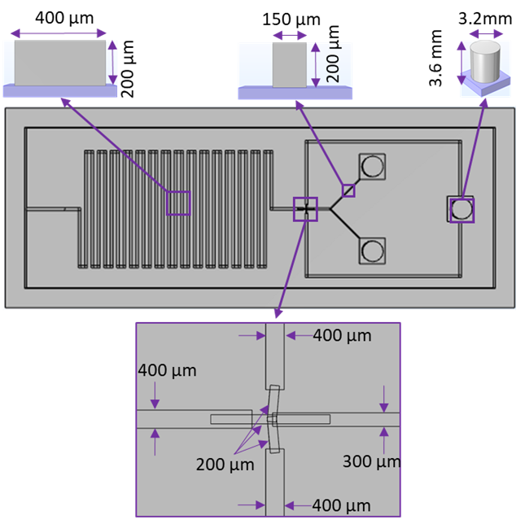
Figure S1. Design of the mold with a serpentine shape by Solidworks Professional 2022 SP3.1 software.

Optimization of droplet generation
To determine the size of the droplet, we applied two colors of fluid and took photos at three spots as illustrated in Figure S2.
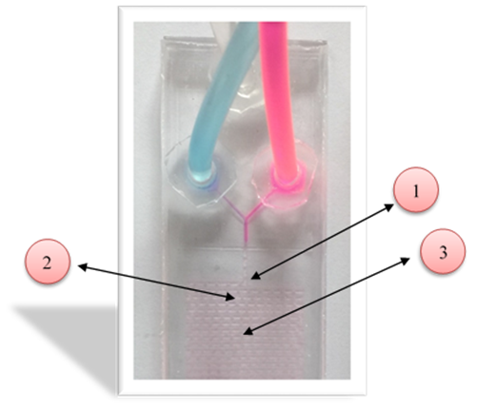
Figure S2. Droplet-based microfluidic device.

The sizes of droplets based on the flow rate ratio between oil and solutions were investigated. For the ratio of 5:5 µL /min (aqueous solutions: oil), with this condition the size of the droplet couldn’t determine due to the camera’s angle is smaller than the droplet’s size (Figure S3). Therefore, we continue increasing the flow rate of oil from 5 µL/min to 20 µL/min, and 40 µL/min, respectively, belonging to that region, the size of the droplets could determine. However, the droplets that generate under these conditions are not stable. Hence, to improve the stability of droplets, we have increased the flow rate ratio of aqueous solutions and oil from 5 µL/min to 10 µL/min and 20 µL/min. The uniform and stable droplets were obtained, as displayed in Figure S4 and Figure S5. As illustrated in Figure S6, the sizes of droplets are inversely proportional to the flow rate. For instance, the increase in the flow rate resulted in the formation of smaller droplets, whereas decreasing the flow rate allowed larger droplets to form. It is worth noting that droplets generated at a lower flow rate of solutions (5 µL/min and 10 µL/min) were not stable. However, more stable droplets were formed when the flow rate of the aqueous solution was increased to 20 µL/min, notably at the flow rate of 1:3.5 and 1:4 (aqueous solutions: oil). Therefore, all silver nanoparticles in this research are synthesized with a flow rate ratio of the aqueous solution to oil was 1:4 (20:80 µL/min).

- Maintain the flow rate of solutions at 5 µL/min and change the oil’s flow rates.
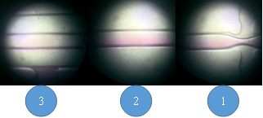
Figure S3. Droplets size distribution with maintaining the flow rate of aqueous solutions at 5 µL/min and changing the oil’s flow rates from 5.5 µL/min(1), 5.2 µL/min (2), and 5.4 µL/min (3).

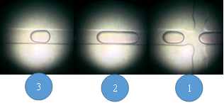
Figure S4. Droplets size distribution with maintaining the flow rate of solutions at 5 µL/min and changing the oil’s flow rates from 5 µL/min (1), 20 µL/min (2), and 40 µL/min (3).

- Maintain the flow rate of solutions at 10µL/min and change the oil’s flow rates.
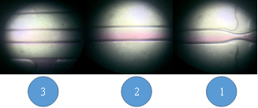
Figure S5. Droplets size distribution with maintaining the flow rate of aqueous solutions at 10 µL/min and changing the oil’s flow rates from 10 µL/min(1), 30 µL/min (2), and 60 µL/min (3).

- Maintain the flow rate of solutions at 20µL/min and change the oil’s flow rates.
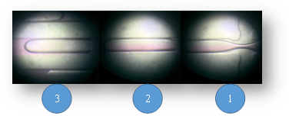
Figure S6. Droplets size distribution with maintaining the flow rate of solutions at 20 µL/min and changing the oil’s flow rates from 20 µL/min (1), 40 µL/min (2), and 80 µL/min (3).

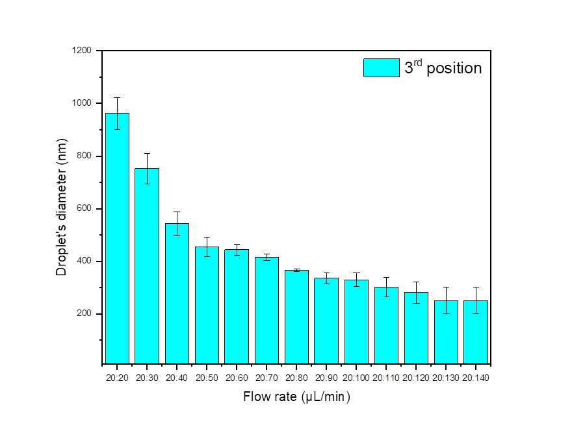
Figure S7. The droplet’s diameter distribution is based on the third position of the microfluidic chip obtained as the flow rate of solutions at 20 µL/min and change the oil’s flow rate from 20 µL/min to 140 µL/min, respectively.

Synthesis of silver nanoparticles via droplet-based microfluidic device
Through the chemical reduction reaction, Ag NPs were synthesized using the microfluidic device. The Ag NPs were synthesized from silver nitrate (AgNO₃) as an Ag⁺ source, sodium citrate (TSC) as a stabilizer, and sodium borohydride (NaBH₄) as a reducing agent [1, 2]. Ag NPs were synthesized at room temperature with a flow rate ratio of aqueous solutions and oil of 20:80 µL/min with various mole ratios of silver nitrate to sodium borohydride, as shown in Figures S8-9.

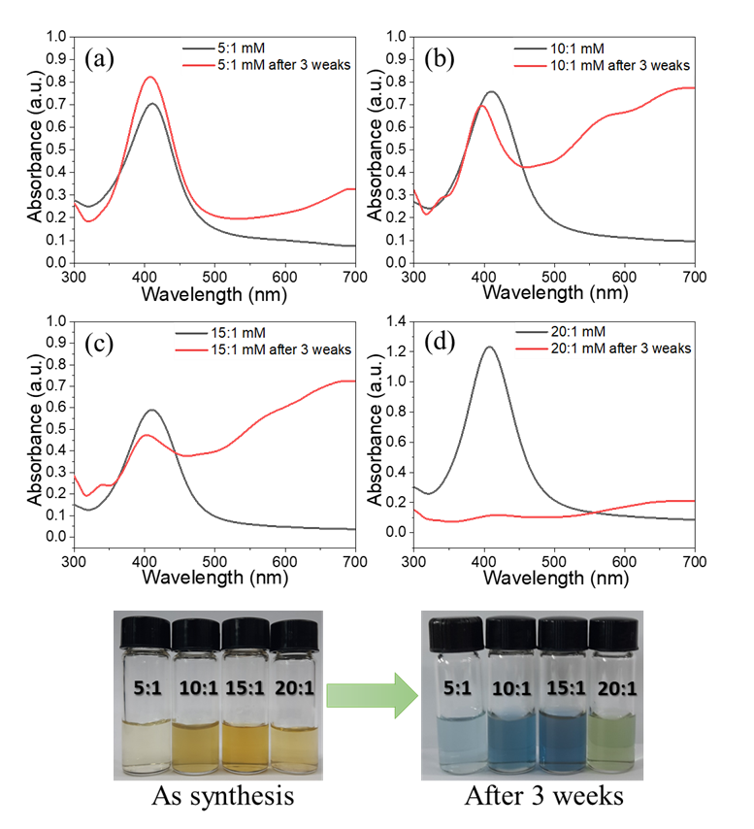
Figure S8. Optical images and absorbance spectra of Ag NPs synthesized using silver nitrate and sodium borohydride 5:1mM (a), 10:1 mM (b), 15:1mM (c), 20:1 mM (d).

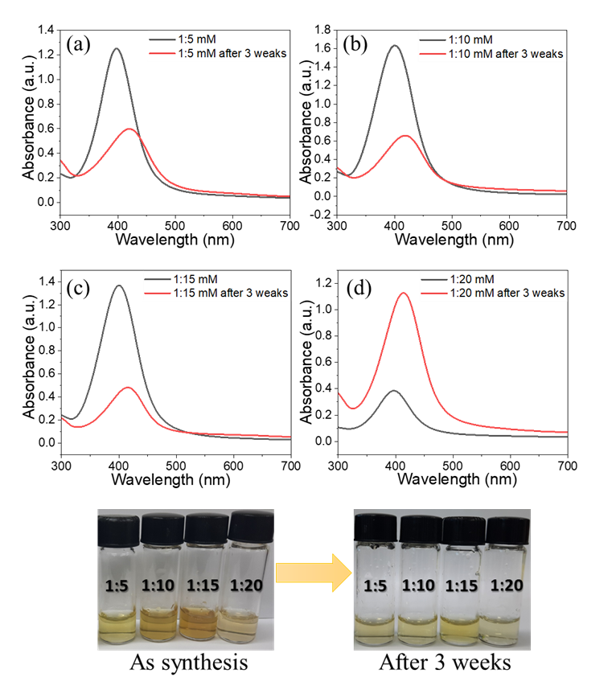
Figure S9. Optical images and absorbance spectra of Ag NPs synthesized using silver nitrate and sodium borohydride 1:5mM (a), 1:10mM (b), 1:15mM (c), 1:20 mM (d).

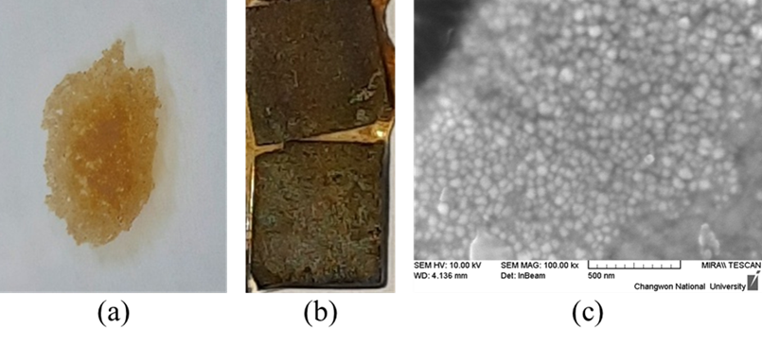
Figure S10. (a) SAM of Ag NPs on the surface of methanol, (b) PS@Ag, (c) FE-SEM images PS@Ag.

FESEM image and EDX spectra of the SERS substrate
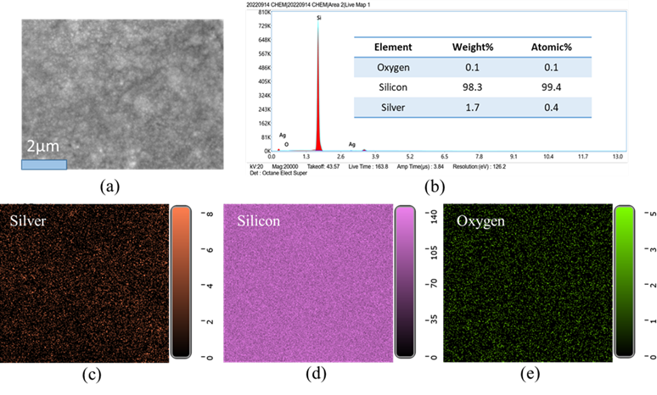
Figure S11. (a) FE-SEM image of the PS@Ag substrate surface. (b) EDX spectrum with the inset table listing the weight and atomic concentration of oxygen, silicon, and silver. Elemental mapping by EDX of silver (c), silicon (d), and oxygen (e).

SEM images of the SERS substrate with RhB
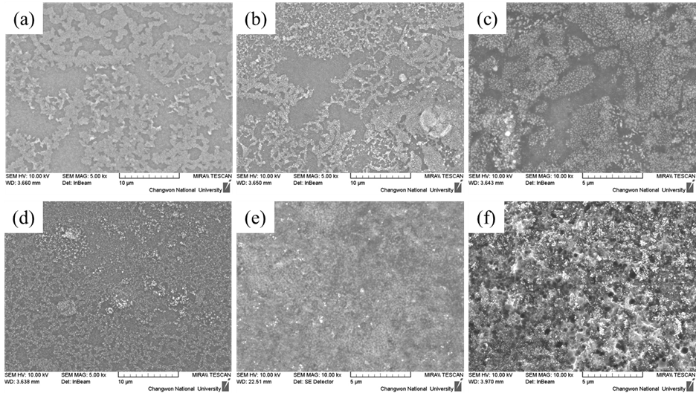
Figure S12. SERS substrate with different etching time (a) PS0min@Ag, (b) PS5min@Ag, (c) PS10min@Ag, (d) PS20min@Ag, (e) PS40min@Ag, and (f) PS80min@Ag.

Calculating the enhancement factor for RhB
The EF of the SERS substrates at 621 cm⁻¹ peak with RhB concentration of 10⁻⁹ M was calculated to be 8.59 × 10⁶. Taking into consideration the strong fluorescence of Rhodamine B in the solid state, SERS intensity is compared with normal Raman intensity from the molecules on a blank silicon substrate under laser irradiation. The EF calculation is presented in equation (1) [3]:
$EF=\frac{I_{SERS}}{I_{R}}.\frac{N_{R}}{N_{SERS}}$ (1)
$N_{R}=C_{R}.V_{R}.N_{A}.\frac{S_{laser}}{S_{R}}$ (2)
$N_{SERS}=C_{SERS}.V_{SERS}.N_{A}.\frac{S_{laser}}{S_{SERS}}$ (3)
Substitute equations (3) and (4) into (2)
$EF=\frac{I_{SERS}}{I_{R}}.\frac{C_{R}.V_{R}.S_{SERS}}{C_{SERS}.V_{SERS}.S_{R}}$ (4)
where I_{R}, C_{R}, V_{R}, and S_{R} are the Raman intensity, concentration, volume, and surface area of the RhB solution dropped on the blank silicon substrate, respectively. I_{SERS}, C_{SERS}, V_{SERS}, and S_{SERS} are the SERS intensity, concentration, volume, and surface area of the RhB solution dropped on the SERS substrate, respectively.
V_{R} = V_{SERS} = 30 µL; S_{R} = S_{SERS} = 0.5x0.5 cm²
I_{SERS} = 656.291 at 621 cm⁻¹ peak; C_{SERS} = 10⁻⁹ M
I_{R} = 763.245 at 621 cm⁻¹ peak; C_{R} = 0.01 mol/L
From formula (5), the EF of RhB at 621 cm⁻¹ on the SERS substrate is calculated to be 8.59 x 10⁶.

Calculating the enhancement factor for MLM
SERS peak at 682 cm⁻¹ was chosen to calculate the enhancement factor (EF) of the PS@Ag SERS substrate with MLM at a concentration of 10⁻⁷ M. The EF can be calculated from expression (5), in which SERS intensity is compared with normal Raman intensity from the molecules in powder [4].
$EF= \left(\frac{I_{SERS}}{I_{R}}\right).\left(\frac{N_{bulk}}{N_{SERS}}\right)$ (5)
where I_{SERS} is the intensity of the selected vibrational mode of the adsorbed MLM molecules on the SERS substrate. I_{SERS} = 623.297 at Raman peak of 682 cm⁻¹ at MLM concentration of 10⁻⁷ M. I_{bulk} = 15772.544 at 682 cm⁻¹. I_{R} is the intensity Raman of the target molecules in MLM powder at 682 cm⁻¹. N_{bulk} is the number of molecules in the volume of MLM powder irradiated by laser. N_{SERS} is the number of MLM molecules adsorbed under the area covered by the incident laser spot. Assuming that the molecules are distributed regularly on the substrate surface, N_{SERS} is calculated by the formula (6).
$N_{SERS}=C.V.N_{A}.\frac{S_{laser}}{S_{SERS}}$ (6)
where, C = 10⁻⁷ M, is the concentration of MLM chosen for EF calculation, and V = 30 µL, is the total volume of the MLM solution dropped on the SERS substrate. S_{SERS} is the area of the SERS substrate surface area (0.5x0.5 cm²). N_{A} = 6.022.10²³ is the Avogadro number. S_{laser} = πd²/4 is the area of the laser spot on the substrate surface, which $d=1.22\frac{λ}{NA}$ , where NA = 0.45 (for 20x objective lens and working distance 3.1 mm), λ = 633 nm. Then, d = 1.7 µm. The total weight of MLM molecules in the cylinder with a height of H and diameter of d is calculated by the following formula: m = $\left(\frac{π}{4}\right).d^{2}.H.ρ$, where $ρ$ is the weight density. The number of MLM molecules in the cylinder is calculated by the formula (7):
$N_{bulk}=\frac{\left(\frac{π}{4}\right).d^{2}.H.ρ.N_{A}}{M}$ (7)
where H = 2 µm is the penetration depth of the laser. ρ = 1.573 g/cm³, is the density of MLM powder. M = 126.123 g/mol, is the molecular weight of MLM. From formula (5), the EF of MLM on the PS@Ag SERS substrate is calculated to be 8.21x 10³.
REFERENCES
1. Hao, N., et al., Ultrafast microfluidic synthesis of hierarchical triangular silver core-silica shell nanoplatelet toward enhanced cellular internalization. J Colloid Interface Sci. 542: p. 370-378 (2019).
2. Ilangeswaran, K.S.a.D.D., Synthesis and Characterization of Silver Nanoparticles Using Zinc Chloride-Sugar-Amino Acids Based Novel Ternary Deep Eutectic Solvents. The Electrochemical Society, (2022).
3. Zhang, L., et al., Sensitive Detection of Rhodamine B in Condiments Using Surface-Enhanced Resonance Raman Scattering (SERRS) Silver Nanowires as Substrate. Appl Spectrosc. 71(10): p. 2395-2403 (2017).
4. Phatangare, A.B., et al., Ultra-high sensitive substrates for surface enhanced Raman scattering, made of 3 nm gold nanoparticles embedded on SiO2 nanospheres. Applied Surface Science. 441: p. 744-753 (2018).

