Carbon nanotube-cellulose ink for rapid liquid identification

Tiago Amarante †,‡, Thiago H. R. Cunha‡, Claudio Laudares‡, Ana P. M. Barboza⁋, Ana Carolina dos Santos†,‡,Cíntia L. Pereira†,‡, Vinicius Ornelas†,‡,Bernardo R. A. Neves†, André S. Ferlauto§,‡, Rodrigo G. Lacerda†,‡*
†Departamento de Física, Universidade Federal de Minas Gerais, Belo Horizonte - CEP 31270-901
‡CTNano-UFMG - Centro de Nanotecnologia em Nanomateriais e Grafeno, Universidade Federal de Minas Gerais, Belo Horizonte - CEP 31270-901, Belo Horizonte - CEP 31310-260
⁋Departamento de Física, Universidade Federal de Ouro Preto, Ouro Preto - CEP 35400-000
§Centro de Engenharia, Modelagem e Ciências Sociais Aplicadas, Universidade Federal do ABC, Santo André - CEP 09210-580

Supplementary Information – part 1
The water-based carbon nanotube (CNT) ink was produced by direct dispersing functionalized CNTs in water. The CNTs were produced by Chemical Vapor Deposition (CVD) [1] and the functionalization was carried out via a modified oxidation process as reported elsewhere [2]. The CNTs were poured in water at a concentration of 1 %(w/v) and dispersed under sonication for 3h. The resultant suspension was centrifugated until a uniform ink was obtained, with concentration varying between 0.4-0.6 %(w/v). Some characterizations of the CNTs are presented in figure S1.
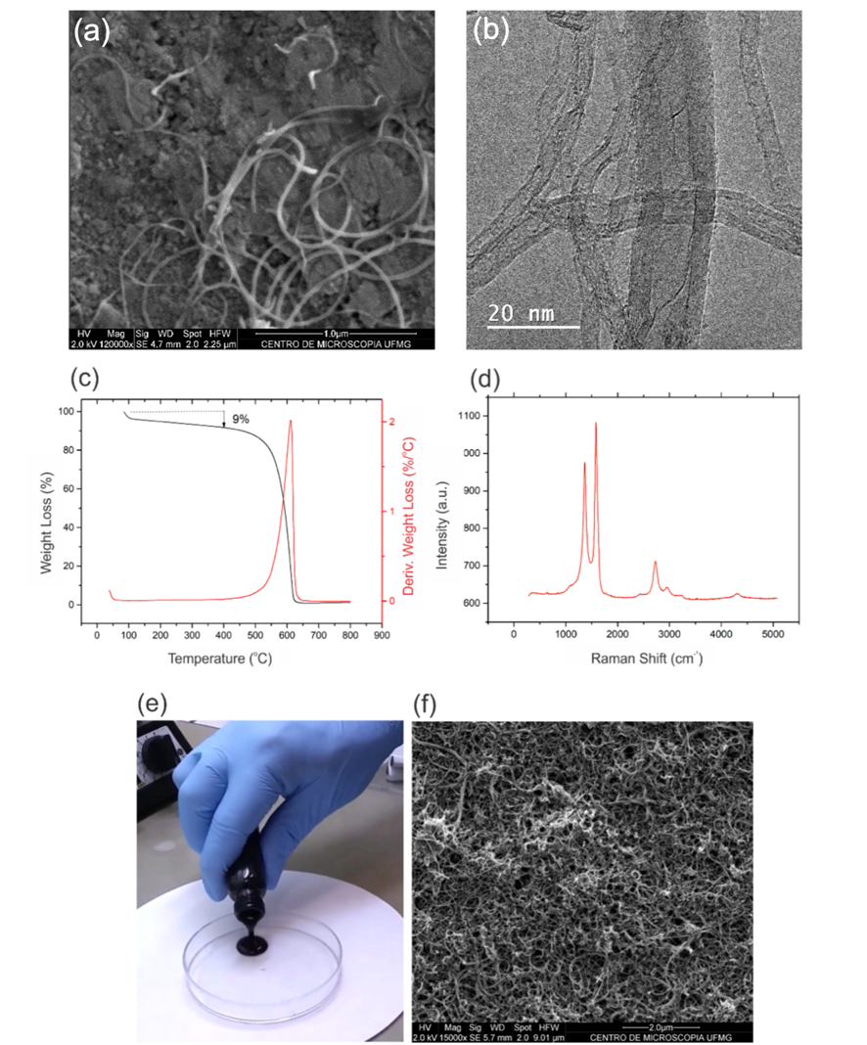
(a)
(b)

Figure S1 – Typical morphology and characteristics of the functionalized multi-walled carbon nanotubes (MWCNTs) used in this work (a) SEM image; (b) TEM image; (c) Thermogravimetric Analyses; (d) Raman spectra; (e) CNT ink; (f) thin film SEM image from spray-deposited ink.

Further characteristics are as follows:

- Viscosity: ~ 1.0 mPa.s
- Tube diameter: 10-30 nm
- Tube Length: 1-5 µm
- Sheet resistance (10 µm - width): 10³ Ω/□

Supplementary information – part 2

PCA features variables
Variable | Definition | Algorithm
Area | Area of gain (S) curve data | Area = sum(S)
max | Maximum value of the gain (S) curve | max = max(S)
t_max | time corresponding to the max position | tmax =time(max)
slope | Slope of a line passing through (0,0) and (tmax, max) | slope = max/tmax
reslope | The slope^(-1) | reslope = slope-1
maxdev | Maximum value of the numeric differential of gain (S) curve | maxdev = max(diff(S))
mindev | Minimum value of the numeric differential of gain (S) curve | mindev = min(diff(S))
ratio_minmax | Ratio of min_dev and max_dev | ratiominmax = maxdev/mindev
WAHM | Width of the curve measured at a factor of maximum λ. | WAHM = time2(max. * λ) - time1(max. * λ)

[1] DA CUNHA, THIAGO H.R.; DE OLIVEIRA, SERGIO; MARTINS, ICARO L.; GERALDO, VIVIANY; MIQUITA, DOUGLAS; RAMOS, SERGIO L.M.; LACERDA, RODRIGO G.; LADEIRA, LUIZ O.; FERLAUTO, ANDRE S. High-yield synthesis of bundles of double- and triple-walled carbon nanotubes on aluminum flakes. CARBON, v. 133, p. 53-61, 2018.
[2] CASTRO, VINÍCIUS; COSTA, INGRID; LOPES, MAGNOVALDO; LAVALL, RODRIGO; FIGUEIREDO, KÁTIA; SILVA, GLAURA. Tailored Degree of Functionalization and Length Preservation of Multiwalled Carbon Nanotubes by an Optimized Acid Treatment Process. JOURNAL OF THE BRAZILIAN CHEMICAL SOCIETY, v. 28, p. 1158, 2016.

