**Supporting Information**

An accelerated Rauhut-Currier dimerization enabled synthesis of (±)-Incarvilleatone and anticancer studies

Tharun K. Kotammagaria,b, Sweta Misrac, Sayantan Paula,b, Sunita S. Kuntea, Rajesh G. Gonnaded, Manas K. Santrac, and Asish K. Bhattacharya*a,b

a Division of Organic Chemistry, CSIR-National Chemical Laboratory,

Dr. Homi Bhabha Road, Pune-411 008, India.

b Academy of Scientific and Innovative Research (AcSIR),

Dr. Homi Bhabha Road, Pune-411 008, India.

c Cancer Biology Division, National Centre for Cell Sciences,

Ganesh Khind Road, Pune-411 007, India.

d Centre for Material Characterization, CSIR-National Chemical Laboratory,

Dr. Homi Bhabha Road, Pune-411 008, India.

E-mail: ak.bhattacharya@ncl.res.in

**Table of Contents**

1. Experimental S2
2. Synthesis of (±)-Incarvilleatone **1** and (±)-incarviditone **2** S3-S4
3. References S5
4. Biological Protocols S6
5. 1H & 13C NMR and HRMS Spectra S7-S14
6. Figure S1 and Figure S2 S15
7. HPLC chromatograms S16-S18

Experimental

All melting points were recorded on a Büchi melting point apparatus in open capillaries and are uncorrected. Commercially available reagents and dried solvents were used as received. Dry THF, MeOH and DCM were prepared following the standard procedures. All dry reactions were carried out under an argon atmosphere and flash chromatography was performed with CombiFlash *R*f 200i with UV/VIS and ELSD, Isco Teledyne Inc., USA using RediSep® column (SiO2). 1H NMR spectra were recorded on Bruker 500 or 400 or 200 MHz spectrometers, and 13C NMR spectra were recorded at 125 or 100 or 50 MHz, respectively. Chemical shifts are reported as δ values (ppm) relative to internal standard tetramethylsilane in CDCl3. HRMS (ESI) were recorded on an Orbitrap (quadrupole plus ion trap) and TOF mass analyser. Optical rotations were recorded on a JASCO P-1020 polarimeter. HPLC was performed with Agilent HPLC system (UV detection at 200 nm, Column: Chiralpak-IA (0.46 mm X 250 mm), Mobile phase: acetonitrile-water (70:30),flow rate 1.0 mL/min.

**Synthesis of** ***3a,3'a-Dihydroxy-3,3a,3',3'a,4,5,7,7a,7',7'a-decahydro-[4,5'-bibenzo furan]-6,6'(2H,2'H)-dione (4):***

To a solution of (±)-rengyolone **3** (2.6 g, 1 equiv.) in THF (20 mL) at rt, TBAF in THF (1.0 M, 9.7 mL, 2 equiv.) was added and the resulting solution was stirred for 24 h. Then the solution was quenched with few drops of water and the solution was concentrated *in vacuo*. The residue was purified by flash chromatography (CombiFlash *R*f 200*i*, Isco Teledyne) using Redisep™ (silica gel, 12 g) as gradient of 1-3% of MeOH-CH2Cl2 to give heterochiral dimerized compound (±)-**4** (1.06 g, 41%).

***3a,3'a-Dihydroxy-3,3a,3',3'a,4,5,7,7a,7',7'a-decahydro-[4,5'-bibenzo furan]-6,6'(2H,2'H)-dione (4)*:** Pale-yellow solid; m.p.:120-123 °C; *Rf* 0.55 (1% MeOH-DCM);1H NMR(DMSO-d6, 400 MHz): *δ*H 6.75 (s, 1H), 5.60 (s, 1H), 5.03 (s, 1H), 4.02 (t, *J*=4.9 Hz, 1H), 3.85-3.73 (m, 5H), 3.66-3.65 (m,1H), 2.79 (dd, *J*=4.3, 15.9 Hz, 1H), 2.66-2.58 (m, 3H), 2.15-2.11 (m, 2H), 1.86 (dd, *J*=3.7, 15.9 Hz 1H), 1.76-1.67(m, 3H); 13C NMR(DMSO-d6, 100 MHz): *δ*C 209.4, 197.4, 148.5, 135.7, 83.4, 80.8, 77.9, 74.9, 66.0, 65.8, 42.8, 41.3, 40.6, 39.3, 37.8, 36.0; HRMS (ESI) *m/z*: calcd for C16H20O6Na [M+Na]+ 331.1152, found 331.1150.

***Synthesis of (±)-Incarvilleatone (1):*** A stirred solution of heterochiral dihydroxy compound (±)-**4** (653 mg, 2.1 equiv.) in THF (20 mL) was cooled to 0 °C, and a solution of KHMDS (399 mg, 2 equiv.) in THF was added dropwise at 0 °C slowly under argon atmosphere. The resulting reaction mixture was stirred at rt for 24 h. Then the solution was quenched with few drops of water. The resulting solution was concentrated under reduced pressure and purified by flash chromatography (CombiFlash *R*f 200*i*, Isco Teledyne) using Redisep™ (silica gel, 12g) as the gradient of 1-2% of MeOH-CHCl3 to furnish (±)-incarvilleatone **1** (101 mg, 15%). as white solid. The product was identified as (±)-incarvilleatone **1** by comparison of its 1H NMR and 13C NMR spectra with the reported spectra of natural (±)-incarvilleatone **1.**[1]

***(±)-Incarvilleatone (1)*:** White solid;*Rf* 0.28 (1% MeOH-CHCl3); 1H NMR(D2O containing 1% CD3OD, 400 MHz): *δ*H 4.47 (d, *J* = 4.9 Hz, 1 H), 4.08-3.98 (m, 4H), 3.89-3.84 (m, 2 H), 2.91 (d, *J* = 4.3 Hz, 1H), 2.83-2.82 (m, 1H), 2.63 (dd, *J* = 3.1, 20.1 Hz, 1H), 2.56 (t, *J* = 4.3 Hz, 1H), 2.46-2.35 (m, 1H), 2.32-2.21 (m, 4H), 2.01 (ddd, *J* = 2.4, 7.3, 14.0 Hz, 1H), 1.83 (dd, *J*=9.8, 14.6 Hz, 1H); 13C NMR(D2O containing 1% CD3OD, 100 MHz): *δ*C 214.0, 88.4, 83.3, 80.9, 80.1, 79.8, 72.6, 68.8, 65.8, 59.7, 46.3 44.4, 41.8, 36.3, 33.5, 32.5; HRMS (ESI): *m/z* calcd for C16H20O6Na [M+Na]+ 331.1152, found 331.1150.

***(-)-Incarvilleatone (1):*** *Rf* 0.28 (1% MeOH- CHCl3); [α]D24  -15.0 (*c* 0.30, MeOH); 1H NMR(CD3OD, 500 MHz): *δ*H 4.34 (d, *J* = 4.2 Hz, 1H), 4.01-3.97 (m, 2H), 3.95 (dd, *J*=8.8, 2.7 Hz 1H), 3.90 (dd, *J*=5.3, 9.1 Hz, 1H), 3.84-3.81 (m, 1H), 3.78 (dd, *J*=1.9, 5.0 Hz, 1H), 2.74 (d, *J*=5.0 Hz, 1H), 2.70 (dd, *J*=1.9, 3.8 Hz 1H), 2.53 (dd, *J*=3.1, 19.5 Hz, 1H), 2.45 (t, *J*=4.2 Hz, 1H), 2.34 - 2.30 (m, 1H), 2.29 (t, *J*=3.4 Hz 1H), 2.24 (d, *J*=3.4 Hz, 1 H), 2.22-2.19 (m, 2H), 2.17-2.15 (m, 1H), 1.97-1.91 (m, 1H), 1.81 (dd, *J*=9.3, 14.7 Hz, 1 H); 13C NMR(CD3OD, 125 MHz): *δ*C 209.8, 88.8, 84.1, 81.8, 81.1, 79.9, 72.5, 68.6, 66.1, 60.4, 47.9, 45.7, 42.9, 37.4, 33.8, 33.6; HRMS (ESI): *m/z* calcd for C16H20O6Na [M+Na]+ 331.1152, found 331.1152.

***(+)-Incarvilleatone (1):*** *Rf* 0.28 (1% MeOH-CHCl3); [α]D24  +18.0 (*c* 0.30, MeOH); 1H NMR(CD3OD, 500 MHz): *δ*H 4.34 (d, *J*=4.2 Hz, 1H), 4.01-3.97 (m, 2H), 3.95 (dd, *J*=2.7, 8.8 Hz, 1H), 3.90 (dd, *J* = 5.5, 9.3 Hz, 1H), 3.84-3.80 (m, 1H), 3.78 (dd, *J*=1.5, 5.0 Hz, 1H), 2.74 (d, *J*=5.0 Hz, 1H), 2.70 (dd, *J*=1.9, 3.8 Hz, 1H), 2.54 (dd, *J*=3.1, 19.5 Hz, 1H), 2.45 (t, *J*=4.2 Hz, 1H), 2.33-2.30 (m, 1H), 2.29 (t, *J*=3.4, 1H), 2.24 (d, *J*=3.4 Hz, 1H), 2.22 - 2.15 (m, 3H), 1.95 (td, *J*=5.2, 13.2 Hz, 1H), 1.80 (dd, *J* = 9.3, 14.7 Hz, 1H); 13C NMR(CD3OD, 125 MHz): *δ*C 209.8, 88.8, 84.1, 81.8, 81.1, 79.9, 72.5, 68.6, 66.1, 60.4, 47.9, 45.7, 42.9, 37.4, 33.8, 33.6; HRMS (ESI): *m/z* calcd for C16H20O6Na [M+Na]+ 331.1152, found 331.1150.

***Synthesis of*** ***(±)-incarviditone 2:*** A stirred solution of (±)-rengyolone **3** (400 mg, 2.6 mmol) in THF (15 mL) was cooled to 0 °C, and a solution of KHMDS (1.03 g, 2 equiv.) in THF (10 mL) was added dropwise at 0 °C slowly under argon atmosphere. The resulting reaction mixture was stirred at rt for 24 h. Then the solution was quenched with few drops of water. The resulting solution was concentrated under reduced pressure and purified by flash chromatography (CombiFlash *R*f 200*i*, Isco Teledyne) using Redisep™ (silica gel, 12g) as the gradient of 0.5-1% of MeOH-CHCl3 to give (±)-incarviditone **2** (48 mg, 12%) as colorless liquid. The product was identified as (±)-incarviditone**2** by comparison of its 1H NMR and 13C NMR spectra with the reported spectra of natural (±)-incarviditone**2**.[2]

***(±)-incarviditone 2*:** Colorless liquid; *Rf* 0.48 (1% MeOH- CHCl3); 1H NMR(CD3OD, 400 MHz): *δ*H 4.58 (d, *J*=7.3 Hz, 1H), 4.07 (t, *J* = 4.9 Hz 1H), 4.02-3.96 (m, 4H), 3.94-3.90 (m, 1H), 2.97-2.93 (m, 1H), 2.89 (t, *J*=7.9 Hz, 1H), 2.85-2.81 (m, 1H), 2.65 (dd, *J*=4.3, 17.8 Hz 1H), 2.59 (d, *J*=5.5 Hz, 1H), 2.54-2.49 (m, 2H), 2.42-2.37 (m, 1H), 2.33-2.27 (m, 2H), 1.98 (ddd, *J* = 5.5, 7.3, 12.8 Hz, 1H); 13C NMR(CD3OD, 100 MHz): *δ*C 211.1, 209.3, 90.3, 83.2, 82.7, 81.9, 79.3, 67.6, 67.3, 55.7, 45.2, 43.8, 43.3, 40.4, 39.4, 37.9; HRMS (ESI): *m/z* calcd for C16H20O6Na [M+Na]+ 331.1152, found 331.1152.

References:

1. Gao, Y. P.; Shen, Y. H.; Zhang, S. D.; Tian, J. M.; Zeng, H. W.; Ye, J.; Li, H. L.; Shan, L.; Zhang, W. D. *Org. Lett*. **2012**, *14*, 1954-1957.
2. Chen, Y. Q.; Shen, Y. H.; Su, Y. Q.; Kong, L. Y.; Zhang, W. D. *Chem.* *Biodiversity*, **2009**, *6*, 779-783.

**Biological Protocols**

**Anticancer assay:**

**Cell Culture**

Breast cancer MCF7 cells were grown in DMEM media (GIBCO). MCF7 cell line was a kind gift from Michael R. Green (UMass Medical School, USA). Cells were grown in media supplemented with 10% fetal bovine serum (Gibco) at 37°C in 5% CO2 under humidified conditions.

**Cell Survival Assays**

Cytotoxiceffect of thecompounds on MCF7 cells was determinedafter three independent experimentsusing standard 3-(4,5-dimethylthiazol-2-yl)-2,5-diphenyltetrazolium bromide (MTT) assays as described previously.12 Five thousand cells were seeded in each well of a 96-welled plate. At 24 h of post seeding, cells were treated with different concentrations of the compounds (0–100 μM). Vehicle (DMSO) treated cells were used as control. After 48 h of treatment, cells were grown in the presence of 0.83 mg/mL MTT reagent for additional 4 h.The media containing the MTT reagent was then replaced with 100 μL/well of MTT solvent (5 mM HCl and 0.1% Triton X-100 in isopropanol) and incubated at 25 °C for 10 min with gentle shaking and subsequently absorbance was taken at 575 nm in Thermo Scientific Multiskan Go plate reader. The numbers of live cells after 48 h of treatment were calculated based on the readout of reduction of the MTT salt into its formazan derivative, which has absorbance at 575 nm. Growth of vehicle treated cells was taken as 100%. An average of three experiments was plotted as percentage of growth inhibition.

**1H & 13C NMR and HRMS Spectra**



**1H NMR (DMSO-d6, 400 MHz) of compound (±)-4**



**13C NMR (DMSO-d6, 100 MHz) of compound 4**



**HRMS of compound 4**



**1H NMR (400 MHz, D2O containing 1%CD3OD) of compound 1**



**13C NMR (100 MHz, D2O containing 1%CD3OD) of compound 1**



**HRMS of compound 1**



**1H NMR (500 MHz, CD3OD) of compound (-)-1**



**13C NMR (125 MHz, CD3OD) of compound (-)-1**

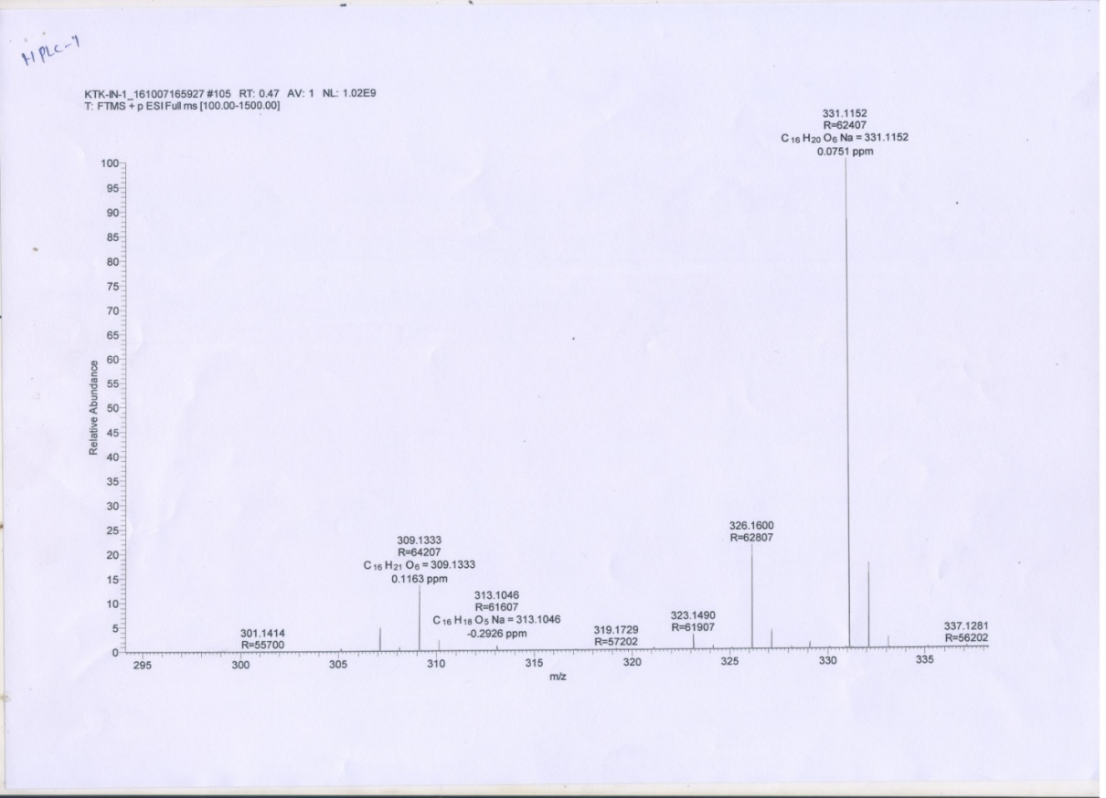

**HRMS of compound (-)-1**



**1H NMR (500 MHz, CD3OD) of compound (+)-1**



**13C NMR (125 MHz, CD3OD) of compound (+)-1**

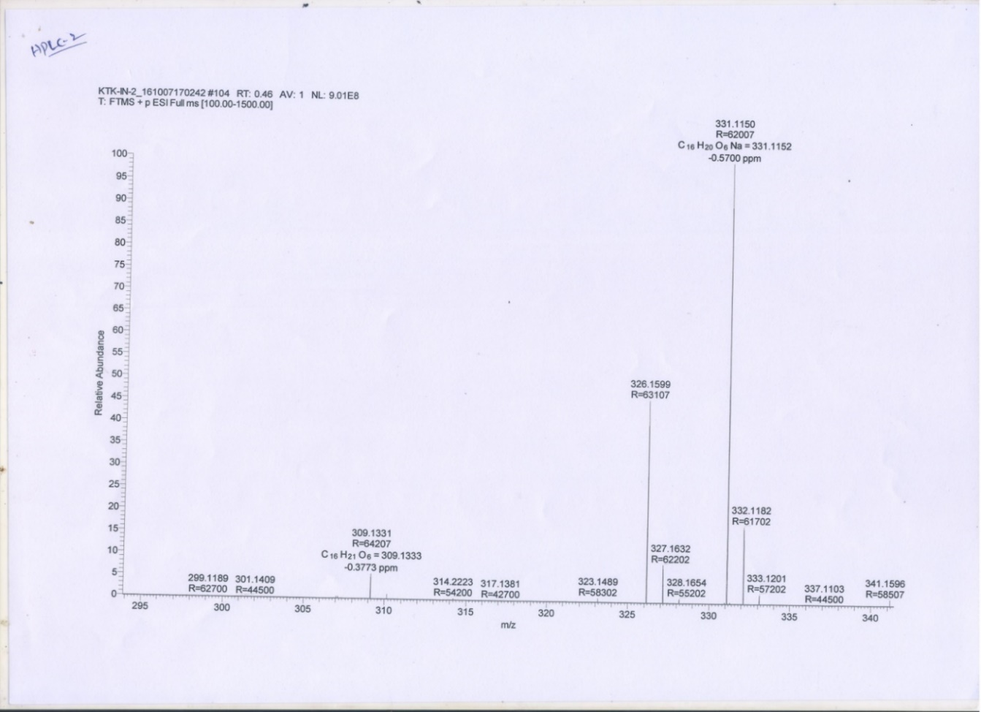

**HRMS of compound (+)-1**



**1H NMR (400 MHz, CD3OD) of compound 2**



**13C NMR (100 MHz, CD3OD) of compound 2**



**HRMS of compound 2**



**Figure S1.** D2O shake experiment: 1H NMR of the compound **4** with D2O (Red), 1H NMR of the compound without D2O (Blue).

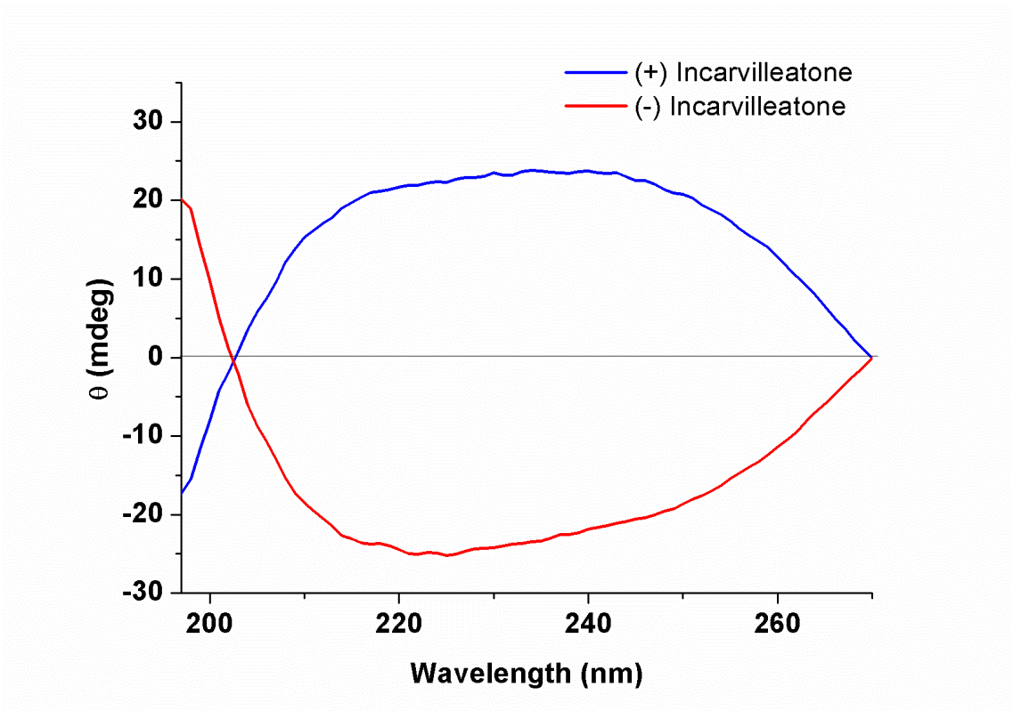

**Figure S2.** Circular Dichroism (CD) spectra of the (-)-incarvilleatone **1** and (+)-incarvilleatone **1**.

**HPLC Chromatograms**

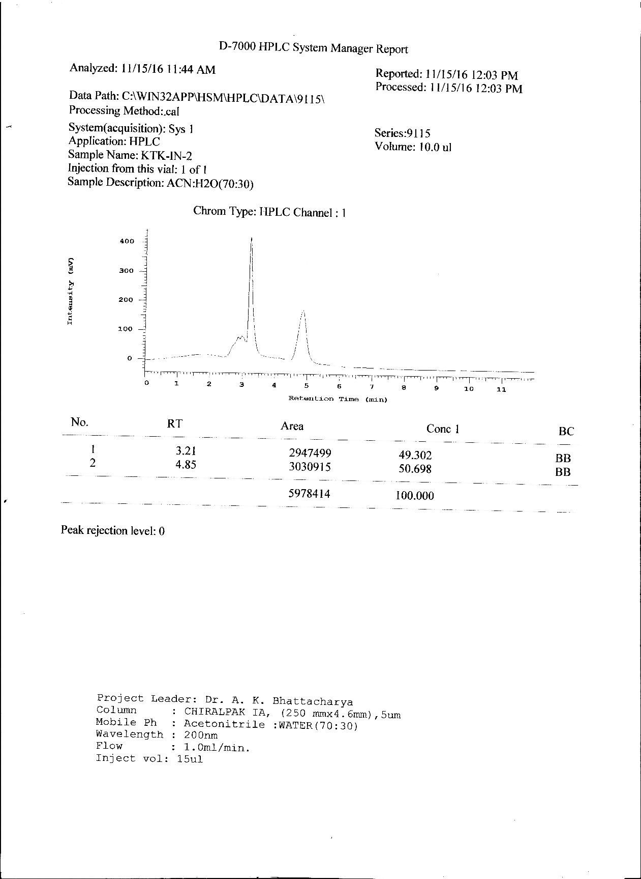

**HPLC report of (±)-incarvilleatone 1**

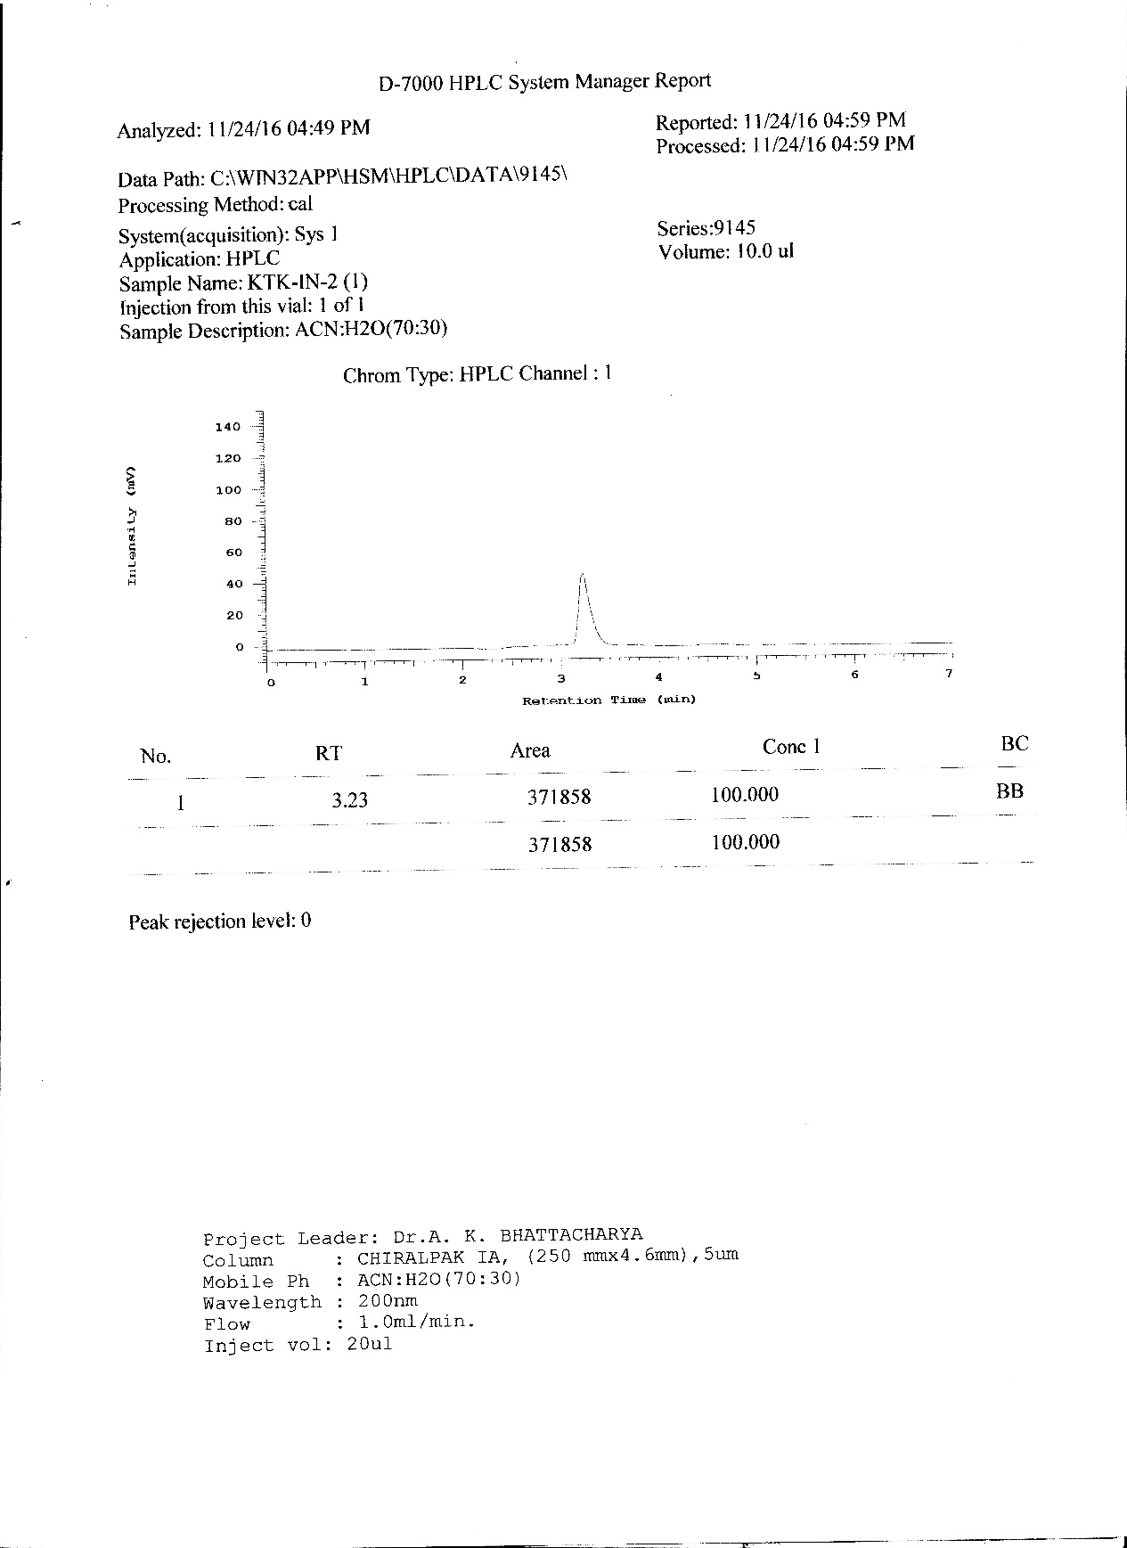

**HPLC report of (-)-1**

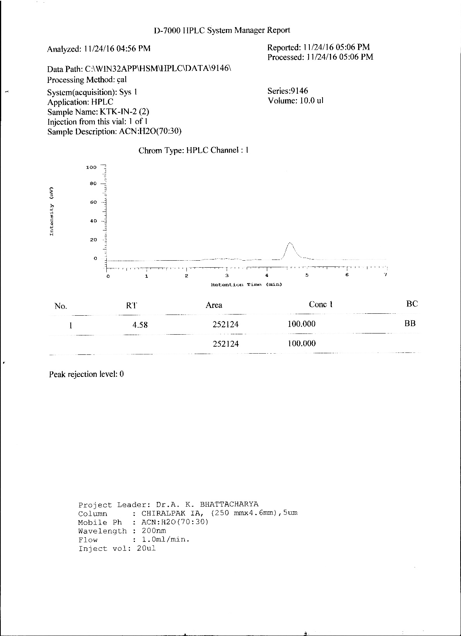

**HPLC report of (+)-1**