**Supporting Information**

for

Automated Grindstone Chemistry: A Simple and Facile Way for PEG-assisted Stoichiometry-controlled Halogenation of Phenols and Anilines Using *N*-Halosuccinimide

Dharmendra Das, Akhil A. Bhosle, Amrita Chatterjee* and Mainak Banerjee*

**Experimental procedures, spectral data, and copies of spectra**

**Table of contents**

|  |  |  |  |  |  |  |  |  |  |  |
| --- | --- | --- | --- | --- | --- | --- | --- | --- | --- | --- |
| |  |  | | --- | --- | | Experimental procedures……………………………….......................... | 03 | | Spectral data of products………………………………………………... | 04-13 | | Comparative table..……………………………………………………... | 14-15 | | 1H & 13C NMR spectra of products……………………………………... | 16-64 | | References…………………………………………………………........ | 65-67 |   **Experimental Procedures**  **General information**  All the reagents and solvents of AR grade were procured from commercial sources and used without further purification. The mechanochemical grinding reactions were carried out in an indigenous electrical grinder (Scientech instruments, India) with Agate-made mortar and pestle. The thin-layer chromatography (TLC) of 0.25 mm silica gel aluminum plates (60F-254) were used to monitor the progress of the reaction, and visualization was done using UV light (254 or 365 nm). The synthesized products were purified by flash chromatography or conventional column chromatography with 100-200 mesh silica gel. 1H NMR and 13C NMR spectra were recorded on Bruker AVANCE (400 MHz and 500 MHz) instrument and tetramethylsilane as the internal standard. The multiplicity of NMR peaks was represented using standard abbreviations, and chemical shifts are reported in parts per million (δ) units. CHN data were recorded with the Vario MICRO elementar CHNS analyzer. IR spectra were recorded in KBr pellets with IR Affinity 1, Shimadzu.    **General procedure for di-halogenation of the substrates**  The phenol (or aniline) derivative (1.0 mmol) was taken in an Agate mortar attached to an electrical grinder and to it NXS (2.1 mmol; X = Br, I) and PEG-400 (0.2 mL) were added one after another, and grinding was continued by an electrically operated pestle for the specific time period as mentioned in Table 3. The completion of the reaction was monitored by TLC. After complete conversion, 1 g of silica gel (230-400 mesh) was added and the slurry was subjected to flash chromatography and eluted with a mixture of EtOAc-petroleum ether to afford the pure di-bromo phenol (or aniline) derivative. Once again, the side product succinimide was subsequently eluted using 1:10 MeOH-CHCl3.  **General procedure for tri-halogenation of the substrates**  Phenol or aniline derivatives (**1**, 1.0 mmol), NXS (3.0 mmol; X = Br, I) were taken in an agate mortar containing PEG-400 (0.2 mL) and electrical grinding was continued with a pestle at 100 rpm for the specific time period as mentioned for respective substrates in Table 4. 1 g of silica gel (230-400 mesh) was added and the slurry was subjected to flash chromatography and eluted with a mixture of EtOAc-petroleum ether to afford the pure tri-bromo phenol (or aniline) derivative.  **Characterization data of products 2a-aj, 3a-j and 4a-c**  **2-Bromo-4-methylphenol (2a) [1]:** Off-white solid, 170 mg (91%), m.p. 57-59 °C (lit. m.p. 55-57 °C); 1H NMR (400 MHz, CDCl3): δ (ppm) 2.27 (s, 3H), 5.36 (s, 1H), 6.91 (d, *J* = 8.2 Hz, 1H), 7.01 (dd, *J1* = 1.4 Hz, *J2* = 8.2 Hz, 1H), 7.271-7.274 (m, 1H). 13C NMR (100 MHz, CDCl3): δ (ppm) 20.2, 109.8, 115.7, 129.8, 131.4, 132.1, 150.0. Anal. Calcd for C7H7BrO: C, 44.95; H, 3.77. Found: C, 45.01; H, 3.76. IR (KBr) *ν̃*: 3498, 2924, 1608, 1493, 1040, 866, 812, 760, 671 and 550 cm−1.    **4-Bromo-2-*tert*-butylphenol (2b) [2]:**Light-grey liquid, 210 mg (92%), 1H NMR (400 MHz, CDCl3): δ (ppm) 1.39 (s, 9H), 4.14 (br, 1H), 6.56 (d, *J* = 8.4 Hz, 1H), 7.16 (dd, *J1* = 2.4 Hz, *J2* = 8.4 Hz, 1H), 7.35 (d, *J* = 2.4 Hz, 1H). 13C NMR (100 MHz, CDCl3): δ (ppm) 29.3, 34.7, 112.8, 118.1, 129.5, 130.1, 138.5, 153.3. Anal. Calcd for C10H13BrO: C, 52.42; H, 5.72. Found: C, 52.51; H, 5.74. IR (KBr) *ν̃*: 3549, 2959, 1597, 1489, 1398, 1249, 1176, 1082, 880, 806, 706, 631 and 567 cm−1.    **4-Bromo-2,6-dimethylphenol (2c) [1]:** Light-brown solid, 190 mg (95%), m.p. 79-80 °C (lit. m.p. 74-78 °C); 1H NMR (400 MHz, CDCl3): δ (ppm) 2.22 (s, 3H), 4.58 (s, 1H), 7.10 (s, 2H). 13C NMR (100 MHz, CDCl3): δ (ppm) 15.7, 112.0, 125.2, 131.0, 151.3. Anal. Calcd for C8H9BrO: C, 47.79; H, 4.51. Found: C, 47.65; H, 4.49. IR (KBr) *ν̃*: 3383, 2916, 1609, 1476, 1329, 1190, 941, 853, 718 and 555 cm−1.    **4-Bromo-3-methylphenol (2d) [1,2]:** Off-white solid, 164 mg (88%), m.p. 59-60 °C (lit. m.p. 59-61 °C); 1H NMR (400 MHz, CDCl3): δ (ppm) 2.34 (s, 3H), 4.97 (s, 1H), 6.55 (dd, *J1* = 3.0 Hz, *J2* = 8.8 Hz, 1H), 6.73 (d, *J* = 3.0 Hz, 1H), 7.35 (d, *J* = 8.4 Hz, 1H). 13C NMR (100 MHz, CDCl3): δ (ppm) 22.9, 114.5, 115.5, 117.8, 133.0, 139.2, 154.6. Anal. Calcd for C7H7BrO: C, 44.95; H, 3.77. Found: C, 45.05; H, 3.73. IR (KBr) *ν̃*: 3383, 2922, 1587, 1169, 1028, 860, 810 and 602 cm−1.    **2-Bromobenzene-1,4-diol (2e) [3,4]:**Grey solid, 156 mg (83%), m.p. 114-116 °C (lit. m.p. 114 °C); 1H NMR (400 MHz, CDCl3): δ (ppm) 6.73 (dd, *J1* = 3.2 Hz, *J2* = 8.8 Hz, 1H), 6.89 (d, *J* = 8.8 Hz, 1H), 6.99 (d, *J* = 3.0 Hz, 1H). 13C NMR (100 MHz, CDCl3): δ (ppm) 109.9, 115.8, 116.3, 118.6, 147.2, 149.5. Anal. Calcd for C6H5BrO2: C, 38.13; H, 2.67. Found: C, 38.31; H, 2.69. IR (KBr) *ν̃*: 3487, 3372, 1624, 1585, 1312, 1263, 1028, 893, 746, 638 and 548 cm−1.    **3-Bromobiphenyl-4-ol (2f) [5]:**White crystalline solid, 210 mg (85%), m.p. 93-95 °C (lit. m.p. 94-95 °C); 1H NMR (400 MHz, CDCl3): δ (ppm) 5.55 (br, 1H), 7.10 (d, *J* = 8.4 Hz, 1H), 7.31-7.36 (m, 1H), 7.40-7.48 (m, 3H), 7.50-7.53 (m, 2H), 7.71 (d, *J* = 2.4 Hz, 1H). 13C NMR (100 MHz, CDCl3): δ (ppm) 110.6, 116.3, 126.7, 127.2, 127.9, 128.8, 130.4, 135.4, 139.4, 151.6. Anal. Calcd for C12H9BrO: C, 57.86; H, 3.64. Found: C, 58.01; H, 3.63. IR (KBr) *ν̃*: 3300, 2361, 1603, 1487, 1229, 1042, 882, 762, 671 and 581 cm−1.    **2-Bromo-4-chlorophenol (2g) [1]:** Yellow oil, 180 mg (87%); 1H NMR (400 MHz, CDCl3): δ (ppm) 5.56 (s, 1H), 6.95 (d, *J* = 8.8 Hz, 1H), 7.19 (dd, *J1* = 2.4 Hz, *J2* = 8.8 Hz, 1H), 7.46 (s, 1H). 13C NMR (100 MHz, CDCl3): δ (ppm) 110.3, 116.9, 125.8, 129.8, 131.3, 151.2. Anal. Calcd for C6H4BrClO: C, 34.7; H, 1.94. Found: C, 34.67; H, 1.93. IR (KBr) *ν̃*: 3501, 3070, 1703, 1578, 1275, 1180, 862, 698, and 552 cm−1.    **4-Bromo-2-chlorophenol (2h) [1]:** Peach crystalline, 162 mg (80%); 1H NMR (400 MHz, CDCl3): δ (ppm) 5.54 (s, 1H), 6.90 (d, *J* = 8.6 Hz, 1H), 7.29 (dd, *J1* = 2.4 Hz, *J2* = 8.4 Hz, 1H), 7.46 (d, *J* = 2.4 Hz, 1H). 13C NMR (100 MHz, CDCl3): δ (ppm) 112.3, 117.6, 120.8, 131.3, 131.4, 150.7. Anal. Calcd for C6H4BrClO: C, 34.74; H, 1.94. Found: C, 34.70; H, 1.97. IR (KBr) *ν̃*: 3520, 3080, 1580, 1327, 1186, 862, 709, and 550 cm−1.    **2,4-Dibromophenol (2i) [1]:**White solid, 206 mg (82%), m.p. 37-38 °C (lit. m.p. 37-39 °C); 1H NMR (400 MHz, CDCl3): δ (ppm) 5.61 (br, 1H), 6.90 (d, *J* = 8.6 Hz, 1H), 7.32 (dd, *J1* = 2.0 Hz, *J2* = 8.4 Hz, 1H), 7.59 (d, *J* = 2.2 Hz, 1H). 13C NMR (100 MHz, CDCl3): δ (ppm) 110.8, 112.6, 117.4, 132.1, 134.1, 151.7. Anal. Calcd for C6H4Br2O: C, 28.61; H, 1.60. Found: C, 28.67; H, 1.57. IR (KBr) *ν̃*: 3406, 2984, 1699, 1277, 867, 743, 683, and 546 cm−1.    **2-Bromo-4-iodophenol (2j) [6]:** Light-brown solid, 235 mg (79%), m.p. 50-53 °C (lit. m.p. 52-54 °C); 1H NMR (400 MHz, CDCl3): δ (ppm) 5.59 (br, 1H), 6.78 (d, *J* = 8.6 Hz, 1H), 7.49 (dd, *J1* = 2.0 Hz, *J2* = 8.4 Hz, 1H), 7.75 (d, *J* = 2.0 Hz, 1H). 13C NMR (100 MHz, CDCl3): δ (ppm) 82.0, 111.3, 118.1, 138.0, 139.6, 152.3. Anal. Calcd for C6H4BrIO: C, 24.11; H, 1.35. Found: C, 24.21; H, 1.36. IR (KBr) *ν̃*: 3499, 1709, 1395, 1182, 868, 744, 677, 608 and 542 cm−1.    **5-Bromo-2-hydroxybenzaldehyde (2k) [7]:** Beige solid, 144 mg (72%), m.p. 102-104 °C (lit. m.p. 104-105 °C); 1H NMR (500 MHz, CDCl3): δ (ppm) 6.90 (d, *J* = 8.8 Hz, 1H), 7.59 (dd, *J1* = 2.8 Hz, *J2* = 8.8 Hz, 1H), 7.66 (d, *J* = 2.6 Hz, 1H), 9.83 (s, 1H), 10.92 (s, 1H). 13C NMR (125 MHz, CDCl3): δ (ppm) 111.3, 119.7, 121.7, 135.6, 139.7, 160.5, 195.4. Anal. Calcd for C7H5BrO2: C, 41.83; H, 2.51. Found: C, 41.75; H, 2.47. IR (KBr) *ν̃*: 3229, 2923, 2866, 1677, 1472, 1169, 825, 692 cm−1.    **3-Bromo-4-hydroxy-5-methoxybenzaldehyde (2l) [2]:** White solid, 224 mg (97%), m.p. 164-166 °C (lit. m.p. 166-168 °C); 1H NMR (400 MHz, CDCl3): δ (ppm) 3.98 (s, 3H), 6.54 (br, 1H), 7.36 (d, *J* = 1.6 Hz, 1H), 7.64 (d, *J* = 1.6 Hz, 1H), 9.78 (s, 1H). 13C NMR (100 MHz, CDCl3): δ (ppm) 56.6, 108.0, 108.1, 130.0, 130.1, 147.7, 148.9, 189.7. Anal. Calcd for C8H7BrO3: C, 41.59; H, 3.05. Found: C, 41.70; H, 3.06. IR (KBr) *ν̃*: 3298, 2941, 2848, 2745, 1674, 1591, 1159, 1047, 855, 831, 795, 681cm−1.    **5-Bromo-2-hdroxyacetophenone (2m) [7]:** Off**-**white solid, 179 mg (83%), m.p. 58-60 °C (lit. m.p. 59-60 °C); 1H NMR (500 MHz, CDCl3): δ (ppm) 2.61 (s, 3H), 6.87 (d, *J* = 8.5 Hz, 1H), 7.53 (dd, *J1* = 2.5 Hz, *J2* = 8.6 Hz, 1H), 7.82 (d, *J* = 2.5 Hz, 1H), 12.14 (s, 1H). 13C NMR (125 MHz, CDCl3): δ (ppm) 26.7, 110.4, 120.4, 120.8, 132.9, 139.1, 161.2, 203.5. Anal. Calcd for C8H7BrO2: C, 44.68; H, 3.28. Found: C, 44.51; H, 3.19. IR (KBr) *ν̃*: 3014, 1753, 1643, 1457, 1194, 802, 730, 615 cm−1.    **2-Bromo-4-nitrophenol (2n) [1]:**Off-white solid, 210 mg (97%), m.p. 110-112 °C (lit. m.p. 111-114 °C); 1H NMR (400 MHz, CDCl3): δ (ppm) 6.82 (d, *J* = 9.2 Hz, 1H), 8.0 (d, *J* = 9.2 Hz, 1H), 8.26 (s, 1H). 13C NMR (100 MHz, CDCl3): δ (ppm) 109.7, 114.5, 124.6, 126.6, 139.0, 156.1. Anal. Calcd for C6H4BrNO3: C, 33.06; H, 1.85; N, 6.42. Found: C, 33.16; H, 1.87; N, 6.38. IR (KBr) *ν̃*: 3375, 3078, 1514, 1327, and 633 cm−1.    **4-Bromo-2-nitrophenol (2o) [8]:**White solid, 185 mg (85%), m.p. 90-92 °C (lit. m.p. 89-92 °C); 1H NMR (500 MHz, CDCl3): δ (ppm) 7.10 (d, J = 8.9 Hz, 1H), 7.69 (dd, *J2* = 2.5 Hz, *J1* = 9.0 Hz, 1H), 8.27 (d, *J* = 2.5 Hz, 1H), 10.60 (s, 1H). 13C NMR (125 MHz, CDCl3): δ (ppm) 111.7, 121.7, 127.3, 134.0, 140.3, 154.1. Anal. Calcd for C6H4BrNO3: C, 33.06; H, 1.85; N, 6.42. Found: C, 33.13; H, 1.83; N, 6.39. IR (KBr) *ν̃*: 3249, 3078, 1536, 1327, and 519 cm−1.    **2-Bromo-4-nitrophenol (2p) [9]:**White solid, 188 mg (95%), m.p. 155-157 °C (lit. m.p. 156 °C); 1H NMR (500 MHz, CDCl3): δ (ppm) 6.60 (s, 1H,) 7.08 (d, *J* = 8.4 Hz, 1H), 7.52 (dd, *J1* = 2.0 Hz, *J2* = 8.4 Hz, 1H), 7.79 (d, *J* = 2.0 Hz, 1H). 13C NMR (125 MHz, CDCl3): δ (ppm) 105.0. 110.6, 116.9, 117.6, 133.3, 136.2, 156.6. Anal. Calcd for C6H4BrNO3: C, 42.46; H, 2.04; N, 7.07. Found: C, 42.39; H, 2.01; N, 6.33. IR (KBr) *ν̃*: 3438, 3089, 2228, 1661, 1428, 1121, 638 and 575 cm−1.    **1-Bromonaphthalen-2-ol (2q) [1,2]**:Off-white solid, 219 mg (98%), m.p. 77-79 °C (lit. m.p. 78-81 °C); 1H NMR (400 MHz, CDCl3): δ (ppm) 5.97 (s, 1H), 7.29–7.31 (m, 1H), 7.41–7.45 (m, 1H), 7.58–7.62 (m, 1H), 7.76–7.82 (m, 2H), 8.07 (d, *J* = 8.8 Hz, 1H). 13C NMR (100 MHz, CDCl3): δ (ppm) 106.1, 117.1, 124.1, 125.3, 127.8, 128.2, 129.3, 129.7, 132.3, 150.6. Anal. Calcd for C10H7BrO: C, 53.84; H, 3.16. Found: C, 54.02; H, 3.17. IR (KBr) *ν̃*: 3279, 3055, 1499, 808, 644 and 519 cm−1.    **3-Bromo-4-hydroxycoumarin (2r) [6,10]**:White solid, 232 mg (96%), m.p. 189-191 °C (lit. m.p. 192-194 °C); 1H NMR (400 MHz, CDCl3): δ (ppm) 7.36–7.42 (m, 2H), 7.64–7.69 (m, 1H), 7.95 (dd, *J1* = 1.6 Hz, *J2* = 8.0 Hz, 1H ), 9.18 (br, 1H). 13C NMR (100 MHz, CDCl3): δ (ppm) 89.1, 115.9, 116.4, 123.4, 124.4, 132.8, 151.7, 158.5, 162.3. Anal. Calcd for C9H5BrO3: C, 44.85; H, 2.09. Found: C, 44.94; H, 2.13. IR (KBr) *ν̃*: 3184, 2344, 1699, 1551, 1211, 826, 746 and 590 cm−1.    **4-Bromoaniline (2s) [11,12]:** Brown solid, 130 mg (75%), m.p. 62-63 °C (lit. m.p. 63-64 °C); 1H NMR (400 MHz, CDCl3): δ (ppm) 3.51 (br, 2H), 6.56 (d, *J* = 8.8 Hz, 2H), 7.23 (d, *J* = 8.8 Hz, 2H). 13C NMR (100 MHz, CDCl3): δ (ppm) 110.2, 116.7, 132.0, 145.3. Anal. Calcd for C6H6BrN: C, 41.89; H, 3.52; N, 8.14. Found: C, 41.78; H, 3.50; N, 8.09. IR (KBr) *ν̃*: 3474, 3381, 1612, 1489, 1287, 1180, 1070, 1005, 818, 692 and 604 cm−1.    **2-bromo-4-methylbenzenamine (2t) [12]:**Brown oil, 164 mg (88%); 1H NMR (500 MHz, CDCl3): δ (ppm) 2.23 (s, 3H), 3.83 (br, 2H), 6.73 (d, *J* = 7.5 Hz, 1H), 6.97 (d, *J*= 7.5 Hz, 1H), 7.29 (s, 1H). 13C NMR (125 MHz, CDCl3): δ (ppm) 20.0, 109.2, 115.7, 128.9, 130.1, 132.7, 141.5. Anal. Calcd for C7H8BrN: C, 45.19; H, 4.33; N, 7.53. Found: C, 45.22; H, 4.30; N, 7.61. IR (KBr) *ν̃*: 3477, 3371, 3018, 1624, 1489, 1309, 746, 1038 and 810 cm−1.    **2,4-Dibromoaniline (2u) [13]:**Brown solid, 213 mg (85%), m.p. 78-80 °C (lit. m.p. 79-80 °C); 1H NMR (400 MHz, CDCl3): δ (ppm) 4.08 (br, 2H), 6.64 (d, *J* = 8.4 Hz, 1H), 7.19 (dd, *J1* = 2.4 Hz, *J2* = 8.8 Hz, 1H), 7.53 (d, *J* = 2.4 Hz, 1H). 13C NMR (100 MHz, CDCl3): δ (ppm) 108.8, 109.5, 116.7, 131.1, 134.4, 143.2. Anal. Calcd for C6H5Br2N: C, 28.72; H, 2.01; N, 5.58. Found: C, 28.69; H, 2.02; N, 5.56. IR (KBr) *ν̃*: 3404, 3302, 3075, 2924, 1618, 1479, 1393, 1288, 1032, 866, 810, 684 and 536 cm−1.    **2-Bromo-4-nitroaniline (2v) [14]:**Yellow solid, 174 mg (80%), m.p. 88-90 °C (lit. m.p. 89-93 °C); 1H NMR (400 MHz, CDCl3): δ (ppm) 4.86 (br, 2H), 6.74 (d, *J* = 8.8 Hz, 1H), 8.01 (dd, *J1* = 2.4 Hz, *J2* = 8.8 Hz, 1H), 8.35 (d, *J* = 2.4 Hz, 1H). 13C NMR (100 MHz, CDCl3): δ (ppm) 106.9, 113.4, 124.9, 129.1, 138.9, 149.9. Anal. Calcd for C6H5BrN2O2: C, 33.21; H, 2.32; N, 12.91. Found: C, 33.29; H, 2.30; N, 12.99. IR (KBr) *ν̃*: 3487, 3372, 3098, 1624, 1489, 1312, 746, 698, 638 and 548 cm−1.    **2-Amino-5-bromopyridine (2w) [15,16]:**Lightbrown solid, 148 mg (85%), m.p. 133-135 °C (lit. m.p. 135-138 °C); 1H NMR (400 MHz, CDCl3): δ (ppm) 4.57 (br, 2H), 6.40 (d, *J* = 8.8 Hz, 1H), 7.48 (dd, *J1* = 2.4 Hz, *J2* = 8.8 Hz, 1H), 8.06 (s, 1H). 13C NMR (100 MHz, CDCl3): δ (ppm) 108.2, 110.0, 140.1, 148.6, 157.0. Anal. Calcd for C5H5BrN2: C, 34.71; H, 2.91; N, 16.19. Found: C, 34.60; H, 2.90; N, 16.24. IR (KBr) *ν̃*: 3453, 3294, 3152, 1707, 1589, 1549, 1487, 1389, 1261, 1142, 1090, 1001, 927, 825, 633 and 515 cm−1.    **3-Bromo-5-chloropyridin-2-amine (2x) [16]:**Pale-yellowsolid, 160 mg (77%), m.p. 78-79 °C (lit. m.p. 78-84 °C); 1H NMR (400 MHz, CDCl3): δ (ppm) 5.03 (br, 2H), 6.66 (d, *J* = 2.2 Hz, 1H), 7.97 (d, *J* = 2.0 Hz, 1H). 13C NMR (100 MHz, CDCl3): δ (ppm) 104.1, 120.4, 139.6, 145.2, 154.0. Anal. Calcd for C5H4BrClN2: C, 28.95; H, 1.94; N, 13.50. Found: C, 28.93; H, 1.93; N, 13.47. IR (KBr) *ν̃*: 3474, 3291, 3146, 2345, 1638, 1389, 1242, 1124, 889, 741, 656 and 507 cm−1.    **3,5-Dibromopyridin-2-amine (2y) [16,17]:**White crystallinesolid, 224 mg (89%), m.p. 99-101 °C (lit. m.p. 104-105 °C); 1H NMR (400 MHz, CDCl3): δ (ppm) 4.99 (br, 2H), 7.76 (d, *J* = 2.4 Hz, 1H), 8.05 (d, *J* = 2.2 Hz, 1H). 13C NMR (100 MHz, CDCl3): δ (ppm) 104.5, 107.2, 141.9, 147.6, 154.3. Anal. Calcd for C5H4Br2N2: C, 23.84; H, 1.60; N, 11.12. Found: C, 23.80; H, 1.64; N, 11.04. IR (KBr) *ν̃*: 3464, 3279, 3140, 2345, 1570, 1385, 1240, 893, 743, 694, and 544 cm−1.    **2-Bromo-1,4-dimethoxybenzene (2z) [18]:**Light brown liquid, 146 mg (67%); 1H NMR (500 MHz, CDCl3): δ (ppm) 6.97-7.00 (m, 2H), 7.28 (d, *J* = 2.7 Hz, 1H). 13C NMR (125 MHz, CDCl3): δ (ppm) 55.8, 56.8, 112.8, 113.6, 114.6, 118.9, 150.2, 153.9. Anal. Calcd for C8H9BrO2: C, 44.27; H, 4.18. Found: C, 44.21; H, 4.12. IR (KBr) *ν̃*: 3030, 2947, 1633, 1509, 1237, 1032, 816, 702, 515 cm−1.    **2-Iodo-4-methylphenol (2aa) [19]:** Yellow oil, 206 mg (88%); 1H NMR (400 MHz, CDCl3): δ (ppm) 2.25 (s, 3H), 5.16 (br, 1H), 6.88 (d, *J* = 8.4 Hz, 1H), 7.04 (dd, *J1* = 1.6 Hz, *J2* = 8.4 Hz, 1H), 7.48 (s, 1H). 13C NMR (100 MHz, CDCl3): δ (ppm) 19.9, 85.4, 114.7, 130.8, 131.9, 138.3, 152.6. Anal. Calcd for C7H7IO: C, 35.92; H, 3.01. Found: C, 36.01; H, 3.04. IR (KBr) *ν̃*: 3482, 2920, 1601, 1485, 1246, 858, 754, 665 and 544 cm−1.    **4-Iodo-3-methylphenol (2ab) [20]:** Yellow liquid, 201 mg (86%); 1H NMR (500 MHz, CDCl3): δ (ppm) 2.36 (s, 3H), 6.42 (dd, *J1* = 3.2 Hz, *J2* = 8.5 Hz, 1H), 6.76 (d, *J* = 3.0 Hz, 1H), 7.60 (d, *J* = 8.5 Hz, 1H), 7.48 (s, 1H). 13C NMR (125 MHz, CDCl3): δ (ppm) 29.1, 89.6, 114.9, 117.1, 139.5, 142.6, 155.7. Anal. Calcd for C7H7IO: C, 35.92; H, 3.01. Found: C, 36.01; H, 3.02. IR (KBr) *ν̃*: 3351, 1571, 1465, 1285, 1160, 1010, 807, 682 cm−1.    **4-Hydroxy-3-iodo-5-methoxybenzaldehyde (2ac) [2]:** Pale-yellow solid, 272 mg (98%), m.p. 179-181 °C (lit. m.p. 180-182 °C); 1H NMR (400 MHz, CDCl3): δ (ppm) 3.97 (s, 3H), 6.71 (br, 1H), 7.38 (d, *J* = 1.6 Hz, 1H), 7.82 (d, *J* = 1.6 Hz, 1H), 9.77 (s, 1H). 13C NMR (100 MHz, CDCl3): δ (ppm) 56.5, 80.5, 108.6, 131.1, 136.2, 146.5, 151.4, 189.5. Anal. Calcd for C8H7IO3: C, 34.56; H, 2.54. Found: C, 34.77; H, 2.55. IR (KBr) *ν̃*: 3156, 2847, 1460, 1416, 1354, 1294, 855, 785, 673 and 584 cm−1.    **1-Iodonaphthalen-2-ol (2ad) [21]**:Off-white solid, 256 mg (95%), m.p. 94-96 °C (lit. m.p. 93-94 °C); 1H NMR (500 MHz, CDCl3): δ (ppm) 5.82 (s, 1H), 7.25 (d, *J* = 8.2 Hz, 1H), 7.38 (t, *J* = 8.2 Hz, 1H), 7.55 (t, *J* = 8.0 Hz, 1H), 7.73-7.75 (m, 2H), 7.93 (d, *J* = 8.2 Hz, 1H). 13C NMR (125 MHz, CDCl3): δ (ppm) 86.2, 116.4, 124.1, 128.2, 128.3, 129.6, 130.2, 130.6, 134.8, 153.7. Anal. Calcd for C10H7IO: C, 44.47; H, 2.61. Found: C, 44.31; H, 2.58. IR (KBr) *ν̃*: 3363, 1590, 1482, 1213, 999, 813, 593 cm−1.    **2-Iodo-4-methylaniline (2ae) [22]:** Yellow solid, 198 mg (85%), m.p. 38-40 °C (lit. m.p. 39 °C); 1H NMR (400 MHz, CDCl3): δ (ppm) 2.21 (s, 3H), 3.74 (br, 2H), 6.70 (d, *J* = 8.0 Hz, 1H), 6.95 (dd, *J1* = 1.4 Hz, *J2* = 8.0 Hz, 1H), 7.48 (d, *J* = 1.4 Hz, 1H). 13C NMR (100 MHz, CDCl3): δ (ppm) 19.8, 84.3, 114.7, 129.6, 130.0, 139.0, 144.2. Anal. Calcd for C7H8IN: C, 36.08; H, 3.46; N, 6.01. Found: C, 36.18; H, 3.43; N, 5.94. IR (KBr) *ν̃*: 3447, 3360, 2920, 1732, 1495, 1155, 810, 665 and 540 cm−1.    **2-Iodo-4-nitroaniline (2af) [23]:** Yellow solid, 209 mg (79%), m.p. 100-102 °C (lit. m.p. 98-107 °C); 1H NMR (400 MHz, CDCl3): δ (ppm) 4.83 (br, 2H), 6.70 (d, *J* = 8.8 Hz, 1H), 8.05 (dd, *J1* = 2.4 Hz, *J2* = 8.8 Hz, 1H), 8.55 (d, *J* = 2.6 Hz, 1H). 13C NMR (100 MHz, CDCl3): δ (ppm) 80.5, 112.2, 125.7, 135.5, 139.2, 152.4. Anal. Calcd for C6H5IN2O2: C, 27.29; H, 1.91; N, 10.61. Found: C, 27.34; H, 1.94; N, 10.54. IR (KBr) *ν̃*: 3478, 3372, 2924, 2347, 1609, 1491,1258, 1117, 899, 746, 681 and 638 cm−1.    **5-Iodopyridin-2-amine (2ag) [24]:** Yellow solid, 167 mg (76%), m.p. 128-131 °C (lit. m.p. 128-130 °C); 1H NMR (500 MHz, DMSO-d6): δ (ppm) 5.90 (s, 2H), 6.45 (t, *J* = 8.0 Hz, 1H), 7.36 (t, *J* = 8.2 Hz, 1H), 7.89 (d, *J* = 8.0 Hz, 1H). 13C NMR (125 MHz, DMSO-d6): δ (ppm) 72.3, 111.9, 147.4, 152.9, 159.4. Anal. Calcd for C6H5IN2O2: C, 27.30; H, 2.29; N, 12.73. Found: C, 27.21; H, 2.32; N, 12.59. IR (KBr) *ν̃*: 3459, 3360, 3184, 1601, 1482, 1154, 777, 646 cm−1.    **1-Chloronaphthalen-2-ol(2ah) [25]:** White solid, 160 mg (90%), m.p. 65-67 °C (lit. m.p. 64-66 °C); 1H NMR (500 MHz, CDCl3): δ (ppm) 5.94 (s, 1H), 7.27 (d, *J* = 8.8 Hz, 1H), 7.41 (t, *J*= 8.6 Hz, 1H), 7.58 (t, *J* = 8.6 Hz, 1H), 7.71 (d, *J* = 8.8 Hz, 1H), 7.80 (d, *J* = 8.8 Hz, 1H), 8.07 (d, *J* = 8.6 Hz, 1H). 13C NMR (125 MHz, CDCl3): δ (ppm) 113.3, 117.2, 122.7, 124.1, 127.5, 128.2, 128.4, 129.4, 131.0, 149.3. Anal. Calcd for C10H7ClO: C, 67.25; H, 3.95. Found: C, 67.21; H, 3.92. IR (KBr) *ν̃*: 3300, 1590, 1494, 1232, 1093, 812, 644 cm−1.    **5-Chloro-2-hydroxybenzaldehyde(2ai) [26]:** Whitesolid, 115 mg (74%), m.p. 100-102 °C (lit. m.p. 98-100 °C); 1H NMR (500 MHz, CDCl3): δ (ppm) 6.94 (d, *J* = 8.5 Hz, 1H), 7.45 (dd, *J1* = 3.0 Hz, *J2* = 8.6 Hz, 1H), 7.52 (d, *J* = 3.0 Hz, 1H), 9.83 (s, 1H), 10.90 (s, 1H). 13C NMR (125 MHz, CDCl3): δ (ppm) 119.3, 121.1, 124.6, 132.6, 136.8, 160.1, 195.6. Anal. Calcd for C7H5ClO2: C, 53.70; H, 3.22. Found: C, 53.64; H, 3.18. IR (KBr) *ν̃*: 3220, 3038, 2876, 1686, 1471, 1265, 1160, 898, 697, 635 cm−1.    **5-Chloropyridin-2-amine (2aj) [27]:** Brown solid, 102 mg (80%), m.p. 135-137 °C (lit. m.p. 136-137 °C); 1H NMR (500 MHz, CDCl3): δ (ppm) 4.57 (s, 2H), 6.43 (d, *J* = 8.8 Hz, 1H), 7.35 (dd, *J1* = 2.6 Hz, *J2* = 8.7 Hz, 1H), 7.99 (d, *J* = 2.6 Hz, 1H). 13C NMR (125 MHz, CDCl3): δ (ppm) 109.4, 120.8, 137.5, 146.3, 156.8. Anal. Calcd for C5H5ClN2: C, 46.71; H, 3.92; N, 21.79. Found: C, 46.60; H, 3.84; N, 21.63. IR (KBr) *ν̃*: 3459, 3296, 3148, 1624, 1476, 821, 754, 649 cm−1.    **2,6-Dibromo-4-methylphenol (3a) [1]:** Off-white solid, 231 mg (87%), m.p. 47-49 °C (lit. m.p. 49-50 °C); 1H NMR (400 MHz, CDCl3): δ (ppm) 2.18 (s, 3H), 5.65 (s, 1H), 7.18 (s, 2H). 13C NMR (100 MHz, CDCl3): δ (ppm) 20.0, 109.4, 132.4, 147.1. Anal. Calcd for C7H6Br2O: C, 31.62; H, 2.27. Found: C, 31.60; H, 2.28. IR (KBr) *ν̃*: 3420, 2922, 1560, 1476, 1323, 1273, 1231, 1163, 851, 775, 739, 706, and 563 cm−1.    **2,4-Dibromonaphthalen-1-ol (3b) [28]:**Light brownsolid, 244 mg (81%), m.p. 105-106 °C (lit. m.p. 105-107 °C); 1H NMR (400 MHz, CDCl3): δ (ppm) 5.97 (s, 1H), 7.57 (td, *J1* = 1.2. Hz, *J2* = 6.8 Hz, 1H), 7.63 (td, *J1* = 1.2. Hz, *J2* = 6.8 Hz, 1H), 7.79 (s, 1H), 8.13 (d, *J* = 8.0 Hz, 1H), 8.25 (d, *J* = 7.6 Hz, 1H). 13C NMR (100 MHz, CDCl3): δ (ppm) 103.2, 113.3, 122.8, 125.1, 126.9, 127.1, 128.1, 131.1, 131.9, 148.2. Anal. Calcd for C10H6Br2O: C, 39.78; H, 2.00. Found: C, 39.70; H, 2.01.IR (KBr) *ν̃*: 3283, 3070, 1630, 1490, 1348, 1236, 985, 808, 644 and 575 cm−1.    **2,4-Dibromo-6-nitrophenol (3c) [29]:**Yellow solid, 235 mg (79%), m.p. 107-109 °C (lit. m.p. 110 °C); 1H NMR (400 MHz, CDCl3): δ (ppm) 7.98 (d, *J* = 2.4 Hz, 1H), 8.24 (d, *J* = 2.4 Hz, 1H), 11.04 (s, 1H). 13C NMR (100 MHz, CDCl3): δ (ppm) 112.3, 114.5, 126.7, 134.4, 142.9, 151.4. Anal. Calcd for C6H3Br2NO3: C, 24.27; H, 1.02; N, 4.72. Found: C, 24.17; H, 1.04; N, 4.65. IR (KBr) *ν̃*: 3338, 3372, 3098, 1624, 1510, 1439, 1312, 1121, 893, 746, 638 and 545 cm−1.    **3,5-Dibromo-4-hydroxybenzonitrile (3d) [30]:** Off-white solid, 235 mg (85%), m.p. 185-186 °C (lit. m.p. 190-192 °C); 1H NMR (400 MHz, CDCl3): δ (ppm) 6.42 (br, 1H), 7.77 (s, 2H). 13C NMR (100 MHz, CDCl3): δ (ppm) 106.5, 110.4, 116.2, 135.6, 153.6. Anal. Calcd for C7H3Br2NO: C, 30.36; H, 1.09; N, 5.06. Found: C, 30.30; H, 1.09; N, 5.03. IR (KBr) *ν̃*: 3438, 3089, 2228, 1661, 1428, 1121, 893, 746, 638 and 575 cm−1.    **2,6-Dibromo-4-chlorophenol (3e) [31]:** White solid, 245 mg (85%), m.p. 84-86 °C (lit. m.p. 79-84 °C); 1H NMR (400 MHz, CDCl3): δ (ppm) 5.85 (s, 1H), 7.46 (s, 2H). 13C NMR (100 MHz, CDCl3): δ (ppm) 109.9, 126.2, 131.6, 148.5. Anal. Calcd for C6H3Br2ClO: C, 25.17; H, 1.06. Found: C, 25.20; H, 1.06. IR (KBr) *ν̃*: 3483, 3076, 2924, 1558, 1456, 1387, 1312, 1273, 1217, 1155, 856, 738, 713 and 555 cm−1.    **2,4-Dibromo-6-chlorophenol (3f) [29]:** White solid, 240 mg (84%), m.p. 87-89 °C (lit. m.p. 92 °C); 1H NMR (400 MHz, CDCl3): δ (ppm) 5.90 (s, 1H), 7.45 (d, *J* = 2.4 Hz, 1H), 7.55 (d, *J* = 2.0 Hz, 1H). 13C NMR (100 MHz, CDCl3): δ (ppm) 110.8, 112.2, 121.5, 131.4, 133.6, 148.2. Anal. Calcd for C6H3Br2ClO: C, 25.17; H, 1.06. Found: C, 25.26; H, 1.03. IR (KBr) *ν̃*: 3460, 3075, 2924, 1560, 1460, 1385, 1312, 1271, 1231, 1153, 855, 770, 691 and 556 cm−1.    **2,4,6-Tribromophenol (3g) [29]:** Pale-white solid, 265 mg (80%), m.p. 91-93 °C (lit. m.p. 95 °C); 1H NMR (400 MHz, CDCl3): δ (ppm) 5.90 (s, 1H), 7.59 (s, 2H). 13C NMR (100 MHz, CDCl3): δ (ppm) 110.4, 112.7, 134.2, 148.9. Anal. Calcd for C6H3Br3O: C, 21.78; H, 0.91. Found: C, 21.88; H, 0.94. IR (KBr) *ν̃*: 3447, 3071, 1546, 1458, 737, 671, and 552 cm−1.    **2,6-Dibromo-4-iodophenol (3h) [32]:** White solid, 317 mg (84%), m.p. 98-99 °C (lit. m.p. 99-101 °C); 1H NMR (400 MHz, CDCl3): δ (ppm) 5.91 (br, 1H), 7.74 (s, 2H). 13C NMR (100 MHz, CDCl3): δ (ppm) 81.7, 110.8, 139.7, 149.6. Anal. Calcd for C6H3Br2IO: C, 19.07; H, 0.80. Found: C, 19.14; H, 0.82. IR (KBr) *ν̃*: 3414, 3061, 1547, 1377, 1263, 856, 735, 648, and 552 cm−1.    **2,6-Diiodo-4-methylphenol (3i) [19]:** Pale-yellow solid, 306 mg (85%), m.p. 48-50 °C (lit. m.p. 49-51 °C); 1H NMR (400 MHz, CDCl3): δ (ppm) 2.22 (s, 3H), 5.57 (s, 1H), 7.49 (s, 1H). 13C NMR (100 MHz, CDCl3): δ (ppm) 19.4, 81.9, 133.9, 139.6, 151.4. Anal. Calcd for C7H6I2O: C, 23.36; H, 1.68. Found: C, 23.30; H, 1.64. IR (KBr) *ν̃*: 3449, 2918, 1543, 1456, 1150, 853, 766, 710 and 556 cm−1.    **2,6-Dibromo-4-methylaniline (3j) [2,29]:**Off-white solid, 233 mg (88%), m.p. 73-75 °C (lit. m.p. 74-76 °C); 1H NMR (400 MHz, CDCl3): δ (ppm) 2.21 (s, 3H), 4.32 (br, 2H), 7.20 (s, 2H). 13C NMR (100 MHz, CDCl3): δ (ppm) 19.8, 108.8, 129.4, 132.2, 139.4. Anal. Calcd for C7H7Br2N: C, 31.73; H, 2.66; N, 5.29. Found: C, 31.63; H, 2.65; N, 5.27. IR (KBr) *ν̃*: 3487, 3380, 2942, 1570, 1486, and 682 cm−1.    **2,4,6-Tribromoaniline (4a) [29]:** White solid, 294-310 mg (89-94%), m.p. 121-122 °C (lit. m.p. 121-122 °C); 1H NMR (400 MHz, CDCl3): δ (ppm) 4.50 (br, 2H), 7.50 (s, 2H). 13C NMR (100 MHz, CDCl3): δ (ppm) 108.8, 133.8, 141.3. Anal. Calcd for C6H4Br3N: C, 21.85; H, 1.22; N, 4.25. Found: C, 21.81; H, 1.24; N, 4.29. IR (KBr) *ν̃*: 3414, 3287, 3073,1456, 1381, 1067, 860, 733, 706, 671 and 548 cm−1.    **2,4,6-Triiodophenol (4b) [33]:** White solid, 439-448 mg (93-95%), m.p. 150-151 °C (lit. m.p. 148 °C); 1H NMR (400 MHz, CDCl3): δ (ppm) 5.76 (s, 1H), 7.93 (s, 2H). 13C NMR (100 MHz, CDCl3): δ (ppm) 83.28, 83.33, 146.4, 153.7. Anal. Calcd for C6H3I3O: C, 15.27; H, 0.64. Found: C, 15.30; H, 0.63. IR (KBr) *ν̃*: 3447, 3047, 1437, 1371, 1138, 860, 700, 650, and 542 cm−1.    **2,4,6-Triiodoaniline (4c) [34]:** Off-white solid, 447-456 mg (95-97%), m.p. 175-177 °C (lit. m.p. 175-176 °C); 1H NMR (400 MHz, CDCl3): δ (ppm) 4.66 (br, 2H), 7.86 (s, 2H). 13C NMR (100 MHz, CDCl3): δ (ppm) 78.7. 81.8, 146.2, 149.0. Anal. Calcd for C6H4I3N: C, 15.31; H, 0.86; N, 2.97. Found: C, 15.38; H, 0.85; N, 2.90. IR (KBr) *ν̃*: 3396, 3306, 1607, 1437, 1051, 860, 698 and 538 cm−1. |

Comparative Table: Comparison of reported method with our method for aromatic halogenation with NXS.

|  |  |  |  |  |  |  |  |  |  |
| --- | --- | --- | --- | --- | --- | --- | --- | --- | --- |
|  | | | | | | | | | |
| Sl. No. | | Method | Solvent | Catalyst (mol %)/ Additive (equiv) | Condition | X | Yield  (%) | E-factor | Ref |
| 1 | Solution  phase | | ACN | - | rt, 30 min-16 h | Br | 89-97 | (16.5-20.2) x 103 | 35 |
| 2 | Solution  phase | | ACN | - | 0 °C-rt, 18 h | Br | 18-99 | (3.6-21.7) x 103 | 36 |
| 3 | Solution  phase | | ACN | PTSA (0.5-2) | rt, 2 h | Br, Cl | 33-91 | (77.4-279.3) x 103 | 37 |
| 4 | Solution  phase | | ACN | Thiourea (5) | rt, 10 min- 64 h | Br, I, Cl | 38-98 | (58.1-159.7) x 103 | 38 |
| 5 | Solution  phase | | ACN | I2 (10) | rt-50 °C, 12-48 h | Br | 78-99 | (13.2-15.8) x 103 | 39 |
| 6 | Solution  phase | | DCM | AgNTf2 (7.5) | 20-45 °C, 18 min-7.3 h | I | 67-99 | 25.9-33.3 | 23 |
| 7 | Solution  phase | | DCE | Pd(OAc)2 (5),  PTSA (0.5) | 70 °C, 12 h | Br, I, Cl | 61-94 | 19.3-22.7 | 40 |
| 8 | Solution  phase | | DCE | [RhCp*Cl2]2 (1-2.5),  AgSbF6 (4-10),  PivOH (1.1) or Cu(OAc)2 (2.2) | 60-120 °C, 16-52 h | Br, I | 35-99 | 23.1-87.5 | 41 |
| 9 | Solution  phase | | DCM | DABCO (5) | rt, 1 h | Br, I, Cl | 53-99 | 26.6-29.1 | 42 |
| 10 | Solution  phase | | HFIP | - | rt (or 0-100 °C), 5 min -16 h | Br, I, Cl | 74-99 | 30.8-35.7 | 2 |
| 11 | Milling | | Neat milling | - | 21 Hz, rt, 45 min-2 h | Br, I, Cl | 70-98 | 0.43-1.2 | 43 |
| 12 | Milling | | Neat milling | MCM41-SO3H (0.2 g/mmol of substrate) | 30 Hz, rt, 1-20 min | Br | 92-96 | 1.2-1.4 | 44 |
| 13 | Automated  grinding | | PEG-400 | - | 100 rpm, rt, 2-15 min | Br, I, Cl | 67-98 | 2.1-3.6 | Present  work |

**1H & 13C NMR spectra of products**

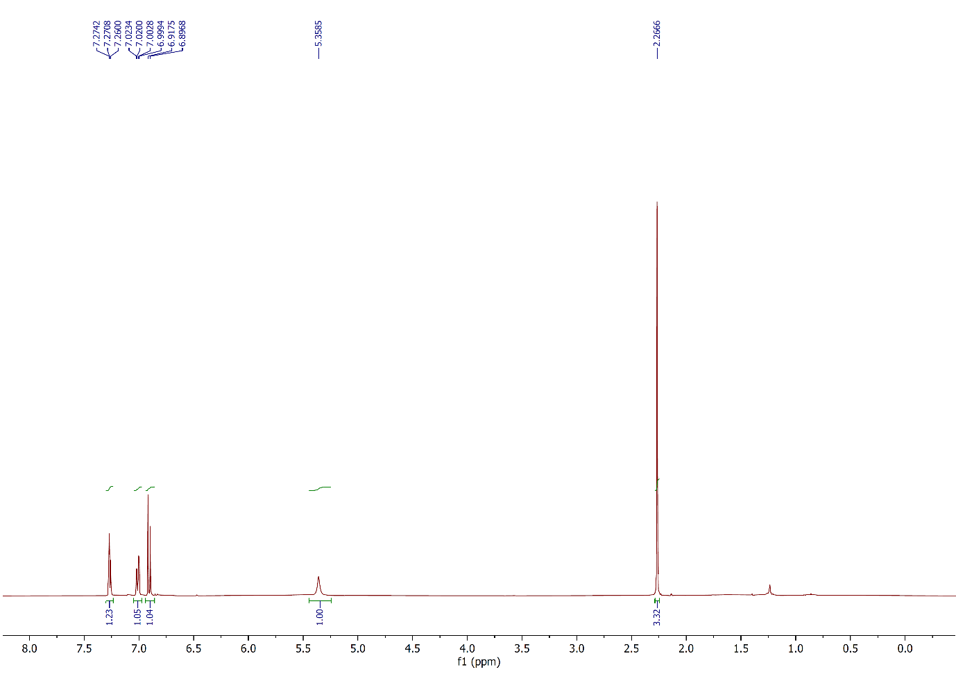Figure 1: 1H NMR spectrum of compound **2a**,(CDCl3, 400 MHz).

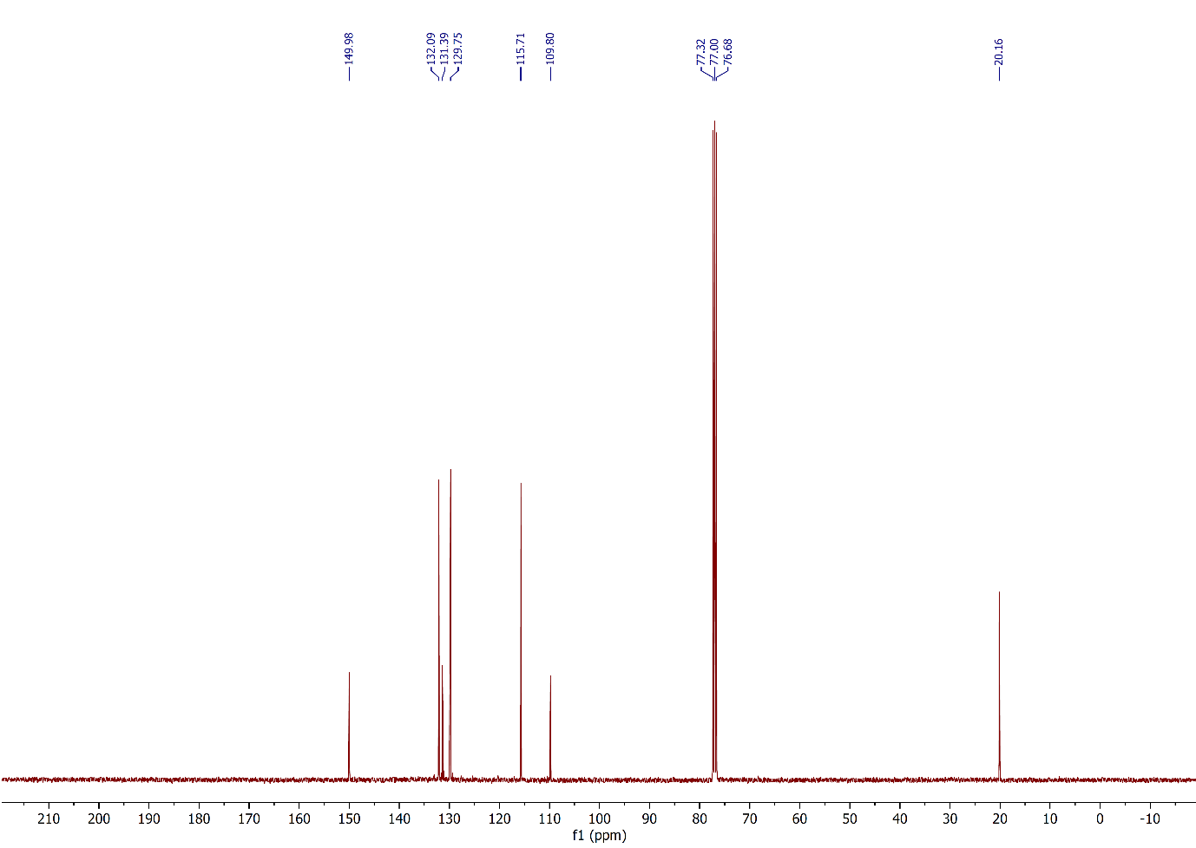

Figure 2: 13C NMR spectrum of compound **2a**,(CDCl3, 100 MHz).

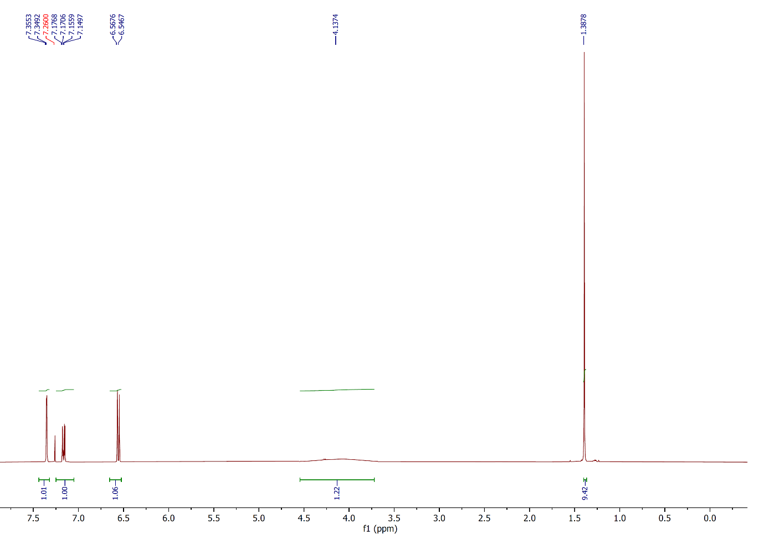

Figure 3: 1H NMR spectrum of compound **2b**,(CDCl3, 400 MHz).

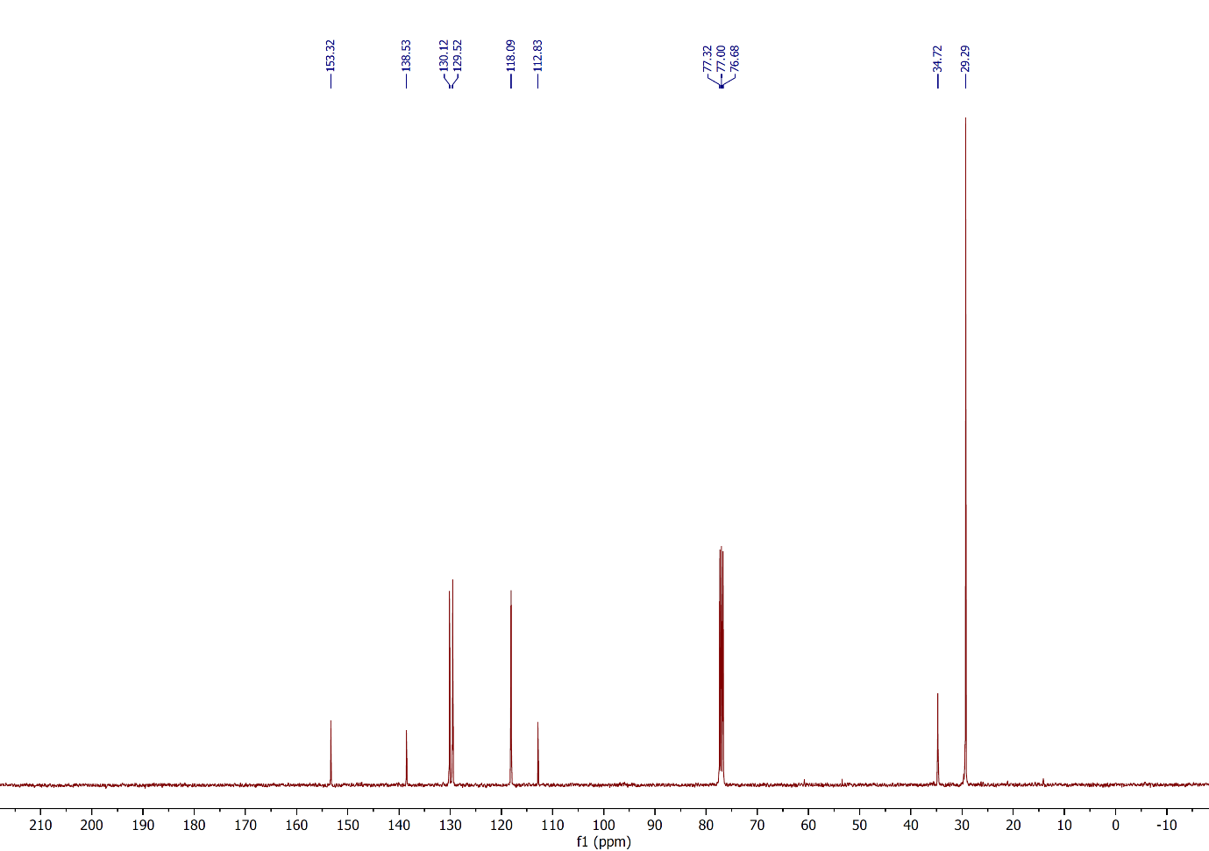

Figure 4: 13C NMR spectrum of compound **2b**,(CDCl3, 100 MHz).

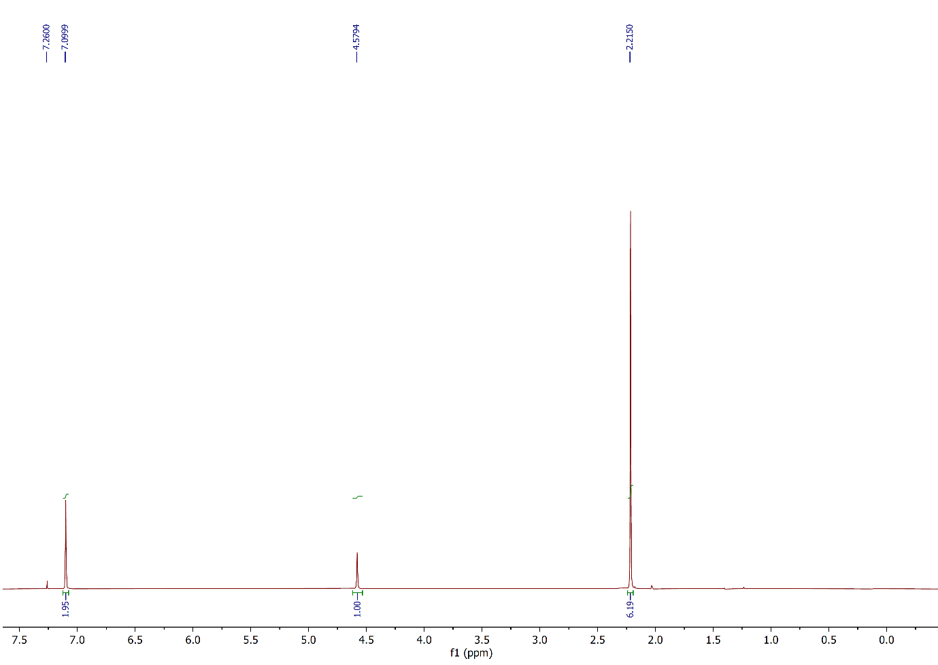 Figure 5: 1H NMR spectrum of compound **2c**,(CDCl3, 400 MHz).

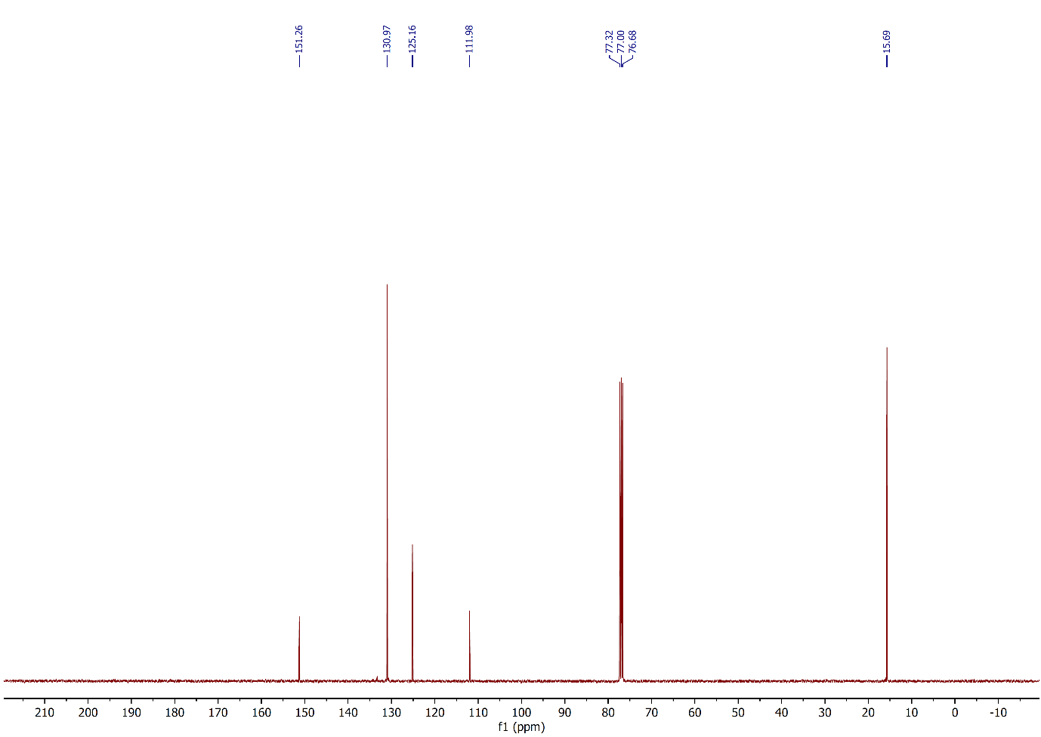

Figure 6: 13C NMR spectrum of compound **2c**,(CDCl3, 100 MHz).

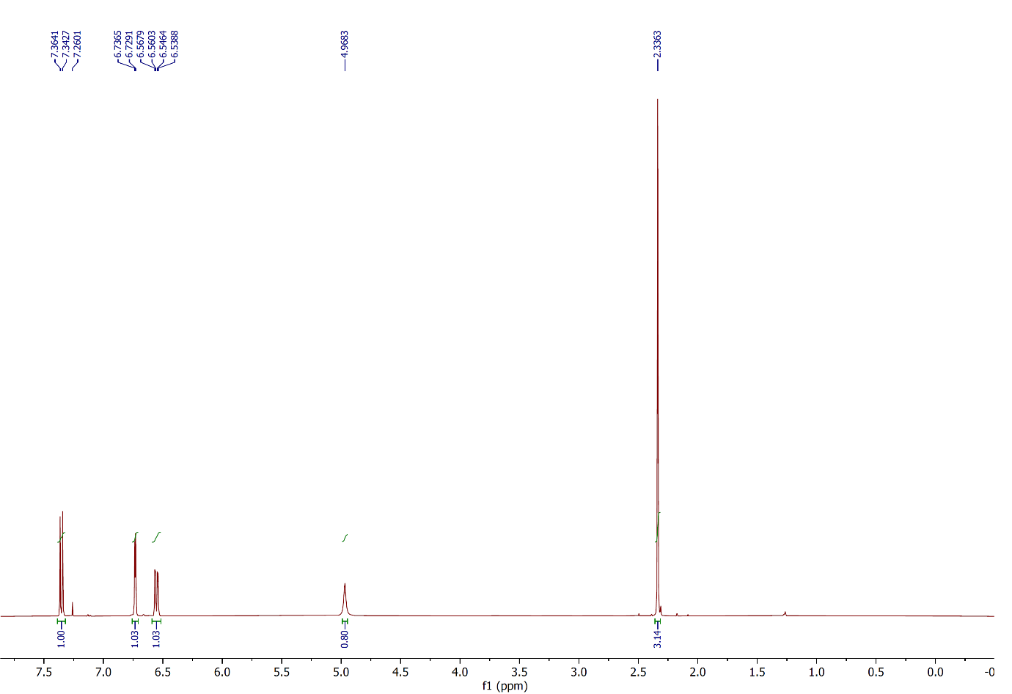

Figure 7: 1H NMR spectrum of compound **2d**,(CDCl3, 400 MHz).

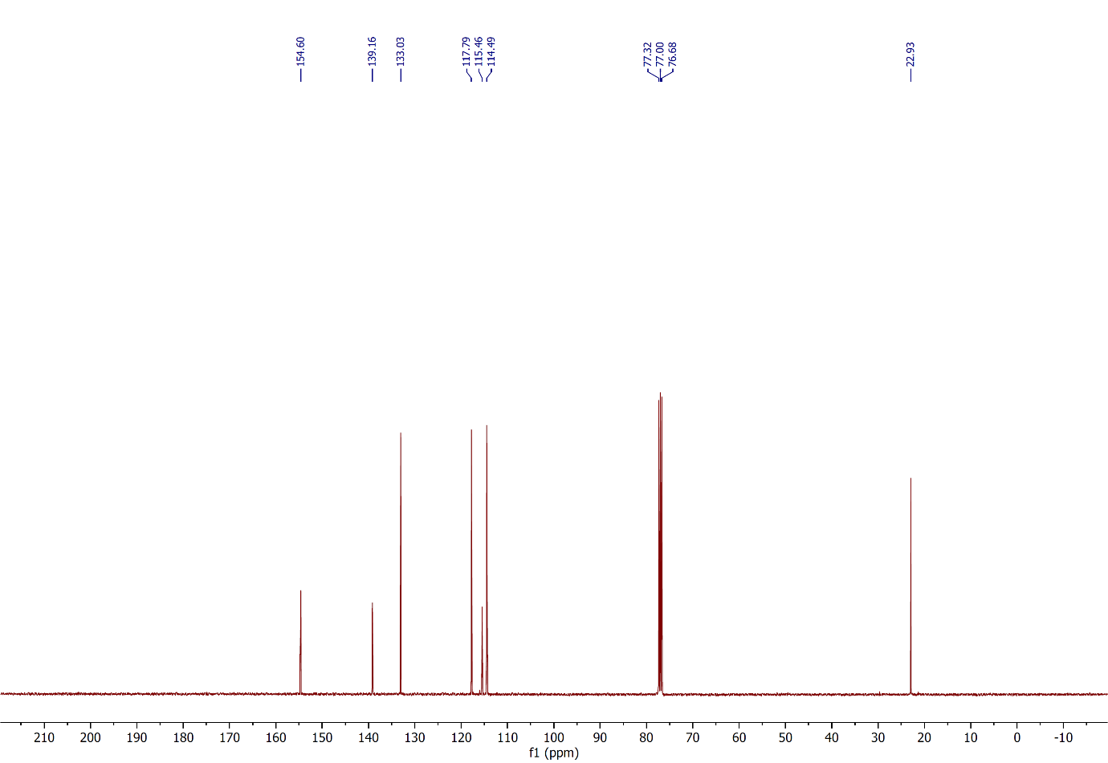

Figure 8: 13C NMR spectrum of compound **2d**,(CDCl3, 100 MHz).

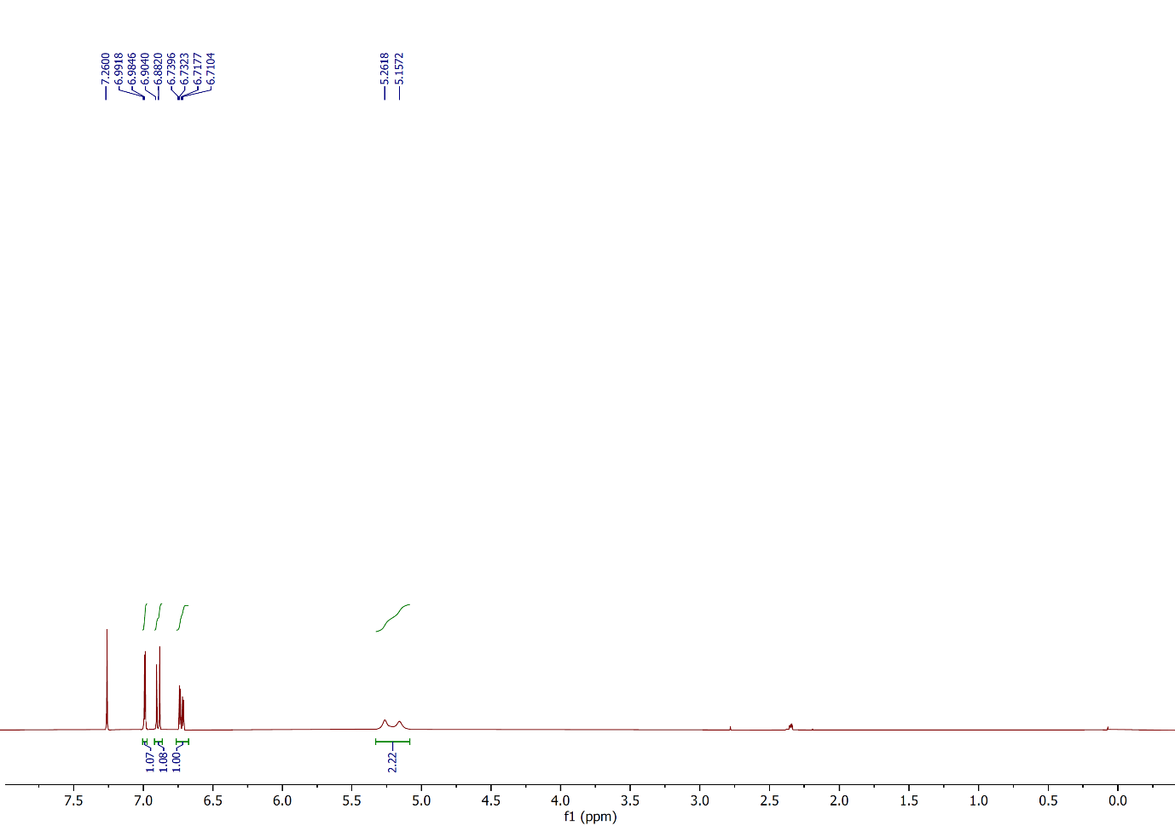

Figure 9: 1H NMR spectrum of compound **2e**,(CDCl3, 400 MHz).

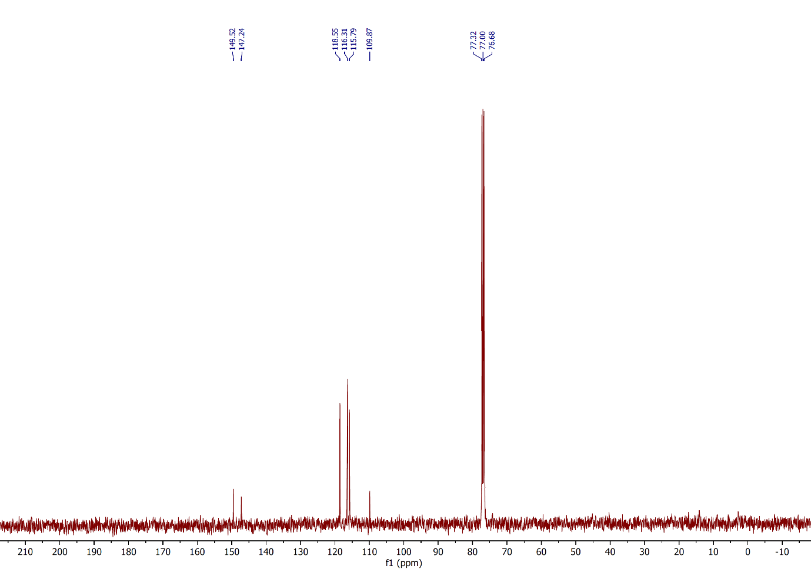

Figure 10: 13C NMR spectrum of compound **2e**,(CDCl3, 100 MHz).

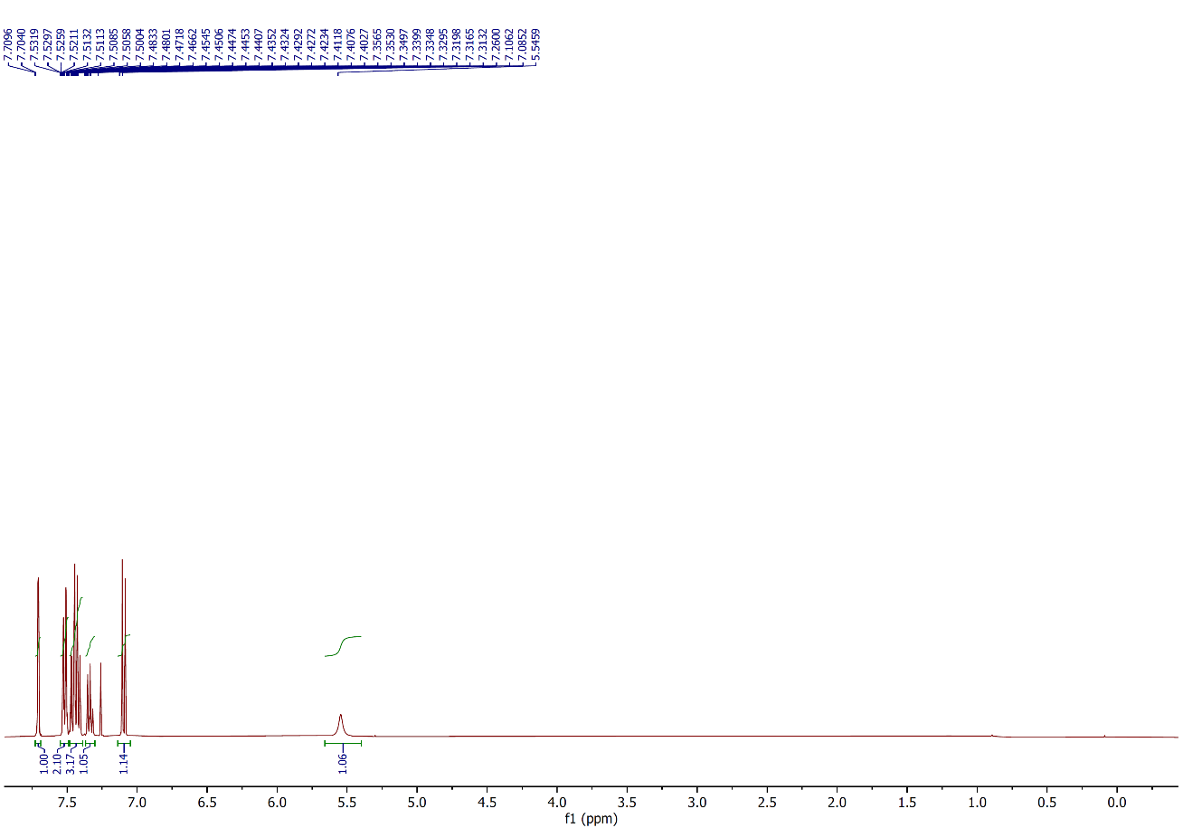

Figure 11: 1H NMR spectrum of compound **2f**,(CDCl3, 400 MHz).

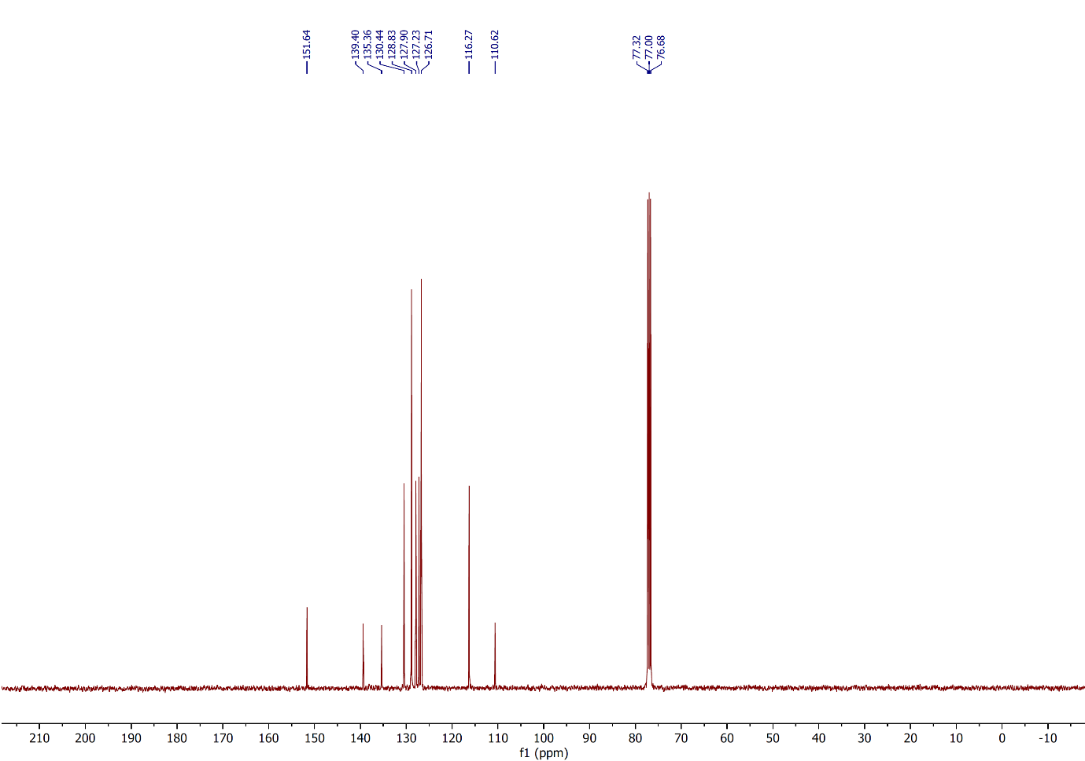

Figure 12: 13C NMR spectrum of compound **2f**,(CDCl3, 100 MHz).

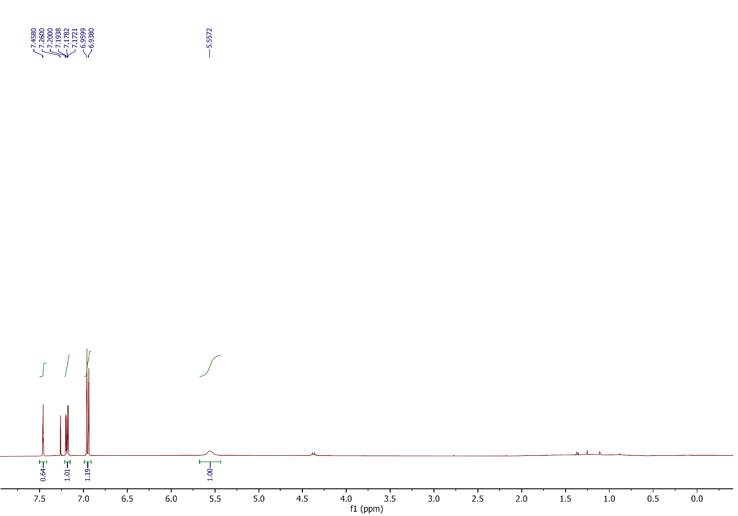

Figure 13: 1H NMR spectrum of compound **2g**,(CDCl3, 400 MHz).

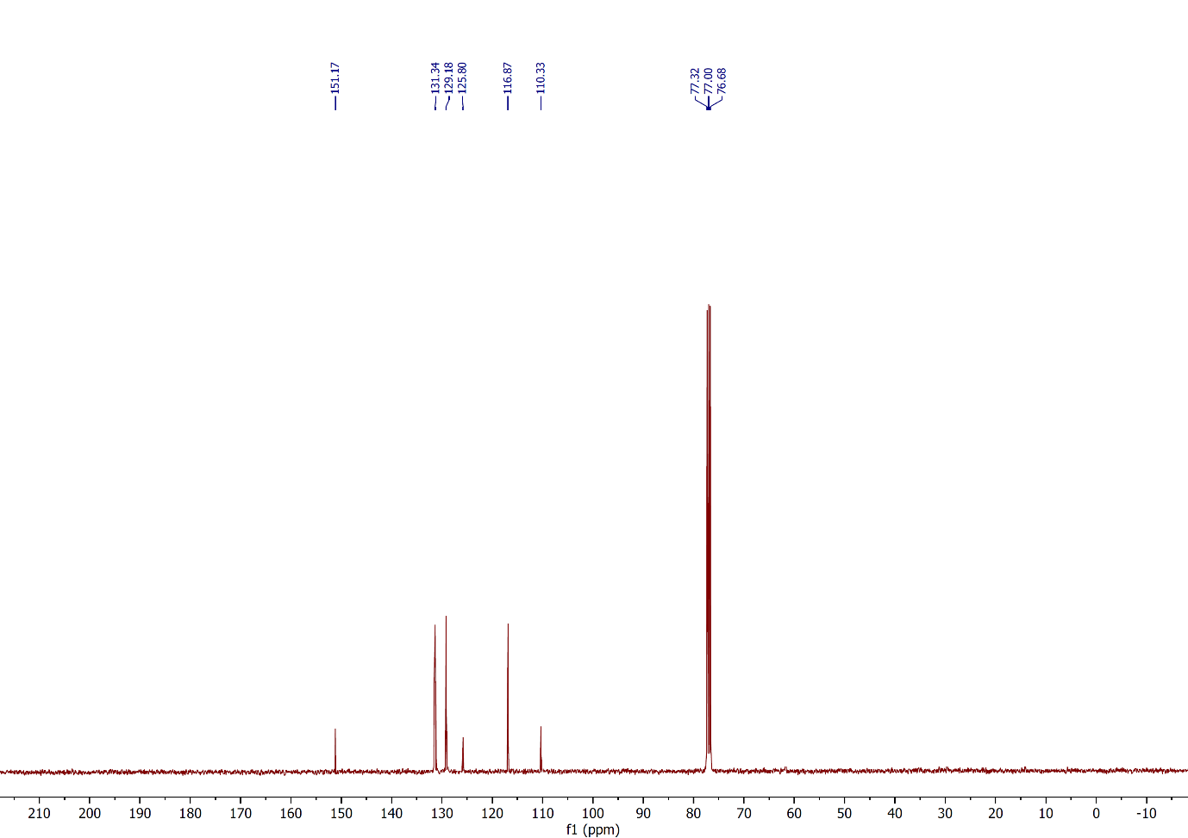

Figure 14: 13C NMR spectrum of compound **2g**,(CDCl3, 100 MHz).

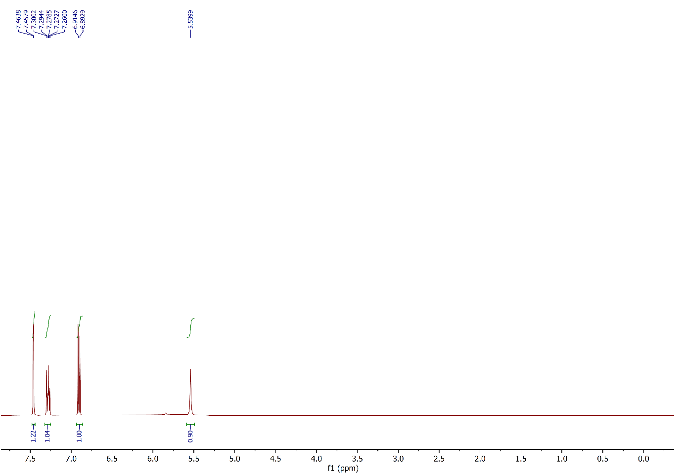

Figure 15: 1H NMR spectrum of compound **2h**,(CDCl3, 400 MHz).

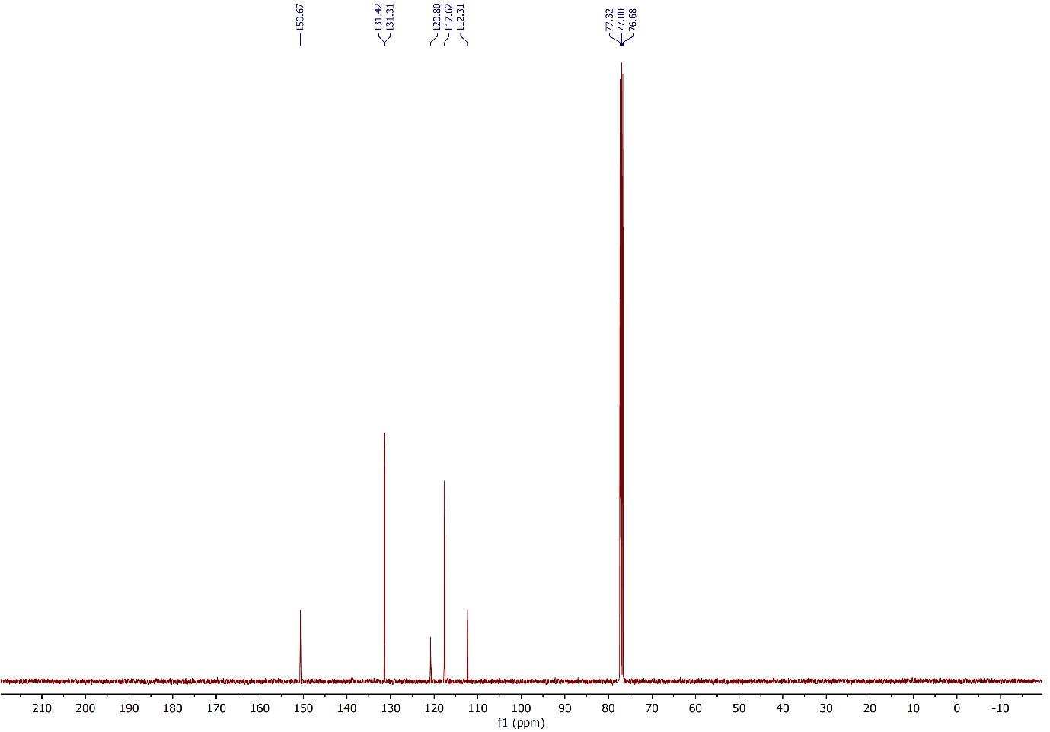 Figure 16: 13C NMR spectrum of compound **2h**,(CDCl3, 100 MHz).

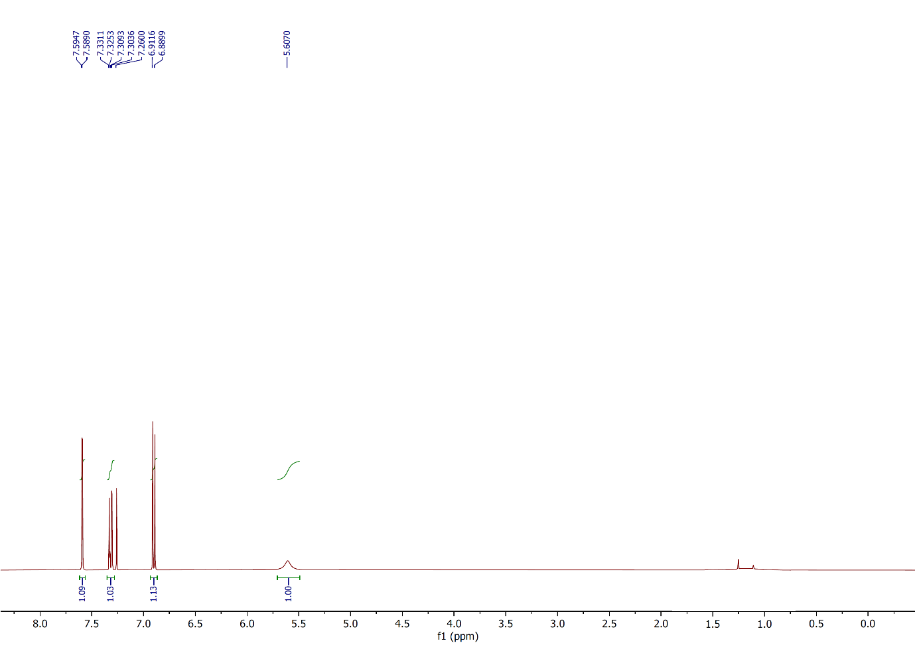

Figure 17: 1H NMR spectrum of compound **2i**,(CDCl3, 400 MHz).

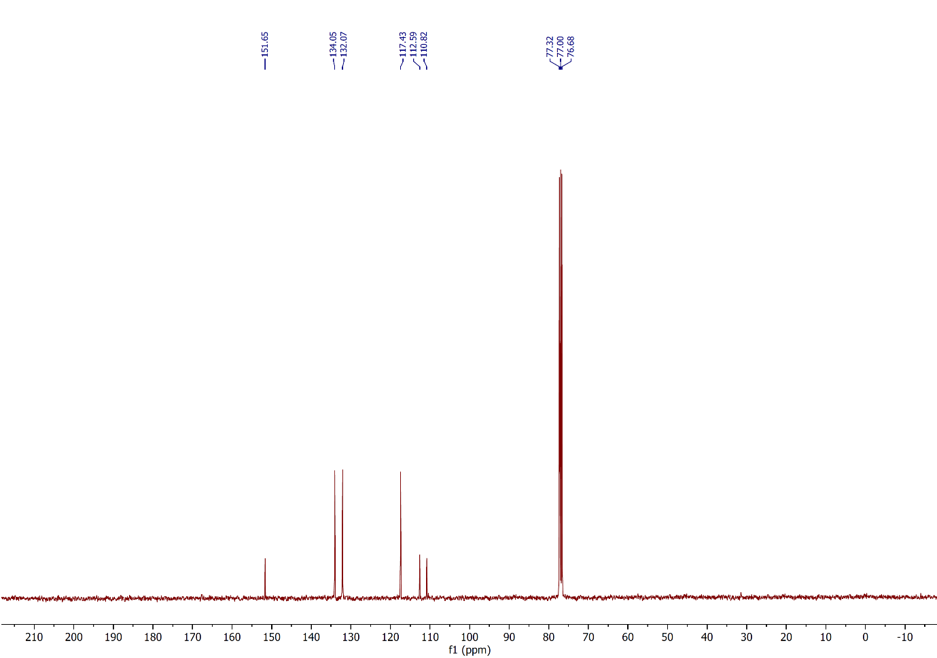

Figure 18: 13C NMR spectrum of compound **2i**,(CDCl3, 100 MHz).

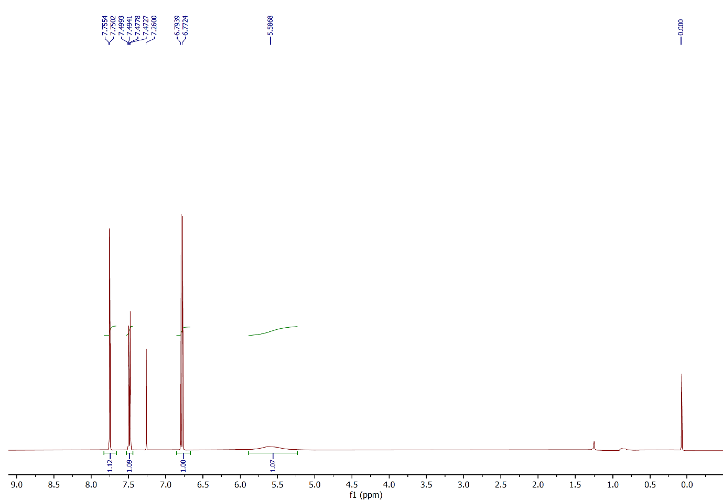

Figure 19: 1H NMR spectrum of compound **2j**,(CDCl3, 400 MHz).

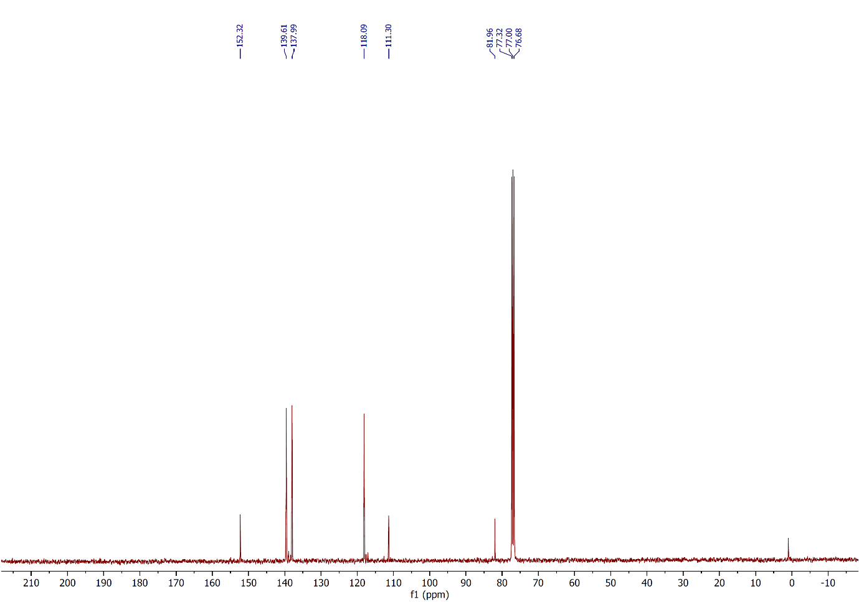

Figure 20: 13C NMR spectrum of compound **2j**,(CDCl3, 100 MHz).

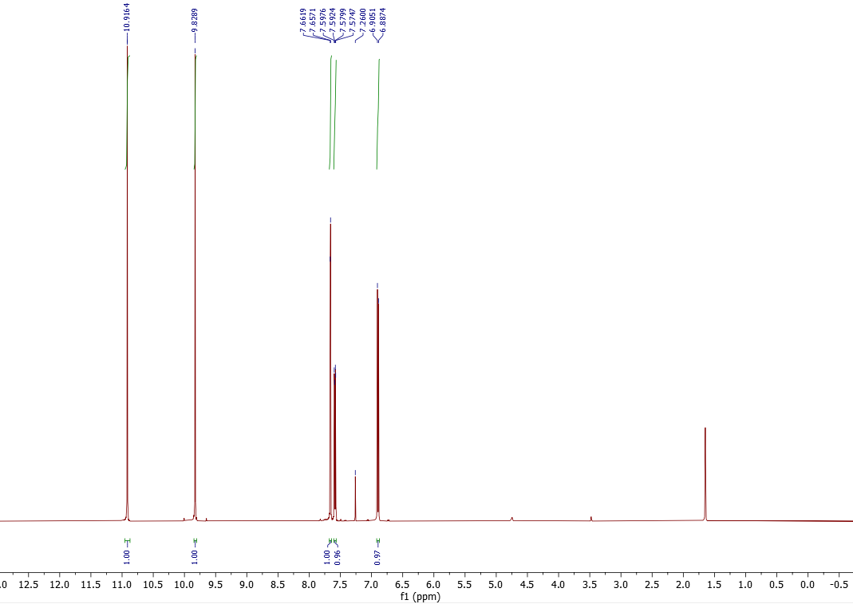

Figure 21: 1H NMR spectrum of compound **2k**,(CDCl3, 500 MHz).

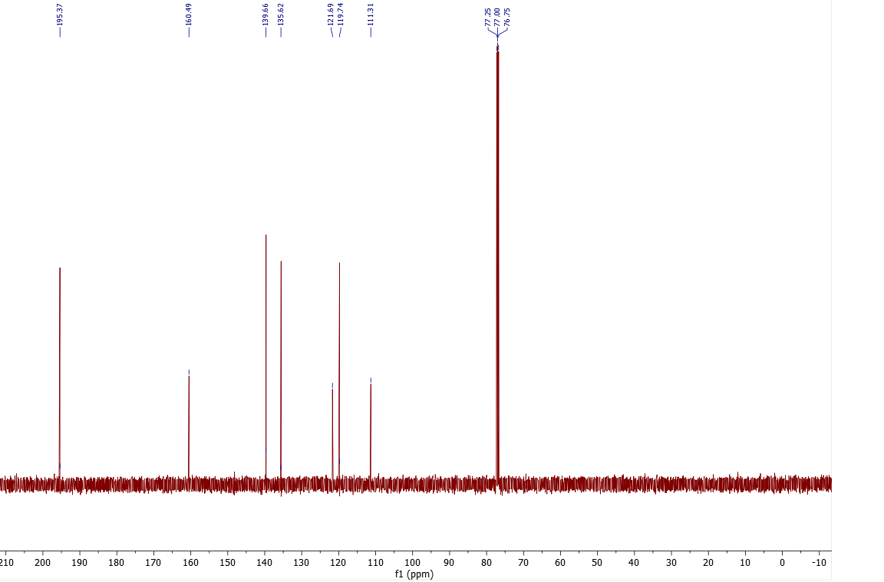

Figure 22: 13C NMR spectrum of compound **2k**,(CDCl3, 125 MHz).

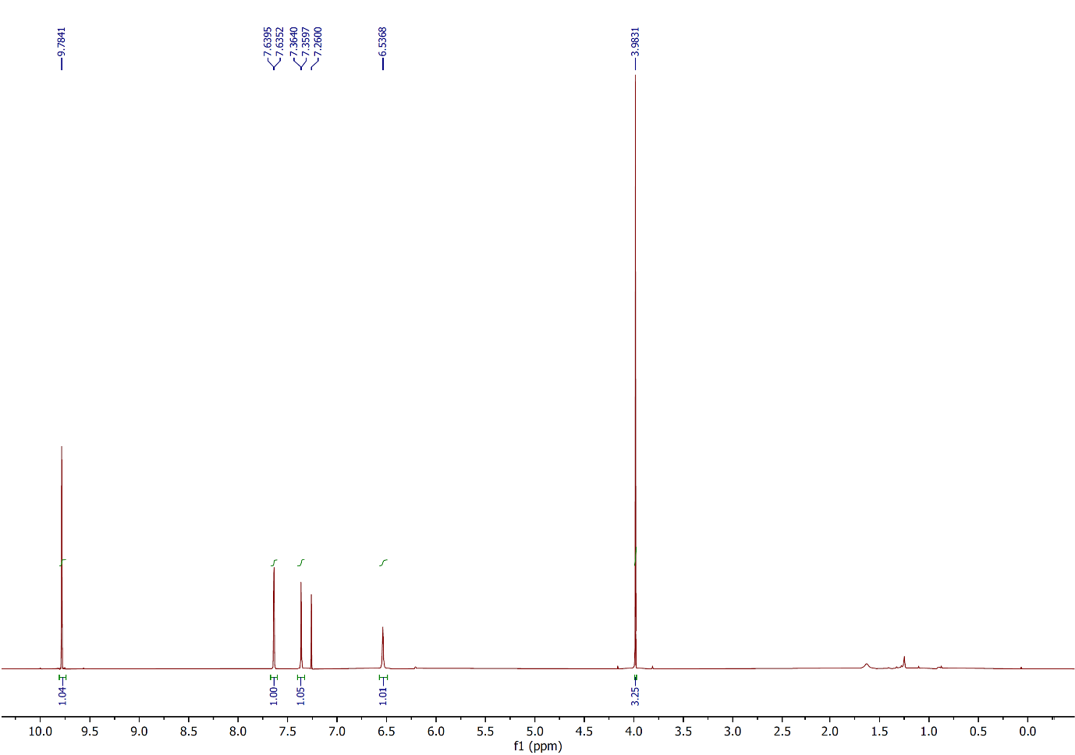

Figure 23: 1H NMR spectrum of compound **2l**,(CDCl3, 400 MHz).

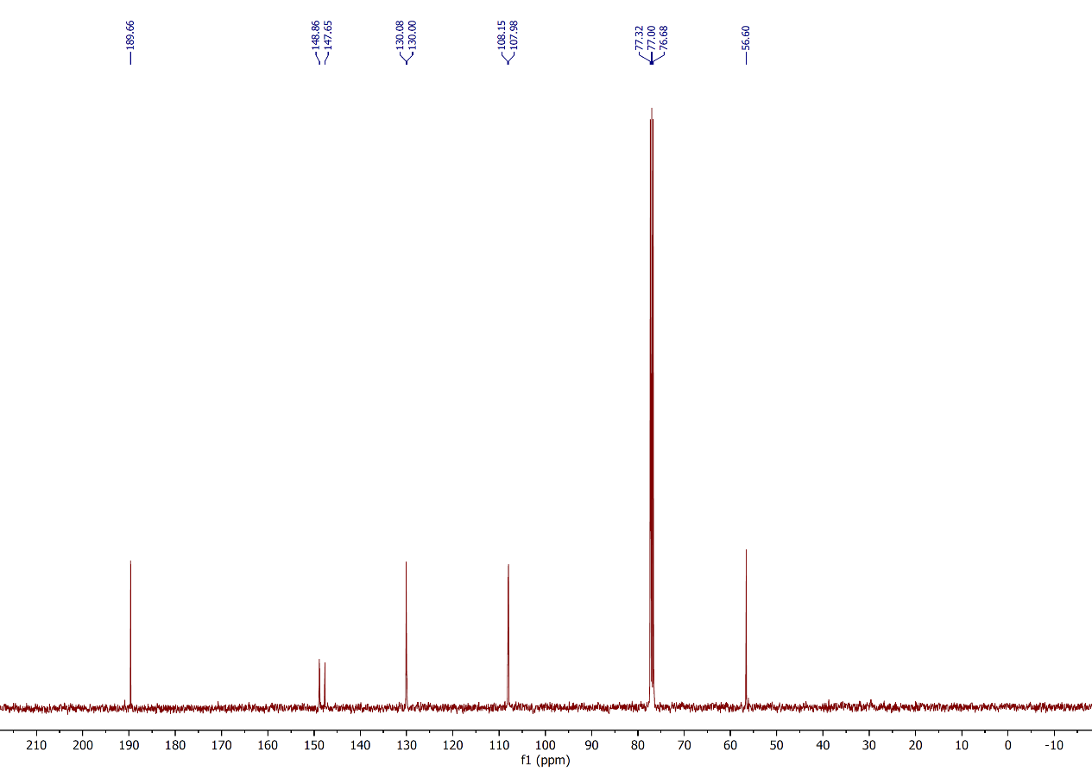

Figure 24: 13C NMR spectrum of compound **2l**,(CDCl3, 100 MHz).

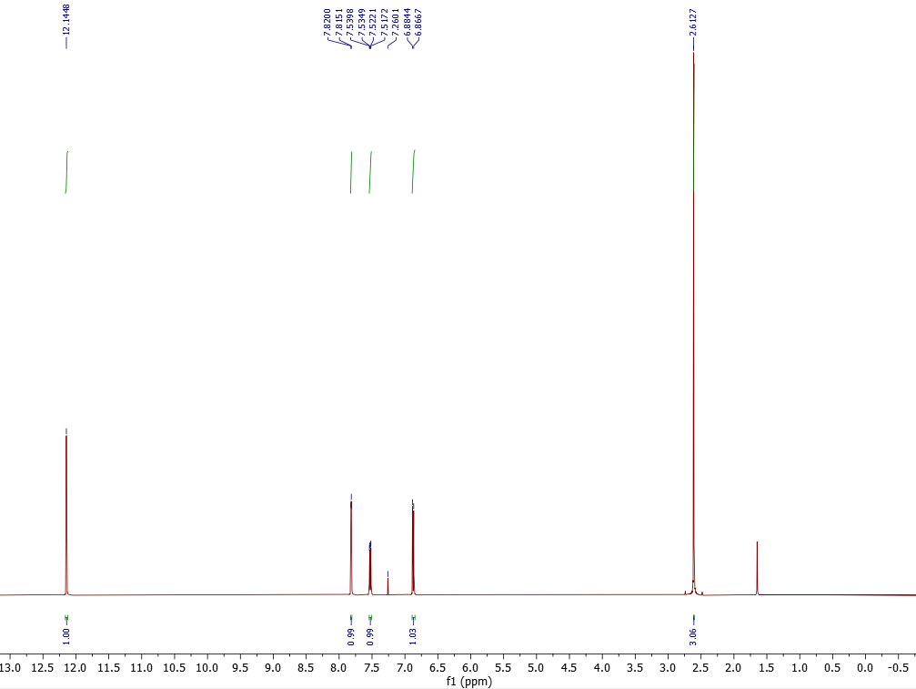

Figure 25: 1H NMR spectrum of compound **2m**,(CDCl3, 500 MHz).

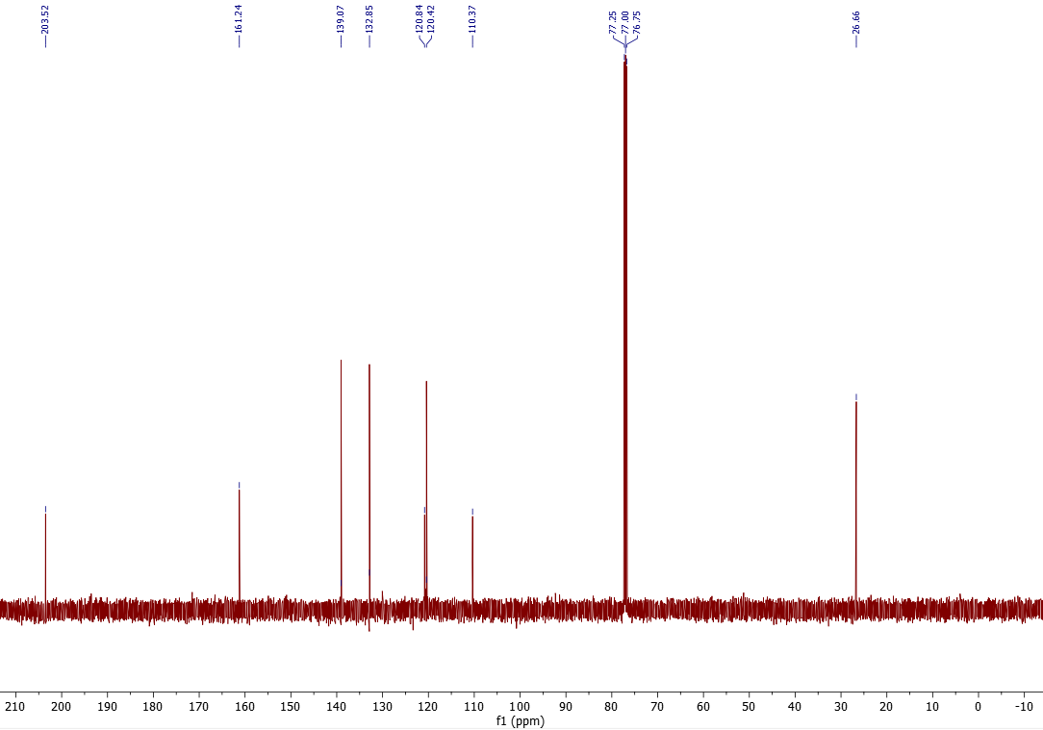

Figure 26: 13C NMR spectrum of compound **2m**,(CDCl3, 125 MHz).

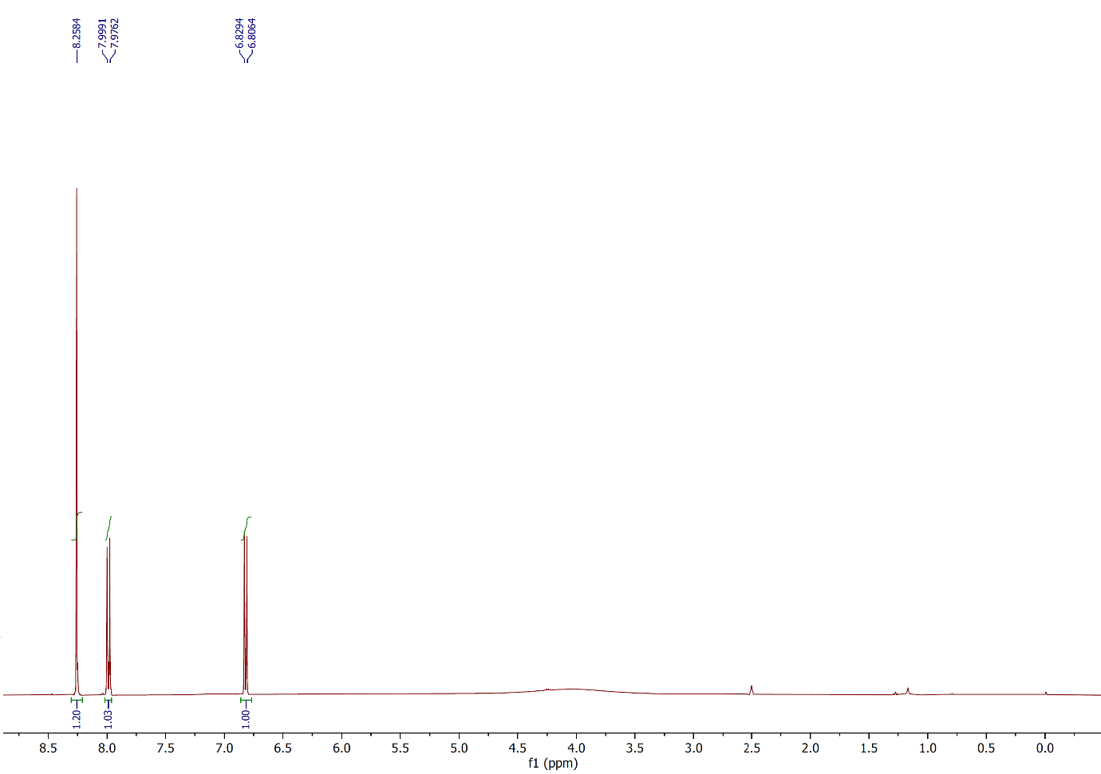

Figure 27: 1H NMR spectrum of compound **2n**,(CDCl3, 400 MHz).

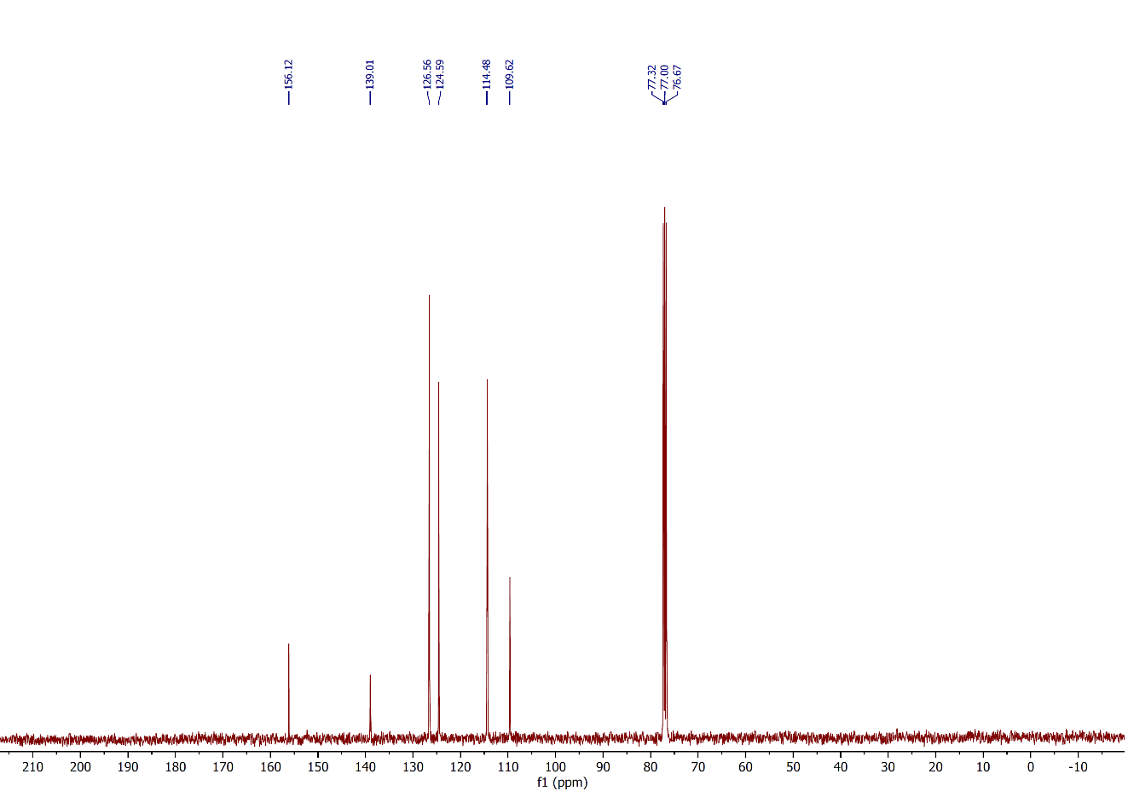

Figure 28: 13C NMR spectrum of compound **2n**,(CDCl3, 100 MHz).

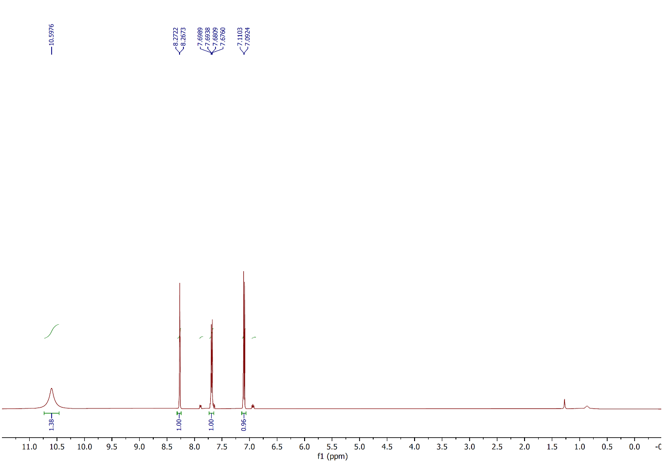Figure 29: 1H NMR spectrum of compound **2o**,(CDCl3, 500 MHz).

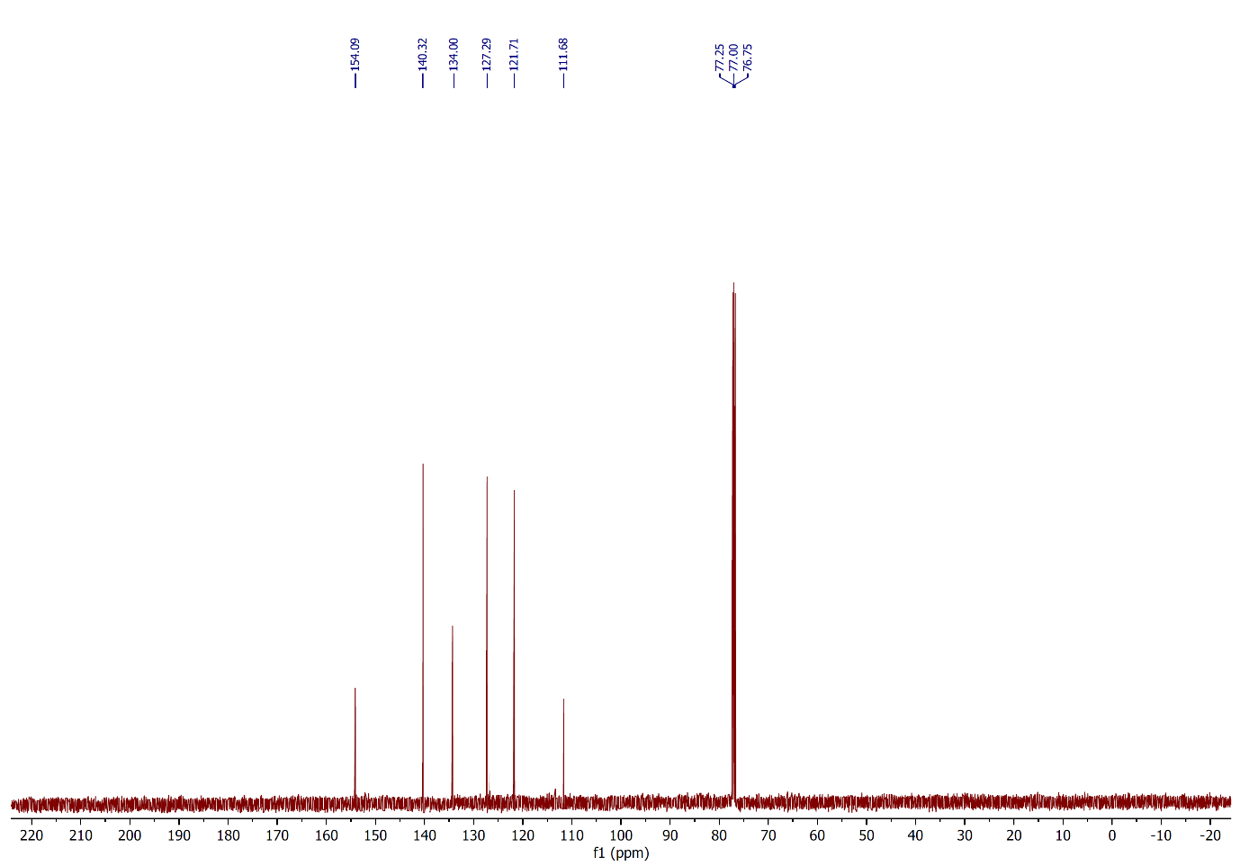

Figure 30: 13C NMR spectrum of compound **2o**,(CDCl3, 125 MHz).

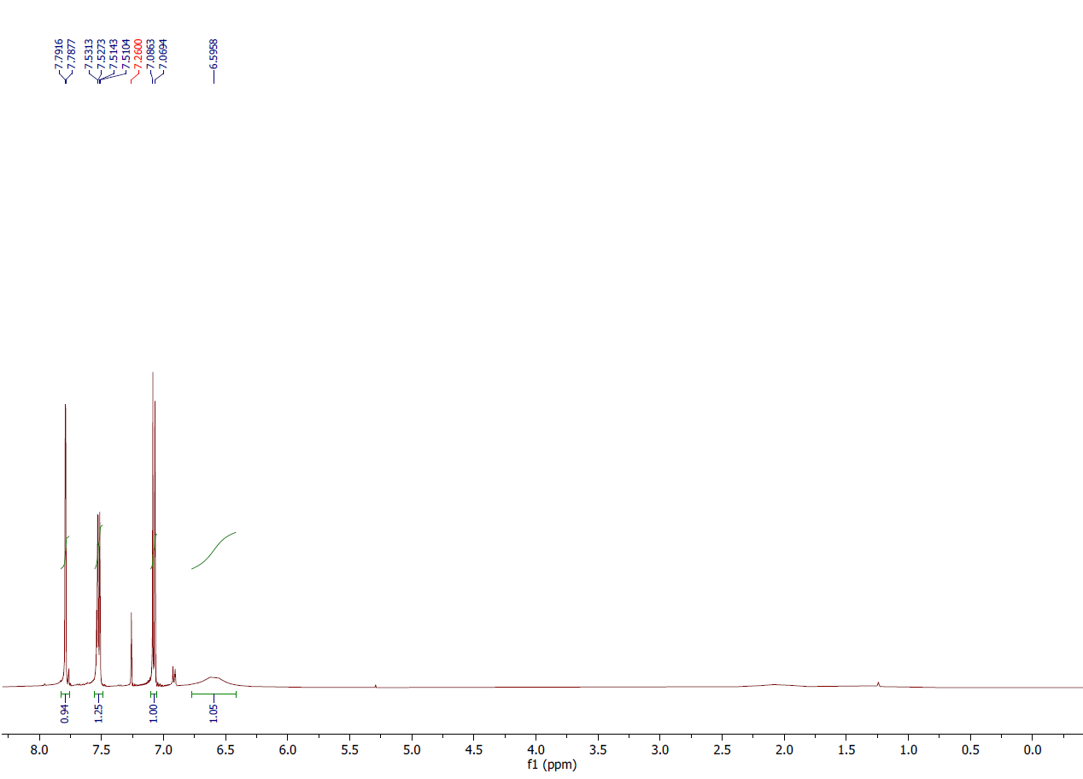Figure 31: 1H NMR spectrum of compound **2p**,(CDCl3, 500 MHz).

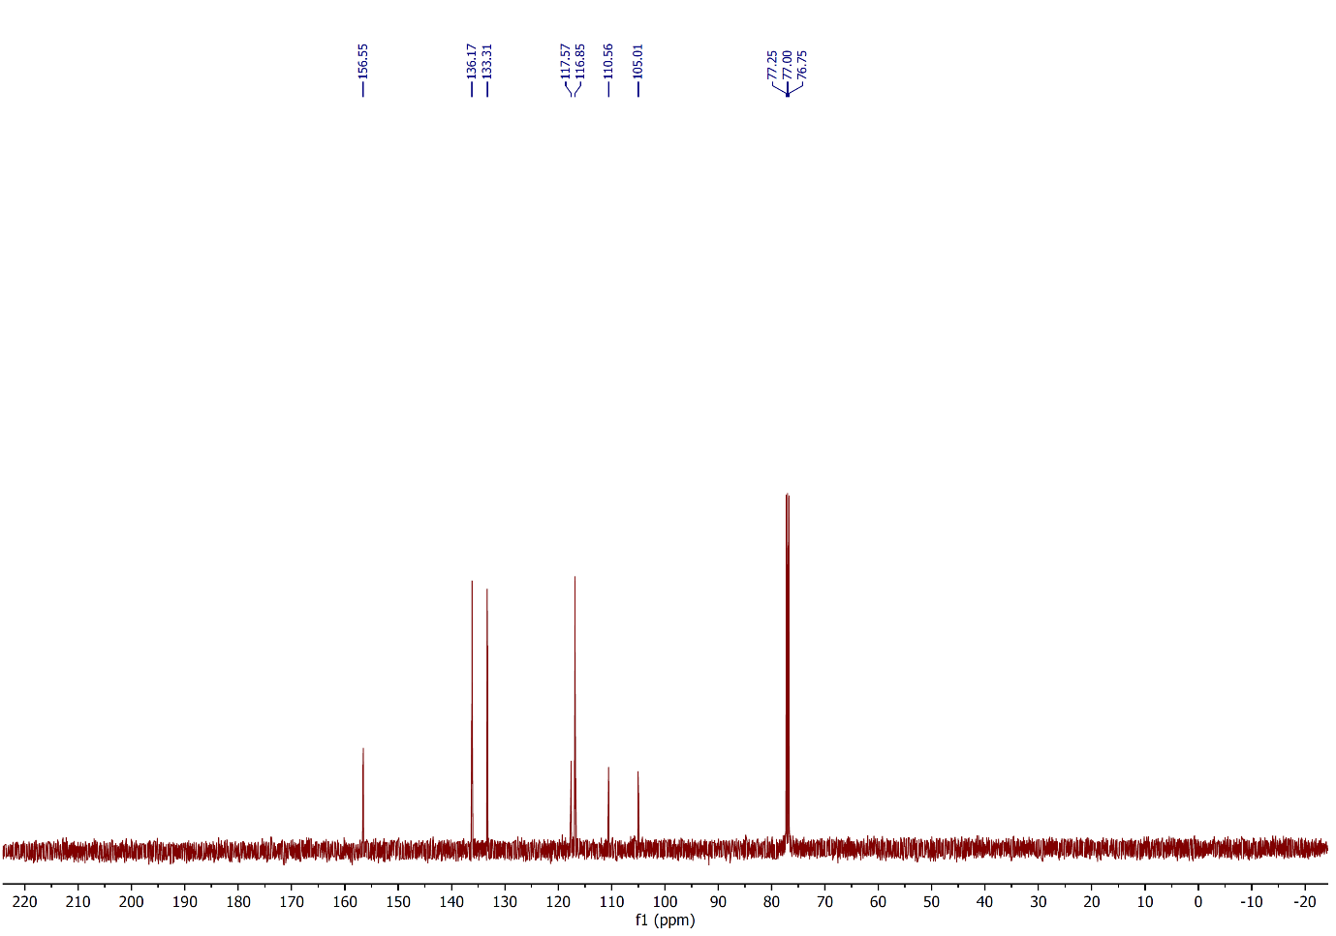

Figure 32: 13C NMR spectrum of compound **2p**,(CDCl3, 125 MHz).

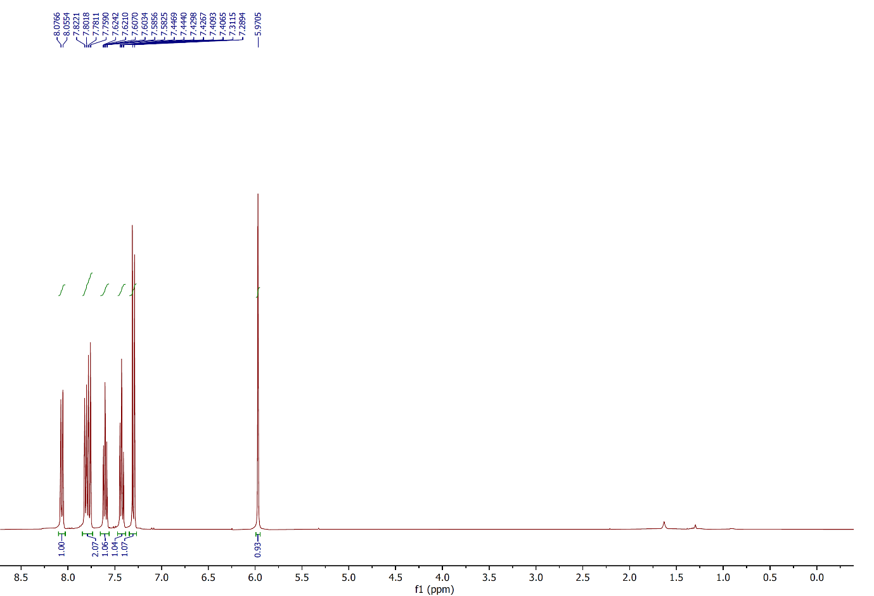

Figure 33: 1H NMR spectrum of compound **2q**,(CDCl3, 400 MHz).

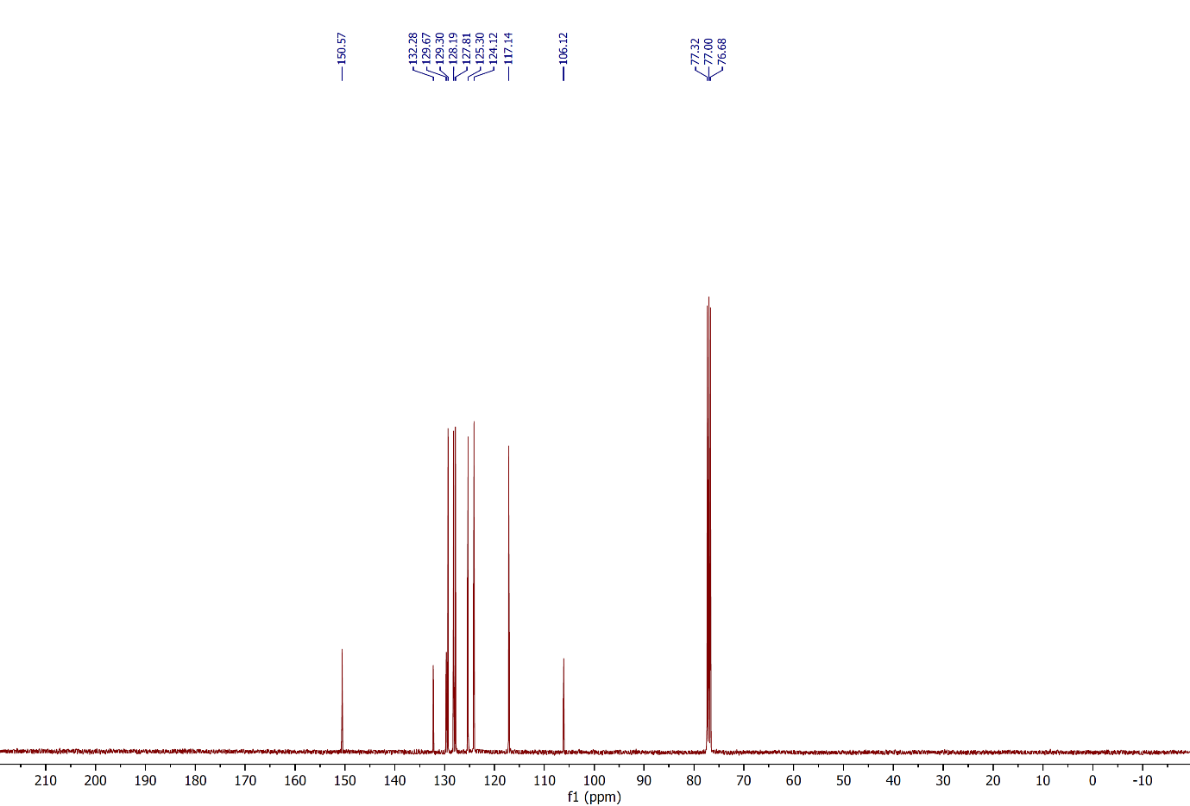 Figure 34: 13C NMR spectrum of compound **2q**,(CDCl3, 100 MHz).

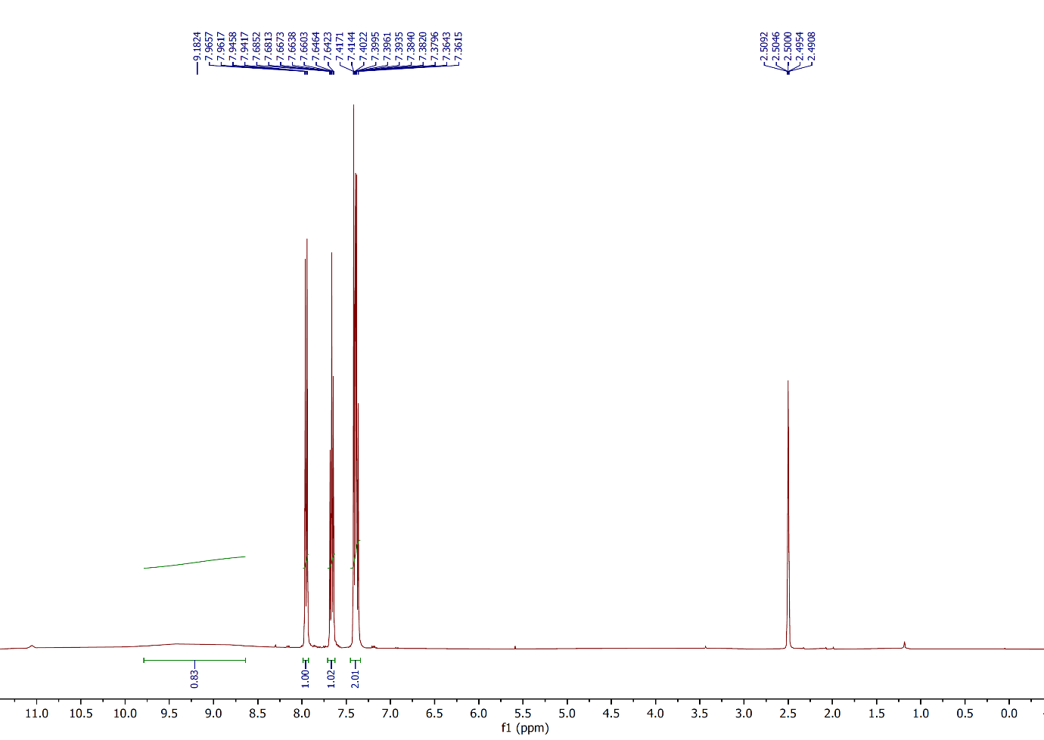

Figure 35: 1H NMR spectrum of compound **2r**,(CDCl3, 400 MHz).

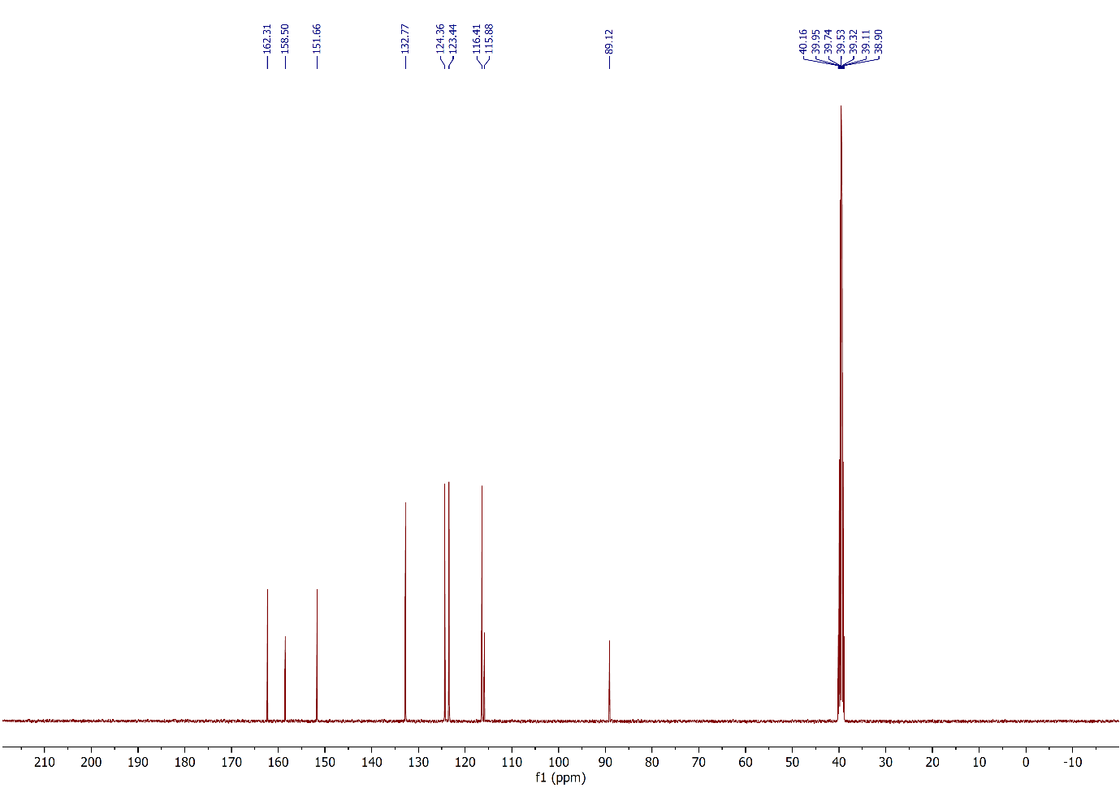

Figure 36: 13C NMR spectrum of compound **2r**,(CDCl3, 100 MHz).

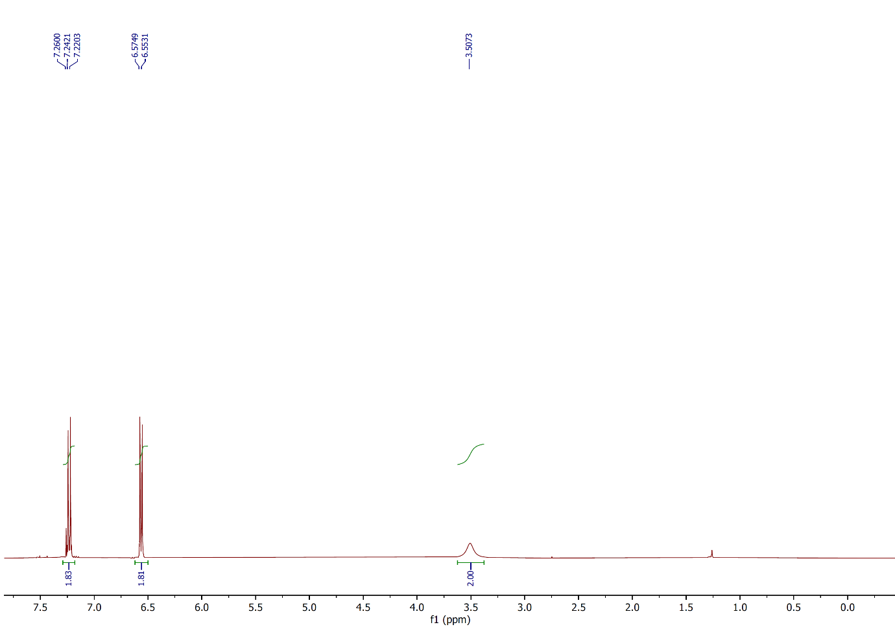

Figure 37: 1H NMR spectrum of compound **2s**,(CDCl3, 400 MHz).

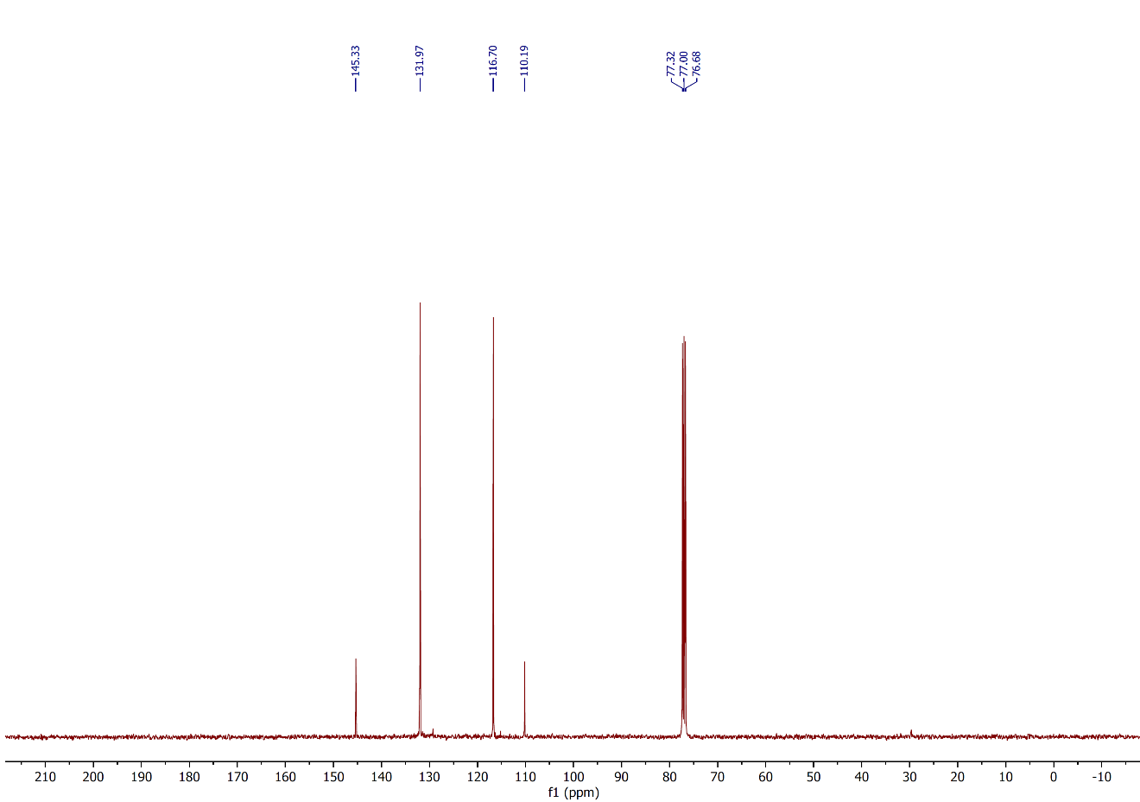

Figure 38: 13C NMR spectrum of compound **2s**,(CDCl3, 100 MHz).

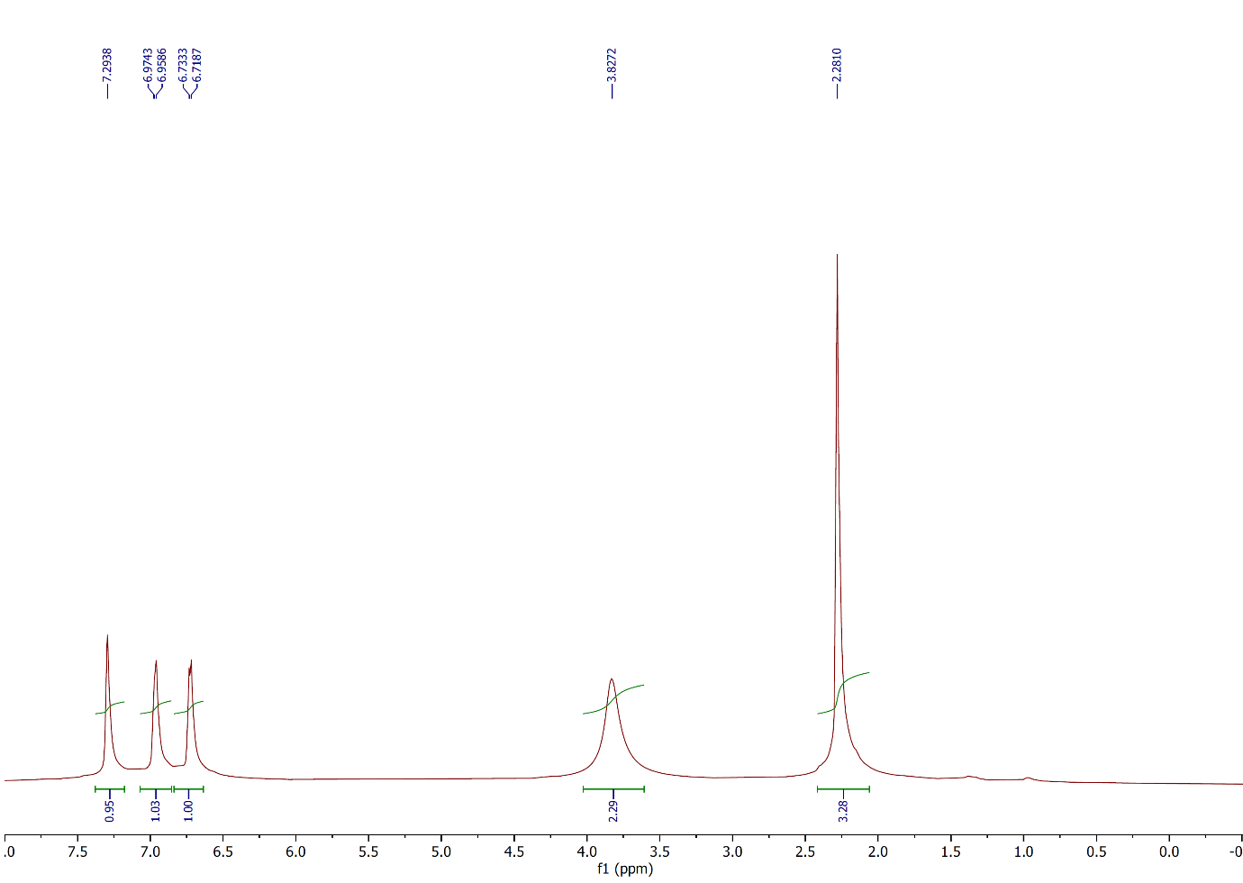Figure 39: 1H NMR spectrum of compound **2t**,(CDCl3, 500 MHz).

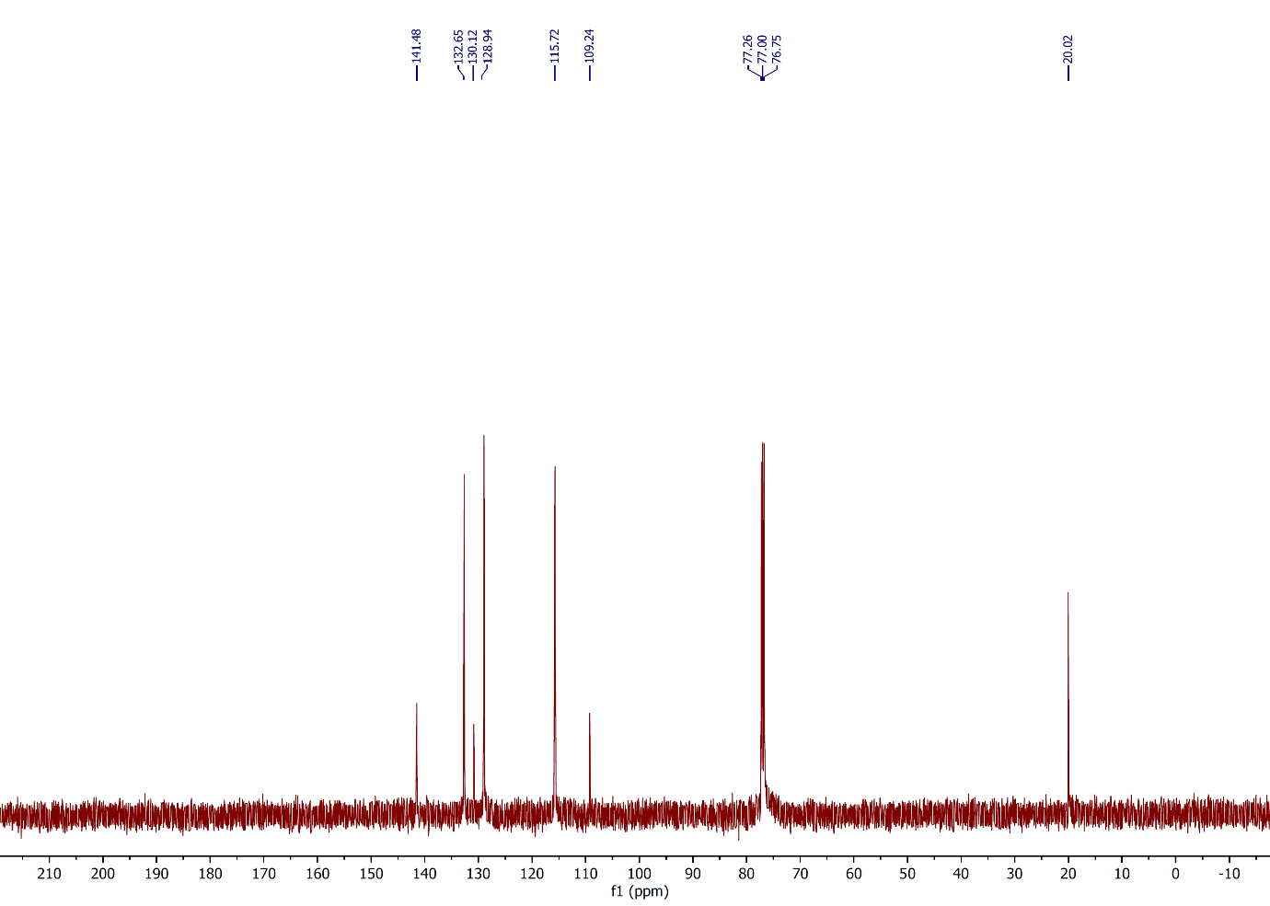

Figure 40: 13C NMR spectrum of compound **2t**,(CDCl3, 125 MHz).

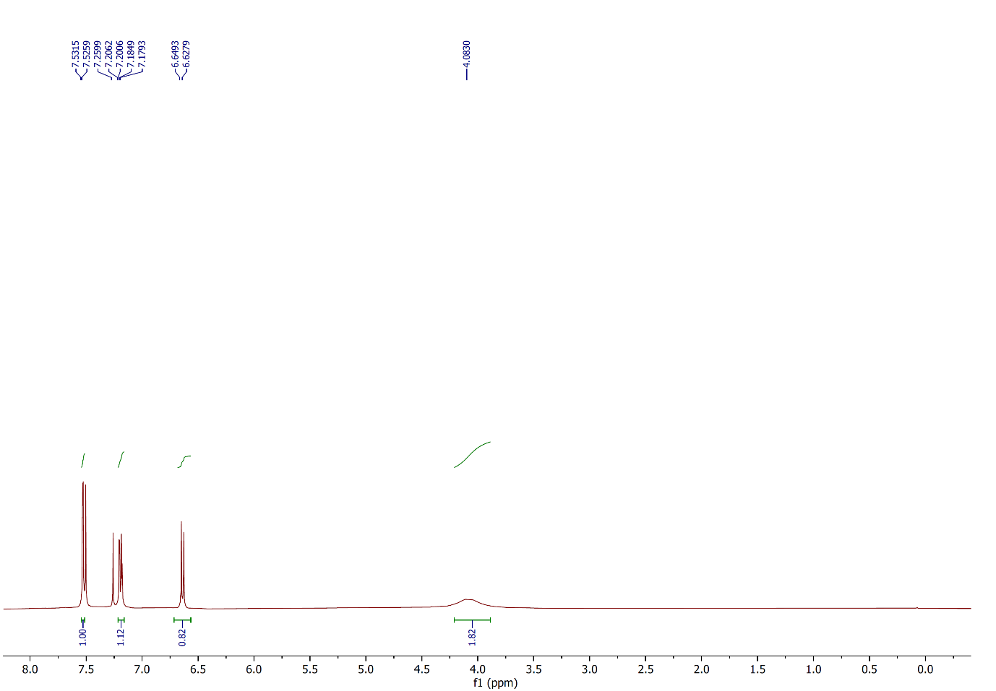

Figure 41: 1H NMR spectrum of compound **2u**,(CDCl3, 400 MHz).

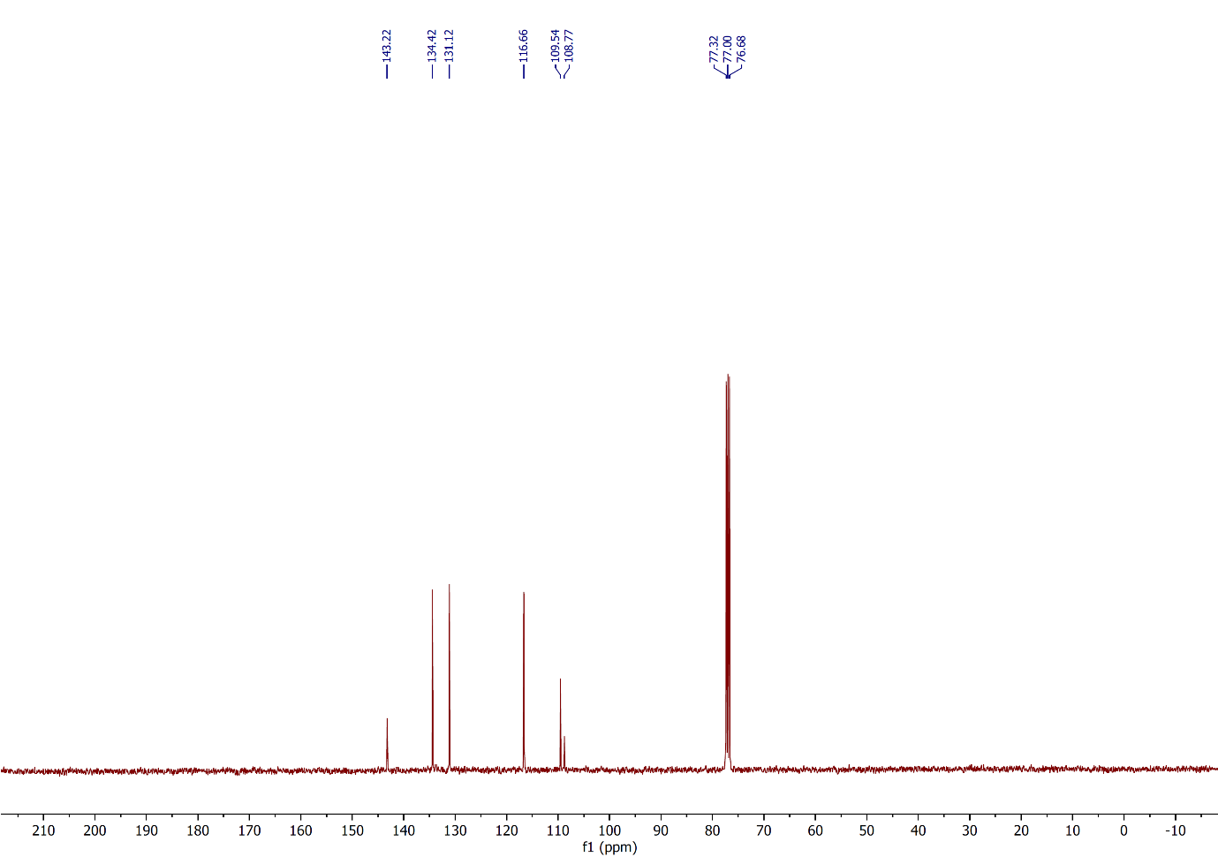

Figure 42: 13C NMR spectrum of compound **2u**,(CDCl3, 100 MHz).

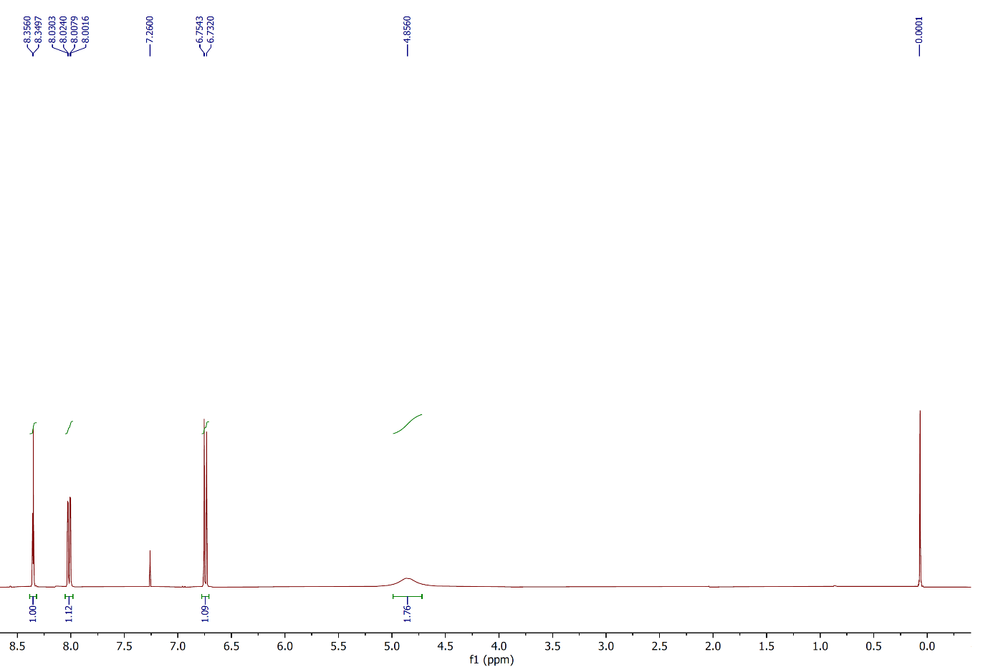

Figure 43: 1H NMR spectrum of compound **2v**,(CDCl3, 400 MHz).

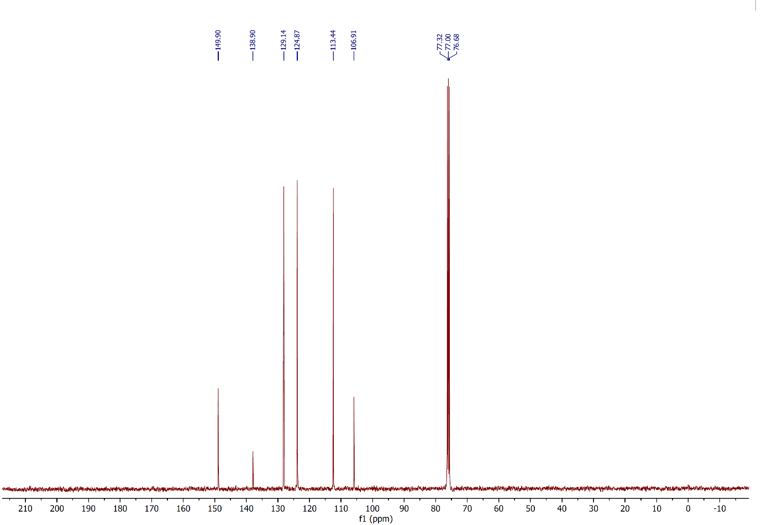

Figure 44: 13C NMR spectrum of compound **2v**,(CDCl3, 100 MHz).

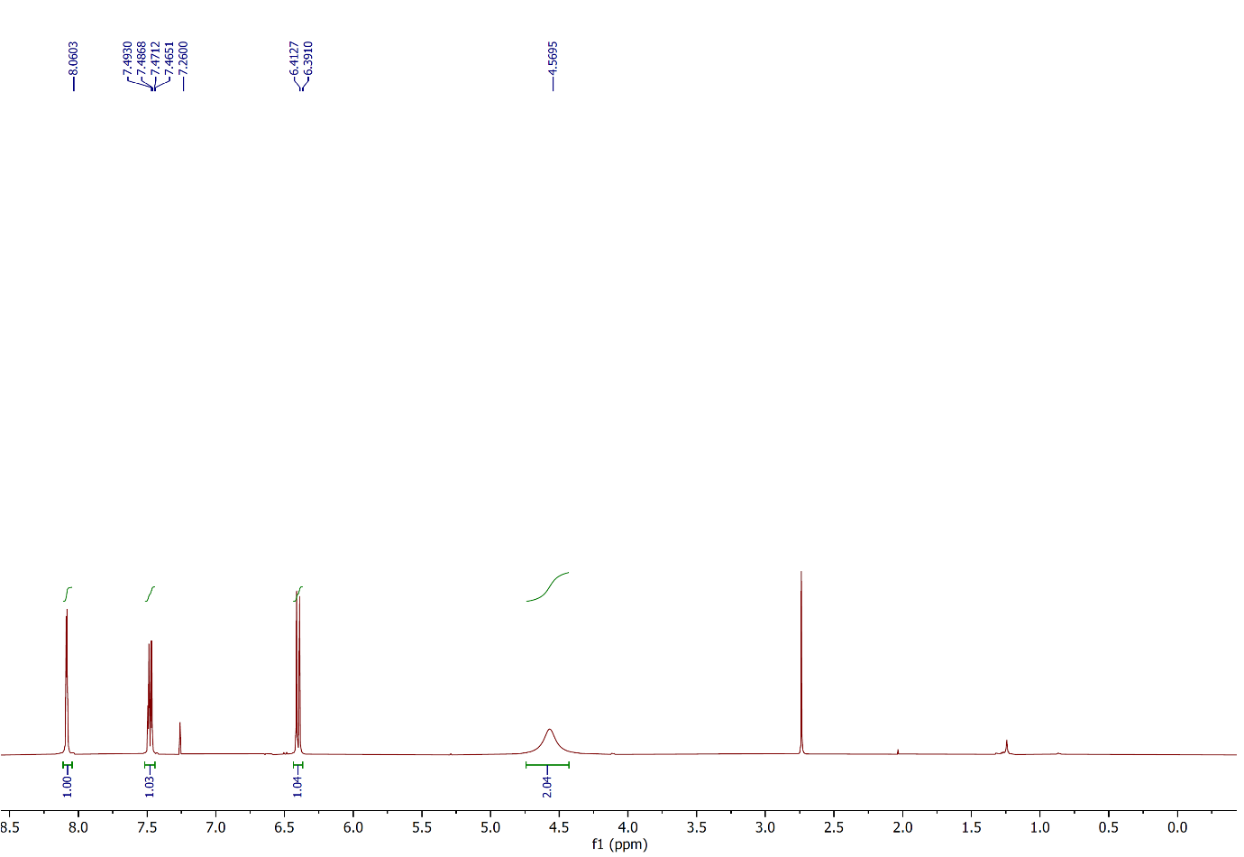

Figure 45: 1H NMR spectrum of compound **2w**,(CDCl3, 400 MHz).

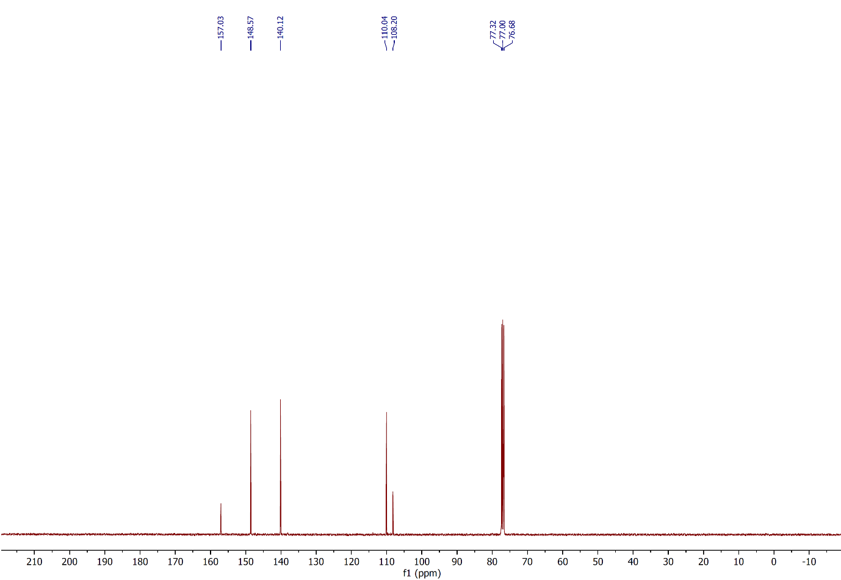

Figure 46: 13C NMR spectrum of compound **2w**,(CDCl3, 100 MHz).

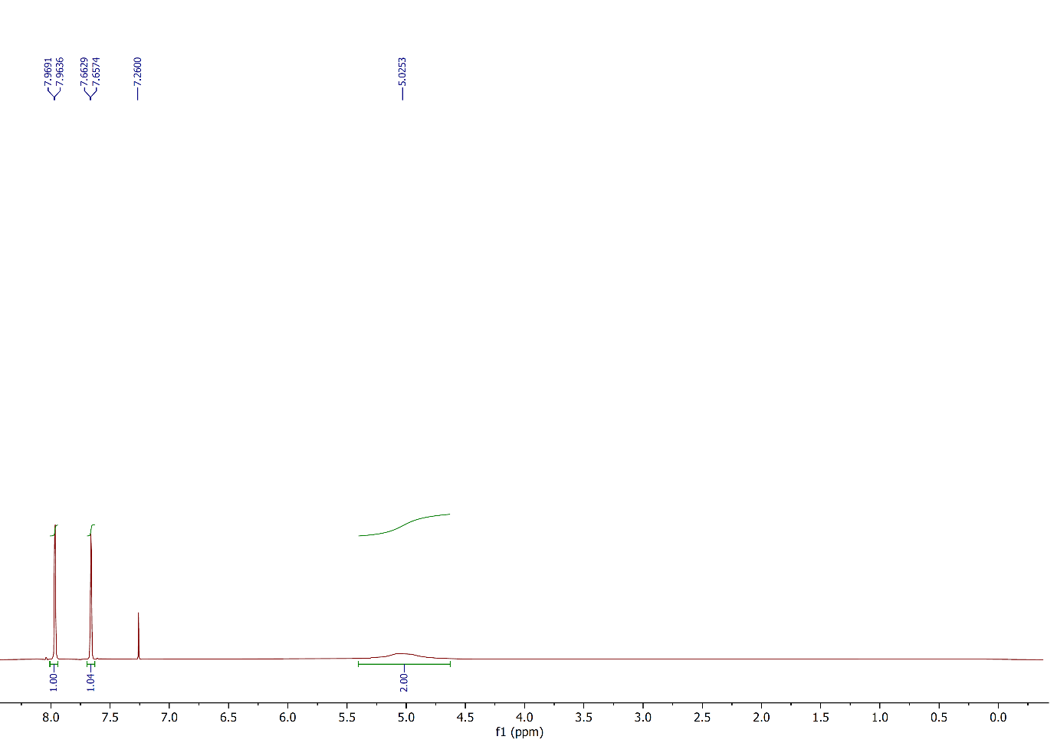

Figure 47: 1H NMR spectrum of compound **2x**,(CDCl3, 400 MHz).

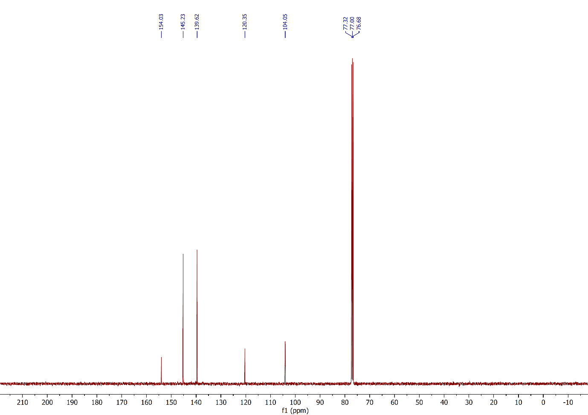

Figure 48: 13C NMR spectrum of compound **2x**,(CDCl3, 100 MHz).

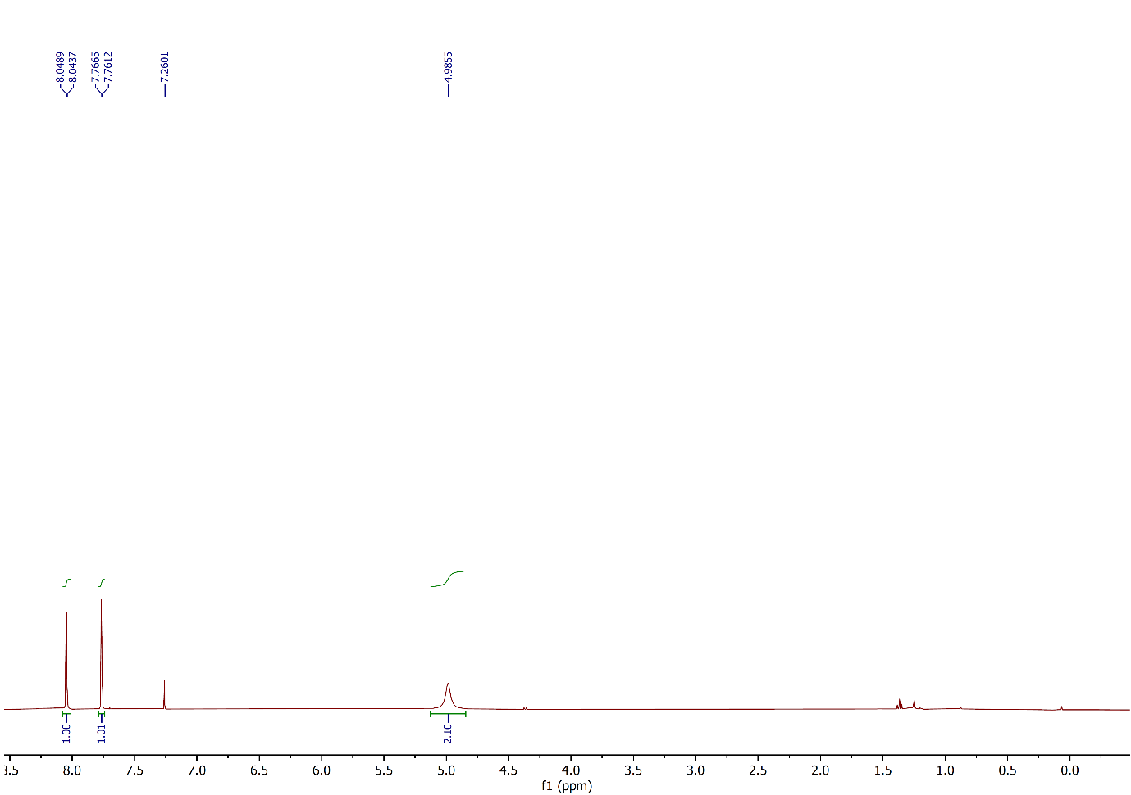

Figure 49: 1H NMR spectrum of compound **2y**,(CDCl3, 400 MHz).

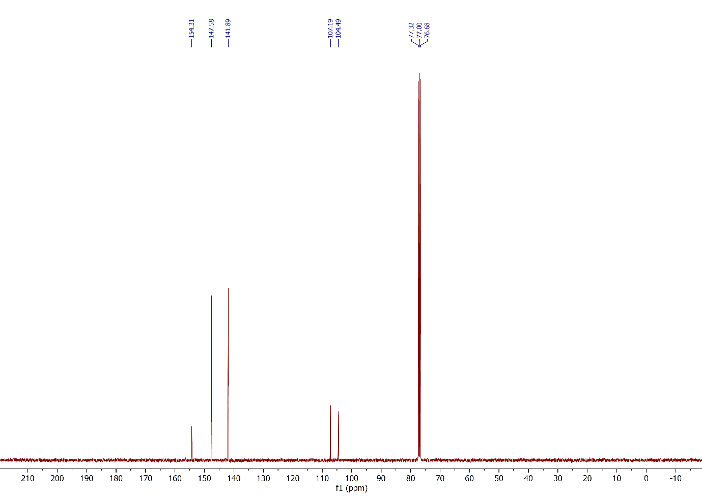

Figure 50: 13C NMR spectrum of compound **2y**,(CDCl3, 100 MHz).

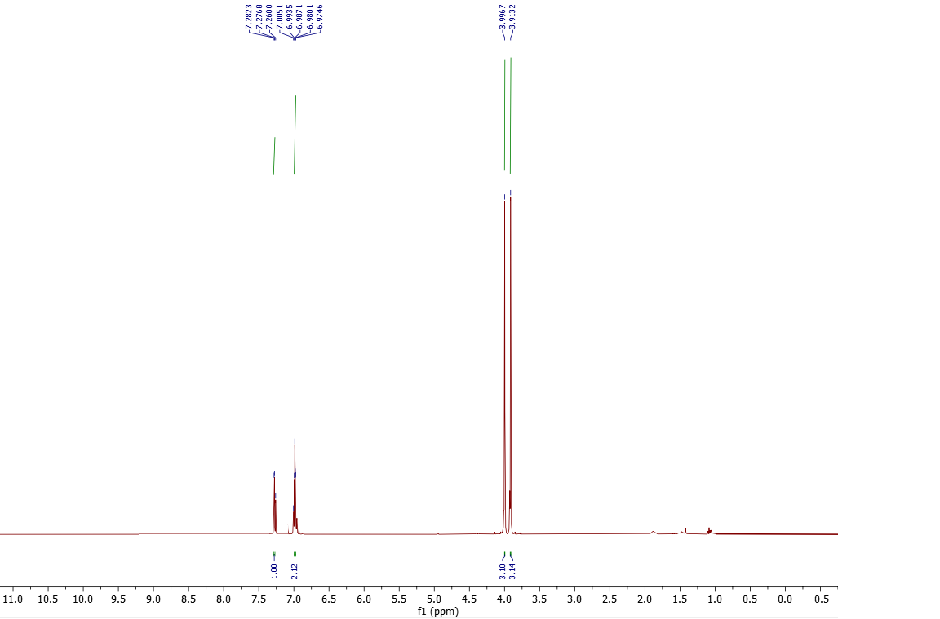

Figure 51: 1H NMR spectrum of compound **2z**,(CDCl3, 500 MHz).

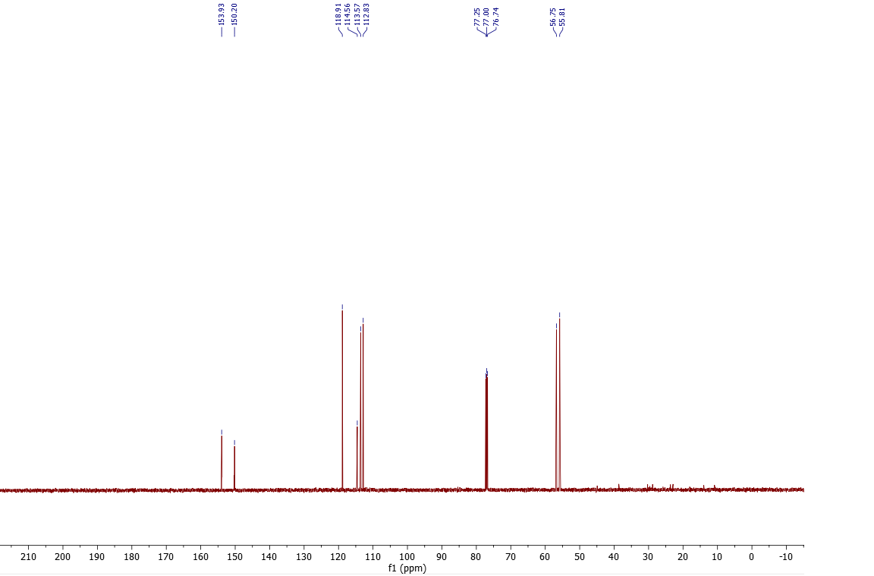

Figure 52: 13C NMR spectrum of compound **2z**,(CDCl3, 125 MHz).

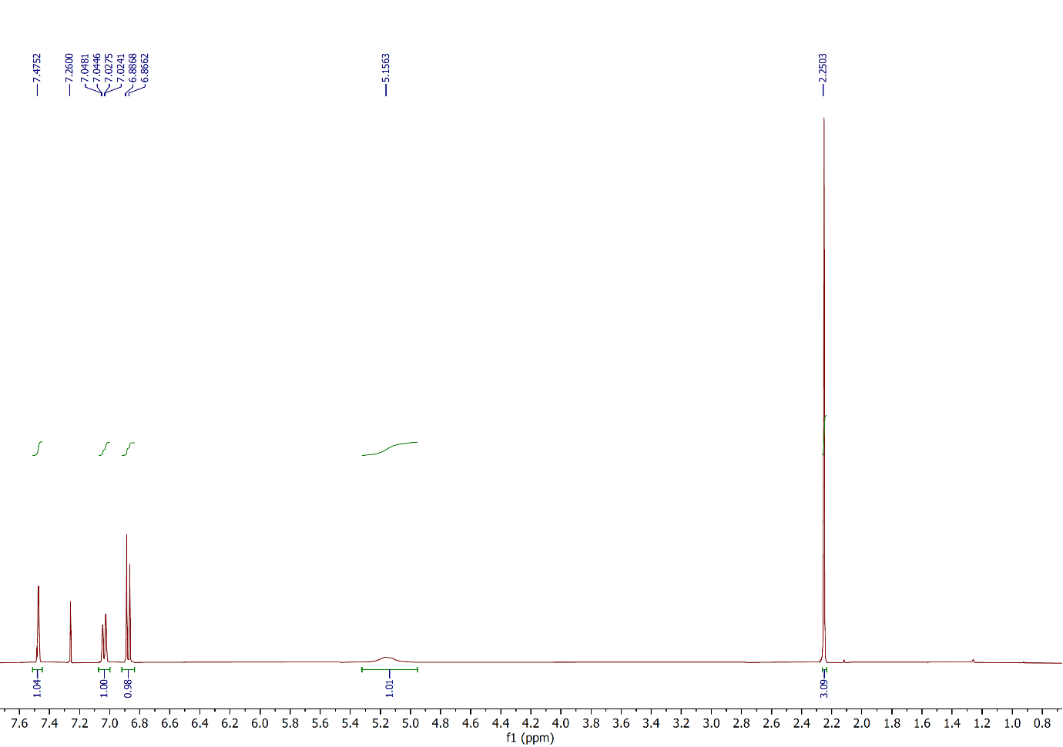

Figure 53: 1H NMR spectrum of compound **2aa**,(CDCl3, 400 MHz).

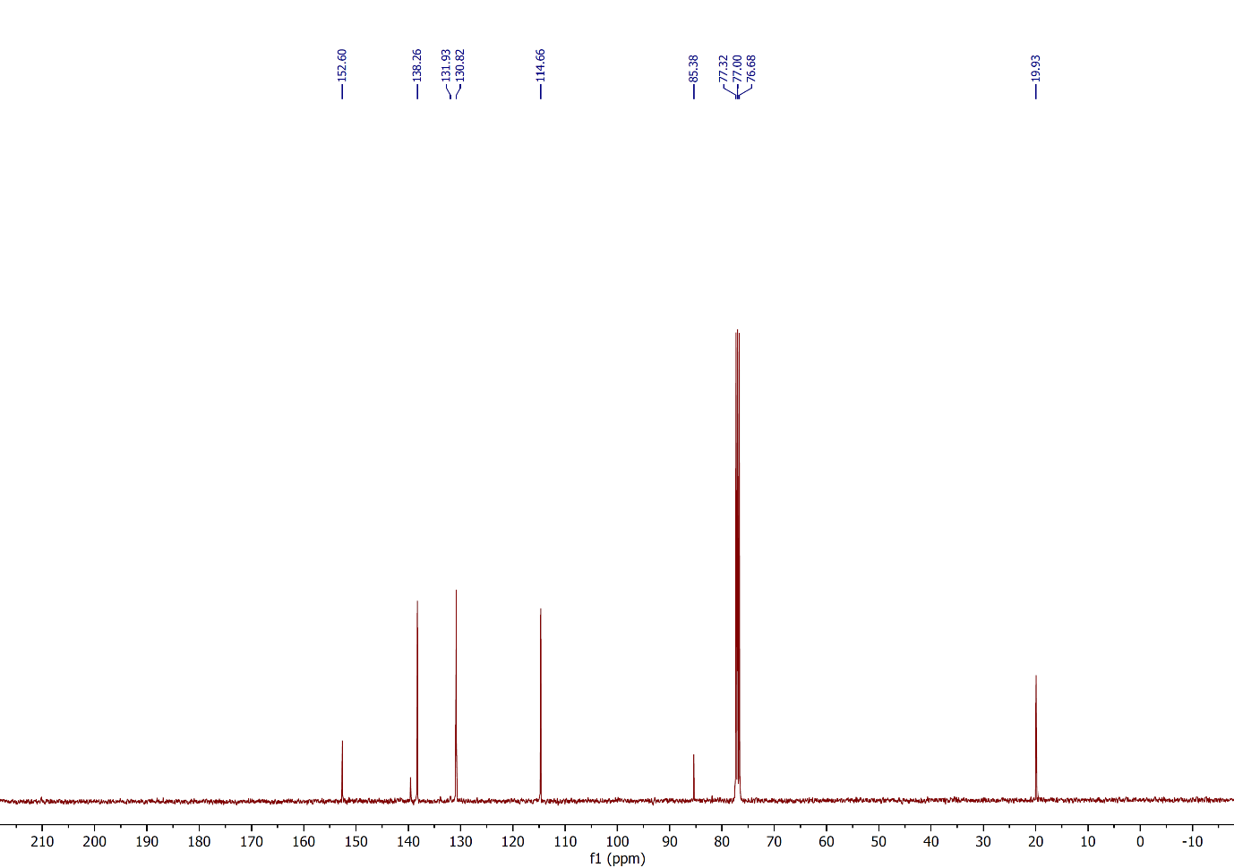

Figure 54: 13C NMR spectrum of compound **2aa**,(CDCl3, 100 MHz).

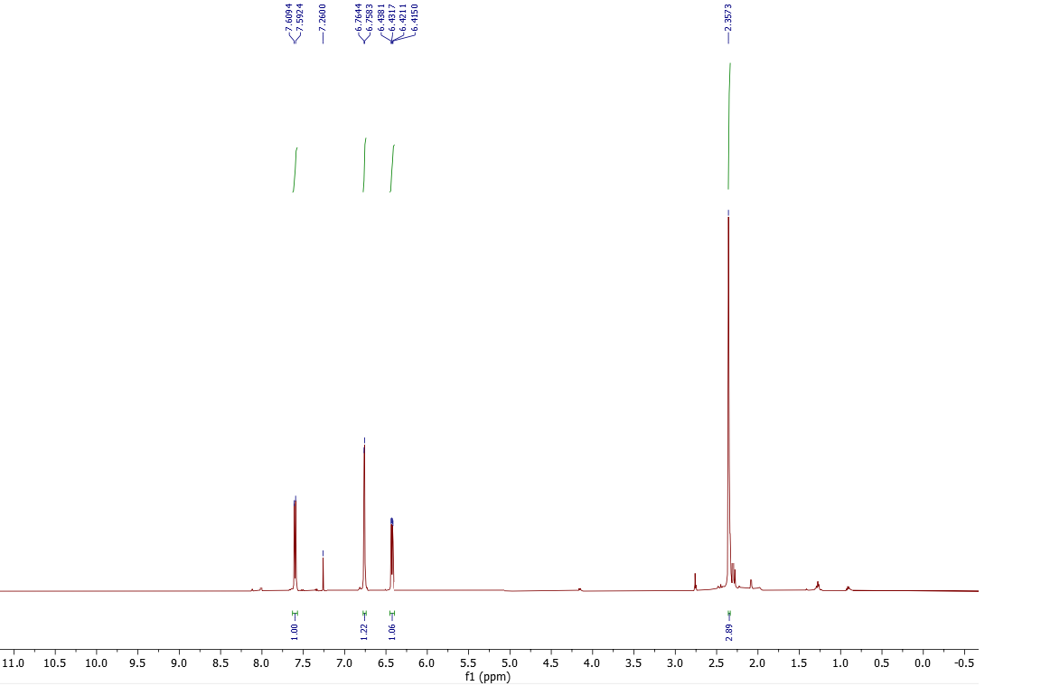

Figure 55: 1H NMR spectrum of compound **2ab**,(CDCl3, 500 MHz).

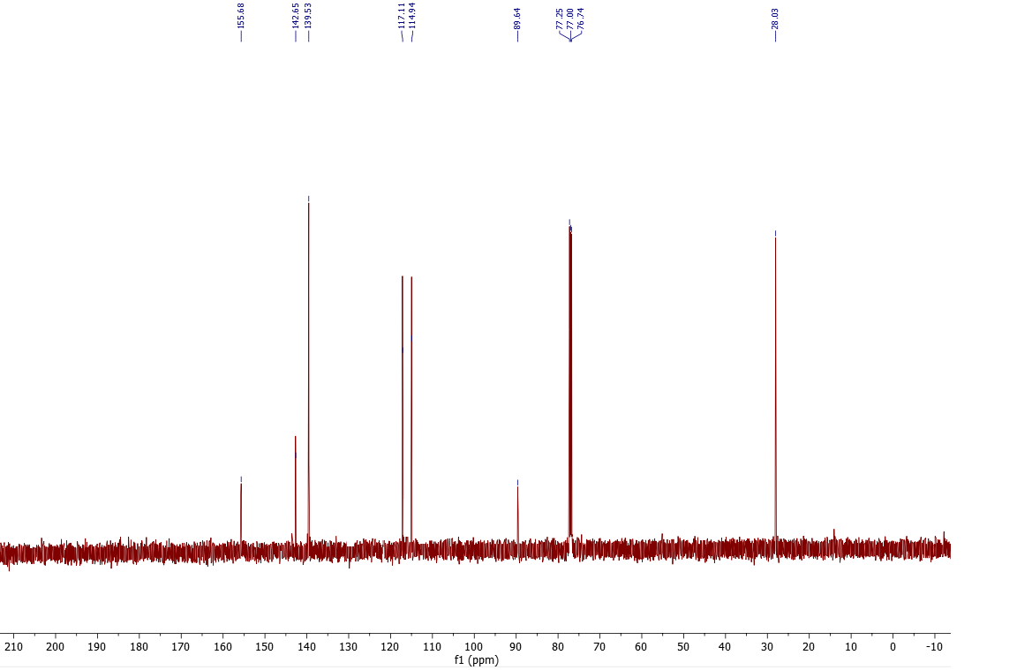

Figure 56: 13C NMR spectrum of compound **2ab**,(CDCl3, 125 MHz).

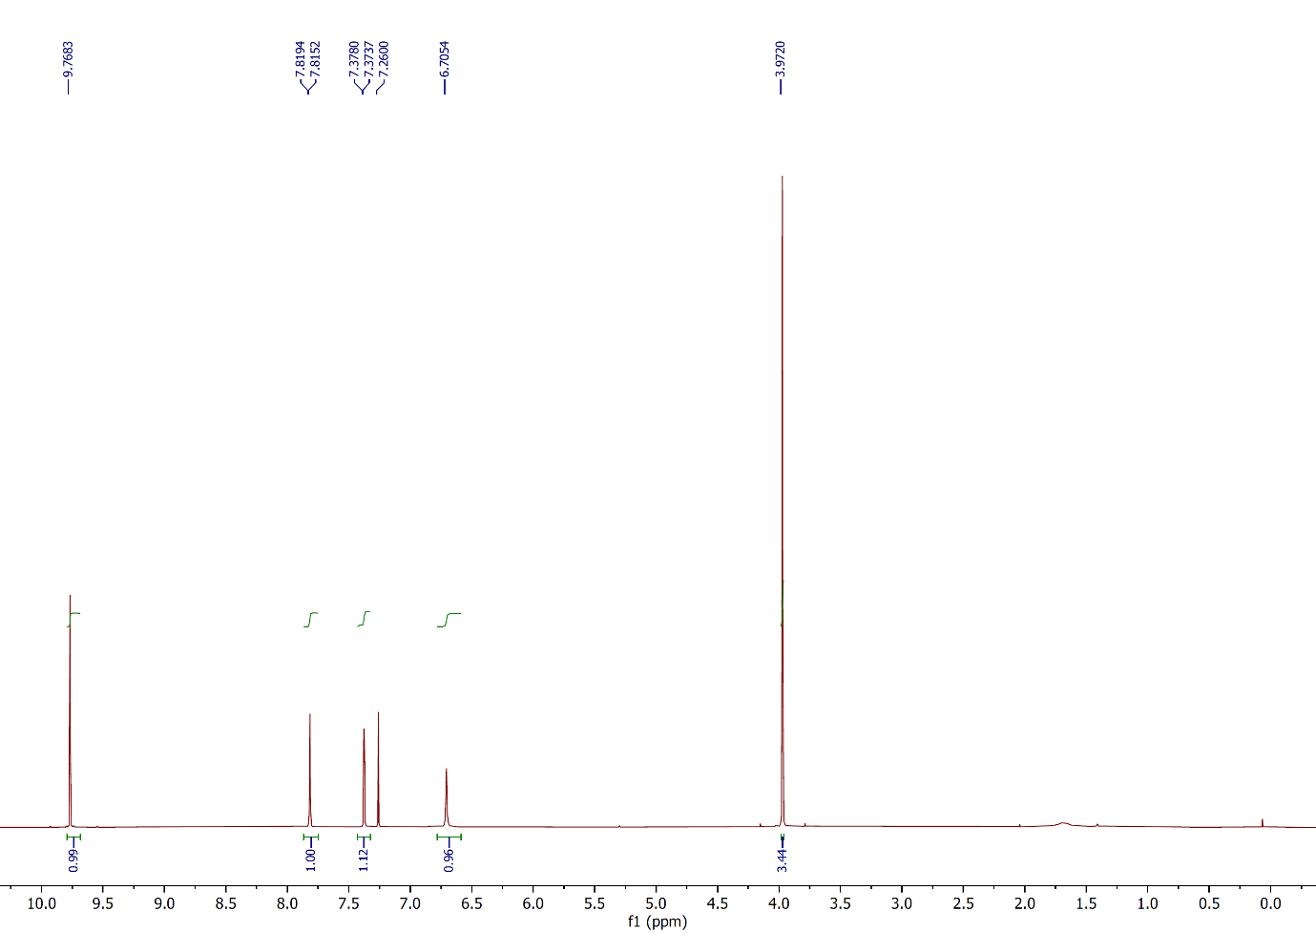

Figure 57: 1H NMR spectrum of compound **2ac**,(CDCl3, 400 MHz).

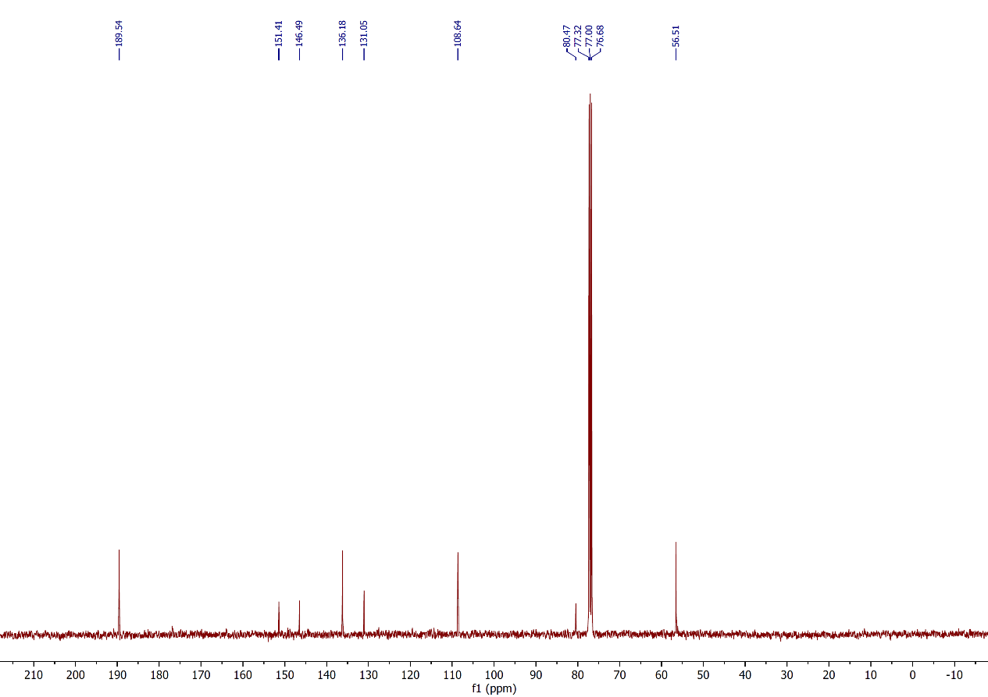

Figure 58: 13C NMR spectrum of compound **2ac**,(CDCl3, 100 MHz).

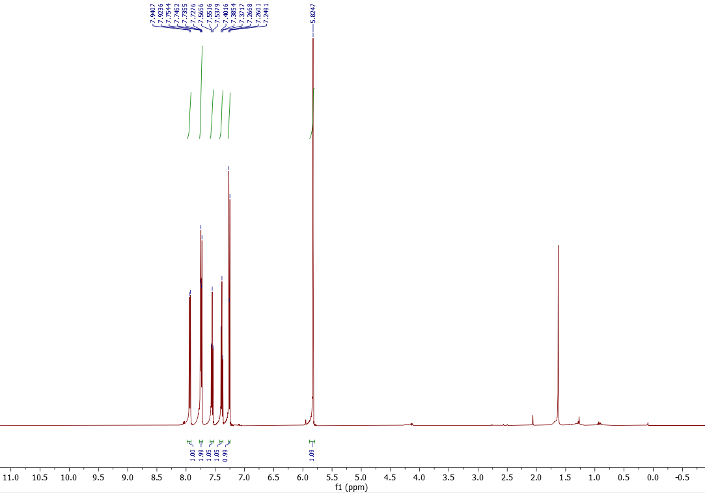

Figure 59: 1H NMR spectrum of compound **2ad**,(CDCl3, 500 MHz).

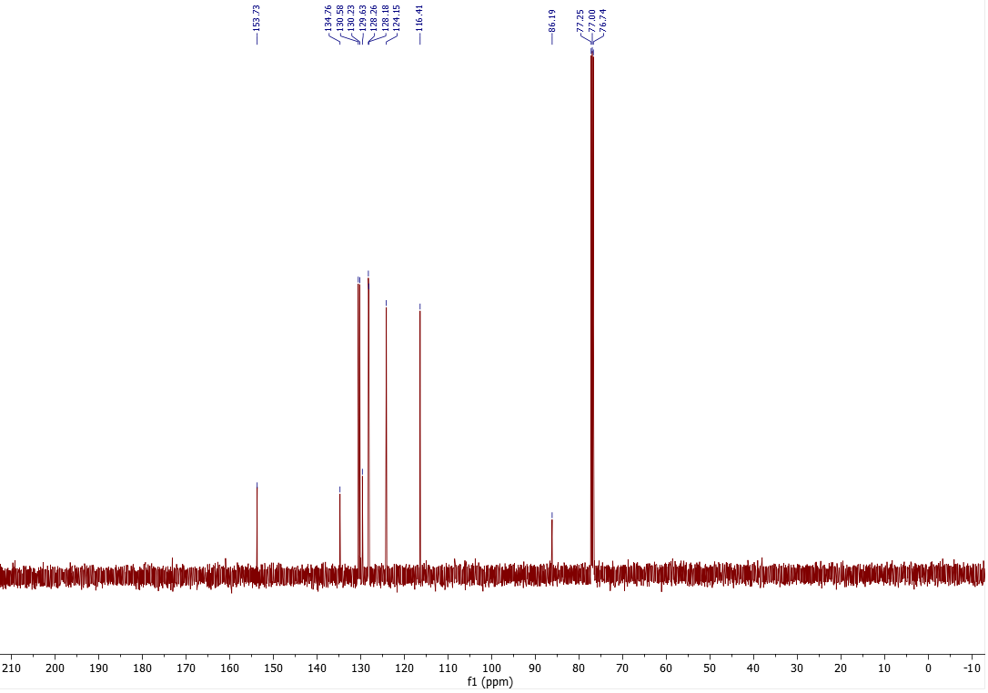

Figure 60: 13C NMR spectrum of compound **2ad**,(CDCl3, 125 MHz).

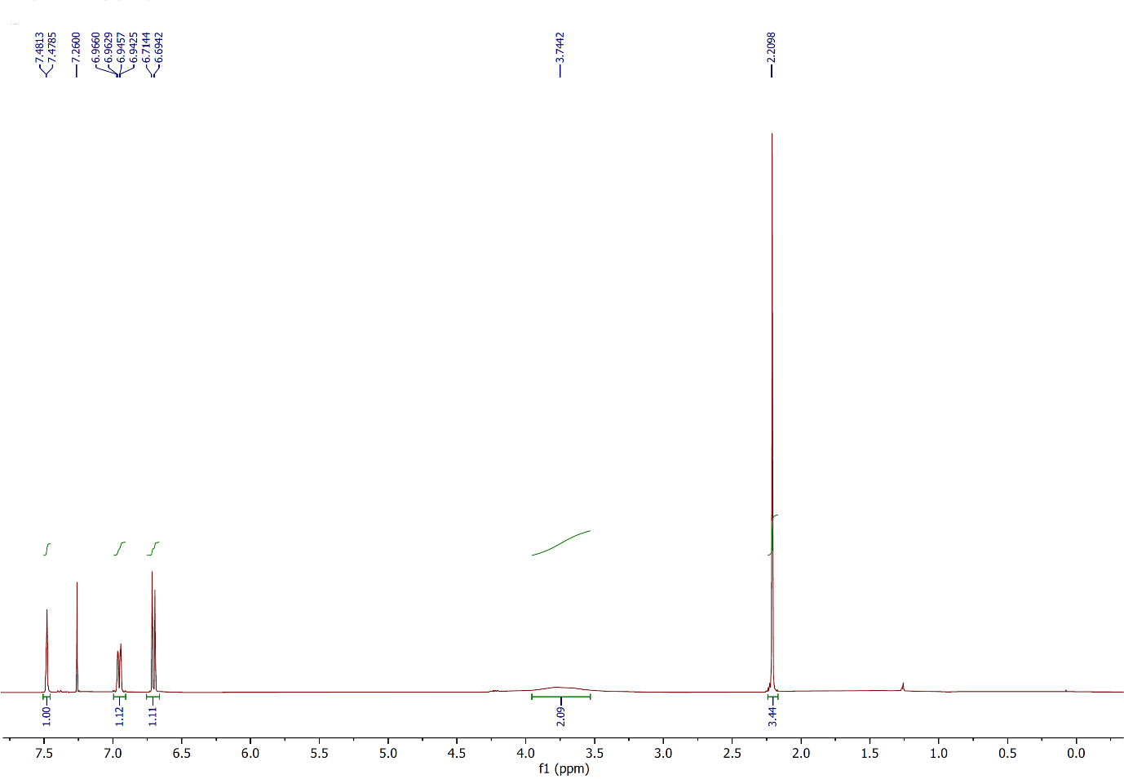

Figure 61: 1H NMR spectrum of compound **2ae**,(CDCl3, 400 MHz).

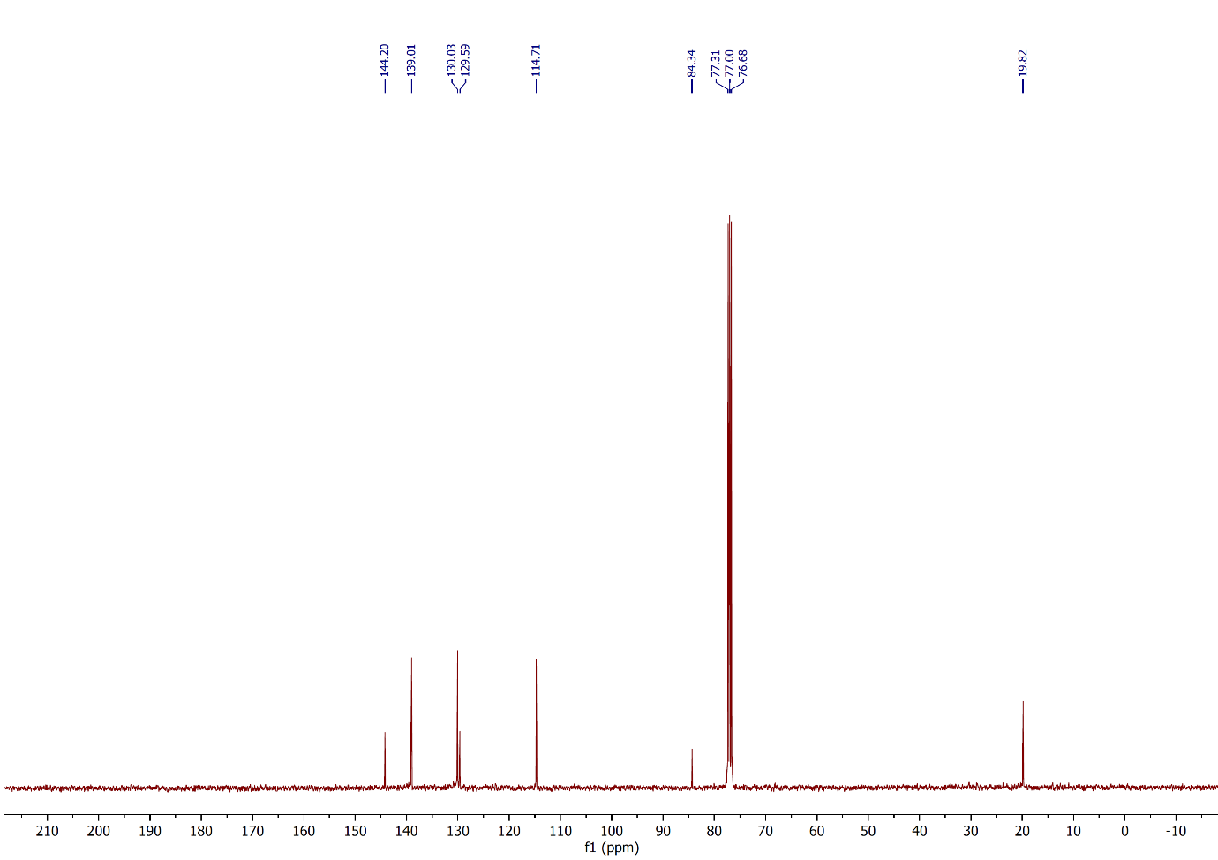

Figure 62: 13C NMR spectrum of compound **2ae**,(CDCl3, 100 MHz).

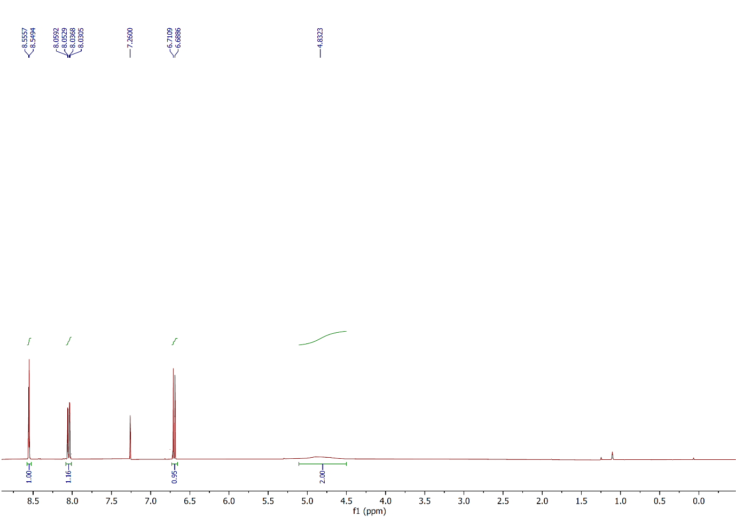

Figure 63: 1H NMR spectrum of compound **2af**,(CDCl3, 400 MHz).

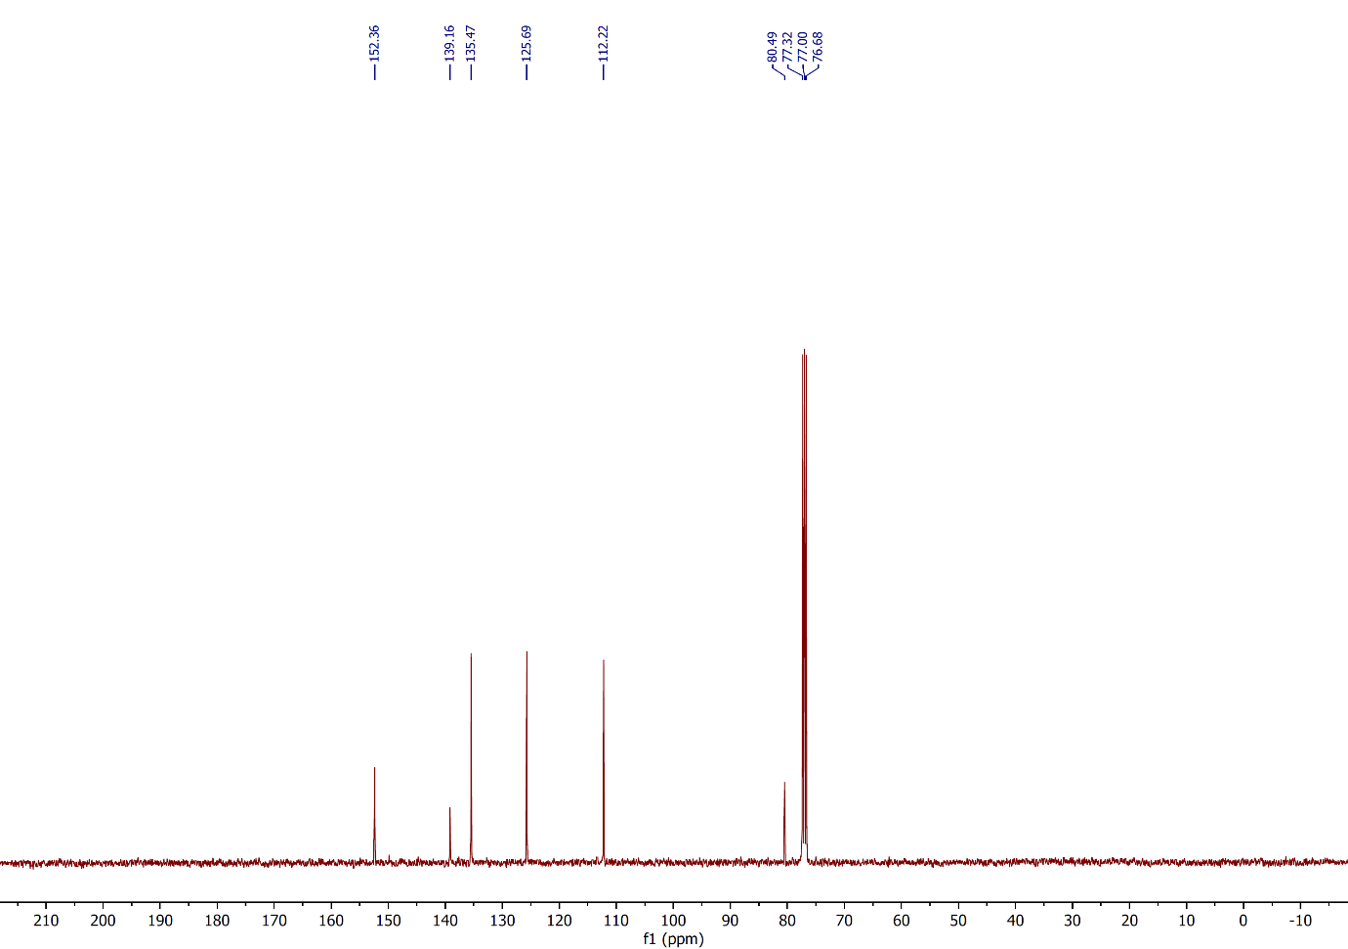

Figure 64: 13C NMR spectrum of compound **2af**,(CDCl3, 100 MHz).

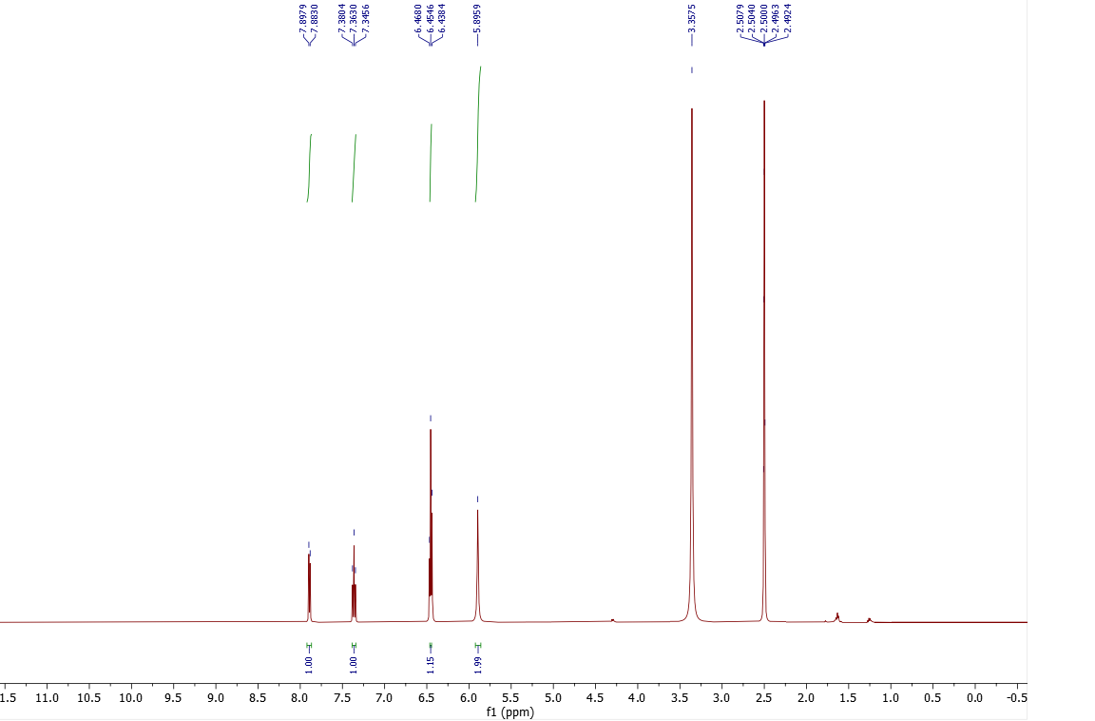

Figure 65: 1H NMR spectrum of compound **2ag**,(DMSO-d6, 500 MHz).

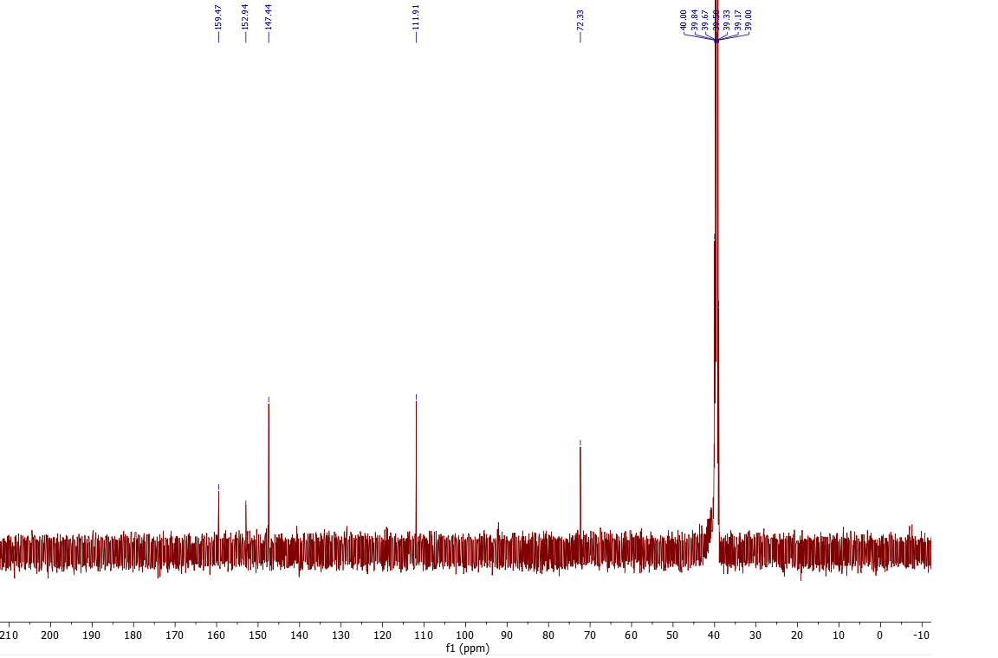

Figure 66: 13C NMR spectrum of compound **2ag**,(DMSO-d6, 125 MHz).

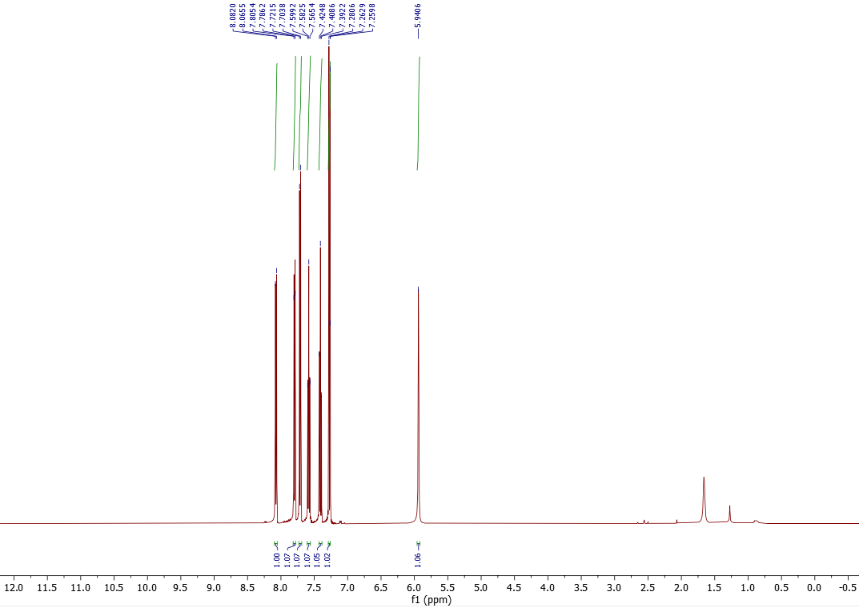

Figure 67: 1H NMR spectrum of compound **2ah**,(CDCl3, 500 MHz).

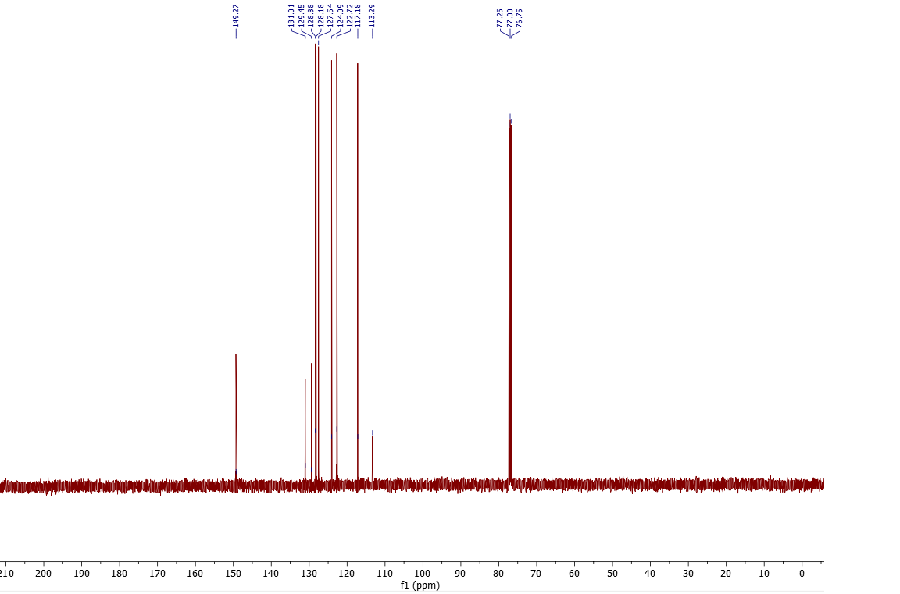

Figure 68: 13C NMR spectrum of compound **2ah**,(CDCl3, 125 MHz).

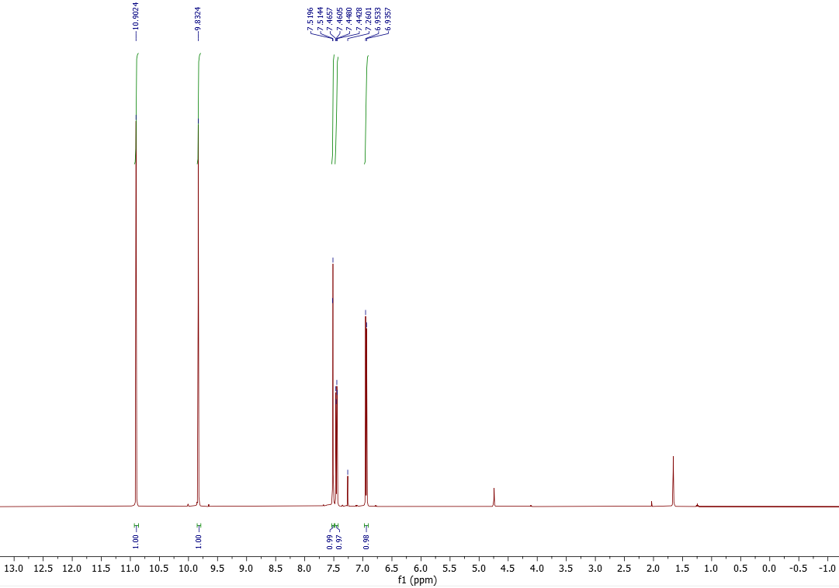

Figure 69: 1H NMR spectrum of compound **2ai**,(CDCl3, 500 MHz).

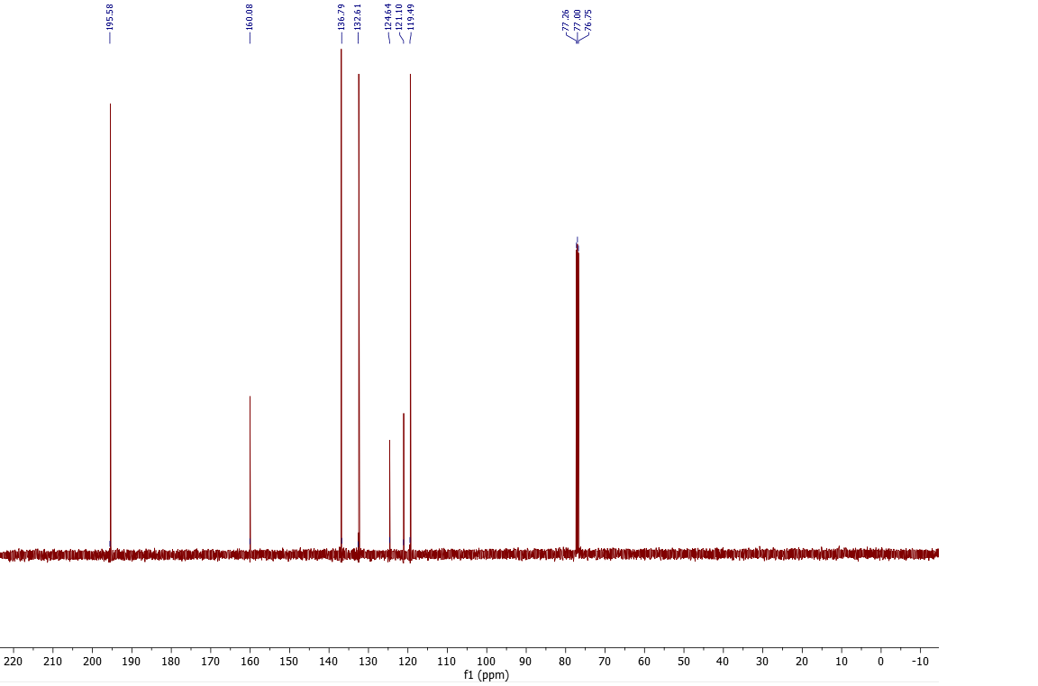

Figure 70: 13C NMR spectrum of compound **2ai**,(CDCl3, 125 MHz).

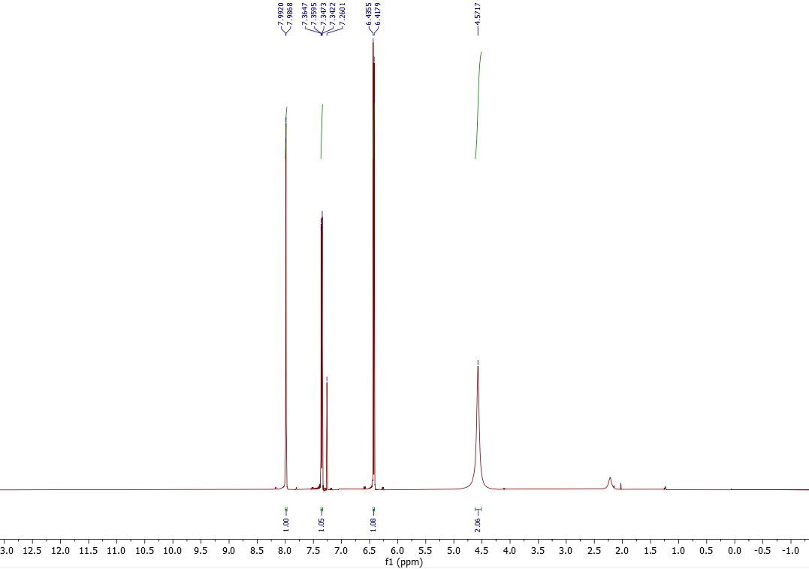

Figure 71: 1H NMR spectrum of compound **2aj**,(CDCl3, 500 MHz).

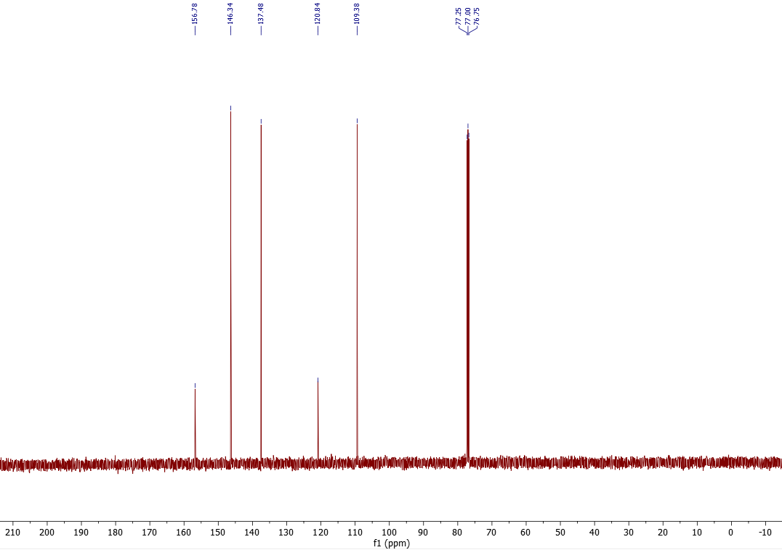

Figure 72: 13C NMR spectrum of compound **2aj**,(CDCl3, 125 MHz).

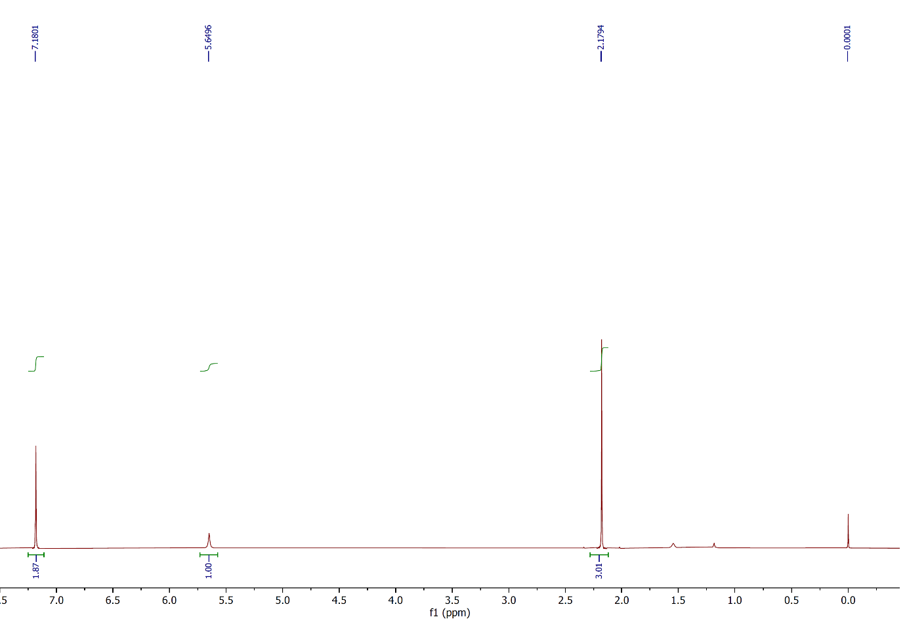

Figure 73: 1H NMR spectrum of compound **3a**,(CDCl3, 400 MHz).

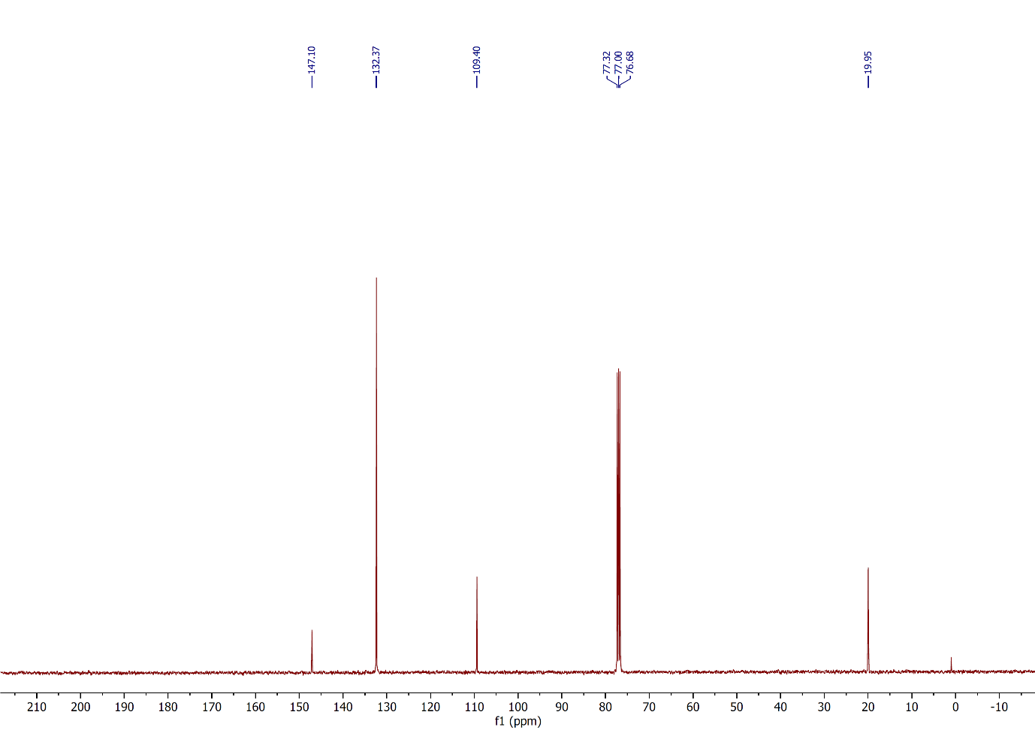

Figure 74: 13C NMR spectrum of compound **3a**,(CDCl3, 100 MHz).

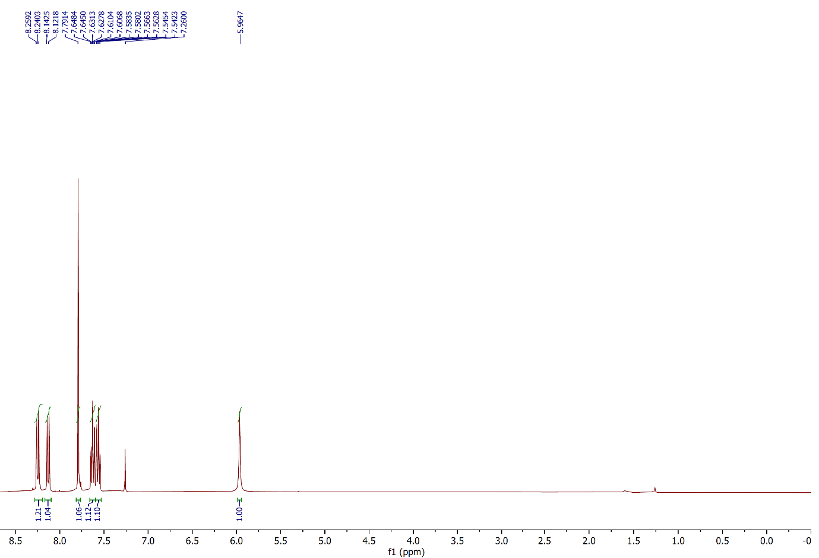

Figure 75: 1H NMR spectrum of compound **3b**,(CDCl3, 400 MHz).

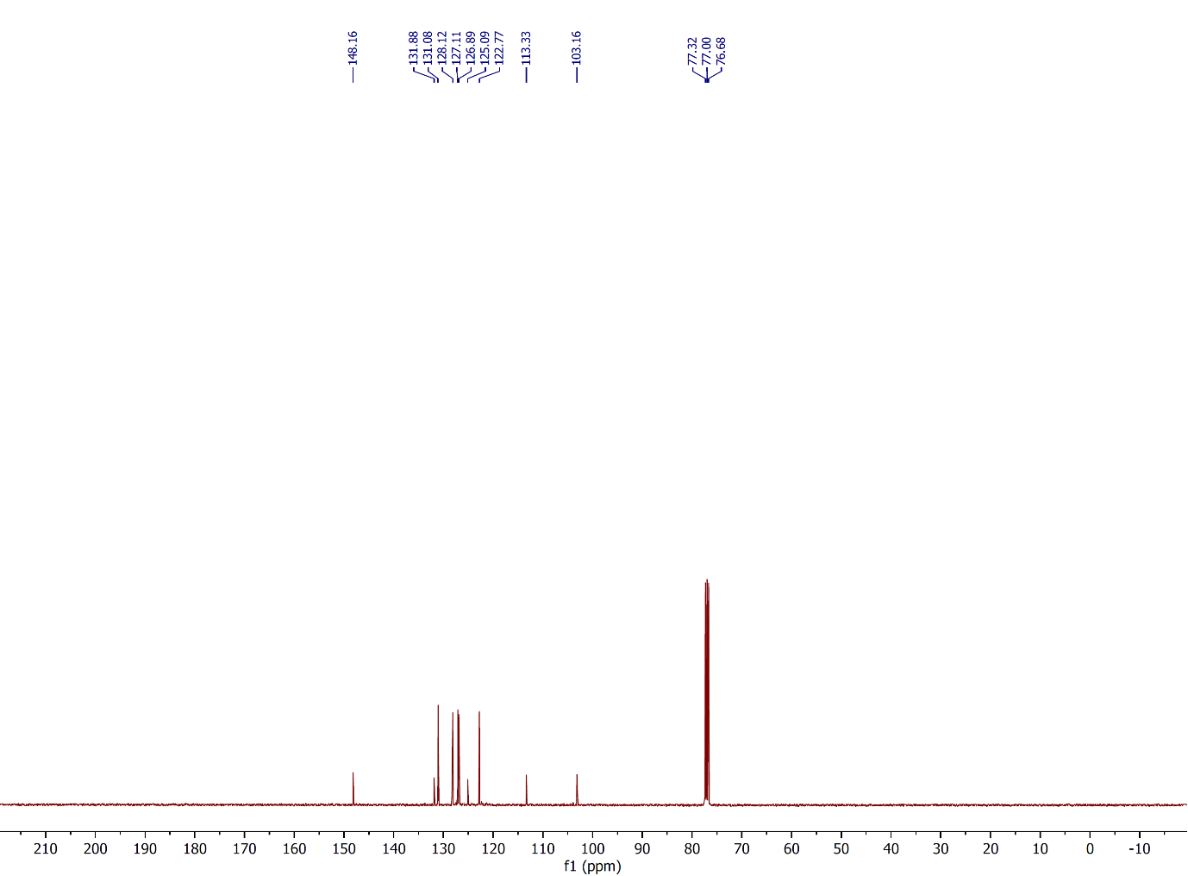

Figure 76: 13C NMR spectrum of compound **3b**,(CDCl3, 100 MHz).

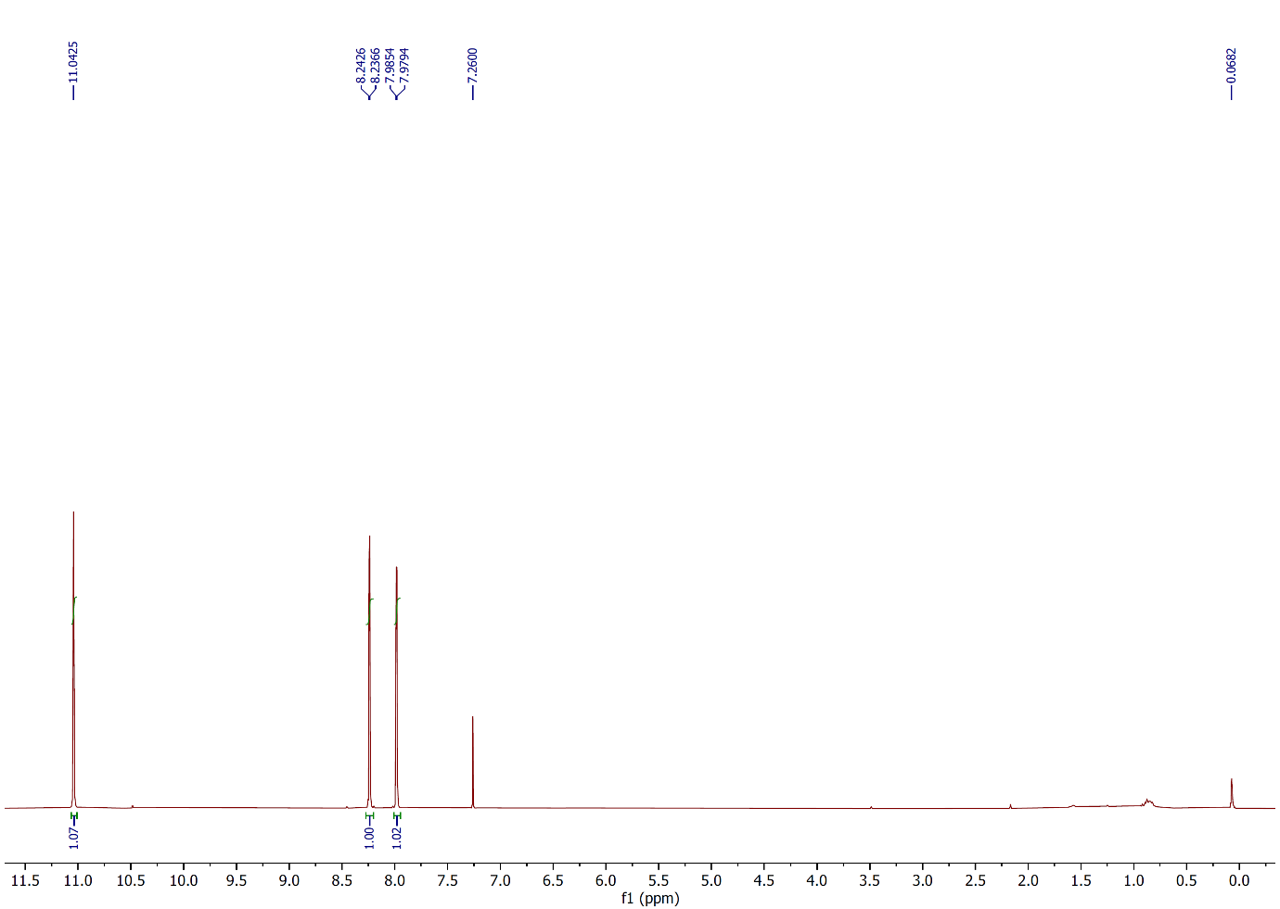

Figure 77: 1H NMR spectrum of compound **3c**,(CDCl3, 400 MHz).

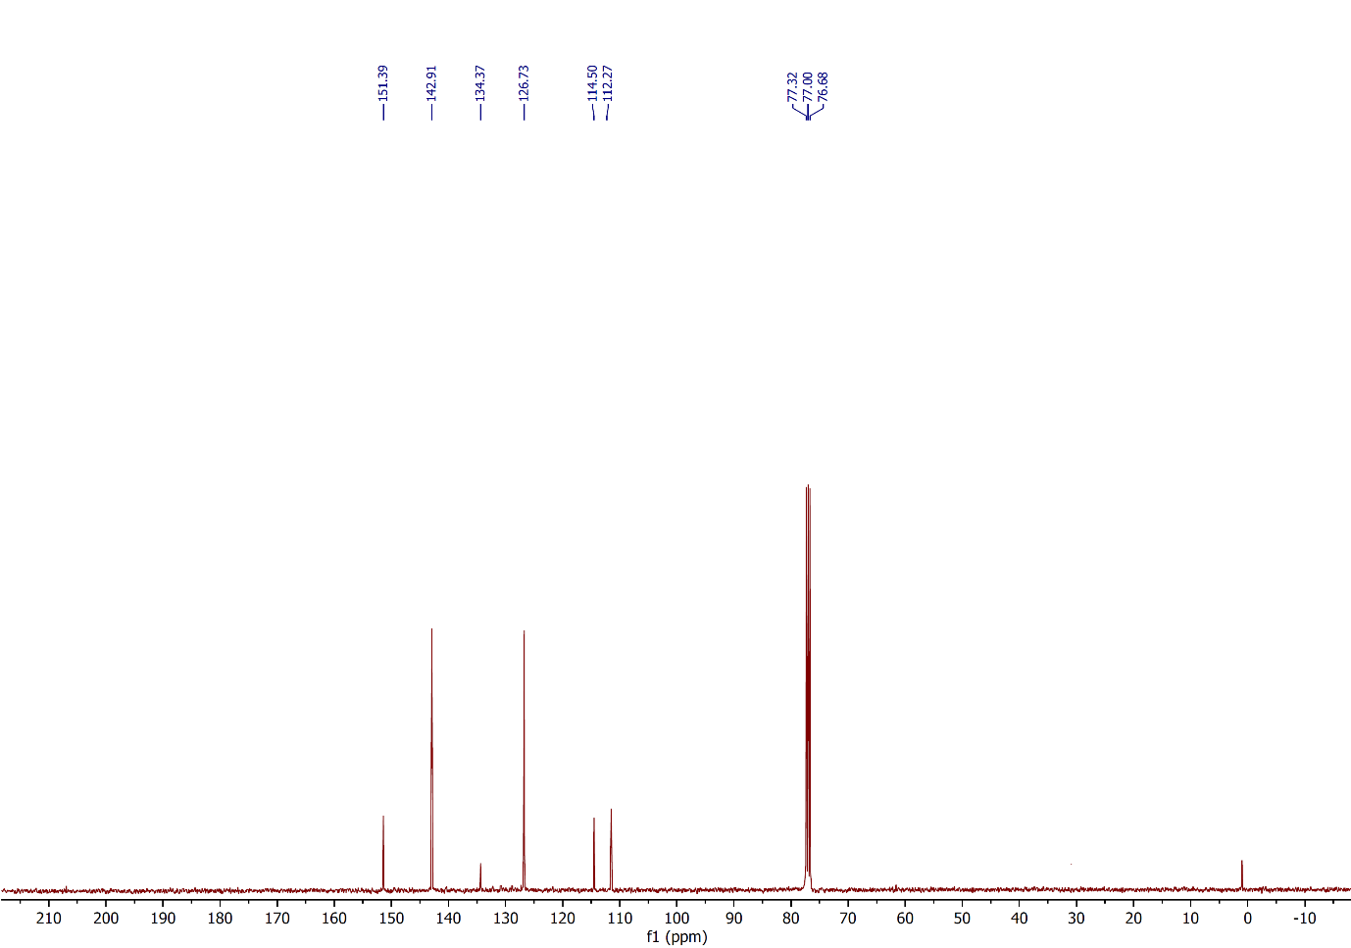

Figure 78: 13C NMR spectrum of compound **3c**,(CDCl3, 100 MHz).

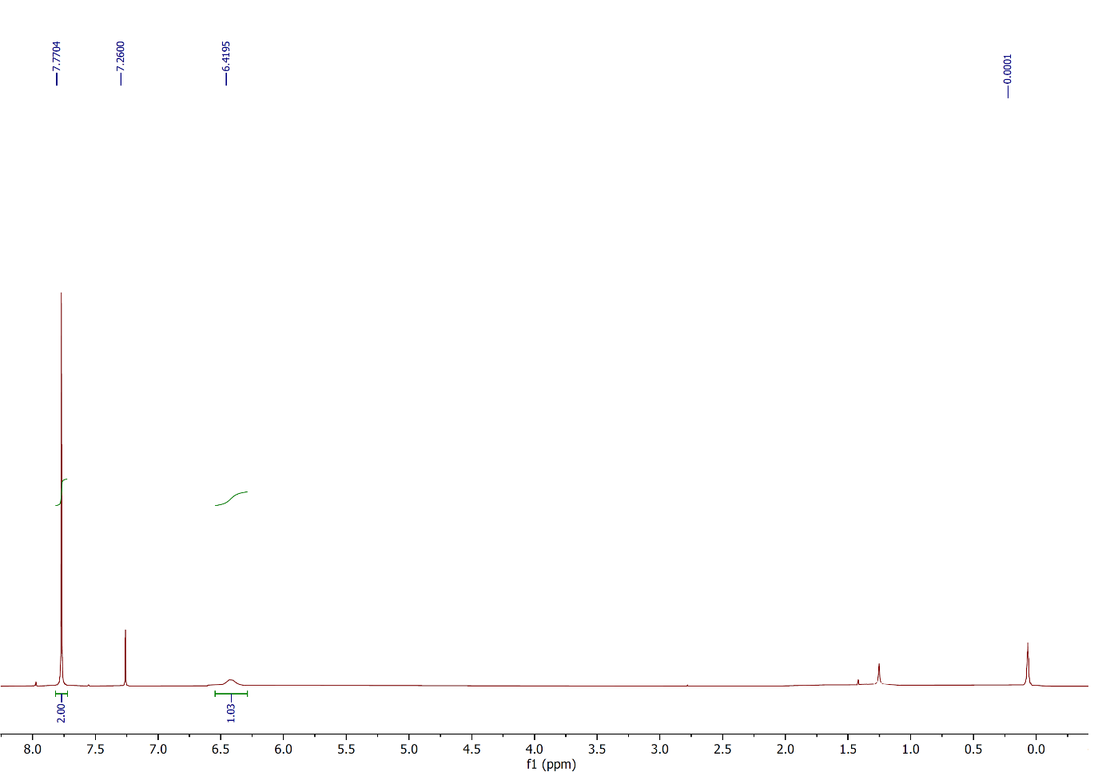

Figure 79: 1H NMR spectrum of compound **3d**,(CDCl3, 400 MHz).

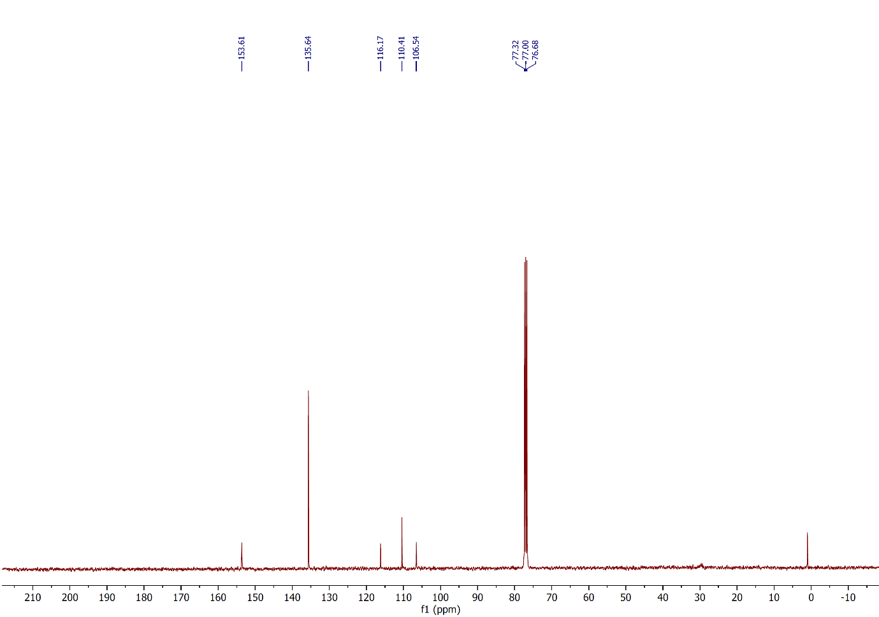

Figure 80: 13C NMR spectrum of compound **3d**,(CDCl3, 100 MHz).

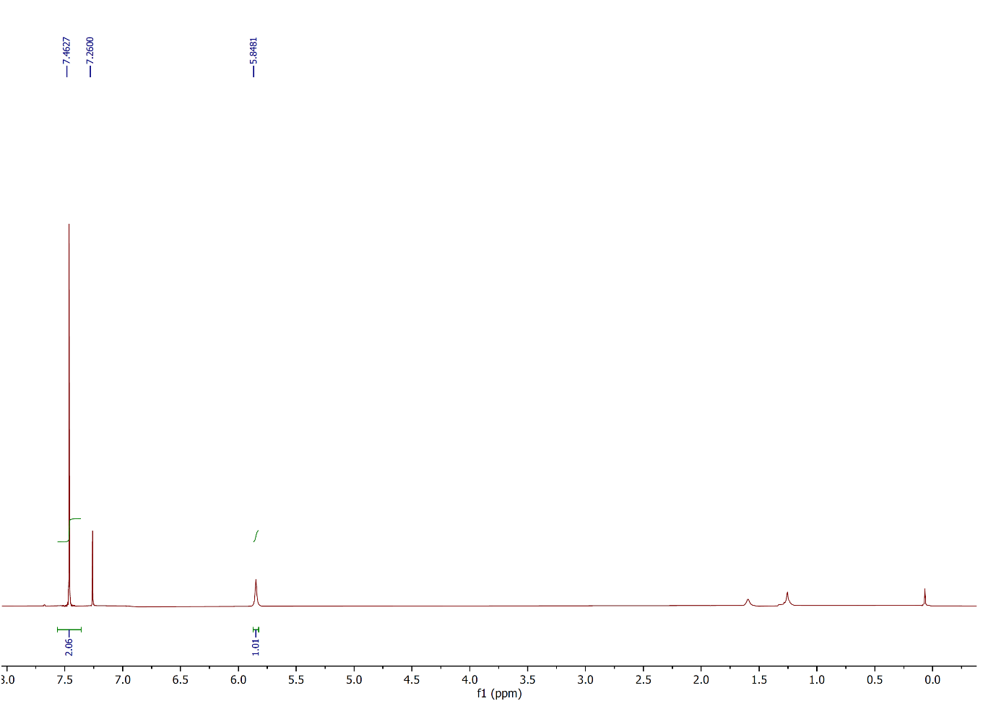

Figure 81: 1H NMR spectrum of compound **3e**,(CDCl3, 400 MHz).

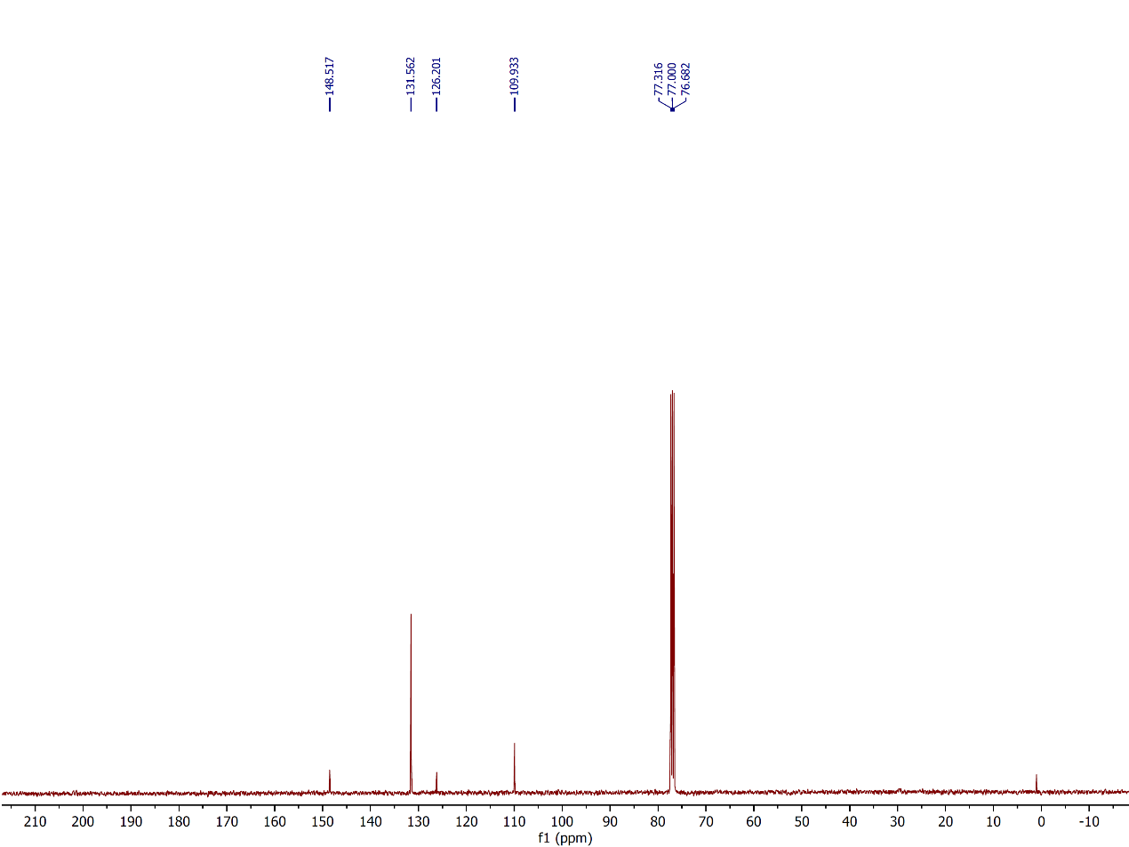

Figure 82: 13C NMR spectrum of compound **3e**,(CDCl3, 100 MHz).

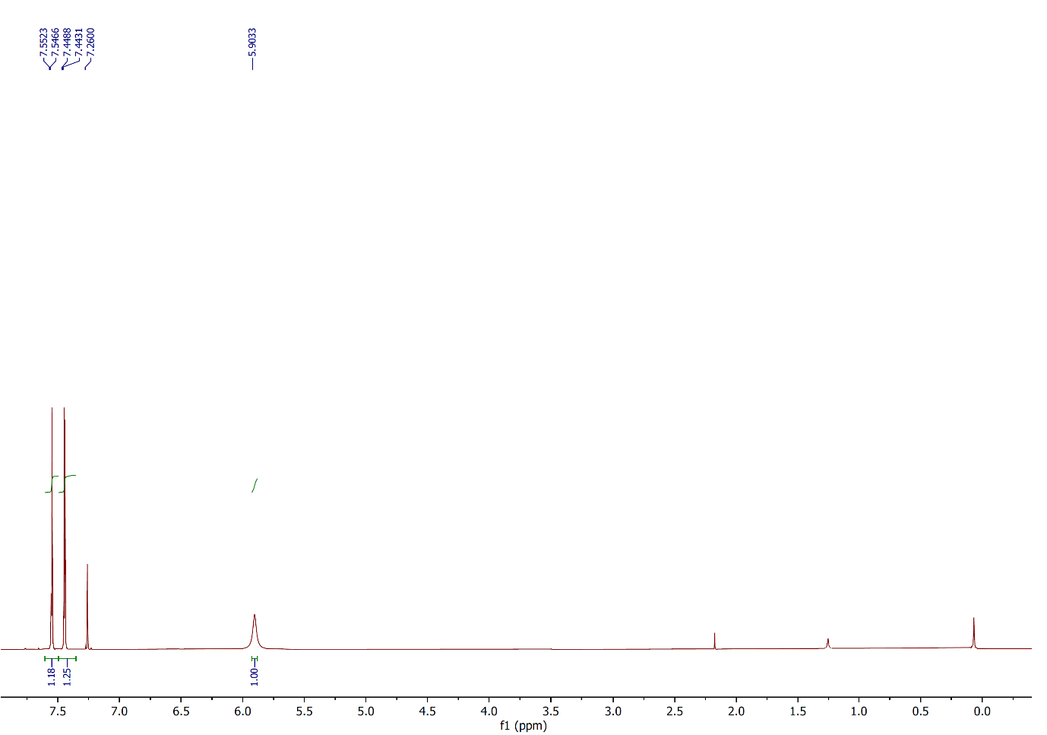

Figure 83: 1H NMR spectrum of compound **3f**,(CDCl3, 400 MHz).

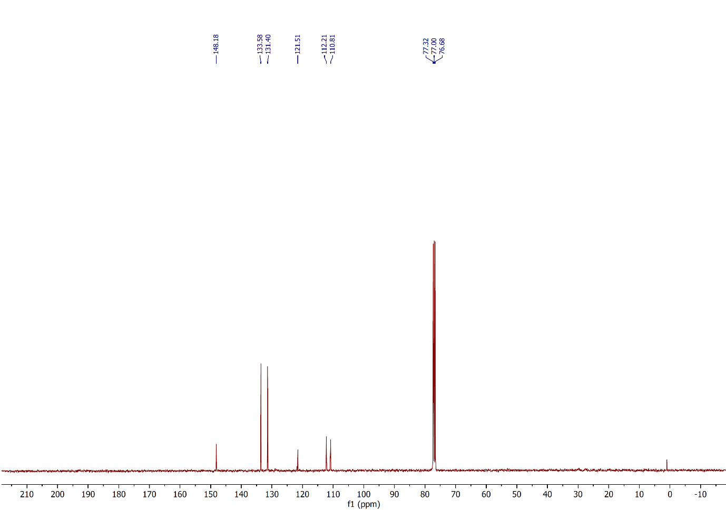

Figure 84: 13C NMR spectrum of compound **3f**,(CDCl3, 100 MHz).

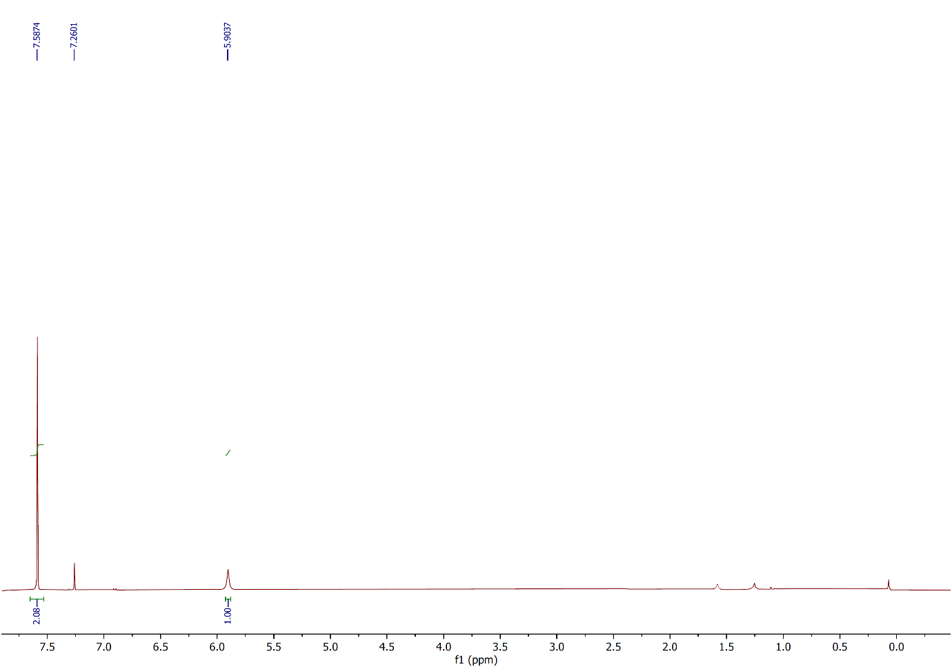

Figure 85: 1H NMR spectrum of compound **3g**,(CDCl3, 400 MHz).

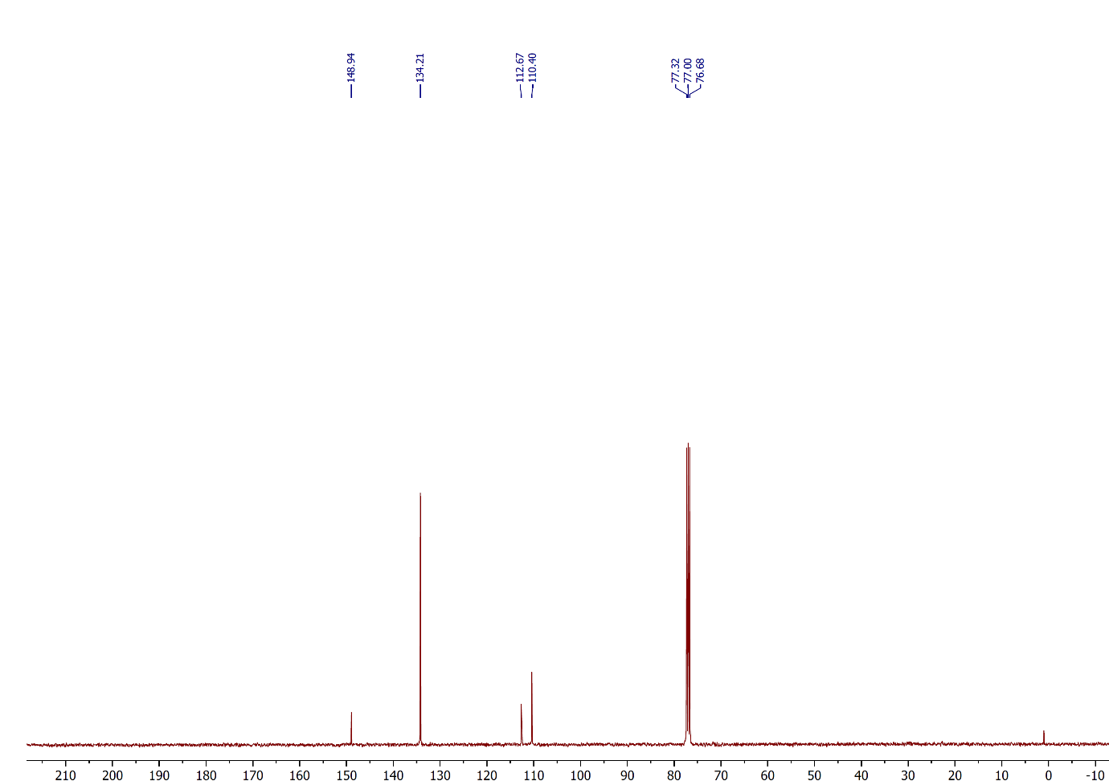

Figure 86: 13C NMR spectrum of compound **3g**,(CDCl3, 100 MHz).

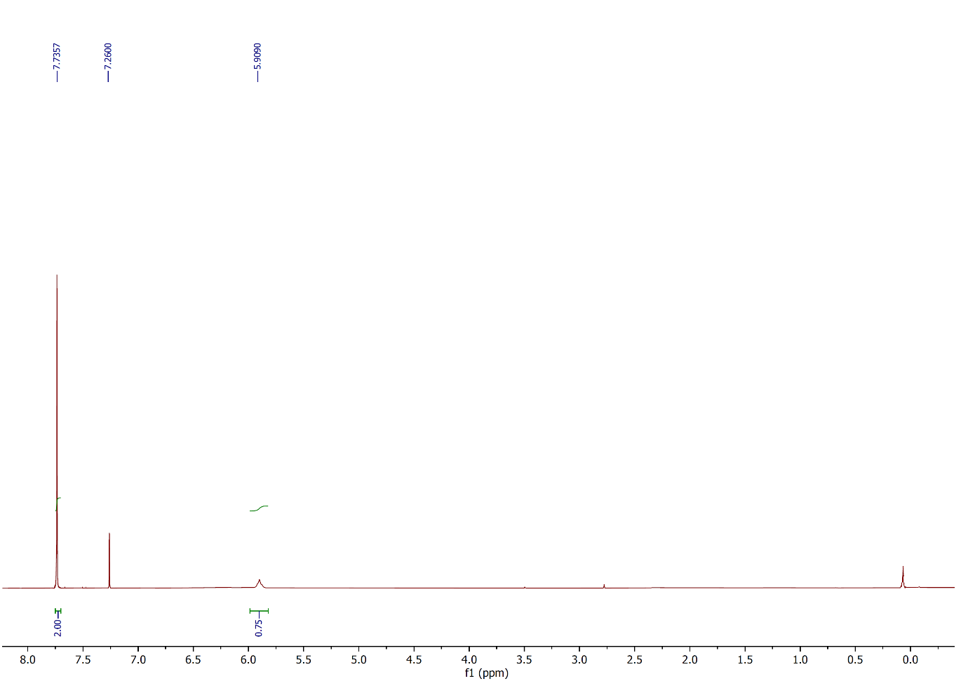

Figure 87: 1H NMR spectrum of compound **3h**,(CDCl3, 400 MHz).

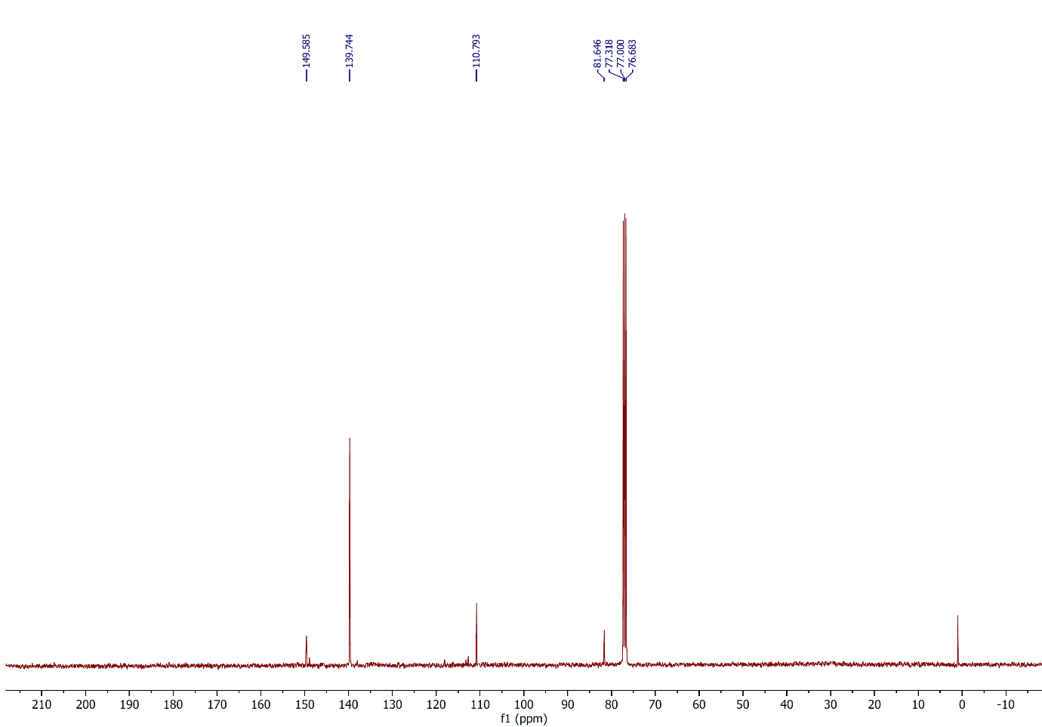

Figure 88: 13C NMR spectrum of compound **3h**,(CDCl3, 100 MHz).

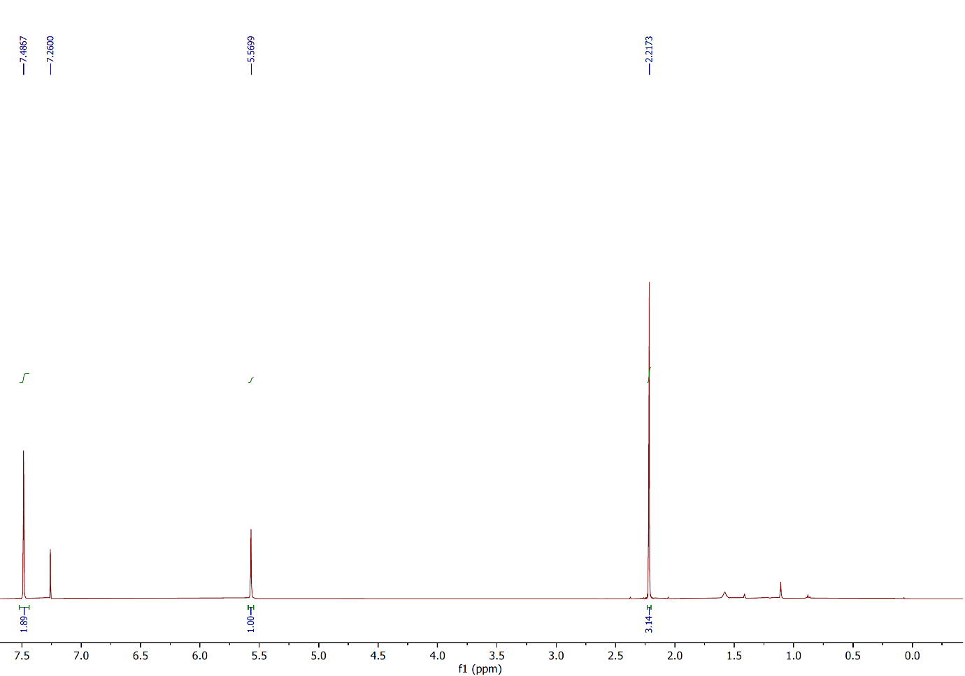

Figure 89: 1H NMR spectrum of compound **3i**,(CDCl3, 400 MHz).

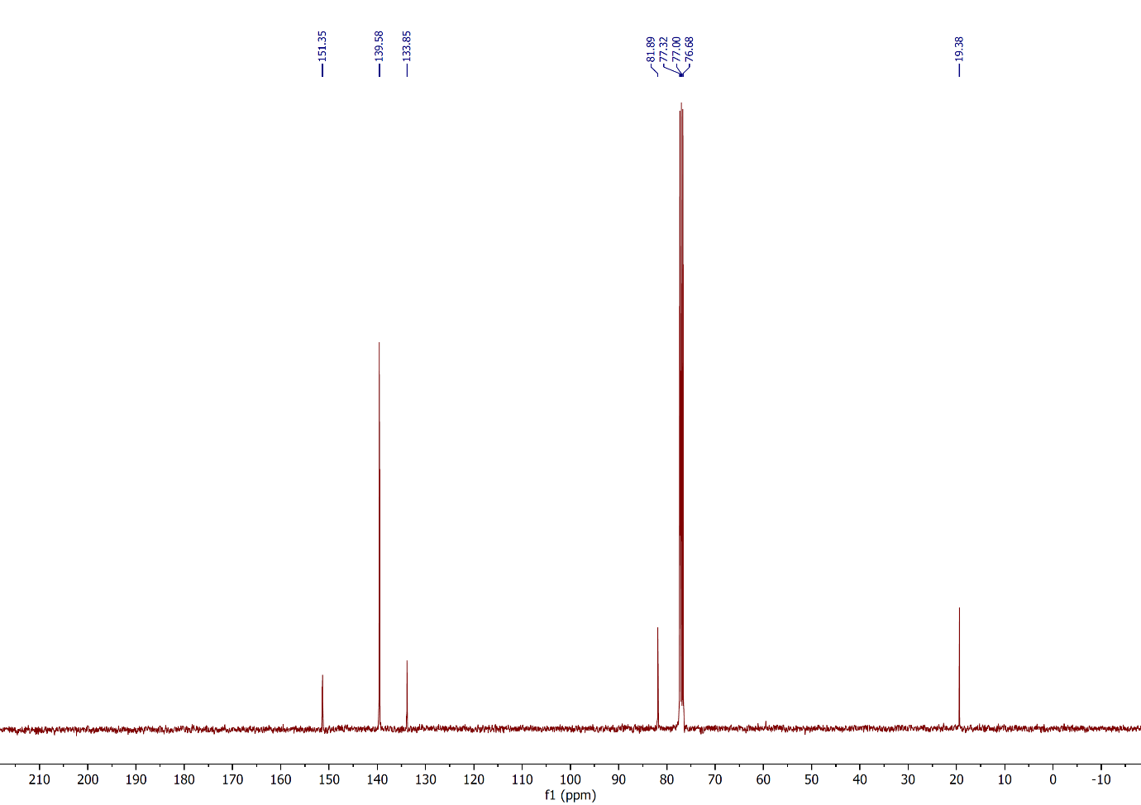

Figure 90: 13C NMR spectrum of compound **3i**,(CDCl3, 100 MHz).

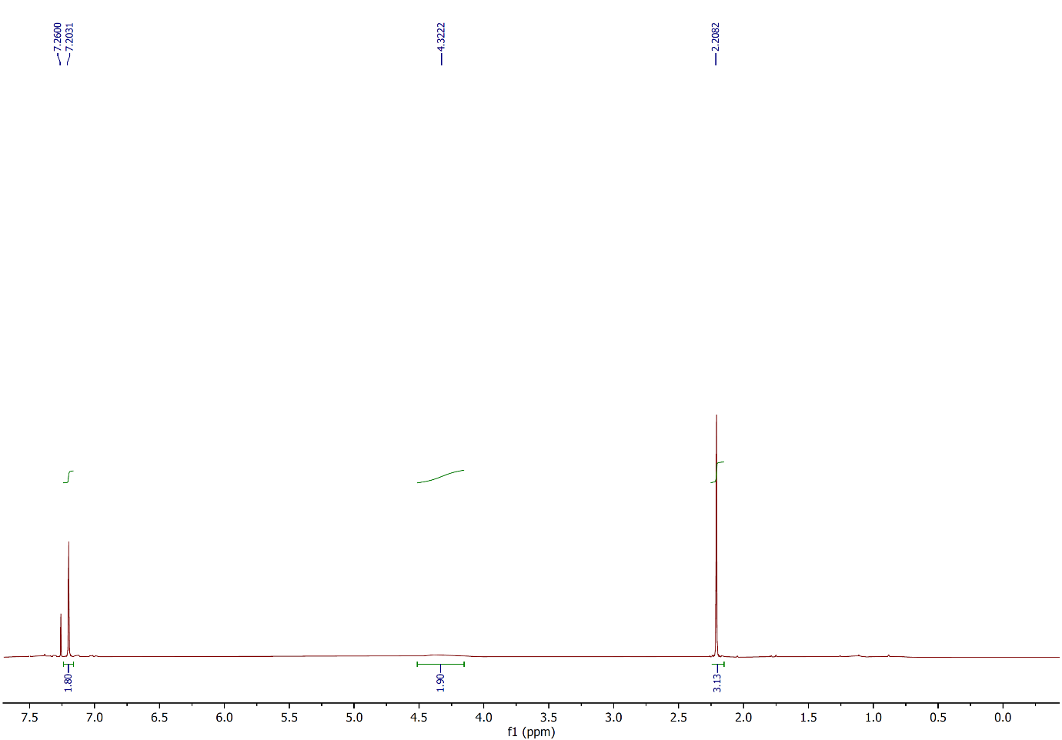

Figure 91: 1H NMR spectrum of compound **3j**,(CDCl3, 400 MHz).

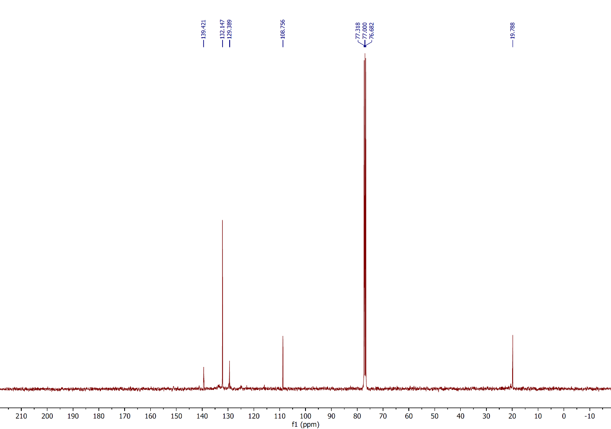

Figure 92: 13C NMR spectrum of compound **3j**,(CDCl3, 100 MHz).

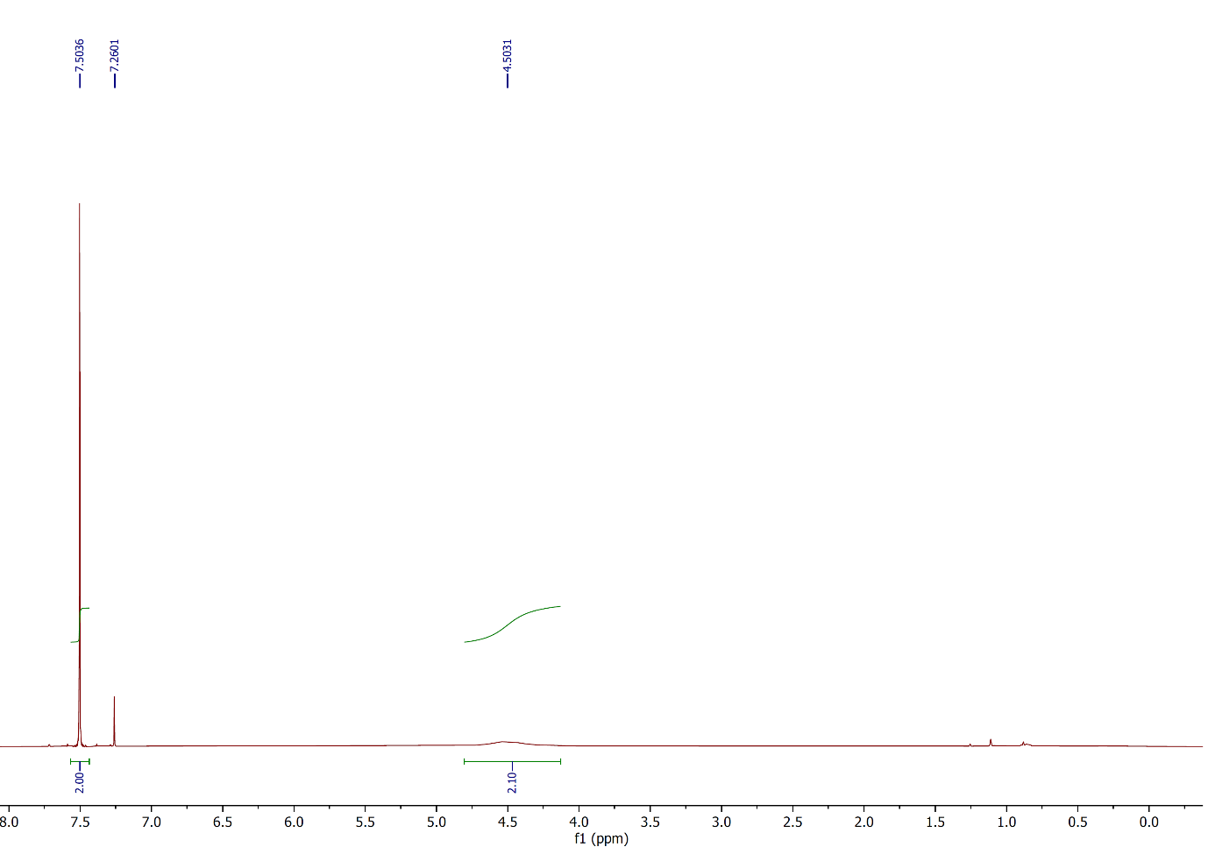

Figure 93: 1H NMR spectrum of compound **4a**,(CDCl3, 400 MHz).

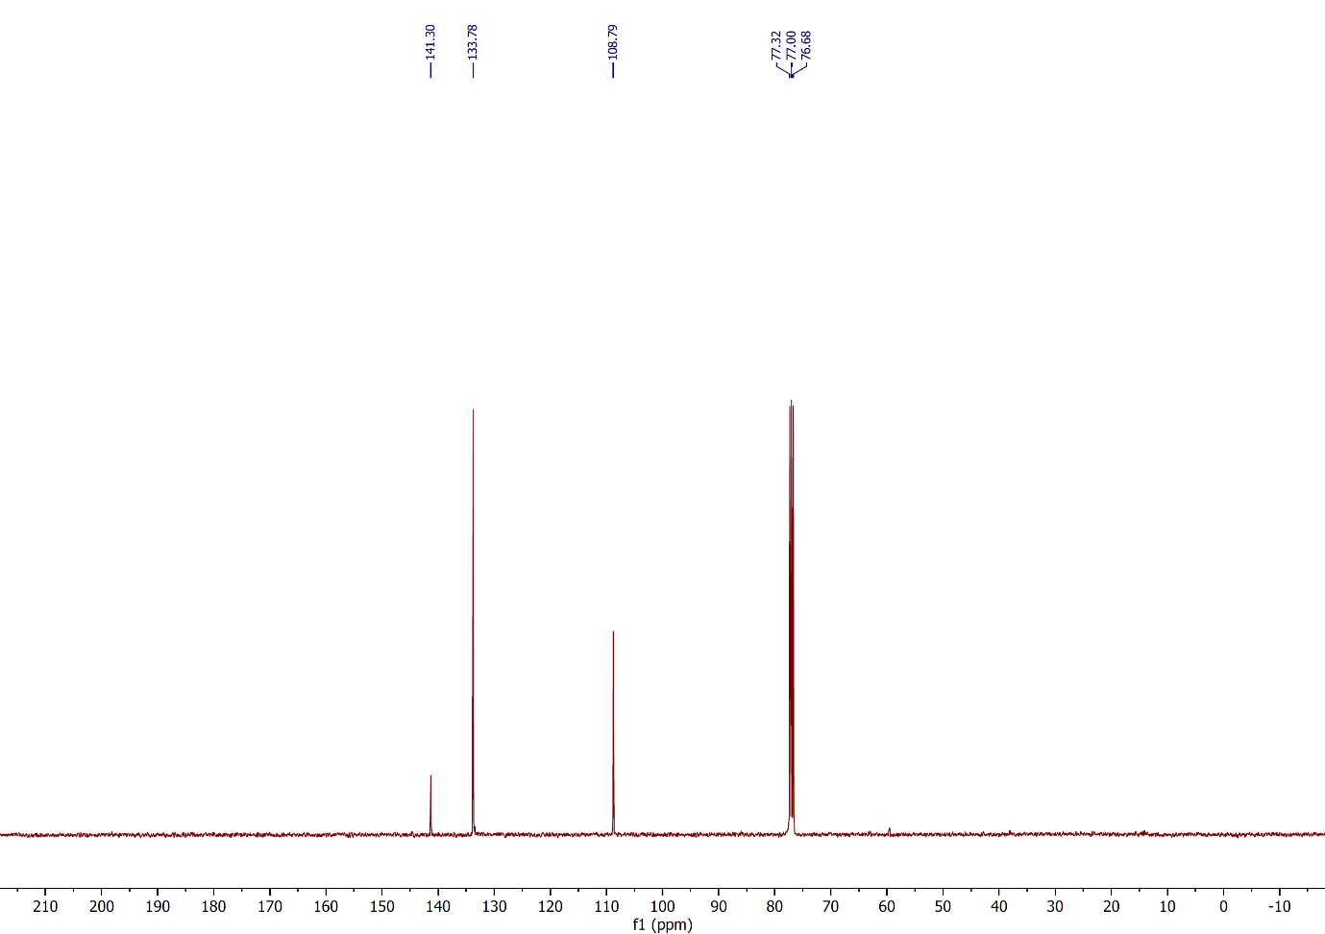

Figure 94: 13C NMR spectrum of compound **4a**,(CDCl3, 100 MHz).

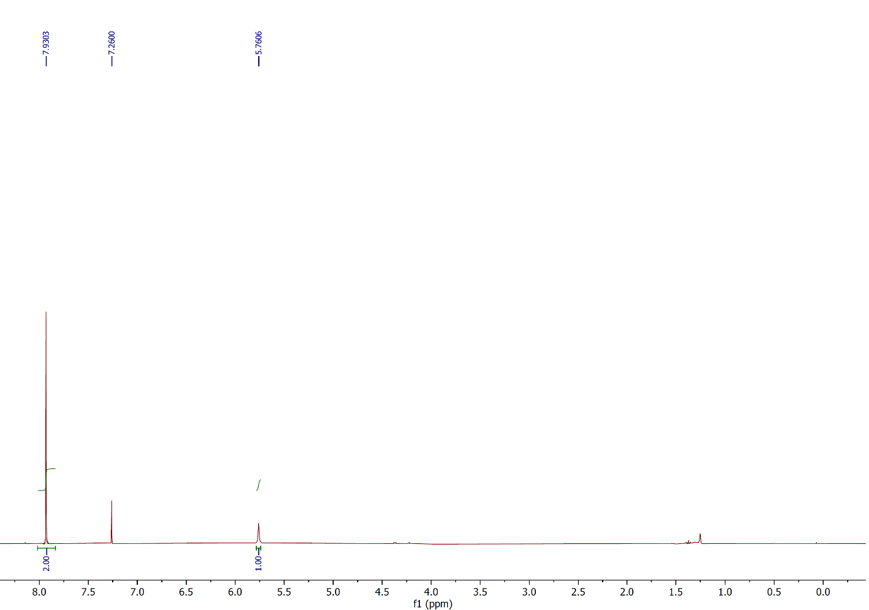

Figure 95: 1H NMR spectrum of compound **4b**,(CDCl3, 400 MHz).

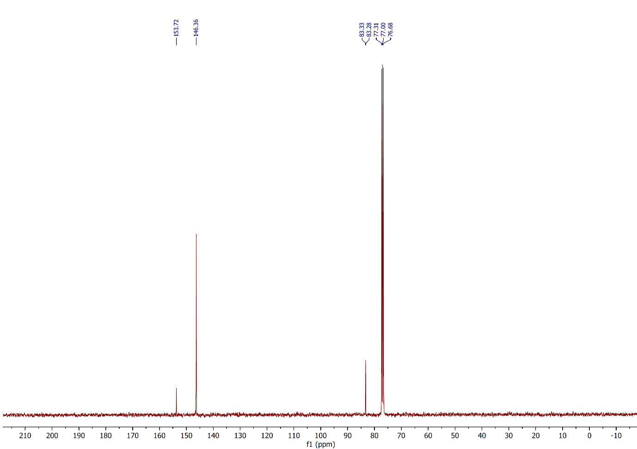

Figure 96: 13C NMR spectrum of compound **4b**,(CDCl3, 100 MHz).

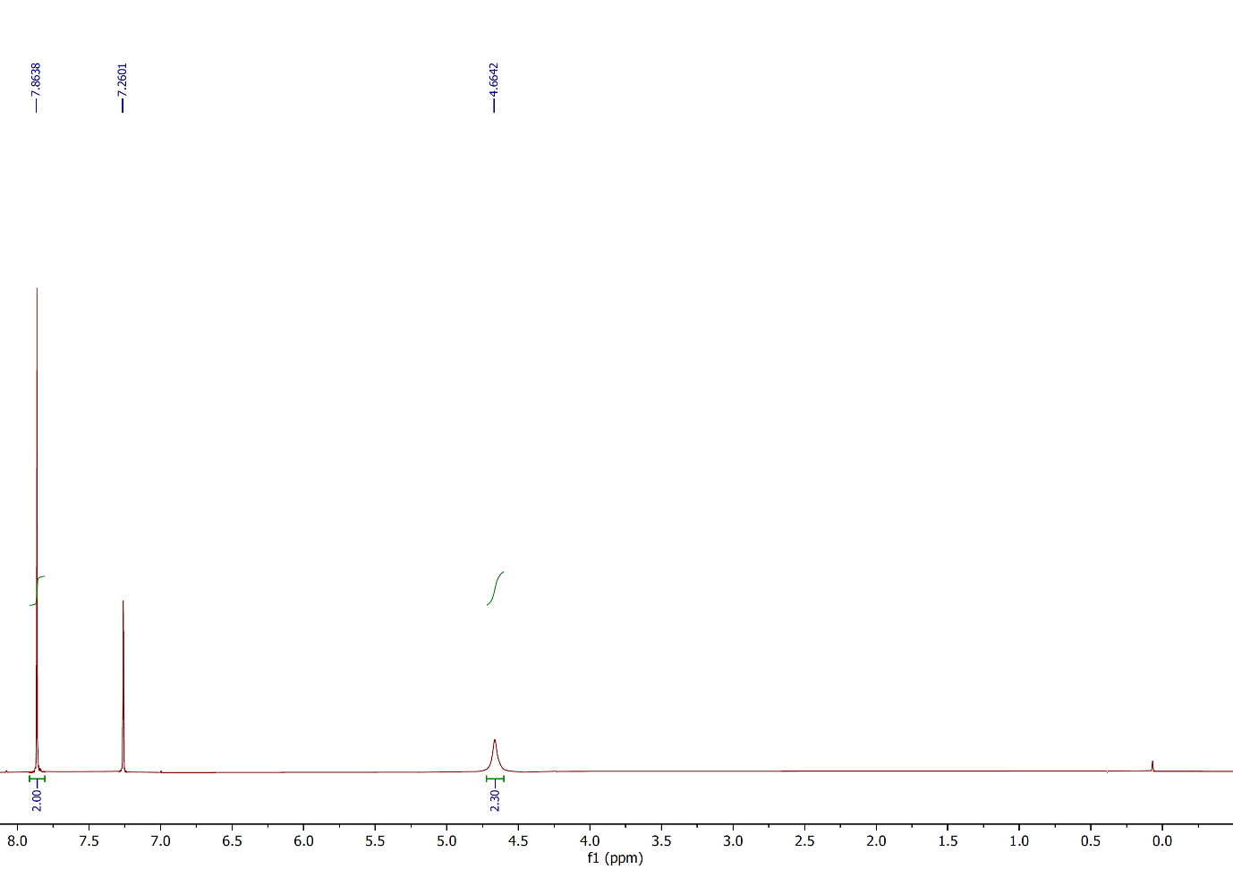

Figure 97: 1H NMR spectrum of compound **4c**,(CDCl3, 400 MHz).

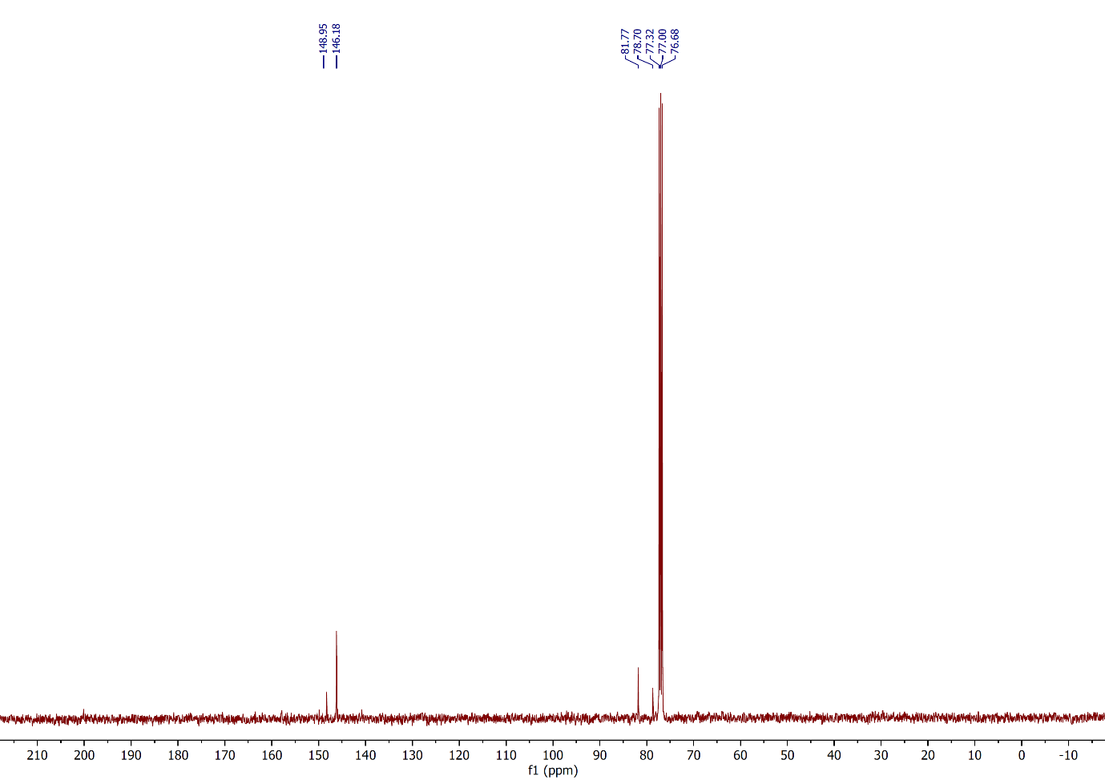

Figure 98: 13C NMR spectrum of compound **4c**,(CDCl3, 100 MHz).

**References**

1. Wang, L.; Feng, C.; Zhang, Y.; Hu, J. *Molecules* **2020**, *25*, 914. doi:10.3390/molecules25040914
2. Tang, R.-J.; Milcent, T.; Crousse, B. *J. Org. Chem*. **2018**, *83*, 930−938. doi:[10.1021/acs.joc.7b02920](https://doi.org/10.1021/acs.joc.7b02920)
3. Otomatsu, T.; Bai, L. M.; Fujita, N.; Shindo, K.; Shimizu, K.; Misawa, N. *J. Mol. Catal. B Enzym.* **2010**, *66*, 234–240. doi:10.1016/j.molcatb.2010.05.015
4. Boruah, J. J.; Das, S. P.; Borah, R.; Gogoi, S. R.; Islam, N. S. *Polyhedron* **2013**, *52*, 246−254. doi:10.1016/j.poly.2012.09.036
5. Schmidt, B.; Holter, F. *Org. Biomol. Chem*. **2011**, *9*, 4914−4920. doi:10.1039/c1ob05256j
6. Eisenhauer, H. R.; Link, K. P. *J. Am. Chem. Soc.* **1954**, *76*, 6, 1647–1649. doi: [10.1021/ja01635a054](https://doi.org/10.1021/ja01635a054)
7. Ma, X.; Yu, J.; Jiang, M.; Wang, M.; Tang, L.; Wei, M.; Zhou, Q. *Eur.* *J. Org. Chem*. **2019**,*28*,4593–4596. doi:10.1002/ejoc.201900794ax
8. Clewley, R. G.; Cross, G. G.; Fischer, A. Henderson, G. N. *Tetrahedron*, **1989**, *45*, 1299–1310. doi: 10.1016/0040-4020(89)80128-0
9. Denton, R. M.; An, J.; Lindovska, P.; Lewis, W. *Tetrahedron*, **2012**, *68*, 2899–2905. doi:10.1016/j.tet.2012.01.067
10. Popa, M. M.; Draghici, C.; Barbu, L.; Dumitrescu, D. E.; Dumitrascu, F. *Synth. Commun.* **2017**, *47*, [344](https://www.thieme-connect.com/products/ejournals/linkout/10.1055/s-0035-1562492/id/JR000-13006)–350. doi:10.1080/00397911.2016.1264603
11. Vijaykumar, G.; Mandal, S. K. *Dalton Trans*. **2016**, *45*, 7421−7426. doi:10.1039/c6dt00470a
12. Le, Z. G.; Chen, Z. C.; Hu, Y.; Zheng, Q. G. *Synthesis* **2004**, *17*, 2809−2812. doi:10.1055/s-2004-831239
13. Ageshina, A. A.; Chesnokov, G. A.; Topchiy, M. A.; Alabugin, I. V.; Nechaev, M. S.; Asachenko, A. F. *Org. Biomol. Chem*. **2019**, *17*, 4523−4534. doi:10.1039/c9ob00615j
14. Khalifa, A.; Conway, L.; Geoghegan, K.; Evans, P. *Tetrahedron Lett*. **2017**, *58*, 4559–4562. doi:10.1016/j.tetlet.2017.10.053
15. Zhou, Y.; Zhou, H.; Liu, S.; Pi, D.; Shen, G. *Tetrahedron* **2017**, *73*, 3898– 3904. doi:10.1016/j.tet.2017.05.056
16. Wu, Y.; Xu, S.; Wang, H.; Shao, D.; Qi, Q.; Lu, Y.; Ma, L.; Zhou, J.; Hu, W.; Gao, W.; Chen, J. *J. Org. Chem.* **2021**, *86*, 16144–16150. doi: 10.1021/acs.joc.1c00923
17. Zhou, Z.; Ma, Z.; Behnke, N. E.; Gao, H.; Kürti, L. *J. Am. Chem. Soc*. **2017**, *139*, 115−118. doi: 10.1021/jacs.6b12712
18. Syvret, R. G.; Butt, K. M.; Nguyen, T. P.; Bulleck, V. L.; Rieth, R. D. *J. Org. Chem*. **2002**,*67*,4487–4493. doi:10.1021/jo020053u
19. Satkar, Y.; Yera-Ledesma, L. F.; Mali, N.; Patil, D.; Navarro-Santos, P.; Segura-Quezada, L. A.; Ramírez-Morales, P. I.; Solorio-Alvarado, C. R. *J. Org. Chem.* **2019**, *84*, 4149–4164. doi:[10.1021/acs.joc.9b00161](https://doi.org/10.1021/acs.joc.9b00161)
20. Rao, A. S.; Ramesh, K.; Rajanna, K. C.; Chakrvarthi, I. *Asian. J. Chem.* **2018**, *30*, 1892–1896. doi:10.14233/ajchem.2018.21413
21. Moorthy, J. N.; Senapati, K.; Kumar, S. *J. Org. Chem.* **2009**, *74*, 6287–6290. doi:10.1021/jo9007892
22. Rong, N.; Yuan, Y.; Chen, H.; Yao, C.; Li, T.; Wanga, Y.; Yang, W. *Org. Chem. Front*., **2021**, *8*, 4479–4484. doi:10.1039/d1qo00461a
23. Racys, D. T.; Sharif, S. A. I.; Pimlott, S. L.; Sutherland, A. *J. Org. Chem*. **2016**, *81*, 772– 780. doi:10.1021/acs.joc.5b02761
24. Shinde, A. T.; Zangade, S. B.; Chavan, S. B.; Vibhute, A. Y.; Nalwar, Y. S.; Vibhute, Y. B. *Synth. Commun*. **2010**, *40*, 3506–3513. doi:10.1080/00397910903457332
25. Tavana, M.; Montazeri, N.; Imanzadeh, G. *Asian J. Chem.* **2011**, *23*, 3097–3100.
26. Vibhute, Y. B.; Lonkar, S. M.; Sayyed, M. A.; Baseer, M. A. *Mendeleev Commun.* **2007**, *17*, 51. doi:10.1016/j.mencom.2007.01.020.
27. Kress, T. J.; Moore, L. L.; Costantino, S. M. *J. Org. Chem.* **1976**, *41*, 93−96. doi:10.1021/jo00863a020
28. Satkar, Y.; Ramadoss, V.; Nahide, P. D.; García-Medina, E.; Juárez-Ornelas, K. A.; Alonso-Castro, A. J.; Chávez-Rivera, R.; ́ Jiménez-Halla, J. O. C.; Solorio-Alvarado, C. R. *RSC Adv*. **2018**, *8*, 17806−17812. doi: 10.1039/c8ra02982b
29. Ghorpade, P. V.; Pethsangave, D. A.; Some, S.; Shankarling, G. S. *J. Org. Chem*. **2018**, 83, 7388–7397. doi:10.1021/acs.joc.8b00188
30. Mostafa, M. A. B.; Calder, E. D. D.; Racys, D. T.; Sutherland, A. *Chem. Eur. J.* **2017**, *23*, 1044−1047.doi:10.1002/chem.201605671
31. Rogers, D. A.; Brown, R. G.; Brandeburg, Z. C.; Ko, E. Y.; Hopkins, M. D.; LeBlanc, G.; Lamar, A. A. *ACS Omega* **2018**, *3*, 12868−12877. doi:10.1021/acsomega.8b02320
32. Chae, J.; Buchwald, S. L. *J. Org. Chem.* **2004**, *69*, 3336−3339. doi:[10.1021/jo035819k](https://doi.org/10.1021/jo035819k)
33. Kösel, T.; Dräger, G.; Kirschning, A. *Org. Biomol. Chem.* 2021, 19, [2907](https://www.thieme-connect.com/products/ejournals/linkout/10.1055/a-1480-8983/id/JR000-8)–2911. doi: 10.1039/d1ob00083g
34. Ferreira, I. M.; Casagrande, G. A.; Pizzuti, L.; Raminelli, C. *Synth. Commun.* **2014**, 44, [2094](https://www.thieme-connect.com/products/ejournals/linkout/10.1055/s-0035-1562492/id/JR000-13006)–2102. doi:10.1080/00397911.2013.879900
35. Carreno, M. C.; Garcia Ruano, J. L.; Sanz, G.; Toledo, M. A.; Urbano, A. *J. Org. Chem*. **1995**, *60*, 5328−5331. doi:10.1021/jo00121a064
36. Zysman-Colman, E.; Arias, K.; Siegel, J. S. *Can. J. Chem*. **2009**, *87*, 440−447. doi:10.1139/v08-176
37. Bovonsombat, P.; Ali, R.; Khan, C.; Leykajarakul, J.; Pla-on, K.; Aphimanchindakul, S.; Pungcharoenpong, N.; Timsuea, N.; Arunrat, A.; Punpongjareorn, N. *Tetrahedron* **2010**, *66*, 6928–6935. doi:10.1016/j.tet.2010.06.041
38. Bovonsombat, P.; Teecomegaet, P.; Kulvaranon, P.; Pandey, A.; Chobtumskul, K.; Tungsirisurp, S.; Sophanpanichkul, P.; Losuwanakul, S.; Soimaneewan, D.; Kanjanwongpaisan, P.; Siricharoensang, P.; Choosakoonkriang, S. *Tetrahedron* **2017**, *73*, 6564–6572. doi:10.1016/j.tet.2017.10.005
39. Pramanick, P. K.; Hou, Z.-L.; Yao, B. *Tetrahedron* **2017**, *73*, 7105–7114. doi:10.1016/j.tet.2017.10.073
40. Du, B.; Jiang, X.; Sun, P. *J. Org. Chem.* **2013**, *78*, 6, 2786–2791. doi: [10.1021/jo302765g](https://doi.org/10.1021/jo302765g)
41. Schröder, N.; Wencel-Delord, J.; Glorius, F. *J. Am. Chem. Soc*. **2012**, *134*, 8298−8301. doi:10.1021/ja302631j
42. Xu, H.; Hu, L.; Zhu, G.; Zhu Y.; Wang, Y.; Zheng-Guang Wu, Z.-G.; Zi, Y.; Huang, W. *RSC Adv.* **2022**, *12*, 7115–7119. doi: 10.1039/d2ra00197g
43. Bose, A.; Mal, P. *Tetrahedron Lett*. **2014**, *55*, 2154–2156. doi:10.1016/j.tetlet.2014.02.064
44. Ghanbarin, N.; Ghafuri, H.; Zand, H. R. E.; Eslami, M. *SynOpen*, 2017, **1**, 143–146. doi:10.1055/s-0036-1590959