SUPPLEMENTARY MATERIAL

Synthesis, characterization, and cytotoxic evaluation of iron oxide nanoparticles functionalized with galactomannan

Francisco R.S. Mendes^{1,9}, Fernanda N. Rodrigues⁴, Nidyedja G.G. Gonçalves⁴, Mateus T. Aerre³, Kelvi W.E. Miranda⁵, Francisco F. Bezerra⁶, Paulo A. S. Mourão⁶, Ana C.O. Monteiro-Moreira^{1,3}, Maria S.R Bastos², Huai N. Cheng⁷, Atanu Biswas⁸, Antônio C.H. Barreto¹⁰, Hélcio S. dos Santos^{1,9}, Alexandre M.R. Teixeira^{1,} *⁹, Renato A. Moreira^{1,3,4}

Address: ¹ Graduate Program in Biotechnology, Northeast Biotechnology Network, State University of Ceará, Campus Itaperi, Fortaleza, CE, Brazil.
² Food Packaging Technology Laboratory, Embrapa Agroindústria Tropical, Fortaleza, CE, Brazil.
³ Centre of Experimental Biology (NuBEx), University of Fortaleza, Fortaleza, CE, Brazil.
⁴ Department Biochemistry and Molecular Biology, Federal University of Ceará, Fortaleza, CE, Brazil.
⁵ Graduate Program in Biomaterials Engineering, Federal University of Lavras, Lavras, MG, Brazil.
⁶ Institute of Medical Biochemistry Leopoldo de Meis, University Hospital Clementino Fraga Filho, Federal University of Rio de Janeiro, 21941-913 Rio de Janeiro, RJ, Brazil. ⁷ USDA Agricultural Research Service, Southern Regional Research Center, 1100 Robert E. Lee Blvd., New Orleans, LA 70124, USA.
⁸ USDA Agricultural Research Service, National Center for Agricultural Utilization Research, 1815 N. University St., Peoria, IL 61604, USA.
⁹ Graduate Program in Biological Chemistry, Department of Biological Chemistry, Regional University of Cariri, Crato, CE, Brazil.
¹⁰ Department of Physics, Federal University of Ceará, Fortaleza, CE, Brazil.

Email: Alexandre M.R. Teixeira – alexandre.teixeira@urca.br
* Corresponding author
Figure S1: ¹H NMR of the galactomannan.

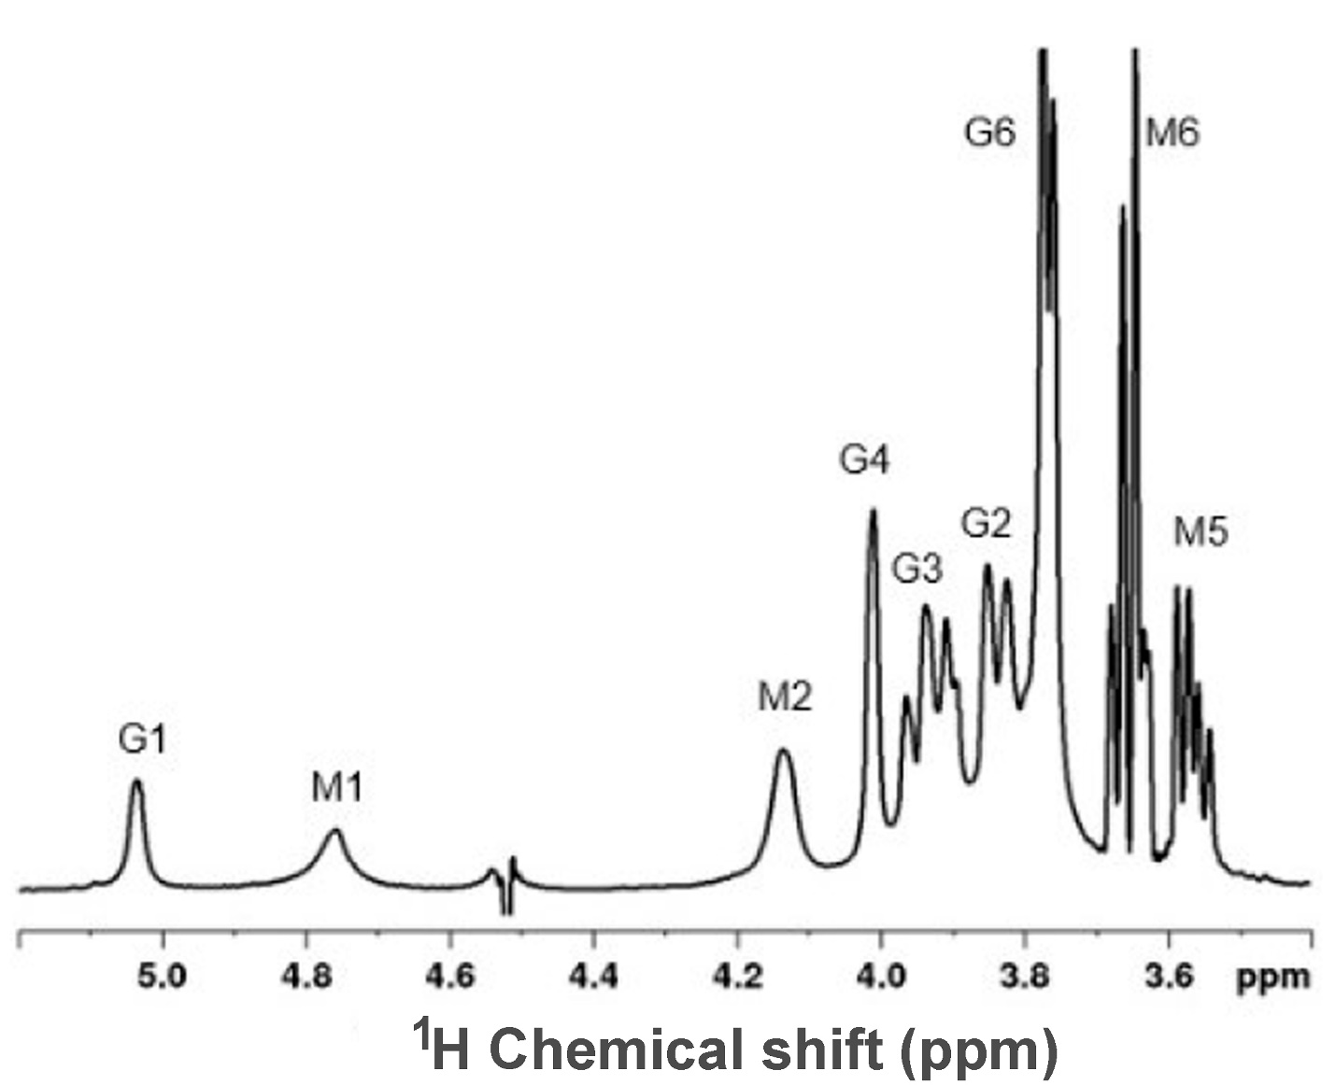

Figure S2: ¹H-¹³C HSQC spectrum of the galactomannan.

